Reply Form
  - Call for evidence on the market structure of European equity markets.

  - Responding to this Consultation Paper
ESMA invites comments on all matters in this Consultation Paper and in particular on the specific questions summarised in Annex 1. Comments are most helpful if they:
- respond to the question stated;
- indicate the specific question to which the comment relates;
- contain a clear rationale; and
- describe any alternatives ESMA should consider.
ESMA will consider all comments received by 30 June 2026.
All contributions should be submitted online at www.esma.europa.eu under the heading ‘Your input - Consultations’.
  - Instructions
In order to facilitate analysis of responses to the Consultation Paper, respondents are requested to follow the below steps when preparing and submitting their response:
• Insert your responses to the questions in the Consultation Paper in this reply form.
• Please do not remove tags of the type < ESMA_QUESTION_MSEM_0>. Your response to each question has to be framed by the two tags corresponding to the question.
• If you do not wish to respond to a given question, please do not delete it but simply leave the text “TYPE YOUR TEXT HERE” between the tags.
• When you have drafted your responses, save the reply form according to the following convention: ESMA_CP1_ MSEM_nameofrespondent.
For example, for a respondent named ABCD, the reply form would be saved with the following name: ESMA_CP1_ MSEM_ABCD.
• Upload the Word reply form containing your responses to ESMA’s website (pdf documents will not be considered except for annexes). All contributions should be submitted online at www.esma.europa.eu under the heading ‘Your input - Consultations’.

Publication of responses
All contributions received will be published following the close of the consultation, unless you request otherwise. Please clearly and prominently indicate in your submission any part you do not wish to be publicly disclosed. A standard confidentiality statement in an email message will not be treated as a request for non-disclosure. A confidential response may be requested from us in accordance with ESMA’s rules on access to documents. We may consult you if we receive such a request. Any decision we make not to disclose the response is reviewable by ESMA’s Board of Appeal and the European Ombudsman.
Data protection
Information on data protection can be found at www.esma.europa.eu under the heading ‘Data protection’.
Who should read this paper?
This paper is primarily addressed to all financial market participants, including trading venues and investment firms, as well as to asset management, data reporting service providers, trade associations, issuers and other stakeholders involved in financial regulation, investor education, and retail investment market developments.

General information about respondent
Name of the company / organisation | Association for Financial Markets in Europe (AFME)
Activity | Trade association
Are you representing an association? | ☒
Country / Region | Europe

Questions
- Do you agree with the description of the market structure summarised in Figure 1 for the purpose of the study in sections 3 and 4 based on transaction reporting data? If not, could you provide an alternative description that you consider more adapted to the reality of the European trading landscape for shares?
<ESMA_QUESTION_MSEM_1>
Executive Summary
AFME welcomes ESMA’s study as an important and timely contribution to the broader ongoing policy debate regarding equity market structure. The results of ESMA’s analysis demonstrate that the European equity markets remain stable, competitive and resilient. The EU equity market is complex but well-functioning and continues to grow. Investors benefit from a range of trading options designed to meet different needs, but over 90% of transactions are executed on exchanges and MTFs.
Changes in the relative use of different trading mechanisms reflect the continued evolution of investor execution needs, the diversity of trading strategies, and the development of a broader range of mechanisms through which participants can access liquidity. While lit continuous order book activity has declined in relative terms, this has been offset to a large extent by increased use of auction mechanisms. This indicates that multilateral trading remains robust, but is being expressed through a broader mix of lit execution protocols.
We strongly consider this diversification as beneficial: flexibility about how and where to execute transactions is essential for our members to ensure compliance with best execution obligations.
Within that broader market structure, investment firms acting in the capacity of a systematic internaliser (SI) play an important role. These firms provide liquidity and use risk capital to facilitate execution in a way that can offer immediacy, execution certainty and reduced market impact, particularly for orders where those features are important. In doing so, they support best execution outcomes for investors and help meet a wide range of investor needs, including through bespoke execution solutions that are not replicable in multilateral environments. Their role should therefore be understood as complementary to lit order books, rather than as detracting from market quality or price formation.
AFME does not see evidence that current market developments are undermining price formation or the overall functioning of EEA equity markets. In particular, price formation should not be viewed as dependent solely on lit continuous order books. It is informed by a wider range of inputs, including transparent post-trade data, auction activity, bilateral trading, market fundamentals and news flow. In this context, the evidence available does not demonstrate structural harm that would justify new restrictions on particular trading models or execution mechanisms. Any future assessment should therefore remain focused on observable outcomes, such as execution quality and price formation process, rather than assumptions that changes in the shares of the different multilateral and bilateral execution mechanisms are in themselves evidence of harm.
Accordingly, AFME does not consider that there is a case at this stage for broad regulatory intervention aimed at reshaping the market structure. Any future policy action should remain evidence-based, proportionate and clearly targeted at identifiable risks. In our view, the more meaningful policy priority is to improve transparency and market-wide access to data, through effective implementation of market data rules and the successful delivery of a high-quality consolidated tape. These measures would better support price formation and market efficiency, while preserving well-functioning and innovative execution models.
Response to Q1: AFME agrees that the use of a structured taxonomy provides a helpful high-level starting point for analysing market structure and enables a degree of comparability across datasets and jurisdictions.
However, we also note that market terminology used by practitioners may differ in some instances from regulatory classifications. While the grouping of “periodic auctions” in Figure 1 of the ESMA Call for Evidence is broadly consistent with MiFIR RTS 1, market participants would not typically refer to closing auctions under this label. “Periodic auctions” and “Frequent Batch Auctions” are typically used interchangeably by market participants. For clarity, the segment referred to as “periodic auctions” (in Figure 1) could be renamed more simply as “Auctions”.
<ESMA_QUESTION_MSEM_1>

- Do you have any insights on the XOFF transactions reported by investment firms who also act as an SI (SI-OTC trades)?
<ESMA_QUESTION_MSEM_2>
EU investment firms that are SIs do not always solely act in an SI capacity. Many firms who handle orders will assess prices available on a range of execution venues (trading venues and SIs), and may select their own SI as the execution venue and report the trade as such. If the best result for the client is obtainable on a third party SI, the trade will be reported once in the EU by the entity with the reporting obligation under the reporting waterfall. In addition, where permitted by the STO (e.g. for trades in non-EEA ISINs or for trades that are exempt such as dual-listings) EU investment firms may seek liquidity outside the EU (e.g. in the UK). In such a chain (i.e. an EU investment firm that is also an SI but executes with a third party UK SI), the UK entity will report the trade as SI in the UK and the EU entity may report the trade in the EU as XOFF (as from the perspective of the EU entity it was order handling the transaction and was not acting in a SI capacity when it filled the client).
We have also been made aware of instances where an EU investment firm with a UK branch executing SI transactions out of its UK branch for UK/non-EU clients, and reporting the trades as required by the UK rules in the UK, has been required by its EU NCA to also report the transactions in the EU. It is possible this double reporting is being done in XOFF capacity.
Accordingly, we re-iterate our request that the EU and UK authorities work together to ensure there is no double reporting of transactions (which undermines confidence in liquidity figures). EU and UK authorities each consider on-venue transaction transparency equivalent and we see no reason why off-venue transaction transparency should also be considered equivalent.
Finally, XOFF may be used by some investment firms for reporting certain transactions that are out of scope of the STO, namely trades that do not contribute to the price discovery process. Examples of these could be those flagged as BENC and PORT. Before the relevant content was moved from the market structure Q&A into the post-trade manual (and before give-ups were taken out of scope of reporting), it was explicit that certain of those transactions were to be reported as XOFF (and accordingly some firms may use that behaviour for all trades exempt from the STO because they do not contribute to the price discovery process for consistency).
<ESMA_QUESTION_MSEM_2>

- Do you agree with the general trends identified regarding on-book vs. off-book trading, and addressable vs. non-addressable liquidity? What other trends do you consider relevant, also in terms of competitive pressures?
<ESMA_QUESTION_MSEM_3>
AFME broadly agrees with the general trends identified, which clearly show that EU equity markets are well-functioning, stable and growing. ESMA’s data evidences a stable level of addressable liquidity and on-book trading. Observed shifts between trading mechanisms should be interpreted as reflecting a structural evolution in the needs of investors, rather than a decline in market quality.
In particular, increased use of different execution venues and mechanisms represents greater diversity of liquidity provision and should not be equated with negative outcomes. A range of competitive drivers underpin these developments, including the availability of execution models that are better suited for lower urgency strategies, or larger sizes.
Within on-book trading, AFME notes a rebalancing rather than a material reduction in multilateral trading, with the decline in lit continuous trading largely offset by the growing role of auction mechanisms.
As well as monitoring ongoing trends in market structure, we believe this analysis would be significantly enriched by more in-depth analysis of the underlying reasons for these trends, in coordination with market participants. This should include both quantitative data such as all-in transaction costs and market impact of different execution mechanisms, as well as qualitative feedback from market practitioners regarding their investment or order routing decision-making.
<ESMA_QUESTION_MSEM_3>

- Do you have any concerns on the impact of the identified trends on the general functioning of the EEA markets for shares? In your view, what are the implications of the relative decreasing trend in trading on CLOB for the effective price formation in the EEA markets for shares? What are the implications on price formation should this trend persist or even accelerate?
<ESMA_QUESTION_MSEM_4>
We do not have any major concerns regarding the current functioning of EEA equity markets.
The share of CLOB has been declining consistently and gradually for a number of years. To date, there has been no deterioration in price discovery, the market has remained robust, active and reaching all-time records in terms of volume traded. Arguments suggesting that a decline in CLOB would lead to risks in price discovery continue to remain unsubstantiated and yet part of a narrative that generates distrust in markets. We note that this argument has been put forward by stock exchanges for over a decade, allowing them ample opportunity to bring forward evidence of market harm – yet none has been provided.
Equating price formation solely with CLOB trading is simplistic and incomplete – a much broad set of information sources, including the post-trade reporting applicable to all forms of trading, market fundamentals, macro conditions, and news flow, shape participants’ assessment of a “true” or fair price (Figure 1).
Figure 1
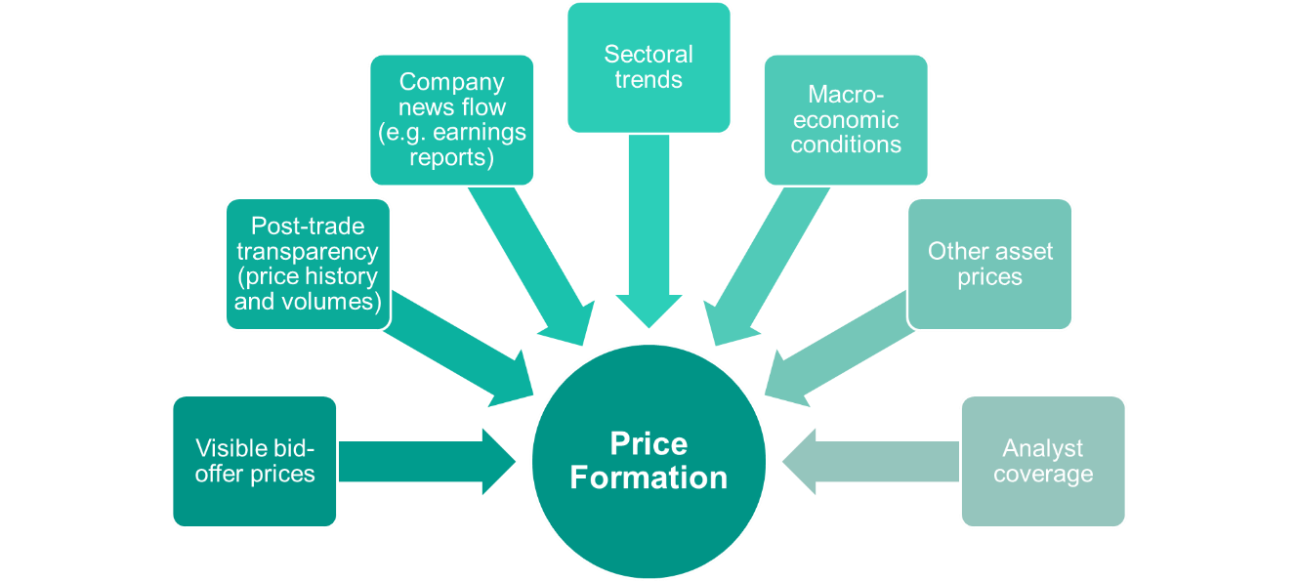

We see no evidence that prices are persistently less reliable or less efficient than would be expected given fundamentals and observable trading conditions. No single metric can conclusively measure price formation on its own, and no robust body of evidence has been established to show that EEA equity prices are structurally failing to reflect information because of market structure.
A common indicator which helps to provide a practical view of market quality is the ‘spread’ - the difference between bid and offer prices. Narrow spreads are generally consistent with competitive liquidity provision and confidence in current prices. We note that a recent ESMA analysis found that stocks with a higher degree of trading ‘fragmentation’ (i.e. activity was more dispersed across different execution methods) also exhibited tighter spreads (Figure 2).
Figure 2
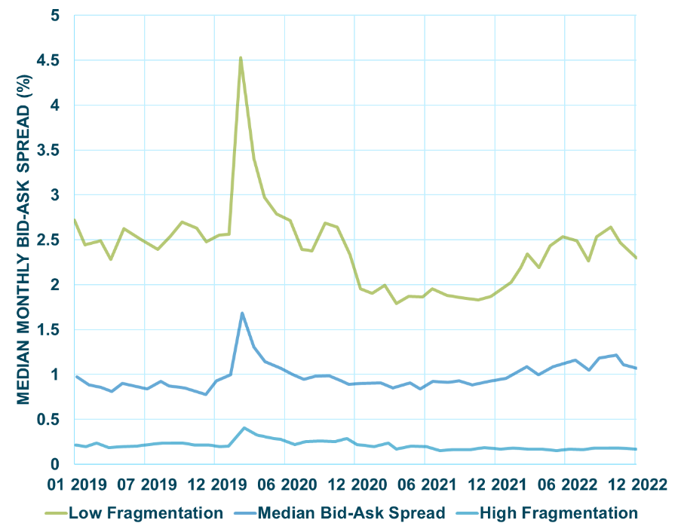
Ultimately, price formation is a function of the information available to market participants. As such, improving access to market data would be conducive to supporting price formation. robust enforcement of rules around market data fees would therefore be the most meaningful regulatory interventions to support healthy price formation.
Furthermore, the delivery of a comprehensive consolidated tape (CT) that would provide a comprehensive and precise view of the available liquidity across different execution methods would materially improve effective price formation. In this respect, it is important that an assessment of the CT is completed drawing on operational experience and actual data. This assessment should also take into account the findings from ESMA’s report pursuant to Article 52(14) MiFIR on the market demand for the CT, the impact on the functioning, attractiveness and international competitiveness of EU markets and firms, and whether the CT has delivered on its aim to decrease information asymmetries between market participants and to make the EU a more attractive location to invest.
<ESMA_QUESTION_MSEM_4>

- As the choice of trading facility has increased, it is important for ESMA to understand why market participants are choosing the execution facilities that they do. What are the drivers that you consider most relevant when choosing on which execution venue and with which execution method to trade?
<ESMA_QUESTION_MSEM_5>
Execution choices are driven by best execution obligations, with decisions about the appropriate execution mechanism based on order size, liquidity, market impact, timing and execution certainty. Access to a range of trading mechanisms allows participants to optimise outcomes by selecting the most appropriate method(s) for each order, rather than relying on a single model. In this context, bilateral liquidity (including SIs) remains important, where risk transfer, immediacy and reduced information leakage are key.
Market participants also consider factors such as access costs, latency, and the availability of different execution models, including reference-price trading, auctions (notably closing auctions for valuation and FBAs for short-duration matching), and bilateral execution.
Clients are actively involved in assessing best execution and also have their own preferred benchmarks for best execution (e.g. arrival price). Client expectations are therefore also relevant into how their orders are represented in the market.
Accordingly, the diversity of execution methods in EU markets is a competitive strength, enabling tailored solutions and better outcomes for end investors, including pensioners and savers.
It is therefore important to preserve a framework that supports a diverse, innovative and efficient market structure, rather than implying a single “optimal” venue or outcome. Continued innovation in trading protocols will be key to aligning venue offerings with evolving client execution preferences. AFME encourages ESMA to focus on outcomes (e.g. execution quality, spreads, investor results) rather than market share as a proxy for quality.
<ESMA_QUESTION_MSEM_5>

- What are your experiences with regard to gaining access to liquidity? To what extent are you, either directly or via a broker, able to access liquidity on relevant trading venues or relevant systematic internalisers? If not, please explain what stands in the way of gaining such access.
<ESMA_QUESTION_MSEM_6>
We believe that market participants are generally able to access wholesale liquidity across trading venues and SIs, reflecting the diversity and openness of the EU market structure and investor demand.
However, maintaining and enhancing access requires significant resources. The continuous pace of regulatory changes increases compliance burden on market participants - greater regulatory stability and simplification would help redirect resources towards improving liquidity access and execution capabilities.
With respect to retail liquidity, we do notice that it is not generally well integrated with wholesale liquidity and there are a number of venue services that seek to segregate it. It is likely that more competition in the retail market will improve execution outcomes for investors as it has for wholesale market investors.
Additionally, improving transparency of available liquidity is also key. A high-quality CT will enhance visibility across venues and execution methods, supporting more efficient access and routing. Overall, in the wholesale markets there are no clear structural barriers to access, but further improvements depend on greater transparency and a framework that enables firms to prioritise connectivity and innovation.
<ESMA_QUESTION_MSEM_6>

- If you are an issuer, how do you see these market developments? Do you consider this an attractive environment for listing? If not, why?
<ESMA_QUESTION_MSEM_7>
We agree there is a symbiotic relationship between primary and secondary markets, where deep and liquid secondary markets support vibrant primary markets, and vice versa. From an issuer perspective, what matters is overall liquidity and investor access, rather than the concentration of trading on a particular venue.
AFME does not observe a correlation between on-exchange trading concentration and growth in IPO activity (see response to Q8 for further details). Evidence shows that strong primary markets can coexist with dispersed trading (e.g. Sweden, where only 37% of trading took place on Nasdaq Sweden had 193 IPOs between 2021 and 2025, the largest number of IPOs across all EEA countries), while more concentrated markets have not necessarily supported IPO growth.
Listing decisions are driven by a range of factors, including macroeconomic conditions, investor sentiment, commercial strategy, listing frameworks and capital availability, rather than secondary market structure. Traditionally, jurisdictions with a diverse pool of investors and strong brand recognition are attractive environments for listing.
Issuers may also underestimate the true scale of EU liquidity if focusing only on trading activity on primary venues. A high-quality CT will be critical in providing a complete and accurate view of the size of the market and liquidity across execution methods. Overall, AFME thinks that current developments do not detract from the attractiveness of EU markets and that the CT will materially contribute to a better representation of liquidity which will support more informed listing decisions.
<ESMA_QUESTION_MSEM_7>

- What conclusions would you draw from the distribution of liquidity across EEA ISINs? Do you identify any policy recommendations in this context, with a view to enhancing price formation while ensuring a level playing field across different types of venues? Do you have explanations for the high share of OTC trading observed in the ISIN’s of some jurisdictions?
<ESMA_QUESTION_MSEM_8>
Evidence indicates that there is a correlation between the existence of diversified liquidity pools and larger, more developed equity markets. In particular, as demonstrated in the Call for Evidence, in the vast majority of countries that are front-runners in the most traded-ISINs, including Germany, France, the Netherlands, Sweden, Denmark, Finland, Norway and Belgium, liquidity is not concentrated on lit continuous trading carried out on the respective RMs. In fact, the proportion of trading on primary CLOB is less than 30%. However, the market capitalisation of the relevant RMs in those countries has been in 2025 substantially higher than the countries where there is a moderate (30-50%) or high (more than 50%) degree of concentration of trading on lit continuous RMs. In particular, the primary stock exchanges/RMs in the above-mentioned countries where CLOB trading on RMs represents less than 30% of the volume are included in the top 10 across EEA in terms of market capitalisation.
Likewise, the ratio of market capitalisation to GDP in 2025 has been substantially higher in those countries with a lower degree of CLOB trading on RMs. Thus, the existence of a diverse range of execution mechanisms benefits RMs by allowing them to gain better market capitalisation.
A similar positive corelation is also visible in IPO activity. In particular, during the last 5 years (2021-2025) Sweden, Finland, France, Germany, the Netherlands and Denmark have been among the markets with the highest number of IPOs. This suggest that markets that generally have more diversified trading ecosystems and a lower degree of concentration of primary CLOB trading can be more attractive listing places than those where trading is concentrated on lit continuous RMs. The same pattern is also observed with respect to the total IPO value (in EUR). In particular both in Germany and Sweden the total value of IPOs surpassed 20 billion (approximately 24,1 and 20,2 billion, respectively) followed by the Netherlands (approximately 14,3 billion) and Norway (8,4 billion). This suggests that the existence of a broad range of execution mechanisms is not an obstacle to healthy primary markets, but actually can help support strong listing activity.
For a detailed analysis please see the figures included in the Annex.
Furthermore, regarding ESMA’s observations on the high share of OTC in the ISINs of some jurisdictions it is noted that such findings are common in markets where there is limited liquidity (with the exception of Ireland).
<ESMA_QUESTION_MSEM_8>

- What is your view on the evolution of dark trading on EU trading venues? Are there any structural shifts that you noticed, which you believe should be further monitored?
<ESMA_QUESTION_MSEM_9>
In recent years, the range of dark equity trading services offered by trading venues has expanded, and a wide range of dark pools are now operated by leading European venues, including Euronext, Deutsche Börse, Turquoise, Aquis and Cboe. Despite this expansion, evidence suggests that overall dark trading volumes have remained broadly stable throughout the reference period in the ESMA Call for Evidence.
Moreover, in the UK, despite the fact that a volume cap has no longer applied since 2023, the level of dark trading has remained largely stable between 2022 and 2025 and no noticeable increases have been observed (see Figure 3). This suggests that there is, in practice, a natural threshold to the use of dark trading, driven by the execution needs of market participants and the continued use of lit markets and auctions. In other words, removal of regulatory restrictions on dark trading has not resulted in any material market shift or meaningful migration of activity from lit to dark venues.
Figure 3
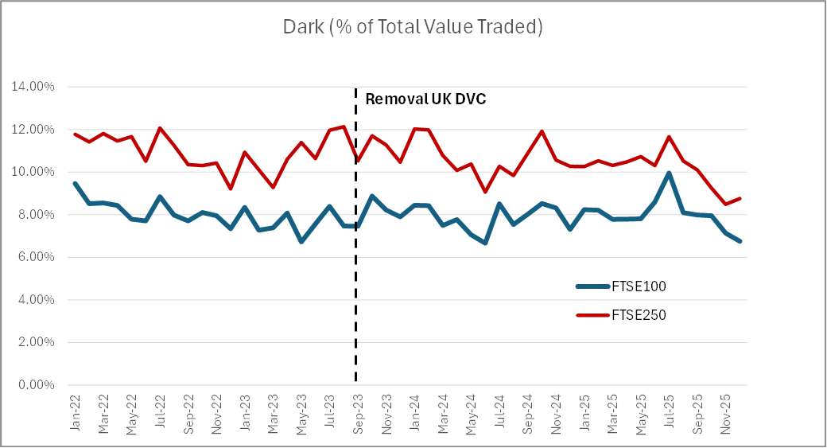

On the basis of the data currently available, AFME has not identified any significant concerns or observed any material structural shifts in market dynamics. This points to a relatively stable role for dark venues within the broader trading landscape, with no clear evidence of disruptive trends or emerging risks.
<ESMA_QUESTION_MSEM_9>

- What concerns/issues do you highlight at this stage? Do you see a need for specific regulatory interventions also in consideration of evidence available regarding practices related to dark trading functionalities (please provide details)?
<ESMA_QUESTION_MSEM_10>
AFME does not consider that current evidence justifies any regulatory interventions that would impose new restrictions on dark trading or related functionalities. Any concerns are better addressed through targeted supervision, rather than broad rule changes. Before considering any intervention, ESMA should clearly define the specific issues of concern and establish robust evidentiary thresholds demonstrating concrete risks to market quality or investor outcomes. A data-driven, proportionate approach is essential to avoid unintended consequences, including reduced liquidity, higher costs, or constraints on legitimate execution strategies.
<ESMA_QUESTION_MSEM_10>

- What is your view on the evolution and effects of trading in closing auctions on the EU markets? Do you agree with the presented rationale for trading in closing auctions or do you consider other drivers more important for explaining the growth and increasing significance of closing auctions trading?
<ESMA_QUESTION_MSEM_11>
AFME agrees that closing auctions are important, supporting the orderly formation of a single closing reference price widely used for valuation, benchmarking and index tracking. We believe that their growth is primarily driven by passive and index-linked investing, reflecting investor execution needs rather than structural weaknesses in other trading mechanisms.
AFME cautions against attributing the observed concentration on liquidity in the primary exchange’s closing auction to intra-day fragmentation as it is suggested in paragraph 59 of the Call for Evidence. In our view, the execution of large volumes at the close is driven by the time-based concentration of liquidity (due to the short time duration), not by venue-based concentration. The closing auction has become an increasingly prominent liquidity event, allowing traders to execute at size with lower market impact and reducing adverse selection risks present on trading venues during the continuous trading period.
It is also related to the fact that closing auctions are used for portfolio management purposes, notably passive flows management and benchmarking needs. This view is further supported by the absence of similar growth in opening or intra-day auctions, despite limited competing venue activity in those periods.
Overall, the increasing role of closing auctions reflects efficient market adaptation to investor demand, supporting effective price formation and execution outcomes and should not be regarded as a sign of cross-venue fragmentation.
<ESMA_QUESTION_MSEM_11>

- What is your view on the effects of alternative closing mechanisms offered by MTFs and SIs?
<ESMA_QUESTION_MSEM_12>
These services are complementary to closing auctions and provides additional liquidity and flexibility around the close. This enables further risk transferring at the established closing price, thereby reinforcing the validity and market acceptance of the closing price as a price-forming benchmark.
From an investor perspective, this service reflects demand for execution choice, allowing participants to interact with the closing price under different timing and liquidity constraints. We would welcome increased transparency around the use of the closing price as a benchmark and accordingly support FIX in calling for a dedicated flag to clearly identify transactions executed at the closing price as has been adopted in the UK.
AFME would caution that proposals under discussion (including in the context of MISP) to introduce or promote alternative reference points, such as volume-weighted closing benchmarks could risk fragmenting the closing price and disrupt established market conventions, which rely on a single, widely accepted closing reference.
<ESMA_QUESTION_MSEM_12>

- What will be in your view the effects of 24h/ extended trading ours on closing auctions?
<ESMA_QUESTION_MSEM_13>
From a wholesale market perspective, AFME expects limited near-term impact on the role of closing auctions. The current market structure (opening, continuous trading, and closing auction) is likely to remain intact, given the continued need for a single daily reference price point for valuation, benchmarking and operational processes.
Experience and analysis from the US suggest that even with the existence of pre- and post-market as well as overnight trading, volumes remain high (at around 90%) during regular trading hours (9am-4pm) with concentration of liquidity at specific points in the day, particularly around the open and close. Outside core trading hours, volumes remain low with wider spreads observed. This reinforces the importance of a coordinated closing event, rather than weakening it. Accordingly, while extended / 24h trading might enable greater retail participation, we consider more effort should be made to encourage investors (including retail investors) to trade during core market hours where higher volumes should mean they obtain better outcomes.
While extended trading may enhance flexibility and allow participants to react to news in real time, and potentially support the growth of retail investment in the region, it does not remove the institutional need for a widely accepted closing benchmark. Industry discussions in the US similarly point to the need to retain a defined “close” (or equivalent reference point) even in a near-continuous trading environment.
Overall, AFME considers that extended trading hours are unlikely to diminish the importance of closing auctions, which should continue to play a central role as the primary price-forming event and benchmark anchor at the end of the trading day.
<ESMA_QUESTION_MSEM_13>

- Are there any structural shifts that you noticed, which you believe the competent authorities should monitor? Would you like to highlight any concerns/issues at this stage? Do you see a need for specific regulatory interventions (please provide details relating them possibly to the data and observations available)?
<ESMA_QUESTION_MSEM_14>
AFME highlights operational resilience around closing auctions as an important area for ongoing monitoring by competent authorities. In particular, it is important that trading venues maintain robust and transparent protocols governing whether and how a closing auction will run in stressed conditions, and how a closing reference price is determined and communicated in the event of disruption. Timely, consistent and clear communication to market participants is critical given the central role of the closing price for valuation, benchmarking and risk management. AFME does not see a case for specific regulatory interventions based on the available evidence and supports further analytical and evidence-based work by ESMA on closing auctions and related market developments as the basis for any future policy considerations.
<ESMA_QUESTION_MSEM_14>

- What is your view on the evolution of trading in FBAs on EU markets? Why are those mechanisms gaining traction in your view? Which are the benefits and shortcomings they offer? (please elaborate)
<ESMA_QUESTION_MSEM_15>
FBAs are a recognised and essential execution mechanism within the European trading market structure. These mechanisms are fully transparent and price-forming, allowing execution at the midpoint only when doing so maximises tradeable volume.
In addition, FBAs eliminate latency arbitrage and enhance execution quality for investors by reducing the advantage of speed-based strategies. The randomisation of the uncrossing timing, the transparent nature of the FBAs together with their price forming matching design prevent tick level targeting / gaming and ensure that executions (including midpoint) are price neutral and cannot be predicted when orders are submitted. This results in high execution performance for the end investor through a transparent on venue book, which makes FBAs a unique and additive component to the liquidity landscape These benefits align with the objectives of MiFIR and the wider European framework for fair and orderly markets.
FBAs offer a significant competitive advantage to the European equity markets and represent flexibility and innovation in the current trading landscape. The flexibility to innovate is essential to the ability of exchanges to appeal to the broadest range of investment strategies and market participants, and thereby enhance the scale, efficiency and international competitiveness of EU capital markets. Therefore, AFME would encourage venues to consider ways to promote innovation both for FBAs and continuous lit trading.
<ESMA_QUESTION_MSEM_15>

- Do you have any particular observations as regards the impact of SVC on FBAs?
<ESMA_QUESTION_MSEM_16>
Evidence suggests that periodic auction activity counts for a small but growing share of the overall equity trading market. Following the move to the SVC, an increase in trading volume was observed for instruments suspended in October 2025. However, in the second suspension phase trading activity was normalised and the stabilisation continued also during the third suspension phase. In any case, due to the short reference period, further analysis would be welcome in the coming years to determine the development of any new trends.
We further note that in the UK where the double volume cap was removed in 2023 and there are no restrictions on dark trading, a similar growth of FBAs has been observed - with activity doubling from around 4% in 2023 to 8% in 2026 (Figure 4). This demonstrates that the growth of FBAs cannot be attributed to restrictions on dark trading.
Figure 4
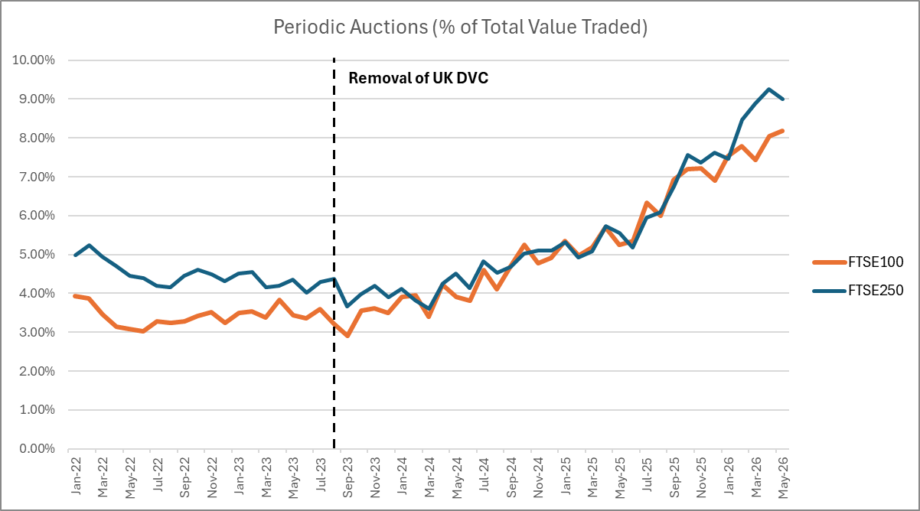

<ESMA_QUESTION_MSEM_16>

- Are there any emerging structural shifts which you believe would warrant closer monitoring? (please elaborate)
<ESMA_QUESTION_MSEM_17>
AFME does not see evidence at this stage of any emerging structural shift that could lead to negative market outcomes. We agree that ESMA should continue to monitor the evolution of the market structure on a data-led basis as markets are adapting to the recent MiFIR review.
Any future assessment should therefore remain focused on observable outcomes, such as execution quality and price formation process, rather than assumptions that changes in the shares of the different multilateral and bilateral execution mechanisms are in themselves evidence of harm.
<ESMA_QUESTION_MSEM_17>

- What is your view regarding the contribution of FBAs to price formation and transparency? Should those mechanisms be generally considered as price forming/ non price forming or this assessment should be done on a case-by-case basis depending on the specific design of the auction? (please elaborate, supplementing your views with data evidence when available)
<ESMA_QUESTION_MSEM_18>
As previously noted, FBAs are subject to pre-trade transparency and are price forming. Due to their innovative nature, they enhance execution choice, support competition between trading models and provide a transparent mechanism that may be particularly useful for orders seeking to balance price, market impact and immediacy.
<ESMA_QUESTION_MSEM_18>

- Please highlight any concerns/issues you may have at this stage. Do you see a need for specific regulatory interventions, particularly regarding the tick size regime and its application to transactions and periodic auctions (please provide details)?
<ESMA_QUESTION_MSEM_19>
AFME does not see a case at this stage for targeted regulatory intervention specifically aimed at FBAs, absent clear evidence of harm to price formation or market integrity.
Regarding the application of the tick size, which was originally developed with CLOBs in mind, it should be clarified that the regime is not necessary to achieve orderly functioning of periodic auctions, where the absence of time-priority and generation of a single uncross price reduce the utility of finer pricing granularity, and where pre-trade transparency is satisfied via dissemination of an indicative trade price. In general, FBAs execute at the midpoint of the best bid and best offer only when doing so maximises tradeable volume. The midpoint represents the most neutral and equitable price for counterparties when neither is demanding liquidity of the other. This principle always holds, irrespective of whether the prevailing spread comprises an odd or even number of ticks.
In recognition of the desirability of midpoint outcomes to end investors, the 2024 MiFIR review formalised the ability for SIs to trade at the midpoint. Restricting midpoint executions, in any trading mechanism, based on an unpredictable and arbitrary factor (i.e. the number of ticks comprising the spread) would introduce unnecessary distortions and undermine fairness by forcing venues to advantage one party over another by rounding prices away from the midpoint.
AFME thinks that allowing off-tick midpoint executions where the prevailing spread comprises of an odd number of ticks does not undermine the tick size regime and its objectives. Accordingly, we welcome the repeal of the ESMA Q&A. The disapplication of the tick size regime for FBAs enables both SIs and trading venues to offer execution at midpoint ensuring a more consistent application of rules.
<ESMA_QUESTION_MSEM_19>

- What is your view on the evolution of trading of SIs on the EEA markets? What are the main drivers of their growth?
<ESMA_QUESTION_MSEM_20>
The evolution of bilateral trading in EEA equity markets reflects a gradual diversification of execution models. This activity has long been a feature of European markets, with bilateral liquidity provision pre-dating MiFID. The MiFID SI regime primarily formalised and labelled these activities.
The observed increase in internalisation has been driven by investor preference for execution choice (including reduced market impact, execution certainty and customised liquidity access) as well as continued investment by banks in innovative execution solutions. Banks also conduct rigorous Transaction Cost Analysis (TCA) and consistently ensure that the internalisation of order flow results in more favourable all-in cost outcomes for their client than executing via any other trading mechanism.
A bank acting in SI capacity uses its capital and balance sheet to facilitate an efficient and bespoke service which leads to better priced investment transactions to its clients, with lower market footprint. In turn this benefits end investors, such as pensioners and savers, who entrust their money to the asset managers to obtain the best possible results for them.
By providing access to liquidity and offering balance sheet to clients, bilateral liquidity providers act as a ‘shock absorber’ for end-users by limiting price impacts of client orders. This represents the only trading mechanism that can guarantee execution against risk capital and it is vital to preserve such risk provision as part of the EU’s market eco-system in order to ensure that investors varying needs can continue to be met.
Assessments on the use of bilateral trading that focus on the relative regulatory framework applicable to bilateral liquidity providers versus multilateral venues miss the point. It is matter of investor demand. Restricting investors’ access to bilateral liquidity or other alternative trading mechanisms would not change this underlying demand, and it should not be assumed that regulatory intervention would result in an increase in activity on multilateral trading venues.
Caution is warranted in interpreting the scale of internalisation as differences between transaction reporting data and post-trade transparency data (including treatment of intra-group transactions) and potential double counting linked to branch reporting structures might have contributed to an overstatement of internalisation activity.
<ESMA_QUESTION_MSEM_20>

- Does this picture reflect the trends you observe in SI trading? Do SI offer trading for both large and small sizes? Do these different trade size reflect different types of clients / SI businesses?
<ESMA_QUESTION_MSEM_21>
AFME’s experience broadly aligns with ESMA’s observation that order flow is internalised across a wide range of sizes, including both: below-SMS trades, and larger executions. This is consistent with the recognised diversity of business models and their role in servicing a wide range of trading needs across the market offering bespoke execution solutions.
Differences in trade size do not map cleanly to retail vs institutional activity: trade size is not a reliable proxy for client type. Larger trades are typically associated with institutional activity and balance sheet provision, while smaller trade sizes can arise in a variety of contexts, including algorithmic execution strategies and order slicing. Smaller trade sizes do not necessarily indicate retail activity. A significant proportion of smaller transactions are most likely the result from the use of execution algorithms and smart order routers, which systematically slice larger institutional orders (“parent orders”) into smaller “child orders” targeting the most suitable venue to minimise market impact and optimise execution outcomes. Any conclusions drawn purely on the basis of trade size should therefore be treated with caution.
<ESMA_QUESTION_MSEM_21>

- What is your perception of the application of price improvement by SIs? Does the data analysis reflect the reality, or do you believe that there are some data quality issues in the flagging of transactions subject to price improvement?
<ESMA_QUESTION_MSEM_22>
We would like to note that Articles 14 and 15 of MiFIR require firms to make public quotes at a minimum of SMS and execute transactions at those quotes when dealing in sizes up to 2x SMS. There are certain exclusions for certain trade types (e.g. for a portfolio trade where the price is not subject to the current market price) and a more narrow exclusion that allows firms, in justified cases, to execute orders at a better price than the quoted price to the extent that that price within a public range close to market conditions. The ability to execute away from the public quote, where justified, plays an important role in allowing banks acting in SI capacity to provide risk pricing across a range of execution styles and time horizons. Many trading strategies cannot be adequately represented by a single point-in-time bid/mid/ask construct, and limited flexibility in pricing enables liquidity providers to respond to client needs in a more tailored and efficient manner. It is only in this limited instance where firms are relying on the flexibility set out in Article 15(2) of MiFIR the ‘received price improvement’ (RPRI) flag is populated.
It is therefore not surprising to us, given that it is a narrow exclusion to the ability to trade away from your quoted price, that it is not used more widely. We would like to re-iterate that it is not, and its use should not be used as, a measure of best execution or an indication that the execution price represents the best price. It is used sparingly because we understand that the regulatory expectation is that banks acting in SI capacity should trade at their quoted price unless an exclusion applies or there is a justified case to depart from it.
That being the case it does not, and cannot capture, the instances in which SI prices are the best prices (whether that is below or above SMS). Banks are also able to rely on other exclusions to trade away from their quoted price such as when dealing above 2x SMS, when transactions are not subject to the current market price (e.g. for benchmarks, portfolio and similar transactions) and when trading at mid-point. The ability of banks to provide price improvement is an important feature of the current market structure. It enables banks to manage risk inventory more effectively, provide clients with a differentiated and additional bilateral liquidity offering that can deliver improved pricing and, in certain cases, lower market impact. Furthermore, execution at the midpoint remains a widely accepted benchmark for fair value between buyers and sellers. In our experience, midpoint execution can offer a balanced form of price improvement to both parties and is often associated with lower market impact compared to trading at the touch. However, it should be clear that these forms of price improvement do not attract the RPRI flag as the flag is not relevant or applied when trading above 2xSMS, when the quoted price is the best price or when trading at mid.
Furthermore, AFME members who are also SIs are required to consider the execution factors relevant to their client base (typically professional clients). Whilst price is an important factor, other factors feature prominently in the calculation including, for example, likelihood of execution. It is when considering all relevant factors (and the weights attached to them – which may differ from order to order) that they decide the venue or venues that can provide clients with the best outcome for that order. This assessment is done on a granular basis taking into account multiple factors and cannot be replaced with a flag-based metric which is only relevant in a narrow range of circumstances.
<ESMA_QUESTION_MSEM_22>

- Which flags do you consider important to identify certain trade related to SI trading?
<ESMA_QUESTION_MSEM_23>
As we explain in our response to Q44, intragroup transactions executed by SIs should not be considered as addressable liquidity and price forming and accordingly should not be subject to post-trade transparency reporting. However, as a second-best alternative, AFME would support the introduction of a specific flag to identify this activity, allowing for it to be clearly segmented in liquidity analysis.
AFME is also supportive of the work carried out by FIX which aims to promote regular dialogue between the industry and ESMA on the application of flags.
<ESMA_QUESTION_MSEM_23>

- What is your view on the evolution of SI trading on the EU markets? Are there any structural shifts that you noticed, or envisage, which you believe should be further monitored?
<ESMA_QUESTION_MSEM_24>
AFME notes that the evolution of execution practices is an area for monitoring: the increasing use of technology, including algorithmic execution and order slicing, may influence observed trading patterns (e.g. trade size distribution) and should be considered when interpreting market data.
AFME stresses that internalised transactions in liquid instruments are subject to pre- and post-trade transparency according to the relevant provisions in RTS1. Therefore, the misperceived view expressed by some market participants which equates bilateral trading carried out by SIs to dark trading is misleading.
<ESMA_QUESTION_MSEM_24>

- Please highlight any concerns/issues you may have at this stage? Do you see a need for specific for regulatory interventions (please provide details possibly relating to the information and data available or observed)?
<ESMA_QUESTION_MSEM_25>
AFME does not consider that current evidence demonstrates market harm or dysfunction requiring new regulatory intervention specific to SIs. Observations in ESMA data, particularly on price improvement and trade characteristics, should be interpreted with caution given acknowledged data quality limitations.
Any policy response should therefore remain evidence-based, preserve a level playing field across execution mechanisms, and avoid measures that would reduce execution choice or impair liquidity provision.
In this context, AFME would caution against a number of potential interventions that risk unintended consequences:
- Requiring investment firms acting as SIs to update public quotes prior to execution to reflect client-specific price improvements would fundamentally conflict with the bilateral nature of off-book trading. Such an approach would prevent banks from offering bespoke prices and expose them to undue risk by effectively extending those prices to a broader client base. This would disincentivise liquidity provision and reduce execution quality, ultimately shrinking overall market liquidity rather than redistributing it, and leaving investors worse off.
- Expanding public quoting obligations (by requiring banks acting in SI capacity to provide quotes for non-liquid instruments and/or via ESMA adopting a broader definition of what “liquid” means) could impose artificial obligations that are not aligned with underlying liquidity conditions, potentially widening spreads and increasing volatility, particularly in less liquid instruments.Restricting execution of trades below SMS to be exclusively on a RM/MTF would be inappropriate as size is not a proxy for client type. A significant proportion of institutional flow is executed in smaller sizes (e.g. via algorithmic execution). Preventing internalisation below SMS would therefore reduce execution flexibility and impair best execution outcomes.
- Public identification of SIs in post-trade feeds (akin to venues) would be disproportionate and would reveal commercially sensitive information regarding positions and trading strategies. This would undermine the ability of banks to provide liquidity and is not comparable to venue-level disclosure given the fundamentally different role of risk-taking counterparties.
- Extending trading venue-style requirements to bilateral liquidity providers (e.g. publication of rule books) would be conceptually misplaced. Banks operate bilateral client relationships and do not perform multilateral matching functions requiring rulebooks. Subjecting banks to same authorisation and supervision requirements as trading venues would be inappropriate as they are already subject to comprehensive regulatory and supervisory frameworks, including best execution and risk management obligations. Additional requirements would introduce complexity without improving market outcomes.
- We do not support the inclusion of SI quotes in the consolidated tape, noting that these quotes are already available in public, aggregated form but are generally not a material driver of actual executed SI activity. Incorporating SI quotes into the CT would increase the scope of work for the Consolidated Tape Provider without a commensurate benefit to users. This could dilute the quality of the tape and complicate its development, adding unnecessary costs and therefore undermining its core purpose of improving transparency and market efficiency.
More broadly, AFME supports further ESMA work on price formation and market functioning, provided this is based on robust data and incorporates input from market practitioners. Improvements to market-wide data availability, including through an effective consolidated tape, are likely to be a more impactful and proportionate way to enhance transparency and support price formation.
Overall, the focus at this stage should remain on monitoring market developments and improving data quality, rather than introducing prescriptive measures that risk constraining well-functioning and diverse execution models.
<ESMA_QUESTION_MSEM_25>

- Have you witnessed an increase in the use of benchmark trades? If so, what are the drivers of such increase on venue and on SI?
<ESMA_QUESTION_MSEM_26>
The current level of benchmark trades is driven by investor demand. In response to market demand, many MTFs and SIs have developed trajectory crossing mechanisms allowing execution of trades at a forward benchmark price. This pricing methodology allows investors to meet their price objectives for scheduled volumes while reducing market impact, as benchmark execution allows large orders to be executed over time, to meet investors’ requirements regarding scheduling of orders. It also promotes cost efficiency, as operators are able to access execution at a fair, market-referenced price while keeping execution costs contained.
<ESMA_QUESTION_MSEM_26>

- Should the use of transactions from multiple trading venues be allowed when calculating the benchmark?
<ESMA_QUESTION_MSEM_27>
Yes, a benchmark’s calculation for the purposes of a VWAP trade should take into consideration a broad set of venues to capture and reflect distribution curves that are in line with the real size of the market.
Similarly, when referring to trading venues operating under the reference price waiver (RPW) sourcing the mid-price from a wider set of trading venues will lower operational complexity and contribute to market resilience. This will further support the orderly migration of trading to alternative venues in the event of an outage of the most relevant market in terms of liquidity (MRMTL).
<ESMA_QUESTION_MSEM_27>

- When performing benchmark trades, on how many transactions is the calculation of the benchmark trade based (on average, min, max, liquid vs. illiquid instruments)?
<ESMA_QUESTION_MSEM_28>
There are different factors that are taken into account to calculate the benchmark. The number of transactions underpinning a benchmark varies significantly, depending amongst others on the liquidity of the instrument on an intraday basis (which varies significantly), the order size and duration, and the client objectives. Moreover, time duration will vary. Accordingly, there is no “one size fits all” approach and thus, prescribing certain requirements via regulatory guidance could lead to unnecessary constraints on market activity.
AFME emphasises the need for flexibility and the prioritisation of market expertise to determine the calculation underpinning a benchmark trade. In absence of any evidence indicating issues with the current definition of a benchmark trade, we strongly encourage ESMA to monitor developments in this area before any changes to the current Benchmark definition.
<ESMA_QUESTION_MSEM_28>

- To what extent SI take advantage of the provision in Article 15(3) of MiFIR? Please share any data you may be informative in this context to understand the extent to which SIs use this provision.
<ESMA_QUESTION_MSEM_29>
As previously noted, firms may use trajectory crossing mechanisms that enable execution at a future volume weighted average price (VWAP). These mechanisms help investors achieve their price objectives and illustrate how innovation can support better outcomes for investors. Encouraging the development of on-venue trajectory crossing systems as well in the EU will help facilitate a competitive and dynamic trading environment.
<ESMA_QUESTION_MSEM_29>

- Would you be supportive of ESMA issuing guidance on benchmark trades? If yes, should it encompass quantifying the minimum requirements (e.g. minimum number of transactions to be included when calculating a benchmark price, minimum time period to cover).
<ESMA_QUESTION_MSEM_30>
AFME does not think that there are any concerns which warrant the issuance of guidance by ESMA (please refer to our answer in Q28). In any case, it would be extremely difficult to calibrate an appropriate “one size fits all” approach to benchmark trades - the volume traded and price volatility can vary significantly between stocks, and even within the same stock, depending on the time of day and broader market conditions. Imposing requirements for a minimum number of transactions and/or minimum time duration would place unnecessary constraints on market activity and is misaligned with the principle of regulatory simplification.
AFME also disagrees with the view that guidance might be necessary to clarify the application of NT waivers on benchmark transactions as indicated in par. 101 of the CfE which states that “[..] benchmark trades executed under Article 6a should not systematically be executed at the midpoint or a market price very close to the midpoint. This appears in particular important to mitigate the risk of the waiver being used as a reference price trade to circumvent the SVC”. The operation and use of waivers is well understood and there is no need for more detailed guidance that would prescribe additional restrictions.
Furthermore, AFME thinks that a potential guidance would negatively impact innovation and competition and undermine the flexibility of MTFs and SIs to develop appropriate trajectory crossing mechanisms to match scheduled volumes.
<ESMA_QUESTION_MSEM_30>

- Does member preferencing lead to unfair outcomes for end-investors, other members or the markets? Please explain, if possible on the basis of data.
<ESMA_QUESTION_MSEM_31>
AFME does not observe evidence that member preferencing results in unfair outcomes for end-investors, other members, or overall market functioning. In particular, we are not aware of any member preferencing arrangements which breach price priority principles. The practice operates within defined venue rules and competitive market conditions, which ensure that pricing remains efficient. It is operated by primary market operators covering a number of jurisdictions in the EU as well as by pan-EU MTFs.
From an investor perspective, member preferencing can contribute to reduced transaction costs, including through a streamlined post-trade process. These outcomes are aligned with firms’ best execution obligations
Overall, AFME therefore considers that member preferencing, as currently applied, does not result in systematically unfair outcomes, and may in certain cases support improved end-to-end efficiency.
<ESMA_QUESTION_MSEM_31>

- To what extent do you see evidence that member preferencing extends in practice beyond jumping the queue and may also violate price priority principles?
<ESMA_QUESTION_MSEM_32>
AFME is not aware of evidence that member preferencing extends beyond queue-prioritisation to bypass or undermine price priority principles. Member preferencing is generally applied within defined venue rules, which preserve core pricing disciplines and do not permit execution at inferior prices relative to available liquidity. In practice, member preferencing is not designed to bypass pricing rules, but rather to rationalise post-trade processing and associated costs, for example by enabling more efficient clearing and settlement outcomes. As such, AFME does not observe that the practice leads to systematic violations of price priority.
<ESMA_QUESTION_MSEM_32>

- Should member preferencing be (a) prohibited, (b) should there be rules restricting the practice, or (c) should nothing be done? If you suggest there should be rules (b), which rules would you suggest? Please explain.
<ESMA_QUESTION_MSEM_33>
AFME does not support prohibition of member preferencing and does not consider that regulatory intervention is warranted at this stage. Available evidence, including venue-level disclosures (e.g. data published by Cboe shows that broker preferencing accounts only for a small portion of executed notional at periodic auctions: 4.4% on Cboe NL during Q1 2026), indicates that member preferencing is used in a very limited share of transactions and remains a minority feature of overall trading activity. As such, the practice does not appear to be systemic or sufficiently prevalent to give rise to market-wide concerns requiring intervention.
As outlined in previous responses, there is no evidence of price priority breaches or deterioration in execution quality associated with its use.
In this context, introducing restrictions or prescriptive rules would risk addressing a limited issue with potentially disproportionate measures, including unintended impacts on execution efficiency and operational processes. If, notwithstanding our assessment that no action is necessary, ESMA believe some action is warranted, we would suggest that a more proportionate course of action would be to standardise descriptions of when and how member preferencing is employed or enabled by venues (e.g. in their rulebooks).
<ESMA_QUESTION_MSEM_33>

- What would be the consequence of prohibiting certain forms of member preferencing? Please explain, if possible on the basis of data.
<ESMA_QUESTION_MSEM_34>
Prohibiting member preferencing would risk increasing post-trade and operational costs, in particular by removing mechanisms that facilitate efficient clearing and settlement. These efficiencies ultimately benefit end investors, who would otherwise face higher execution and settlement costs.
Available evidence suggests member preferencing is used in a very limited share of transactions, meaning any intervention would target a small minority of activity. The cost of prohibition—in terms of reduced efficiency and higher transaction costs—would likely outweigh any unproven benefits.
<ESMA_QUESTION_MSEM_34>

- Are you aware of other similar and common practices, for example on RFQs, where on venue competition is limited to the detriment of other investors or members? Please explain, if possible with data.
<ESMA_QUESTION_MSEM_35>
In the context of equity markets, single market maker venues can give rise to potential conflicts of interest if they operate as part of the same group/ affiliated entity with the respective trading venue/exchange. Despite the recent ban of payments for order flow, new single market maker models have emerged that may lead to conflicts of interest and suboptimal execution quality. The practices that have been observed recently can vary across member states but the common ground is the tightening of relationships of single market maker venues with brokers and trading venues. This allows access to highly preferential or exclusive terms that restrict even more competition for retail order flow. As noted in previous responses, further scrutiny of such models’ compliance with the existing best execution framework should be considered by regulators.
<ESMA_QUESTION_MSEM_35>

- Do you agree with the above three approaches?
<ESMA_QUESTION_MSEM_36>
Although AFME broadly agrees with ESMA’s methodological approach to determine addressable liquidity and price forming trades, we believe that further refinements are needed.
In our view, the determining factor to distinguish between addressable and non-addressable liquidity and price forming and non-price forming trades should be the existence of a genuine economic interest between the counterparties. This is the reason why technical trades, should not be regarded as addressable liquidity and should not be captured in the CT as there is not a genuine buyer-seller transfer of economic interest that would classify them as price forming. On the other hand, OTC trades can be price-forming if they reflect genuine market interaction.
<ESMA_QUESTION_MSEM_36>

- Do you agree with this first part of the table on addressable liquidity and price forming?
<ESMA_QUESTION_MSEM_37>
Trades marked as NPFT are non-addressable and non-price forming. Given that such trades do not have real economic interest, they should be exempted from post-trade transparency, and thus removed from the CT.
<ESMA_QUESTION_MSEM_37>

- Do you agree with this second part of the table on addressable liquidity and price forming?
<ESMA_QUESTION_MSEM_38>
AFME agrees that RFMD give-ups should be considered non-addressable and non-price-forming.
However, we disagree with ESMA’s assessment with respect to benchmark transactions, portfolio trades and contingent trades as we think these should be considered to be addressable and price forming. This is because all of these transactions have a real economic interest.
<ESMA_QUESTION_MSEM_38>

- Would you consider that some benchmark transactions should be classified as non-addressable and non-price forming? If so, provide a clear description of the case and rationale.
<ESMA_QUESTION_MSEM_39>
We disagree. In our view all benchmark transactions have a real economic interest and are therefore addressable and price forming.
In addition, we are supportive of the adoption of a manual/automated indicator to identify use cases, as some benchmark trades may be more accessible than others. For example, a guaranteed VWAP trade executed by an SI’s Program Trading desk may be less accessible than a trade executed on a trajectory cross facility run by an exchange or SI.
<ESMA_QUESTION_MSEM_39>

- Do you agree with this third part of the table on addressable liquidity and price forming?
<ESMA_QUESTION_MSEM_40>
AFME agrees that reference price transactions, negotiated transactions in liquid financial instruments and negotiated transactions in illiquid financial instruments should be considered addressable liquidity. Moreover, these transactions should be also considered price forming as they have a real economic interest.
Regarding the LRSG flag, this does not indicate that a trade is either addressable or non-addressable. In our view post-trade large in scale transactions are always addressable and price forming and thus should be reared the same as trades without any flag.
<ESMA_QUESTION_MSEM_40>

- Do you agree that all transactions without a flag should be considered addressable liquidity and price forming?
<ESMA_QUESTION_MSEM_41>
Yes, we agree that all transactions without a flag should be considered addressable liquidity and price forming.
<ESMA_QUESTION_MSEM_41>

- Do you agree with this fourth and last part of the table on addressable liquidity and price forming?
<ESMA_QUESTION_MSEM_42>
The presence of the SDIV or ALGO flags does not indicate that a trade is either addressable or non-addressable AFME thinks that all special dividend transactions and algorithmic transactions should be treated as addressable and price forming (i.e. have the same treatment as trades without any flag).
<ESMA_QUESTION_MSEM_42>

- Do you agree with the approach on the combination of flags in the case of addressable liquidity?
<ESMA_QUESTION_MSEM_43>
AFME largely agrees with the approach on the combinations of flags, with the following exceptions:
- Trades marked as CONT have real economic interest to the market and should therefore be seen as addressable. It is also unclear why a combination of CONT and SDIV would be addressable if all other combinations of CONT are not.
- We do not see why a combination of either PORT or CONT with NPFT would not be possible, when the combination of BENC with NPFT is. We would, however, market practitioners are not aware of any scenarios where either BENC, PORT or CONT would be combined with NPFT. AFME thinks that trades flagged as NPFT should be removed from post-trade transparency.
- We do not believe that the presence of LRGS and SDIV flags alone indicates that the trade is either addressable or non-addressable. Instead, the categorisation of such trades should be driven by the other flags on the trade.
<ESMA_QUESTION_MSEM_43>

- Do you agree that intragroup transactions executed by SIs should not constitute addressable liquidity and therefore, could be flagged (i.e. a new flag in RTS 1 could be added to disentangle those transactions)? Do you agree that intragroup transactions executed by SIs should be classified as non-price forming?
<ESMA_QUESTION_MSEM_44>
AFME agrees that intragroup transactions executed by SIs should not be considered as addressable liquidity and should be regarded as non-price forming.
Given the non-price-forming nature of these transactions, AFME considers that they should therefore not be subject to post-trade transparency reporting. As a second-best alternative, AFME would support the introduction of a specific flag to identify this activity, allowing for it to be clearly segmented in liquidity analysis.
<ESMA_QUESTION_MSEM_44>

- Do you believe that other transactions should be flagged and excluded from the calculation of addressable liquidity (i.e. a new flag in RTS 1 should be added to disentangle those transactions)?
<ESMA_QUESTION_MSEM_45>
There are opportunities to improve data accuracy and prevent overstating trading activity through the removal of duplicative reporting. As explained in the context of our response to Q2, there have been instances recently where an EU investment firm with a UK branch executing SI transactions out of its UK branch for UK/non-EU clients, and reporting the trades as required by the UK rules in the UK, has been required by its EU NCA to also report the transactions in the EU. To address this double reporting, AFME would welcome guidance from ESMA clarifying that those transactions are exempted from the scope of EU post-trade reporting if they are already reported via an APA in the UK.
<ESMA_QUESTION_MSEM_45>

Following the PRIIPs review, UCITS funds in the EU have been required since 2024 to use the arrival price (AP) methodology to calculate the implicit transaction costs that should be disclosed. This method captures the impact of market movements and liquidity. Accordingly, this leads EU asset managers to favour certain execution mechanisms that help to limit the deviation from AP. We note that in the UK, the obligation to disclose implicit costs altogether has been removed (https://www.fca.org.uk/publication/policy/ps25-20.pdf).
Some members note that the volume of closing activity may be in part driven by tax treatments of ETFs, as in the EU, creation and redemption orders would require a market execution by the ETF provider (whereas, in the US, they are typically managed ‘in kind’).
https://www.cboe.com/insights/posts/european-equities-q-1-2026-review

