Reply form

**On the review of the UCITS Eligible Assets Directive**

Responding to this paper

ESMA invites comments on all matters in this paper and in particular on the specific questions summarised in Annex 1. Comments are most helpful if they:

* respond to the question stated;
* indicate the specific question to which the comment relates;
* contain a clear rationale; and
* describe any alternatives ESMA should consider.

ESMA will consider all comments received by **Wednesday 7 August 2024.**

All contributions should be submitted online at [www.esma.europa.eu](http://www.esma.europa.eu) under the heading ‘Your input - Consultations’.

Instructions

In order to facilitate analysis of responses to the Call for Evidence, respondents are requested to follow the below steps when preparing and submitting their response:

• Insert your responses to the questions in the Call for Evidence in this reply form.

• Please do not remove tags of the type < ESMA_QUESTION_EADC_0>. Your response to each question has to be framed by the two tags corresponding to the question.

• If you do not wish to respond to a given question, please do not delete it but simply leave the text “TYPE YOUR TEXT HERE” between the tags.

• When you have drafted your responses, save the reply form according to the following convention: ESMA_CP1_EADC_nameofrespondent.

For example, for a respondent named ABCD, the reply form would be saved with the following name: ESMA_CP1_EADC _ABCD.

• Upload the Word reply form containing your responses to ESMA’s website (**pdf**  **documents will not be considered except for annexes**). All contributions should be submitted online at <https://www.esma.europa.eu/press-news/consultations/call-evidence-review-ucits-eligible-assets-directive> under the heading *‘Your input -*  *Consultations’.*

**Publication of responses**

All contributions received will be published following the close of the consultation, unless you request otherwise. Please clearly and prominently indicate in your submission any part you do not wish to be publicly disclosed. A standard confidentiality statement in an email message will not be treated as a request for non-disclosure. A confidential response may be requested from us in accordance with ESMA’s rules on access to documents. We may consult you if we receive such a request. Any decision we make not to disclose the response is reviewable by ESMA’s Board of Appeal and the European Ombudsman.

**Data protection**

Information on data protection can be found at [www.esma.europa.eu](http://www.esma.europa.eu) under the heading ‘[Data protection](https://www.esma.europa.eu/about-esma/data-protection)’.

**Who should read this paper?**

This Call for Evidence is of particular interest for investors and consumer groups interested in retail investment products, management companies of Undertakings for Collective Investment in Transferable Securities (UCITS), self-managed UCITS investment companies, depositaries of UCITS and trade associations.

# General information about respondent

| Name of the company / organisation | Click or tap here to enter text. |
| --- | --- |
| Activity | Click or tap here to enter text. |
| Country / Region | Choose an item. |

# Questions

1. **In your view, what is the most pressing issue to address in the UCITS EAD with a view to improving investor protection, clarity and supervisory convergence across the EU?**

<ESMA_QUESTION_EADC_1>

TYPE YOUR TEXT HERE

<ESMA_QUESTION_EADC_1>

1. **Have you experienced any recurring or significant issues with the interpretation or consistent application of UCITS EAD rules with respect to financial indices? If so, please describe any recurring or significant issues that you have experienced and how you would propose to amend the UCITS EAD to improve investor protection, clarity and supervisory convergence. Where relevant, please specify what indices this relates to and what were the specific characteristics of those indices that raised doubts or concerns. Where possible, please provide data to substantiate the materiality of the issue.**

<ESMA_QUESTION_EADC_2>

TYPE YOUR TEXT HERE

<ESMA_QUESTION_EADC_2>

1. **Have you experienced any recurring or significant issues with the interpretation or consistent application of UCITS EAD rules with respect to money market instruments? If so, please describe the issues you have experienced and how you would propose to amend the UCITS EAD to improve investor protection, clarity and supervisory convergence. Where relevant, please describe the specific characteristics of the money market instruments that raised doubts or concerns.**

<ESMA_QUESTION_EADC_3>

TYPE YOUR TEXT HERE

<ESMA_QUESTION_EADC_3>

1. **Have you experienced any recurring or significant issues with the interpretation or consistent application of UCITS EAD provisions using the notions of « liquidity » or « liquid financial assets »? If so, please describe the issues you have experienced and how you would propose to amend the UCITS EAD to better specify these notions with a view to improving investor protection, clarity and supervisory convergence. Where relevant, please explain any differences to be made between the liquidity of different asset.**

<ESMA_QUESTION_EADC_4>

TYPE YOUR TEXT HERE

<ESMA_QUESTION_EADC_4>

1. **The 2020 ESMA CSA on UCITS liquidity risk management identified issues with respect to the presumption of liquidity and negotiability set out in UCITS EAD. In light of the changed market conditions since 2007, do you consider such a presumption of liquidity and negotiability still appropriate? Where possible, please provide views, data or estimates on the possible impact of removing the presumption of liquidity and negotiability set out in the UCITS EAD.**

<ESMA_QUESTION_EADC_5>

TYPE YOUR TEXT HERE

<ESMA_QUESTION_EADC_5>

1. **Please explain your understanding of the notion of ancillary liquid assets and any recurring or significant issues that you might have experienced in this context. Please clarify if these are held as bank deposits at sight and what else is used as ancillary liquid assets. Where relevant, please distinguish between ancillary liquid assets denominated in (1) the base currency of the fund and (2) foreign currencies.**

<ESMA_QUESTION_EADC_6>

TYPE YOUR TEXT HERE

<ESMA_QUESTION_EADC_6>

1. **Beyond holding currency for liquidity purposes, do you think UCITS should be permitted to acquire or hold foreign currency also for investment purposes, taking into account the high volatility and devaluation/depreciation of some currencies? Where relevant, please distinguish between direct and indirect investments.**

<ESMA_QUESTION_EADC_7>

TYPE YOUR TEXT HERE

<ESMA_QUESTION_EADC_7>

1. **Have you observed any recurring or significant issues with the interpretation or consistent application of the 10% limit set out in the UCITS Directive for investments in transferable securities and money market instruments other than those referred to in Article 50(1) of the UCITS Directive? If so, please explain the issues and how you would propose to address them in the UCITS EAD with a view to improving investor protection, clarity and supervisory convergence.**

<ESMA_QUESTION_EADC_8>

TYPE YOUR TEXT HERE

<ESMA_QUESTION_EADC_8>

1. **Are the ‘transferable security’ criteria set out in the UCITS EAD adequate and clear enough? If not, please describe any recurring or significant issues that you have observed and how you would propose to amend the UCITS EAD to improve investor protection, clarity and supervisory convergence.**

<ESMA_QUESTION_EADC_9>

TYPE YOUR TEXT HERE

<ESMA_QUESTION_EADC_9>

1. **How are the valuation and risk management-related criteria set out in the UCITS EAD interpreted and applied in practice, in particular the need for (1) risks to be “adequately captured” by the risk management process and (2) having “reliable” valuation/prices. Please describe any recurring or significant issues that you have observed with the interpretation or consistent application of these criteria and how you would propose to amend the UCITS EAD to improve investor protection, clarity and supervisory convergence.**

<ESMA_QUESTION_EADC_10>

TYPE YOUR TEXT HERE

<ESMA_QUESTION_EADC_10>

1. **Are the UCITS EAD provisions on investments in financial instruments backed by, or linked to the performance of assets other than those listed in Article 50(1) of the UCITS Directive adequate and clear enough? Please describe any recurring or significant issues that you have observed in this respect and how you would propose to amend the UCITS EAD to improve investor protection, clarity and supervisory convergence.**

<ESMA_QUESTION_EADC_11>

TYPE YOUR TEXT HERE

<ESMA_QUESTION_EADC_11>

1. **Is the concept of « embedded » derivatives set out in the UCITS EAD adequate and clear enough? Please describe any recurring or significant issues that you have observed with the interpretation or consistent application of this concept and how you would propose to amend UCITS EAD to improve investor protection, clarity and supervisory convergence.**

<ESMA_QUESTION_EADC_12>

TYPE YOUR TEXT HERE

<ESMA_QUESTION_EADC_12>

1. **Linked to Q11 and Q12, ESMA is aware of diverging interpretations on the treatment of delta-one instruments under the EAD, taking into account that they might provide UCITS with exposures to asset classes that are not eligible for direct investment (see also Section 3.2). How would you propose to amend the UCITS EAD to improve investor protection, clarity and supervisory convergence? Please provide details on the assessment of the eligibility of different types of delta-one instruments, identify the issues per product and provide data to support the reasoning.**

<ESMA_QUESTION_EADC_13>

TYPE YOUR TEXT HERE

<ESMA_QUESTION_EADC_13>

1. **Have you observed any recurring or significant issues with the interpretation or consistent application of the rules on UCITS investments in other UCITS and alternative investment funds (AIFs)? In this context, have you observed any issues in terms of the clarity, interaction and logical consistency between (1) the rules on investments in UCITS and other open-ended funds set out in the UCITS Directive and (2) the provisions on UCITS investments in closed ended funds set out in the UCITS EAD? Please describe any recurring or significant issues that you have observed in this respect and how you would propose to amend the relevant rules to improve investor protection, clarity and supervisory convergence. Where relevant, please distinguish between different types of AIFs (e.g. closed-ended, open-ended), investment strategies (real estate, hedge fund, private equity, venture capital etc.) and location (e.g. EU, non-EU, specific countries). In this context, please also share views on whether there is a need to update the legal wording used in the UCITS EAD and UCITS Directive given the fact that e.g. they refer to ‘open-ended’ and ‘closed ended funds’, whereas it might seem preferable to use the notion of ‘AIFs’ by now given the subsequent introduction of the AIFMD in 2011.**

<ESMA_QUESTION_EADC_14>

TYPE YOUR TEXT HERE

<ESMA_QUESTION_EADC_14>

1. **More specifically, have you observed any recurring or significant issues with the interpretation or consistent application of the rules on UCITS investments in (1) EU ETFs and (2) non-EU ETFs? Please describe any issues that you have observed in this respect and how you would propose to amend the relevant rules to improve investor protection, clarity and supervisory convergence.**

<ESMA_QUESTION_EADC_15>

TYPE YOUR TEXT HERE

<ESMA_QUESTION_EADC_15>

1. **How would you propose to amend the UCITS EAD to improve investor protection, clarity and supervisory convergence with respect to the Efficient Portfolio Management (EPM)-related issues identified in the following ESMA reports: (1) Peer Review on the ESMA Guidelines on ETFs and other UCITS issues; (2) Follow-up Peer Review on the ETF Guidelines; and (3) CSA on costs and fees. In this context, ESMA is interested in also gathering evidence and views on how to best address the uneven market practices with respect to securities lending fees described in the aforementioned ESMA reports with a view to better protect investors from being overcharged.**

<ESMA_QUESTION_EADC_16>

TYPE YOUR TEXT HERE

<ESMA_QUESTION_EADC_16>

1. **Would you see merit in linking or replacing the notion of EPM techniques set out in the UCITS Directive and UCITS EAD with the notion of securities financing transaction (SFT) set out in the SFTR? Beyond the notions of EPM and SFT, are there any other notions or issues raising concerns in terms of transversal consistency between the UCITS and SFTR frameworks?**

<ESMA_QUESTION_EADC_17>

TYPE YOUR TEXT HERE

<ESMA_QUESTION_EADC_17>

1. **Apart from the definitions and concepts covered above, are there any other definitions, notions or concepts used in the UCITS EAD that may require updates, further clarification or better consistency with definitions and concepts used in other pieces of EU financial legislation, e.g. MiFID II, EMIR, Benchmark Regulation and MMFR? If so, please provide details on the issues you have observed and how you would propose to clarify or link the relevant definitions or concepts.**

<ESMA_QUESTION_EADC_18>

TYPE YOUR TEXT HERE

<ESMA_QUESTION_EADC_18>

1. **Are there any national rules, guidance, definitions or concepts in national regulatory frameworks that go beyond (‘gold-plating’), diverge or are more detailed than what is set out in the UCITS EAD? If so, please elaborate whether these are causing any recurring or significant practical issues or challenges.**

<ESMA_QUESTION_EADC_19>

TYPE YOUR TEXT HERE

<ESMA_QUESTION_EADC_19>

1. **Please fill in the table in the Annex to this document on the merits of allowing direct or indirect UCITS exposures to the asset classes listed therein, taking into account the instructions provided in the same Annex. Please assess and provide evidence on the merits of such exposures in light of their risks and benefits taking into account the characteristics of the underlying markets (e.g. availability of reliable valuation information, liquidity, safekeeping). To substantiate your position, please fill the table with any available data and evidence (e.g. on liquidity or valuation of the relevant asset classes and underlying markets). ESMA acknowledges that the availability of data on direct/indirect exposures to some of the asset classes listed in this table is limited and would welcome receiving any available data (whether on individual market participants and products or market-wide) and even rough estimates that help to understand the practical relevance of the relevant asset class for UCITS and the possible impact of any future policy measures.**

<ESMA_QUESTION_EADC_20>

| **To:**  European Securities and  Markets Authority (ESMA)  201-203 rue de Bercy  75012 Paris, France  **August 7, 2024** | **Coinbase response to ESMA Call for Evidence on the review of the UCITS Eligible Assets Directive**  Coinbase Global, Inc. (together with its subsidiaries, **Coinbase**) appreciates the opportunity to respond to the Call for Evidence on the review of the UCITS Eligible Assets Directive (the **CfE**) published by the European Securities and Markets Authority (**ESMA** or **Regulator**).  We appreciate the opportunity to respond to the Cfe as it relates to crypto-assets and their treatment under the UCITS Eligible Assets Directive (**UCITS EAD**) as it relates to the ongoing implementation of Market in Crypto Asset Regulation (**MiCAR**).  Our overarching view is that certain crypto-assets, including stablecoins, should be eligible assets under the UCITS EAD given similarities to existing eligible assets. The implementation of MiCAR is highly relevant as MiCAR introduces regulatory requirements for crypto asset service providers and trading platforms, including compliance with conduct standards, prudential safeguards, organisational requirements, safeguarding of crypto-assets and funds, complaints procedures, and management of conflicts of interest, many of which mirror requirements under MiFID II.  Coinbase appreciates the Regulator's attention and efforts and looks forward to working with the Regulator going forward.  Yours sincerely,   |  |  | | --- | --- | | Tom Duff Gordon, Vice President,  International Policy, Coinbase | Scott Bauguess, Vice President,  Global Regulatory Policy, Coinbase | |
| --- | --- | --- | --- | --- | --- |

# Introduction

We appreciate the opportunity to respond to ESMA’s CfE on the merits of allowing direct or indirect UCITS exposures to certain additional asset classes listed in Q20 of the CfE, and in particular, crypto-assets. In our view, crypto-assets that fall within the perimeter of MiCAR[1] (MiCAR Crypto-Assets) should be treated as UCITS eligible assets for the purposes of the UCITS Directive[2] and the UCITS EAD[3].

We set out our arguments in this regard below.

# 1 - Analogies to existing UCITS eligible assets

There are directly relevant analogies between existing UCITS eligible assets, specifically transferable securities and money market instruments,[4] and MiCAR Crypto-Assets that support treating the latter as UCITS eligible assets. This should not be surprising given that the requirements of MiCAR are designed to establish a fit for purpose regulatory framework that meets the same goals as existing regulations applicable to other asset classes.

We also believe that UCITS should be allowed to hold certain stablecoins regulated under MiCAR (**MiCAR Stablecoins**), as detailed further below. Not only are MiCAR Stablecoins similar in risk profile to deposits or, potentially, money market funds, they are also critical tools for participating in the digital economy. UCITS that invest in other crypto assets will benefit from using stablecoins to purchase or trade crypto assets. While it is possible to buy crypto assets for fiat, stablecoins allow more efficient transactions, settled atomistically on a 24/7 basis, including on weekends when traditional financial institutions are closed.

## Transferable securities

At a high level, the requirements of Article 50(1)(a)-(c) of the UCITS Directive are designed to capture instruments which are admitted to, or dealt in, a regulated venue. In each reference, the Directive refers to a “regulated market,” which, in our view, fulfils the same functions for transferable securities as a MiCAR-registered platform fulfils for crypto-assets. As we explain in more detail below, registered MiCAR platforms will by their design satisfy critical aspects of the UCITS Directive to ensure appropriate levels of liquidity and robust valuations to enable UCITS to meet redemption requests when made. Moreover, we show that MiCAR Crypto-Assets that trade on these platforms (or other trading platforms regulated outside of the EU) will similarly meet the equivalent requirement of Article 2(1), which sets forth the criteria of a “transferable security.”

We consider this to be the case given the requirements MiCAR introduces for crypto-asset trading platforms. This includes compliance with conduct standards, prudential safeguards, organisational requirements, safeguarding of crypto-assets and funds, complaints procedures, management of conflicts of interest, and outsourcing restrictions, which mirror requirements under MiFID II. Finally, because ESMA has specified that a “regulated market” can encompass an MTF,[5] it should logically extend the same classification to crypto-asset trading platforms.

Our premise should not be controversial given that MiCAR requirements were designed with this in mind – an appropriate, recognized regulatory structure for crypto-asset market infrastructure. Put differently, it is hard to imagine that the drafters of MiCAR intended regulations for crypto-asset trading platforms to be less robust than those applicable to “regulated markets” more generally.

Recognition that MiCAR requirements establish a substantially equivalent framework for MiCAR Crypto-Assets and crypto-asset trading platforms to the one that appears to have been contemplated in the UCITS Directive is also consistent with the reference in Article 50(1)(b) to “instruments deal in on another regulated market in a Member State, which operates regularly and is recognized and open to the public”. We understand that this broader category was intended to capture any regularly operating, recognized, regulated and publicly accessible market, given the strong presumption of liquidity and tradability of instruments traded on such markets. Crypto-asset trading platforms regulated under MiCAR clearly fall within “another regulated market,” as do non-EU crypto-platforms, in at least the broad if not strict sense, as many such platforms will be regulated, regularly operating, and publicly accessible. This supports the proposition that crypto-assets traded on such platforms should be capable of being eligible for UCITS to invest in.

We also believe that the criteria listed in Article 2(1) of the UCITS EAD (which must be fulfilled by a “transferable security” for the purposes of the UCITS EAD) are likely to be substantially satisfied in relation to MiCAR Crypto-Assets. We examine each of these, below:

* ***2(1)(a) potential loss which the UCITS may incur with respect to holding those instruments is limited to the amount paid for them;***

Holding MiCAR Crypto-Assets should not subject a UCITS to potential loss (or risk exposure) greater than the amount paid for them, because crypto assets generally can't incur liabilities beyond this amount by nature. MiCAR defines ”crypto-asset” as a “digital representation of a value or of a right that is able to be transferred and stored electronically using distributed ledger technology or similar technology”[6] The definition does not include assets which extend obligations or liabilities to the asset holder, nor does it include derivatives in relation to crypto-assets. As such, no profit or loss is possible other than related to the intrinsic value of the digital asset itself, making it not possible for any loss to be greater than the amount paid for it.

* ***(b) their liquidity does not compromise the ability of the UCITS to comply with Article 37 of Directive/611/EEC;[7]***

It is already well-understood that asset classes can have wildly different liquidity characteristics, and the same is true for the set of assets within each of those classes. For example, debt securities are generally far less liquid than equity securities. And some equities can be vastly more or less liquid than others equities.[8] The same will be true for MiCAR Crypto-Assets, hence we do not see that MiCAR Crypto-Assets should be treated differently from traditional financial instruments in this regard.

The liquidity of the portfolio of UCITS is also dependent on the key investment features of such UCITS. As such, it is accepted that the liquidity of a UCITS portfolio cannot be defined following a predetermined checklist. Instead, such UCITS should take into account a number of factors such as[9]:

* volume and turnover in the transferable security;
* if price is determined by supply and demand in the market; the issue size; the portion of the issue that the asset manager plans to buy; and evaluation of the opportunity and timeframe to buy or sell;
* where necessary, an independent analysis of bid and offer prices over a period of time may indicate the relative liquidity and marketability of the instrument, as may the comparability of available prices; and
* in assessing the quality of secondary market activity in a transferable security, analysis of the quality and number of intermediaries and market makers dealing in the transferable security concerned should be considered.

These criteria (altogether, the **Liquidity Criteria**) can easily be applied to crypto-assets. As we can see in the analysis below, the global liquidity of crypto-assets significantly surpasses that of traditional securities traded in both European or American markets.[10]

Figure 1 compares the global trading volume of the largest crypto-assets (red dots) to the largest equity securities (black dots) traded on EU markets, represented by the EURO STOXX 50. Notably, the trading volume of crypto-assets is, on average, an order of magnitude higher than that of EU stocks of the same market capitalization.

**Figure 1.**

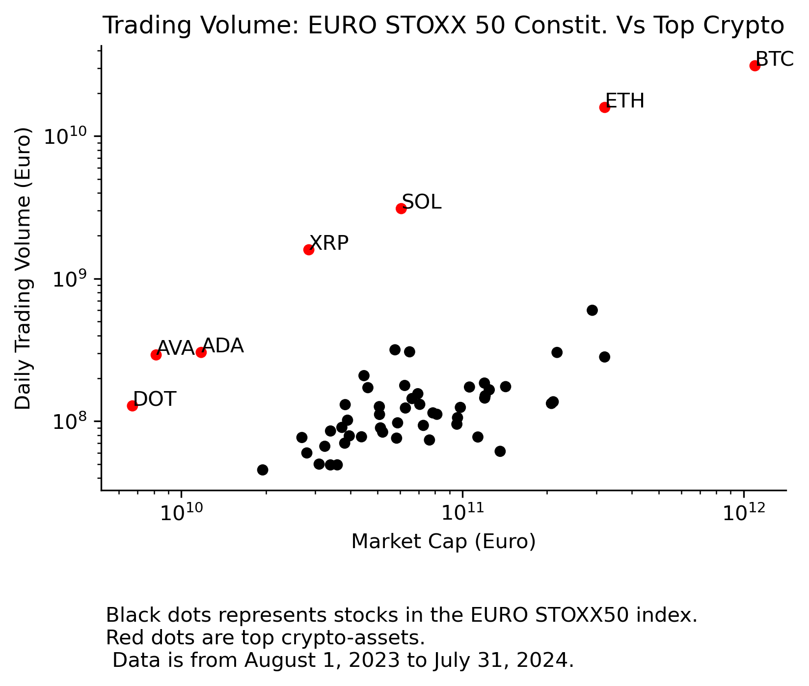

Further, Figure 2 shows that the top two global crypto assets, Bitcoin and Ethereum, have bid-ask spreads (as a percent of their spot prices) that are narrower than all constituents of the S&P 500 index except for Apple (AAPL). Moreover, these liquidity characteristics reflect a market that trades 24/7, 365 days per year, such that liquidity would be available at all times, demonstrating far superior liquidity and market quality characteristics than traditional securities.

**Figure 2.**

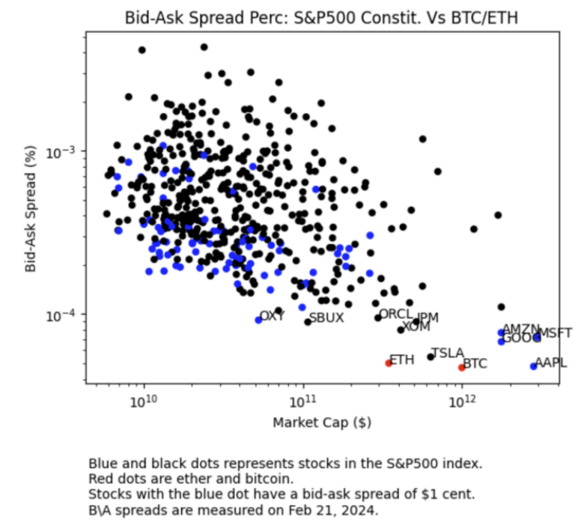

Crypto assets also offer novel economic exposures and considerable diversification benefits to UCITS portfolios. In particular, the top 10 crypto assets demonstrate higher volatility, a proxy for risk (Figure 3) but exceptionally low correlation with the Euro STOXX 50 (Figure 4). This gives UCITS portfolios an ability to lower portfolio risk and thus improve the efficient investment frontier. For example, while the global equities market may underperform and be subject to sale pressures, the crypto-asset market may be more resilient, offer more liquidity and act as a safe investment opportunity at times of uncertainty.

**Figure 3.**

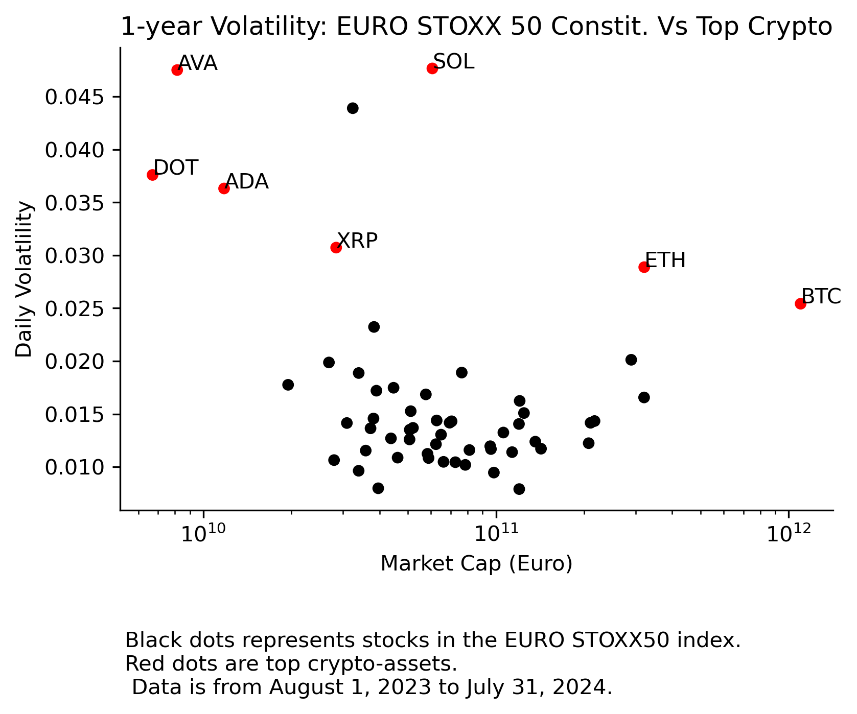

**Figure 4.**

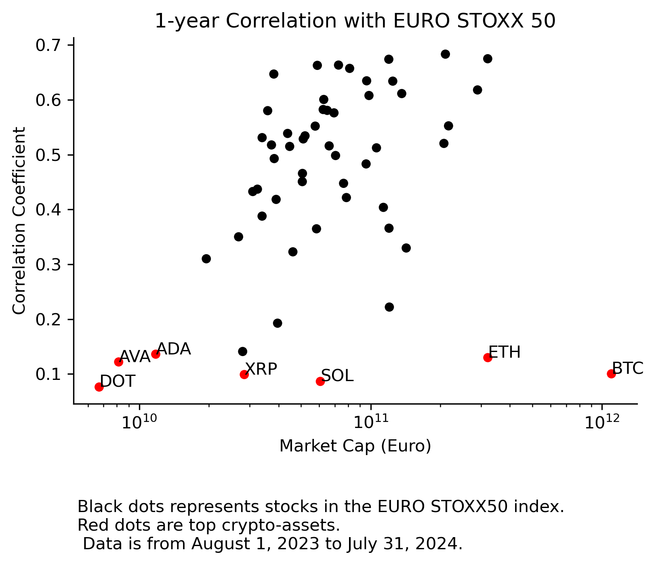

This diversification ensures the stability and liquidity of the overall UCITS portfolio, provided the exposure is adequately limited. Furthermore, incorporating crypto-assets as a new UCITS asset class will help distribute liquidity across markets, thereby addressing concerns about portfolio liquidity concentration in few asset classes.

Lastly, we note that even if crypto-assets are included in the list of eligible assets, UCITS will still be required to assess whether specific crypto-assets satisfy the relevant liquidity criteria pursuant to Article 2(1)(b) of the UCITS EAD – i.e. assets cannot compromise the ability of the UCITS to comply with its obligation to repurchase or redeem its units or shares at the request of its investors. This will act as a further constraint on the types of crypto-asset which UCITS will invest in.

* ***(c) reliable valuation is available for them as follows:***

*(i) in the case of securities admitted to or dealt in on a regulated market as referred to in points (a) to (d) of Article 19(1) of Directive 85/611/EEC, in the form of accurate, reliable and regular prices which are either market prices or prices made available by valuation systems independent from issuers;*

*(ii) in the case of other securities as referred to in Article 19(2) of Directive 85/611/EEC, in the form of a valuation on a periodic basis which is derived from information from the issuer of the security or from competent investment research;*

With respect to achieving reliable valuations, MiCAR requires trading platforms to have operational procedures in place, which should lead to valuations in relation to crypto-assets admitted to trading on those platforms being reliable. In particular, Article 77(2) requires trading platforms to publish a firm price of the crypto-assets or a method for determining the price of the crypto-assets that they propose to exchange for funds or other crypto-assets.

We also note that when seeking authorization under MiCAR (or submitting a notification if already regulated), crypto-asset trading platforms must describe their methodology for determining the price of crypto-assets that they propose to exchange for funds or other crypto-assets. This must include how the volume and market volatility of crypto-assets impact the pricing mechanism.[11]

Furthermore, trading platforms must also keep records about the price of the crypto-assets, or the method for determining their price, including noting if the crypto-asset can be exchanged for funds or crypto-assets, or both, and the amount of one crypto-asset exchanged for another.[12]

Even absent regulation, most crypto-asset trading platforms that operate globally offer a level of disclosure and trade transparency that is unparalleled in the traditional financial system. Order books and trading data are publicly accessible through APIs, providing anyone with access to high-quality, high-frequency data. This openness enhances market efficiency and liquidity.

The fact that MiCAR includes, and other jurisdictions are implementing, specific market abuse framework also supports the idea that reliable valuations would be available for MiCAR Crypto-Assets, as the market abuse framework should help to ensure that the price discovery mechanism is reliable. Articles 86-92 of MiCAR set out the core requirements in this regard, and include rules relating to the treatment of inside information concerning crypto-assets, prohibitions on insider dealing and market manipulation.

* ***(d) appropriate information is available for them as follows:***

*(i) in the case of securities admitted to or dealt in on a regulated market as referred to in points (a) to (d) of Article 19(1) of Directive 85/611/EEC, in the form of regular, accurate and comprehensive information to the market on the security or, where relevant, on the portfolio of the security;*

*(ii) in the case of other securities as referred to in Article 19(2) of Directive 85/611/EEC, in the form of regular and accurate information to the UCITS on the security or, where relevant, on the portfolio of the security;*

The requirements to (i) publish a crypto-asset white paper and (ii) submit it to the relevant authority prior to seeking admission to trading of a crypto-asset under Article 5 MiCAR are consistent with the requirement to provide comprehensive information to the market under the UCITS EAD.

In our view, the prescriptive requirements as to content and form of a crypto-asset white paper under Article 6 MiCAR set standards equivalent to the UCITS EAD with respect to the form of regular and accurate information relevant to crypto-assets.

* ***(e) they are negotiable;***

The final paragraph of Article 2(1) of the UCITS EAD states that unless there is information available to the UCITS that would lead to a different determination, financial instruments are presumed to be negotiable when they are admitted or dealt in on a regulated market.

As we detailed above, MiCAR Crypto Assets are traded on platforms that we believe should be treated as admitted or dealt in on a regulated market. While this is not typically the case for crypto-assets we note that the CESR concluded that a UCITS may invest in ‘*not freely negotiable*’ transferable securities, provided that it is aware of the existence of limitations to their transferability and that, notwithstanding that, it will be able to redeem units at the request of the unit holders.[13]

* ***(f) their acquisition is consistent with the investment objectives or the investment policy, or both, of the UCITS pursuant to Directive 85/611/EEC;***

As we have noted elsewhere, most recently in our [response](https://www.esma.europa.eu/system/files/webform/207770/104219/Coinbase_response_to_3rd_ESMA_consultation_on_requirements_in_MiCA.pdf) to ESMA’s 3rd consultation under MiCA, suitability assessments in respect of crypto assets should take into consideration both the utility of a crypto asset as well as its potential as an investment. While crypto assets are designed to have intrinsic utility, they can be purchased for investment purposes that are entirely consistent with Directive 85/611/EEC

Ensuring consistency with the UCITS’ investment objectives or policy would be the responsibility of the UCITS when defining/amending its investment policy and performing the Suitability Assessment.

* ***(g) their risks are adequately captured by the risk management process of the UCITS.***

UCITS would be able to satisfy this requirement by appropriately drafting or amending its risk management process. There is no reason that a UCITS would not be able to appropriately manage the risks presented by MiCAR crypto-assets,especially given the disclosure criteria that are required to be satisfied before MiCAR Crypto- Assets can be admitted to trading under MiCAR.

## Stablecoins

Stablecoins regulated under MiCAR either as electronic money tokens or asset-referenced tokens are most analogous with transferable securities (for the reasons set out above) and money market instruments.

However, with respect to electronic money tokens and asset-referenced tokens where the reference assets are deposits or fiat currencies, there are also parallels with “deposits” under Article 50(1)(f) of the UCITS Directive.

Money market instruments share a number of features with transferable securities that also make them a good proxy for MiCAR Stablecoins. Here, too, many of the requirements for money market funds to be considered eligible under the UCITS EAD are satisfied or presumed satisfied where the instruments trade on a regulated venue. As we note above, we think trading on a crypto- asset trading platform regulated under MiCAR (or similarly regulated non-EU venue) achieves the same end.

For example,

* Article 50(1)(a)-(c) of the UCITS Directive is generally designed to capture instruments which are traded on a regulated venue.
* Money market funds are also subject to similar liquidity requirements as transferable securities.[14]
* Article 4(3) of the UCITS EAD creates a rebuttable presumption that financial instruments that are normally dealt in on the money market for the purposes of the UCITS Directive Article and which are admitted to, or dealt in on, a regulated market are liquid instruments.
* Article 4(2) of the UCITS EAD provides that financial instruments have accurate and reliable valuations systems, if they

(a) enable the UCITS to calculate a net asset value in accordance with the value at which the financial instrument held in the portfolio could be exchanged between knowledgeable willing parties in an arm’s length transaction; and

(b) are based either on market data or on valuation models including systems based on amortised costs.

* Crypto-assets traded exhibit liquidity levels that are comparable to, if not greater than, the largest European stocks. This ensures that their prices can be accurately determined and reported at any time. Again, Article 4(3) of the UCITS EAD creates a rebuttable presumption that financial instruments which are normally dealt in on the money market for the purposes of the UCITS Directive Article and which are admitted to, or dealt in on, a regulated market, have accurate and reliable valuation systems.

Shifting to electronic money tokens and asset-referenced tokens where the reference assets are deposits or fiat currencies, we note that these MiCAR Stablecoins also have parallels with “deposits” under Article 50(1)(f) of the UCITS Directive.

Article 50(1)(f) of the UCITS Directive allows UCITS funds to invest in deposits with credit institutions, provided that these deposits are repayable on demand or have the right to be withdrawn, maturing in no more than 12 months. Such deposits are generally considered low-risk and are used to preserve the capital of the UCITS fund. By ensuring that the deposits can be accessed quickly, UCITS funds can meet redemption demands from investors, thereby maintaining overall liquidity. This liquidity allows funds to manage their portfolios more effectively without being forced to sell other assets, which might be more volatile or less liquid.

Similarly, MiCAR Stablecoins are designed to maintain a stable value through low-risk reserve asset backing, which should enable them to act effectively as a store of value and enable a UCITS to meet redemption requests from investors:

* With respect to asset-referenced tokens, Article 37 of MiCAR includes strict requirements on issuers to ensure their stablecoins maintain their value peg and are backed by adequate reserves. In particular, reserve assets are required to be custodied with regulated entities, and credit institutions are listed as the only permissible custodian for reserve assets in the form of cash.[15] With respect to stablecoins in the form of e-money tokens or asset-referenced tokens where the reference assets are deposits or fiat currencies, in practice it should therefore always be the case that the reference assets are held with a credit institution.
* With respect to e-money tokens, funds received by issuers of e-money tokens in exchange for e-money tokens must invest at least 30% with credit institutions, while the remaining funds can be invested in secure, low-risk assets that qualify as highly liquid financial instruments with minimal market risk, credit risk and concentration risk, in accordance with Article 38 of MiCAR, and which are denominated in the same official currency as the one referenced by the e-money token.[16] Per Article 38(1) of MiCAR, these investments have to be capable of being liquidated rapidly with minimal adverse price effect.

Given these regulations, MiCAR Stablecoins should be able to act as a reliable store of value and medium of exchange.

# 2 - Crypto assets are suitable to be included in the expanded list

Q20 of the CfE indicates that ESMA is looking to expand the list of eligible assets. We believe that crypto-assets are at least as suitable as the assets that ESMA is considering, across a range of metrics.

In particular, MiCAR Crypto-Assets would be regulated assets subject to stringent requirements. For example, issuers and crypto-asset service providers are subject to (and liable for the contents of)[17] initial and ongoing information disclosure requirements,[18] strict transparency requirements, custodial requirements and consumer protection policies (ex. the right of withdrawal for retail crypto-asset holders).[19] These types of requirements are at least as, and in many cases more, stringent and onerous than requirements applicable to other assets within the list of assets that ESMA is consulting on (including, in particular, certain loans, commodities and real estate).

Even absent a comprehensive federal regulatory framework for crypto-assets traded in the US, crypto assets have been securitised within funds (notably Bitcoin and Eth ETFs) and serve as the underlying for futures contracts. These products have been approved by the US Securities Exchange Commission and US Commodity Futures Trading Commission, respectively, and the regulatory regimes for ETFs and futures both require the underlying assets to be sufficiently liquid and subject to reliable valuation.

# 3 - The MiCAR provides for constraints on the types of crypto-assets that can be admitted to trading

The MiCAR framework should afford regulators a degree of comfort as to what is being permitted to enter the regulatory sphere.

In particular, Article 62 of MiCAR requires a crypto-asset service provider to include details on the types of crypto-assets for which it intends to offer services, as part of any application for authorization. Article 76(1)(a) further requires that operators of a trading platform include exclusion criteria within their operating rules.

In addition, Article 94 of MiCAR provides both supervisory and investigative powers to national competent authorities.[20] These powers include issuing specific directions to entities to ensure compliance with MiCAR and imposing conditions or restrictions on operations.

MiCAR also provides the national competent authorities with powers to:

* suspend the provision of crypto-asset services for up to 30 consecutive working days or where there are reasonable grounds for suspecting an infringement of MiCAR has occurred, or ban such provision of services outright where an infringement has occurred;[21]
* effect disclosure of all material information which could have an effect on the provision of crypto-asset services, in order to protect the interests of clients in particular retail holders, or the smooth operation of the market;[22] and
* temporarily suspend the provision of crypto-asset services where they are detrimental to the interests of clients, in particular retail holders.[23]

**Conclusion**

We believe that MiCAR Crypto-Assets should be considered eligible assets under the UCITS EAD given liquidity and other features that are comparable to transferable securities and other eligible assets. The implementation of MiCAR, as well as regulatory frameworks globally, will heighten the transparency of crypto asset markets, and provide for regulatory oversight of trading, both of which should provide comfort to the Regulator when considering expanding the list of eligible assets.

<ESMA_QUESTION_EADC_20>

1. **Please elaborate and provide evidence on how indirect exposures to the aforementioned asset classes (e.g. through delta-one instruments, ETNs, derivatives) increase or decrease costs and/or risks borne by UCITS and their investors compared to direct investments.**

<ESMA_QUESTION_EADC_21>

TYPE YOUR TEXT HERE

<ESMA_QUESTION_EADC_21>

1. **Under the EAD, should a look-through approach be required to determine the eligibility of assets? Please explain your position taking into account the aforementioned risks and benefits of UCITS gaining exposures to asset classes that are not directly investible as well as the increased/decreased costs associated with such indirect investments. A look-through approach would aim to ensure that the list of eligible asset classes set out in the UCITS Level 1 Directive would be deemed exhaustive and reduce risk of circumvention by gaining indirect exposures to ineligible asset classes via instruments such as delta-one instruments, exchange-traded products or derivatives. Where possible, please provide views, data or estimates on the possible impact of such a possible policy measure.**

<ESMA_QUESTION_EADC_22>

TYPE YOUR TEXT HERE

<ESMA_QUESTION_EADC_22>

1. **What are the risks and benefits of UCITS investments in securities issued by securitisation vehicles? Please share evidence and experiences on current market practices and views on a possible need for legislative clarifications or amendments.**

<ESMA_QUESTION_EADC_23>

TYPE YOUR TEXT HERE

<ESMA_QUESTION_EADC_23>

1. **What are the risks and benefits of permitting UCITS to build up short positions through the use of (embedded) derivatives, delta-one instruments or other instruments/tools? Please share evidence and experiences on current market practice and views on a possible need for legislative clarifications or amendments.**

<ESMA_QUESTION_EADC_24>

TYPE YOUR TEXT HERE

<ESMA_QUESTION_EADC_24>

1. **Apart from the topics covered in the above sections, have you observed any other issues with respect to the interpretation or consistent application of the UCITS EAD? If so, please describe the issues and how you would propose to revise the UCITS EAD or UCITS Directive with a view to improve investor protection, clarity and supervisory convergence.**

<ESMA_QUESTION_EADC_25>

TYPE YOUR TEXT HERE

<ESMA_QUESTION_EADC_25>

1. Regulation (EU) 2023/1114, as amended (“**MiCAR**”)
2. Directive 2009/65/EC, as amended (the “**UCITS Directive**”)
3. Commission Directive 2007/16/EC, as amended (the “**UCITS EAD**”)
4. Here we consider money market instruments of the type listed in Article 50(1)(a) to (d) (inclusive)
5. ESMA has specified that the term “regulated market in a member state” as referred to in Article 50(1)(a) of the UCITS Directive can encompass a multilateral trading facility (MTF) as defined under Article 4(1)(15) of MiFID II.
6. MiCAR, Art 3(5)
7. N.b. in short this means that the liquidity of transferable securities cannot compromise the ability of the UCITS to comply with its obligation to repurchase or redeem its units or shares at the request of its investors. The final paragraph of Article 2(1) of the UCITS EAD states that, with respect to this criterion, unless there is information available to the UCITS that would lead to a different determination, financial instruments which are admitted or dealt in on a [regulated market] shall be presumed not to compromise the ability of the UCITS to comply accordingly.
8. See point 27: CESR/06-005 - CESR’s Advice to the European Commission on Clarification of Definitions concerning Eligible Assets for Investments of UCITS
9. See Box 1: CESR/06-005 - CESR’s Advice to the European Commission on Clarification of Definitions concerning Eligible Assets for Investments of UCITS
10. However, assessing the liquidity of a portfolio by taking into account only the Liquidity Criteria of each of its individual transferable securities is not an accurate proxy for determining whether a UCITS will be able to comply with its obligation to redeem foreseeable redemption requests.

    The liquidity of a transferable security should therefore also take into account the redemption frequency of a given UCITS (See point 26: [CESR/06-005](https://www.esma.europa.eu/sites/default/files/library/2015/11/06_005_0.pdf)). For instance, a daily dealing UCITS will need to maintain a different liquidity profile compared to a UCITS that deals less frequently (the “Suitability Assessment”, See section 1.2: [CESR/06-013](https://www.esma.europa.eu/sites/default/files/library/2015/11/06_013.pdf)).

    While a UCITS’ assets as a whole must meet certain liquidity criteria in view of supporting redemption requests, this does not mean that each transferable security (or category thereof) must be able to do so on their own. CESR made it clear that there must be adequate prospective liquidity so that the UCITS is reasonably satisfied that it can redeem investors upon request, putting the emphasis on the reasonable and foreseeable nature of the redemption requests (See point 26: [CESR/06-005](https://www.esma.europa.eu/sites/default/files/library/2015/11/06_005_0.pdf)). One should therefore take into account the liquidity of all constituents of the portfolio as a whole and assess their adequacy in light of the redemption frequency of the UCITS in question. In this respect, holdings in crypto-assets could be subject to investment limits similar to those applied to any other eligible investments.

    Taking this into account, the liquidity of the UCITS as a whole would hence not be materially affected by the UCITS’ additional exposure to crypto-assets (conforming to the Liquidity Criteria), as long as the holding percentage is reasonably adapted to the redemption frequency of the UCITS and the other constituents of its portfolio (and their liquidity).
11. We refer also to ESMA’s consultation paper on technical standards specifying certain requirements of MiCAR ([ESMA74-449133380-425_MiCA_Consultation_Paper_1st_package.pdf (europa.eu)](https://www.esma.europa.eu/sites/default/files/2023-07/ESMA74-449133380-425_MiCA_Consultation_Paper_1st_package.pdf)) and ESMA’s related final report the draft technical standards ([ESMA18-72330276-1634_Final_Report_on_certain_technical_standards_under_MiCA_First_Package.pdf (europa.eu)](https://www.esma.europa.eu/sites/default/files/2024-03/ESMA18-72330276-1634_Final_Report_on_certain_technical_standards_under_MiCA_First_Package.pdf))
12. Again we refer to ESMA’s consultation paper on technical standards specifying certain requirements of MiCAR ([ESMA74-449133380-425_MiCA_Consultation_Paper_1st_package.pdf (europa.eu)](https://www.esma.europa.eu/sites/default/files/2023-07/ESMA74-449133380-425_MiCA_Consultation_Paper_1st_package.pdf)) and ESMA’s related final report the draft technical standards ([ESMA18-72330276-1634_Final_Report_on_certain_technical_standards_under_MiCA_First_Package.pdf (europa.eu)](https://www.esma.europa.eu/sites/default/files/2024-03/ESMA18-72330276-1634_Final_Report_on_certain_technical_standards_under_MiCA_First_Package.pdf))
13. See section 1.5 “Transferability” : CESR/06-013 - CESR’s Advice to the European Commission on Clarification of Definitions concerning Eligible Assets for Investments of UCITS : Feedback Statement
14. See Article 4(1) of the UCITS EAD, which clarifies the meaning of “liquid instruments” (used within the definition of “money market instruments” in the UCITS Directive) to mean financial instruments which can be sold at limited cost in an adequately short time frame, taking into account the obligation of the UCITS to repurchase or redeem its units at the request of any unit holder.
15. MiCAR, Article 37(3)(b).
16. MiCAR, Article 54.
17. MiCAR, Article 15
18. MiCAR, Article 9
19. MiCAR, Article 13
20. MiCAR, Article 94(2)
21. MiCAR, Article 94(b), Article 94(c)
22. MiCAR, Article 94(d)
23. MiCAR, Article 94(f)