Annex – Question 20. Table on eligible assets UCITS EAD.
For the purposes of Question 20, please complete the table below with the requested information, taking into account the instructions provided in the footnotes. After having completed the form, please save the document (according to the following convention: “ESMA_Q20_nameofrespondent”) and upload it online at https://www.esma.europa.eu/press-news/consultations/call-evidence-review-ucits-eligible-assets-directive under the heading ‘Your input - Consultations’, as an Annex to the Reply Form. In case you upload a pdf file, please choose an editable form.
Asset class | Merits of allowing direct UCITS exposures | Merits of allowing indirect UCITS exposures | Extent/amount of existing UCITS exposures | Additional comments
1. Loans
2. Catastrophe bonds (‘Cat bonds’)
3. Contingent Convertible bonds (‘CoCo bonds’)
4. Unrated bonds
5. Distressed securities
6. Unlisted equities
7. Crypto assets | (1) | (2) | (3) | (4)
8. Commodities and precious metals
9. Exchange-traded commodities (‘ETCs’)
10. Real estate
11. Real Estate Investment Trusts (‘REITs’)
12. Special Purpose Acquisition Companies (‘SPACs’)
13. EU AIFs
14. Non-EU AIFs
15. Emission allowances
16. Delta-one instruments
17. Exchange-traded notes (‘ETNs’)
18. Asset-backed securities (‘ABS’) including mortgage-backed securities (‘MBS’)
19. Other relevant asset classes (please specify)

- Merits of allowing direct UCITS exposures
The crypto asset market has evolved significantly, with major financial regulators such as the US or Hong Kong allowing crypto asset ETFs. Institutional and retail investors value the low correlation between crypto assets and other major asset classes and the clear benefits that an allocation in crypto assets has on the portfolio. For the sake of clarity, 21Shares will mostly provide data around Bitcoin and Ethereum, the two largest crypto assets by market capitalization, as representatives of the crypto asset class.

Correlation
Bitcoin’s correlation with major asset classes ranges from 0.02 to 0.36, similar to what Gold (GLD) offers, ranging from 0.13 to 0.24 from January 1, 2019, to May 31, 2024. Similarly, Ethereum promises to be a viable diversification tool, showcased by also having a low correlation with major asset classes, ranging from -0.01 to 0.35. This low level of correlation makes both assets a vital diversification source for traditional portfolios, which are a mix of equities and bonds. Furthermore, there is almost no correlation (0.14) between gold and Bitcoin, or gold and Ethereum (0.13) making both crypto assets unique diversification resources for investors’ portfolios:
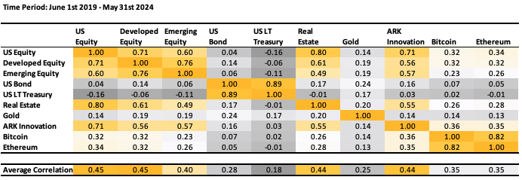
Correlation matrix of Bitcoin and Ethereum to major asset classes, timeframe 1 January 2019 - 31 May 2024; Source: 21Shares, Data from Yahoo Finance

When comparing the correlation of different crypto assets amongst each other, some crypto assets only show a low correlation towards other crypto assets. With different use cases and utilities, crypto assets can be divided into different sectors that may function similar to traditional equity sectors. In summary, one could argue that the crypto asset asset class itself is diversified enough.

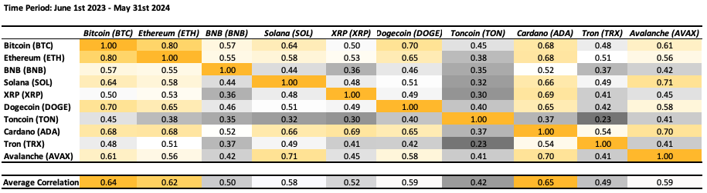
Correlation matrix of the top 10 crypto assets as of 2 August 2024, excluding stablecoins, timeframe 1 June 2023 - 31 May 2024; Source: 21Shares, Data from Yahoo Finance

Portfolio Allocation
To provide key performance metrics and objectively assess the impact of crypto assets on portfolio performance, 21Shares has modeled the effect of having an allocation of 5% Bitcoin and 1% Ethereum into a simple growth portfolio (60% US Equity and 40% US Bond) with different rebalancing strategies: daily, weekly, monthly, quarterly, annually and without rebalancing:
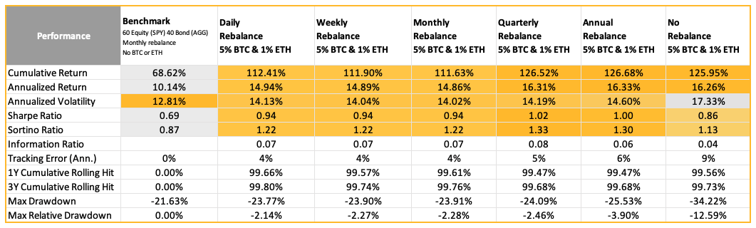
Measures of risk and ratio-based performance metrics of a benchmark portfolio vs. 5% Bitcoin / 1% Ethereum allocation in different rebalancing schedules, timeframe 1 January 2019 - 31 May 2024, Source: 21Shares, Data from Yahoo Finance

The inclusion of crypto assets (in this case Bitcoin and Ethereum) in an investment portfolio demonstrates clear advantages across various performance metrics with the following key takeaways:

- Improved risk-adjusted returns: Both Sharpe and Sortino ratios increased with the addition of Bitcoin and Ethereum, with the Sharpe ratio being enhanced from 0.69 to a range of 0.94 to 1.02 and the Sortino ratio being enhanced from 0.87 to a range of 1.13 to 1.22. This shows that the addition of crypto assets has improved the overall efficiency of the portfolio by enhancing the risk-adjusted returns and by increasing the mitigation of the downside portfolio risk. The annual return increased between around 4% and 6%.

- Only small increases in risk: The addition of Bitcoin and Ethereum slightly increased both the Value at Risk (VaR) from -5.4% to -6.7% and the maximum drawdown from -21.6% to -24.1% for a quarterly rebalance. This reflects the higher volatility associated with crypto assets. However, this increased risk is relatively small and needs to be weighed against the improved risk-adjusted returns, as shown by the substantially higher Sharpe and Sortino ratio. This may be considered acceptable by many investors.

- Importance of rebalancing: For all rebalancing strategies, a lack of rebalancing leads to the worst risk-adjusted return and risk metrics that are mentioned above. The most risk-efficient rebalancing schedule is quarterly as it has historically proven to provide outstanding cumulative returns of 127% while maximizing Sharpe (1.02) and Sortino (1.33) ratios. UCITS employing effective rebalancing strategies will be able to optimize the risk-return of the investment portfolio.

- Timing doesn’t really matter: The cumulative rolling hits indicate that, irrespective of whether the portfolio is rebalanced daily, weekly, monthly, quarterly, annually, or not at all, the inclusion of 5% BTC and 1% ETH resulted in outperforming the benchmark (a 60% equity and 40% bond portfolio with no crypto allocation) over 99% of the time in the subsequent year and the next three years. This consistent outperformance across different rebalancing strategies highlights that the timing of crypto allocation is not crucial, what matters is the inclusion of BTC and ETH itself.

Volatility
As mentioned above, the risk metrics of a portfolio containing Bitcoin and Ethereum reflect the volatility of the asset class, which is a concern for investors and regulators alike. Although crypto assets tend to exhibit higher volatility compared to more traditional asset classes, it's noteworthy that this volatility has been consistently decreasing. 21Shares anticipate this downward trend will persist, particularly with the increasing adoption by traditional and institutional investors.

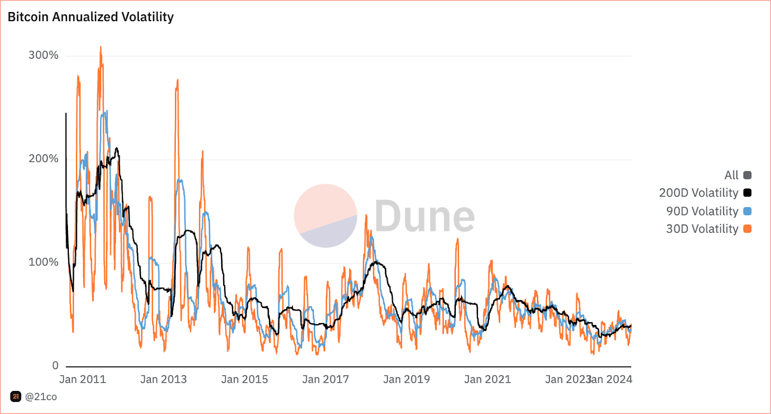
Annualized 30d, 90d and 200d volatility of Bitcoin, timeframe 31 July 2011 - 10 July 2024, Source: 21Shares/21co on Dune.com

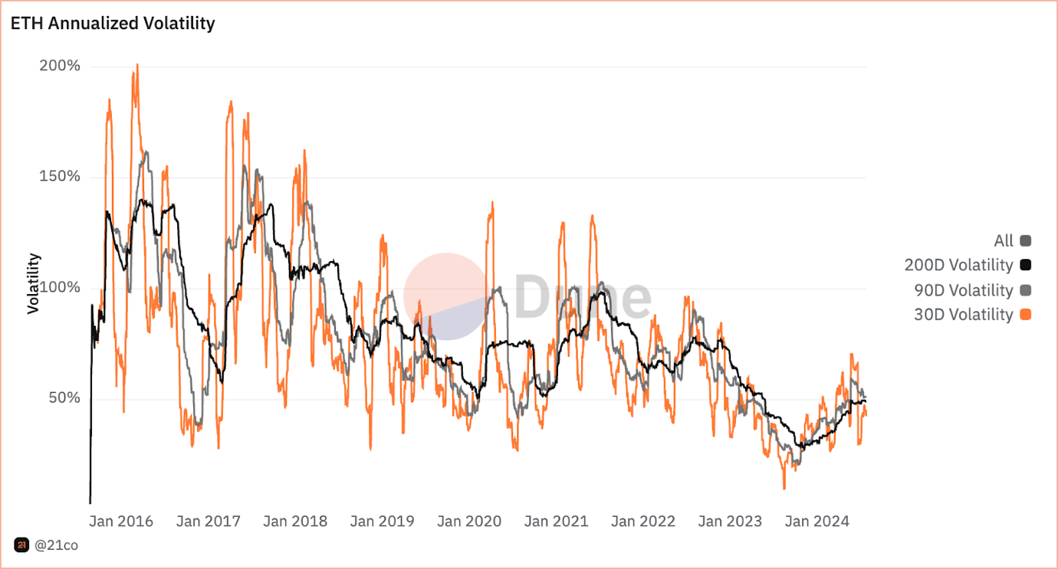
Annualized 30d, 90d and 200d volatility of Ethereum, timeframe 23 August 2015 - 19 July 2024, Source: 21Shares/21co on Dune.com

Availability of reliable valuation information
The open and transparent nature of blockchain technology allows anyone to verify transactions in real-time. Market data, such as transaction volumes and historical prices, are therefore accessible and verifiable. Major cryptocurrency exchanges and decentralized finance (DeFi) platforms provide comprehensive data on trading volumes, order books and price history. These exchanges and platforms operate 24/7, offering continuous pricing information. Furthermore, there are numerous price aggregators, such as CoinMarketCap (https://coinmarketcap.com/), CoinGecko (https://www.coingecko.com/) or CryptoCompare (https://www.cryptocompare.com/) that aggregate prices from multiple exchanges to provide an average price, reducing the impact of discrepancies between different platforms. There are also numerous crypto asset indices available on Bloomberg, such as the CCIX (https://ccdata.io/indices/ccix) or the BRR (https://www.cfbenchmarks.com/) by reputable index providers that are subject to the Benchmark Regulation (BMR).

Liquidity
The crypto asset market is highly liquid. As of 29 July 2024, Bitcoin and Ethereum combined had a daily 30d average volume of around $47 billion. However, 85 crypto assets have had a daily 30d average volume of at least $50 million, suggesting substantial investor interest and activity beyond Bitcoin and Ethereum. Taking the example of the recent Bitcoin ETF launch in the US, with currently around $60 billion combined AuM across 11 Bitcoin ETFs as shown below, the asset class has demonstrated that the underlying market liquidity is sufficient even in times of great demand. With around $14 billion traded value in the first week after inception and some of the most successful ETF launches of all times, the crypto asset market has shown the magnitude of volume it is able to absorb without impacts on liquidity.
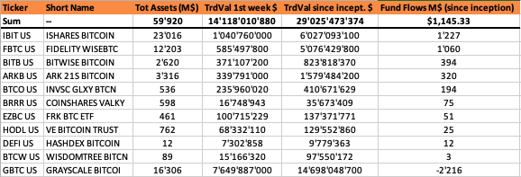
US Spot ETFs: Total assets, traded value 1 week after inception, traded value since inception and fund flows since inception, Source: Bloomberg as of 30 July 2024

Safekeeping
UCITS would most likely use a custody solution for the direct holding of crypto assets. There are numerous regulated and compliant third-party institutional-grade custodians that provide safekeeping services of crypto assets, such as Coinbase Custody, Zodia Custody or Copper. They are subject to a variety of European regulations, including MiCA or AML, and are subject to independent audits and due diligence. The assets held in custody are generally stored in multi-signature cold storage solutions to keep the majority of crypto assets offline, significantly reducing the risk of hacking and cyber attacks. Additionally, reputable custodians provide insurance policies that protect against the loss or theft of assets, giving investors an additional layer of financial security.

Merits of allowing indirect UCITS exposures
Allowing indirect UCITS exposures to crypto assets yields similar effects on a portfolio, such as low correlation to major asset classes and improvement of risk-adjusted performance metrics while relatively small increases in risk, as highlighted in (1). However, indirect exposure through exchange-traded products (ETPs), such as the ones offered by 21Shares since 2018, offers additional benefits with regards to convenience, operational risk and regulatory compliance and oversight.

Regulatory Compliance and Oversight
As outlined above, ETPs themselves are regulated and ensure adherence to investor protection standards. As they are issued on the basis of a Prospectus according to the EU Prospectus Regulation, the risks associated with investing in crypto asset ETPs, the providers that the issuer works with, as well as the function of the ETPs are thoroughly disclosed. Any changes in the underlying crypto asset market will be reflected in the Prospectus timely, as (at least) a yearly update of the Prospectus is required to ensure compliance with the Prospectus Regulation. Extraordinary changes, e.g. changes in e.g. service providers have to be communicated immediately via a Prospectus Supplement. The Prospectus and any Supplements, as well as the Final Terms, are publicly available for investors and UCITS and their investors can therefore be comfortable with accuracy and relevance of the content of the Prospectus at any time. As retail investors can already buy crypto asset ETPs themselves, issuers are required to provide a Key Information Document (KID). This standardized document provides the essential information in a clear and easily understandable format. Investors can therefore enjoy enhanced transparency and comparability, e.g. with regards to the risk factors. UCITS can therefore use these provided documents as part of their fund selection and due diligence process and assess whether an ETP aligns with the investment strategy, risk profile and regulatory requirements.

Exchanges serve as additional gatekeepers in the process of listing an ETP and during the lifecycle of an ETP, where compliance to exchange and regulatory requirements is required to set up and maintain the listing. It is important to mention that crypto asset ETPs are subject to the same exchange requirements as other asset classes in terms of liquidity, due diligence and reporting. Some examples include:

- Extensive DDQ on the crypto asset itself before used as an underlying of an ETP: Regulated Markets require a case by case assessment of the underlying crypto asset before allowing listing an ETP that follows its performance. Each exchange on which a listing should occur completes their own individual assessment of the underlying crypto asset. While the DDQ criteria are specific to each exchange, the Swiss Exchange (SIX) (as an example for the ETPs of 21Shares listed in Switzerland) provides a good example on what criteria a crypto asset should fulfill to be fit for an ETP. The recently issued Directive on Crypto-Assets as Underlying Instruments (https://www.ser-ag.com/dam/downloads/regulation/listing/listing-rules/dca-en.pdf, 1 April 2024) complements the Additional Rules for the Listing of Exchange Traded Products (https://www.ser-ag.com/dam/downloads/regulation/listing/listing-rules/aretp-en.pdf, 1 April 2024). Provisions thereof include the crypto asset underlying to “have a market capitalisation of at least USD 500 million”, “demonstrate average daily liquidity of at least USD 50 million over the past 30 calendar days”, to have a “price feed available via a reputable information system, such as [...] Bloomberg or Reuters” and “not systematically favour any individual persons'' in case of issuing further units of the crypto assets. UCITS wanting indirect exposure to crypto assets via ETPs can therefore be assured that multiple layers of DDQ with regards to the crypto asset have happened and that the legal and reputational concerns are minimized on a local (exchange) and national level (jurisdiction of exchange).

- Reporting obligations: The issuer is subject to recurring and ad hoc reporting obligations based on exchange reporting regulations, the EU Transparency Regulation obligations and the EU Prospectus Regulation. This includes the annual financial statements, the change of service providers, risk factors or changes of the structure of the ETP. Investors receive communication about any ad hoc reportings through official notices that are issued by the issuer and disseminated through the Central Security Depositories (CDSs). Further, the Prospectus and Supplements have to be approved by the competent financial supervisory authority. UCITS can therefore be assured that listed ETPs fulfill all obligations.

Lastly, issuers also need to adhere to provisions and regulations with regards to the service providers involved. For example, the involved authorized participants (APs) and custodians have to be fully regulated and are subject to AML laws. As ETPs are only traded on regulated exchanges and OTC with vetted counterparties, the access to those is restricted for those who clear the AML requirements. Therefore ETPs are only traded in a fully regulated environment. With the introduction of the above-mentioned SIX Directive and Rules and MiCA in Europe, not only the trading environment but also at least one level of the ETP structure itself is fully regulated (e.g. the custodian as provider of crypto storage services).

Availability of reliable Information
In addition to the availability of reliable information in case of direct exposure, as pointed out in (1), ETPs provide additional benefits and ease of operations for UCITS. Listed ETPs have a daily NAV valuation that is confirmed with an external and independent calculation agent, employing reference rates provided by a reputable index provider. ETPs also employ an intraday net asset value (iNAV), also calculated by an independent third party and are quoted on exchange throughout the day. The NAVs and the constituents of the ETP are disseminated daily through major reputable information systems, such as Bloomberg. UCITS looking for indirect crypto asset exposure through ETPs profit from the transparency that comes with the regulated structure of ETPs and their integration into traditional financial systems.

Liquidity
The liquidity of ETPs can be divided into three layers: on-screen liquidity, OTC liquidity and underlying liquidity. As highlighted in the point “Regulatory Compliance and Oversight”, the listing rules for an ETP require the underlying crypto asset to provide sufficient liquidity. ETPs have a variable amount of shares outstanding, meaning that Authorized Participants (APs) are allowed to create or redeem shares in the primary market based on market demand. Market makers act as a link between primary market (where APs operate) and secondary market, facilitating the ETP trading on various regulated exchanges. The value traded across the different venues represent the liquidity on-screen of the ETP, additionally market makers provide liquidity over-the-counter (OTC), adding another layer to the instrument’s liquidity. This market structure is analogous to that of fixed income securities. Both have a primary market, where new securities are issued and only certain participants can access, and a secondary market, where exchange participants (like broker dealers and market makers) operate. In fixed income, primary market liquidity is mainly driven by the underlying asset's liquidity and the issuer's credibility, while secondary market liquidity is divided between OTC liquidity and on-exchange liquidity. 21Shares offers bid-ask spreads as low as 6 bps for their products. This mechanism was already stress-tested multiple times for 21Shares, notably during the collapse of FTX in November 2022, when all creations and redemptions were processed as usual, and investors were at all times able to buy or sell their ETPs on exchange or OTC. To ensure the stability and liquidity of ETPs, comprehensive risk management strategies are in place. These include real-time monitoring of market conditions, stringent collateral requirements, and diversified liquidity sources to handle market volatility effectively

Safekeeping
Allowing indirect exposures via ETPs would lighten the operational burden of UCITS managers related to setting up and maintaining new crypto asset custody relationships and to manage the crypto assets during rebalancing of the fund. ETPs can be held in normal security accounts and provide the UCITS and their investors with (at least) the same level of protection as if a UCITS would hold crypto assets directly with a custodian, as the collateral is pledged for the investors through a collateral agent.

Professional Management and Expertise
The issuer’s expertise with crypto assets can also be leveraged by the UCITS, especially when it comes to questions about risk or changes in the crypto asset protocols. Issuers have an interest in continuously improving their products and can offer additional yield in their products through e.g. staking, a crypto native way of securing the network and receiving rewards for doing so. As an example, 21Shares’ Solana Staking ETP with $1 billion AuM currently offers an additional yield of around 5%. This additional yield provides an attractive option for UCITS and their investors to achieve additional performance.

In summary, allowing indirect exposure to crypto assets through ETPs offers UCITS and their investors a regulated, battle-tested and streamlined option to an asset class that proves to be a viable diversification tool and offers improved risk-adjusted returns. UCITS can profit from the crypto asset native expertise of ETP issuers and the integration of ETPs into the ecosystem of traditional finance markets.

Extent/Amount of existing UCITS exposures
To date, 21Shares is aware of two indirect UCITS exposures via ETNs/ETPs:

- Domiciled in Germany: DWS Fintech with assets under management of around EUR 25 mln and a crypto asset exposure of 0.5% via Ethereum ETN, as of 31 March 2024 (https://funds.dws.com/en-ch/equity-funds/de000dws2mw2-dws-fintech-fc/#downloads)
- Domiciled in Malta: Digital Assets Momentum Fund, a sub fund of Augmenta SICAV p.l.c. (https://www.diamanpartners.com/augmenta-sicav)

However, the potential for significant exposure can be inferred from the strong market interest observed in recently launched crypto asset ETFs in other jurisdictions. For instance, in the US, Bitcoin ETFs currently have an AuM of around $60 billion, while the Bitcoin and Ethereum ETFs in Hong Kong hold around $280 million combined. These examples suggest that, should regulatory frameworks within the EU evolve to accommodate indirect crypto asset exposure within UCITS, similar levels of interest and investment might be anticipated, highlighting the potential for significant exposure and the need to address this topic swiftly.

Additional Comments
To provide some background on ETPs, 21Shares would like to explain the structure of their ETPs. All of 21Shares’ ETPs are structured as open-ended, fully collateralized, senior secured, non-interest-bearing debt instruments. Other key structural features include:
- 21Shares acts as Special Purpose Vehicle (SPV) with the sole purpose of issuing and listing ETPs.
- ETPs are structured as debt securities and are issued on the basis of the EU Prospectus Regulation.
- Each ETP is collateralised with at least 100% of its value by the underlying crypto asset, in accordance with stock exchange listing regulation.
- ETPs allow investors to participate in the performance of crypto assets, e.g. by buying or selling the ETP on stock exchanges.
- ETPs have no predefined return or term. They bear no interest and offer no guarantee of capital or minimum return.
- ETPs can be traded at any time by investors on regulated exchanges or terminated by both parties at specific times.
- ETPs are no collective investment schemes.

ESMA acknowledges that most of the asset classes listed below have not been clearly defined in EU legislation and this might be a source of divergent interpretations and misunderstandings. Where possible, ESMA invites stakeholders to specify their understanding or definition of the relevant asset classes under the “additional comments” box.
Where relevant, please distinguish between indirect exposures via instruments such as delta-one instruments, exchange-traded products, derivatives, or AIFs (EU or non-EU).
Please share any available data or estimates that help to assess the amount or extent to which there are existing UCITS exposures (distinguishing between direct and indirect, where possible) to these asset classes. Where no reliable data is available, ESMA would appreciate receiving estimates in terms of numbers and/or percentages of UCITS exposed to these asset classes and what is the average proportion in the relevant portfolios. Any additional data and insights on strategies, techniques and instruments used to gain exposure to these asset classes would be also highly appreciated.
Please include under this column any other evidence or views that you would like to share.
Where relevant, please distinguish between leveraged/structured loans, collateralised loan obligations (CLOs) and other types of loans or loan participations (please specify).
Where relevant, please distinguish between equity instruments issued by (1) private companies and (2) shares in public companies that that are not listed.
Where relevant, please specify what type of crypto assets and whether the implementation of MICA will change anything in terms of your assessment. With respect to indirect exposures, ESMA is particularly interested in stakeholder input on exchange-traded products including ETFs with crypto assets as an underlying.
With respect to indirect exposures, ESMA is particularly interested in stakeholder input on ETFs with commodities/precious metals as underlying. Please note that under the current UCITS rules, precious metals and certificates representing them are not eligible (Article 50(2)(b) of the UCITS Directive).
Where relevant, please distinguish between different types of AIFs (e.g. open-ended, closed-ended) and investment strategies (e.g. real estate, private equity, hedge funds).

