**Annex – Question 20. Table on eligible assets UCITS EAD.**

For the purposes of Question 20, please complete the table below with the requested information, taking into account the instructions provided in the footnotes. After having completed the form, please save the document (according to the following convention: “ESMA_Q20_nameofrespondent”) and upload it online at <https://www.esma.europa.eu/press-news/consultations/call-evidence-review-ucits-eligible-assets-directive>under the heading *‘Your input - Consultations’*, as an Annex to the Reply Form. In case you upload a pdf file, please choose an editable form.

|  |  |  |  |  |
| --- | --- | --- | --- | --- |
| **Asset class[1]** | **Merits of allowing direct UCITS exposures** | **Merits of allowing *indirect* UCITS exposures[2]** | **Extent/amount of existing UCITS exposures[3]** | **Additional comments[4]** |
| 1. Loans[5] | A. Loans have comparable features to many of the assets in which UCITS may currently invest under the UCITS EAD. In particular, and as outlined in more detail in our response to question 1 of the ESMA response form:  - it is possible to ensure that the potential loss that the UCITS may incur is limited to the amount paid for the loan;  - the secondary loan market is a liquid market;  - there are reliable valuation mechanisms in the market for secondary loan purchases; and  - appropriate information is available when engaging in the purchase of secondary loans.  As a result, we cannot see an obvious policy rationale for adopting a different approach towards loans when compared to other asset classes in which UCITS may currently invest under the UCITS EAD.  B. In addition, we believe there are strong policy reasons for confirming that UCITS may invest in loans. In particular, and as outlined in more detail in our response to question 1 of the ESMA response form:  - loans are not a complex product from an investment perspective and, unlike some Eligible Assets, do not require a sophisticated investment strategy in order to generate returns;  - permitting UCITS to invest in loans may assist UCITS to achieve a greater spread of asset types and greater diversification of exposures to underlying counterparties;  - permitting UCITS to invest in loans would allow retail investors that wish to gain exposure to loans to do so through UCITS, which are a transparent and highly-regulated product;  - funds that invest in loans can be structured to increase liquidity where necessary, using liquidity techniques such as liquidity facilities;  - loans present an attractive investment and risk profile;  - permitting UCITS to invest in loans would contribute to the European Commission's efforts to support non-bank lending; and  - permitting UCITS to invest in loans would prevent the regulatory arbitrage that could occur if some EU Member States (or non-EU jurisdictions) permitted certain types of retail funds to invest in loans whilst the EU prohibited this for its main retail fund product, the UCITS.  As a result, we consider that permitting UCITS to gain direct exposure to loans would benefit UCITS, their investors and the broader economy. | We believe that many of the benefits of permitting **direct** exposure to loans also apply to permitting **indirect** exposure to loans. In particular, indirect exposure to loans, such as through CLOs, presents an attractive risk and return profile, would permit UCITS to diversify and gain exposure to a wide range of counterparties and would enable retail investors to gain exposure to this asset class via UCITS vehicles.  Data from S&P Global indicates that CLOs are a robust asset class, weathering significant macroeconomic events, such as the global financial crisis, the COVID-19 pandemic and subsequent recessions, with minimal defaults.  European CLO 1.0 (which refers to those issued before the financial crisis) performance has stood the test of time, with data indicating that only 1.5% of rated tranches suffering a loss since 2000.  European CLO 2.0 (which refers to transactions originated in 2010 and thereafter) performance has also been strong, with data indicating zero defaults and a low number of downgrades in the past 11 years.  We set out beneath this table data from S&P Global indicating the low number of defaults by European CL0 2.0 issuers.  As a result, and as with direct exposure, overall we consider that permitting UCITS to gain indirect exposure to loans would benefit UCITS, their investors and the broader economy. |  |  |
| 2. Catastrophe bonds (‘Cat bonds’) |  |  |  |  |
| 3. Contingent Convertible bonds (‘CoCo bonds’) |  |  |  |  |
| 4. Unrated bonds |  |  |  |  |
| 5. Distressed securities |  |  |  |  |
| 6. Unlisted equities[6] |  |  |  |  |
| 7. Crypto assets[7] |  |  |  |  |
| 8. Commodities and precious metals[8] |  |  |  |  |
| 9. Exchange-traded commodities (‘ETCs’) |  |  |  |  |
| 10. Real estate |  |  |  |  |
| 11. Real Estate Investment Trusts (‘REITs’) |  |  |  |  |
| 12. Special Purpose Acquisition Companies (‘SPACs’) |  |  |  |  |
| 13. EU AIFs[9] |  |  |  |  |
| 14. Non-EU AIFs |  |  |  |  |
| 15. Emission allowances |  |  |  |  |
| 16. Delta-one instruments |  |  |  |  |
| 17. Exchange-traded notes (‘ETNs’) |  |  |  |  |
| 18. Asset-backed securities (‘ABS’) including mortgage-backed securities (‘MBS’) |  |  |  |  |
| 19. Other relevant asset classes (please specify) |  |  |  |  |

**Data on defaults by CLO 2.0 issuers (source: S&P Global)**

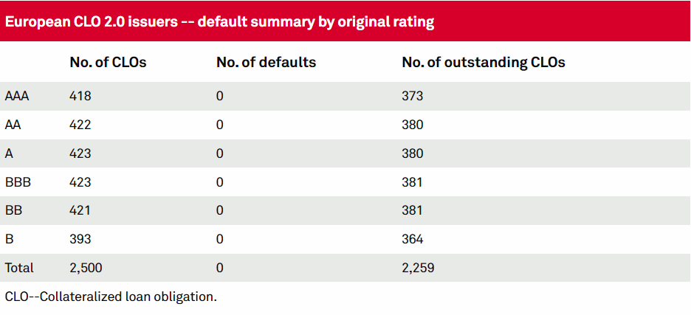

1. ESMA acknowledges that most of the asset classes listed below have not been clearly defined in EU legislation and this might be a source of divergent interpretations and misunderstandings. Where possible, ESMA invites stakeholders to specify their understanding or definition of the relevant asset classes under the “additional comments” box.
2. Where relevant, please distinguish between indirect exposures via instruments such as delta-one instruments, exchange-traded products, derivatives, or AIFs (EU or non-EU).
3. Please share any available data or estimates that help to assess the amount or extent to which there are existing UCITS exposures (distinguishing between direct and indirect, where possible) to these asset classes. Where no reliable data is available, ESMA would appreciate receiving estimates in terms of numbers and/or percentages of UCITS exposed to these asset classes and what is the average proportion in the relevant portfolios. Any additional data and insights on strategies, techniques and instruments used to gain exposure to these asset classes would be also highly appreciated.
4. Please include under this column any other evidence or views that you would like to share.
5. Where relevant, please distinguish between leveraged/structured loans, collateralised loan obligations (CLOs) and other types of loans or loan participations (please specify).
6. Where relevant, please distinguish between equity instruments issued by (1) private companies and (2) shares in public companies that that are not listed.
7. Where relevant, please specify what type of crypto assets and whether the implementation of MICA will change anything in terms of your assessment. With respect to indirect exposures, ESMA is particularly interested in stakeholder input on exchange-traded products including ETFs with crypto assets as an underlying.
8. With respect to indirect exposures, ESMA is particularly interested in stakeholder input on ETFs with commodities/precious metals as underlying. Please note that under the current UCITS rules, precious metals and certificates representing them are not eligible (Article 50(2)(b) of the UCITS Directive).
9. Where relevant, please distinguish between different types of AIFs (e.g. open-ended, closed-ended) and investment strategies (e.g. real estate, private equity, hedge funds).