Reply form

**On the review of the UCITS Eligible Assets Directive**

Responding to this paper

ESMA invites comments on all matters in this paper and in particular on the specific questions summarised in Annex 1. Comments are most helpful if they:

1. respond to the question stated;
2. indicate the specific question to which the comment relates;
3. contain a clear rationale; and
4. describe any alternatives ESMA should consider.

ESMA will consider all comments received by **Wednesday 7 August 2024.**

All contributions should be submitted online at [www.esma.europa.eu](http://www.esma.europa.eu) under the heading ‘Your input - Consultations’.

Instructions

In order to facilitate analysis of responses to the Call for Evidence, respondents are requested to follow the below steps when preparing and submitting their response:

• Insert your responses to the questions in the Call for Evidence in this reply form.

• Please do not remove tags of the type < ESMA_QUESTION_EADC_0>. Your response to each question has to be framed by the two tags corresponding to the question.

• If you do not wish to respond to a given question, please do not delete it but simply leave the text “TYPE YOUR TEXT HERE” between the tags.

• When you have drafted your responses, save the reply form according to the following convention: ESMA_CP1_EADC_nameofrespondent.

For example, for a respondent named ABCD, the reply form would be saved with the following name: ESMA_CP1_EADC _ABCD.

• Upload the Word reply form containing your responses to ESMA’s website (**pdf**  **documents will not be considered except for annexes**). All contributions should be submitted online at <https://www.esma.europa.eu/press-news/consultations/call-evidence-review-ucits-eligible-assets-directive> under the heading *‘Your input -*  *Consultations’.*

**Publication of responses**

All contributions received will be published following the close of the consultation, unless you request otherwise. Please clearly and prominently indicate in your submission any part you do not wish to be publicly disclosed. A standard confidentiality statement in an email message will not be treated as a request for non-disclosure. A confidential response may be requested from us in accordance with ESMA’s rules on access to documents. We may consult you if we receive such a request. Any decision we make not to disclose the response is reviewable by ESMA’s Board of Appeal and the European Ombudsman.

**Data protection**

Information on data protection can be found at [www.esma.europa.eu](http://www.esma.europa.eu) under the heading ‘[Data protection](https://www.esma.europa.eu/about-esma/data-protection)’.

**Who should read this paper?**

This Call for Evidence is of particular interest for investors and consumer groups interested in retail investment products, management companies of Undertakings for Collective Investment in Transferable Securities (UCITS), self-managed UCITS investment companies, depositaries of UCITS and trade associations.

# General information about respondent

|  |  |
| --- | --- |
| Name of the company / organisation | LAFV Liechtensteinischer Anlagefondsver-band |
| Activity | Official representative of the Liechtenstein fund industry |
| Country / Region | Liechtenstein |

# Questions

1. In your view, what is the most pressing issue to address in the UCITS EAD with a view to improving investor protection, clarity and supervisory convergence across the EU?

<ESMA_QUESTION_EADC_1>

In responding to ESMA’s Call for Evidence LAFV is focusing on the asset class of insurance-linked securities / Cat Bonds. In this area no particular pressing issue warranting changes to the UCITS EAD framework have been observed.

<ESMA_QUESTION_EADC_1>

1. Have you experienced any recurring or significant issues with the interpretation or consistent application of UCITS EAD rules with respect to financial indices? If so, please describe any recurring or significant issues that you have experienced and how you would propose to amend the UCITS EAD to improve investor protection, clarity and supervisory convergence. Where relevant, please specify what indices this relates to and what were the specific characteristics of those indices that raised doubts or concerns. Where possible, please provide data to substantiate the materiality of the issue.

<ESMA_QUESTION_EADC_2>

In responding to ESMA’s Call for Evidence LAFV is focusing on the asset class of insurance-linked securities / Cat Bonds. In the field of investments in insurance-linked securities, i.e. Cat Bonds no issues have been observed.

<ESMA_QUESTION_EADC_2>

1. Have you experienced any recurring or significant issues with the interpretation or consistent application of UCITS EAD rules with respect to money market instruments? If so, please describe the issues you have experienced and how you would propose to amend the UCITS EAD to improve investor protection, clarity and supervisory convergence. Where relevant, please describe the specific characteristics of the money market instruments that raised doubts or concerns.

<ESMA_QUESTION_EADC_3>

TYPE YOUR TEXT HERE

<ESMA_QUESTION_EADC_3>

1. Have you experienced any recurring or significant issues with the interpretation or consistent application of UCITS EAD provisions using the notions of « liquidity » or « liquid financial assets »? If so, please describe the issues you have experienced and how you would propose to amend the UCITS EAD to better specify these notions with a view to improving investor protection, clarity and supervisory convergence. Where relevant, please explain any differences to be made between the liquidity of different asset.

<ESMA_QUESTION_EADC_4>

In responding to ESMA’s Call for Evidence LAFV is focusing on the asset class of insurance-linked securities / Cat Bonds. We have not experienced any issues with the interpretation or consistent application of UCITS EAD provisions using the notions of «liquidity» or «liquid financial assets».

<ESMA_QUESTION_EADC_4>

1. The 2020 ESMA CSA on UCITS liquidity risk management identified issues with respect to the presumption of liquidity and negotiability set out in UCITS EAD. In light of the changed market conditions since 2007, do you consider such a presumption of liquidity and negotiability still appropriate? Where possible, please provide views, data or estimates on the possible impact of removing the presumption of liquidity and negotiability set out in the UCITS EAD.

<ESMA_QUESTION_EADC_5>

In responding to ESMA’s Call for Evidence LAFV is focusing on the asset class of insurance-linked securities / Cat Bonds. With regard to Cat Bonds we consider the presumption of liquidity and negotiability still appropriate.

Since 1996, the securitized transfer of insurance risks to the capital market through Cat Bonds has gained popularity for both insuring natural catastrophe risks in the reinsurance market and as a component of strategic asset allocation. The increase in natural disasters, growing population density, and value concentration in affected areas have all driven the demand for insurance coverage. Concurrently, the persistently low interest-rate environment for EUR and CHF investors, along with the rising popularity of ESG investments, has fuelled inflows into the Cat Bond market. This trend is further supported by the commitment of the ECB and EIOPA to discuss Cat Bonds as a policy option for reducing the climate-related insurance gap, as noted in their 2023 discussion paper. Additionally, fund volumes have benefited from cyclical factors such as the sharp rise in insurance premiums.

Approximately a quarter of all outstanding Cat Bonds are held by UCITS-regulated Cat Bond funds, a market segment that has experienced significant growth since 2010. As of December 31, 2023, the total assets under management (AuM) of all Cat Bond UCITS funds reached USD 10.9bn, within a broader Cat Bond market valued at USD 45 bn (Source: Artemis.bm).

**The changed market conditions since 2007 for Cat Bonds are:**

1. The Cat Bond market has grown significantly
2. Traded volumes have increased significantly
3. Diversification potential has improved substantially
4. Cat Bond structures have improved significantly
5. **The Cat Bond market has grown significantly**

The Cat Bond market began in 1996 with the issuance of the first Cat Bonds. Since then, nearly USD 200 billion worth of Cat Bonds have been issued across more than 1,000 individual deals. Today, the market's outstanding volume is close to USD 50 billion. In May 2024 alone, a record-breaking USD 4 billion in Cat Bonds was issued.

Since 2007, the outstanding market volume has more than tripled from USD 15bn to 47bn (source: artemis.bm).

1. Traded volumes have increased significantly

The secondary market reflects the growth of the primary market. As the primary market has expanded, so has the secondary market for Cat Bonds, which operates as an OTC market with brokers primarily based in the US and Europe. US brokers typically report their trade volumes to TRACE. The daily traded volumes in the Cat Bond market from April 9 to June 14 2024 are depicted in the following chart**. During this 50-day period, TRACE reported 832 trades with a total volume of USD 2.6 billion, representing approximately 5% of the entire Cat Bond market**. Detailed data is available in the accompanying Excel sheet. Trace data does not include European brokers and ISINs starting with “XS” (hence, all European Cat Bonds and Cat Bonds issued by the IBRD are not captured!).

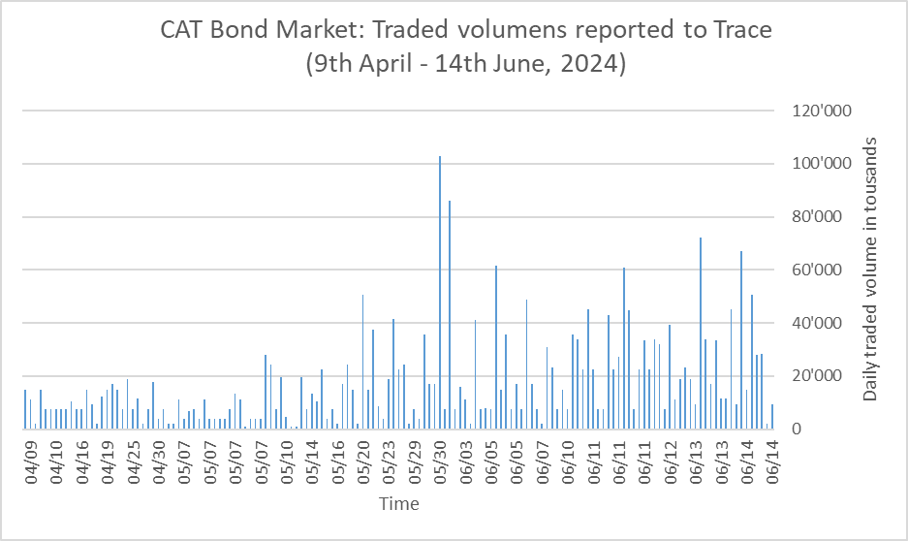

Source: Bloomberg.

In addition to the traded volumes reported via TRACE, there are trades conducted by European brokers that are not reported to TRACE. **Cat Bonds typically have a maturity of 3 years, meaning that one-third of the entire Cat Bond market matures each year**, generating significant additional cash flows for fund managers. At the current market size, these maturities account for approximately USD 15 billion in annual cash flows. Additionally, fund managers receive coupon income on their investments, currently accounting for approximately another USD 6 billion annually.

**Considering both reported and unreported trading volumes, as well as the substantial cash flows from Cat Bond maturities and coupon income, Cat Bond UCITS funds benefit from ample liquidity throughout the year.**

In order to look at the broader picture the European Broker Tullett Prebon has provided us with the aggregated data of their trades in addition to TRACE.



Source: Tullett Prebon

It is important to note that Tullett Prebon’s statistic captures a Buy and Sell trade as ONE TRADE. In order to adjust this, the numbers have to be doubled to make them comparable with the data reported to TRACE.



The conclusion from the data is the following:

* **Trading volumes doubled between 2020 and 2024.**
* **The traded volume in 2023 was USD 10bn which is around 25% of the entire market.**
* **All of this does not capture Cat Bonds maturities which account for another 33% of the market and coupon income which accounts for another approx. 12% of the market.**
* **Summing it all up, the average annual turnover of the market was close to 70% in 2023 and will likely be topped this year.**
* **The assumption of liquidity is therefore confirmed.**

In comparison, the NYSE market capitalisation was 28 trillion USD as of March 2024 whereas the monthly traded volume as of April 2024 was 2.5 trillion USD. I.e. monthly turnover for one of the most liquid markets of the world was 8.9% per month which is equivalent to 107% per year which is not significantly more compared to the 76% mentioned above.[1]The Federal Reserve Bank of St. Louis**[2]** came to a similar conclusion: While the Stock Market Turnover Ratio for the US fluctuates for various reasons, the average Stock Market Turnover Ratio of around 100% seems to be a normal turnover rate with the exception of the Great Financial Crisis after 2008 where the turnover rate reached 400% at one point in time.

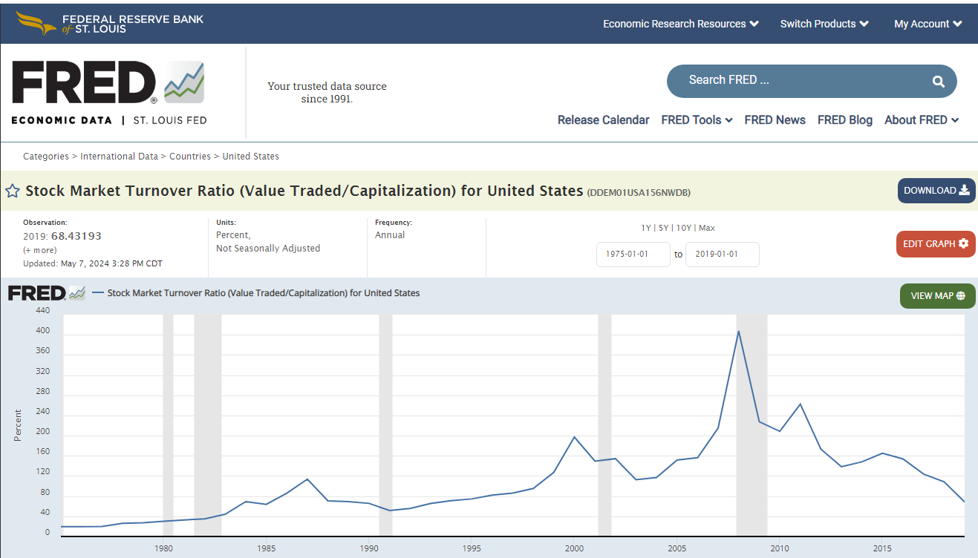

**Source: Federal Reserve Bank of St. Louis.**

1. **Diversification potential has improved substantially**

Diversification potential has also greatly improved. Cat Bonds issued **prior to 2007** covered the following perils: Australia cyclone, Australia earthquake; Casualty losses; Credit reinsurance; European windstorm; Extreme mortality; Japan earthquake & typhoon; Mediterranean earthquake; Mexico earthquake; Motor policies; Taiwan earthquake; U.S. hurricane, U.S. earthquake.

Cat Bonds issued **after 2007** covered the following perils: Australia and New Zealand catastrophe risks; California wildfire; Caribbean hurricane and earthquake; Chile earthquake; China earthquake; China typhoon risks; Cloud outage; Colombia earthquake; Systemic Cyber risks; European earthquake; European windstorm; European windstorm (France only); European windstorm, Italy earthquake; Extreme mortality; Germany earthquake, flood, hailstorm, windstorm; Jamaica named storms; Japan earthquake and typhoon; Medical benefit claims levels; Mexico earthquake; Motor third-party liability; Operational risks; Pandemics; Peru earthquake; Philippine earthquakes & tropical cyclones; Terrorism risk; Turkey earthquake; U.S named storm, earthquake, severe thunderstorm, wildfire, winter storm, volcanic eruption, meteorite impact; U.S. flood risk (from named storms); Workers compensation claims resulting from California earthquakes; Volcanic eruption.

Since 2007, the diversity in perils and regions covered by Cat Bonds has greatly expanded, along with the granularity of risks. For instance, insurers in various U.S. states now purchase coverage specifically tailored to natural catastrophes in their respective states. From a portfolio perspective, combining hurricane or earthquake exposures at the state level adds an additional dimension of diversification.

1. Cat Bond structures have improved significantly

Since 2007, Cat Bond structures have improved significantly. Prior to the financial crisis, Cat Bond structures could have any type of security as long as it was rated AAA. This led to problems in the case of four Cat Bonds (Ajax Re, Carillon Re, Newton Re and Willow Re) where Lehman Brothers Special Financing, a subsidiary of the investment bank Lehman Brothers, had entered into a Total Return Swap arrangement. Lehman Brothers declared bankruptcy in September 2008. The bankruptcy triggered the termination of the Total Return Swaps, which acted as a credit enhancement tool for both cedents and investors. The swap arrangements committed Lehman Brothers Special Financing to paying fixed interest rates to investors, i.e., Libor + set spread (interest rate swap element of the total return swap), and to make up for any funding deficiency experienced by the funds held by the SPVs to cover for any losses experienced by the sponsor – or to pay back the principal to investors at maturity. The Lehman Brothers bankruptcy severely affected the structure of the four securitisation arrangements, changing the fully funded nature of the transaction.[3]

In response to lessons learned from the bankruptcy of Lehman Brothers, which acted as a Total Return Swap Counterparty in Cat Bond structures, the market has significantly improved collateralization practices. Since the financial crisis, Cat Bond structures have transitioned to using US Treasury Money Market Funds with a rating of AAA or notes issued by the IBRD as direct collateral. This change has greatly enhanced the robustness and security of Cat Bond structures.

**Evidence in secondary literature:**

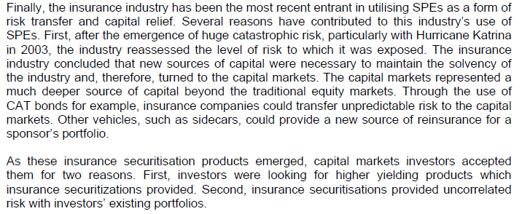

Source: Basel Committee on Banking Supervision: The Joint Forum Report on Special Purpose Entities. September 2009.

**Evidence in data:**

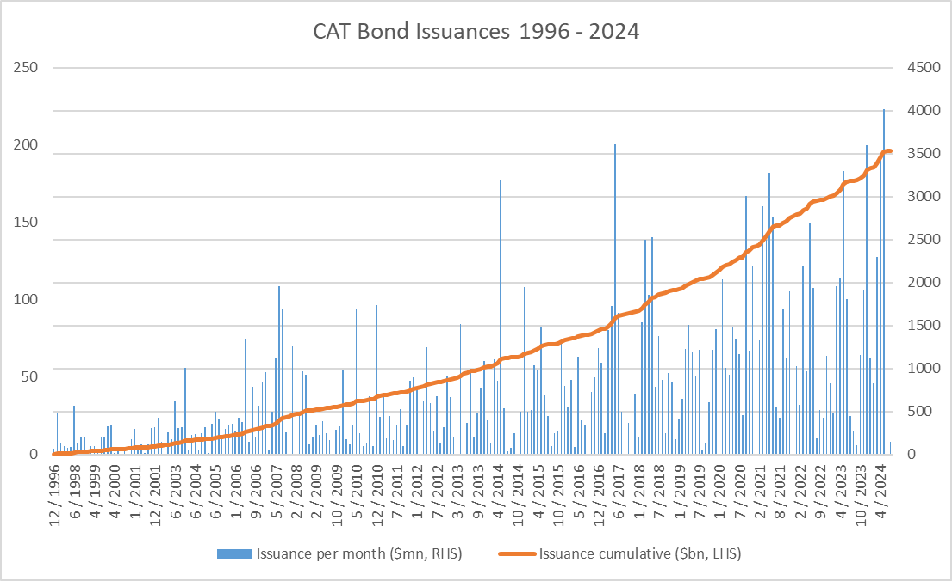

Cumulative CAT Bonds issues and monthly issues. Source. Artemis.bm

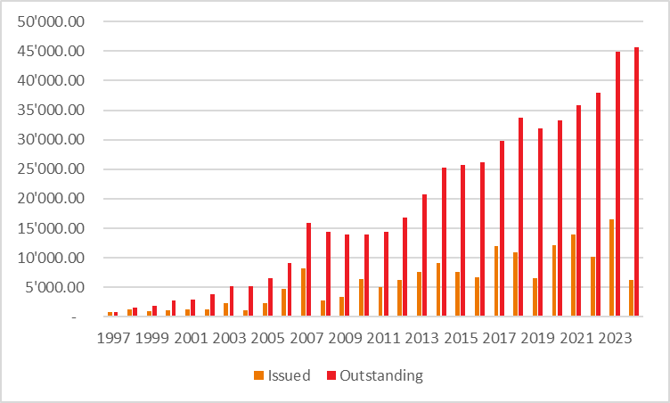

CAT Bond Market: Outstanding Volume in USD million. Source: artemis.bm

<ESMA_QUESTION_EADC_5>

1. Please explain your understanding of the notion of ancillary liquid assets and any recurring or significant issues that you might have experienced in this context. Please clarify if these are held as bank deposits at sight and what else is used as ancillary liquid assets. Where relevant, please distinguish between ancillary liquid assets denominated in (1) the base currency of the fund and (2) foreign currencies.

<ESMA_QUESTION_EADC_6>

TYPE YOUR TEXT HERE

<ESMA_QUESTION_EADC_6>

1. Beyond holding currency for liquidity purposes, do you think UCITS should be permitted to acquire or hold foreign currency also for investment purposes, taking into account the high volatility and devaluation/depreciation of some currencies? Where relevant, please distinguish between direct and indirect investments.

<ESMA_QUESTION_EADC_7>

TYPE YOUR TEXT HERE

<ESMA_QUESTION_EADC_7>

1. Have you observed any recurring or significant issues with the interpretation or consistent application of the 10% limit set out in the UCITS Directive for investments in transferable securities and money market instruments other than those referred to in Article 50(1) of the UCITS Directive? If so, please explain the issues and how you would propose to address them in the UCITS EAD with a view to improving investor protection, clarity and supervisory convergence.

<ESMA_QUESTION_EADC_8>

In responding to ESMA’s Call for Evidence LAFV is focusing on the asset class of insurance-linked securities / Cat Bonds. We view this limitation as a sensible approach to ensure the open tradability and thus liquidity of each outstanding bond.

<ESMA_QUESTION_EADC_8>

1. Are the ‘transferable security’ criteria set out in the UCITS EAD adequate and clear enough? If not, please describe any recurring or significant issues that you have observed and how you would propose to amend the UCITS EAD to improve investor protection, clarity and supervisory convergence.

<ESMA_QUESTION_EADC_9>

In responding to ESMA’s Call for Evidence LAFV is focusing on the asset class of insurance-linked securities / Cat Bonds. We can confirm that we never experienced any recurring or significant issues with the interpretation or consistent application of the “transferable security” criteria set out in the UCITS EAD. We thus believe these criteria to be adequately defined.

<ESMA_QUESTION_EADC_9>

1. How are the valuation and risk management-related criteria set out in the UCITS EAD interpreted and applied in practice, in particular the need for (1) risks to be “adequately captured” by the risk management process and (2) having “reliable” valuation/prices. Please describe any recurring or significant issues that you have observed with the interpretation or consistent application of these criteria and how you would propose to amend the UCITS EAD to improve investor protection, clarity and supervisory convergence.

<ESMA_QUESTION_EADC_10>

In responding to ESMA’s Call for Evidence LAFV is focusing on the asset class of insurance-linked securities / Cat Bonds. As highlighted in our answer to question 5, Cat Bonds are liquid instruments that are frequently traded, short-dated in maturity and valued regularly on a mark-to-market basis. Risks are adequately captured usually by means of specialized risk management products provided by third party vendors (AIR or RMS Moody’s). Fund valuations are reliable and we have never heard of any Cat Bond funds that had to suspend valuations or had to create side-pockets. No recurring or significant issues have come to our attention with respect to Cat Bonds.

<ESMA_QUESTION_EADC_10>

1. Are the UCITS EAD provisions on investments in financial instruments backed by, or linked to the performance of assets other than those listed in Article 50(1) of the UCITS Directive adequate and clear enough? Please describe any recurring or significant issues that you have observed in this respect and how you would propose to amend the UCITS EAD to improve investor protection, clarity and supervisory convergence.

<ESMA_QUESTION_EADC_11>

In responding to ESMA’s Call for Evidence LAFV is focusing on the asset class of insurance-linked securities / Cat Bonds. The insurance-linked securities asset class is fully governed by Article 50 of the UCITS Directive. Based on our assessment, the provisions on investments in financial instruments as outlined in Article 50 are adequate and clear.

<ESMA_QUESTION_EADC_11>

1. Is the concept of « embedded » derivatives set out in the UCITS EAD adequate and clear enough? Please describe any recurring or significant issues that you have observed with the interpretation or consistent application of this concept and how you would propose to amend UCITS EAD to improve investor protection, clarity and supervisory convergence.

<ESMA_QUESTION_EADC_12>

In responding to ESMA’s Call for Evidence LAFV is focusing on the asset class of insurance-linked securities / Cat Bonds. Insurance-linked securities (UCITS) funds are not allocating to “embedded” derivatives as set out in the UCITS EAD; in our view there is no issue with these criteria regarding the insurance-linked securities / Cat Bonds market.

<ESMA_QUESTION_EADC_12>

1. Linked to Q11 and Q12, ESMA is aware of diverging interpretations on the treatment of delta-one instruments under the EAD, taking into account that they might provide UCITS with exposures to asset classes that are not eligible for direct investment (see also Section 3.2). How would you propose to amend the UCITS EAD to improve investor protection, clarity and supervisory convergence? Please provide details on the assessment of the eligibility of different types of delta-one instruments, identify the issues per product and provide data to support the reasoning.

<ESMA_QUESTION_EADC_13>

In responding to ESMA’s Call for Evidence LAFV is focusing on the asset class of insurance-linked securities / Cat Bonds. Insurance-linked securities fully meet the UCITS EAD and qualify as direct investments. For the purpose of the asset class of insurance-linked securities / Cat Bonds, we believe the UCITS EAD criteria to be adequately defined. We are not aware of Cat Bonds that have been repackaged into a delta one instrument and we also see no need in doing so.

<ESMA_QUESTION_EADC_13>

1. Have you observed any recurring or significant issues with the interpretation or consistent application of the rules on UCITS investments in other UCITS and alternative investment funds (AIFs)? In this context, have you observed any issues in terms of the clarity, interaction and logical consistency between (1) the rules on investments in UCITS and other open-ended funds set out in the UCITS Directive and (2) the provisions on UCITS investments in closed ended funds set out in the UCITS EAD? Please describe any recurring or significant issues that you have observed in this respect and how you would propose to amend the relevant rules to improve investor protection, clarity and supervisory convergence. Where relevant, please distinguish between different types of AIFs (e.g. closed-ended, open-ended), investment strategies (real estate, hedge fund, private equity, venture capital etc.) and location (e.g. EU, non-EU, specific countries). In this context, please also share views on whether there is a need to update the legal wording used in the UCITS EAD and UCITS Directive given the fact that e.g. they refer to ‘open-ended’ and ‘closed ended funds’, whereas it might seem preferable to use the notion of ‘AIFs’ by now given the subsequent introduction of the AIFMD in 2011.

<ESMA_QUESTION_EADC_14>

TYPE YOUR TEXT HERE

<ESMA_QUESTION_EADC_14>

1. More specifically, have you observed any recurring or significant issues with the interpretation or consistent application of the rules on UCITS investments in (1) EU ETFs and (2) non-EU ETFs? Please describe any issues that you have observed in this respect and how you would propose to amend the relevant rules to improve investor protection, clarity and supervisory convergence.

<ESMA_QUESTION_EADC_15>

TYPE YOUR TEXT HERE

<ESMA_QUESTION_EADC_15>

1. How would you propose to amend the UCITS EAD to improve investor protection, clarity and supervisory convergence with respect to the Efficient Portfolio Management (EPM)-related issues identified in the following ESMA reports: (1) Peer Review on the ESMA Guidelines on ETFs and other UCITS issues; (2) Follow-up Peer Review on the ETF Guidelines; and (3) CSA on costs and fees. In this context, ESMA is interested in also gathering evidence and views on how to best address the uneven market practices with respect to securities lending fees described in the aforementioned ESMA reports with a view to better protect investors from being overcharged.

<ESMA_QUESTION_EADC_16>

TYPE YOUR TEXT HERE

<ESMA_QUESTION_EADC_16>

1. Would you see merit in linking or replacing the notion of EPM techniques set out in the UCITS Directive and UCITS EAD with the notion of securities financing transaction (SFT) set out in the SFTR? Beyond the notions of EPM and SFT, are there any other notions or issues raising concerns in terms of transversal consistency between the UCITS and SFTR frameworks?

<ESMA_QUESTION_EADC_17>

In responding to ESMA’s Call for Evidence LAFV is focusing on the asset class of insurance-linked securities / Cat Bonds. Securities financing transactions (SFT) are out of scope for our asset class. For the purpose of our asset class, we believe the UCITS EAD criteria to be adequately defined.

<ESMA_QUESTION_EADC_17>

1. Apart from the definitions and concepts covered above, are there any other definitions, notions or concepts used in the UCITS EAD that may require updates, further clarification or better consistency with definitions and concepts used in other pieces of EU financial legislation, e.g. MiFID II, EMIR, Benchmark Regulation and MMFR? If so, please provide details on the issues you have observed and how you would propose to clarify or link the relevant definitions or concepts.

<ESMA_QUESTION_EADC_18>

TYPE YOUR TEXT HERE

<ESMA_QUESTION_EADC_18>

1. Are there any national rules, guidance, definitions or concepts in national regulatory frameworks that go beyond (‘gold-plating’), diverge or are more detailed than what is set out in the UCITS EAD? If so, please elaborate whether these are causing any recurring or significant practical issues or challenges.

<ESMA_QUESTION_EADC_19>

In 2016, the Luxembourg regulator CSSF decided to expand the enforcement of ESMA 12/832, section XIII, point 50 to the asset class of Cat Bonds. Managers with Luxembourg-based funds are therefore required to adhere to this “20%/35% rule”. We understand that other jurisdictions with active UCITS Cat Bond funds are not actively enforcing the adherence to this rule.

<ESMA_QUESTION_EADC_19>

1. Please fill in the table in the Annex to this document on the merits of allowing direct or indirect UCITS exposures to the asset classes listed therein, taking into account the instructions provided in the same Annex. Please assess and provide evidence on the merits of such exposures in light of their risks and benefits taking into account the characteristics of the underlying markets (e.g. availability of reliable valuation information, liquidity, safekeeping). To substantiate your position, please fill the table with any available data and evidence (e.g. on liquidity or valuation of the relevant asset classes and underlying markets). ESMA acknowledges that the availability of data on direct/indirect exposures to some of the asset classes listed in this table is limited and would welcome receiving any available data (whether on individual market participants and products or market-wide) and even rough estimates that help to understand the practical relevance of the relevant asset class for UCITS and the possible impact of any future policy measures.

<ESMA_QUESTION_EADC_20>

TYPE YOUR TEXT HERE

<ESMA_QUESTION_EADC_20>

1. Please elaborate and provide evidence on how indirect exposures to the aforementioned asset classes (e.g. through delta-one instruments, ETNs, derivatives) increase or decrease costs and/or risks borne by UCITS and their investors compared to direct investments.

<ESMA_QUESTION_EADC_21>

TYPE YOUR TEXT HERE

<ESMA_QUESTION_EADC_21>

1. Under the EAD, should a look-through approach be required to determine the eligibility of assets? Please explain your position taking into account the aforementioned risks and benefits of UCITS gaining exposures to asset classes that are not directly investible as well as the increased/decreased costs associated with such indirect investments. A look-through approach would aim to ensure that the list of eligible asset classes set out in the UCITS Level 1 Directive would be deemed exhaustive and reduce risk of circumvention by gaining indirect exposures to ineligible asset classes via instruments such as delta-one instruments, exchange-traded products or derivatives. Where possible, please provide views, data or estimates on the possible impact of such a possible policy measure.

<ESMA_QUESTION_EADC_22>

TYPE YOUR TEXT HERE

<ESMA_QUESTION_EADC_22>

1. What are the risks and benefits of UCITS investments in securities issued by securitisation vehicles? Please share evidence and experiences on current market practices and views on a possible need for legislative clarifications or amendments.

<ESMA_QUESTION_EADC_23>

Cat Bonds make active use of special purpose vehicles/securitisation vehicles in order to shield the investor from credit counterparty risk of the Cat Bond’s sponsor. Cat Bond structures have been significantly improved since the early days of the market and we see no need for any need for legislative clarifications or amendments.

<ESMA_QUESTION_EADC_23>

1. What are the risks and benefits of permitting UCITS to build up short positions through the use of (embedded) derivatives, delta-one instruments or other instruments/tools? Please share evidence and experiences on current market practice and views on a possible need for legislative clarifications or amendments.

<ESMA_QUESTION_EADC_24>

TYPE YOUR TEXT HERE

<ESMA_QUESTION_EADC_24>

1. Apart from the topics covered in the above sections, have you observed any other issues with respect to the interpretation or consistent application of the UCITS EAD? If so, please describe the issues and how you would propose to revise the UCITS EAD or UCITS Directive with a view to improve investor protection, clarity and supervisory convergence.

<ESMA_QUESTION_EADC_25>

TYPE YOUR TEXT HERE

<ESMA_QUESTION_EADC_25>

1. https://www.statista.com/statistics/1277225/equities-market-turnover-operator-usa/
2. https://fred.stlouisfed.org/series/DDEM01USA156NWDB
3. INTERNATIONAL ASSOCIATION OF INSURANCE SUPERVISORS: Developments in (Re)Insurance Securitisation

   Global Reinsurance Market Report Midyear Edition. 26 August 2009