ESMA
Attn Ms Van Laere
Head of Unit Credit Rating Agencies

14 June 2024

Dear Ms Van Laere,
Deloitte response to ESMA Consultation on European Green Bond Regulation (EUGBR) Regulatory Technical Standards
We are pleased to have the opportunity to reply on behalf of Deloitte to ESMA’s consultation paper on Technical Standard on the European Green Bond Regulation and welcome its request to describe alternatives that ESMA may consider.
Deloitte’s overall stance in this regard is that where an external reviewer applicant is accredited and subject to oversight by a relevant existing national body, ESMA should recognize and leverage such accreditations and evaluate whether the applicant already complies with the relevant criteria that ESMA seeks to ensure through its standards.
Our responses sometimes include some follow-up questions seeking to clarify our understanding of the regulation and consultation paper.
If you would have any questions on our comments, please contact Pablo Zalba at pzalba@deloitte.es or Niall Walsh at niwalash@deloitte.ie.

Yours Sincerely,

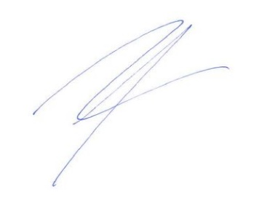

Pablo Zalba Niall Walsh
Managing Director EU Policy Centre Global Assurance Quality and Risk Leader

For more information, see Deloitte.

