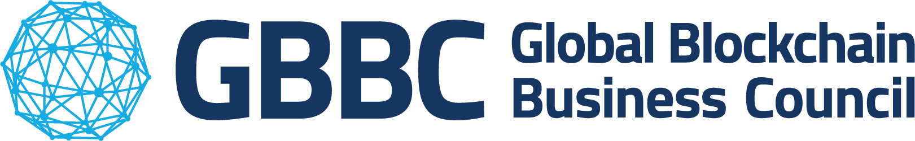

**About us:**

**GBBC** is the largest leading industry association for the blockchain technology and digital assets community. Launched in Davos in 2017, GBBC is a Swiss-based non-profit, with more than 500 institutional members, and 301 Ambassadors across 117 jurisdictions and disciplines. The organisation is dedicated to furthering adoption of blockchain technology by convening regulators, business leaders, and global changemakers to foster collaboration and advance dialogue to create more secure, equitable, and functional societies.

**ESMA Level 3 Package –**

**Reverse Solicitation and Crypto Asset and Security Token Classification**

**Q1: Do you agree with the approach chosen by ESMA? Do you see any potential loophole that could be exploited by third-country firms to circumvent the MiCA authorisation requirements?**

Restrictions on promotional activities, that are not directly related to offering specific crypto-assets or services, could inadvertently deter well-established financial institutions from non-EU countries from engaging with EU markets. This could hinder the ability of these institutions to respond to client requests regarding crypto-assets or services in the future, even if their primary business lines are not primarily associated with crypto-assets.

To foster broader adoption and ensure inclusivity, adjustments to the proposed guidelines may be necessary to accommodate entities from non-EU countries with diverse business lines. Regulators should consider the potential unintended consequences of overly restrictive guidelines and aim to strike a balance between promoting market integrity and facilitating innovation and market participation. For example, in the case of Swiss Crypto Asset Service Providers (CASPs), activities aimed at domestic customers in languages commonly spoken in Switzerland (such as Italian, French, or German) should not automatically be interpreted as targeting EU customers. These activities are likely intended for local audiences and should be considered within the context of the provider's domestic market.

Therefore, Regulators should take into account various factors when assessing whether activities are targeted towards EU customers, including the language used, the geographic location of the audience, and the specific content and context of the activities. This nuanced approach can help avoid misinterpretations and ensure that regulatory requirements are applied appropriately. A balanced and pragmatic approach is needed to distinguish between activities targeting EU customers and purely local activities. By considering the specific circumstances and intentions behind these activities, regulators can mitigate the risk of overreach and support the continued participation of non-EU financial service providers in the EU market.

**Q2: Are you able to provide further examples of pairs of crypto-assets that would not belong to the same type of crypto-assets for the purposes of Article 61 of MiCA? Or are you able to provide other criteria to be taken into account to determine whether two crypto-assets belong to the same type?**

When determining whether two crypto-assets belong to the same type, there are several criteria beyond their basic functionality that you can consider, such as: 1) different cryptocurrencies may utilise different consensus mechanisms, such as Proof of Work (PoW), Proof of Stake (PoS), Delegated Proof of Stake (DPoS), etc; or 2) the technical aspects of the blockchain, including its structure, scalability, interoperability, and governance model; 3) the security measures implemented by each cryptocurrency, including measures to prevent double spending, protect against attacks, and ensure network resilience; and, last but not least 4) take into account the regulatory landscape surrounding each crypto asset, including legal status, compliance with regulations, and any regulatory challenges or uncertainties that may impact its long-term viability. Some examples will include the following categories: utility tokens, asset-referenced tokens or electronic money tokens (ART or EMT); crypto-assets not stored or transferred using the same technology; electronic money tokens not referencing the same official currency; asset-referenced tokens based mostly on FIAT currencies and asset-referenced tokens having significant crypto-currency ponderations; liquid and illiquid crypto-assets; crypto-assets other than asset-reference tokens and electronic money tokens with a non-identifiable-offeror and crypto-assets other than asset-reference tokens and electronic money tokens with an identifiable offeror.

**Q3: Do you consider the proposed supervision practices effective with respect to detecting undue solicitations? Would you have other suggestions?**

The use of local email or website addresses by established financial entities or crypto asset service providers (CASPs) from non-EU countries should not automatically imply engagement in prohibited activities. Many legitimate businesses maintain a presence in multiple jurisdictions for specific business lines or to serve local customers without necessarily targeting EU clients. To safeguard against unfounded investigations and potential misunderstandings, regulators should require credible suspicion of wrongdoing supported by reasonable grounds before initiating an investigation into potential breaches of reverse solicitation requirements. This ensures that investigations are conducted in a fair and objective manner, taking into account the specific circumstances and nuances of each case. Clear guidelines and communication from regulators can help clarify the expectations and obligations for businesses operating in cross-border contexts. By promoting transparency and cooperation between regulators and industry participants, regulators can effectively enforce regulations while minimising unnecessary burdens and disruptions to legitimate business activities.