Reply form
  - on the call for evidence on shortening of the settlement cycle

  - Responding to this paper
ESMA invites comments on all matters in this paper and in particular on the specific questions summarised in Annex 1. Comments are most helpful if they:
- respond to the question stated;
- indicate the specific question to which the comment relates;
- contain a clear rationale; and
- describe any alternatives ESMA should consider.
ESMA will consider all comments received by 15 December 2023.
All contributions should be submitted online at www.esma.europa.eu under the heading ‘Your input - Consultations’.
  - Instructions
In order to facilitate analysis of responses to the Consultation Paper, respondents are requested to follow the below steps when preparing and submitting their response:
• Insert your responses to the questions in the Consultation Paper in this reply form.
• Please do not remove tags of the type < ESMA_QUESTION_SETT_0>. Your response to each question has to be framed by the two tags corresponding to the question.
• If you do not wish to respond to a given question, please do not delete it but simply leave the text “TYPE YOUR TEXT HERE” between the tags.
• When you have drafted your responses, save the reply form according to the following convention: ESMA_CP1_SETT _nameofrespondent.
For example, for a respondent named ABCD, the reply form would be saved with the following name: ESMA_CP1_SETT _ABCD.
• Upload the Word reply form containing your responses to ESMA’s website (pdf documents will not be considered except for annexes). All contributions should be submitted online at www.esma.europa.eu under the heading ‘Your input - Consultations’.
Publication of responses
All contributions received will be published following the close of the consultation, unless you request otherwise. Please clearly and prominently indicate in your submission any part you do not wish to be publicly disclosed. A standard confidentiality statement in an email message will not be treated as a request for non-disclosure. A confidential response may be requested from us in accordance with ESMA’s rules on access to documents. We may consult you if we receive such a request. Any decision we make not to disclose the response is reviewable by ESMA’s Board of Appeal and the European Ombudsman.
Data protection
Information on data protection can be found at www.esma.europa.eu under the heading ‘Data protection’.
Who should read this paper?
All interested stakeholders are invited to respond to this consultation paper. In particular, ESMA invites market infrastructures (CSDs, CCPs, trading venues), their members and participants, other investment firms, issuers, fund managers, retail and wholesale investors, and their representatives to provide their views to the questions asked in this paper.

General information about respondent
Name of the company / organisation | European Fund and Asset Management Association (EFAMA)
Activity | Associations, professional bodies, industry representatives
Are you representing an association? | ☒
Country / Region | Belgium

Questions
- : Please describe the impacts on the processes and operations from compressing the intended settlement date to T+1 and to T+0. Please:
- provide as much detail as possible on what issues would emerge in both cases and how they could be addressed with special attention to critical processes (matching, allocation, affirmation and confirmation) and interdependencies. Where relevant please explain if these are general or asset class/instrument/ trade specific.
- Identify processes, operations or types of transaction or financial instrument class that would be severely impacted or no longer doable in a T+1 and in a T+0 environment.
Please, suggest if there are legislative or regulatory actions that would help address the problems. Where relevant please explain if these are general or asset class/instrument/ trade specific.
<ESMA_QUESTION_SETT_1>
General Comments:
- EFAMA believes that it is right and appropriate that a move to T+0 should be discussed. T+0 is a longer-term strategic objective for European capital markets which will require engagement from industry. It may be more efficient however to discuss T+1 and T+0 on separate tracks given that T+0 involves a paradigm shift to the post-trade life cycle. T+1 merely optimises further existing technology and market structures. T+0 (especially in its atomic settlement form) will revolutionise today’s post-trade activites, making some activities/players redundant, and radically altering how we manage market liquidity and risk. We therefore propose not to discuss T+0 in any of our responses to the current consultation. There is a clear need to focus the resources of our firms on implementation of T1 at the present time. A future workstream on T0, once T1 migration for the EU is stabilised, should not be ruled out however.
- The experience of the EFAMA membership in responding to this consultation has been one of frustration given the difficulties in obtaning data in a short-time frame, and the fact that an important set of data only becomes available once the US has moved to T1. Nevertheless we are in a position to make informed predicitions given our knowledge of our business and the broader post-trade ecosystem.
- We find a compelling case for the EU to commit to a timely transition to T1
- We will face important costs with the US move to T1 which will ultimately be reflected in performance losses for EU investors. The funding gap will persist in a misaligned environment, with investors bearing the ultimate cost. This combined with the expected decrease in securities lending will increase the cost of trading for all funds with any US exposure.
- There is a major and serious risk that if Europe fails to act, other jurisdictions will follow the US while Europe remains on T2 for a prolonged time. European capital markets would be behind their peers in terms of capital effiency and risk management. Our institutions would rely on older technology and more manual-driven processes while most other advanced economies would have migrated to greater and greater levels of STP and automation.
- On the other side, we find equally strong arguments questioning the benefits of a move to T1 in Europe:
- In Europe, we function in an environment with mulitple CSDs and multiple currencies. Some instruments settle on multiple CSDs, resulting in a complex settlement process where several settlement processes need to take place to reach the final counterparty of the trade. Given that ETFs trade on multiple venues, there is a more complex cross border settlement structure at play with the need to realign securities via accounts at various CSDs. Such cross-CSD operations are better handled over a 2-day settlement cycle
- Many in the industry recognise that with the investment requirements and the need for scale, both the US migration to T1 and an eventual EU migration could act as trigger for further consolidation in the asset management industry. Larger asset managers are simply better equipped to make major investments in systems which will be recouped fairly quickly. In contrast, the cost of automation for smaller asset managers that trade less frequently may be prohibitive.
- T2 might be an optimal settlement cycle for UCITs held by non-EU investors in timezones where a shorter settlement cycle would increase errors, impede the fund administration process and make the daily NAV calculation difficult.
- Finally, there are impacts that we simply do not know today, and would only become known sometime after the US transition:
- Was a unilateral T1 move by the world’s largest capital market ill-managed and did it introduce more risk into the system (operational risk, settlement risk..)
- Given different global timezones, and the reliance on existing technology and market strucutres, is there a natural limit to how much the settlement timeframe can be compressed, and is T1 a step too far?
- Did fails in the US increase as a result of T1 and never recover?
- Is the issue with FX settlement and CLS emblematic of the inability to squeeze the timeframe further given existing business models and technologies?
- Given the level of unknowns and gaps in data, and at the same time the possible major impacts of adopting either strategy, we recommend the following:
- To actively build the roadmap for a timely transition for the EU to T1 settlement, with the strong proviso that the roadmap and accompanying milestones can be revisited based on the experience of the US transition. The roadmap needs to be dynamic and able to be adapted at different junctures when hard data becomes available.
- We strongly recommend that the EU and UK commit to a coordinated move. Failing to do so is not in the interest of financial markets and their participants. Any perceived competitive advantage is ouweighed by the costs to partipants in managing another settlement misalignment. Failure to coordinate also means that all remaining markets intend to compete on speed. Any objective analysis of developments in the US become impossible with such a narrow focus.
<ESMA_QUESTION_SETT_1>

- : What would be the consequences of a move to a shorter settlement cycle for (a) hedging practices (i.e. would it lead to increase pre-hedging practices?), (b) transactions with an FX component?
<ESMA_QUESTION_SETT_2>
- One of the main innovations brought to FX markets in the last 20 years, has been the growth of PVP (Payment versus Payment) settlement through the increased use of the CLS platform. PVP reduces settlement risk by allowing for the simultaneous settlement of transactions for both sides of the trade, meaning that one transacting party’s payment instruction in one currency is not settled unless the corresponding payment instruction in the counter currency is settled.
- Despite this positive development, challenges around FX Settlement Risk remain:
- Time zone related challenges: instruction deadlines come from different regions, with some coming very close to the CLS deadline.
- Fund pricing is a challenge as cut-offs come at different points in the day depending on the currency/counterparty/custodian. There is also little consistency from custodians on their cut-offs for instructions.
- CLS Settlement does not support all currencies
- According to CLS’s own estimates 60-100billion of spot FX a day, is taking place outside of CLS.
The need for FX is a constant as funds in Europe are denominated in Euros but will trade US stocks. The US move to T1, according to EFAMA estimates will put 1/3 of USD FX trades at risk as they may not make the CLS cut-off for net settlement. A shortening of the settlement cycle in Europe will not improve the FX settlement risk issue. It is the compressed timeframes for accessing FX liqudity and the CLS model and deadlines themselves which are not optimised for T1 in any jurisdiction.
As to whether an EU move to T1 will impact Europes’ non-EU investors, there is an expectation tha global investors will have adapted processes for USD trades already, making an EU shortening of the settlement cycle less impactful from an FX settlement risk point of view. Non-EU-investors would have a longer time to generate and execute FX for EU equity trades, given the much wider gap between market close: 5pm CET, and the CLS deadline: 12am CET. The comparable gap for US trades is much smaller, markets close at 10pm CET, facing the same 12am CET cut-off on CLS.
It should be noted that the US move alone undermines the CLS model, increasing liquidity and funding risk as described above. It also drives up the trading cost for EU fund managers as all alternatives to net settlement on CLS are more costly: bilateral settlement the next day, prefunding in USD, or insructing the FX trade before a security trade has been confirmed, requiring true-up the next day.
<ESMA_QUESTION_SETT_2>

- : Which is your current rate of straight-through processing (STP ), in percentage of the number and of the volume of transactions broken down per type of transaction or per instrument as relevant? In case STP is used only for certain processes/operations, please identify them. Which are the anticipated challenges that you envisage in improving your current rate of STP?
<ESMA_QUESTION_SETT_3>
For buy-side firms, we assume this question to apply mostly to the trade matching process .
We can also point out that currently in back and middle-office functions, night batches are used to ensure settlements overnight between T1 and T2. Current operational processes are therefore not optimised for a T1 environment. Any change would require a significant operational build for some asset managers. Settlement fails would be expected to increase until such new systems are in place.
Larger asset management firms are at an advantage here. Their scale allows them to make the necessary investments in new systems, while smaller firms may not be able to justify the cost. Given that even in the production of this response, smaller asset managers were not well represented it may be an idea for ESMA to carry out targeted analysis on market structure impacts. What will the impact of EU T1 be on the diverse landscape of management companies in Europe?
<ESMA_QUESTION_SETT_3>

- : Please describe the impacts that, in your views, the shortening of the securities settlement cycle could have beyond post-trade processes, in particular on the functioning of markets (trading) and on the access of retail investors to financial markets. If you identify any negative impact, please identify the piece of legislation affected (MiFID II, MiFIR, Short Selling Regulation…) and elaborate on possible avenues to address it.
<ESMA_QUESTION_SETT_4>
It is not clear if EU T1 would be limited to securities as in CSDR today, or if it would also extend to fund units. Currently, we expect each ManCo to make an individual decision on the settlement timing that is best for them for fund settlement.
We expect negative impacts on at least several fronts with an EU T1 move for transferable securities executed on trading venues:
- Most EU securities are traded on close, meaning that trade matching and FX trading will be difficult to manage within a T1 cycle and will certainly require a high degree of automation. EU fund managers still rely on some level of human intervention. Today’s manual processes around pre-matching, SWIFT messaging, reconciliation and dispute resolution are acceptable on a T2 environment. The interdpeendencies in the settlement work flow will have to be identified, and system upgrades and in some cases a total IT rebuild would be required.
- Securites lending would contract impacting both the liquidity in the market ,and funds’ performance as they would lose their ability to loan out shares. The recall process will be more complicated in Europe, the process though should be managed by agency lenders. For US shares today, and EU shares if EU also moves to T1, we expect a contraction in liquidity and a performance drag for end-investors, as fund managers would be less inclined to loan out stocks.
We anticipate greater impacts if the shortening to T1 is extended to the settlement cycle of unit funds. As also expressed in Q20, at this stage we do not see reason or need to bring other transactions currently excluded into scope of the mandatory settlement cycle under a specific settlement period (Art. 5 (2) CSDR). Currently, we expect each ManCo to make an individual decision on the settlement timing that is best for them for fund settlement.
Distribution of funds- regions like Asia Pacific rely on a T2 or T3 settlement cycle for theri investors into EU domiciled UCITS. A minimum 48-hour cycle compensates for the fact that when Asia trades, Europe is closed, with only a short overap in the morning in Europe, by which time it is unlikely that the trade lifecyle will have culminated in settlement. This means also that the NAV of the fund will only reflect an incoming Asian trade on T+2. The current timeline therefore allows sufficient time for matching and confirmation, and custodial instructions and reliable NAV calculations. A shorter settlement cycle may be unwelcome by overseas UCITS investors. This is not a group that should be overlooked. Global investors of UCITS represent 36% of overall UCITS investments. The local dimentions of key overseas markets should therefore be taken into account to avoid any negative impacts for overseas based investors.
<ESMA_QUESTION_SETT_4>

- : What would be the costs you would have to incur in order to implement the technology and operational changes required to work in a T+1 environment? And in a T+0 environment? Please differentiate between one-off costs and on-going costs, comparing the on-going costs of T+1 and T+0 to those in the current T+2 environment. Where relevant please explain if these are general or asset class/instrument/ trade specific.
<ESMA_QUESTION_SETT_5>
Exchanges, CCPs and CSDs providing trading, clearing and settlement services expect that they could function in a T1 environment today. It is the trade allocation, confirmation and matching which buy-side, brokers and custodians are responsible for which would need greater investment and automation. Firms, to varying degrees, rely on manual processes and human intervention. A compressed timeframe to T1 would therefore involve, inter alia:
- Human costs : need for night shifts in order to improve operational coverage and meet the different cut offs ;
- Technological costs : need to have faster tools, automated processes, systems that operate at night. This will impact the internal workload and involve third-party service providers.
- Operational costs and of implementation. For example, a decorrelation in the settlement cycle of fund’s assets and liabilities will require more funding and therefore more costs.
- Costs related to fails : an increase of settlement fails and cash penalties.
- Cost related to repapering i.e. fund prospectuses, agreements with depositories, legal and commercial documentation …
- Risk management costs.
<ESMA_QUESTION_SETT_5>

- : In your view, by how much would settlement fails increase if T+1 would be required in the short, medium and long term? What about T+0? Please provide estimates where possible.
<ESMA_QUESTION_SETT_6>
It’s difficult for EFAMA to make projections here as approximately 80% of settlement fails are caused by brokers. A shortened settlement timeframe should not change that number. However we can imagine that there could be a spike in fails in the short-term as firms adjust to matching trades in a compressed timeframe.
From a buy-side perspective from looking at CSDR cash penalties, our members are able to get a broad view of where settlement fault lies for trades that they engage in.
From a recent IA survey, on average they saw that around 83% of cash penalties were attributable to the broker, and of this, the vast proportion were because the brokers were short of stock, with the buy-side account receiving a credit cash penalty. Of the remaining 17%, our members saw around 10% due to the custodian or client, the largest cause of this was security lending recall fails. Of the remainder, the asset management community have been looking to solve for the challenges. This includes a greater leverage of SSI vendors, a more robust onboarding process and a better reconciliation of where stock is (e.g. whether it’s at an ICSD like Euroclear or sits with the primary market CSD).
Of the fail types:
Counterparty/broker fails – This makes up the biggest component of current fails. Potentially one of the reasons that counterparty/broker fails make-up the majority of fails the buy-side see, are that many brokers will manage their inventory (clearing position) to near 0 as the most cost-efficient funding process for holding stock and brokering transactions through their clearing account. Accordingly, on any given day, tens or hundreds of deliveries through a brokers’ clearing account for a particular security may be reliant on tens or hundreds of receipt trades, with the end of day position expected to be near 0 in the account should all trades settle. Should one big receipt trade fail, this will impact a large number of deliver trades (which may then impact onward trades for those counterparts). We don’t believe that moving to T+1 will change this problem, though increased fails into brokers would then exacerbate settlement fails onto onward counterparts.
Asset manager fails – These are likely to increase following a move to T+1 settlement but we wouldn’t expect this to be significant. Some of the steps taken for US T+1 will also help prepare asset managers for the EU transition.
Custodian/sec lending fails – Securities lending recalls remain a challenge as outlined in our response to question 1. Where there’s a sale on a loaned security, it will be very difficult to recall the stock in time to settle the onward leg. Whilst some steps will have been improved with regards to T+1 in the US, the European securities lending flow works a little differently. Depending on process improvements between now and the transition date, settlement fails relating to securities lending could spike. The onward challenge of this is that CSDR cash penalties for securities lending is complex, and often involves a time consuming process of determining who of the counterpart, agent lender, asset manager and client is at fault and claiming the difference.
New fails arising from a shortened settlement cycle – These are difficult to quantify but it is expected that there will be a rise in fails as a result of a transition to T+1. Any processes undertaken on T+1 of today’s T+2 settlement cycle will now have to be resolved on T. An example might include where SSIs are incorrect following an onboarding process and insufficient time is available after pre-matching to resolve for this. Significant automation would have to be achieved in other flows to lessen this impact.
General – More generally, it is likely that there would be a rise in settlement fails but we don’t envisage that the current highest reason of fails the buy-side see (CLAC – Counterparty lack of securities), will be materially impacted.
It's impossible to quantify what impact a move to T+0 against current metrics of settlement fails would be, as it would likely require a significant overhaul in systems and processes.
Currently fund managers at Back-Office and Middle-Office levels make use of night batches to ensure settlements overnight between T+1 and T+2. This would no longer be possible under T+1. It would require changing operational and organisational practices incurring high costs for a poor benefit. It would of course impact settlement efficiency with more fails. The additional one-day safety net would disappear and would require back-offices to make their operations on trade date.
<ESMA_QUESTION_SETT_6>

- : In your opinion, would the increase in settlement fails/cash penalties remain permanent or would you expect settlement efficiency to come back to higher rates with time? Please elaborate.
<ESMA_QUESTION_SETT_7>
TYPE YOUR TEXT HERE
<ESMA_QUESTION_SETT_7>

- : Is there any other cost (in particular those resulting from potential impacts to trading identified in the previous section) that ESMA should take into consideration? If yes, please describe the type of cost and provide estimates.
<ESMA_QUESTION_SETT_8>
For dual-listed securities, there could be short-selling opportunities with some listings on T1 and others on T2.
We stress the cost of non-alignment with US T1 ( a market which we are exposed to the order of 42% for our overall equity holdings. See our response to question 15 for greater detail.
<ESMA_QUESTION_SETT_8>

- : Do you agree with the mentioned benefits? Are there other benefits that should be accounted for in the assessment of an eventual shortening of the securities settlement cycle?
<ESMA_QUESTION_SETT_9>
At this point, there is definitely a strong use case for European ETFs moving to T1 (i.e transactions executed on trading venues). Such a move would align secondary market trades with primary market trades exposed to a US T1, thereby aligning the underlying basket and the wrapper. This would reduce the cost of trading US shares on T1 while settling ETFs on T1 in Europe.
An EU move to T1 for all assets (equity, bonds, futures and ETFs), would mean that all cash flows for ETFs would match in T1:
- Underlying trades in the equity, bonds and futures market
- Deals on the ETF primary market (issuance of ETF shares)
- Deals on the secondary market (on-exchange trade)
This would smooth out operations, lower the risk of settlement failure and lower the cost of funding to the benefit of the end-investor.
Traditional funds would also benefit from realignment, although the urgency is arguable greater for ETFs as trading on exchange for ETFs and the applied settlement cycle is completely out of the hands of the ETF issuer.
It is also difficult to argue against more efficient payment systems, and general improvements in speed and efficiency of the settlement cycles of the securities underlying the funds.
<ESMA_QUESTION_SETT_9>

- :Please quantify the expected savings from an eventual reduction of collateral requirements derived from T+1 and T+0 (for cleared transactions as well as for non-cleared transactions subject to margin requirements).
<ESMA_QUESTION_SETT_10>
TYPE YOUR TEXT HERE
<ESMA_QUESTION_SETT_10>

- : If possible, please provide estimates of the benefits that you would expect from T+1 and from T+0, for example the on-going savings of potentially more automated processes.
<ESMA_QUESTION_SETT_11>
The key benefits revolve around restoring alignment with the US after they move to T1 and thereby reducing/eliminating the associated costs of the funding mismatch
Key jurisdictions are moving to T+1, Europe cannot afford to be a late adopter when it comes to more efficient payment systems. A conservative approach now will hurt us in the long run.
Another important impact of an EU move to T1 could be a wave of consolidation across the market infrastructure providers, with as a result, better, more efficient trade processes, investments in new technology and an important catalyst to solve for heavily fragmented market we face in post-trade services.
<ESMA_QUESTION_SETT_11>

- : How do you assess the impact that a shorter settlement cycle could have on the liquidity for EU markets (from your perspective and for the market in general)? Please differentiate between T+1 and T+0 where possible.
<ESMA_QUESTION_SETT_12>
TYPE YOUR TEXT HERE
<ESMA_QUESTION_SETT_12>

- : What would be the benefits for retail clients?
<ESMA_QUESTION_SETT_13>
TYPE YOUR TEXT HERE
<ESMA_QUESTION_SETT_13>

- : How would you weigh the benefits against the costs of moving to a shorter settlement cycle? Please differentiate between a potential move to T+1 and to T+0.
<ESMA_QUESTION_SETT_14>
One important cost that we have identified, but which is difficult to quantify given the range of interdependencies is the disruption to an established distribution model around UCITs. What are the local dimensions in markets like APAC , LAT AM and Middle East, will the requirement to settle on T+1 be viewed positively, or will it be seen as an unwelcome disruptor? How efficient and well-coordinated is the post-trade settlement chain involving those jurisdictions, can the transfer agents and custodians along the chain move seamlessly to T+1?
It should be noted that the standard settlement for APAC for instance, is T2, suggesting that EU UCITs remaining on T2 might be more competitive than T1 UCITs for that market. The eventual scope of an EU move to T1 should consider the exclusion of UCITS funds as is the case today in CSDR. The settlement cycle of the fund (buying and selling of fund units) should be left to the fund manager.
From a purely buy-side ETF perspective, the cost/benefit analysis will centre around the benefits of closing the settlement misalignment with the US for US-invested ETFs (particularly those with mixed baskets where the management is more complex and costly) and any reduction in investment from Asia and Lat Am where investors would potentially prefer to remain on a T2 standard settlement.
<ESMA_QUESTION_SETT_14>
- : Please describe the main steps that you would envisage to achieve an eventual shorter securities settlement cycle. In particular, specify: (i) the regulatory and industry milestones; and (ii) the time needed for each milestone and the proposed ultimate deadline.
<ESMA_QUESTION_SETT_15>
From a buy-side standpoint, we can shorten the timeframe for settling fund units. This may go from T3 to T2, or even T2 to T1 to accommodate some funds that have a high exposure to US securities. Similarly, on the ETF side, there appears to be a consensus in the market on how to minimise the impact of misaligned cycles. For the primary market transactions for ETF creates, the settlement cycle will move to T1 for pure US and mixed baskets. For the redemptions, the primary market will likely remain on T+2. This will mean that for both types of flow ETF issuers will remain long cash. See the two graphics below that illustrate this:
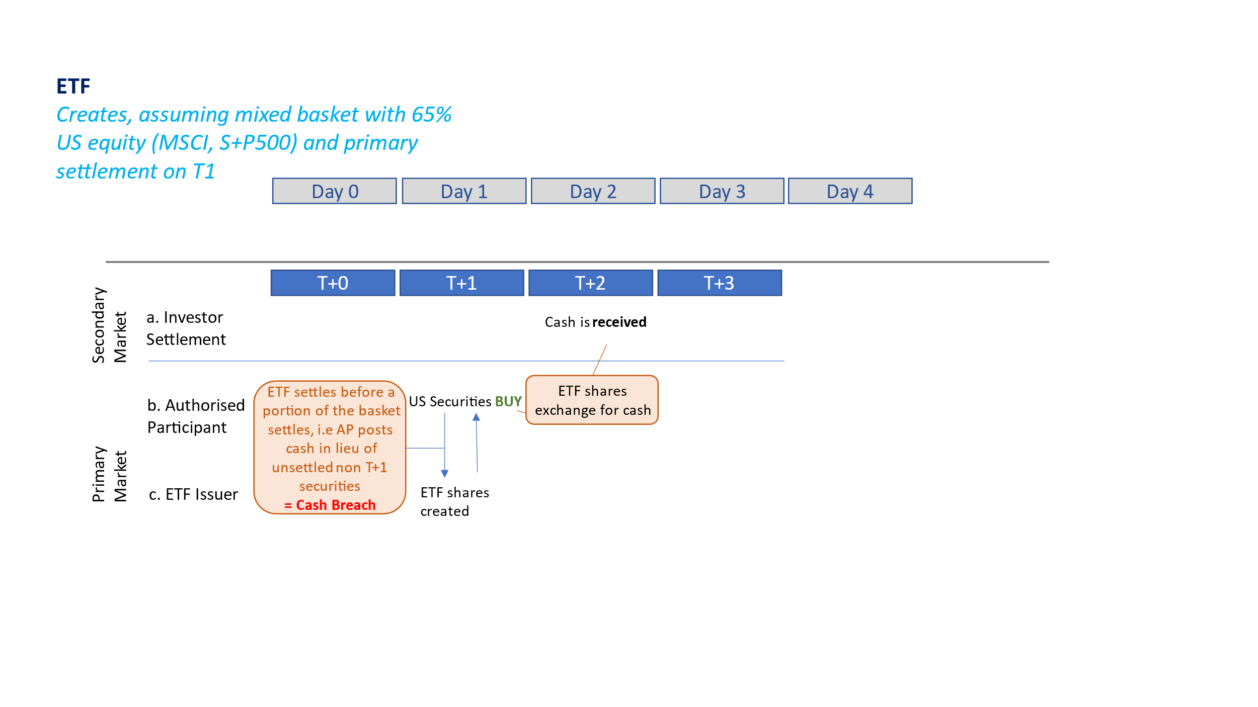
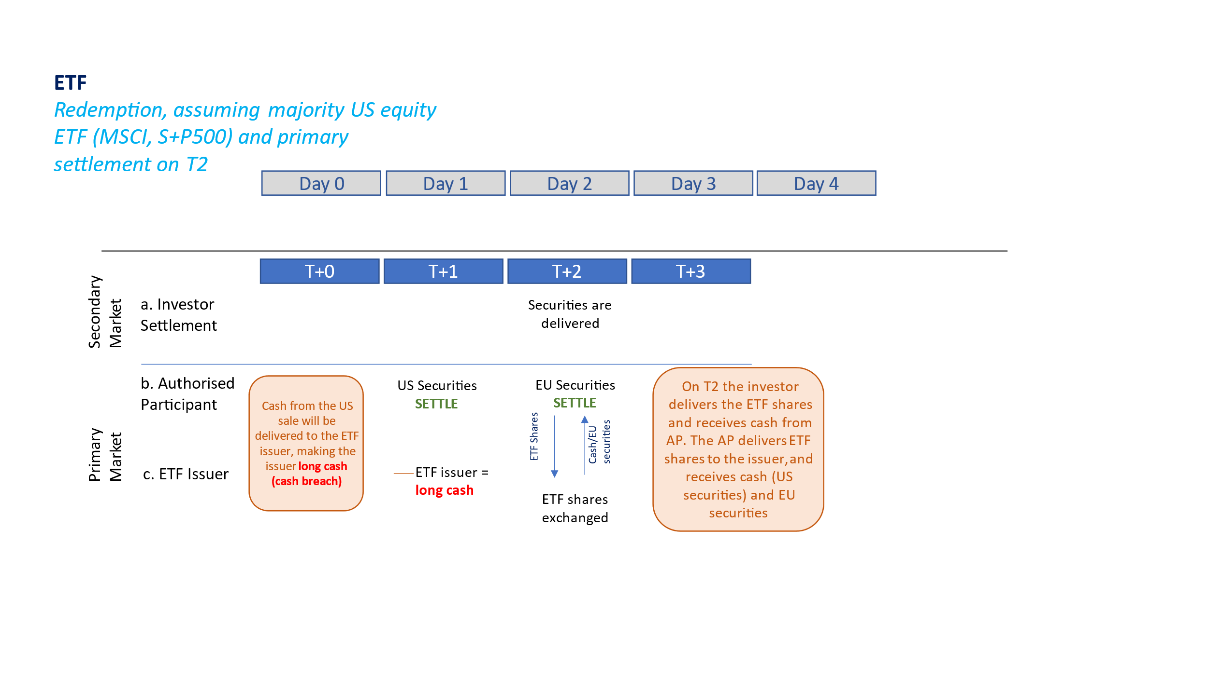
However, it is important to note that on secondary market trades, ETFs are aligned with the exchanges that they are listed on. Therefore for the secondary market trades, the settlement cycle will very much depend on the different venues where the ETFs are listed.
This means that traditional fund and ETFs can make limited adjustments, i.e shortening to T2 in the former case, or moving some primary trades to T1 in the latter, but a funding mismatch will persist and can only be fully resolved with full alignment between EU settlement cycles on both funds and securities and the US settlement cycle.
Below we show traditional funds which settle on T3 often, though we are aware that some funds have managed to move to T2 shortening the funding mismatch by one day. Fund unit settlement cycles can be reduced, although this is a complex process involving fund distributors and local regulators. Full global alignment on T1 would remove this remaining day of funding mismatch impacts:
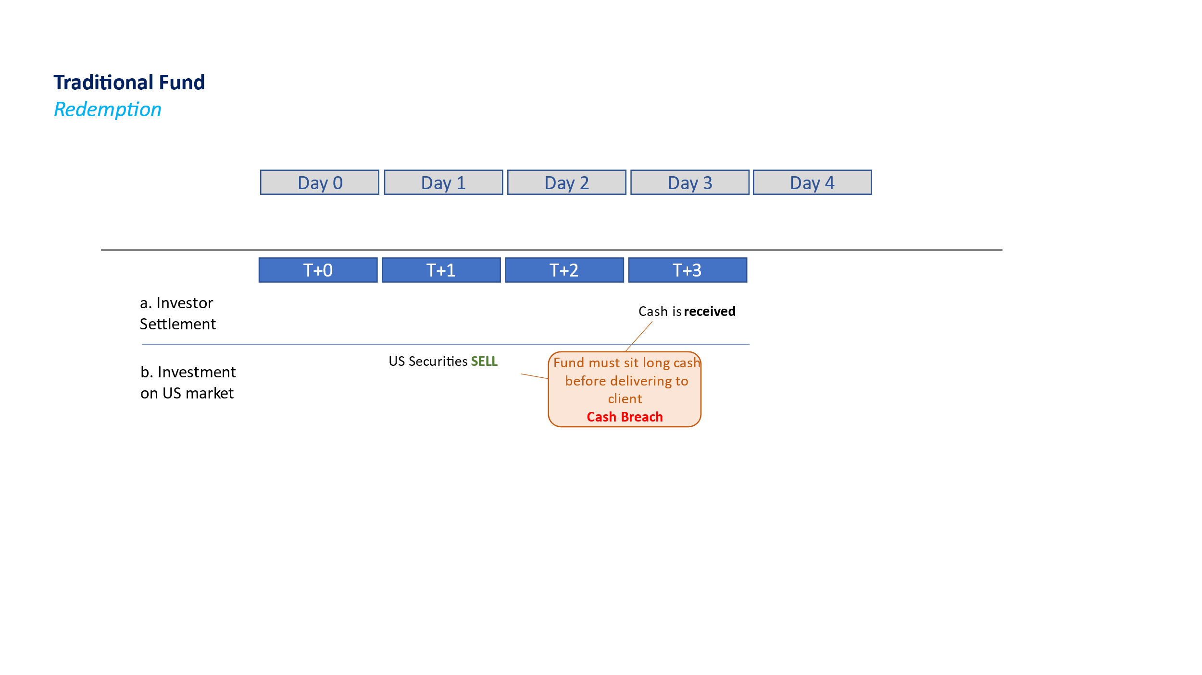
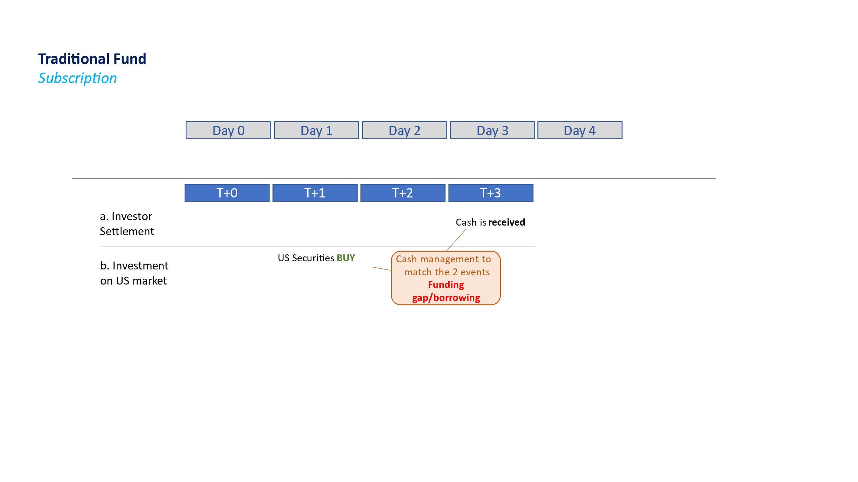
<ESMA_QUESTION_SETT_15>

- : Assuming that the EU institutions would decide to shorten the securities settlement cycle in the EU, how long would you need to adapt to the new settlement cycle? And in the case of a move to T+0?
<ESMA_QUESTION_SETT_16>
TYPE YOUR TEXT HERE
<ESMA_QUESTION_SETT_16>

- : Do you think that the CSDR scope of financial instruments is adequate for a shorter settlement cycle? If not, what would be in your views a more adequate scope?
<ESMA_QUESTION_SETT_17>
See our answer to Q14. Traditional funds should not be in scope of a shorter settlement cycle. That decision should be an individual fund managers decision informed likely by global footprint and need to accommodate global investors.
<ESMA_QUESTION_SETT_17>

- : Is it feasible to have different settlement cycles across different instruments? Which are the ones that would benefit most? Which least?
<ESMA_QUESTION_SETT_18>
From a Management Company perspective, it would be preferable if there were no differences for the settlement cycles among instruments, especially for investment funds that can invest in different types of instruments. The impact is of course reduced in the case of funds which are only invested in a single type of instrument. In the case of investment funds with mixed policies it will add operational difficulties when the manager rebalances the portfolio if different instruments are subject to different settlement cycles.
If anything differing settlement cycles across different instruments would reinforce the tendency for the fund manager to opt for a longer fund settlement cycle (T2), to accommodate different instruments settling on different dates.
<ESMA_QUESTION_SETT_18>

- : Which financial instruments/ transaction types are easier to migrate to a shorter settlement period in the EU capital markets? Does the answer differ by asset class? Should it be feasible/advisable to have different migration times for different products/markets/assets? If yes, please elaborate.
<ESMA_QUESTION_SETT_19>
TYPE YOUR TEXT HERE
<ESMA_QUESTION_SETT_19>

- : Do you think that the settlement cycle for transactions currently excluded by Article 5 of CSDR should be regulated? If you think that the settlement cycle of some or all of these transactions should be regulated, what would be in your view an appropriate length for their settlement cycle?
<ESMA_QUESTION_SETT_20>
At this stage, we do not see any reason to bring other transactions currently excluded into scope of the mandatory settlement cycle under a specific settlement period. Currently, for units in collective investment undertakings we expect each ManCo to make an individual decision on the settlement timing that is best for them for fund settlement. Also see our answer to Q14.
<ESMA_QUESTION_SETT_20>

- : Please describe the impact(s) that the transition to T+1 in other jurisdictions has had or will have on your operations, assuming the EU remains on a T+2 cycle.
<ESMA_QUESTION_SETT_21>
There are two important risks that the EU faces:
- If the US transition is smooth, and other key jurisdictions start to move to T1 also, there is a serious reputational risk where the EU will appear conservative, outdated in terms of technology, processes and approach to risk management, and therefore less attractive as a place to invest. This is contigent up on the UST1 move being a success and T1 settlement becoming the accepted global norm
- Under this scenario, if the EU waits too long, it runs the risk of opening too great a gap with major markets which even if eventually closed will have inflicted damage on EU capital markets.
<ESMA_QUESTION_SETT_21>

- : Can you identify any EU legislative or regulatory action that would reduce the impact of the move to T+1 in third countries for EU market participants? Please specify the content of the regulatory action and justify why it would be necessary. In particular, please clarify whether those regulatory actions would be necessary in the event of a transition of the EU to a shorter settlement cycle, or they would be specific only to address the misaligned cycles.
<ESMA_QUESTION_SETT_22>
EFAMA has identified two provisions under UCITS which will regularly be tested with the US migration to T1. These are the asset concentration limits (cash breach in Art. 52(1) of UCITs), set at 20% of Net Asset Value (NAV) of the fund and the limits on borrowing under UCITS article 83(2) set at 10% of the NAV of the fund.
We expect cash breaches and borrowing limits to become much more frequent due to the misaligned settlement cycles between EU-based funds and US securities settling on T1. These scenarios are further explained in annex 1 of this response. (see EFAMA Note on Impact of UST1 on EU Regulation)
We request that ESMA and the European Commission provide regulatory guidance according to which cash breaches due to misaligned settlement cycles will not be considered a breach, and at the very least not considered an active breach. Similarly, the buy-side requests forbearance on the borrowing limits which may be exceeded for 1 day again due to the mismatch. It is difficult to predict with accuracy the frequency or dimension of these events, as they will depend on the exposure of the fund, the size of the fund and the size of subscriptions/redemptions.
Separately, with an EU move to a shorter settlement cycle, it is widely expected that settlement fails should increase for a time. Given the new provisions for Mandatory Buy-Ins under CSDR Refit, and the fact that increased fails could lead to MBIs being triggered, we strongly recommend that the Settlement Discipline Regime provisions be reviewed in light of the expected, temporary impact of a T1 move.
<ESMA_QUESTION_SETT_22>

- : Do you see benefits in the harmonisation of settlement cycles with other non-EU jurisdictions?
<ESMA_QUESTION_SETT_23>
The impact of having bifurcated settlement cycles between EU and UK would be similar to the case of bifurcated settlement cycles between US and EU, in particular with similar funding mismatch issues for ETFs.
Given that the UK time zone is similar to the EU one, FX funding would be less problematic in case of bifurcated settlement cycles between UK and EU.
Market participants value a stable and predictable environment in which to trade. The US is already committed to a timetable for the transition to T1 which other jurisdictions are preparing for without the notice and lead-time that they would have liked. It makes little sense to not coordinate the transition with other major jurisdictions. EU and UK have significant interdependencies on each other’s markets. UK equity funds are 20% invested in European shares. To minimise cost and disruption any future transitions should be harmonised.
<ESMA_QUESTION_SETT_23>

- : Would reducing the settlement cycle bring any other indirect benefits to the Capital Markets Union and the EU's position internationally?
<ESMA_QUESTION_SETT_24>
TYPE YOUR TEXT HERE
<ESMA_QUESTION_SETT_24>

- : Do you consider that the adaptation of EU market participants to the shorter settlement cycles in other jurisdictions could facilitate the adoption of T+1 or T+0 in the EU? Please elaborate.
<ESMA_QUESTION_SETT_25>
TYPE YOUR TEXT HERE
<ESMA_QUESTION_SETT_25>

- : Would different settlement cycles in the EU and other non-EU jurisdictions be a viable option?
<ESMA_QUESTION_SETT_26>
TYPE YOUR TEXT HERE
<ESMA_QUESTION_SETT_26>

- : Please elaborate about any other issue in relation to the shortening of the securities settlement cycle in the EU or in third-country jurisdictions not previously addressed in the Call for Evidence.
<ESMA_QUESTION_SETT_27>
There is an overwhelming feeling among our membership that the key priority currently is to ensure preparedness for US T1. Given the significant resource demand for this coming change, it is hard alongside to request a detailed cost analysis for an EU T1 move. Firms are still reviewing investment processes, third party services and staffing options to prepare for the compressed settlement timeframe. The cost and benefit calculations required for the ESMA CfE are further frustrated by the fact that many of the US T1 impacts are not known. A more prudent approach would consist in:
- Ensuring a coordinated approach for remaining jurisdictions, including Europe
- Deciding on the timetable for EU T1 once reliable figures are availalbe on any changes to cost of trading for EU funds, and once other shifts/changes in trading behaviour have been observed (i.e APAC, Lat Am and Middle East).
<ESMA_QUESTION_SETT_27>

See CLS whitepaper: Shaping FX 02 | FX settlement risk: To PvP or not to PvP

