Annex 2 – Overview of Current Trade Lifecycle

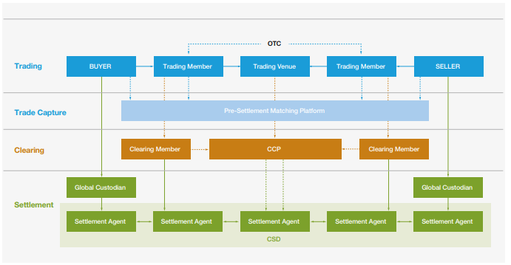

Trading
During the trading process, the two counterparties, whether acting for their own accounts or as brokers or intermediaries on behalf of clients, engage in negotiations to establish a sale/purchase contract. They mutually agree on the precise quantity and price of a security, defining the terms under which the seller and buyer commit to executing the trade.
In scenarios where a trade is being executed in a trading venue, the exchange will issue a notice of execution upon the transaction has been completed. If operating through a broker intermediary acting on behalf of the counterparty, the trading venue will submit this confirmation that the trade has been executed to the broker, who will subsequently send it to its client (buyer/seller).

Trade Capture / Matching
After the order is completed, the buyer/seller will perform the booking and allocation of the trade details, which will be sent to the broker. The broker will then recalculate the trade economics and send them back to the client, who will generate the trade confirmation outlining the key details of the transaction.
In some scenarios, once the trade details have been confirmed, the counterparties (or the broker intermediary) will submit these to a third-party matching platform. This platform acts as an independent service that facilitates the comparison and verification of trade details between the buyer and the seller. If discrepancies are identified during the matching process, the platform notifies the counterparties. The discrepancies may include differences in trade details, such as quantity or price. Counterparties must then work together to resolve these discrepancies and reach a consensus on the accurate trade details..

Clearing
Clearing occurs after the trade has been matched and confirmed by the parties involved. It can occur in a formal manner, either through a central counterparty (CCP) or clearing house, or informally through direct arrangements between the buyer and seller. In the case of CCP clearing, the process involves the CCP acting as the buyer to the seller and the seller to the buyer. This results in the transfer of counterparty risk from the actual trade parties to the CCP.

Settlement
Once the clearing process has concluded, the parties will inform their global custodians of the trades being agreed. If the trade was cleared by a CCP, the clearing house will notify the settlement agent to initiate the actual exchange of securities and funds. This includes instructions for the delivery of securities from the seller to the buyer and the corresponding transfer of cash amounts from the buyer to the seller.
To facilitate a seamless technical collaboration and optimise processing efficiency, custodian banks establish interconnections through Securities Settlement Systems (SSSs), which are typically administered by Central Securities Depositories (CSDs). Each custodian will then transmit the settlement instructions to the SSS, outlining the precise terms received from their respective clients (buyer/seller) who act as counterparts in the trade. The seller's custodian will issue instructions for delivering a specific type and quantity of securities to the buyer's account, while the buyer's custodian will instruct for the payment of a designated cash amount to the seller's account.
For these instructions to be correlated and executed concurrently within the SSS, a specific process known as CSD-matching is essential before settlement can happen. Matching serves as a vital mechanism to accurately select the pair of settlement instructions corresponding to the two trading counterparts in the original trade that requires settlement. To prevent any mismatches in settlement instructions, various additional elements must be specified in each instruction submitted by each custodian, including the trade date, intended settlement date, and the counterparty bank's account details, in addition to information about the securities and cash to be exchanged.
In a Delivery-versus-Payment scenario, if no discrepancies have been raised as a result of the CSD-matching process, the banks of both trading parties will need to coordinate between themselves the simultaneous and reciprocal exchange of securities and cash, as per the terms that have been agreed in the trade.
In the settlement process, there is no differentiation between transactions related with trades executed in a regulated exchange or a trading venue, from those executed through bilateral arrangements (commonly known as 'over-the-counter' trading). Similarly, no distinction exists between transactions linked to trades settled individually on a gross basis and those directed to a central counterparty (CCP) for clearing and netting.
In all cases, there is a transfer of securities from the safekeeping account of the party initiating the transfer to the recipient party, accompanied by the payment of cash from the recipient party's cash account to that of the initiating party. To ensure the seamless and accurate settlement of this diverse range of transactions, precision in settlement instructions is paramount. These instructions must precisely outline the terms governing the reciprocal transfers of securities and cash for each trade.

