Brussels, 13 December 2023

Response to:

https://www.esma.europa.eu/sites/default/files/2023-10/ESMA75-453128700-438_MiCA_Consultation_Paper_2nd_package.pdf

All contributions should be submitted online at www.esma.europa.eu under the heading ‘Your input - Consultations’

The Open Dialogue Foundation (ODF) welcomes the opportunity to participate in this consultation of the European Securities and Markets Authority (ESMA) concerning “Technical Standards specifying certain requirements of Markets in Crypto Assets Regulation (MiCA)”. We believe our comments will help to shape the regulation of the use crypto-assets in line with fundamental human rights not only in the EU, but also, will be reflected in the relevant report and recommendations of the Parliamentary Assembly of the Council of Europe (PACE), Parliamentary Assembly of the Organization for Security and Co-operation Europe (OSCE PA), as well as the Organisation for Economic Co-operation and Development (OECD) and the Financial Action Task Force (FATF).

ODF is a human rights and rule of law watchdog coordinating the efforts of the Building True Change coalition (BTC Coalition) composed of human rights defenders, political activists, Bitcoin entrepreneurs, and industry experts. The BTC Coalition aims to: (1) combat the Anti-Money Laundering / Countering the Financing of Terrorism (AML/CFT) abuse within the wider range of transnational repression mechanisms; (2) promote financial inclusion in non-democratic and developing countries; (3) promote Bitcoin and stablecoins as tools to support human rights efforts and provide humanitarian aid worldwide; and (4) educate on the role of Bitcoin mining as an instrument to facilitate the adoption of renewable energy sources. This Submission has been prepared by Lyudmyla Kozlovska and Bota Jardemalie. The Testimonials included within it are attributed to the individuals as described therein.

Introduction

Combining the extensive experience of the BTC Coalition members, we believe that numerous positive cases demonstrating the positive impact of Bitcoin and Bitcoin mining on society should be taken into account by ESMA and, in general, other regulatory and legislative bodies mentioned above.

As we recognise the need to assess the current regulatory direction by EU institutions, including the European Commission,, European Central Bank, and ESMA, we would like to provide information and highlight the following applications of Bitcoin and Proof-of-Work (PoW):
- instruments against financial exclusion,
- humanitarian aid delivery,
- human rights support,
- protection of the result of elections from fraud and potential misuse of Artificial Intelligence (AI) and disinformation campaigns, and
- facilitation of adoption of renewable energy sources.

In addition, we would like to address the issue of biased comparison between Proof of Stake (PoS) blockchain mechanisms and Proof of Work (PoW) technologies.

We also would like to provide our comments on the issue of the sustainability indicators (as requested in the 3.3.3 Indicators, methodologies and presentation of the information part of the EMSA’s Consultation Paper).

- Bitcoin as a bank of last resort: the role of Bitcoin in supporting civil society amid financial repression and humanitarian crises:

In various authoritarian regimes, financial systems are increasingly being weaponized against dissenters, posing a significant threat to human rights and personal security. Governments in countries like Russia, Turkey, Kazakhstan, Belarus, Venezuela, Afghanistan, and Iran exert control over financial institutions, leading to asset seizures and surveillance of opposition and human rights groups. This situation compels people and opposition movements to turn to alternative means like Bitcoin for financial transactions and support, evading government oversight and safeguarding their assets and personal freedoms.

Voices of civil society: examples of testimonials from around the world:

An extract from the testimonial of Lyudmyla Kozlovska, president of the Open Dialogue Foundation and a human rights defender from Ukraine: “The ODF case is an example of how three authoritarian regimes can join forces to target human rights defenders/dissenters and deprive them the right to have financial services in democratic countries through the abuse of AML/CFT laws as transnational tool for repression. […] Despite the enforced transnational persecution, ODF has managed to operate and raise emergency funds for Ukraine through the use of crypto-assets like Bitcoin and Tether. ODF, as a coordinator and establisher of BTC Coalition, documents abuse of AML/CFT laws and advocates for EU regulators to provide remedies and prevent such practice. At the same time, we support civil society activists using Bitcoin and stablecoins to address financial exclusion, political oppression and the delivery of humanitarian aid.”

An extract from the testimonial of Roya Mahboub, a serial entrepreneur and one of the first female CEOs in her home country, Afghanistan (Afghanistan, currently residing in the US): “Bitcoin allowed the organisation to overcome physical and social obstacles in paying Afghan women. With a simple transaction, Bitcoin could instantly appear in a woman's digital wallet, without interference from men. My team has trained over 17,000 young women in coding, digital skills, and entrepreneurship, and has built dozens of internet classrooms and mobile computer labs across Afghanistan. […]

Since August 2021, bank and wire services like Western Union, MoneyGram have run out of paper currency and have cut off services, leaving one-third of Afghans struggling with food insecurity and 50-70% with unstable housing situations. Websites like GoFundMe have been blocked from fundraising efforts for “compliance” reasons. Bitcoin has provided a crucial financial lifeline for many during these difficult times, who stay in the country and continue working behind closed doors.”
An extract from the testimonial of Jorge Jraissati (Venezuelan, currently residing in Spain), Director of Alumni for Liberty, an international network of young freedom activists with over 10,000 members from 139 countries: “Authoritarian regimes and illiberal governments have been weaponizing the international banking system as a tool for domestic and transnational repression. In response to this development, our activists have turned Bitcoin into their “bank of last resort.” Our organisation has used Bitcoin to finance its activities in over fifty countries, and we currently pay 29 staff members through this cryptocurrency.”

An extract from the testimonial of Anna Chekhovich, financial director of Alexei Navalny’s Anti-Corruption Foundation (FBK) (Russia, currently resides in Lithuania): “The Anti-Corruption Foundation (ACF), founded by Alexei Navalny, has been collecting donations in cryptocurrency since 2016 due to the unsafe nature of collecting only fiat donations, with the Russian banking system being fully controlled by the regime. Since the ACF's recognition as an extremist organisation in 2021, the organisation was forced to leave Russia, and most have moved to EU countries, where they registered legal entities to continue their activities. […] Western banks treat Russians in exile as potential money launderers, and their transactions are often treated as suspicious. This leads to living without bank accounts which is impossible in the modern world. At some point, humanitarian aid was only possible through cryptocurrency, but European banks refused to conduct transactions related to cryptocurrency, making it impossible to buy cryptocurrency directly from the fund's accounts. Paysera payment system closed the organisation's account after attempting to buy BTC.
Now the EU has banned all crypto transactions with Russia within the framework of new sanctions against Russia, making it absolutely impossible for the foundation to financially support activists who are fighting the regime while in Russia.”

A significant example of banks’ de-risking policies relates to the situation with Ukrainian and volunteer initiatives fundraising to provide humanitarian aid to soldiers and refugees. In February 2022, following the Russian attack on Ukraine, the Ukrainian society and the state encountered two critical challenges that the traditional banking system could not adequately address. First, banks and other financial institutions were temporarily paralysed, causing payments from and to Ukraine to be delayed or get stuck "in transit" for several weeks. This was a critical time when life-saving equipment, drones, and other supplies were urgently needed. Second, crowdfunding platforms' accounts and bank accounts of organisations supporting Ukraine financially and through in-kind donations were massively suspended. GoFundMe, Patreon, Wise (formerly TransferWise), and regular banks closed the accounts of numerous organisations around the world, often without explanation or citing internal rules that exclude transactions associated with "armaments, military goods, and services".,

In each of the aforementioned situations, PoW crypto-assets/Bitcoin self-hosted wallets have served as a the only payment and store of value instrument for those who otherwise would have been unable to protect their funds or make money transfers. This has allowed many to keep their savings safe from the hands of corrupt governments, local dictators, and political police. Privacy and ease of use Bitcoin self-hosted wallets have been crucial in making crypto-assets viable tools for civil society, enabling NGOs to continue providing crucial support for financially excluded activists, their families.

Bitcoin’s role in Guatemala’s Digitally Safeguarded Democracy
An Rafael Cordon, a CEO / Co-Founder Simple Proof, a startup that helps institutions uphold information integrity through immutable record-keeping and trustless verification, provides in his testimonials attached hereto: “In Guatemala's 2023 elections, the country's highest electoral authority turned to the Bitcoin Blockchain technology to digitize and secure voting tallies and other key election documents, rendering them tamper-proof and immutable against unauthorized alterations and potential misuse of Artificial Intelligence (AI) and disinformation campaigns. This historic, first-time application played a crucial role in safeguarding the integrity of information in Guatemala's recent elections, especially vital in a post-electoral landscape marked by potential interference and widespread protests.”
Members of the PACE in October 2023 stated: “Following statements by the European Union and the United States in support of the preliminary report of the Organization of American States Electoral Observation Mission, we acknowledge the benefits of employing a public verification module to authenticate official tally sheet images with Bitcoin blockchain technology that increases the certainty of the results published.”
We believe it is a crucial time to address this issue of the use of Bitcoin by civil society and are grateful to Members of the parliaments across not only the European Union, but also the Council of Europe and the OSCE region for considering our recommendations:
- In January 2023, 29 members of the PACE, representing 14 countries, submitted a motion for resolution concerning the misuse of legal cooperation and AML/CFT laws. The motion called to ensure protection against both transnational crime and the protection of privacy and human rights. Notably, this was the first time that European legislators acknowledged the role of crypto assets, such as Bitcoin and stablecoins, as tools for facilitating the work of civil society initiatives and the delivery of humanitarian aid.
- During the June session in 2023, the PACE discussed and adopted a resolution, which stressed the "misuse on politically motivated grounds of interstate legal co-operation mechanisms such as anti-money laundering and anti-terror financing measures may result in violations of the right to a fair trial (…) This may in turn lead to financial exclusion of targeted individuals and NGOs and effectively prevent them from conducting their human rights activities and participating in economic and social life.”
- In July 2023, OSCE PA adopted our amendment to the so-called Vancouver Declaration, which calls its 57 member states to “ensure that Anti-Money Laundering and Countering the Financing of Terrorism (AML/CFT) mechanisms are not used as tools of transnational repression to stifle dissent or target human rights defenders, anti-corruption campaigners, exiled dissidents, and diaspora communities, taking into account the potential unintended consequences of prevention-focused AML/CFT regulations and their side effects, including the potential for increased financial exclusion and further malicious exploitation of strict AML/CFT and related provisions, and further urges them to reflect in relevant regulations the use of crypto-assets, such as bitcoin and stablecoins, to defend human rights and to provide humanitarian aid.”
- In October 2023, members of the PACE submitted a motion for resolution acknowledging the concerns raised by the United Nations Special Rapporteur on counter-terrorism and human rights, Fionnuala Ní Aoláin. She stressed that 69 % of relevant Human Rights Committee recommendations focused on the abuse of counter-terrorism surveillance practices against civil society, as well as the need to define transnational repression and analyse/reflect in the relevant regulation what role bitcoin and stablecoins play in that case.

We hope for an open dialogue between civil society and EU regulators to enhance FATF recommendations and transnational legal cooperation. Such a dialogue will ensure protection against transnational crime while safeguarding privacy and human rights. Furthermore, it should be reflected in relevant regulations how peer-to-peer transactions and Bitcoin self-hosted wallets have become vital tools for human rights activists in illiberal countries.

- Bitcoin mining for facilitation of adoption of renewables
This information should be incorporated in response to Q1: “Do you agree with ESMA’s assessment of the mandate for sustainability disclosures under MiCA?”

In terms of new startup crypto asset projects launched by identifiable teams or individuals, we support the principle that sustainability disclosure should be an integral part of the MiCA Rulebook. However, we find it discriminatory that the Regulation and ESMA's paper focuses solely on alleged negative impact of Bitcoin mining and PoW. This approach overlooks the numerous and diverse positive externalities of bitcoin mining. These include not only reducing greenhouse gas emissions but also the potential for the industry to support the creation of a sustainable electricity grid. These positive externalities specifically discussed by the experts in their testimonials attached hereto.

For example, in the testimonials of cleantech investor Daniel Batten attached hereto, you may see the following data:
- The Bitcoin network now uses a minimum of 52.6% zero-emission energy;
- The Bitcoin network uses +4.49% more zero-emission power each year;
- The inference that the Bitcoin network has coal as a primary power source is incorrect. Instead, the Bitcoin network appears to be one of the few industries that do not have coal as its primary energy source.

Also, PoW crypto-assets (out of which Bitcoin remains the dominant one) have played a significant role serving as an energy buyer of last resort, preventing its waste and facilitating adoption of renewable energy and the overall green transition process (see testimonials of Erik Hersman, the CEO and co-founder of Gridless, a company that harnesses stranded renewable energy to mine bitcoin).

Mark Morton, the managing director and co-founder of Scilling Digital Mining, Ireland’s first and only Bitcoin mining company, argues in his testimonial attached hereto: “[Bitcoin miners are] unfussy & location agnostic energy consumers are facilitating the onboarding of renewable generation in locations where grid capacity delays are hindering renewable buildout, like we are seeing in parts of Portugal. This is particularly useful in parts of Africa, where microgrids are a necessity due to the disjointed nature of their grid system. However, justifying the financial viability of these microgrids can be a difficult task due to the lack of collocated demand. This where companies like Gridless, Kenya and individuals in Virunga National Park, Congo are leveraging Bitcoin mining location agnosticism to improve the financial viability of these systems, and ultimately allow them to come to fruition. Mining can be collocated with the renewable asset to optimise the full energy capacity that cannot be exported. The use of mining as a location and grid agnostic revenue stream can be the potential missing link in renewable projects bypassing grid capacity issues and ultimately making it to market.”

- PoW vs PoS blockchain mechanisms
The European Commission describes Bitcoin mining as “energy wasting mechanism.” Yet, Bitcoin mining is one the most competitive global commodity industries on the planet, and as a result, is forced to constantly innovate and move to areas of the globe where operations are most efficient. There is specific reference in the EU consultation to nation states potentially being forced to cease mining due to potential negative environmental and climate impacts, the evidence provided in the testimonials attached hereto should definitively show that this is not accurate and counterintuitive.

With regard to the social impact, Bitcoin remain by far the most trusted crypto-assets whose strength lies in their actual decentralisation, institutional independence and level of security. When it comes to dealing with human rights causes, funding dissidents and opposition forces in non-democratic countries (as described in the section above on Bitcoin as a bank of last resort), their employment often remains the most effective option. The same cannot be said for PoS crypto-assets which are subject to the control of their creators.

Prioritising PoS over PoW by the regulator may be regarded as arbitrary and discriminatory. In this context, the EC’s tender to develop a methodology and sustainability standards to calculate and mitigate the environmental impact of crypto-assets and their consensus mechanisms, where it targets Bitcoin mining and PoW, stating that “there is evidence that crypto-assets can cause significant harm on the climate and environment and generate negative economic and social externalities, depending on the consensus mechanism used to validate transactions.” The EU asserts that Bitcoin mining “could undermine EU's efforts to achieve its climate and sustainability goals, in line with the Paris Agreement.” We appreciate the efforts made in ESMA’s Consultation Paper. However, based on the expert testimonials we have gathered, we believe there is room for reconsideration of certain approaches that, in our view, could be more effectively aligned with the realities and needs of the industry and civil society.

- Sustainability indicators
The proposed sustainability indicators should take into account the positive social impact played by different blockchain consensus mechanisms, including PoW. These impacts are significant in combating financial exclusion, responding to crises, delivering humanitarian aid, and supporting the oppressed in non-democratic countries and war-torn areas. Additionally, the credibility of the two existing blockchain consensus mechanisms (PoW and PoS), as assessed by their actual use and specific applications, should be studied and applied impartially, avoiding biases potentially arising from lobbying by select interest groups associated with the commercial providers of these technologies. We fully share the views regarding positive sustainability disclosures related to Bitcoin as proposed, as part of this consultation, by the Bitcoin Policy UK.

Table of Content:
- Testimonial of Daniel Batten on evaluating the current and potential future impact of Bitcoin Mining from an environmental standpoint and Annex 1 - BEEST Model: Bitcoin Energy & Emissions Sustainability Tracker
- Testimonial of Erik Hersman on the case study - Energy & Bitcoin in Africa: Weaving a more distributed, resilient global energy tapestry in Africa & beyond
- Testimonial of Mark Morton on Technical Standards specifying certain requirements of Markets in Crypto Assets Regulation (MiCA) – Second Consultation Paper
- Testimonial of Rupert Matthews: Comments to specific questions of the Second Consultation Paper
- Testimonial of Bert de Groot on Bitcoin Brabant - Pioneering Sustainable Solutions in Energy Consumption and Grid Balancing
- Testimonial of Rafael Cordon on Bitcoin’s role in Guatemala’s Digitally Safeguarded Democracy: Bitcoin Simple Proof Solution
- Testimonial of Kristaps Stikuts on Cases of Bitcoin mining in the EU & Africa

Testimonial of Daniel Batten and Annex 1 hereto

My name is Daniel Batten and my background is one of a cleantech investor. From 1996-2007 I was involved, either as an early employee or as a founder, in technology that created disruptive technologies. Since 2004, I have been investing in technology companies, more recently in the climate-tech sector. Over a 10-year period working with New Zealand Govt Agency Kiwinet, I saw and evaluated over 100 technologies and pieces of intellectual property in the climate-tech space. Prior to that, my background was in the environmental movement, where I took part in actions for both Greenpeace Aotearoa and Native Forest Action.

Because Bitcoin is a disruptive technology, and Bitcoin mining like other forms of climate-tech I have seen has both positive and negative environmental externalities, evaluating the current and potential future impact of Bitcoin Mining from an environmental standpoint is a relatively familiar proposition.

Herein, I outline how I arrived at the conclusion that our methods for modelling, collecting data on, reporting on, and evaluating Bitcoin environmental impact have been, as is often the case with emerging technologies, both flawed and skewed negative.

I propose a different rubric for evaluating the environmental impact of emerging technologies, which can be applied to Bitcoin (Mining).

In the paper, there will be a detailed discussion in the following order:
- Setting the scene: a short history of evaluation of the disruptive technology
- Evaluating claims about Bitcoin’s negative externalities
- The positive and negative externalities of Bitcoin
- Acknowledging new data and analysis in 2023
- A rubric for the environmental impact assessment of Bitcoin and other emerging technologies
- Conclusion
- Annex 1: BEEST Model: Bitcoin Energy & Emissions Sustainability Tracker

- Setting the scene: a short history of evaluation of the disruptive technology

It is worth noting that every technology we have invested in is projected to have a significant carbon footprint before they eventually pay off their carbon debt.

When our investment firm was asked to evaluate Bitcoin as a possible form of “climate tech”, I was skeptical. I had heard only negative things about its energy usage and reliance on fossil fuels. However, my memory of the errors the environmental movement so nearly made in its premature evaluation of solar, plus my experience “zooming out” and considering whether a technology could trend net-positive over a longer time horizon caused me to but prejudice to one side and conduct a neutral due diligence as I would any emerging technology, where I evaluated and quantified both negative and positive environmental externalities.

I was surprised to find a lack of robust modeling, complete datasets, and up-to-date datasets on both the anti and pro-bitcoin sides.

Back in 2022, there were many claims that Bitcoin could make solar and wind operators more profitable, but little quantified evidence. Similarly, there were claims that Bitcoin mining could mitigate emissions, but no quantification of the extent to which this was occurring and could occur.

On the other hand, the most widely used model was from the Cambridge Centre for Alternative Finance. Yet, on examination, Cambridge’s model limitations include the exclusion of methane mitigation and off-grid mining.

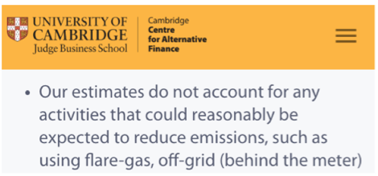

Also, at the time of writing using a mining map which is 23 months out of date (which makes a material difference, because mining was predominantly powered by fossil fuel at that time, with Kazakhstan being a significant player).

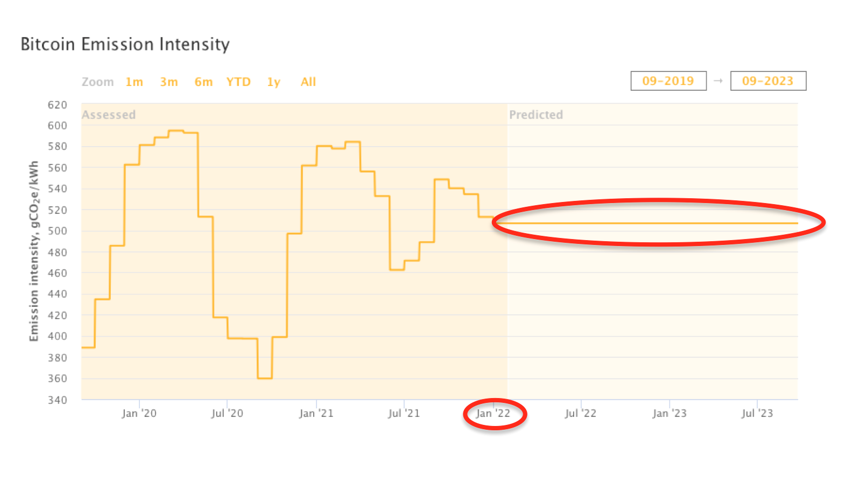
The image above shows how the Cambridge emission intensity calculations has been impacted by lack of new mining map data since Jan 22.

The exclusion of off-grid mining had a particularly large impact on Cambridge model accuracy, because miners choose power providers based predominantly on the cost of power. When miners are “off-grid” they are not constrained to choose the mix of energy the grid happens to use, so will simply choose the cheapest power available. Had they been mining 15 years ago this would have been coal, but today this is almost always renewable.

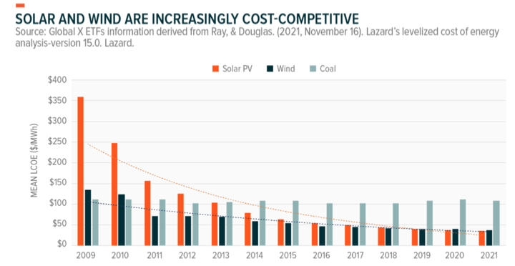

Other researchers began to quantify the impact of Bitcoin on the grid. I turned my attention to developing the first Bitcoin mining model that included:
- Methane mitigation
- An up-to-date mining map
- Off-grid mining.

The methodology for this model is available online and in Section 7 - Annex 1: BEEST Model: Bitcoin Energy & Emissions Sustainability Tracker hereto.

- Evaluating claims about Bitcoin’s negative externalities

2.1 Claim: Bitcoin uses mostly fossil fuel
This was indeed true prior to, and even up to six months after the May 2021 mining ban in China. However, as Bitcoin mining companies moved off the predominantly coal-based sources in China and Kazakhstan, to more sustainable-energy based grids, the power-mix changed considerably. While no model can model Bitcoin mining energy source perfectly due to uncertainty about miner location, there is now very strong evidence that Bitcoin has eclipsed other industries in sustainable energy use and is now mostly sustainable-energy based.
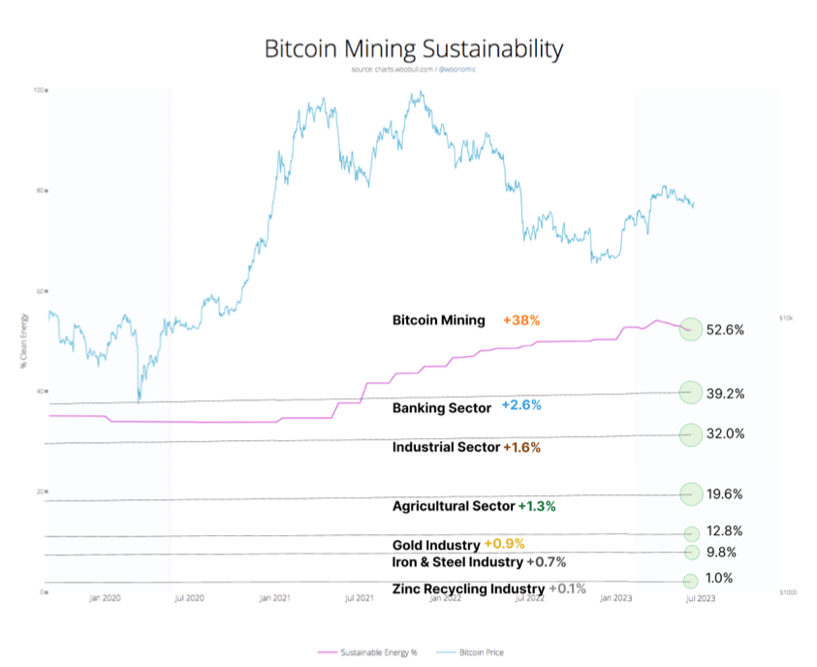
​​

2.2 Claim 2: Bitcoin mining encourages the reopening of mothballed fossil fuel plants

The example of this often used is Greenidge Energy, Lake Senaca. I looked into this claim in some detail, because that would unquestionably be a negative environmental externality were it to be true. I also contacted Greenidge Energy. They claimed that they did not open the facility to do crypto-mining, but to supply energy back to the grid, and it wasn’t until two years afterwards that they started testing a small pilot because it made more economic sense for them to do crypto-mining when wholesale energy prices were low.

Hearing two different stories, I check the original SEC filings. These supported Greenidge’s version of events, that the natural gas facility was not opened to do crypto-mining.

We can see this evolution in the S-1 form with the SEC, which provides a detailed look on when and how the operation grew. Additionally, we can see Greenidge’s initial press release announcing its exploration into bitcoin mining dated March 5, 2020.

2.3 Claim 3: As Bitcoin’s price grows, it will create more and more emissions, and exponentially more energy

Alex De Vries' (Digiconomist) model in 2017 predicted a 25% energy increase per month. This contributed to the World Economic Forum headline "In 2020 Bitcoin will consume more power than the world does today" ~ WEF Dec15, 2017.

I checked the accuracy of this modelling. As we can see below, using the Cambridge model of energy consumption, actual consumption was 67 TWh in 2020, which was 0.03985% of global energy consumption. The estimate was incorrect by a factor of 2509x (or 250,900% overestimated).
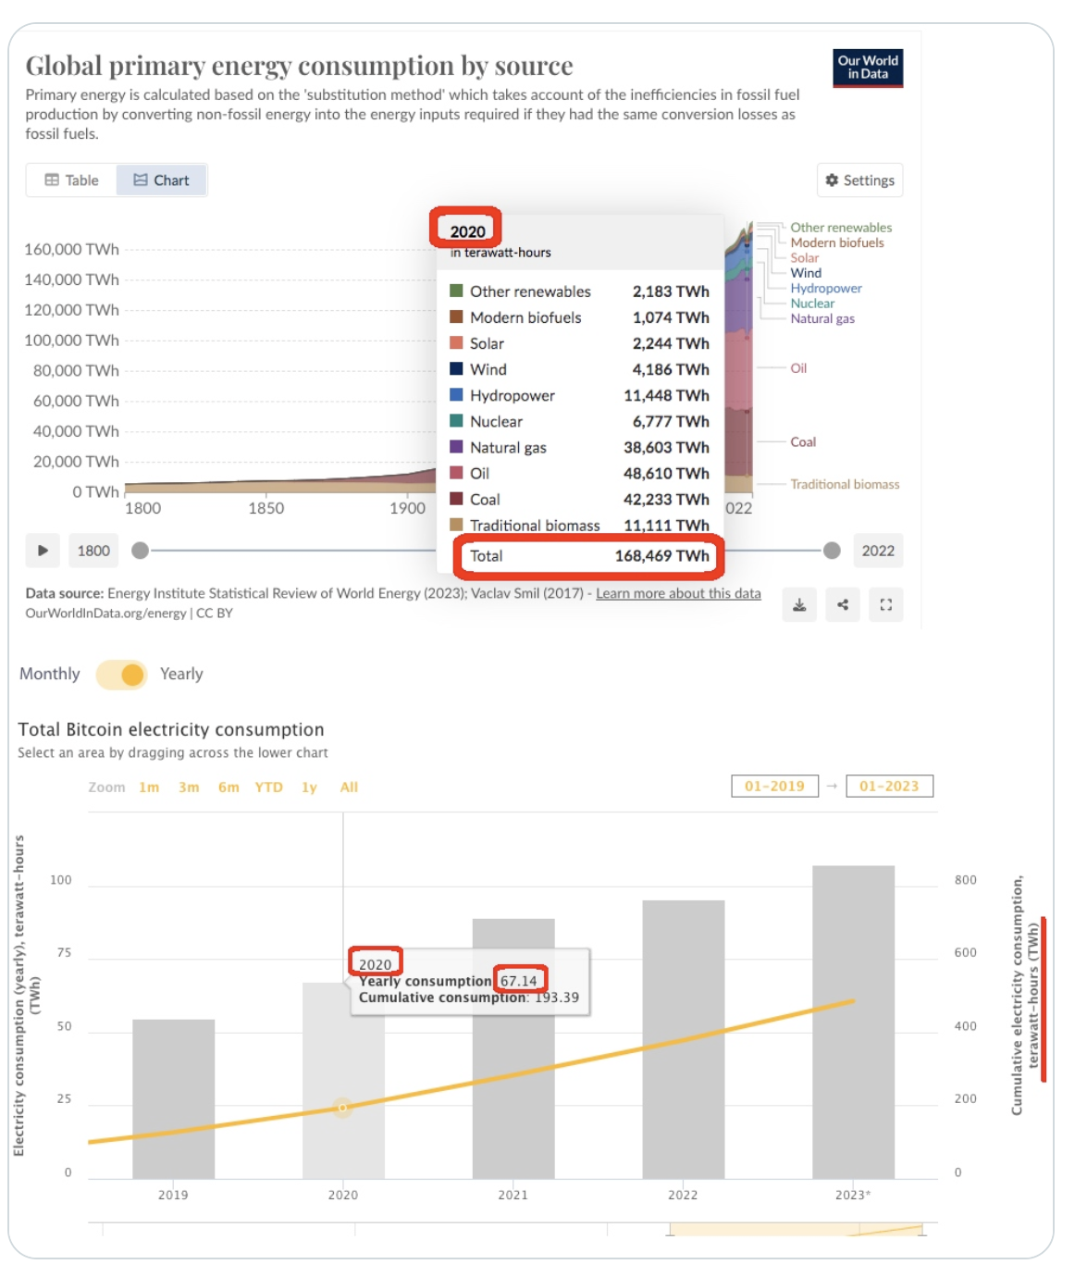

I will not go into why the modelling was inaccurate to this degree other than to say that this is all-too-common. Predictions about the Internet’s use of energy in the late-90s were similarly inaccurate, and a well-known Forbes article predicted that the Internet would require the firing up of many mothballed and new coal plants to keep it running.

By contrast, a conference paper by Hass McCook predicted that:

- Bitcoin mining emissions have likely peaked, and
- Bitcoin will improve sustainable energy mix faster than other industries.

Summary of Paper:

1. Bitcoin is a non-rival energy user

The characteristic that waste, stranded and curtailed energy sources share, is that they would all remain wasted, stranded and curtailed if there were no electrical loads as dynamic and flexible as Bitcoin.

These are non-rival energy sources, meaning that Bitcoin miners are not competing with other customers to obtain this power.

2. Bitcoin uses cleaner energy than world and US average

Whilst Bitcoin does use a large amount of energy, it was shown that the use is … far cleaner than the world or US average on a per unit of energy basis.

3. Carbon Intensity and Emissions

As Bitcoin generally relies upon "the grid", general decarbonisation efforts will positively improve Bitcoin's carbon intensity profile. However, due to the economic incentives on offer for mining with wasted and stranded energy and acting as a controllable load resource, Bitcoin should improve at a far faster pace than the world grid.

Due to continual improvement in mining equipment efficiency and the Chinese migration, it is likely chat Bitcoin's emissions have already peaked.

For emissions to return to pre-China migration levels, energy expenditure would need to grow three-fold, and one would need to accept a demonstrably false assumption that there will never be any further efficiency gains in mining hardware.

Earlier this year, I used the BEEST model to quantify whether there was evidence to support the thesis that Bitcoin emissions would continue to rise as price rose, or whether as Hass McCook claimed emissions had likely peaked.

The data over the last four years (a full “cycle” in Bitcoin) suggests that McCook’s conclusions are likely correct: Bitcoin’s emissions have not increased over this period. The likely catalysts for this are improvements in machine efficiency, migration to more sustainable energy sources and the use of power source which have a net-emission decreasing impact on the network (use of previously flared or vented gas).

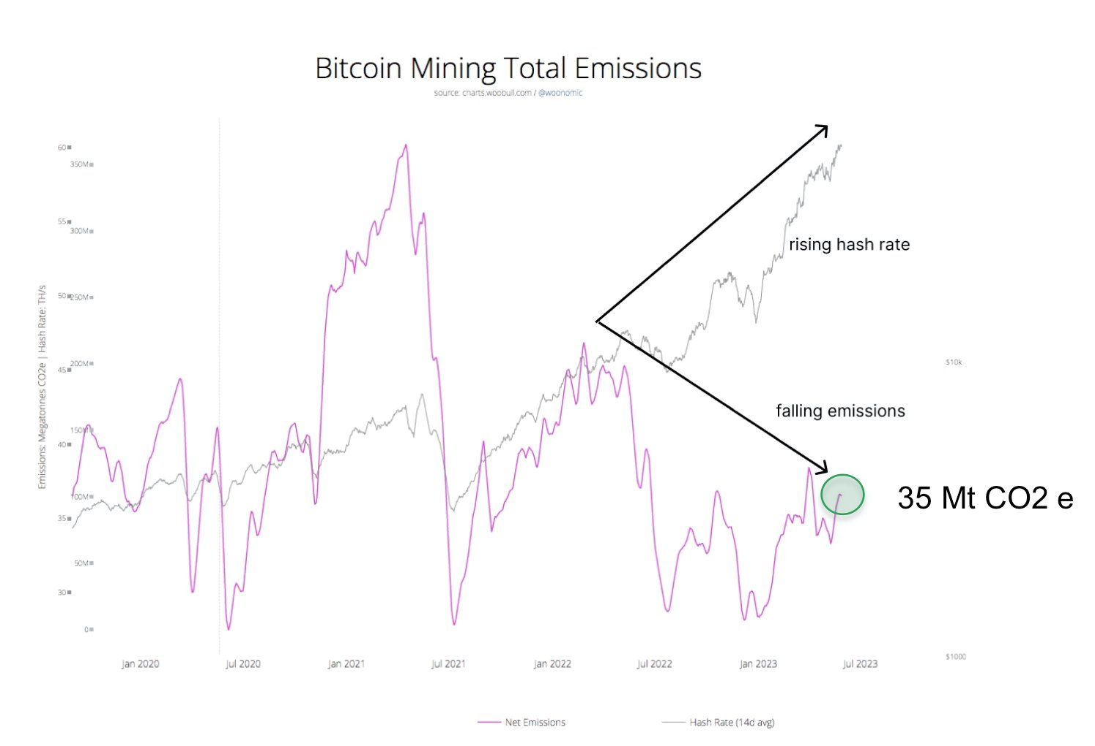

2.4 Claim 4. Bitcoin uses a high amount of resources “per transaction”

Examining the parlance of the blockchain, I was immediately struck by a curious fact: the word “transaction” has a completely different meaning than it does in a traditional finance system.

In the blockchain world, a transaction can bundle many thousand payments on the blockchain itself (analogous to a wire-of-fund payment), and even up to tens of billions of payments using so-called “Layer2” technologies such as the Lighting network (analogous to a visa transaction).

So, the use of a “per transaction” metric is highly misleading to a population not familiar with the non-trivial semantic difference.

There is a second issue with this metric however: Bitcoin energy use does not in fact come from its transactions. That means the number of transactions could be substantially higher, with little or no difference to Bitcoin energy usage. A scientist would say “all you have done is divide one independent variable by another, thereby creating the false impression that as one rises - so will the other.”

To give an illustration of how this effect works:

Fact: New Zealand has a GDP of USD 250Billion and 25Million sheep.
True, but misleading conclusion: New Zealand earns $10,000 GDP per sheep.
False Inference: Therefore, New Zealand had 4 times the number of sheep, it would reach GDP of UDS1 Trillion.

Similarly, the inference is false, because the two variable (GDP and number of sheep) are largely uncorrelated - just as are “number of transactions” and “energy use” in Bitcoin mining.

2.5 Claim 5: “Attempts by the Bitcoin mining industry to demonstrate positive environmental externalities are greenwash”

This claim resurfaced recently in an opinion piece in The Hill, which was countered the following month by Marathon Digital Holdings’s work.

The tenor of the argument was “KPMG has a crypto-assets division therefore they have a vested interest in claiming that Bitcoin has a positive ESG profile. Therefore, their report is greenwash”.

While we are right to look at conflict of interest as part of evaluating a position on Bitcoin, it is an ad hominem argument to dismiss the reasoning of another party by reference to who they are, rather than the merits of their argument.

Proponents of Bitcoin also use ad hominem arguments, stating “Alex de Vries is the paid employee of the Dutch Central Bank, and Bitcoin threatens to disintermediate Central Banks, therefore his arguments should be disregarded.”

Both are poor arguments. We must treat the arguments of each on their merits.

To create intellectually honest debate, we should either exclude all arguments from possible vested interests or allow all for prudent evaluation.
It has been my observation that there has been considerable skew both in the media, and in the way nation states have conducted their evaluation of Bitcoin.

For example, a peer-reviewed Cornell Study on the positive environmental externalities of Bitcoin, published by an award-winning scientist, was picked up by a single large mainstream newspaper. Whereas a commentary that does not appear to have been peer reviewed on the negative externalities on Bitcoin, written by Alex de Vries, a PhD candidate, was the following week picked up by ten news agencies.

The fact that one was written by a student, the other by a decorated scientist does not mean that one was “better quality”. Nor should de Vries’, or anyone’s, analysis on Bitcoin be rejected simply because it has not been peer-reviewed. However, the extent to which one article was reported and the other was not suggests that Bitcoin mining, along with other disruptive technologies, may not historically have enjoyed fair and equal reporting of both its positive and negative externalities during its nascent years.

Further, a 2022 WOSTP report on Bitcoin mining had as its most cited source de Vries/Digiconomist, but no obvious source material from those inside the Bitcoin mining industry. This is a clear and obvious asymmetry. Again, either both vested interests should be equally appraised, or both should be discounted.

As to the argument that those within the industry cannot be trusted because of their vested interest in the success of Bitcoin, this is grounds for being cautious to cross-validate claims and ask for robust supporting data, not grounds to shut them out.

We could just as well claim that we should not trust the professional opinion of a doctor, because they have a vested economic interest in making prescriptions; we should instead consult physiotherapists. After all, they understand the human body too. We could claim that we should eschew the professional advice of dentists, because they have a vested economic interest in diagnosing the need for dental work; we should instead consult osteopaths. Afterall, the tooth is just a bone, and they understand bones too.

Similarly, it has been my observation that we have been too quick to use the same “vested interest” logic to ignore the professional viewpoint that the Bitcoin mining industry has about Bitcoin mining. Are not those who are native to the Bitcoin mining sector the very domain experts we need to consult in order to understand the utility and nuances of a technology?

Have we not already seen ample evidence of what goes horribly wrong where we do not consult the industry in making predictions? Clearly, many people still do not have a basic understanding of (as illustrated by a BBC article which recently erroneously used the word “payment” in its headline about Bitcoin, when it should have said “transaction”).

As part of my evaluation of Bitcoin, I consulted with environmentalists and read the reports of Sierra Club, Greenpeace USA and the Environmental Working Group. But I also talked to grid operators, battery engineers, Bitcoin mining experts, renewable operators, Utility companies and those with a 20-year history in methane mitigation before arriving at an overall assessment of Bitcoin.

This is the recommendation I would make to any government body before arriving at a methodology for the evaluation of Bitcoin mining.

- The positive and negative externalities of Bitcoin

Any evaluation of a disruptive technology must include both positive and negative externalities, and those administering the methodology must take all reasonable measures to ensure that a complete set of positive and negative externalities are evaluated. Otherwise, a methodology is, by definition, not objective.

An accountant would be fired for declaring a business was “in bad shape” if they investigated 100% of that business’ expense ledger, but between 0-10% of its revenue ledger.

Similarly, our evaluation of Bitcoin mining must look equally, fairly, and completely at both the negative and positive externalities of Bitcoin mining.

Whatever public opinion is on Bitcoin mining is irrelevant, and no more grounds for a skewed evaluation than the public opinion on a murder witness is grounds for a trial with no defence attorney present, and where the presupposition is that the witness is “guilty until proven innocent.”

This is particularly true when there is evidence that public opinion may itself have been skewed by both uneven reporting (Cornell study vs de Vries commentary), and highly inaccurate reporting (ie: Bitcoin energy usage in 2020) over many years.

These are the positive and negative externalities we found when evaluating Bitcoin. While there are more positive externalities, this does not mean Bitcoin mining is net positive. It may merely mean that there are more positive benefits, but they are not significant enough to counteract the smaller number of negative externalities. However, neither this nor its opposite can be assumed, and robust investigation of each is required.

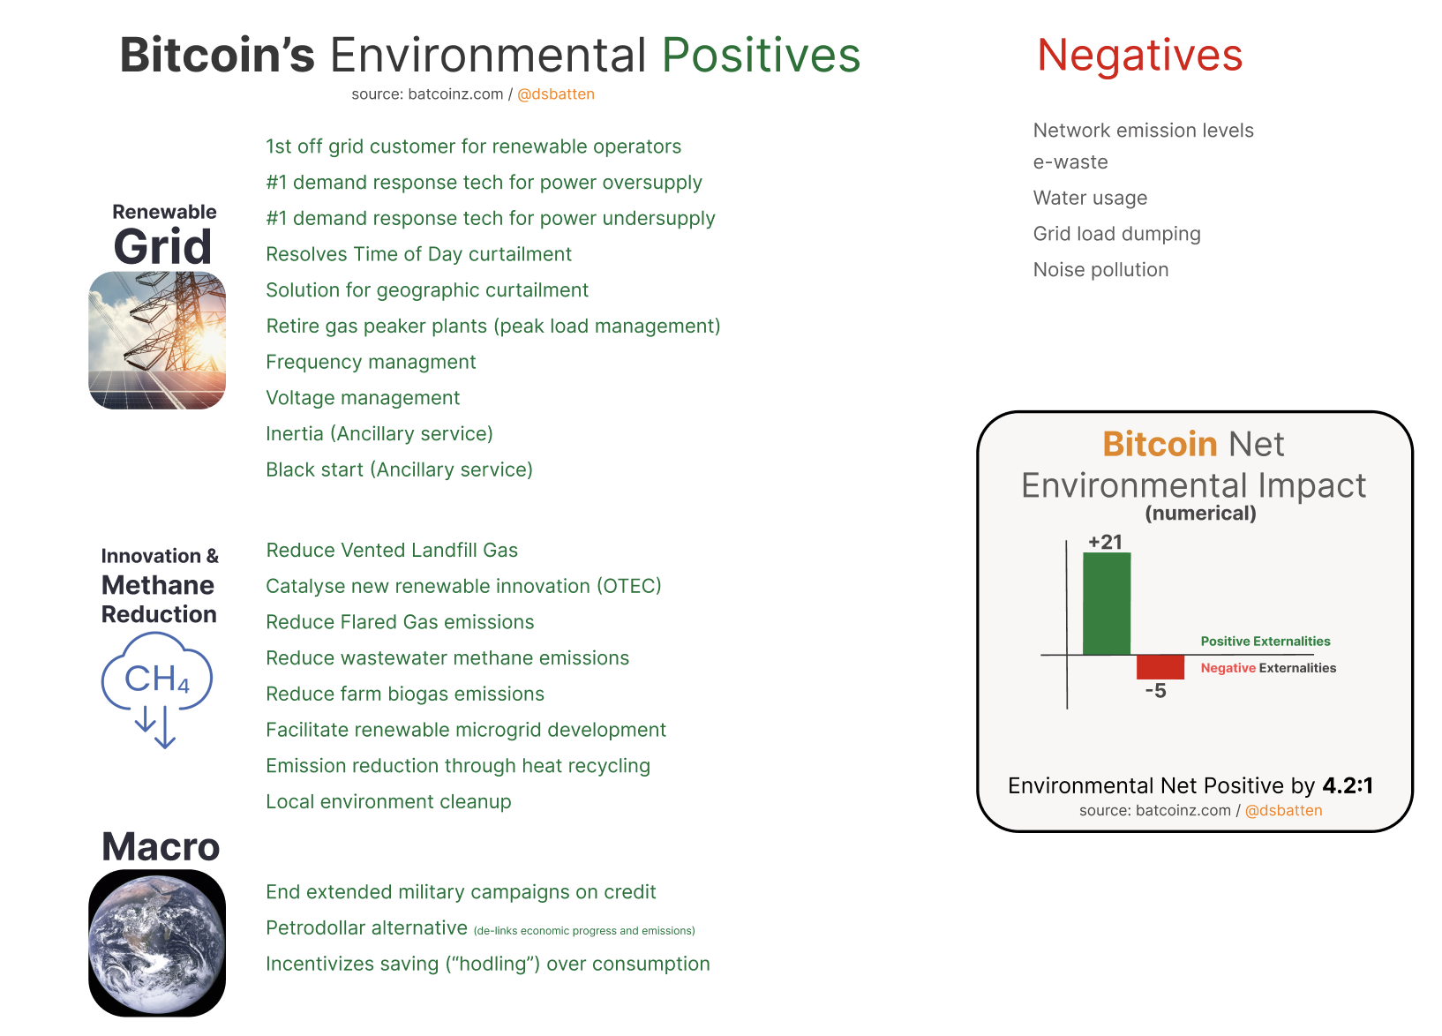

In investigating each of the externalities, it is vitally important to consider not only current impact, but potential future impact, lest we be guilty of “premature evaluation”.

It is worth recalling at this point that every established climatetech proposition from solar to wind had a significant negative environmental impact before it became net positive. Similarly, every emerging technology from direct air capture to biochar still has a large negative environmental impact, but we continue to believe in these technologies because there is sufficient evidence that within 20 years we can turn the net negative into a net positive.

- Acknowledging new data and analysis in 2023

Just as new evidence may lead to a new verdict, there is a substantial weight of new evidence that has emerged during 2023 as to Bitcoin’s potential positive environmental externalities.
This evidence includes but is not limited to:
1. Peer reviewed research and working papers (MIT) including a Cornell University Study which suggested that Bitcoin mining could support the renewable transition and climate action (27 Oct).
2. More balanced reporting of Bitcoin ESG impact, including the first pro-ESG Bitcoin mainstream news coverage in a major UK newspaper, and a4:1 ratio of positive:negative environmental reporting in non-Bitcoin press in Q1, 2023.
3. Cambridge acknowledges Bitcoin energy overestimation and states that emission calculations are still “likely overstated” (30 Aug).
4. Bloomberg Intelligence charts show Bitcoin mining is 53% sustainable, that emission intensity is dropping, and emissions are not rising (14 Sept).
5. Independent Consultancy Firms Institute of Risk Management and KPMG documenting how Bitcoin supports the ESG imperative (1 Aug).
However, there is another largely undocumented story about Bitcoin mining that has the potential to eclipse all other positive externalities: methane mitigation.
Methane is 84x as warming as CO2 over a 20-year period, and much of COP28 was dedicated to finding solutions to how to urgently reduce methane emissions.

This is an area where Bitcoin mining could play a major role. While there are many technologies that can do methane mitigation, few of them are ready today, and even fewer of them are able to mitigate methane profitably.

By contrast, Bitcoin mining has the unique ability to profitably mitigate methane in remote locations such as landfills and oilwells where methane mitigation could not otherwise occur. Our own climatetech fund has pivoted its entire focus to supporting landfill-gas powered Bitcoin mining for this reason.

We did not intend to create a Bitcoin mining fund, rather we asked “How can we maximize the amount of emissions mitigated per dollar invested?”. The result of our analysis was that Bitcoin mining powered by vented landfill gas was the answer.

The 2022 WOSTP report on crypto-mining has also acknowledged the potential for this sort of Bitcoin mining on the climate.

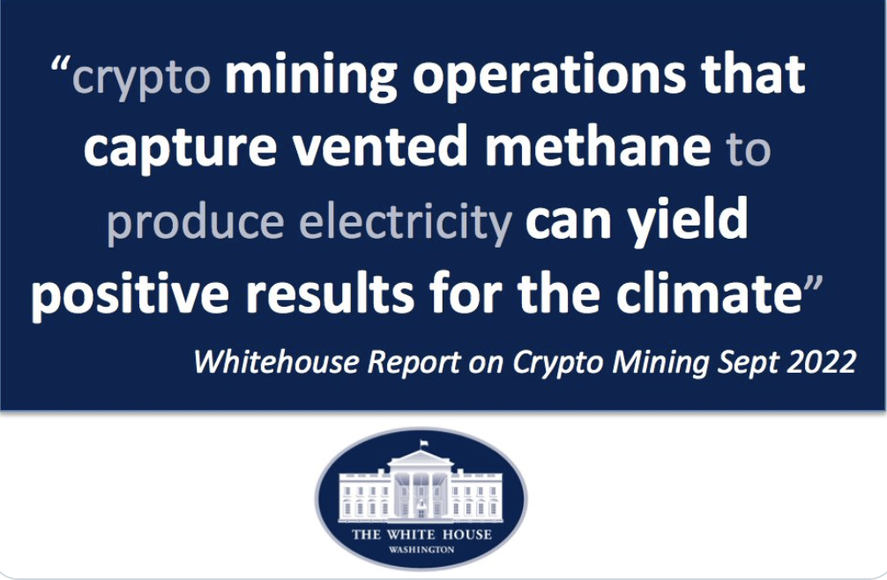

What is encouraging is that this is not a theoretical “one day” possibility. There is a significant amount of methane mitigation occurring today. An early attempt I made to quantify this suggests that 6% of Bitcoin network emissions is now offset through methane mitigation (see “Quantifying the Emission Negative Component of the Bitcoin Network”).

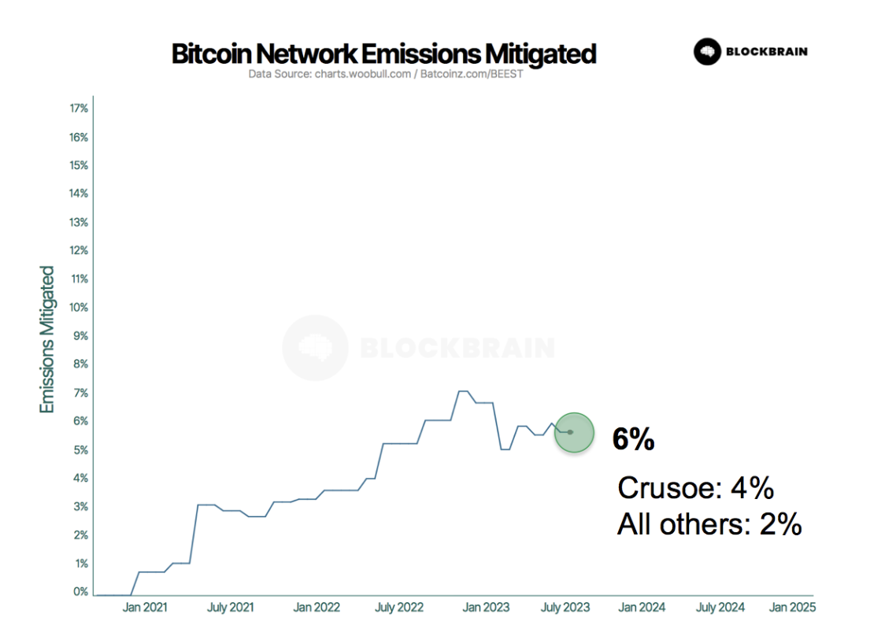
Source: Quantifying the Emission Negative Component of the Bitcoin Network

To my knowledge, Bitcoin mining is both the only industry to have achieved this degree of emission reduction through methane mitigation, and the only industry in the world I am aware of that has the potential to fully offset its emissions without the purchase of offsets.

In Q4, 2023 I was alerted to a number of other Bitcoin mining companies who were using previously vented or flared methane as their power source. I am still quantifying and verifying the data, so have excluded these new companies from my reporting, although initial indications are that the true level of methane mitigation could be 7.5% or even higher.

- A rubric for the environmental impact assessment of Bitcoin and other emerging technologies
An objective question-set for evaluating environmental impact of a new technology should look like this:
5.1. What are the technology’s negative environmental externalities?
- Has this impact been quantified in an objective way that compares it to the impact of existing technologies?
- How do we know that the methodologies and data underlying the models are accurate?
- Do we have an exhaustive list of these negative externalities?
- Are the metrics used to evaluate and measure fit-for-purpose, clear, free from risk of misinterpretation and appropriate to that technology?
5.2. What are its positive environmental externalities?
- Has this impact been quantified in an objective way that compares it to the impact of existing technologies?
- How do we know that the methodologies and data underlying the models are accurate?
- Do we have an exhaustive list of these negative externalities?
- Are the metrics used to evaluate and measure fit-for-purpose, clear, free from risk of misinterpretation and appropriate to that technology?
5.3. Challenge assumption: ask “Could apparent negative externalities have a positive application?”
For example, high energy use is an apparent negative, however could this energy use be able to provide flexibility to the grid that allows grid operators to counterbalance the intermittency of renewable energy? Is this energy use rival or non-rival? Is this energy trending renewable or non-renewable? Can this energy be a stranded or otherwise wasted energy source? Most importantly, could this energy be fueled by emission-negative sources such as vented methane or flared methane, which have a direct emission-reducing impact?
5.4. What is the technology’s likely environmental trajectory?
This is the part of the rubric that guards against the possibility of the type of “premature evaluation” that could have resulted in solar energy being labeled “bad for the environment” in the 1990s due to its high energy use and emission footprint from the coal furnaces required to melt silicon.
- Have we modeled what is likely to happen to emissions and energy use under a range of future scenarios?
- If the technology has the ability to reduce emissions (ie: solar), have we also evaluated its potential to reduce emissions, so we are evaluating net emissions?
- Are there additional negative environmental consequences of this technology that could arise in the future? (Can these be quantified?)
- Are there additional positive environmental uses of this technology that could arise in the future? (Can these and have these been quantified?)
5.5. What is the current utility of the technology?
There are many technologies (such as the Internet) which have a considerable carbon footprint, and are unlikely to ever mitigate it, however we justify our use of this technology by saying “It’s worth it because of the social utility it provides”.
While it is preferable for a technology to earn its rite of passage based purely on environmental net benefit, in assessing environmental impact of an emerging technology, it is still necessary to research the current and future potential utility, otherwise there is a risk that in lieu of information, one may assume a technology to be “useless” or “wasteful”. These sorts of adjectives have often accompanied Bitcoin, however there is little data to support these indictments, and a large and increasing body of data to support the thesis that Bitcoin provides life-enhancing value to millions of people, particularly in the Global South.
- Conclusion
Like every disruptive technology, Bitcoin is in the middle of a rite of passage where the majority of people is still asking “what is it?”, “is it good or bad?”, and “will it have terrible effects on humanity?” While we should ask these questions, we should not ask these questions in lieu of investigating the potential positive impacts of a disruptive technology with equal rigor. We should also make sure that our efforts to understand include talking to people who have a high level of domain expertise in Bitcoin mining.
We propose a methodology for evaluating Bitcoin that is objective, comprehensive, fair, and which would pass the “would this methodology have prematurely labeled the photovoltaic industry as harmful to the environment” test.
There is an increasing weight of evidence that many of the claims, including all of the five most common claims, leveled against Bitcoin’s negative environmental impact have been based on incomplete data. There is evidence that Bitcoin mining has also been both historically misrepresented by inaccurate forward projections of energy use, and had alleged environmental harm amplified by negatively-skewed reporting.
2023 has also been the year when high quality independent research has emerged which quantifies the potentially positive environmental externalities of Bitcoin.
We call on the EC to adopt an evaluation methodology that takes into account these factors and both fairly and objectively measures Bitcoin’s environmental impact, positive and negative.

Annex 1 to Testimonial of Daniel Batten:
BEEST: BITCOIN ENERGY & EMISSIONS SUSTAINABILITY TRACKER

Introduction:
We are at an inflection point in Bitcoin mining history. Policy decisions made now will have far-reaching consequences. So, it is more important than ever that these decisions are based on robust, complete, and up-to-date data.
The Bitcoin Mining Council (BMC) reports that the Bitcoin network uses 59.4% zero-emission* power sources. In contrast, the Cambridge Centre for Alternative Finance (CCAF) report arrives at a much lower figure of 37.6%.
Because of the significant variance, many have assumed that CCAF, an independent academic institute, must have the correct figure, whereas the BMC, an industry body, needs to be corrected.
This has resulted in the BMC data being primarily overlooked in mainstream media.
This approach, however, needs to be more scientific. We cannot believe that the CCAF study is more accurate simply because it is an independent institute. An academic institute may have a more robust methodology but still arrive at an inaccurate answer due to a lack of proximity to the industry or the exclusion of a type of data they do not have ready access.
Similarly, we cannot assume that an industry body will necessarily skew or bias data simply because it is an industry body. An industry’s professional standards may prevent this, or the data may be sufficiently positive that there is no need.
Because of the wide variance, and the importance of having robust data for a diverse group of people, we saw the need for a third study that measured both on-grid mining, but also off-grid mining (which the CCAF has disclosed do not include in their model).
“Our estimates do not account for any activities that could reasonably be expected to reduce emissions, such as using flare-gas, off-grid (behind the meter) Bitcoin mining”.
Specifically, regulators and policymakers must know the following:
– Bitcoin mining’s overall % of zero-emission* energy sources
– Whether Bitcoin is trending to more zero-emission power
– Whether the Bitcoin network’s predominant energy source is coal as has been claimed in one study
Equally, it’s important for ESG investors, as it governs their investment decisions. It’s also important for environmental organizations to make robust decisions about which industries to lobby and pressure for change and how.
We designed our model to answer each of these three questions.
We’ll update this dynamic document as new data becomes available.

Findings:
We found that limitations in the CCAF model result in under-reporting the zero-emission energy used by the Bitcoin network by 15.5%
(CCAF model: 37.1% vs. CCAF Model + data omitted by CCAF Model: 52.6%)
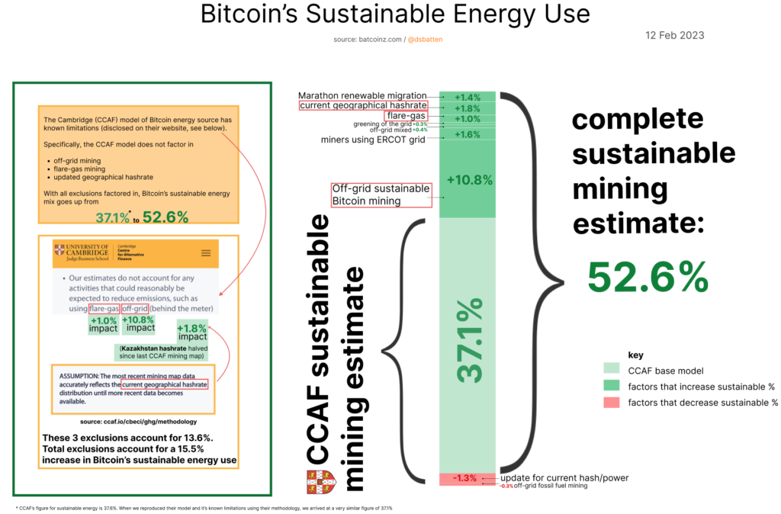
TL; DR – read the infographic below.
CCAF model limitations:
“These limitations are known to and acknowledged by CCAF. “Our estimates do not account for any activities that could reasonably be expected to reduce emissions, such as using flare-gas, off-grid (behind the meter) Bitcoin mining, waste heat recovery or carbon offsetting… we are working to incorporate these factors into future versions of the CBECI”. Source.
CCAF further acknowledges: “While most limitations do not have a major impact on the model’s performance, we are aware of its imperfections”. This is also true – as we can see above. Most limitations only increase the sustainable energy mix calculation by 0.31%-1.72%. The one exception is off-grid sustainable mining, which accounts singlehandedly for a 10.8% underreporting.
Further, the combined impact of excluding other factors (listed in the graph above) results in a 4.63% under-reporting of sustainable energy use, which is significant.
Key Findings of our study:
– The Bitcoin network now uses a minimum of 52.6% zero-emission energy
– The Bitcoin network uses +4.49% more zero-emission power each year
– The inference that the Bitcoin network has coal as a primary power source is incorrect. Instead, the Bitcoin network appears to be one of the few industries that do not have coal as its primary energy source
Our overall zero-emission energy figure is 7.2% lower than the BMC data for reasons we will investigate in the body of the report; however, it is significantly higher than the September 2022 CCAF report, which found that:
– The Bitcoin network used 37.6% zero-emission energy sources
– This had decreased slightly since before the China-Ban
– The primary power source for the bitcoin network was coal
Source of variance with CCAF:
As stated, the CCAF report does not include either off-grid mining or flared-gas mining. We had already quantified the flared-gas percentage of the Bitcoin network to be relatively minor (1.3%).
However, we hypothesized that the off-grid proportion of the Bitcoin network was significant and highly skewed to renewable energy. This thesis proved to be correct and is summarized in the diagram below.
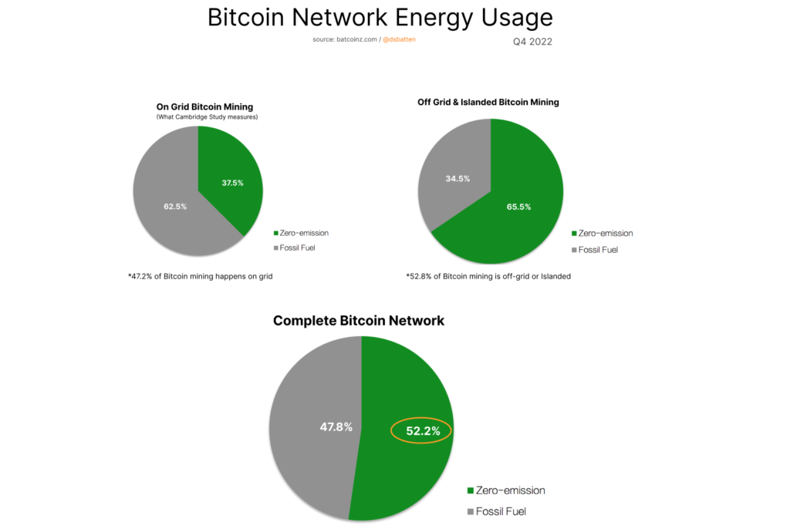
The diagram above uses data from Q4, 2022. As of 1 Feb, 2022 the current Zero-emission power percentage has increased to 52.6%
Using the CCAF methodology, we were able to almost precisely replicate their zero-emission calculation (37.08% vs the CCAF figure of 37.6%) We then step-added both off-grid and flared gas mining operations that we had verified the accuracy of (see methodology). The resulting model reflected a new and (relatively) complete view of the Bitcoin network.
CCAF has it on their agenda to add these components in. Currently, they are working on building a model for another form of alternative finance currently. Their update is therefore unlikely to be ready until the latter part of 2023.
Until their model is updated to factor in off-grid and flared-gas mining, we offer this model as a more complete and up-to-date view of the Bitcoin network.
Coal Based Electricity?
In making statement such as “this technology uses predominantly coal” it is important to also make it clear that any technology using grid electricity for power in locations around the world will also “use predominantly coal”
This reflects the underlying way that today’s electrical grid generates its power.
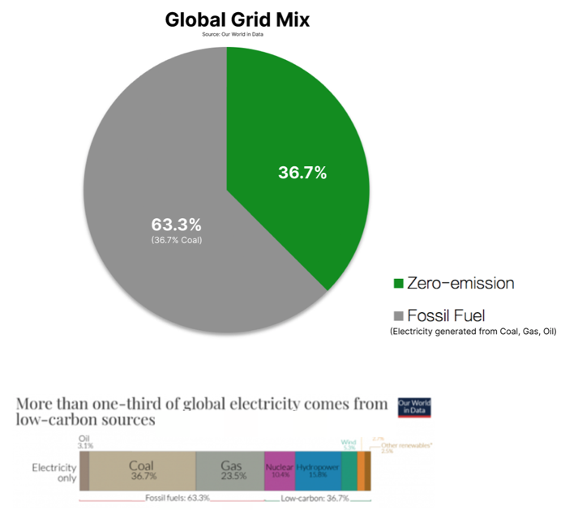
What is interesting about the global grid-mix to us is that the zero-emission percentage (36.7%) closely matches both our calculation for the on-grid portion of the Bitcoin mining network (37.5%) and CCAF’s (37.6%).
This is important, because some critics have in the past claimed that Bitcoin uses grids that tend to be more coal-based. Both our data, and CCAF data, does not support this hypothesis.
This shows the importance at looking at full data sets rather than cherry-picking isolated examples; a method which is not only statistically invalid, but also which risks supporting the confirmation bias of the person doing the picking.
Due to its mobility, Bitcoin mining is one of a rare few industries that can base most of its power usage off-grid. For this reason it would appear that contrary to the findings of the CCAF report, Bitcoin mining is one of the very few industries that does not have coal as its major power source.
Detailed Breakdown of major factors impacting CCAF model accuracy:
By far the most important factor is off-grid sustainable mining, so let’s start there, and work down the list.
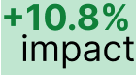
- Off-grid sustainable mining
On the actual percentage of sustainable energy usage of the Bitcoin network. In other words, this factor by itself lifts the sustainable energy calculation from 37.1% to 47.9%.
The single largest factor in the variance is the inclusion of off-grid zero-emission mining. The Mining companies represented below represent 14.28% of all hashpower.
The Cambridge model bases their renewable energy use on the grid they reside in (typically around 30-40% throughout the world, unless located in a majority renewable grid such as Norway or Canada). However, the average zero-emission energy use of these mining organisations is the considerably higher figure of 96.96%.
Together with off-grid hydro-powered zero-emission mining operations in China, the impact of adding these 31 mining groups (listed below) into our model is a 10.8% rise in the amount of zero-emission energy used by the Bitcoin network.
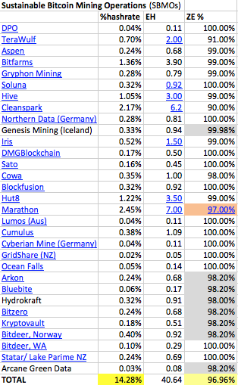
EH = Exohash. ZE: Zero Emission Energy Sources
There are a further 10 sustainable mining companies using flared methane (emission negative) as a power source, covered in 5. below. This means that collectively there are 41 sustainable-energy based mining operations.
- Kazakhstan Exodus
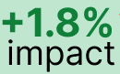
Under the Predicted Interval section, CCAF disclose that their model uses hash rate data from the latest Bitcoin mining map (last updated in Jan 2022, prior to the Kazakhstan mining exodus and when Kazakhstan represented 13.2% of global hashrate).
In most cases the use of a 13-month old mining map does not significantly influence on model accuracy. The one exception is Kazakhstan because
a. Kazakhstan has a heavily fossil-fuel based grid
b. There is strong evidence that significant, quantifiable hashrate has migrated from Kazakhstan since Jan 2022
The impact of these points are expounded upon in detail in my 25 Jan 2023 Bitcoin Magazine article.
- CCAF model significantly underestimates the amount of Bitcoin mining happening off the ERCOT grid
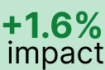
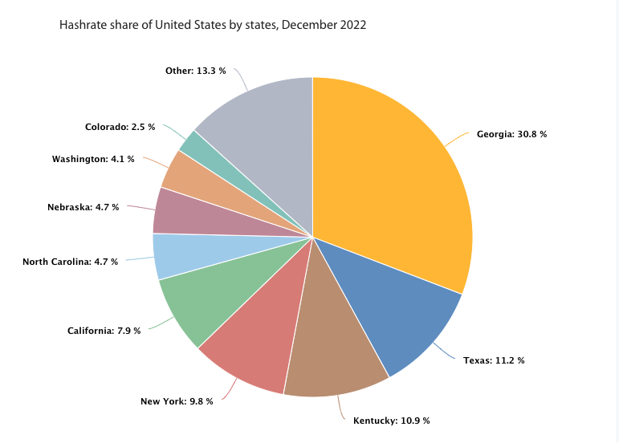
How we know: CCAF deduce the above pie chart on their mining map. As we can see, Texas (ERCOT) is under-represented. The reason for the under-representation on CCAF’s part is that their mining map dataset for the US only includes Foundry Pool and many large Texas Bitcoin Miners do not use that pool. In other words, the dataset is incomplete.
Our own bottom-up calculation of ERCOT-based mining hashrate tells us that these miners represent 20.81% of global hashrate (see below) and 56.22% of all US hashrate.
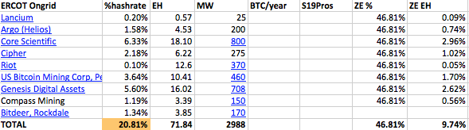
This under-representation of ERCOT matters because ERCOT has a meaningfully higher clean-energy percentage than the National Grid (46.8% for Texas vs 40.3% for US).
- Marathon Renewable Migration
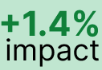
In January 2023, Marathon confirmed they had completed the migration of their 100MW Hardin, Montana Coal-powered data-centre to a wind-powered operation in West Texas and completed other renewable migration projects. I was in touch with the executive team at Marathon who confirmed that they use ERCOT power when there as backup.
- Use of Flare gas
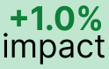
I covered this in some details in previous research, where we found that there are 9 mining operations using flare-gas (down from 10 due to the acquisition of GAI by Crusoe Energy). These 10 operations collectively account for 168 MW of sustainable (and also carbon negative) energy.
- Off-grid mixed
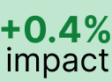
This category refers to off-grid, or partially off-grid mining organizations using a mixture of fossil-fuel and sustainable energy sources. Because these mining organizations have an overall sustainable energy usage of only 51.9%, the extent to which they increase the overall percentage of sustainable energy above the CCAF estimate is small.
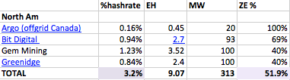
For classification purposes: Argo Canada is on the list of off-grid mixed rather than off-grid renewable because of mixed off-grid users because they have another site (Helios) on the ERCOT grid in Texas.
- Greening of the Grid
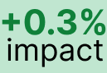
Our World in Data calculates the amount of energy sourced from each energy type, for each year, both by jurisdiction and globally. From there we can calculate a 5-year rolling average of how fast the global grid is moving towards sustainable energy.
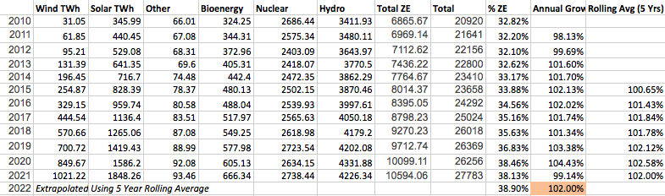
Source: Our World in Data based on BP Statistical Review of World Energy (2022); Ember’s Global and European Electricity Reviews (2022). Annual Growth and Rolling Avg Calculations mine.
It turns out that the global grid has 2% more sustainable energy on it every year. This would have been higher, but for the impact of COVID in 2021. This data allows us to get a more accurate, up-to-the-minute estimate of any technology’s sustainable-energy mix which uses the grid.
- Off-grid Fossil Fuel
The CCAF report also does not factor in off-grid mining operations that are using exclusively or almost exclusively fossil-fuel sources. There is currently only one mining operation in this category, which has a small net-negative impact on the sustainable energy profile of the Bitcoin network.
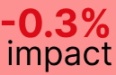
- Update for current hash/power
Since the CCAF study was taken, both hashrate (Glassnode: 1 hour chart, 168hr SMA) and the Energy Consumption (Cambridge Bitcoin Energy Consumption Index) have increased. This has had a non-trivial downward impact on the overall sustainable energy mix.
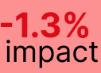
Why is this figure lower than BMC ‘s figure of 58.9%?
There are two likely reasons for this:
- I have used realised hashrate, whereas with self-reported data it is more likely that BMC’s numbers include instances of theoretical hashrate. The impact of this is the BMC numbers may marginally overstate green hashrate
- I have used a lower limit calculation. What that means is that in some cases I may be understating actual green hashrate. For example, available data suggests Kazazkstan’s hashrate is 6.44%. There is some evidence that hashrate is now significantly less than this. But in lieu of verified reports that confirm quantifiable hashrate or megawatts of energy migrating off the network, I have used the higher estimate.
So it’s likely that 52.6% is slight understated, BMC is marginally overstated and Bitcoin’s actual sustainable energy proportion is ~55%
BEEST Model Methodology:
Overview: What we did
- Use Cambridge (CCAF) baseline to calculate the ongrid portion of the network, and for information on where miners are geo-located
- Add in exclusions that Cambridge acknowledge are not accounted for in their model
- Offgrid mining
- Flare and vent-gas mining
- Update for when hashrate has changed quantifiably in a country since the last iteration of the Bitcoin Mining map (Jan 2022)
- Add in exclusions from Cambridge model not explicitly mentioned as exclusions on their website
- Reflect increased renewable energy composition of on-grid electricity
- Improve accuracy of ERCOT estimate, by using a bottom-up measure of all miner activity instead of the CCIF estimate based only on FoundryPool data, which is not a pool used by the majority of ERCOT miners
- Update for other factors that influence sustainable energy mix since the last CCAF measure, namely:
- Update for latest estimated energy consumption and hashrate
- Update to reflect mining activity that has transitioned from one energy source to another (eg: Marathon Digital Holdings in Jan 2023)
- Transition model from an energy-consumption based model (less accurate, as energy consumption is unknown and must be estimated) to hashrate based model (highly accurate, as hashrate can be precisely and dynamically calculated)
Details: How we did it:
- Start with CCAF model and mining map.
Reproduce using Our World in Data grid-mix data for each nation’s national grid. Because we used a different data-source for grid-mix, we arrived at a substantially similar but slightly more conservative base-estimate of sustainable Bitcoin mining
CCAF estimate of on-grid mining – acknowledging known exclusions: 37.6%
Our estimate of on-grid mining excluding flared emissions and other exclusions: 37.1%
Impact of variance: If our source data is more conservative in its aggregation of sustainable energy, our model may slightly understate the overall sustainable energy usage of the Bitcoin network.
The likely reason for the slight variance is that they use a more granular province-by-province approach for estimating Chinese renewable energy statistics. In this instance, the more granular direction of the two is clearly the better approach. When time allows, we will replicate this approach. The likely result will be another slight increase in the percentage of sustainable energy use of the Bitcoin network. As our intention with this model was to provide a lower bound estimate, we deemed it unnecessary in the first iteration of the model to use province-by-province data for China.
- Add in CCAF-disclosed exclusions
2. We used an extensive bottom-up approach, contacting every known on-grid and offgrid miner on the network. We gathered their hashrate. Where hashrate was not available we extrapolated hashrate based on their known energy usage and an estimate of miner-mix used to mine Bitcoin.
Based on known location, we then subtracted their hashrate from the country’s hashrate as gathered from the CCAF mining map, thus progressively nuancing the model with more granular data.
In the case of US, we were able to fully replace the base CCAF-country estimate with a granular bottom-up estimate using actual miner data, fully replacing CCAFs aggregated, assumed-ongrid pool-data.
In the case of other nations such as Canada, where the combined hashrate through granular gathering of data, miner-by-miner, was less than the CCAF mining map estimated hashrate for that country, we assumed that the remainder of that country’s data was coming from ongrid electricity of that nation.
We used “Our world in Data (BP)” grid data for each country to then calculate the sustainable energy portion of those remaining mining companies.
We used a combination of
– Publicly disclosed filings (typically for large publicly traded mining companies)
– Direct contact with mining companies where we gathered disclosures on hashrate, machine composition, energy use, energy source and uptime
– co-operation with other data-quants in the Bitcoin ecosystem who had pre-verified mining data available (esp. Arcane research)
Note – number of miners who refused to disclose data: 0
We then discounted hashrate based on the following uptime calculations
  - Other Bitcoin mining companies: 98%
  - Flared gas: 90%
  - ERCOT-based miners: 94% (ERCOT has a low uptime figure due to participation of Bitcoin mining companies in demand response programs that result in hashrate curtailment)
2a. Offgrid mining total
We divided offgrid miners into 3 categories (associated totals are snapshots as of 21 Mar ‘23)
  - Offgrid Fossil Fuel (4 mining companies found – 3 gas, 1 coal-ash, 0 coal): aggregate hashrate: 11.21 EH using 0% sustainable energy
  - Offgrid Mixed (4 mining companies found): aggregate hashrate of 7.83EH with average sustainable energy use of 59.5%
  - Offgrid sustainable energy sources (33 mining companies found): aggregate hashrate: 53.96EH with average sustainable energy use of 97.06%
2b. Flare and vent-gas mining
We used the 168.35 MW of flare gas mining uncovered in the prior research paper: Quantifying the Emission Negative Component of the Bitcoin Network, we extrapolated hashrate dynamically based on changes in hashrate using the 1hr chart, 168hr SMA (source: Glassnode). We then used the mathematical conversion factor outlined in the same paper to calculate total emissions mitigated.
We then repeated the above approach for the nascent vented-methane Bitcoin mining sector.
2c. We updated hashrate as a % of network for countries that had instituted bitcoin mining bans, or partial-bans, post Jan-2022 (when CCAF paused updating its mining map). We used the absolute hashrate of each country as of Jan-2022, and recalculated %-of-global hash based on current dynamically changing hashrate. Assumption: China and Kazazkstan due to “unfriendly” central government policy has not had new entrants into mining since Jan 2022.
We then used official government news reports of Kazakhstan to estimate
  - seizure of mining equipment (in terms of total MW capacity) in Jan-Mar 2022
  - lose of Bitcoin-mining time through enforced curtailment of electricity to bitcoin miners in Q4 2022
We assumed a low total of mining in Kazakhstan is legal (50%) so as not to over-state the impact of ii. above, then re-estimated Kazakhstan’s current % of global hashrate.
- Add in remaining CCAF-model exclusions
3a. One of the problem with grid-mix data is that with the rate that the grid is transitioning to sustainable energy sources, a figure from 18 months ago may no longer be accurate. We overcame this by using a backtrace of global grid-mix data for each nation (source: Our World in Data).
We then calculated the rolling 5-year average rate at which new sustainable energy enters the grid. Using this we estimated how much new energy enters the grid each year. We then broke this down further to estimate daily changes to the global grid to reflect a dynamic realtime estimate of on-grid sustainable energy.
This improvement in estimated real-time accuracy made a small yet not insignificant +0.3% difference to our overall sustainable energy calculation.
3b. ERCOT data
We used the same approach described above to estimate realtime sustainable energy percentage of the ERCOT grid. We then gathered data from all known miners using the ERCOT grid and then sanity-tested this by cross-validating aggregated data against expert estimates of total aggregated Bitcoin mining data (3 GW).
Using this bottom-up approach, we found 10 major mining companies using the ERCOT grid. Collectively they use 3.258 GW of power. However, due to participation in Demand Response programs, likely uptime is 94%, meaning an average power usage of 3.06 GW.
As of 21 Mar 2023, they represent 26.13% of total hashrate after participation in Demand Response programs is factored in
- 4. Upon updating energy consumption, we noticed anomalous behaviors in the CCAF CBECI energy consumption index data. For example, when Bitcoin price tracked up marginally without an accompanying rise in hashrate, the CBECI index tracked higher than we would have expected.
Examining the CBECI methodology, we realized that it was using the assumption that Bitcoin price was the bigger driver of miner activity, causing more inefficient miners to come onto the network. While this is true to some extent, it is not the primary driver of miner efficiency. Today, this is driven much more by wholesale electricity prices (which in ERCOT for example, have much higher volatility relative to Bitcoin price volatility).
At some stage we will publish a separate paper proposing a new way to estimate energy consumption based on current miner behavior. In the interim, we are using a hybrid approach which averages CBECI’s estimate with Luxor’s BMECI energy consumption estimate.
Because the bulk of our model is hashrate-derived rather than power-consumption derived, this does not have a major impact on overall model performance.
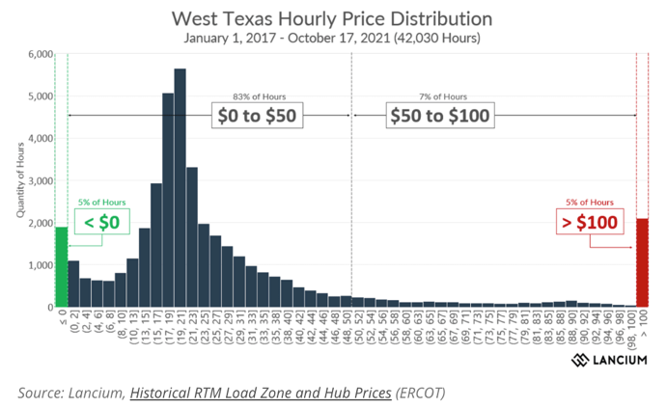
4b. Marathon migrated their final 100MW of non-sustainable energy from the Hardin, Montana facility to West Texas wind-farm. The completion of this migration was announced 26 Nov 22. We reflected this in the model by adding Marathon to renewable-based mining. We also contacted Marathon directly to ascertain the % of the time that they required ERCOT grid-backup when their off-grid wind-farms were producing insufficient power.
- Hashrate-based model
We further enhanced model accuracy, by replacing model reliance on estimates (energy consumption) with reliance on quantifiable real-time data (hashrate), only using energy estimates for mining companies when no hashrate data was available for that model.
Over time, we will progressively improve model accuracy further by replacing remaining energy-based calculations with hashrate-based calculations.
Other information on methodology:
As expected, large publicly traded mining companies had the most considerable portion of off-grid usage.
These companies included Argo (partly on-grid, partly off-grid) and Marathon (fully vertically integrated off-grid).
CCAF research states that China represented 21.1% of the network in Jan 2022. In our previous report on mining since the China “ban,” we provided the case that most of this is now off-grid hydro. However for model estimates, and in lieu of reliable data on Chinese based mining operations, we have assumed that Chinese mining companies have simply maintained their proportion of hydro-based mining.
Stronghold uses 165 MW of power from fossil fuel sources at the time of writing.
The Zero-emission off-grid portion included Cleanspark, DPO, Terawulf, Blockfusion, Aspen Creek, Bitfarms, Gryphon, Soluna, Hive, Cowa, Sato, Genesis, Iris, Hut8, Northern Data, DMG Blockchain, Cipher.
Further commentary on field-research approach:
Field research process took 6 months, during which time we identified 42 mining companies of significance. In the 9 months since the initial model was created, we discovered more mining companies of significance and have been progressively adding them to the model as their power draw and exahash rating gets verified.
Aside from starting with the Cambridge on-grid model, our approach differs from BMC in two other respects:
– We have used publicly verifiable data rather than self-reported data, and
– We have investigated mining companies across the network to avoid the risk of having asymmetric visibility toward only BMC members.
Because we are using a “complete” on-grid and off-grid mining model, where we identified off-grid mining, we took into consideration their geographic location in each instance to avoid the possibility of double-counting.
Field research is statistically simple but laborious. As such, we could use simple statistical tools. This had the advantage that we could use tools that laypeople are familiar with (Excel) for our calculations. Once we have recovered from the late-nighters getting this report ready, we look at how best we could open-source our approach and offer others the chance to edit and validate the entries of collaborators in much the same way Wikipedia works. This community-owned model could evolve in accuracy faster than any model developed by a single research group.
Wherever possible, we gained actual hashrate data of each mining company. Where this was not possible, we calculated hashrate using their power (MW) and mining rig information.
Where mining rig information was not available, we inferred their hashrate through the best estimate using their date of site establishment and likely mining rig composition (in most cases S19Pros)
Field research involves using various strategies to gain information, including looking at public filings/websites/news articles, email, and in several cases, direct conversations with mining company representatives.
Lower bound level focus
Wherever there were grey areas, the model assumes the scenario that paints the least sustainable result for the Bitcoin network. For example:
- When coal-based mining ended in China, we model the scenario that 100% of that migrated on a grid. We know numerous anecdotal examples of this activity migrating into new off-grid micro-hydro, which has a much higher renewable energy mix. However, in the absence of quantifiable evidence of how much of this sort of new off-grid micro-hydro mining exists, we have excluded this until reliable data becomes available and assumed 100% migration to the grid.
- Calculations and estimates suggest that Kazakhstan’s current proper mining level is under 3% of the global hashrate. However, until reports are verified, we have used the higher calculated figure of 6.44%. Due to Kazakhstan’s heavy reliance on coal, this again paints the Bitcoin network as slightly more carbon-intensive than it likely is.
Exclusions
One of the criticisms of Bitcoin mining organizations from environmental groups is the claim of offsets in their net emissions reporting. Another criticism has been locating near renewable energy without a contractual agreement and claiming to use renewable energy rather than a grid mix.
We did not factor in offsets in our emission calculations and excluded adjacent-non-contractual miners from our pool of off-grid miners.
Similarly, we excluded RECs from our calculations, so the model follows a similar methodology as CCIF (based on physics rather than carbon accounting). We recognize the value of developing a second model in the future which calculates the impact of both RECs and offsets. This is outside the scope of the current model.
Model Limitations
While most limitations will not significantly impact overall model performance, we are aware of its imperfections. In most cases, restrictions will result in a slight underestimation of the broad portion of renewable energy used by the Bitcoin network.
We will continuously improve the model as more off-grid information becomes available, and a clearer picture of Kazakhstan hashrate and China grid-mix percentage emerges.
Other limitations:
– Additional mining companies not known about (For example, in our field research we discovered two companies that were entirely off the radar and wished to remain anonymous. These tend to be smaller operations, often using harmful carbon sources (flared gas) as these two were.
– Mining companies that have added additional hashrate without being reported in the media. As off-grid mining uses 65.5% zero-emission energy sources, this may result in under-reporting the zero-emission component.
– Network hashrate is constantly changing, so the picture of the network is also dynamic and constantly changing.
– In some cases, we encountered inaccurate information reported on miner websites. For large mining operations, we cross-verified this information; however, as we investigated 42 miners, we did not cross-verify mining operations under a hashrate of 0.2 EH/s.
– In some cases, EH figures were unavailable, only the amount of MW the mining company used. In these cases, we needed to make assumptions about the TH/s and Wattage of their mining rigs based on their purchase date (we anticipate that this).
– Net emissions reduction of flared/vented methane mining not factored in. Using methane that would have been atmosphere bound is regarded as an emission-negative power source (better than zero-emission). We have not factored this into the model, treating this type of mining in the same bracket as renewables. In future models, we will transparently reflect the net impact of this type of mining on overage network emission status.
– China: As well as screening publicly available information and Cambridge’s data, we did our field research involving owners of mining operations in China. We conclude that over half of China’s hashrate comes from off-grid hydro. However, we have based our calculations on marginally over 1/3 of hashrate coming from off-grid hydro sources (corresponding to the peak part of the wet season only)
– When it was unclear whether a miner was on-grid or off-grid, we categorized them as on-grid. The model may therefore underestimate the actual number of off-grid mining operations.
Terminology
Zero Emission: sources of power that are not considered to create emissions as part of electricity generation. This includes solar, wind, hydro, geothermal, other renewable, and nuclear.
On-grid: Bitcoin mining operations that use the electrical grid of that jurisdiction to mine Bitcoin
Off-grid: Bitcoin mining operations either own their power plant (vertically integrated), have a contractual agreement with the owner of a generation facility for the supply of electricity, or mine directly from a power source that is converted into electricity (such as vented methane, piped into a generator)
Footnotes:
* Our model uses a dynamic grid calculator that considers the last known renewable energy % calculation and the speed at which a given grid is evolving towards renewable energy based on past growth-rate. For example, ERCOT had 42% sustainable energy sources as of April 2021. Based on our calculation of ERCOT renewable growth, we estimate ERCOT to use 46.81% sustainable energy as of Feb 2023. By contrast, the US grid data is 40.3% from sustainable sources (adjusted for growth rate from Nov 2022 data).
Document Revisions:
1 Feb 2023
I have added a comprehensive Breakdown of all sources of variance between the CCAF model and the BEET model (Bitcoin Energy and Emissions Tracker). In particular: separately analyze the impact of off-grid sustainable mining and ERCOT mining.
Revised Zero Emission miner data table graphic based on the latest available data.
Updated model statistics based on the latest movement in hashrate and power consumption and other new data, including Kazakhstan’s further hashrate reduction and Marathon migration off Hardin coal-based power generation facility.
13 Feb 2023
Added ERCOT detailed breakdown, latest infographic, and Breakdown of the minor exclusions from the CCAF model.
28 May 2023
Added link to raw data file.
4 July 2023
Added ERCOT wholesale electricity price volatility chart, to help illustrate how wholesale power prices are significantly more volatile than Bitcoin price.

Testimonial of Erik Hersman

ENERGY & BITCOIN IN AFRICA:
WEAVING A MORE DISTRIBUTED, RESILIENT GLOBAL ENERGY TAPESTRY
IN AFRICA & BEYOND

Erik Hersman is the CEO and co-founder of Gridless, a company that harnesses stranded renewable energy to mine bitcoin. He also started Ushahidi, iHub, Gearbox, Savanna Fund, and BRCK. Erik Hersman is the CEO of BRCK which creates rugged wireless WiFi devices designed and engineered in Kenya for use throughout the emerging markets. BRCK has a free public WiFi network called Moja that sits on top of the BRCK hardware that creates an affordable model for internet in emerging markets. In 2010 Erik founded the iHub, Nairobi’s innovation hub for the technology community, bringing together entrepreneurs, hackers, designers and the investment community. He is also a co-founder of Ushahidi, the free and open source software for crowdsourcing crisis information, and also established afrigadget.com and whiteafrican.com as key online communities promoting creative solutions entrepreneurship and development challenges across Africa. He is also a general partner in the Savannah Fund, and sits on the boards of Gearbox, Akirachix, the Kijabe Forest Trust, PopTech, and the Whitaker Peace and Development Initiative (WPDI).

Reducing the electricity-access gap in underprivileged regions with minigrids and small-scale bitcoin data centers: An open-source blueprint for advancing power infrastructure in Africa and beyond.
Combining small-scale bitcoin data centers and renewables-based minigrids forms the foundation of a new model to expand profitable electrification to communities in emerging markets without the need for charity, aid, gifts, or government subsidy. The main challenge is that minigrids have a low ROI and are not economically viable without subsidies due to their high CAPEX cost, low initial consumption, and long payback period.
The co-location of small-scale Bitcoin mining and renewables-based microgrids helps to address the problem of stranded renewable energy. By providing a consistent and reliable demand for electricity, Bitcoin mining helps to utilize excess renewable energy that might otherwise go to waste, thereby unlocking the potential of stranded renewable energy projects and contributing to a more sustainable energy future.
Sections in this document:
- Context and ongoing problems
- Overview: weaving the business case with the development model
- Addressable market
- In conclusion
- Additional Information - Minigrids by the numbers

- Context and ongoing problems:
Human progress is driven by affordable and accessible energy. At a macro-level we know that economic growth and GDP per capita are directly correlated to energy availability and consumption per capita. We also know that the basic necessities of
life remain out of reach to those without electricity. Yet, last year in Africa, 600 million people, or 43% of the total population in the continent, lacked access
to electricity, most of them in sub-Saharan Africa, according to the International Energy Agency (IEA). Considering energy in all its forms, today, 333 million people living in the United States consume 19 times more per person than 1.4 billion people living in Africa, and the roughly 600 million people living in all of Europe consume more than 8 times per capita than people in Africa, according to BP’s Statistical Review of World Energy 2022. In fact, there is more energy consumed in Norway than all of Africa combined.
To put a finer point on the energy chasm that Africa sits at the bottom of, more energy is used by kitchen appliances in the US each year than all of the energy used by every person in Africa combined.
There are many reasons for this situation, but at a very basic level the problem of Africa’s limited access to electricity is a supply and demand problem, a market problem that both markets and international and multilateral institutions have not been able to solve thus far.
To put it briefly, in remote and underprivileged areas of the world, where many people have little or no home appliances and industrial machinery, electricity demand is too low to justify the large investments necessary to build energy generation stations and power grids. The time it takes for a remote or rural community to build up the demand for electricity takes too long for normal investment to take it seriously, which has meant that the primary way this power capacity is funded today is with concessionary capital such as grants or low cost debt.
The best answer to this problem thus far is minigrids, with a typical energy generation of under 1MW. This is because having a smaller local (more cost efficient) scale grid makes more sense in the case of low demand compared to long and costly extensions of the national grid.
“Once people have access to larger amounts of electricity, they can use cassava grinders, welding equipment, sewing machines, band saws, refrigerators, water pumps, washing machines, and scores of other important devices.” - RMI Minigrids in the Money report
Traditionally, a large, centralized power generation plant produces electricity that is then transported by a transmission and distribution network for consumers and small businesses. This is a one-way delivery system from generation to usage. This model is now being increasingly complemented by bi-directional, small, distributed energy resources (DER) which are located closer to the end-user. DERs often combine renewable energy installations such as rooftop solar modules, small wind turbines, or small hydro-plants, combined with a battery or a generator to form a minigrid.
Large national grids often have gone as far to the edges as is profitable for them to go, so to push the edges of electrification outward to less dense or less profitable areas minigrids are the solution. Minigrid developers can find the right density of people, and using the plentiful renewable energy resources in Africa, they are able to pop up just about anywhere. It is a more resilient and efficient use of energy, as the electricity is used close to where it is produced and provides remote communities with a reliable supply of sustainable electricity.
COMPONENTS OF SUSTAINABLE HYDRO MINI-GRIDS:
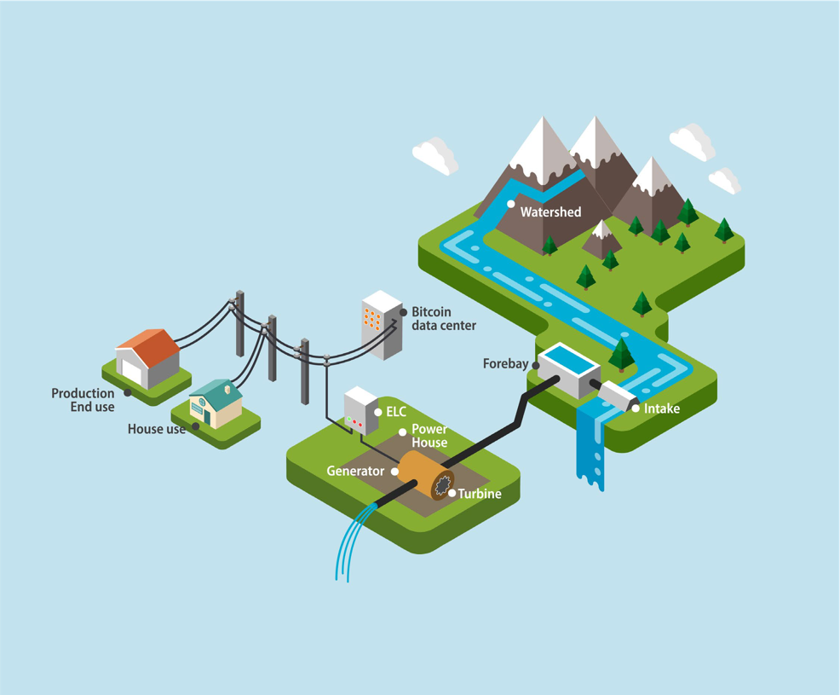
The problem with minigrids is that “the risks perceived to be associated with minigrid projects are not aligned with the risk/return expectations of commercial financiers”, according to the Mini-Grids Partnership’s Global Mini-grids Market Report 2020 published by Bloomberg NEF and Sustainable Energy for All (SEforALL).
In other words, the financial effort required to set up a minigrid is not worth the result as virtually all minigrids projects so far have not been economically sustainable – and if they are not economically sustainable, especially in the initial phase after commissioning when demand is still very low, it’s hard to expect them to help reduce the electricity- access gap in Africa and other regions.
Minigrid developers have to overbuild their sites due to the variable nature of renewable energy supply, whether sun, water, or wind. This is balanced against the consumer demand that starts slow and can take many years to build up to a more “full” capacity in people’s homes and businesses. On top of that, the energy demands by the community peaks at 6-8am and 6-9pm, while there is very little energy used in the other hours of the day. All of these combine to form the image of high upfront capital costs to build, but slow and erratic returns from the electricity sold.
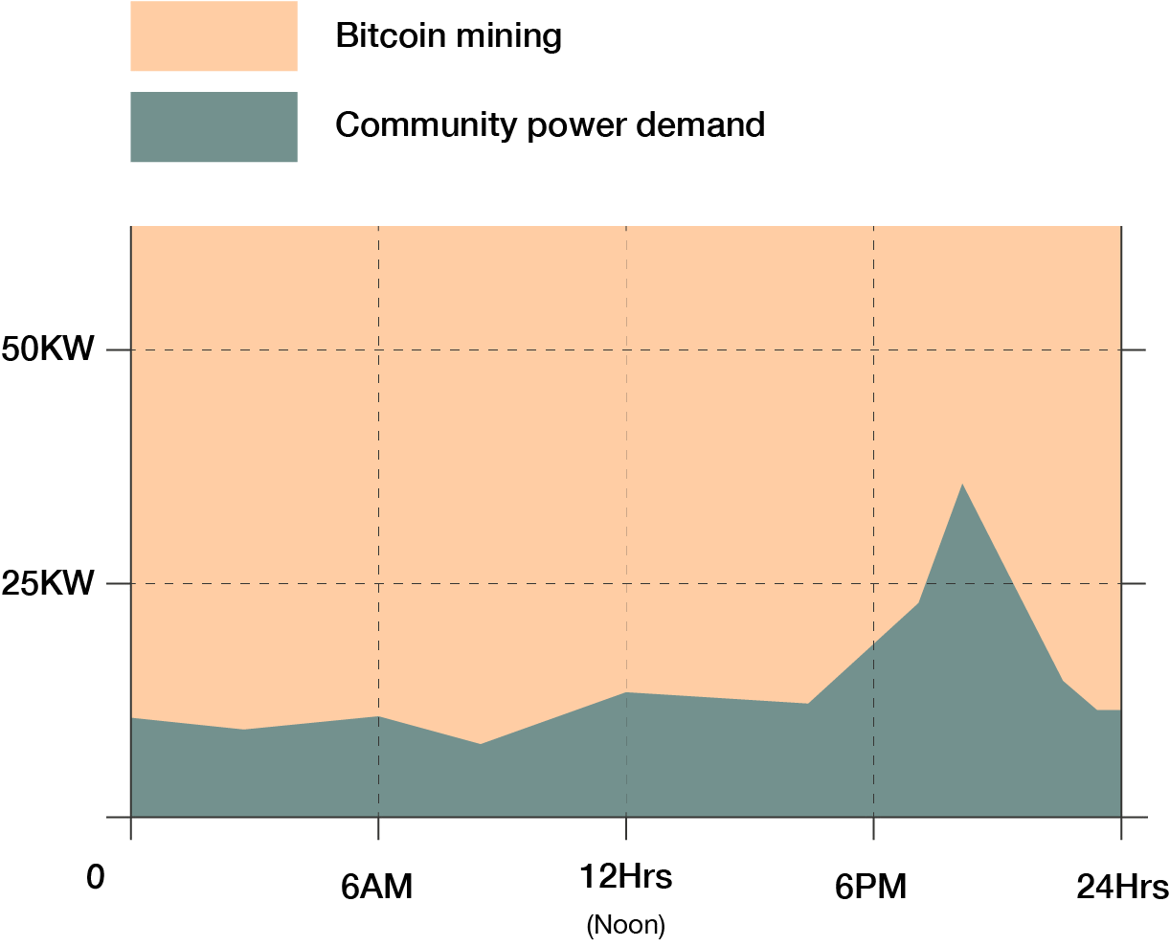
This is where bitcoin data centers come in:
- Wasted energy: Since they have real-time demand leveling, they can turn on or off their energy needs within seconds, increasing efficiency for the energy developer by reducing over- or under-generation of electricity.
- Financial Sustainability: Since they are an anchor tenant, the minigrid developer has financial stability from day one with consistent and predictable demand.
- Co-Located with Generation: Since they are location agnostic, they can be placed anywhere.
“Although the technologies used in minigrids are proven and the costs of solar hybrid minigrids [and other technologies] have become increasingly competitive, most developers rely on their own balance sheets and struggle to raise external finance. Without additional mechanisms, supports or guarantees from public organizations, commercial financiers have shied from funding minigrids due to concerns over ambiguous electrification strategies, a lack of regulations to protect minigrid assets, a lack of developer track records and the limited power demand of rural consumers,” the authors of the Mini- Grids Partnership’s report explain.
New solutions are needed to break the “no power demand - no power supply - no power demand” vicious circle.


- Overview: weaving the business case with the development model:
“Minigrid companies have seen that rural energy consumption does not grow as quickly as once hoped, and therefore load growth must become a core element of their businesses to be viable.” From the 2020 Africa Minigrid Development Association report.
Small-scale bitcoin data centers and renewables- based minigrids can act as the missing link. They can close the gap between perceived risks associated with minigrids and the risk/return expectations
of investors, aligning the incentives of financiers, multilateral organizations and local communities in remote regions.
Minigrids can become sustainable, especially in their crucial initial phase, if they can rely on an anchor customer. Small-sized, specialized bitcoin data centers can provide the initial and ongoing demand for power that makes the initial investment into renewable power infrastructure possible, sustainable and profitable.
The way to address the problem of stranded renewable energy projects is by co-locating small bitcoin data centers alongside these minigrids. This approach can help break the cycle of insufficient power demand leading to inadequate power supply, which in turn creates further low demand. Combined, these data centers and minigrid projects provide a reliable and consistent demand for renewable energy, thereby unlocking the potential of stranded renewable energy projects that have thus far remained untapped.
In addition, clean electricity distributed by minigrids made possible thanks to the power demand provided by location-agnostic, small-scale bitcoin data centers can serve many other local businesses and families that had no access to electricity before. The same setup can also power basic community internet connectivity capabilities where none were present before.
This symbiotic power-bitcoin-connectivity infrastructure can then also act as a metaphorical loom to start weaving together threads in the community into a richer economic and social tapestry. They can provide the basic building blocks, the uncomplicated infrastructure to start twining together key pieces of the prosperity puzzle that have so far remained elusive – energy investments and energy demands that are big enough to kickstart the productivity engine, but small-enough to fit the size and needs of rural communities around the world.
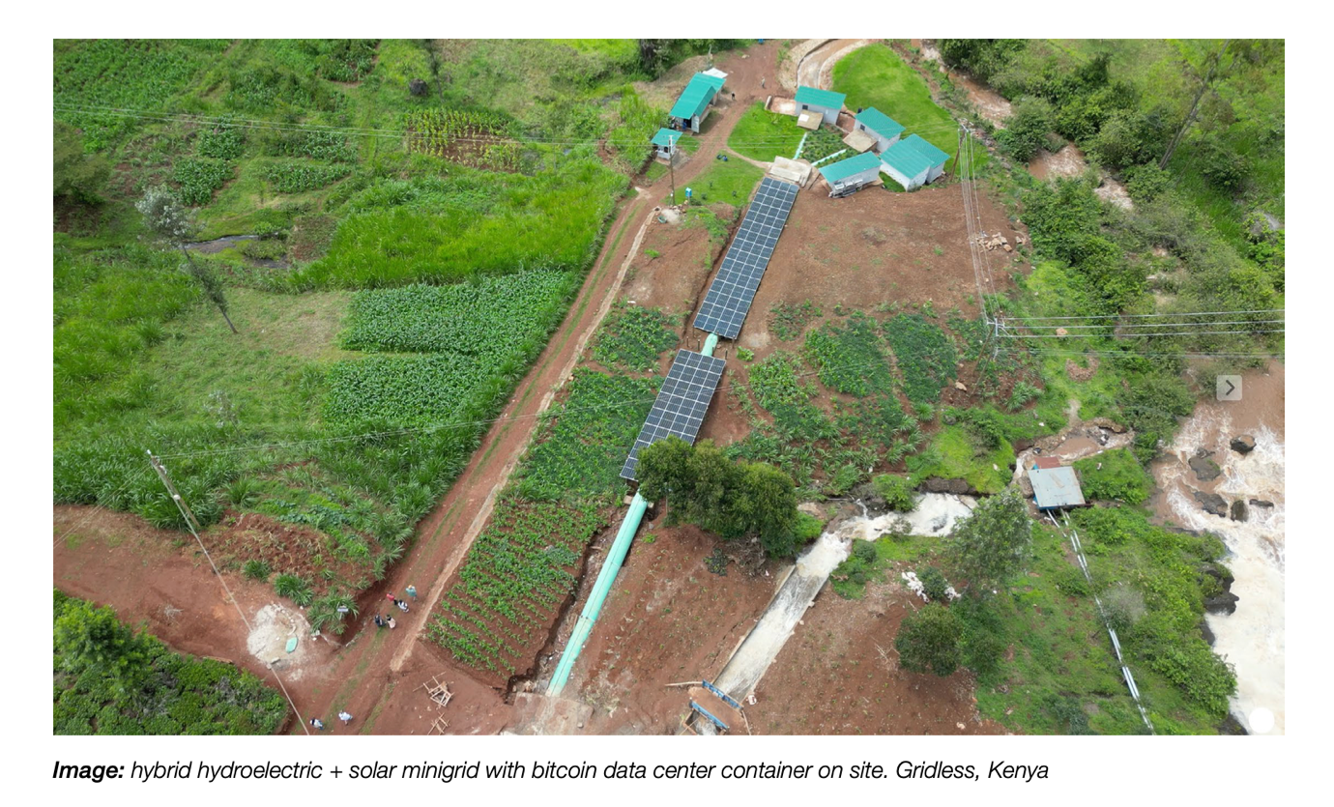
Bitcoin data centers are extremely flexible as to when they use electricity and how much of it they use. With automated real-time demand leveling they ramp consumption up and down as much as needed at a moment’s notice relative to the minigrid’s overall supply. This uncommon feature allows bitcoin data centers to play three crucial roles as:
- buyer of first resort, purchasing energy when there is no other demand;
- buyer of last resort, buying when nobody else has a use for that energy;
- grid-balancer of last resort, providing demand- response ancillary services to keep the minigrid always stable.
The key to this foundational energy-bitcoin- connectivity infrastructure is that it is community- based, locally sourced, location-agnostic, affordable and sustainable for everyone.
A weak point to acknowledge is that there still is a minimum utilization rate that is required. It doesn’t make sense to have a bitcoin miner that runs 1 hour per month. The capital expenditure per terahash, plus the value of the bitcoin will determine where that cut-off point is. For example, does mining on solar mini grids (with sun for only 8h/day) make sense? The answer to that depends on the cost of the bitcoin miner, the efficiency of the machine, and the value of bitcoin.
Small-scale bitcoin data centers and renewables- based minigrids, accompanied by basic connectivity infrastructure, are the spool, the loom, and the sewing machine to start organizing the thread and begin weaving stronger, seamless, diverse, versatile socio- economic fabrics in energy poor areas of the world.
- Addressable Market:
Estimates vary, but, in a sustainability scenario, we need to build between 162,000 and 217,000 minigrids globally between 2022 and 2030 to reach between 288 million and 490 million people, at a total investment cost between $93 billion and $127 billion. This according to data by the International Energy Agency and the World Bank, elaborated by the Energy Sector Management Assistance Program (ESMAP), a partnership between the World Bank and 24 other private and public organizations. Data are included in a 2022 World Bank report titled Mini Grids For Half A Billion People.
That means we need to build around 2,000 minigrid projects per key access-deficit country per year by 2030. Year-on-year growth needed to achieve universal access will require scaling up private-sector- led minigrid deployments from dozens to hundreds to thousands of minigrids per country per year in each of the countries with the highest electricity access deficit rates today.
Importantly, after decades of minigrid development there still isn’t a mobile and flexible consumer of energy, which in turn has throttled the growth of this type of energy development. Bitcoin data centers are just that.
Public or non-for-profit programs do provide important financial and community benefits to countries and end users. Yet, if we are to increase access by orders of magnitude by 2030, private-sector initiatives need to greatly increase across the board to reduce disparities with other regions.

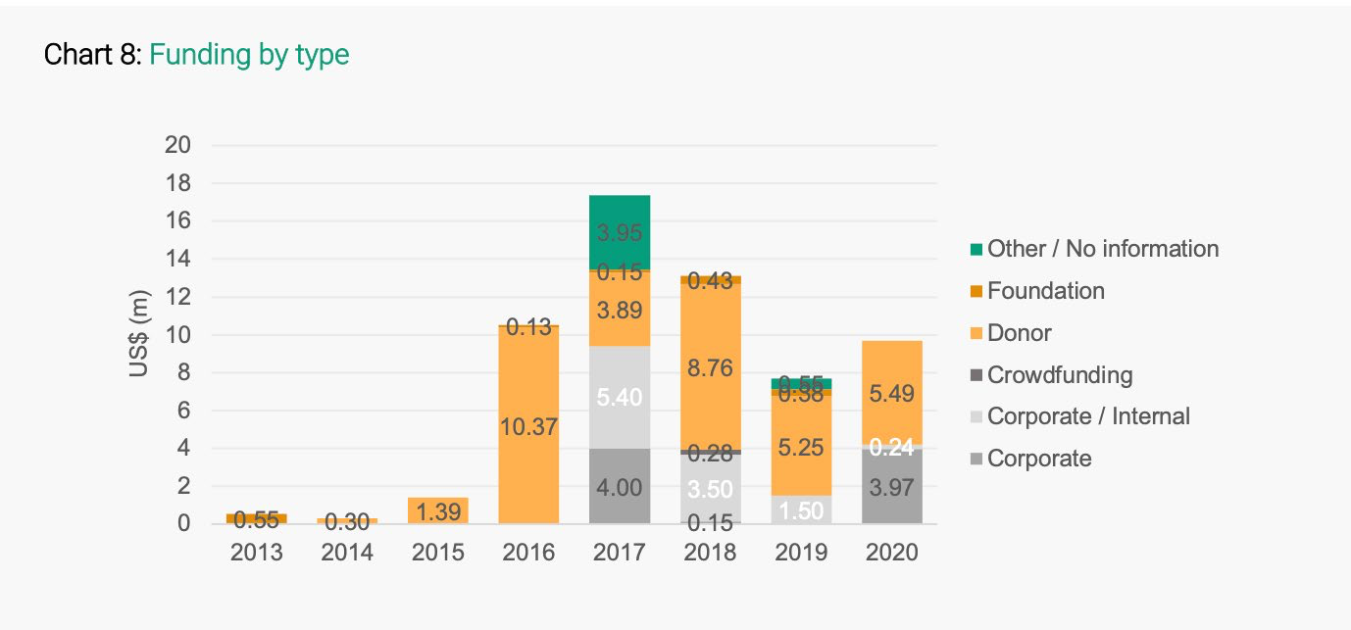
Source: AMDA, 2022 report
ESMAP estimates that the number of minigrids in Africa need to grow from 3,100 in 2021 to 160,000 in 2030, more than 50-times over nine years, with a cumulative investment of $91 billion by 2030. If the current pace of minigrid development continues, only about 44,800 minigrids will be installed by 2030, serving only around 80 million people in Africa.
More than 380 million people in Sub-Saharan Africa living in 58 access-deficit countries can receive electricity access at affordable cost via minigrids, ESMAP says. In Sub-Saharan Africa, nearly 291,000 population clusters have profiles favoring the deployment of minigrids. That is, they are located more than 1 km from the existing grid network and have a population density (>1,000 people/km2) that favors decentralized system deployment, according to the World Bank’s report.
More than 177,000 settlements have a population of 100 to 500 people. These settlements could be powered by smaller minigrids of up to 20 kilowatts (kW) each. Nearly 96,000 settlements, each with populations of 500 to 2,500 people, could be powered by medium-sized minigrids of up to 80 kW. Larger mini grids, up to 200 kW, could power more than 15,000 settlements, each with 2,500 to 10,000 residents. Finally, for nearly 3,000 settlements, each with 10,000 to 100,000 people, minigrids at the 500 kW to 1 megawatt (MW) scale would be required, according to the report.
“Mini grids are not a new phenomenon: nearly all centralized electricity grid systems began as isolated mini grids that were connected to each other over time” – The World Bank.
Achieving universal access to affordable electricity by 2030, as in the International Energy Agency’s Sustainable Africa Scenario (SAS), would require an even more ambitious target of connecting 100 million people a year in the continent.
Current financing commitments to global energy access in the 20 highest-access-deficit countries are estimated at $32 billion a year – just 78% of what is needed to achieve universal access by 2030. However, forecasts indicate that 95% of the investment has to be directed to Sub-Saharan Africa, with only 15% channeled to the continent so far. Looking at the numbers, a 2022 report by the Africa Minigrid Developers Association (AMDA) stated that, “...only $10 million was disbursed to AMDA developers to build projects in 2020, out of a total of only $60 million since 2013. Comparing the $1.6 billion committed to the sector from donors.” In a sector where concessionary funding is supposed to drive growth, the organizations involved talk and commit, but are not following through.
Regulatory hurdles create a high cost of entry to building minigrids, generally taking over one year to get through the approval process, and while countries vary improvements here can make a large impact on the speed of rural electrification. Lighter approaches to regulation for these low-risk, high-reward, decentralized technologies are helpful for both the regulator as well as the independent power producer.
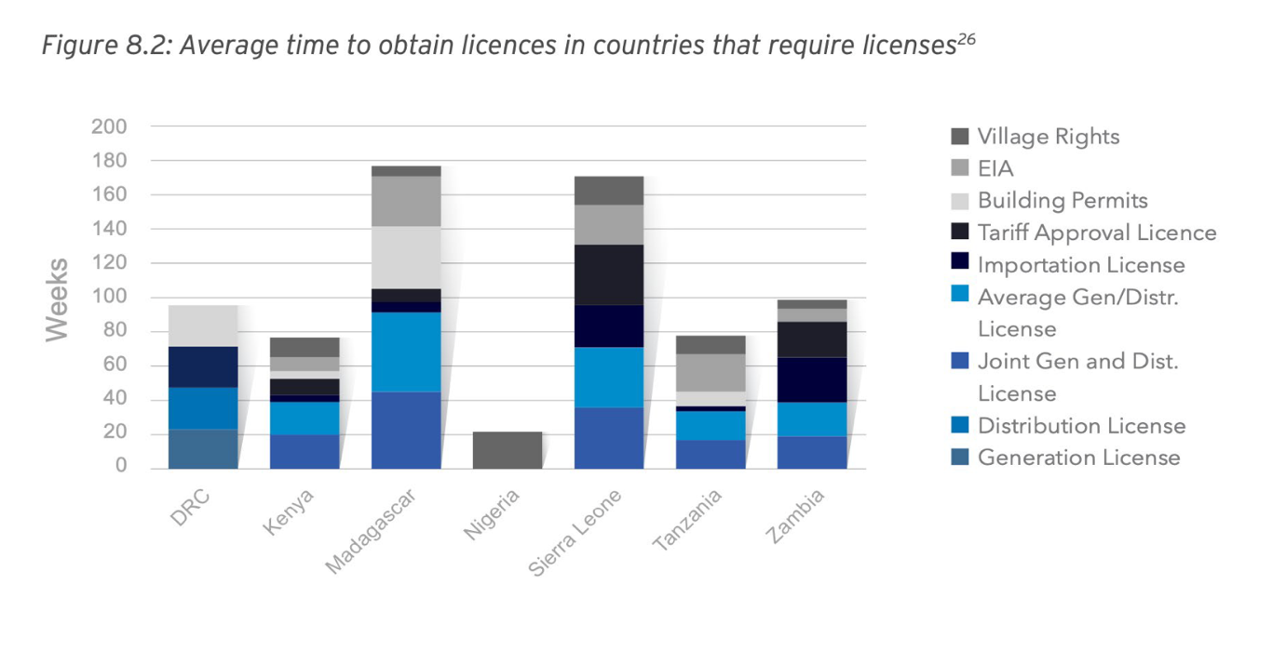
In Africa, where rural communities of more than 200 people are near a road, but more than 10 kilometers (km) from a main grid, minigrids are usually the best solution, according to the IEA’s Africa Energy Outlook 2022. Minigrids represent around 30% of new household connections and meet 65% of new connections in communities more than 20 km from grid infrastructure in the SAS. “Minigrids meet 65% of new connections in sub-Saharan African communities located more than 20 km from a grid” – IEA.
Incremental installed capacity averages around 300 MW per year in the 2021‐30 period, according to the IEA’s Sustainable Africa Scenario. Connections for non‐household uses, including public services such as schools or health facilities and commercial businesses, also increase substantially in the IEA’s sustainable scenario.
“Businesses, notably in agriculture, mining and telecommunications, often serve as important anchor customers for grid extensions and minigrid projects, so integrating energy and rural business development planning is crucial to accelerate connections.
An anchor customer can lower costs and tariffs, boost household incomes and, in turn, improve repayment rates to facilitate the financing of electricity access projects. This calls for better access to credit and the simultaneous development of infrastructure”, concludes the IEA – framing the issue in a way that seems to fit seamlessly with the value proposition linking minigrids with bitcoin data centers.
- In Conclusion:
Minigrids rhyme perfectly with the distributed, decentralized, horizontal nature of renewable energies – sources nobody controls, and anybody can access. Small-scale bitcoin data centers fit perfectly with the distributed, decentralized, participatory nature of a type of money based on energy – a neutral asset nobody controls, and anybody can access.
“Productive uses of electricity can be a game changer for both minigrid developers and socioeconomic development. It presents an ‘everyone-wins’ scenario for developers, local entrepreneurs, communities, and national utilities”, the ESMAP report’s authors say.
They are right. And their case could get a decisive boost when a specific bitcoin data center cost/ benefit analysis is added to the equation. bitcoin data centers can be at the forefront of all the other income- generating uses the report considers.
The energy infrastructure is made more resilient and robust when global energy generation is both decentralized and distributed. Bitcoin is also made more resilient and robust when the mining data centers are decentralized and distributed. Minigrids powering bitcoin data centers as their first and last resort anchor-customer can catalyze the private investments needed to bring electricity to hundreds of million of people living currently without power, and they can help make those investments both profitable and sustainable.
“The only way to reach the scale of investment needed to connect 490 million people to minigrids by 2030 is to enable current investors to invest more and to attract new investors. Existing financial flows are typically the result of one-off deals. What the sector needs are new types of financing vehicles, developed for investors by investors, that remain actively managed and sustainably funded,” ESMAP says.
Small-scale bitcoin data centers and renewables- based minigrids can be the cornerstones for a faster and sounder buildup of the power infrastructure in Africa and beyond, aligning the incentives that will generate more prosperity and sustainability for all.
In an upcoming document we will provide actionable information to help minigrid developers and investors navigate the specifics of co-locating a renewables- powered minigrid with a small-scale bitcoin data center.
- Additional Information - Minigrids by the numbers:
ESMAP identified 21,557 minigrids installed in 131 countries and territories around the world as of 2021. About half of them are powered by solar PV, with hydro and fossil fuels accounting for an additional 35% and 10%, respectively, providing electricity to 48 million people. Another 29,353 minigrids are being planned in 77 countries, 95% of them in Africa and South Asia, with 99% of them powered by solar PV, connecting more than 35 million people at an investment cost of $9.3 billion. ESMAP provides the following estimates.
Investments:
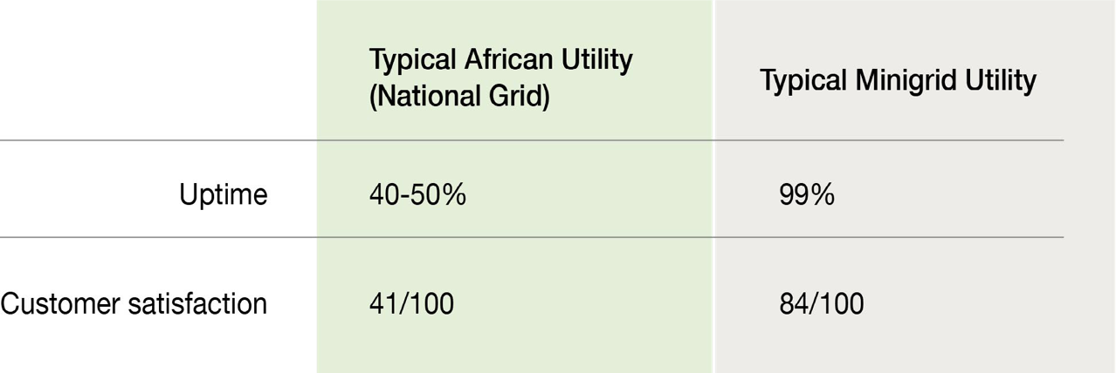
Investments:
- $29 billion – Cumulative global investments in minigrids to date.
- $9 billion – Cumulative global investment in Africa and South Asia in mini grids to date.
- $2.6 billion – Development Partners committed, including AFD, AfDB, FCDO, the Islamic Development Bank, GIZ and the World Bank, among others.
- $1.4 billion World Bank commitment to mini grids in 31 countries through 2027.
- $500+ million – Private-sector investment in minigrid developers in low-incomecountries since 2013
- 25% – Average World Bank share of total mini grid investment (government, development partners, and private sector) in client countries.
- $93 billion – $127 billion needed to reach 2030 global targets.
Profit potential:
- $3.3 billion – Annual profit potential for developers across all minigrids deployed through 2030.
- $5.8 billion – Net profit potential across all minigrid component and service suppliers in 2030 alone.
Typical 3rd generation minigrid:
- $0.5–$1 million investment
- 200–800 clients connected
- 800–4,000 people receiving electricity for the first time

Levelised cost of electricity (LCOE) to achieve universal access to electricity by 2030 in sub-saharan Africa, in the Africa Case
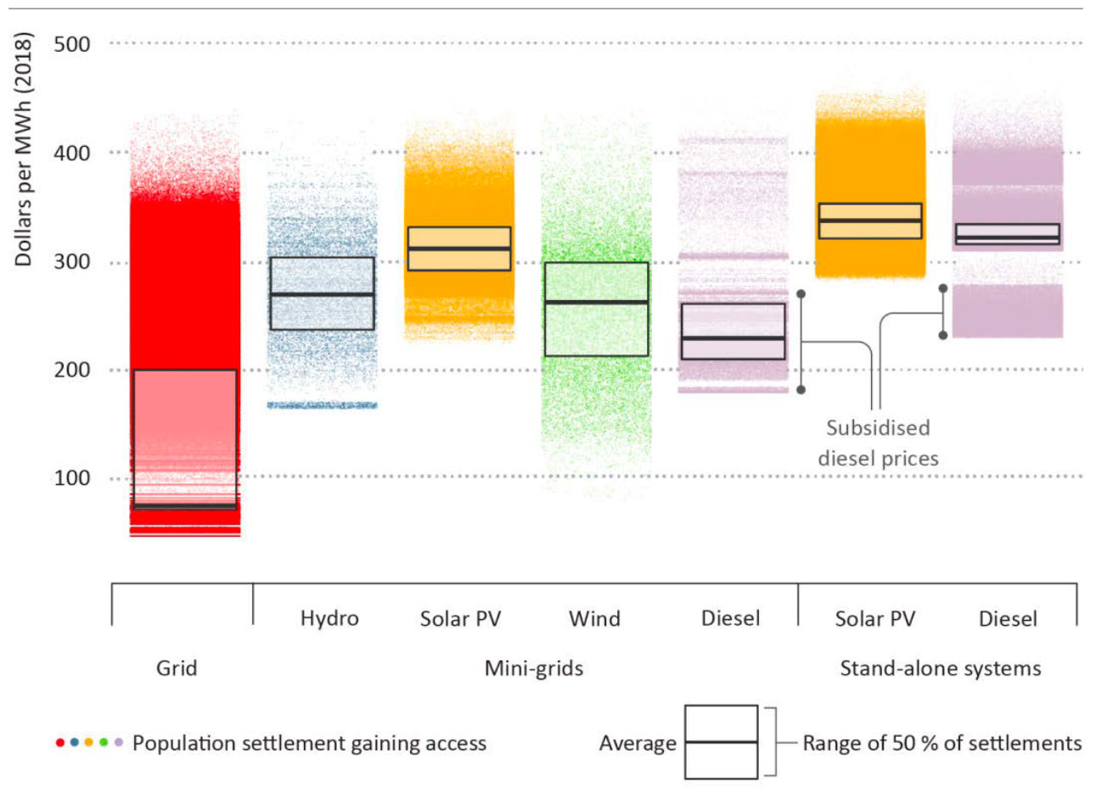
Source: IEA, 2019
Maps of renewable energy locations in Africa:
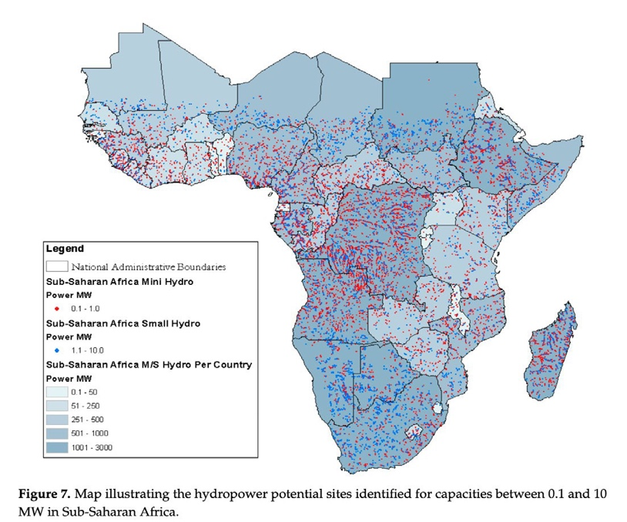
Source: MDPI “Energies” report, 2018

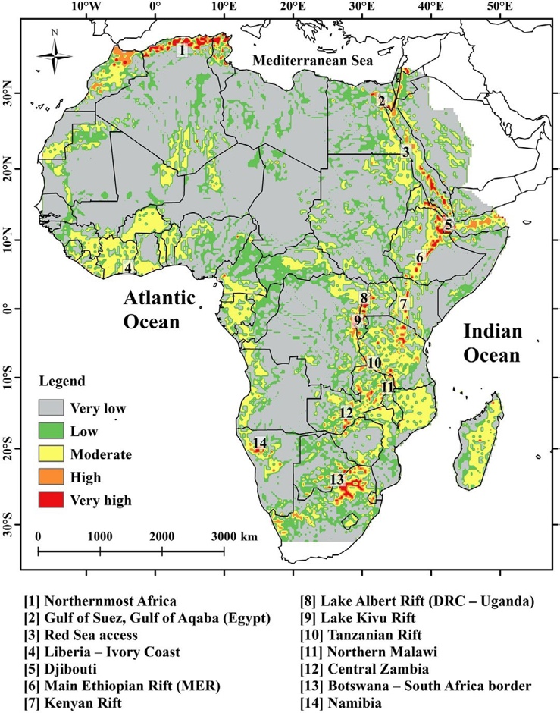
Source: “Geothermal renewable energy prospects of the African continent using GIS” report


For Both Source: World Bank

Testimonial of Mark Morton

On Technical Standards specifying certain requirements of Markets in Crypto Assets Regulation (MiCA) – Second Consultation Paper

I am providing a selection of comments to specific questions as highlighted throughout my submission. I refer throughout to the “Technical Standards specifying certain requirements of Markets in Crypto Assets Regulation (“MiCA” or the “Regulation”) - second consultation paper, dated 5 October 2023” (the “Paper”).

My name is Mark Morton and I am the managing director and co-founder of Scilling Digital Mining, Ireland’s first and only Bitcoin mining company based in the heart of Cork City. We manufacture containerised solutions that allow energy producers to locate mining operations close to their stranded energy sources such as methane or congested renewables. Containerised Bitcoin mining offers these energy producers a consistent and reliable ‘Buyer of Last Resort’. In short, it allows energy producers to monetise power that would have been otherwise wasted, or in some instances sold to the grid for a loss. I will attempt to explain the reasoning behind Bitcoin mining’s transition to a global energy asset and its’ relevance in Europe’s energy transition prior to tackling the specific points raised within the consultation paper.
Sections in this document:
- Introduction
- Bitcoin Mining Plays a Key Role in Global Renewable Buildout
- Mining Optimises Electricity Generation & Efficiency
- Strategic Implementation of Bitcoin Mining Reduces Methane Emissions
- Specific Issues within the Second Consultation Paper
- Bitcoin Mining Should Be Embraced within the EU
      - Introduction
It's firstly worth noting that arguments against any kind of increased compute related energy demand incorrectly assume that any increase in energy consumption is negative. The majority of experts within the renewable industry will note the importance that large scale consumers like data centres play in providing a 24/7 consumer of power which balances the grid system, but also provides energy producers with a key baseline revenue within the system when alternative demand drops (e.g. When the general population sleeps, data centres continue to pay wind operators for their power). The main issue that arises is that these large scale consumers also demand power when the grid system is under stress, or lacking supply, and will generally be incapable of reducing their demand, this is where Bitcoin mining sets itself apart as a highly flexible energy demand.

The overly simplified comparisons to country energy usage such as The Netherlands, do not paint the full picture of this new innovative energy process. Firstly, these traditional reports do not distinguish between on or off grid mining. These statistics are usually derived by estimating energy consumption from the current total global hashrate and their associated emissions via IP address and the grid mix of that region. They glaringly ignore that Bitcoin mining has been evolving with sophisticated off-grid and on-grid mining solutions emerging to not only power Bitcoin in a cost-effective and sustainable manner but to provide a valuable integration to existing power systems and grid infrastructure. The benefits of the strategic and innovative use of Bitcoin mining as a flexible and location agnostic energy asset are consistently overlooked.

It's also worth addressing the references to the e-waste per Bitcoin transaction statistic, that I have seen mentioned on multiple occasions across a variety of EU publications, such as this article published in November 2022 titled “Bitcoin’s last stand”. The energy required to produce the Bitcoin networks global hashrate is not directly correlated to the amount of transactions occurring, a block will be mined approximately every ten minutes whether that block be full of transactions or empty. The narrative that there is a direct correlation between e-waste and the amount of times myself and another individual send each other Bitcoin is inherently flawed. This is before we even begin to explain that the transaction ‘throughput’ figures commonly referenced are clearly only taking into account the Bitcoin base chain, and fail to represent the thousands of transactions occurring on Lightning, Bitcoin’s L2 solution, on a daily basis. Finally, the rationale behind these e-waste critiques usually assume that mining machines have a lifespan of 2-2.5 years after which they are dumped. However, in 2022 there were multiple examples of miners still running S9s off of flare gas and reducing methane emissions six years after their initial release. The emergence of intermittent mining with renewable sources will also see new machines transitioning from high uptime sites to lower uptime ‘soakage’ sites after a few years as miners look for a lower capex setup to offset their lower uptime.

I felt it would be worth exploring specific global examples of Bitcoin mining playing an integral role within heavily renewable grid systems.
      - Bitcoin Mining Plays a Key Role in Global Renewable Buildout
Grid operators around the world are slowly coming to the realisation that Bitcoin mining can play a key role in balancing heavily renewable grid systems. Bitcoin mining is a flexible and instantly interruptible single process energy consumer. It allows hundreds of megawatts of energy consumption to be shut off in seconds, that can then stay off for an indefinite period of time. Renewables by nature are intermittent and mining can play a key role in ironing out the peaks and troughs of renewable generation.

Ireland has 300+ wind farms and ambitious goals to reach 70% renewable generation by 2030. Based on its’ modelling of impacts and feasibility 14 , the Commission is proposing to increase the target in the Renewable Energy Directive to 45% by 2030, up from 40% in last year’s proposal. This would bring the total renewable energy generation capacities to 1236 GW by 2030, in comparison to 1067 GW by 2030 envisaged under Fit for 55 for 2030. Flexible on-grid demand assets like Bitcoin mining should play an integral role in this buildout.

Why?
There are two types of electricity generation: synchronous generation and non-synchronous generation. Synchronous generation produces the same amount of electricity all the time. It is reliable and predictable and, therefore, easy to bring onto the grid.

Non-synchronous generation produces a different amount of electricity depending on the energy available. It does not produce the same amount of electricity all of the time. This makes it less reliable, and more difficult to bring onto the grid. Most renewable forms of energy, such as wind and solar, are types of non-synchronous generation. This is because the amount of wind is always changing and therefore they cannot produce power predictably.

In Ireland, there will be times when it is not possible to accommodate all renewable generation while maintaining the safe, secure operation of the power system. Security-based limits have to be imposed due to both local network and systemwide security issues. It is necessary to reduce the output of renewable generators below their maximum available level when these security limits are reached. This reduction is referred to as the ‘dispatch-down’ of renewable generation.

Constraint: There are wind farms all over Ireland but the majority are along our southern and western coasts where wind conditions are best. This means on a very windy day a lot of electricity is being generated but what happens if there is so much electricity that there is not enough capacity on the power lines to transport it where it must go? When this happens there is a constraint on the transmission system, similar to a traffic jam on the roads. There is no problem producing the electricity, there’s just no way to transport it. To ensure the safe operation of the system one or more generators are instructed to shut off or produce less power to ease the bottleneck. This is done to ensure that the transmission lines don’t overload and become damaged. We say when this happens to a wind farm that it has been ‘constrained’ and this is the most common form of Dispatch Down.

Curtailment: Curtailment occurs because of the challenges of incorporating renewable electricity onto the transmission system. The best known form of curtailment is the SNSP limit. Ireland’s electricity system, like most other systems in the world, operates at a frequency of 50 hertz. Ensuring that our frequency levels stay steady is probably the single most important priority in managing the electricity system. EirGrid have put in place the ‘System Non-Synchronous Penetration’ SNSP limit to ensure that the volume of wind energy is manageable. The limit is currently 75% per cent which means that even on a very wind day when wind could provide 80 or 90 per cent of Ireland’s electricity it is not allowed to do so and wind farms are dispatched down until they hit the 75 per cent limit.

How prevalent is this issue? In Ireland in 2019, the dispatch-down energy from wind resources was 711,000 MW (6.9% of the total available wind energy) - a total overall increase of 254 GWh in dispatch-down energy compared to 2018. Lost wind energy rose to nearly 11.5% of total production in 2020, the equivalent of 1,400,000 MW of electricity. Wind farms lost €75.5m worth of revenue in 2019 - up from €49.7m in 2018 - because they were forced by grid operator EirGrid to either switch off completely or turn down their power output to the national grid at certain times, according to a report from the Irish Wind Energy Association.

ERCOT has become the front runner for incorporating bitcoin mining into their grid ancillary arsenal. In Q1 last year, ERCOT generated a record 34% of their power output from wind and solar. The late ex-CEO of ERCOT Brad Jones has repeatedly cited the benefits mining offers for grid flexibility, stability, and security. Riot Blockchain based in Rockdale, Texas is a prime example of the relief mining operations can offer the grid. This year Riot shut off the entirety of their 450MW facility during winter storms and a summer heatwave to allow their energy allocation to be used elsewhere.
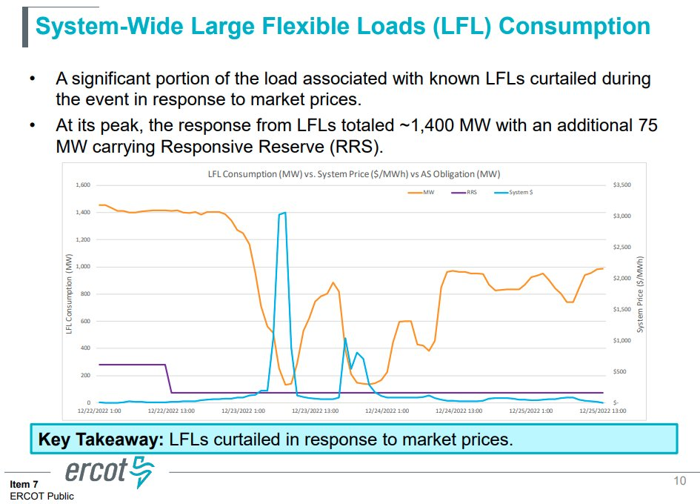
Lancium, a Texas based Bitcoin miner has provided further research on the benefits of flexible demand assets like Bitcoin mining and states that these assets lead to a net decarbonisation of grid systems. The ideology stems from the optionality that mining can bring when renewables are under-producing. High carbon generators like gas turbines and coal plants would no longer have to switch on as mining can simply cut demand to bring the grid back into equilibrium. In instances like the graph below, flexible demand would be cut off instead of relying on a large increase in natural gas generation.

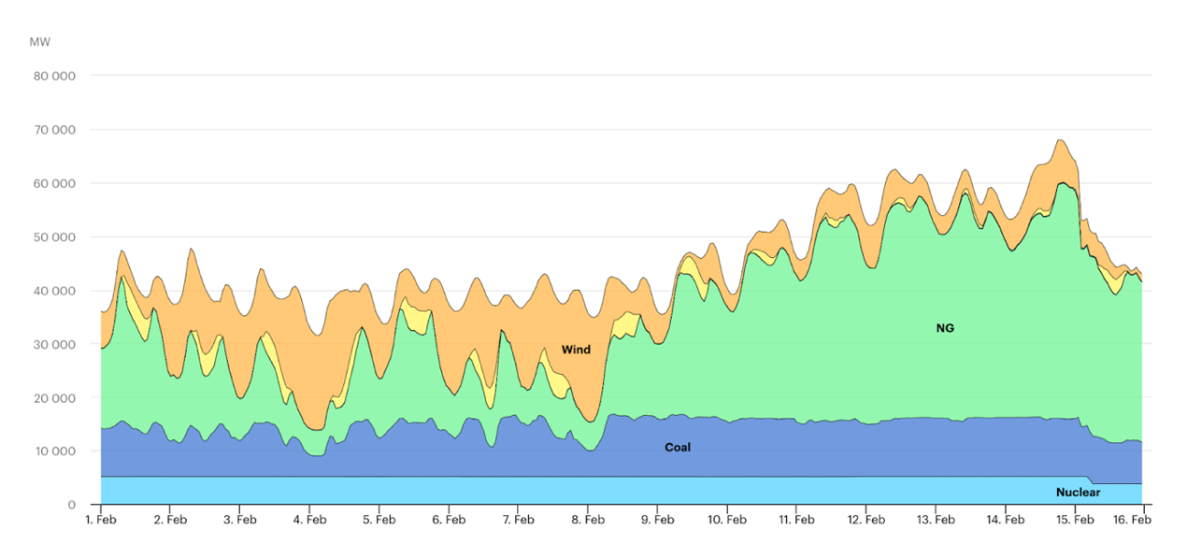
The International Energy Agency has stated that in order to meet global 2050 net zero goals, grid systems globally will need approximately 500GW of demand side assets. The Bitcoin network currently consumes around 17GW and as such we could fit the entire network into this rapidly expanding market many times over. Common narratives would lead you to believe that Bitcoin will hamper energy production but it is clear that mining is solidifying its place as a key grid ancillary that will allow the rapid expansion of renewable infrastructure.

Mining Optimises Electricity Generation & Efficiency
Electricity generation by nature is simple. The transmission and efficient use of that energy is where issues arise as mentioned regarding ERCOT. While mining can be a critical part of grid infrastructure on a large scale, we are also seeing it implemented in behind-the-meter and off-grid solutions.

These unfussy & location agnostic energy consumers are facilitating the onboarding of renewable generation in locations where grid capacity delays are hindering renewable buildout, like we are seeing in parts of Portugal. This is particularly useful in parts of Africa, where microgrids are a necessity due to the disjointed nature of their grid system. However, justifying the financial viability of these microgrids can be a difficult task due to the lack of collocated demand. This where companies like Gridless, Kenya and individuals in Virunga National Park, Congo are leveraging Bitcoin mining location agnosticism to improve the financial viability of these systems, and ultimately allow them to come to fruition. Mining can be collocated with the renewable asset to optimise the full energy capacity that cannot be exported. The use of mining as a location and grid agnostic revenue stream can be the potential missing link in renewable projects bypassing grid capacity issues and ultimately making it to market.

I can speak with first-hand experience that there are multiple renewable operators in Europe viewing mining as an innovative and beneficial bolt on to their existing infrastructure and working to see how it can be used strategically in the development of their renewable assets. Examples include but are not limited to:

- Collocating mining with renewable assets in the Nordics as an alternative revenue source to backstop against negative pricing – specifically renewable sites that are in very remote locations and as such other forms of industry (and energy demand) are reluctant to relocate there – leaving the energy producer with no other solution. Mining also requires very little bandwidth, in stark contrast to other data centres which require high speed fibre optics – this gives Bitcoin mining further leverage to excel as a compact location agnostic consumer of power, even in the most isolated regions.
- Temporarily mining off-grid in Ireland and U.K. to circumnavigate the issues being caused by severely delayed grid connections.
- District heating development in Finland using waste heat from mining operations – the necessary liquid temperature for which can only be achieved by mining machines in such a compact data centre site. This project will also be participating in demand response, further leveraging bitcoin mining’s unique flexible energy demand profile.

These are conversations and projects that are happening right now, but in a forcibly private manner. Mining is being consistently tarnished by articles and rhetoric in the EU that are backed by incorrect data and reasoning, as discussed above and this is forcing renewable industry participants to explore this new technology in private, for fear of a negative public reaction. I believe that if a technology, without any form of government grant or subsidy, is shown to providing a significant net benefit to an industry as important as renewables, should it not be allowed to flourish? All I ask is that mining be given a level playing field to prove its worth amongst some of Europe’s most important renewable operators, and not crush what is an emerging technology due to the fear of negative public and governmental perception. Renewable companies across Europe are already recognising the innovation that mining represents, and they should be capable of adopting this innovation in the same manner in which they are being encouraged to adopt batteries or green hydrogen.

We have seen multiple research papers released in the past 12 months from globally renowned financial institutions like KPMG, to universities such as University College London and Cornell University that substantiate these claims about Bitcoin mining’s harmonious relationship with energy systems and renewable development. I have attached links to the relevant papers below, and an additional research paper by industry leaders on the Texas grid system, ERCOT:

- Leveraging Bitcoin Miners as Flexible Load Resources for Power System Stability and Efficiency:
https://papers.ssrn.com/sol3/papers.cfm?abstract_id=4634256

- Bitcoin’s Carbon Footprint Revisited: Proof of Work Mining for Renewable Energy Expansion: https://papers.ssrn.com/sol3/papers.cfm?abstract_id=4347220

- Bitcoin’s Role in the ESG Imperative: https://kpmg.com/us/en/articles/2023/bitcoin-role-esg-imperative.html

- From Mining to Mitigation: How Bitcoin Can Support Renewable Energy Development and Climate Action: https://pubs.acs.org/doi/10.1021/acssuschemeng.3c05445

Strategic Implementation of Bitcoin Mining Reduces Methane Emissions

ESG analyst Daniel Batten has conducted extensive research on bitcoin mining’s ability to eventually go carbon negative. Bitcoin mining’s compact and location agnostic design can be strategically implemented on flare gas sites, where flaring is currently the only solution to reducing the waste gas, as outlined in detail in the KPMG report attached above.

Marathon Digital Holdings, a US publicly listed miner, recently announced a new project that is reducing methane emissions from landfill gas using Bitcoin mining.

Mining serves as a more economical and efficient use case for the flare gas as combusting the gas in a generator for onsite use allows for a much greater mitigation of methane versus traditional flaring or venting. Companies like Nodal Power are expanding their mining operations in the US, and tapping into the vast availability of flare gas while simultaneously solving a severe problem.

Specific Issues within the Second Consultation Paper
In the simplest summarisation of the extensive evidence provided above, mining is not an energy wasting mechanism. Bitcoin mining is one the most competitive global commodity industries on the planet, and as a result, is forced to constantly innovate and move to areas of the globe where operations are most efficient. There is specific reference in the EU consultation to nation states potentially being forced to cease mining due to potential negative environmental and climate impacts, the above evidence should definitively show that this is counterintuitive.

I have also seen Bitcoin mining targeted as a potential contributor to high energy prices within the EU. However, the entire premise around Bitcoin mining’s high power price sensitivity and directly correlated demand flexibility dictates that there has been negligible on-grid mining in the EU historically, and this will continue in the EU if high energy prices persist. Bitcoin mining will always naturally regulate itself and remove itself from a grid system that is experiencing high demand. This can be in the form of a mining operation ceasing operation entirely, or as simple as shutting off during the day during times of peak demand or severe weather, like is demonstrated in Texas. In short, mining does not need to be forcibly regulated out of an area that is struggling to reduce energy demand and high energy prices, the highly efficient and low margin economics of bitcoin mining dictates that it will always be the first, and most willing demand on a grid system to switch itself off.

Regarding specific points within the paper:

- Page 87 (5) & (6) – there is clear reference here that the adverse impacts of each consensus mechanism should be noted. It should firstly be mentioned that the Bitcoin network’s consensus is governed by globally distributed nodes, not miners. Mining acts a sybil mechanism to maintain the integrity and immutability of the Bitcoin blockchain, in a cohesive manner alongside nodes. Ethereum’s swap to Proof of Stake is often described as a positive move due to its ‘reduction in energy use’, but if we can agree that this is its sole positive narrative, which I believe it is, and we can provide clear justification for Bitcoin’s PoW system above, then the conclusion is that Ethereum has simply moved itself to a more centralised system in which your vote is dictated by your amount of staked Ethereum, which essentially emulates the traditional finance system in which shareholders vote. The globally distributed nature of mining and nodes dotted around the globe is a feature of the Bitcoin network, and is the fundamental driver of Bitcoin maintaining itself as the first and only truly decentralised monetary system. A move away from Proof of Work would simply serve to undermine the core decentralised principle upon which Bitcoin was built.
- Page 87 (7) & Page 88 (10) & (11) – The key indicators described here are grossly over simplified, the yearly average energy consumption, the average energy consumption to validate one transaction, and the yearly average GHG emissions linked to the use of direct and indirect energy sources. To start, each of these metrics will need to be broken down into greater detail, specifically regarding energy consumption per transaction, the lightning network must be considered in this metric. I also found the following phrase, “In light of the global nature of crypto-asset mining activities, quantitative metrics should display gross energy consumption and emissions, without reflecting potential off-setting mechanisms.” to be suggestive that any potential benefits, many of which I have outlined above are to not be considered. The combination of point (7) & (10) seems to suggest an inability for Bitcoin mining to present its potential benefits, and serves to only skew potential data and figures toward crude and oversimplified estimates. Gross consumption will need to be broken into off-grid and on-grid sources to counteract the assumption that all of these operations are only drawing grid power that alternative industrial processes might need, which as I mentioned earlier, we know that in times of peak demand this will not be the case anyway. It is also disappointing that ‘emissions’ will likely just be derived from IP address, global jurisdiction and the associated grid mix in that area, rather than delving into the detail to see if these sites are methane mitigation sites or collocated with renewable sources. If scope 1 and scope 2 emissions are to be stated, then the necessary intricate detail of each mining operation needs be reflected in the methodology of how this data is gathered, not just governed by the estimated global hashrate, the IP associated with the hashrate (which in some instances can be incorrectly displayed), and presumed associated grid mix of these locations.

Fundamentally, Bitcoin mining is being used in a multitude of innovative and sustainable ways around the globe, these cannot be lumped into a single gross consumption figure for the purpose of making crude comparisons to certain countries’ energy usage. The bitcoin network is a highly detailed and intricate ecosystem of globally distributed mining operations and nodes, that should not be represented in such an oversimplified manner.

Bitcoin Mining Should Be Embraced within the EU
The interest in Bitcoin mining that I am seeing on a personal level both from renewable industry experts and education institutions across the EU is profound, just this week I delivered a Bitcoin mining machine to my local university in Cork City as their engineering department is investigating the relationship between renewables and Bitcoin mining. There is a wave of interest stemming from people’s own realisations around Bitcoin mining and its harmonious relationship with energy, I believe this should be embraced in the EU, and the associated innovation be allowed to prosper.

I wanted to note that I will also be chairman of the European Bitcoin Mining Association, which is in the process of being formed in Germany. This association will have a clear goal of engaging with regulators on the EU level, providing transparent data on the mining industry in the EU and ultimately advocating for the development of the industry in a constructive and collaborative manner with energy industry operators and government representatives.

In the interest of staying within my area of expertise, I have focused solely on Bitcoin mining’s various energy related benefits as justification for the networks global energy consumption. It is worth noting that many individuals and communities around the globe have justified the Bitcoin networks existence, whether that be for global remittance, transacting within communities under authoritarian regimes, or escaping hyper inflating currencies in regions where many are de-banked. There are many cases globally, where the Bitcoin network’s existence can be justified, irrespective of its energy use, the cases of which you will hopefully receive in other testimonials. My hope is that in tandem with the evidence provided above, it will be clear without doubt, that the Bitcoin network and crucially, its’ decentralised proof of work sybil mechanism, can provide an innovative and meaningful solution to a multitude of energy and existing financial system inefficiencies.

To conclude, the EU has evidently set out very optimistic renewable and sustainability goals and while mining is by no means the silver bullet to achieving these goals, I believe it certainly has a strong case for inclusion in the conversation. Bitcoin mining is simply an energy asset bolt on, and if well respected and long standing renewable operators are signalling their desire to integrate it into their systems, then I believe it is completely counterintuitive for the EU to be suggesting that it is not only forcibly reduced, but in the worst case scenario, banned completely.

Testimonial of Rupert Matthews
Comments to specific questions of the Second Consultation Paper

My name is Rupert Matthews, I am a senior lecturer at Nottingham Business School, Nottingham Trent University. I teach research methods to undergraduate students and supervise a number of doctorate students. I have conducted and had published in international journals, books and international conferences, research on operational improvement, organisational improvement in public sector organisations, organisational learning and more recently, have begun conducting research into bitcoin. I completed my PhD in business and management at the University of Nottingham in 2013, and from this I published an ABS 4-star journal article (Internationally Excellent), that investigates how small and medium sized firms engaged in operational improvement (1). My research into bitcoin includes a number of journal submissions (two currently under review) and three articles that have been published within Bitcoin Magazine, based on learning about the asset for the past 3 and a half years. Moving forward, I am planning to extend this research through empirical research and applying for research funding in this area.

I am providing a selection of comments to specific questions within the “Technical Standards specifying certain requirements of Markets in Crypto Assets Reulations (“MiCA” or the Regulation”) – second consultation paper, dated 5 October”. When referring to specific sections, this is the document I am referring to.

My background was initially as an engineer, after my undergraduate degree, this provided experiences of real world, practical challenges faced by local and international organisations. When I returned to university after 4 years in industry, I have been able to apply what I learnt in practice to first developing a new appreciation for the value of academic research and models, and combine this with a critical view on the need to be able to apply this to practice. Following taught courses, I began conducting research with firms similar to those I previously work with, to bring academic frameworks into the practices of real-world organisations. If I have learnt anything from my time in academia, it is, there is nothing more practical than a good theory, but there are few things worse that research presented as “academic”, when it is anything but, which within the field of business and management is not generally a problem.

Unfortunately, during my academic exploration of research into bitcoin, I have found that the type of research that often gets published lacks the rigour I would expect from peer reviewed articles. The Whitehouse commissioned report into the implications of crypto assets (2) and Nick Carter’s response (3) provided a useful initiating point for my work. These demonstrated that the sources drawn from by government commissioned reports did not match up to the standard that I would personally hold when conducting research.
As I began to review academic research, I explored literature reviews related to bitcoin and in particular, found a “systematic literature review” comparing the impact of proof of work versus proof of state consensus algorithms (Wendl et al. 2023)(4). Given that my first and most cited article was also a systematic literature review (5), this piqued my interest, given this methodology is one of the most effective methods for developing a broad, unbiased understanding of a field of research. However, the review (published within a peer reviewed journal) drew from many of the sources identified by Nick Carter (3), resulting in the development of a framework that was focused on the negative impact of proof of work cryptocurrency mining.

Reading this work led me to write an article for Bitcoin Magazine (6) that highlights the need for higher quality research within the field of bitcoin, combined with the need for academics to identified and explicitly respond to research of poor quality. To follow my own advice, I wrote a response article to Wendl et al.’s article (6), which specifically focused on identifying and critiquing the papers being drawn from, focusing on some of those identified by Carter (3), in particular, work by Alex de Vries, that the review drew extensively from. My response was submitted to the journal of environmental management, but was rejected because it did not include new empirical data. In addition to outlining limitations with the paper, the response also revised the conceptual framework of Wendl et al., to provide a conceptual model that outlines, evidenced by the paper’s discussion, how proof of work consensus algorithms can positively impact the environment.

I have also written a second response article to a piece looking at the impact of green bonds by Yadev et al. (8). In this work (9), attention was given to critiquing an infamous piece of research published by Mora et al. (10), which has been widely critiqued, but is still getting cited by research. While my article was also rejected, it received positive comments, but in combination with the previous response article, highlights an issue with bitcoin related academic research, where the reviewers, who represent the gatekeepers and arbiters of research quality, are not sufficiently informed about bitcoin to review academic papers on the subject.

Reaching this position leads me to my assessment of particular aspects of the ESMA’s, consultation paper, helping identify specific parts that would benefit from being reflected on, critically reviewed and as a result of this, revised, in order to be more representative of bitcoin mining actual impact of the environment, compared to certain misrepresentations. There are a number of points that I feel would benefit from clarification. I will focus on those points that are specifically related to my understanding, experience and knowledge related to the rigours of high quality academic research. This begins with the tone of a statement very early section of the report:

Section 3.1: “The consensus mechanisms used for the validation of transactions in crypto-assets might have principal adverse impacts on the climate and other environment-related adverse impacts”.
Something that is often misunderstood, is that the consensus algorithm of bitcoin mining uses electricity, so does not itself affect the environment, other than relatively low-level heat emissions (which can be repurposed). The impact on the environment (if any) is a result of the processes used in the generation of the electricity. Following this logic, any process that uses electricity could be viewed as having “adverse impacts on the climate”. Following my own research and the “scientific method”, if such a statement is made, it needs to be backed up by high quality, peer reviewed literature, to pose a hypothesis and then use rigorously collected data to determine whether the null hypothesis can be rejected. From the research I have conducted, while there may be cases of coal fired power stations mining bitcoin, given the costs, this source of electricity is unlikely to be financially sustainable to use in bitcoin mining.

My research instead shows that there are many examples where renewable energy is used to mine bitcoin, as a result of renewable electricity being one of the cheapest sources of electricity, and with bitcoin mining being a user that can make use of intermittent electricity sources and can provide revenue from otherwise wasted electricity. Recently published research (11) demonstrates that bitcoin mining can actually incentivise the development of renewable energy infrastructure, by providing revenue before infrastructure is connected to an electricity grid, as well as providing a use of electricity that is generated when there is not demand. In this situation, rather than adversely impacting the environmental, bitcoin mining has been shown as a tool that promotes the development of renewable energy, so reducing reliance of non-renewable sources. There are also examples of current renewable infrastructure (in Scotland) that is paid to shutdown as a result of insufficient grid connection, meaning bitcoin mining could both reduce this cost as well as monetise generated energy (12).

Point 17: “Based on an initial analysis of the academic body of research”.
Based on previous discussions, this raises some concerns, given issues with previously published research. The topics identified in this section are also interesting, 1) energy consumption of nodes, 2) location of nodes and 3) the devices used to both add transaction and store a copy of the ledger. Given the energy consumption and storage requirements of validator nodes is minimal compared to the operation of ASICs, it would be very interesting to know the academic sources that have been drawn from. Location also raises questions, given that bitcoin mining is location agnostic, meaning it can be collocated anywhere with cheap sources of electricity. Again, this raises questions on the academic sources drawn from, when focusing upon specific energy sources used by bitcoin mining, rather than location in generation, would be a more important factor to consider.

P101: “Natural resources: Total water consumption linked to the validation of transactions and the maintenance of the integrity of the distributed ledger of transactions, expressed in cubic meters”.
Total water consumption linked to the validation of transactions is an unusual metric, given that bitcoin mining uses electricity, water is not directly involved. If water is used to generate electricity, the use of the water related to energy generation is not related to the mining of bitcoin, in the same that environmental damage from power generation is not related to the mining (withstanding heat generated by ASICs and electronic waste). Potentially, water could be used to cool miners (which can improve efficiency), although is some cases, this can be used to heat residential water, so not actually using water, rather heating, while saving energy from other sources (gas or electric) to heat residential water.

A recent publication, again by Alex De Vries (13), uses this measure of water usage related to bitcoin mining. As with other work by the author, this piece was not peer reviewed, presents multiple unsubstantiated claims and fascinatingly, suggested, in the abstract “To address this increasing water footprint, miners could apply immersion cooling and consider using power sources that do not require freshwater”. The simple logic of using water cooling compared to air cooling as a way to use less water is flawed. De Vries later states “Water consumption is not extensively studied in Bitcoin mining”, which is because bitcoin mining does not consume water, it can use water for cooling or used to generate electricity, but in these cases it is the thermal properties and kinetic energy, respectively, that are used, with the state of the water remaining unchanged (so can be reused).
As with the work of De Vries that I critiqued within (5), the work is not academically rigorous, uses flawed logic to develop arguments, with a clear agenda to promote alternate consensus mechanisms, particularly proof of stake. The work of Mr. De Vries (a research student and employee of a bank) demonstrates the impact that poor quality research can have, particularly if it is aligned with sensationalist findings that can be promoted by mainstream media (14). As with other uses of “per transaction” metrics presented by De Vries, it is important to clarify that energy use of the bitcoin network is independent from the number of transactions that are processed. Viewing this from an academic and engineering perspective, the argument and logic for presenting per transaction metrics is simply an error. This metric is used 3 times in the ESMA paper.
While there are other aspects of the consultation that I believe would benefit from clarification, I have focused my comments of the areas that I have particular knowledge and experience, which in within the field of academic research. I would be very happy to be asked for my views on research within the field that you plan to draw from, to ensure that the work, policies and strategies related to the use of cryptocurrencies (but specifically bitcoin) and proof of work consensus algorithms within the European Union provide benefits for individuals, institutions, communities, the economy and the environment. Using sources that are not representatives of the academic understanding, rigorous research and practice, risk negative outcomes into the future.

Thank you very much for considering my comments.
I would be very happy to discuss further if there are any points that are unclear.
Best wishes,

Dr. Rupert L. Matthews

Sources:
- Matthews, R. L., MacCarthy, B. L., & Braziotis, C. (2017). Organisational learning in SMEs: a process improvement perspective. International Journal of Operations & Production Management, 37(7), 970-1006.
- OSTP (2022). Climate and Energy Implications of Crypto-Assets in the United States. White House Office of Science and Technology Policy. Washington, D.C. September 8, 2022. URL https://www.whitehouse.gov/wp-content/uploads/2022/09/09-2022-Crypto-Assets-and-Climate-Report.pdf

Carter, N., (2022), Comments on the White House report on the climate implications of crypto mining”, Published by Medium., URL https://medium.com/@nic__carter/comments-on-the-white-house-report-on-the-climate-implications-of-crypto-mining-8d65d30ec942, accessed 22-11-2022
- Wendl M., Doan, M.H., Sassen, R., (2023). The environmental impact of cryptocurrencies using proof of work and proof of stake consensus algorithms: A systematic review, Journal of Environmental Management, 326, p1-13.
- Matthews, R.L. Marzec, P.E. (2012), Social capital, a theory for operations management: A systematic review of the evidence. Int. J. Prod. Res. 2012, 50, 7081–7099.
- Matthews, R., (2023), “’Don’t Trust, Verify’: Fixing the Problems with Academic Research on Bitcoin”, Published by Bitcoin Magazine, accessed 05-05-2023, URL https://bitcoinmagazine.com/culture/fixing-academic-research-on-bitcoin

Matthews, R.L., (2023), “The Environmental Impact of Cryptocurrencies: A Clarification for Wendl et al. (2023)” Published by SSRN, URL https://papers.ssrn.com/sol3/papers.cfm?abstract_id=4494155

8) Yadav, M.P., Tandon, P., Singh, A.B. et al. Exploring time and frequency linkages of green bond with renewable energy and crypto market. Ann Oper Res (2022).
- https://doi.org/10.1007/s10479-022-05074-8

Matthews R.L., (2023) “Exploring time and frequency linkages of green bond with renewable energy and crypto market: A short clarification”, Published by SSRN, URL https://papers.ssrn.com/sol3/papers.cfm?abstract_id=4597862
- 10) Mora, C., Rollins, R. L., Taladay, K., Kantar, M. B., Chock, M. K., Shimada, M., & Franklin, E. C. (2018). Bitcoin emissions alone could push global warming above 2 C. Nature Climate Change, 8(11), 931–933. https://doi.org/10.1038/s41558-018-0321-8
- Lal, A., J., Zhu, You, F. From Minig to Mitigation: How Bitcoin can Support Renewable Energy Development and Climate Action, ACS Sustainable Chemistry & Engineering 2023 11 (45), 16330-16340 DOI: 10.1021/acssuschemeng.3c05445
- https://news.sky.com/story/britons-paying-hundreds-of-millions-to-turn-off-wind-turbines-as-network-cant-handle-the-power-they-make-on-the-windiest-days-12822156
- De Vries, A., (2023), “Bitcoin’s growing water footprint”, Cell Reports Sustainability, November 29,2023DOI: https://doi.org/10.1016/j.crsus.2023.100004
- Vallance, C., (2023), “Every Bitcoin payment ‘uses a swimming pool of water”, published by the BBC, URL https://www.bbc.co.uk/news/technology-67564205, accessed 07-12-2023

Testimonial of Bert de Groot
Bitcoin Brabant - Pioneering Sustainable Solutions in Energy Consumption and Grid Balancing

Bert de Groot is Chairman United Bitcoin Companies The Netherlands. De Groot is owner of Bitcoin Brabant, a tech company that provides heating for businesses using bitcoin mining and helps businesses transition to the bitcoin standard. Previously Deputy Managing Director & Operations Improvement at the BCTN Network of Inland Terminals, the largest inland terminal operator of the Benelux. De Groot graduated from the IHE Delft Institute of Water Education with an engineering degree.

Bitcoin Brabant is a leading advocate for responsible Bitcoin practices, has been at the forefront of implementing innovative solutions that contribute to a sustainable energy future in The Netherlands and beyond.

Our business answers to the question why computers, mining Bitcoin around the clock, outperform traditional gas-powered heating for office buildings. It is important to notice that the business model is very much depends on prevailing electricity prices. With a current energy price above 25 cents in the EU it is economically irrational to mine Bitcoin. When gas prices started rising, our company proposed to replace old electric heaters in the greenhouse for bitcoin mining computers for heating. As result such solution helped thousands of households in reducing or eliminating the use of natural gas for heating. For example, our installations help to heat greenhouse growing tulips or vegetables. One of our customers, who installed a miner to heat plants in a greenhouse, earned about 7.5 euros every day through this system. That means a passive annual income of around 2,700 euros according to Bitcoin's current price. By leveraging electric Bitcoin heaters, individuals have successfully transitioned to a cleaner and more efficient heating solution.

In Amsterdam and Hamburg, Bitcoin Brabant is making significant strides in the heating sector. The organization is working on heating multiple large apartment buildings using Bitcoin E-Boilers. These boilers generate high-temperature water required for households, utilizing innovative high-temperature chips that also support the Bitcoin network. This approach presents a sustainable alternative to traditional heating methods.

Bitcoin Brabant is actively involved in aiding multiple megawatts of renewable energy projects. The organization provides easily transportable and flexible solutions to expedite capacity expansion, particularly in cases where grid capacity is insufficient. This approach allows for the swift development of solar and wind farms without the need to wait for extended periods until grid capacity catches up.

Bitcoin Brabant is actively contributing to grid balancing efforts in The Netherlands. By deploying Bitcoin grid balancers, the organization plays a crucial role in maintaining grid stability. As a practical example, Bitcoin Brabant has replaced traditional methods, such as infrared lamps in greenhouses, with Bitcoin boilers. This transformation allows for the storage of heat, which can be utilized when needed, reducing the reliance on instantaneous heating and lowering the overall cost of grid balancing.

Bitcoin Brabant is dedicated to not only advancing the use of Bitcoin but also ensuring that these advancements align with environmental sustainability. Our initiatives showcase the practical applications of Bitcoin in addressing real-world energy challenges.

For further information, please contact:

Bert de Groot, Owner
info@bitcoinbrabant.com

Testimonial of Rafael Cordon
Bitcoin’s role in Guatemala’s Digitally Safeguarded Democracy:
Bitcoin Simple Proof Solution

Rafael Cordon is CEO / Co-Founder Simple Proof, a startup that helps institutions uphold information integrity through immutable record-keeping and trustless verification. He recently worked with the Guatemalan government to safeguard elections documents using the Bitcoin blockchain.

Rafa Cordon is an entrepreneur and technology consultant with more than 15 years experience advising governments on data platform strategy and innovation. Cordon is Chief Cloud Architect at ITZ DATA, a Government Competency AWS Advanced Consulting Partner specialized in working with Public Sector institutions on their cloud adoption journeys across Latin America and the Caribbean. Previously, Cordon worked as an IT strategy consultant in Accenture’s New York office, working with financial services clients. Cordon holds a Master of Engineering Management degree from Duke University and a Bachelor in Mechanical Engineering degree from Universidad del Valle de Guatemala.
Bitcoin Simple Proof Solution
In Guatemala's 2023 elections, the country's highest electoral authority turned to the Bitcoin Blockchain technology to digitize and secure voting tallies and other key election documents, rendering them tamper-proof and immutable against unauthorized alterations and potential misuse of Artificial Intelligence (AI) and disinformation campaigns. This historic, first-time application played a crucial role in safeguarding the integrity of information in Guatemala's recent elections, especially vital in a post-electoral landscape marked by potential interference and widespread protests.
We fully share and proved in practice the acknowledgment of the Center for Democracy & Civil Society at Georgetown University about the use of the Bitcoin Blockchain technology. It is […] “widely known for its association with cryptocurrencies such as Bitcoin, is a decentralized and transparent system that records all transactions on a distributed network of nodes. One of the main characteristics of the blockchain is its immutability, which means that once information is recorded, it is incredibly difficult to modify without the consensus of the majority of network participants.
In the context of growing global interest in blockchain technology, it is important to examine how this innovation is being used in various domains. Guatemala has embarked on the adoption of blockchain technology to strengthen the veracity of its electoral mechanisms by leveraging the security, transparency, and resilience of the Bitcoin blockchain. The application of this technology deserves close examination, as it has the potential to catalyze a new era in electoral processes and in general, a new way to safeguard digital documents. It remains to be seen whether – in developing democracies like Guatemala – the use of this technology in elections will usher in a new age of transparency.”
Background: In 2019, Guatemala faced a pivotal chapter in its electoral history. The country’s Supreme Elections Tribunal (TSE), responsible for overseeing elections, and its historically acclaimed decentralized electoral model was seriously threatened. The period leading up to the 2019 elections was marked by political turbulence and uncertainty around the technology systems to be used to count and publish the votes, coupled with the global trend of political parties making unsubstantiated claims of fraud. The night of the elections, after voting centers closed, the TSE IT System crashed, and the online publishing of results became erratic, causing widespread confusion and distrust. In response to these challenges threatening the integrity of democracy itself, for the 2023 elections, the TSE successfully implemented a solution based on the Bitcoin Blockchain, which played a pivotal role in upholding information integrity.
Electoral Process and Centralisation Challenge: At the heart of Guatemala's electoral system are the Vote Reception Boards (JRVs in Spanish), established in all voting centers across the nation, totaling around 25,000. Comprising five citizen volunteers each, these boards form a 'citizen army' of roughly 100,000 individuals, playing a critical role in the electoral process: receiving ballots from voters and ensuring the manual vote count proceeds transparently and impartially. This process, further observed by representatives from opposing political parties and electoral observation missions, both local and international, is foundational in ensuring the credibility of election results. Over the years, the system evolved to incorporate technological advancements that aid in processing and announcing election results that come from the compilation of the tally sheets created by the JRVs. It started with basic tech tools, like fax machines, and gradually moved towards more sophisticated digital solutions. However, like in many democracies across the world, the adoption of centralized IT systems for vote counting has introduced challenges, as it creates a closed, unverifiable environment susceptible to abuse, especially in challenging democratic contexts.
Implementation of the Simple Proof Solution: In response to these challenges, the TSE implemented Simple Proof, a pioneering immutable backup solution that, at its core, utilizes the OpenTimestamps protocol, which leverages the Bitcoin Blockchain and cryptographic mechanisms to provide proof of the authenticity of digital documents. In practice, by digitizing around 150,000 vote tally sheet images and saving them on a decentralized ledger, the system safeguarded the documents from alteration, including making it resilient against attempts at AI manipulation or unsubstantiated allegations of fraud and election theft. Importantly, this system is open to anyone, allowing for broad verification and transparency.
Preserving Decentralization. Impact on Electoral Integrity and Community Empowerment: The implementation of Simple Proof is a pivotal moment in the reclamation of the electoral system's decentralization, enhancing its security, transparency, and integrity while empowering the people. It addresses the vulnerabilities inherent in the digital realm, where previously, alterations to electoral data could occur without leaving any trace. By securing the digital documents that contain manually revised information created under the objective scrutiny of opposing stakeholders at the community level (JRVs and various electoral observers), the use of Simple Proof reinstates the power of verification to the people. Before the implementation of the system there was no way of verifying whether the information used to calculate the final results was compromised, altered, or tampered. Now anyone has the unprecedented ability to independently verify the accuracy of the vote counting process, reducing reliance on central electoral authorities, and fostering a renewed sense of ownership and trust in the democratic process. This became evident as individual groups of citizens started downloading vote tally sheets, validating the counting process and publishing their own findings on social media. Traditional and independent news outlets published articles and podcasts on how the Bitcoin blockchain system was used to safeguard elections information. This has proved crucial amid the turbulent political context of unsubstantiated allegations of election fraud and attempts at political interference.
Solution's Resilience in Guatemala's Political Crisis: Guatemala is currently untangling a complex post-election landscape marked by widespread protests that decry suspected political meddling by the Ministerio Público (Attorney General, or MP by its Spanish acronym). These protests were triggered by the MP’s unprecedented confiscation of all the physical tally sheets, an action deemed unconstitutional by many legal experts. The ongoing demonstrations outside the MP's office, widely covered by local and international news sources, underscore the deep-seated concerns held by the public regarding the credibility of the electoral process and the role of governmental institutions in preserving democratic principles. These protests also reflect the public's demand for increased transparency and accountability.
In this context, Bitcoin blockchain technology played an important role in ensuring election result accuracy, as recognized in reports by the European Union Election Observation Mission (MOE-UE) and the Organization of American States (OAS). However, challenges persist due to actions of the MP’s office undermining the trust in the process. Other inquiries, including an ongoing closed-door investigation into the Simple Proof solution, have also raised concerns of potential political persecution.

Transitioning to a wider view, as observed by the EU Observatory Mission’s report, Guatemala's 2023 elections occurred under complex circumstances, marked by political tension and strained democratic system, compounded by legal controversies such as arbitrary candidate disqualifications. The report highlighted issues like the misuse of institutions or restricted media landscape. Despite these hurdles, the Guatemalan people showcased a strong commitment to their democratic rights. These observations are crucial in understanding the context in which the elections were held, reinforcing the importance of robust systems to uphold electoral integrity.

The United States has already sanctioned key actors, including the attorney general and the anti-corruption prosecutor who is leading investigations into Semilla and the electoral process. Some Guatemala experts, such as former U.S. Ambassador Stephen McFarland, argue that in addition to canceling visas, the United States should consider using the Magnitsky Act to freeze the U.S. assets of those responsible for human rights violations or acts of significant corruption.
Conclusion and Global Relevance: In a time of political uncertainty in Guatemala, as the nation prepares for the inauguration of the President-Elect on January 14, 2024 the importance of transparent and secure electoral systems is readily apparent. The country stands at a crossroads, where the effective use of technology like Bitcoin blockchain can play a pivotal role in restoring faith in democratic institutions and processes. The successful implementation of Guatemala's blockchain-based electoral system also holds profound implications for democracies worldwide. In an era marked by the growing relevance of AI and data security concerns, and amidst the backdrop of coordinated disinformation campaigns and populist challenges to election results, Guatemala's model provides a valuable blueprint for other nations seeking to enhance electoral transparency and integrity. While the adaptation of this system may necessitate adjustments to align with the unique political and technological landscapes of different countries, its fundamental principles of decentralization, transparency, and community empowerment remain universally applicable.
Media References:
- Criminal Lawsuits Against TSE Magistrates
  - https://www.prensalibre.com/guatemala/elecciones-generales-guatemala-2023/antejuicio-contra-magistrados-del-tse-queda-en-manos-del-congreso-tras-resolucion-de-la-csj-breaking/
  - https://prensacomunitaria.org/2023/09/ministerio-publico-presenta-nueva-solicitud-de-antejuicio-contra-magistrados-del-tse/
  - https://cnnespanol.cnn.com/2023/09/27/ministerio-publico-pide-levante-inmunidad-magistrados-tribunal-supremo-electoral-guatemala-orix/
- Allegations Denouncing Irregular Tally Sheets
  - https://www.plazapublica.com.gt/content/con-15-actas-tachadas-la-alianza-oficialista-freno-por-una-semana-las-elecciones
  - https://twitter.com/search?q=actas%20alteradas&src=typed_query
- Attorney General Tally Sheet Investigation
  - https://cnnespanol.cnn.com/2023/09/30/ministerio-publico-guatemala-decomisa-actas-elecciones-orix/
  - https://emisorasunidas.com/2023/09/30/mp-secuestra-actas-electorales-tse/
- International Observation Missions Reports
  - European Union Spanish Report, Page 13: https://www.eeas.europa.eu/sites/default/files/documents/2023/EU%20EOM%20GT%202023%20FINAL%20REPORT%20SPANISH_0.pdf
  - OAS General Elections Report in Spanish, Page 10: https://www.oas.org/fpdb/press/INFORME-PRELIMINAR---Mision-Electoral-OEA-en-Guatemala-1ra-vuelta-.pdf
  - OAS Run-Off Report in Spanish, Page 24: https://www.oas.org/fpdb/press/INFORME-PRELIMINAR---Mision-Electoral-OEA-en-Guatemala-2da-vuelta.pdf
  - Association of World Election Bodies: http://www.aweb.org/eng/bbs/B0000013/view.do?nttId=15825&gubun=1&menuNo=300040
  - Statement by High Representative Josep Borrell on the latest developments in Guatemala: https://www.eeas.europa.eu/eeas/guatemala-statement-high-representative-josep-borrell-latest-developments-guatemala_en
- Guatemalan Supreme Elections Tribunal (TSE) official Communications
  - https://x.com/tseguatemala/status/1699888491260158112?s=61&t=T8VHpe0mnwpiVgBAUYkfKg
  - https://www.tse.org.gt/index.php/comunicacion/noticias/875-el-trep-reporta-99-de-eficacia-y-que-el-61-de-empadronados-votaron
- Independent Citizens:
  - https://twitter.com/andreadelapazgt/status/1675728870626975744
  - https://twitter.com/_mishumish_/status/1675674607553064960
  - https://twitter.com/fsanchinelli/status/1676059020476416000
  - https://twitter.com/Afroboygt/status/1675930537746112527
  - https://twitter.com/camevibes/status/1676275548543229966?s=20
- Podcasts:
  - https://www.youtube.com/watch?v=BLtaDQ38IAE
- Documentary:
  - https://film.simpleproof.com

Testimonial of Kristaps Stikuts

Cases of Bitcoin mining in the EU & Africa
Kristaps Stikuts, COO and co-owner of Power Mining, Power Mining Solar and a Bitcoin mining enthusiast. Kristaps Stikuts discovered cryptocurrency mining in 2013 when he mined Litecoin with his gaming computer and since then he has always followed this industry which later turned into his career. Power Mining is based in Latvia and was founded in December 2017.

Power Mining provides tools and technical infrastructure for Bitcoin miners worldwide. In Europe, our main product is Bitcoin mining containers - portable data centers in a rebuilt shipping container. Power Mining Solar, however, is a developer of solar panel parks. Working with many clients in the Bitcoin mining segment during the recent 5 years, I have seen numerous interesting scenarios which are different from the assumption that Bitcoin mining is a coal / gas burning giant which produces magic internet money.
Bitcoin mining is a very competitive industry. The margins in this industry are lower than most businesses and the market self-adjusts (using difficulty adjustments) combined with the Bitcoin price, which means that Bitcoin miners are fighting for survival when Bitcoin price stagnates and earn larger profits only when Bitcoin price increases faster than the network hashrate can grow. The largest Bitcoin miners are running their operations in the USA (USA has the highest number of publicly listed Bitcoin mining companies as well), as they can find electricity prices under 0.05EUR / kWh over there.

For Bitcoin miners in Europe it's very hard to get such rates consistently (if we look in general, for Bitcoin miners that are willing to operate anywhere in the world, Europe is unappealing, as the electricity price is too high and mostly companies with local capital operate here. However, there are locations in Europe with very cheap energy - remote locations in Sweden (closer to north) with excess renewable energy, Iceland (geothermal energy), Finland (nuclear and booming renewable sector).
Access to cheap energy is a must-have rule for bitcoin mining. Typically, miners utilise surplus energy that is not in high demand. Given the global market for bitcoin mining, miners economically can operate only where energy costs are low. I have observed that the customers I had worked with, who deployed mining farms in more central areas (e.g. Berlin), went bankrupt soon as the energy price was too high to operate such operations efficiently.
As Bitcoin miners in Europe are on average less competitive worldwide than miners with cheaper energy, they need to compensate for it somehow. The pattern that I'm seeing in Europe, especially in Nordics - is Bitcoin miners trying to optimize their operations by utilizing heat reuse and discovering the grid balancing component. There's a big renewable energy (mostly wind + solar) surge in Northern Europe, which will equal decreasing grid stability and more demand of grid balancing (turning on large 'consumers') will be necessary.
A few years ago there were experiments with immersion cooling (immersing Bitcoin miners in dielectric liquid that can be cooled externally), but as of 2023, the hydro and immersive cooling systems are becoming very popular among Bitcoin miners. It allows better cooling but for countries with cold weather it allows much better heat reuse possibilities than air cooled operations.
Heat reuse possibilities can be: connecting to the district heating grid to reuse the emitted miner heat, heating greenhouses, swimming pools. I want to share the cases where the clients I have worked with are doing something out of the ordinary in terms of making more use of Bitcoin mining than just earning Bitcoin.
Finland:
I visited a company in Finland in Q4 2023 which plans to deploy 1MW of immersion cooled miners that will provide the excess heat to the district heating entity. The district heating already has installed their connection in their premises.
Sweden:
One of the clients deployed a Bitcoin miner container which has the warm air output connected to a greenhouse. They are growing different kinds of vegetables there.
Orkney Islands:
One Bitcoin mining container was a part of a demand response scenario with a requirement to be able to ramp up or down the power within a 2 second window (which also required battery banks to secure graceful ramp-down and / or avoid any trickle power).
Netherlands:
A company reached out to us to manufacture a system for grid balancing with Bitcoin miners.
The company is based in the Netherlands and has plans to provide grid balancing with demand response. For providing this demand response utilization of power, the company will get paid.
Given the energy price in the Netherlands, Bitcoin mining wouldn't be profitable but they are getting the mined Bitcoin as a bonus when they are providing the grid balancing service.
Africa:
Companies like GridLess (Kenya) and Big Block Green Services (DRC) are pioneering the Bitcoin mining in Africa by utilizing excess power in already built hydro power plants (BBGS @ DRC) and creating microgrids.
Latvia:
Although the company I work for is based in Latvia, there hasn't been a lot of Bitcoin mining activity here due to the power price (above 0.1 EUR / kWh). In 2018 I was working on a project where a client of ours connected to a cogeneration plant (chipped wood) to run a Bitcoin mining farm.
To conclude, I believe that Bitcoin mining in Europe isn't something that will massively grow due to the high average energy prices unless there is overproduction of new renewable energy in certain regions. There isn't very accurate research available online on the percentage of renewables used by Bitcoin miners in Europe, but from what I see from our customers - 95% of them in Europe are operating in renewable dominating regions. A Bitcoin mining hardware piece doesn't do more harm than an electric car if renewable energy is provided as a source.

https://en.odfoundation.eu/projects-and-campaigns/combating-financial-exclusion-and-work-of-btc-coalition/
https://eur-lex.europa.eu/legal-content/EN/TXT/?uri=CELEX%3A52022DC0552&qid=1666369684560
https://ted.europa.eu/udl?uri=TED:NOTICE:577973-2023:TEXT:EN:HTML
https://www.ecb.europa.eu/pub/financial-stability/macroprudential-bulletin/html/ecb.mpbu202207_3~d9614ea8e6.en.html
https://www.bankingsupervision.europa.eu/press/speeches/date/2023/html/ssm.sp231114~fd1b2cc234.en.html
https://www.reuters.com/article/us-russia-politics-navalny/russia-freezes-bank-accounts-linked-to-opposition-politician-navalny-idUSKCN1UY1ER
https://stockholmcf.org/erdogans-long-arm-deutsche-bank-closes-accounts-of-erdogan-opponents-without-giving-any-reason/
https://www.hrw.org/news/2021/07/07/kazakhstan-crackdown-government-critics
https://en.odfoundation.eu/a/32928,oppositionist-therefore-extremist/
https://www.theguardian.com/world/2020/nov/13/belarus-tells-banks-seize-money-raised-help-protesters-lukashenko
https://bitcoinmagazine.com/culture/bitcoin-financial-freedom-in-afghanistan
https://www.iranintl.com/en/202212067151
Full list of testimonies published as an Annex 1 to the submission of the BTC Coalition to Germany Government and German representation of the Financial Action Task Force (FATF): https://en.odfoundation.eu/a/723329,joint-submission-of-the-civil-society-coalition/
https://en.odfoundation.eu/a/713785,summary-of-humanitarian-aid-to-ukraine-for-the-period-24-02-2022-30-09-2023/
https://en.odfoundation.eu/content/uploads/2023/11/27.11.2023_annex-1-testimonials-on-misuse-of-aml_cft.docx.pdf
https://digitalcitizenfund.format.com/about
https://www.nbcnews.com/business/business-news/afghanistan-braces-even-greater-financial-disaster-n1277032
https://www.buzzfeednews.com/article/clarissajanlim/gofundme-fundraiser-afghanistan-queer-trans
https://en.odfoundation.eu/content/uploads/2023/11/27.11.2023_annex-1-testimonials-on-misuse-of-aml_cft.docx.pdf
https://studentsforliberty.org/alumni-for-liberty/
https://en.odfoundation.eu/content/uploads/2023/11/27.11.2023_annex-1-testimonials-on-misuse-of-aml_cft.docx.pdf
https://acf.international/
https://en.odfoundation.eu/content/uploads/2023/11/27.11.2023_annex-1-testimonials-on-misuse-of-aml_cft.docx.pdf
https://ain.ua/2022/08/09/wise-zablokuvav-rahunky-fondiv-yaki-dopomagaly-ukrayini/
https://vctr.media/ua/ne-takyj-j-idealnyj-chomu-ukrayinczi-vzhe-skarzhatsya-na-paypal-132476/
www.simpleproof.com
https://pace.coe.int/en/files/33143/html
https://pace.coe.int/en/files/31622/html
https://pace.coe.int/en/files/32999/html
https://www.oscepa.org/en/documents/annual-sessions/2023-vancouver/declaration-29/4744-vancouver-declaration-eng/file
https://defendcivicspace.com/wp-content/uploads/2023/06/SRCT_GlobalStudy.pdf
https://ec.europa.eu/commission/presscorner/detail/en/ip_22_6228
https://ted.europa.eu/udl?uri=TED:NOTICE:577973-2023:TEXT:EN:HTML
Our investment fund, Exponential Founders’ Fund, invests into technology that can disrupt entire industry sectors. For this reason we were the lead-investor in Zincovery, who have the potential to decarbonize the entire Zinc Recycling industry. We also made multiple investments into Hot Lime Labs, who have the potential to wean the global Greenhouse industry off fossil fuel from gas (used for heating and CO2 production).
https://batcoinz.com/BEEST/
https://www.sec.gov/Archives/edgar/data/1844971/000119312521332868/d253482ds1.htm
https://greenidge.com/greenidge-generation-announces-successful-start-of-operations-at-state-of-the-art-data-center-for-digital-currencies/
https://link.springer.com/chapter/10.1007/978-3-031-32415-4_2
https://thehill.com/opinion/energy-environment/4245911-dont-buy-bitcoins-dishonest-attempt-to-paint-itself-green/
https://thehill.com/opinion/energy-environment/4315048-bitcoin-mining-is-energizing-sustainability-through-green-innovation/
https://kpmg.com/us/en/articles/2023/bitcoin-role-esg-imperative.html
Despite this, there is evidence that in 2023 the overall weight of journalist coverage of Bitcoin environmental impact has begun tending net positive: https://batcoinz.com/positive-press-about-bitcoin-esg-outnumbers-negatives-51-so-far-in-2023/
https://twitter.com/DSBatten/status/1726129764224938058?s=20
https://ceepr.mit.edu/wp-content/uploads/2023/06/MIT-CEEPR-WP-2023-11.pdf
https://pubs.acs.org/doi/10.1021/acssuschemeng.3c05445
https://www.independent.co.uk/tech/bitcoin-mining-solar-wind-renewable-energy-b2454666.html
https://batcoinz.com/positive-press-about-bitcoin-esg-outnumbers-negatives-51-so-far-in-2023/
https://www.jbs.cam.ac.uk/2023/bitcoin-electricity-consumption/
https://twitter.com/DSBatten/status/1726129770617073684?s=20
https://twitter.com/DSBatten/status/1726129773473357975?s=20
https://twitter.com/DSBatten/status/1726129761247007020?s=20
https://www.whitehouse.gov/wp-content/uploads/2022/09/09-2022-Crypto-Assets-and-Climate-Report.pdf
https://batcoinz.com/quantifying-the-impact-of-using-stranded-methane-on-the-bitcoin-network/
https://batcoinz.com/quantifying-the-impact-of-using-stranded-methane-on-the-bitcoin-network/
https://www.youtube.com/watch?v=bYoHCs_jDcM
https://www.techcircle.in/2022/09/28/gps-based-toll-system-will-need-to-address-accuracy-issues-privacy-challenges
https://earthjustice.org/press/2022/icymi-three-new-reports-paint-damning-picture-of-climate-killing-community-impacts-of-cryptocurrency-mining
https://ccaf.io/cbnsi/cbeci/ghg/methodology
https://ccaf.io/cbnsi/cbeci/ghg/methodology
https://www.jbs.cam.ac.uk/2022/what-is-the-environmental-footprint-of-bitcoin/
https://batcoinz.com/quantifying-the-impact-of-using-stranded-methane-on-the-bitcoin-network/
https://ccaf.io/cbnsi/cbeci/ghg/methodology
https://ccaf.io/cbnsi/cbeci/mining_map
https://bitcoinmagazine.com/business/leaving-kazakhstan-bitcoin-mostly-green
https://ccaf.io/cbnsi/cbeci/mining_map
https://www.youtube.com/watch?v=fIbAUi0t2hg
https://batcoinz.com/quantifying-the-impact-of-using-stranded-methane-on-the-bitcoin-network/
https://studio.glassnode.com/metrics?a=BTC&category=&ema=0&m=mining.HashRateMean&mAvg=168&mMedian=0&resolution=1h
https://ccaf.io/cbnsi/cbeci
http://www.stats.gov.cn/
https://ccaf.io/cbnsi/cbeci/ghg/methodology
https://batcoinz.com/quantifying-the-impact-of-using-stranded-methane-on-the-bitcoin-network/
https://data.hashrateindex.com/chart/bitcoin-energy-index
https://www.youtube.com/watch?v=fIbAUi0t2hg
https://www.nasdaq.com/articles/argo-blockchain-buys-hydro-data-centers-to-realize-green-bitcoin-mining-vision-2021-05-13
https://consent.yahoo.com/v2/collectConsent?sessionId=3_cc-session_4782e342-40b4-4108-901e-5811b450eae1
https://ccaf.io/cbnsi/cbeci/mining_map
https://batcoinz.com/bitcoin-mining-now-uses-10-9-more-renewables-goes-unreported/
https://strongholddigitalmining.com/
https://www.environmentalleader.com/2021/04/renewables-accounted-for-42-of-ercots-energy-generation-in-march/?utm_source=BZ
https://www.eia.gov/tools/faqs/faq.php?id=427&t=3
https://docs.google.com/spreadsheets/d/1nE4cVbfM6me84mIZEwvIF3sIazl0EDWT/edit#gid=2041929466
https://www.iea.org/reports/africa-energy-outlook-2022/key-findings
https://www.bp.com/content/dam/bp/business-sites/en/global/corporate/pdfs/energy-economics/statistical-review/bp-stats-review-2022-full-report.pdf#page=13
https://www.minigrids.org
https://africamda.org/wp-content/uploads/2021/08/AMDA-Benchmarking-2020-.pdf
https://www.iea.org/reports/sdg7-data-and-projections/access-to-electricity
http://Africa%20Minigrid%20Developers%20Association
https://iea.blob.core.windows.net/assets/6fa5a6c0-ca73-4a7f-a243-fb5e83ecfb94/AfricaEnergyOutlook2022.pdf#page=111
https://openknowledge.worldbank.org/server/api/core/bitstreams/32287154-1ccb-46ce-83af-08facf7a3b49/content#page=150
https://www.ecb.europa.eu/press/blog/date/2022/html/ecb.blog221130~5301eecd19.en.html
https://ieefa.org/resources/wind-and-solar-generated-record-34-ercot-power-texas-q1-2022
https://www.cnbc.com/video/2022/03/18/crypto-mines-help-ercot-keep-renewable-energy-operational-says-interim-ceo.html
https://www.iea.org/energy-system/energy-efficiency-and-demand/demand-response
https://ccaf.io/cbnsi/cbeci
https://www.pv-magazine.com/2023/02/21/storage-key-to-portugals-solar-targets-says-globaldata/
https://www.technologyreview.com/2023/01/13/1066820/cryptocurrency-bitcoin-mining-congo-virunga-national-park/
https://www.cnbc.com/2022/12/06/jack-dorseys-block-backs-bitcoin-mining-firm-bringing-affordable-electricity-to-africa.html
https://batcoinz.com
https://ir.mara.com/news-events/press-releases/detail/1330/marathon-digital-holdings-announces-energization-of-its
https://blockworks.co/news/nodal-bitcoin-mining-methane
https://bitcoinbrabant.com/
https://www.euronews.com/next/2022/12/14/a-bitcoin-miner-and-tulip-grower-team-up-to-reduce-costs
https://www.france24.com/en/live-news/20221211-cash-crops-dutch-use-bitcoin-mining-to-grow-tulips
https://www.change.inc/energie/je-kantoor-verwarmen-door-bitcoin-te-minen-het-is-goedkoper-dan-gas-38937
https://businessam.be/kantoor-verwarmen-bitcoin-minen-goedkoper-dan-gas/?_ga=2.92185370.122862922.1702473134-980858915.1702473134
www.simpleproof.com
www.itzdata.tech/en
https://democracyandsociety.net/2023/11/28/blockchain-technology-the-future-of-elections/
https://www.reuters.com/world/americas/least-one-dead-guatemala-protests-demanding-orderly-transition-govt-2023-10-17/
https://www.eeas.europa.eu/sites/default/files/documents/2023/EU%20EOM%20GT%202023%20FINAL%20REPORT%20ENGLISH_0.pdf
https://www.oas.org/fpdb/press/INFORME-PRELIMINAR---Mision-Electoral-OEA-en-Guatemala-2da-vuelta.pdf
https://www.reuters.com/world/americas/us-says-guatemala-ministry-is-interfering-election-transition-power-2023-10-01/
https://www.usip.org/publications/2023/10/guatemala-indigenous-leaders-take-democracy-campaign-nationwide
https://www.powermining.io/

