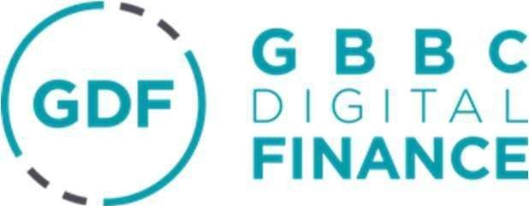
20 September 2023

To whom it may concern,

Re: ESMA Consultation Paper on the Technical Standards specifying certain requirements for MiCA

GBBC Digital Finance (GDF) is a not-for-profit industry body that promotes the adoption of best practices for crypto and digital assets, and digital finance technologies through the development of conduct standards, in a shared engagement forum with market participants, policymakers and regulators.

Established in 2018, GDF has convened a broad range of industry participants, with 300+ global community members - including some of the most influential digital asset and blockchain companies, financial institutions, and professional services firms supporting the industry.

The GDF Code of Conduct (the ‘Code’) is an industry-led initiative driving the creation of global best practices and sound governance policies. GDF is informed by close conversations with regulators and developed through open, inclusive working groups of industry participants, legal, regulatory and compliance experts, financial services incumbents and academia. The principles set out in the Code undergo multiple stages of community peer review and open public consultation prior to ratification.

Thank you very much for inviting GDF to respond to this consultation paper. As ever we draw on our broad membership to be able to give a carefully considered response that is representative of the industry. As with the entire MiCA process, there has been a great level of engagement and scrutiny and given the importance of the RTS, we have seen similar levels of engagement during our discussions. However, over the course of these discussions, our membership has landed on the fact that it is happy with the proposals laid out by ESMA and do not wish to object to anything in there.

As such, we will continue to follow communications over the consultation process and leverage our community to respond accordingly. As always, GDF remains at your disposal for any further questions or clarifications you may have and we would welcome a meeting with you to discuss these matters in more detail with our
members.

Yours faithfully,

Lavan Thasarathakumar
Director of Government and Regulatory Affairs, GBBC Digital Finance

