The Relevance of Adequate Governance Practices in SMEs: Implications for Credit Ratings and Funding

Abstract
Small and medium-sized enterprises (SMEs) play a crucial role in the economy, and effective governance practices are instrumental in their success. This paper aims to explore the significance of implementing proper governance practices in small and medium-sized enterprises (SMEs) and its impact on the financial capital of the company, specifically focusing on credit ratings and access to diversified and suitable funding sources. The analysis is based on a comprehensive database comprising over 500 European SMEs, which have been rated by Inbonis. These ratings reports, containing a wealth of information, serve as a valuable resource for advanced AI models, with over 50,000 data points, hundreds of rating drivers analysed, and more than 50 qualitative questions recorded for each SME.
To analyse the correlation between environmental, social, and governance (ESG) practices and credit ratings, ESG scores were developed for each of the 500+ rating reports using Natural Language Processing (NLP) models. NLP, a subset of Artificial Intelligence (AI), focuses on processing and understanding human-written text. In this study, three models built upon Google's Bidirectional Encoder Representations from Transformers (BERT) model were utilized: FinBert, FinBert-ESG, and FinBert-ESG-9. Credit Rating Reports, which provided detailed information on companies and their methodologies, were analysed using these models. Each sentence was scored based on subject prevalence and sentence sentiment. The aggregated scores of positive or negative sentences were averaged to obtain a final score for each company report.
The findings indicate a strong correlation between governance practices, as defined in this analysis, and credit ratings, consequently influencing the availability of financial capital for the company. Analysis of the rating distribution among the 500+ sample revealed that companies with lower governance scores obtained credit ratings ranging from CCC- to BB-, while those with higher governance scores achieved ratings from BB- to BBB, representing an average improvement of four notches.
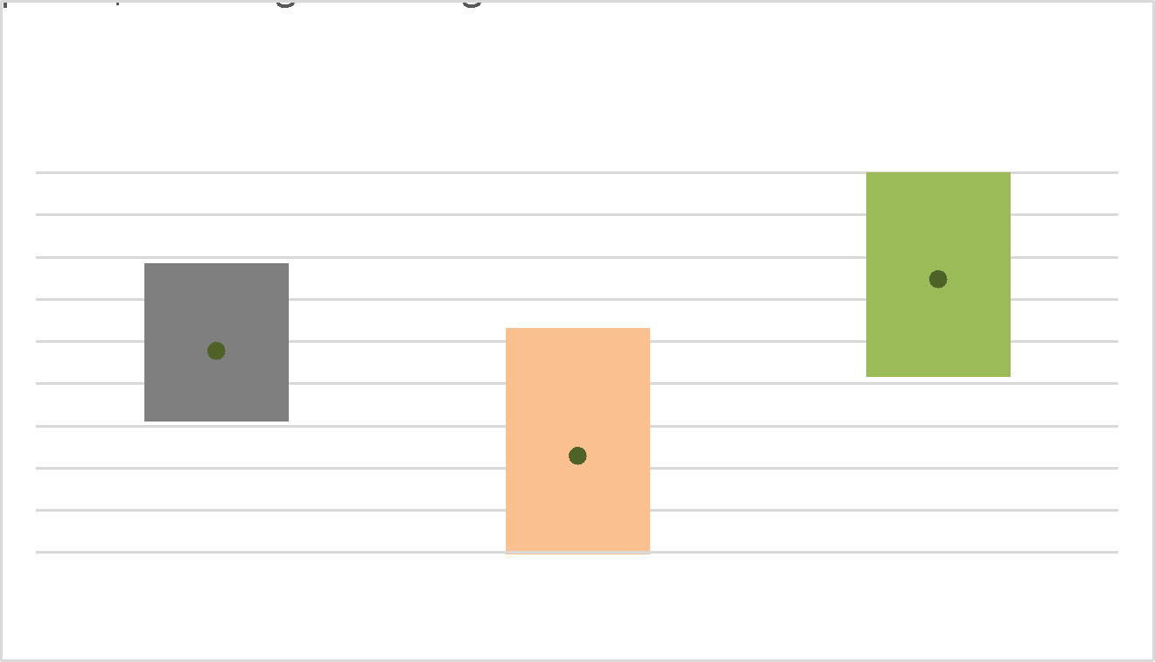

Data Scheme
The analysed data was mainly comprised of reports performed by Inbonis on the state of the SME/company post-Credit rating. These reports are performed by professionals and contain a vastly rich source of information for these models to take advantage. It is worth noting that, since these reports aren’t ESG specific, there could be “missing information”. Though the aggregate of all companies radically decreases this “gap”. The following models act more as an objective method of extracting and scoring wanted information.
Models
Part of the ESG Scoring involved the usage of Natural Language Processing (NLP) models, a subset of Artificial Intelligence (AI) research which aims to process and comprehend human-written text. This seemingly easy task requires a great deal of training and resources for AI algorithms, since each subject/field within human language has different terminology and intrinsic differences. The models used all stem from Google’s Bidirectional Encoder Representations from Transformers (BERT) model. A model previously trained using specialised hardware (TPUs) in Googles Servers, using vast amounts of text data, such as Wikipedia. This is an incredibly useful resource since it allows further specialisation or fine-tuning of models, with relative ease. Akin to how us humans learn to read and write and build up on that knowledge to specialise on other subjects. For the purposes of this body of research, we utilised 3 models built on this base:
- FinBert. Built on the BERT Model, specialised in analysing the sentiment (positive, negative, and neutral) and trained on a vast corpus of financial data from the Financial PhraseBank by Malo et al. (2014). This model outperforms other available models and scores a 97% sentiment accuracy.
- FinBert-ESG. Built on the FinBert classification model and specialised in classifying and “scoring” text into the different ESG (Environmental, Social, Governance or Non-ESG) sections.
- FinBert-ESG-9. Trained by the same researchers that trained FinBert-ESG but offers more granularity in the detection of themes within the text, including the following categories: Climate Change, Natural Capital, Pollution & Waste, Human Capital, Product Liability, Community Relations, Corporate Governance, Business Ethics & Values.
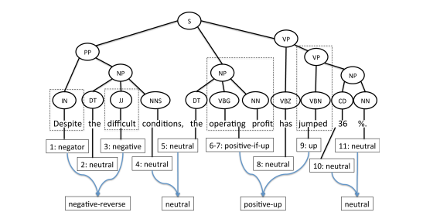

Figure 1 From: “Good Debt or Bad Debt: Detecting Semantic Orientations in Economic Texts”, by Malo et al. Offers a deconstruction of a financial sentence used to train the FinBert model. It is a perfect insight into how these NLP models understand the text and assign a score.

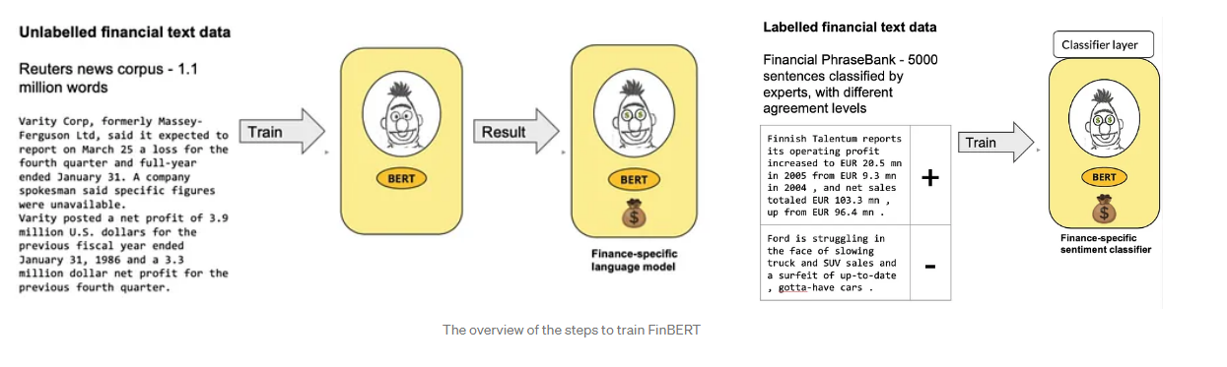
Figure 2 From: ProsusAI, Diagram illustrating the training process for FinBert. Involving the training of the Google BERT model with over 1 million Finance related words, prior to a second training round with the Financial PhraseBank to allow it to distinguish and classify the sentiment of a text.
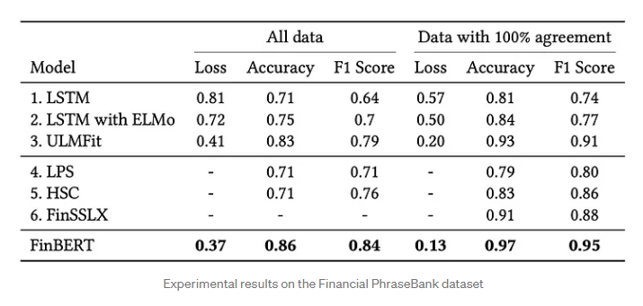

Methodology
To obtain the scores, over 500 Credit Rating Reports with detailed information on companies and their working methodologies were studied. Each sentence of the report was run through the models and scored based on the prevalence of each subject and the sentiment of the sentence itself. E.g. a company with a high mention of Climate Change but a high negative sentiment would score poorly in this subsection.
To score each company the scores of either positive or negative sentences were averaged to obtain a final score for each of the identified sectors.
Special thanks to ProsusAI and Huang, Allen H., Hui Wang, and Yi Yang for the research and training of FinBert and FinBert-ESG respectively.

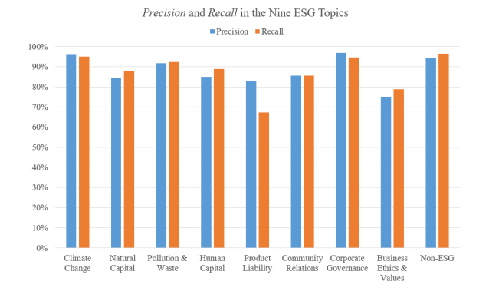

https://cloud.google.com/ai-platform/training/docs/algorithms/bert-start?hl=en
https://medium.com/prosus-ai-tech-blog/finbert-financial-sentiment-analysis-with-bert-b277a3607101

