Response Form to the Consultation Paper

Review of RTS No 153/2013 with respect to procyclicality of margin

Responding to this paper
ESMA invites comments on all matters in this consultation paper and in particular on the specific questions summarised in Annex III. Comments are most helpful if they:
- respond to the question stated;
- indicate the specific question to which the comment relates;
- contain a clear rationale; and
- describe any alternatives ESMA should consider.
ESMA will consider all comments received by 31 March 2022.
All contributions should be submitted online at www.esma.europa.eu under the heading ‘Your input - Consultations’.
Instructions
In order to facilitate analysis of responses to the Consultation Paper, respondents are requested to follow the below steps when preparing and submitting their response:
- Insert your responses to the questions in the Consultation Paper in the present response form.
- Please do not remove tags of the type <ESMA_QUESTION_APC_1>. Your response to each question has to be framed by the two tags corresponding to the question.
- If you do not wish to respond to a given question, please do not delete it but simply leave the text “TYPE YOUR TEXT HERE” between the tags.
- When you have drafted your response, name your response form according to the following convention: ESMA_APC_nameofrespondent_RESPONSEFORM. For example, for a respondent named ABCD, the response form would be entitled ESMA_APC_ABCD_RESPONSEFORM.
- Upload the form containing your responses, in Word format, to ESMA’s website (www.esma.europa.eu under the heading “Your input – Open consultations” “Consultation on the review of RTS 153/2013 with respect to procyclicality of margin”).

Publication of responses
All contributions received will be published following the close of the consultation, unless you request otherwise. Please clearly and prominently indicate in your submission any part you do not wish to be publicly disclosed. A standard confidentiality statement in an email message will not be treated as a request for non-disclosure. A confidential response may be requested from us in accordance with ESMA’s rules on access to documents. We may consult you if we receive such a request. Any decision we make not to disclose the response is reviewable by ESMA’s Board of Appeal and the European Ombudsman.
Data protection
Information on data protection can be found at www.esma.europa.eu under the heading Legal Notice.
Who should read this paper?
All interested stakeholders are invited to respond to this consultation. In particular, this paper may be specifically of interest for EU central counterparties, clearing members and clients of clearing members.

General information about respondent
Name of the company / organisation | CCP12 – The Global Association of Central Counterparties
Activity | Central Counterparty
Are you representing an association? | ☒
Country/Region | Other

Introduction
Please make your introductory comments below, if any
<ESMA_COMMENT_APC_00>
TYPE YOUR TEXT HERE
<ESMA_COMMENT_APC_00>

Questions

- : Do you agree that CCPs should be able to explain and justify their APC tool choices?

<ESMA_QUESTION_APC_01>
The Global Association of Central Counterparties (“CCP12”) appreciates the opportunity to comment on the European Securities and Markets Authority’s (“ESMA”) Consultation Paper on the review of the European Market Infrastructure Regulation’s (“EMIR”) requirements on anti-procyclicality (“APC”) margin measures for central counterparties (“CCPs”) (“the Consultation Paper”).
CCP12 is the global association for CCPs, representing 41 members who operate over 60 individual CCPs globally across the Americas, EMEA and the Asia-Pacific region.
Before responding to the specific questions of the Consultation Paper, CCP12 would like to highlight the following key points:
- CCP12 agrees with the general finding of the Consultation Paper, that “EU CCPs performed overall well during the crisis,” despite lockdowns and working from home. IM levels were adjusted appropriately according to the established risk management practices of CCPs to reflect the new market conditions, and not, for instance due to the reduced credit risk ratings of banks. The fact that margin calls reflect market movements and are appropriately risk-based was noted recently in a speech given a by Sir Jon Cunliffe, Bank of England:

“Margin call is of course pro-cyclical, insofar as it reflects movements in markets. This is not a bug in the system, it is a feature. As markets move, losers have to pay variation margin to winners. And as risks grow, initial margin rises to protect the members of a clearing house from the consequences of a future default by other members.”

- CCPs’, including EU CCPs,’ margining practices were appropriately anti-procyclical and as such, CCPs successfully supported the stability of their respective markets and the financial markets in general. We therefore suggest that improvements should be reviewed on a more holistic basis across financial markets. In this comprehensive assessment, liquidity risk practices of clearing members, customers and other market participants should be evaluated to identify where the vulnerabilities are and how to support proper liquidity preparedness for the next crisis. This was also emphasised recently in a speech given by Fabio Panetta, Member of the Executive Board of the ECB:

“When assessing the resilience of the clearing ecosystem, regulators should not focus exclusively on CCPs: clearing members also need to react to external shocks to ensure they deliver on their obligations to clients and other end users.”

- In addition to the reports from standard setters and regulators,, we would like to refer to the following CCP12 publications, which also demonstrate these points:
  - CCPs again demonstrate strong resilience in times of crisis – a CCP12 paper (Link)
  - CCP12 Annual Markets Review in Central Counterparty Clearing (“CCP12 AMR”) (Link)
  - CCP12 Public Quantitative Disclosure (“PQD”) Newsflash publications – especially Q4 2020 data (Link)
  - CCP12 response to BCBS, CPMI and IOSCO Consultative Report on Review of Margining Practices (Link)
The publications conclude that the IM increases were limited relative to the extraordinary volatility observed, and the substantial increases in the size of Variation Margin (“VM”) flows. This suggests that built-in conservativeness as well as the anti-procyclical measures of the CCPs’ margin models worked as designed.

- It is important for ESMA to recognize and account for the differences in risk frameworks between banks and CCPs. Many of the APC concerns grow out of the banking sector relating to capital management, loan loss provisions, and their impact on banks’ lending appetite in which counterparty risk is largely managed bilaterally. APC concerns for banks also arise out of the economic cycle. CCPs, which are understood to generally improve financial stability as a matter of inherent design, have risk frameworks that are very different than banks and other financial institutions. CCPs are risk managers for all the trades they clear – not risk-takers. CCPs employ practices that are designed to incentivise their participants to effectively manage their risks. These practices are designed to account for the specific characteristics of the products they clear, and the market participants they serve. Where macro-prudential authorities and credit institutions must consider and model longer term economic cycles, CCPs’ margin models determine the collateral required to mitigate credit risk from impairing markets utilize a time horizon or margining period that is much shorter than such macro-cycles. Thus, CCP12 believes that proposals to standardise and homogenize the APC margin measures used by CCPs is misplaced. Standardization and homogenization were the needed remedy for bilateral markets - not cleared markets.

- We believe risk-based margining by CCPs is appropriate and does not create a negative feedback loop. The complexity of procyclicality is not solved by limiting the variability of CCP margining. Indeed, by limiting such variability, there is the potential risk that CCPs will not be as effective in their ability to respond and manage the risks that emerge in the markets they clear. It is important to recognize that margin variability due to sharp price changes would not be the cause of a financial crisis by itself. Financial crises have historically occurred when there are feedback effects in the system – often the result of the interconnected nature of the financial system. We believe that ESMA should, as the next step, spend additional time understanding where there is vulnerability in the system, how those vulnerabilities could impact the real economy, and what steps are appropriate to mitigate those feedback effects.

- CCPs’ IM models are designed to adequately account for prevailing market conditions and to provide for the necessary coverage of risk. As recently noted by BCBS, CPMI and IOSCO in their Consultative Report on Review of Margining Practices “[a]n increase in IM requirements following an unprecedented shock is expected and, in many cases, is prudent risk management.” The data set forth in the papers cited, above show that CCPs’ IM models serve to mitigate procyclical risk. A CCP’s financial resources also cover extreme but plausible market conditions in the form of Default Fund (“DF”) resources. From our perspective, it is unclear from some of the proposals included in ESMA’s Consultation Paper whether the standards sought for IM would cover aspects that are already covered by the DF. Please also refer to our response to Question 15, where we outline that stress testing and margining are designed for different purposes.

- We do not believe that an incorporation and enhancement of provisions of the existing Guidelines into the RTS is necessary. We believe that the APC measures of a CCP’s IM model must be tailored to the unique characteristics of its offering and market. Thus, we urge ESMA to not apply an overly prescriptive approach, but rather leave it to EU CCPs, in consultation with their direct supervisors, to decide what APC measures and practices are appropriate taking into consideration their market(s), products, participants, and risk appetite, among other things. CCP12 is pleased to note, that ESMA has recognized that CCPs’ unique products and risk models need to be considered and in addition, that CCPs’ need the flexibility to manage an event given the specific facts and circumstances presented in order to stay within its specified risk appetite.

- However, we want to emphasize, that indeed, there is no “one size fits all” approach to APC measures for EU CCPs’. Requiring EU CCPs to select from one or more of the same three APC measures and be subject to the same implementation requirements, could potentially result in an increased risk of procyclicality. In part, this is because EU CCPs would have the same potential weaknesses in their risk programs during times of stress. CCP12 believes that APC approaches should be outcomes-based/results oriented, as overly prescriptive approaches to achieve the stated APC objectives could result in outcomes that may undermine, rather than support financial stability, particularly where a CCP is required to implement practices that are not uniquely tailored to their product offering. ESMA’s proposal highlights the shortcomings of a prescriptive approach to APC measures, since in many instances ESMA is revising the APC measures to make them fit for the current markets (e.g., appending the 10-year period with additional stress periods). Broadly, we believe an outcomes-based approach is preferential to determining CCP risk management practices and caution against the prescriptiveness that is included in the proposal, such as the items related to the APC policy and additional metrics for measuring the efficacy of those tools.

- With this in mind, we appreciate ESMA’s recognition that imposing hard thresholds to the proposed RTS for maximum margin changes over a period (e.g., “speed limit”) could be both counterproductive and potentially harmful to the stability of cleared markets. Unless the expected increase in volatility or price levels in known in advance, a delay in application will either result in a greater requirement for a large compensating margin increase or reduce the surety of safety and imperil margin adequacy. ESMA correctly recognizes that CCPs are best placed to determine and examine the adequacy of its own APC practices taking into consideration the characteristics of its unique product offerings and its membership, as well as risk management practices. We believe this recognition should be further reflected in the RTS by embracing a principles-based approach for the selection of APC tools at CCPs.

- The Consultation Paper expressly highlights the international work being conducted by standard setting bodies on this subject. It notes that the BCBS, CPMI and IOSCO are consulting on six potential areas for further work in view of potential international policy consideration. We recommend that ESMA, to the extent it moves forward with amendments, coordinate its efforts with these standard setting bodies rather than moving forward separately at this point in time. Rather, it would be helpful to EU CCPs and other market participants, especially those that are in the non-bank financial intermediation sector, for there to be coordination with the timeframes being observed by the international standard setters on this topic, so that these matters can be assessed holistically. Doing so would also prevent duplication of efforts by EU CCPs.

- We would like to point out that CCP12 is a strong proponent of CCP transparency, given the benefits for risk management. CCPs already provide significant transparency to the market, and we support future efforts on transparency, especially for the uncleared market and the practices of Clearing Members. Due to this and as highlighted in our response to the BCBS, CPMI and IOSCO Consultative Report on Review of Margining Practices, CCP12 members have prepared a concept paper for Market Participant Public Quantitative Disclosures, which would complement regulatory statistics (e.g., BIS statistics) and those available from CCPs (e.g., CCP PQDs). In particular, under CCP12’s proposal clearing members (e.g., entities that face a CCP directly to provide clearing for their own and/or their customers’ activity) would create and publish quantitative data and give high-level information for their firm with respect to their cleared and uncleared exposures.

Question 1: Do you agree that CCPs should be able to explain and justify their APC tool choices?
We support the provisions in the Consultation Paper that allow EU CCPs discretion in terms of choosing the APC tools and internal targets to be used. However, we note that EU CCP’s employ internal procedures and governance arrangements as part of their risk management framework that are, in part, designed to appropriately limit procyclicality, which includes having defined margin methodologies and related monitoring practices. These serve to provide adequate validation and review of APC measures. Therefore, we believe the focus should be on whether a CCP’s risk management practices are achieving the desired outcomes from an APC perspective and not how this is being achieved. If a selected APC approach achieves the intended anti-procyclical objectives, requiring an evidencing comparison with different APC tools creates an unnecessary burden for CCPs without providing clear risk management benefits, while also having practical operational implications. Notwithstanding this, as CCPs do today, they continue to undertake the appropriate analysis to calibrate their APC measures and monitor their margin methodologies on an ongoing basis. Therefore, we would urge ESMA to remove any requirement for explanation, justification or comparison and leave it to the discretion of the EU CCP to decide on which tool to use.
Broadly, we believe that the APC measures of a CCP’s IM model must be tailored to the unique characteristics of its offering and market and appreciate that ESMA has recognized the importance of this. Thus, we urge ESMA to not apply an overly prescriptive approach. EU CCPs are best placed to consider these unique characteristics in designing their risk management frameworks, including their APC measures. Along these lines, APC approaches should be outcomes-based/results oriented, as overly prescriptive approaches to achieve the stated APC objectives could result in outcomes that may undermine, rather than support financial stability, particularly where a CCP is required to implement practices that are not uniquely tailored to their product offering.

<ESMA_QUESTION_APC_01>

- : Do you agree that CCPs should define their own APC thresholds for margin changes based on their risk appetite/tolerance? Should the RTS explicitly require that CCPs seek the advice of the risk committee, when setting or reviewing its APC policies, including defining the risk appetite?
<ESMA_QUESTION_APC_02>
We generally agree with the approach set out in the Consultation Paper of not imposing a prescriptive approach on how APC targets/thresholds should be defined. CCP12 believes that EU CCPs are best positioned to define the thresholds and risk appetite of the CCP. While we believe that the advice of the risk committee can be obtained by the respective EU CCP in accordance with its rules, it is not necessary to make this a requirement, since it is important for the CCP, as the primary risk management expert in the products it clears, to maintain the authority to set the specific margins for the products it clears within the margin methodology that has been reviewed and approved in accordance with its governance arrangements. Risk committee feedback would typically only include general APC policies and not the details of the specific metrics. An EU CCP’s risk appetite should be defined by the Board / management of the CCP, in accordance with its governance arrangements.
CCP12 agrees with ESMA’s proposal that to the extent that EU CCPs are required to adopt such thresholds for margin changes, where thresholds are breached the CCP should have the authority, subject to appropriate governance, to decide if they do or do not adjust their practices – e.g., eroding the margin buffer or changing weights to stress. Furthermore, we agree with ESMA’s conclusions on the inappropriateness of “speed limits” and the implementation of common thresholds and applaud ESMA for leaving the flexibility to the CCP to extent that it is required to adopt thresholds for margin changes.
<ESMA_QUESTION_APC_02>

- : Do you agree with ESMA’s proposal to draft a new Article 28a? What other requirements should ESMA consider introducing in relation to the CCP APC policies and procedures?
<ESMA_QUESTION_APC_03>
ESMA’s general finding, that “EU CCPs performed overall well during the crisis,” demonstrates the sufficiency of the current standards employed by the EU CCPs. As described further in our key points, this was also recognized by many market stakeholders, including BCBS, CPMI, and IOSCO, which noted in a Consultative Report on Review of Margining Practices that “[g]enerally, margin rate and IM increases were lower than the corresponding increases in the price volatility of key risk factors for CCPs.” We believe the current practices are appropriate and therefore - as described in our response to Question 1 and 2 - we do not agree with the prescriptive approach to the draft new Article 28a. As also highlighted in our key points, CCP12 believes that the introduction of new RTS is premature considering that international work is currently being conducted. A coordinated approach to timing of this work would be beneficial for all market participants, as it would, in part, prevent duplication of efforts by EU CCPs. It would also provide an opportunity for a more holistic approach that includes assessments of liquidity drivers broadly and liquidity planning of CCP members and their customers. Discrepancies in such preparedness, and the differences in clients’ ability to meet their liquidity needs, especially among smaller members, has been cited as an area in which further work is needed to inform next steps in this area.
<ESMA_QUESTION_APC_03>

- : Do you agree with ESMA’s proposed amendment to require CCPs to assess margins based on quantitative metrics in the context of procyclicality?
<ESMA_QUESTION_APC_04>
For the reasons outlined in our response to Q1 and Q3, CCP12 does not agree with the proposal to require EU CCPs to assess margins based on quantitative metrics in the context of procyclicality, particularly given EU CCPs successful navigation of the COVID-related volatility. Therefore, further work on practices, metrics and disclosures concerning procyclicality in CCP IM models, or additional prescriptive standards is not warranted at this time. We would also caution against the difficulty in creating metrics that would appropriately balance prudency with reactivity across the wide variety of methodologies and market behaviors across the cleared spectrum.
However, we welcome that ESMA recognizes that if metrics are required to be adopted by the CCPs they should not be hard thresholds but rather the EU CCPs should have flexibility to adapt to the situation. This judgement and flexibility in a crisis are essential to permit a considered response in case circumstances are such that a mechanistic approach would exacerbate stress or impair the ability to operate risk managed markets.
<ESMA_QUESTION_APC_04>

- : Do you agree with ESMA’s proposal to introduce these three dimensions? Should these be mandatory or optional? How do these compare to the quantitative metrics that CCPs currently consider in practice?
<ESMA_QUESTION_APC_05>
Although, many EU CCPs already consider the three dimensions (stability, conservativeness, and over-collateralization) when setting risk policies, we would urge ESMA not to mandate their inclusion so as to allow for CCPs’ flexibility when designing their risk models, which may incorporate these. There is no “one size fits all” approach for CCPs’ APC measures, as EU CCPs are diverse in terms of products cleared, markets served and margin methodologies.
Further, the term “excessive level” in connection with setting margins, included in proposed Article 28a 1c, can be interpreted differently according to the risk appetite of the respective EU CCP. Therefore, we would caution against using such language and suggest removing it.
<ESMA_QUESTION_APC_05>

- : Do you agree with ESMA’s proposal to include in the RTS a requirement for CCPs which clear products whose price/yield can vary significantly to perform the assessment of the procyclicality of its margin model across different price/yield levels?
<ESMA_QUESTION_APC_06>
Although we agree that an assessment across different price/yield levels can be beneficial, we would urge ESMA not to implement such a requirement as it could lead to huge computational efforts and smaller EU CCPs in particular might not be able to conduct this. Therefore, CCP12 would advocate against including such a provision.
<ESMA_QUESTION_APC_06>

- : Do you agree with ESMA’s proposal to introduce into the RTS the requirement on CCPs to calculate APC margin requirements at all material risk factors?
<ESMA_QUESTION_APC_07>
We do not agree with ESMA’s proposal to calculate APC margin requirements at all material risk factors, mainly because we believe, that the intent behind this proposal is already covered by the other aspects of ESMAs proposal. Also, if all risk factors are intended to be included, which could run into the millions for large CCPs, we believe – from an operational perspective – this is overburdensome and in some cases even impossible. We therefore urge ESMA to revise this proposal and leave it to the discretion of the CCP.
<ESMA_QUESTION_APC_07>

- : Do you agree with ESMA’s proposal to consider the impact that the risk factor change will have on the margin, including for products with non-linear dependence on risk factors?
<ESMA_QUESTION_APC_08>
Please see our response to Question 7.
<ESMA_QUESTION_APC_08>

- : Do you agree with ESMA’s proposal on how to apply the APC options for different risk factors?
<ESMA_QUESTION_APC_09>
Please see our response to Question 7. Furthermore, we want to emphasize one of our key points, we disagree with this type of prescriptive approach. As a general matter, we believe an outcomes-based approach is preferential to determining CCP risk management practices and that there is no “one-size-fits-all” approach, given the diversity of products and market participants supported by CCPs.
<ESMA_QUESTION_APC_09>

- : Do you agree with ESMA’s proposal that CCPs using the APC tool under Article 28(1)(a) should develop policies and procedures detailing the use of the buffer and its replenishment as included in the draft RTS test? Are there other items that the procedures should consider in the RTS?
<ESMA_QUESTION_APC_10>
Please see our responses to Questions 1 and 4. Should it be the case that an EU CCP is required to adopt any policies and procedures detailing the use of the margin buffer and its replenishment, CCPs must have the discretion to adopt practices that recognize the unique products they have and market participants they serve. Moreover, as recognized by ESMA, any policies and procedures should not bind CCPs to taking an action, as they must maintain the necessary flexibility to manage an event given the specific facts and circumstances and to stay within their specified risk appetite. As such, policies and procedures may be helpful to describe possible scenarios in which the buffer and its replenishments might be used, but these should be illustrative and can be adopted according to the situation at hand.
<ESMA_QUESTION_APC_10>

- : Do you agree that CCPs should set predefined thresholds but also be granted a degree of discretion when triggering the exhaustion of the margin buffer subject to appropriate governance arrangements?
<ESMA_QUESTION_APC_11>
Yes, CCP12 agrees that if an EU CCP elects to set predefined thresholds, a degree of discretion should be granted when triggering the exhaustion of the margin buffer, subject to appropriate governance.
<ESMA_QUESTION_APC_11>

- : Do you agree with ESMA’s proposal to set the minimum buffer to 25% while requiring CCPs to assess if a higher buffer would be needed and justify / regularly check the appropriateness of their choice?
<ESMA_QUESTION_APC_12>
The Consultation Paper emphasizes that the 25% level of the margin buffer is a minimum and that in some cases different asset classes, warrant different buffers to achieve the same stability outcomes. The Consultation Paper furthermore states that “there was no evidence that would disqualify the existing choice of 25% as an adequate minimum size of the buffer.” Therefore, we would question what evidence exists that a 25% minimum is also always appropriate for the unique characteristics of an EU CCP’s offering. CCP12 believes that it should be at the discretion of the EU CCP to set the minimum buffer according to the respective CCP’s circumstances (market, product, participants, risk appetite).
Also, requiring a CCP to justify why a higher buffer is needed, can be problematic as it is not feasible for CCPs to include all possible scenarios in their margin models and CCPs need to be reactive to market changes. Therefore, we would urge removing the justification of the choice.
<ESMA_QUESTION_APC_12>

- : Do you agree with ESMA’s proposal on how to apply the APC options for different risk factors?
<ESMA_QUESTION_APC_13>
Yes, as described in Question 12 above, we urge removing the justification requirement.
<ESMA_QUESTION_APC_13>

- : Are there cases where ESMA’s proposal to modify Article 28(1)(a) RTS would present difficulties for CCPs in practice?
<ESMA_QUESTION_APC_14>
CCP12 believes that while certain extreme historical and/or potential market movements used in stress scenarios identified in Article 30 may be suitable for consideration purposes of this APC tool, it should not be required that such scenarios be included in an EU CCP’s stress margin. Requiring the use of these scenarios could inappropriately result in an outcome where tail risk is assumed by different resources (e.g., IM and default fund) inappropriately changes (e.g., risk of mutualization is inappropriately diminished), which could undermine the carefully calibrated incentives structure for central clearing. Stress testing and margining are designed for different purposes, and we urge ESMA to recognize this. Thus, EU CCPs should retain the flexibility and discretion to make the determination of which market events are appropriate to include in their stressed margin. As highlighted above, we also disagree with such a prescriptive approach as it prohibits the CCP from appropriately calibrating its risk management tools to the unique characteristics of its clearing services and therefore ask to remove the requirement.
<ESMA_QUESTION_APC_14>

- : Do you agree with ESMA’s proposal that CCPs should also consider including the extreme market movements from the potential future stress scenarios identified under Article 30(2)(b)?
<ESMA_QUESTION_APC_15>
Please see our response to Question 14.
<ESMA_QUESTION_APC_15>

- : Do you agree to require that CCPs ensure the set of extreme market movements includes an adequate number of extreme market movements for all margined products, including the ones that could expose it to the greatest financial risks?
<ESMA_QUESTION_APC_16>
CCP12 disagrees with the proposal to include a specific stress scenario for every single unique product. This would be overly burdensome with little risk management benefit, particularly from an operational perspective, where a CCP may list thousands of products. CCPs’ margin requirements are also typically applied on a portfolio-level basis. Thus, we believe scenarios should focus on those products that pose the significant majority of financial risk and holistically capture the risk profile of portfolios of participants, while providing the necessary margin coverage.
<ESMA_QUESTION_APC_16>

- : Do you agree with ESMA’s proposal not to include a specific time restriction on when CCPs should add new stress observations in the set of extreme market movements used for the purpose of the APC tool, but instead add a provision to consider reviewing more frequently taking into account the procyclical effects from such revision?
<ESMA_QUESTION_APC_17>
Yes, CCP12 agrees with ESMA’s proposal.
<ESMA_QUESTION_APC_17>

- : Do you agree with ESMA’s proposal that CCPs should calculate the stress margin using the same model and parameters in compliance with Articles 24, 26 and 27, except for the time horizon under Article 25?
<ESMA_QUESTION_APC_18>
While CCP12 agrees with the spirit of the proposal, the confidence level requirement, when combined with linkage to stress testing scenarios, which are already pre-selected as a small number of the most extreme scenarios over a very long lookback, elevates the confidence level of this component to nearly 100%. Given the at least 25% weight given to APC tools, this would result in overall margin requirements (ordinary margin elements plus APC tools) substantially exceeding the confidence level set out in Art. 41 of EMIR and CPMI-IOSCO - not only at times of extraordinarily low volatility but through the entire economic cycle.
Using the same model and parameters as for the unstressed margin, could potentially lead to amplified model risk, as in general it would be expected the number of scenarios in the unstressed margin to be significantly higher than in the stress margin component. Therefore, and in alignment with our response to Question 14, we suggest removing this requirement.
<ESMA_QUESTION_APC_18>

- : Do you agree that for the purpose of calculating the stress margin to be used for the calibration of the APC tool, CCPs should recompute the stress margin at least daily and shall avoid using scaling techniques that can affect the severity of observations or calculated stressed margin?
<ESMA_QUESTION_APC_19>
CCP12 agrees, that a clearing member’s stress margin should be calculated daily, however, we disagree with the suggestion that EU CCPs should avoid the use of scaling techniques. Scaling techniques are important tools for EU CCPs. CCPs should have the discretion to use scaling techniques, which for instance, allow a CCP to appropriately recognize prevailing market dynamics in its margin methodology. This is particularly relevant where a long lookback period is used, which is the case with using stress margin as an APC tool, particularly as ESMA modifies it in its proposal (this proposal would also be the case with using the 10-year lookback as an APC tool, particularly as ESMA modifies in its proposal).
If scaling techniques are removed, we interpret this as flooring the margins at historical worst cases. In many cases, this will be covering those scenarios which are captured by the default fund of a CCP and would thus inappropriately increase margins to be held at extreme but plausible levels on a constant basis. This could undermine the carefully calibrated incentives of the central clearing model that distinguishes between loss bearing for margin versus default fund resources.
<ESMA_QUESTION_APC_19>

- : Do you agree with ESMA’s proposal to include the provision to allow CCPs to temporarily increase the weight that is applied to the unadjusted margin and equally reduce the weight applied to the stress margin? Should there be a time limit on this provision?
<ESMA_QUESTION_APC_20>
CCP12 agrees with ESMA’s proposal, especially regarding ESMA’s findings that the CCP should have some discretion, subject to appropriate governance, to determine the right timing and length of time for adjusting weights and that “there is no indication that there is a “weight-reduction” strategy that is always optimal. Hence, the CCP should not be obliged to have hard thresholds.”
An EU CCP should have the flexibility to employ practices that allow it to react appropriately to the prevailing market conditions in order to support financial stability. There should not be a time limit on this provision and as much flexibility as possible should be left to the CCP in order to allow the CCP to tailor its actions to address current market dynamics and/or scenarios.
<ESMA_QUESTION_APC_20>

- : Are there cases where ESMA’s proposal to modify Article 28(1)(b) RTS would present difficulties for CCPs in practice?
<ESMA_QUESTION_APC_21>
As described in our responses to other questions above, we would like to reiterate, that it is not possible to capture all possible eventualities accurately, as the future might be different than predicted.

<ESMA_QUESTION_APC_21>

- : Do you agree with ESMA’s proposal that the margin floor should include stress market movements in addition to the 10-year lookback period? Do you agree with the methodology used to identify these extreme market movements?
<ESMA_QUESTION_APC_22>
We disagree with ESMA’s proposal to require stress market movements in addition to the 10-year lookback period, since it may not be appropriate for all asset class. While it may be appropriate to include stress market movements reflecting the Global Financial Crisis in 2008 for some asset classes, this may not be appropriate for others and is potentially subject to change in the future as market conditions evolve. For example, recently observed stress events would be captured in the 10-year lookback period (such as the COVID-related period). Additionally, as a broader point, the very need for ESMA to amend this requirement to append the 10-year lookback periods with additional stress market movements demonstrates the challenges of taking a prescriptive approach, where the 10-year period may be inappropriate for some asset classes as an APC tool. Therefore, we emphasize our position again, that a prescriptive approach is problematic and should not be pursued. Discretion should be left to the CCP to decide on the best approach based on the prevailing facts and circumstances. Furthermore, for the reasons noted in our response to Question 14, we disagree with the methodology used to identify extreme market movements (i.e., using stress scenarios identified under Article 30).
<ESMA_QUESTION_APC_22>

- : Do you agree that the margin floor should be calculated in compliance with Articles 24, 26 and 27 of the RTS?
<ESMA_QUESTION_APC_23>
Yes, CCP12 agrees with ESMA’s proposal.
<ESMA_QUESTION_APC_23>

- : Do you agree that the margin floor should be recomputed at the same frequency than the baseline margin requirements?
<ESMA_QUESTION_APC_24>
CCP12 agrees that the EU CCP should calculate IM requirements of clearing members at least daily, including considering the margin floor. However, we do not believe daily recalibration of the margin floor should be required, as parametrization of the floor should remain relatively stable.
<ESMA_QUESTION_APC_24>

- : Do you agree that, when calculating the margin floor, CCPs shall avoid using scaling techniques that can affect the severity of observations, extreme market movements or calculated floor margin?
<ESMA_QUESTION_APC_25>
As describe further in CCP12’s response to Question 19, scaling techniques are important tools for EU CCPs to use and CCPs should have the discretion to use them.
<ESMA_QUESTION_APC_25>

- : Are there cases where ESMA’s proposal to modify Article 28(1)(c) RTS would present difficulties for CCPs in practice?
<ESMA_QUESTION_APC_26>
Please see our response to Question 21.

- Appendix – Graphs illustrating EU CCP12 members data (as highlighted in the key points)
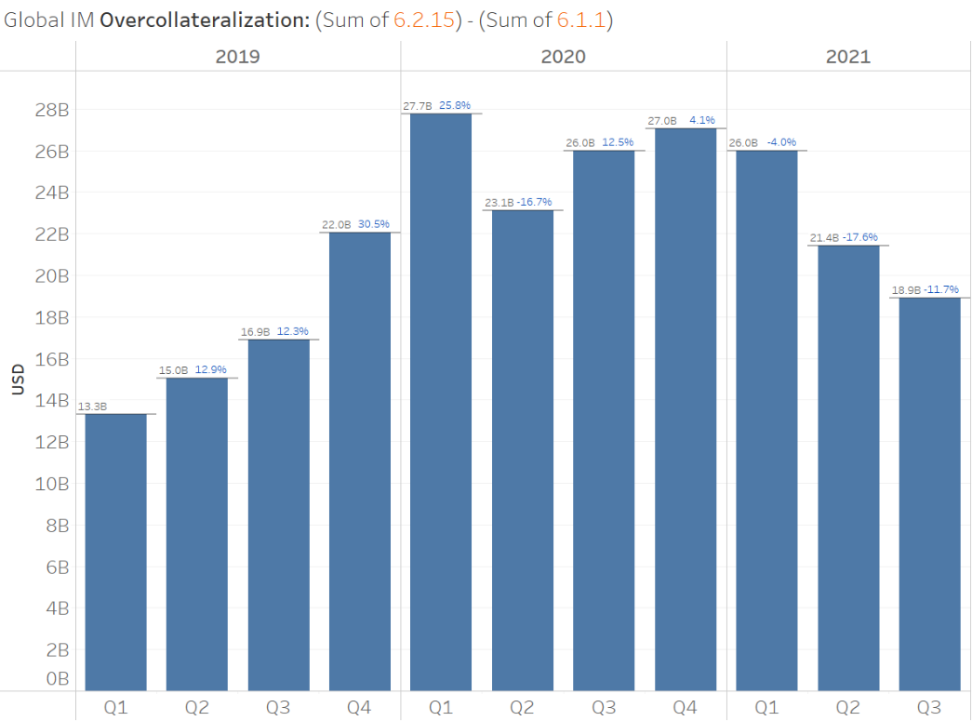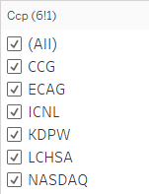
Chart 1: EU CCP12 Members IM Overcollateralization - Q1 2019 to Q3 2021
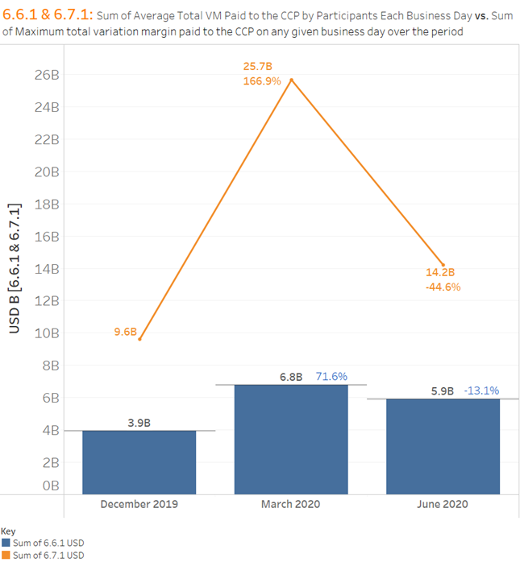
Chart 2: Sum of Total VM Paid to EU CCP12 Members vs. Sum of Maximum VM Paid to EU CCP12 Members – Q4 2019 to Q2 2020
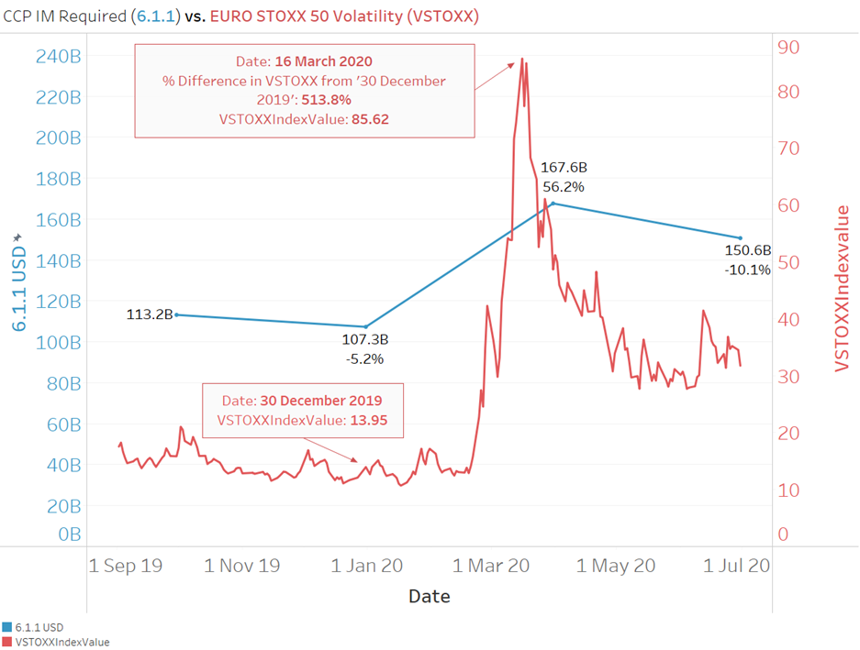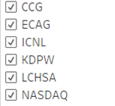
Chart 3: Percentage Change of IM Required by EU CCP12 Members vs. Percentage Change of the VSTOXX – Q4 2019 to Q3 2020
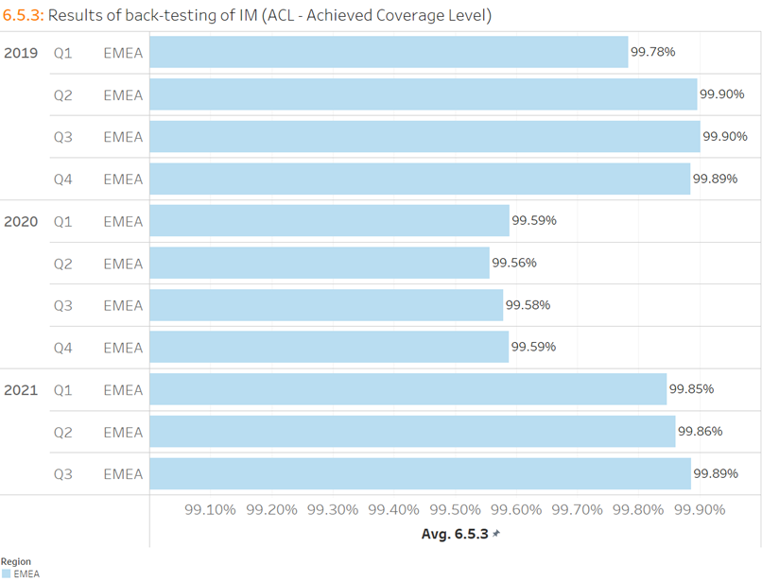
Chart 4: 6.5.3: IM Back-testing EU CCP12 Members – Q1 2019 to Q3 2021

<ESMA_QUESTION_APC_26>

ESMA, Consultation Paper, Review of EMIR RTS on APC Margin Measures (Jan. 2022), available at Link
ESMA, Consultation Paper, Review of EMIR RTS on APC Margin Measures (Jan. 2022), available at Link, page 7
BIS, Speech, Jon Cunliffe: Learning from the dash for cash – findings and next steps for margining practices (Feb. 2022), available at Link
ECB, Speech, Welcome address by Fabio Panetta, Member of the Executive Board of the ECB, at the Fourth Annual Joint Conference of the Deutsche Bundesbank, European Central Bank and Federal Reserve Bank of Chicago on CCP Risk Management (Mar. 2022), available at Link
FSB, Report, Lessons Learnt from the COVID-19 Pandemic from a Financial Stability Perspective: Final report (Oct. 2021), available at Link
BCBS, CPMI, IOSCO, Consultative Report, Review of Margining Practices (Oct. 2021), available at Link,
BCBS, CPMI, IOSCO, Consultative Report, Review of Margining Practices (Oct. 2021), available at Link, pages 11 and 13
CCP12, Report, Annual Markets Review in Central Counterparty Clearing (Mar. 2021), available at Link, page 23
BCBS, CPMI, IOSCO, Consultative Report, Review of Margining Practices (Oct. 2021), available at Link, page 20
CCP12, Paper, CCPs again demonstrate strong resilience in times of crisis – a CCP12 paper (Jul. 2020), available at Link
CCP12, Response, BCBS, CPMI, IOSCO, Consultative Report, Review of Margining Practices (Jan. 2022), available at Link
Some further charts with data from EU CCPs illustrating the fact that IM models serve to mitigate procyclical risk are included in the Appendix.
ESMA, Consultation Paper, Review of EMIR RTS on APC Margin Measures (Jan. 2022), available at Link, page 11
ESMA, Consultation Paper, Review of EMIR RTS on APC Margin Measures (Jan. 2022), available at Link, page 12
ESMA, Consultation Paper, Review of EMIR RTS on APC Margin Measures (Jan. 2022), available at Link, page 9
CCP12, Response, CCP12 response to BCBS, CPMI and IOSCO Consultative Report on Review of Margining Practices (Jan. 2022), available at Link, page 16-20
The CCP’s Board of Directors may be called in some jurisdictions Supervisory Board.
The CCP’s senior management may be called in some jurisdictions Executive Committee or Management Committee.
ESMA, Consultation Paper, Review of EMIR RTS on APC Margin Measures (Jan. 2022), available at Link, page 12
ESMA, Consultation Paper, Review of EMIR RTS on APC Margin Measures (Jan. 2022), available at Link, page 12
ESMA, Consultation Paper, Review of EMIR RTS on APC Margin Measures (Jan. 2022), available at Link, page 7
Supra note 6, page 38. BCBS, CPMI, IOSCO, Consultative Report, Review of Margining Practices (Oct. 2021), available at Link, page 38
ESMA, Consultation Paper, Review of EMIR RTS on APC Margin Measures (Jan. 2022), available at Link, page 20
ESMA, Consultation Paper, Review of EMIR RTS on APC Margin Measures (Jan. 2022), available at Link, page 28
EU CCP12 Members PQD Data Q1 2019 to Q3 2021
EU CCP12 Members PQD Data Q4 2019 to Q2 2020
EU CCP12 Members PQD Data Q4 2019 to Q3 2020
EU CCP12 Members PQD Data Q1 2019 to Q3 2021

