|  |
| --- |
| 9 July 2021 |

|  |
| --- |
| Reply form for the Consultation Paper on the RTS 1 and RTS 2 Review |
|  |

|  |
| --- |
| Date: 9 July 2021 |

Responding to this paper

The European Securities and Markets Authority (ESMA) invites responses to the specific questions listed in the Consultation Paper on the RTS 1 and RTS 2 review published on the ESMA website.

*Instructions*

Please note that, in order to facilitate the analysis of the large number of responses expected, you are requested to use this file to send your response to ESMA so as to allow us to process it properly. Therefore, ESMA will only be able to consider responses which follow the instructions described below:

* use this form and send your responses in Word format (pdf documents will not be considered except for annexes);
* do not remove the tags of type <ESMA_QUESTION_RVEW_0> - i.e. the response to one question has to be framed by the 2 tags corresponding to the question; and
* if you do not have a response to a question, do not delete it and leave the text “TYPE YOUR TEXT HERE” between the tags.

Responses are most helpful:

* if they respond to the question stated;
* indicate the specific question to which the comment relates;
* contain a clear rationale; and
* describe any alternatives ESMA should consider.

**Naming protocol**

In order to facilitate the handling of stakeholders’ responses please save your document using the following format:

ESMA_CP_RVEW_NAMEOFCOMPANY_NAMEOFDOCUMENT.

e.g. if the respondent were ESMA, the name of the reply form would be:

ESMA_CP_RVEW_ESMA_REPLYFORM or

ESMA_CP_RVEW_ANNEX1

***Deadline***

Responses must reach us by 1 October 2021.

All contributions should be submitted online at [www.esma.europa.eu](http://www.esma.europa.eu) under the heading ‘Your input - Consultations’.

***Publication of responses***

All contributions received will be published following the end of the consultation period, unless otherwise requested. **Please clearly indicate by ticking the appropriate checkbox in the website submission form if you do not wish your contribution to be publicly disclosed. A standard confidentiality statement in an email message will not be treated as a request for non-disclosure.** Note also that a confidential response may be requested from us in accordance with ESMA’s rules on access to documents. We may consult you if we receive such a request. Any decision we make is reviewable by ESMA’s Board of Appeal and the European Ombudsman.

***Data protection***

Information on data protection can be found at [www.esma.europa.eu](http://www.esma.europa.eu) under the headings ‘Legal notice’ and ‘Data protection’.

# General information about respondent

|  |  |
| --- | --- |
| Name of the company / organisation | Cboe Europe B.V. |
| Activity | Regulated markets/Exchanges/Trading Systems |
| Are you representing an association? | ☐ |
| Country/Region | Netherlands |

# Introduction

Please make your introductory comments below, if any:

<ESMA_COMMENT_CP_RVEW_1>

Cboe Europe is a pan European operator of stock exchanges and OTC reporting services, with licenses to operate regulated markets, MTFs and APAs in the Netherlands and the UK. Cboe is also the sole shareholder of EuroCCP, the Netherlands-based, pan-European clearing house. Cboe is the largest OTC reporting service for Equities in Europe, is consistently one of the largest venues for trading European equities and equity like instruments, and has been at the forefront of the many positive developments in European equity markets since MiFID was implemented in 2007. These have included dramatic reductions in trading and reporting fees, the development of a competitive interoperable clearing model and innovative trading services. Cboe is also a large consumer of European equity market data from all of the EU’s major equity exchanges and uses the data for market control and reference price purposes.

<ESMA_COMMENT_CP_RVEW _1>

Q1 : Do you agree with the proposed amendment to Article 7(2) of RTS 1? If not, please explain your concerns about the proposed increase of the threshold.

<ESMA_QUESTION_RVEW_1>

TYPE YOUR TEXT HERE

<ESMA_QUESTION_RVEW_1>

Q2 : Do you agree with the proposed amendment to Table 5 of Annex II of RTS 1? If not, please explain why you are concerned about the proposed increase of the thresholds.

<ESMA_QUESTION_RVEW_2>

TYPE YOUR TEXT HERE

<ESMA_QUESTION_RVEW_2>

Q3 : Do you agree with ESMA’s amendments to Articles 2, 6 and 13 of RTS 1 described above? If not, please explain why.

<ESMA_QUESTION_RVEW_3>

Yes – ESMA’s proposed rationalisations will help to ensure consistent application and understanding. We welcome this initiative by ESMA and agree that there is a currently a large amount of confusion around the relative size of the tradeable market for equities. This current confusion makes it difficult to draw reliable conclusions about the effectiveness of the MiFID framework. However, we believe that this should be an interim step and that changes to Level 1 should be made as part of the MiFID review. In particular, the transactions that are exempted from OTC transparency should also be exempted from post trade transparency when undertaken on venues under the third leg of the Negotiated Trade Waiver. The decision to undertake such business on a venue will generally be driven by a desire to access central clearing, however, information about such trades is equally irrelevant to the price formation process as it would be had they taken place off exchange. These trades contribute significantly to the volume published by venues such as Cboe Europe. By way of example, 56% of the negotiated trades reported to Cboe Europe’s NL and UK venues in August were flagged with NPFT and would have qualified as transactions done for “Clearing and Settlement Purpose” and would not therefore require publication if conducted OTC.

<ESMA_QUESTION_RVEW_3>

Q4 : Do you agree with the proposed description of FBA trading systems and the updated description of periodic auction trading systems? If not, please explain why and which elements should be added to the description and/or removed.

<ESMA_QUESTION_RVEW_4>

We do not agree with the need for a separate description for FBA trading systems.

We believe that the factors most relevant to determining the transparency regime are the fundamentals of the auction algorithm and the price formation process, and these are common across FBAs, opening auctions, intra-day scheduled auctions, intra-day unscheduled auctions (e.g. volatility auctions) and Closing auctions.

We disagree that the auction triggering mechanism is a basis for establishing a specific category for FBAs since participant orders are also the triggers for Volatility Auctions. We also disagree that the relatively small number of orders in FBAs is basis for establishing a specific category for FBAs since many scheduled Opening auctions and intra-day auctions similarly involve very few participant orders.

Hence ESMA’s rationale for introducing a discrete definition does not appear warranted and, in our view, would be detrimental to their usefulness and/or future place in the market. We believe that the current PAB offering has been very beneficial to investors and we speak to these benefits and potential adverse impacts in our detailed response to Q5.

If FBAs must be differentiated, then the key difference to recognise is the fact that FBAs run *alongside* continuous markets. Therefore, if FBAs are subjected to continuous-market models of pre trade transparency (including publication of un-matched orders or the direction of any imbalance), participants will be exposed to adverse movements in continuous market while waiting for FBA to uncross. Differentiated on this basis makes it clear why the current level of FBA transparency needs to be preserved, even if opening/closing auctions are to be changed. Hence a separate category is only justified if the intention is to change transparency rules for opening/closing auctions.

<ESMA_QUESTION_RVEW_4>

Q5 : Which of the two options for the pre-trade transparency requirements for FBA trading systems do you prefer? Please explain in case you are supportive of a different approach than the two options presented.

<ESMA_QUESTION_RVEW_5>

Neither. In addition to being unnecessary, both options would have the same negative consequences for investors, would be detrimental to market transparency, and hence should not be taken forward.

The current transparency regime is appropriate for these mechanisms and should not be amended at this time for the following reasons:

* Frequent Batch Auctions have the potential to deliver better outcomes for non-low latency market participants (i.e. institutional investors) than can be achieved in other continuous market models (both lit continuous and dark continuous orderbooks), while also allowing for genuine and transparent price formation - the proposed changes would result in poorer outcomes;
* The current transparency regime is appropriately calibrated for these mechanisms – the changes proposed would be fatal for their usefulness, and would drive liquidity towards less transparent alternatives;
* A review of FBA transparency in isolation is not warranted at this time - any amendments made in isolation from other elements of the MiFIR transparency regime will lead to unintended consequences;
* Changes such as those proposed must be subject to proper cost benefit analysis – such an analysis has not been attempted by ESMA, and may be impossible in isolation; and
* Damaging FBAs will lead to a migration of trading to mechanisms that deliver similar trading outcomes but with lower levels of pre trade transparency and price formation

**Frequent Batch Auctions deliver good outcomes for non-low latency market participants**

Periodic auctions/FBAs have been a success since their introduction in 2015. As the chart below demonstrates, they have established a position in the market of just over 3.5% of on-venue executions.

*Source: Cboe Europe/BigXYT*

That success is attributable to the market model which can deliver a better trading outcome for non-low latency traders than executing the liquidity in a continuous book;

* In continuous markets only a tiny minority of market participants are able to invest sufficiently and compete to be amongst the very fastest;
  + On the positive side, that minority makes markets more efficient and liquid for everyone, arbitraging away inefficiencies, porting liquidity across asset classes, keeping the prices of correlated assets aligned and acting as a counterparty to those seeking immediate execution.
  + On the negative side, when trading in continuous limit order books (CLOBs) those who cannot compete on speed face a trade-off between the benefits listed above and conceding an advantage to the fastest participants.
* Unlike CLOBs, periodic auctions (as currently implemented) *confer no advantages to participants based on their speed.*
  + Their periodic nature, randomised end-time, and (in some cases) price/size priority eliminate any speed advantage one participant (or intermediary) might have over another.
  + The existing pre-trade transparency, where only the equilibrium indicative price and equilibrium indicative volume are published, is sufficient to inform market participants of the potential to trade at/near that price, and to attract additional price-forming participation, but crucially does not reveal exploitable information about any disequilibrium.
  + This makes periodic auctions a more level playing field for institutional investors accessing the market through (still fast, but *relatively slower*) broker algorithms and smart routers; by opting out of the speed race, patient investors can interact with one another.

Quantitatively, the benefits to investors of FBAs is material and measurable. The charts below show the “mark-outs” on FBAs (see “Cboe, Periodic Auction Book”) when compared with other types of platforms i.e. the price-stability or market impact of a trade on a given platform in the periods immediately before and after a trade takes place. Crucially, the charts show that the FBA performance – with substantially lower mark-outs - is better than both lit and dark continuous books.

Given that FBAs deliver execution characteristics that are important to a large segment of investors (whilst being fully price-forming and providing pre-trade transparency in accordance with the obligations of auction models), they are gradually winning market share from RPW dark books. This explains why so few EU stocks are now capped under the DVC regime, but also suggests that any measures damaging to FBAs would likely drive liquidity back towards less transparent market mechanisms from where it has been obtained.

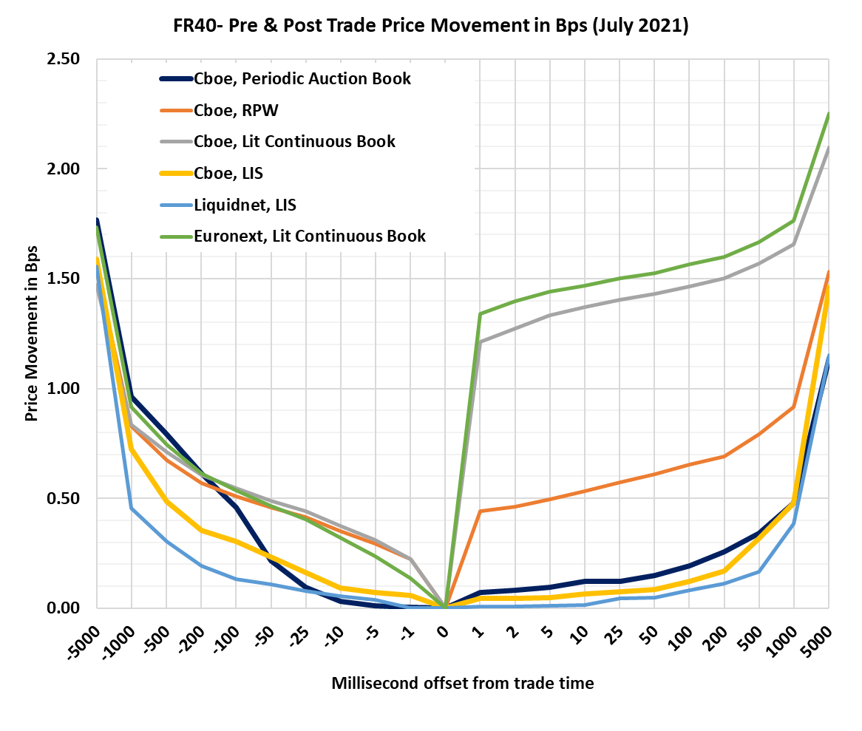

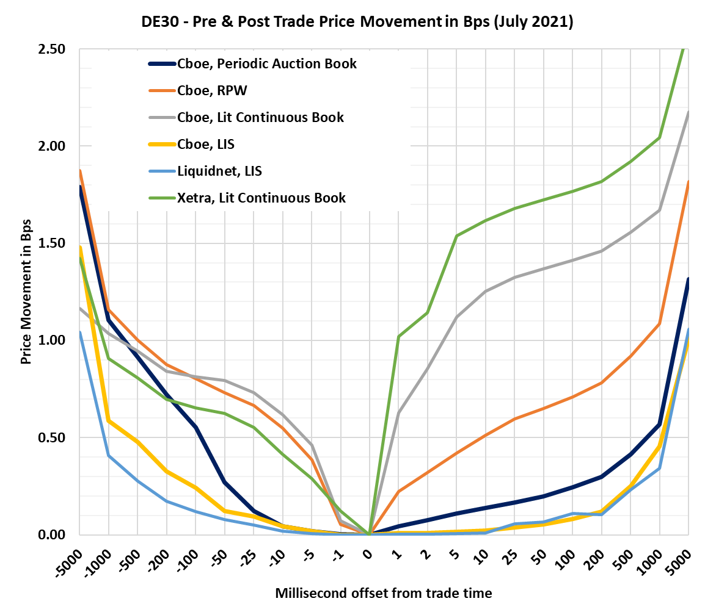

*Source: Cboe Europe/BigXYT*

To be clear, lit and dark continuous books are a critically important part of the trading ecosystem, and the above charts are not intended to demonstrate otherwise. The point here is that the current FBA framework allows less technically sophisticated market participants and institutional investors an alternative to the high-speed environment found in continuous books. They are able to interact with the Cboe Periodic Auctions knowing that if they submit their orders, they are less likely to be in a speed race with ultra-low latency participants to find an execution. Simply put, this diversity of execution method is a good thing and reflects a dynamic trading ecosystem that helps serve the diverse needs of diverse investors.

The FBA market model is somewhat unique in that it delivers all of the advantages above while also being (certainly in Cboe Europe’s implementation) fully price forming. In its final report from its Call for Evidence on Periodic Auctions, ESMA concluded that “for a system to provide for a genuine price forming mechanism it should be the result of buy and sell interaction and include the possibility for limit orders to interact within the system.” Cboe’s FBAs operate on the basis of exactly the same auction algorithm as the one used in conventional scheduled auctions. The ultimate uncrossing price is derived entirely from the prices of the orders that are entered into the auction.

**The current transparency regime is appropriately calibrated for these mechanisms – and the changes proposed would be fatal for their usefulness**

RTS 1/MiFIR set a transparency regime for auctions – a baseline that currently works for scheduled and unscheduled auctions, infrequent and frequent. Some auctions go beyond the baseline, but this has been a commercial and operational decision by the operator However, there is no suggestion that either is right or wrong. These are product decisions by operators which will ultimately be made based on their assessment of usefulness and likely investor outcomes.

In the case of FBAs, Cboe and most/all FBA operators have elected to comply with RTS 1 by publishing only an indicative volume and price – summarising the current equilibrium – and not to publish information on any disequilibrium/imbalance. There are two reasons for this.

Firstly, both the operators, and the market participants judge that this level of transparency is appropriate/sufficient to enable active contribution to price discovery (from an initially low base, a growing number of participants ingest this data and use it actively), and to allow firms to join in-progress auctions if the available price/liquidity is attractive. Participants consuming the data feed and joining auctions already in progress typically contribute to a tripling of auction volume.

Also, given historical concerns about the multilateral nature of FBAs, our own shows that during 2021, up until the end of August, 85% of successful auctions are multilateral in nature – a figure that does not differ substantially from other orderbooks (e.g. Primary exchange lit trading) with member-priority matching.

Secondly, the operators, and the market participants judge that the provision of information on the disequilibrium/imbalance, as proposed by ESMA, will be detrimental/fatal to the usefulness of FBAs: The question of additional transparency for FBAs is more significant than it is for end of day auctions, as they take place alongside continuous trading – which means that there is always an opportunity to exploit any FBA imbalance/disequilibrium information published by racing to trade ahead in continuous markets, particularly by those firms that have a speed advantage. To require the disclosure of order/imbalance information as suggested (both of ESMA’s suggested amendments would require the disclosure of individual orders prior to a match being identified), would be to re-establish the speed advantage, and undermine the key value proposition of FBAs to the detriment of investor protection.

We note that both of ESMA’s proposals would require the disclosure of individual orders: Option 2 would require full order book transparency (which it should be noted is a level of transparency that is not required of any other lit trading mechanism), and option 1, by requiring publication of “the best price and the aggregated volume on both sides at that price shall be made public” prior to a match being identified, would also in effect require the disclosure of individual orders, certainly for the first order entered, but also for any subsequent order that is on the other side of the book.

Requiring such disclosure will subject the participant to the risk that other market participants with low latency capabilities can trade against them on other continuous platforms while the submitter of the order is waiting for the auction to uncross, negating the benefits listed above, namely the removal of that speed advantage generally, and the effective prioritisation of size over speed in execution allocation. The users of our FBA have told us that they will not be able to use the platform to the same extent, if at all, if either of the proposals are implemented.

ESMA has also proposed providing details of order imbalance – both side and size. While less dramatic than the proposals detailed above, firms have told us that such a requirement, particularly the disclosure of side, would also provide an opportunity for lower latency participants to trade against the information in the continuous markets that operate alongside FBAs. Such a requirement is demonstrably unnecessary since the current information is adequate to allow interested parties to join an in-progress auction.

ESMA notes that in many auctions, where no match is identified, no pre trade transparency is shown. The nature of Cboe’s FBA means that is indeed the case, as an auction is technically considered to have started whenever an order is entered on one side. By contrast, other FBA venues deem an auction to have started only when there is a potential match between two orders. The distinction is somewhat meaningless – since at the point that a match is discovered, all FBAs commence publishing an equilibrium price and volume. From the point at which Cboe publishes an indicative price and volume, >95% of all auctions result in trades.

ESMA contends that the low number of orders in any given periodic auction provides a rationale for heightened transparency obligations. That contention is flawed; forcing additional transparency upon single orders (especially in a system specifically designed not to deliver immediacy of execution) will discourage their submission. ESMA recognised this, in its previous Final Report from its Call for Evidence on Periodic Auctions, noting; “that for [auctions that commence when an order is entered], it would be challenging to provide pre-trade information on the basis of only one order throughout the whole auction call.” We don’t believe any rationale has been offered to undermine this conclusion. ESMA instead concluded that an auction start message would be a sufficient enhancement to transparency (which was duly implemented by Cboe Europe and other operators).

**A review of FBA transparency in isolation is not warranted at this time and any amendments made in isolation from other elements of the MiFIR transparency regime will lead to unintended consequences**

ESMA conducted a fundamental review of FBAs in 2019 and concluded that the transparency regime was fit for purpose. The facts and views on which those conclusions were based have not changed. Market share remains steady, customer experience remains good. No threat to lit volumes has been demonstrated, and RPW volumes in the EU have gradually declined.

As noted previously, damaging the viability of FBAs will likely drive liquidity back towards less transparent trading mechanisms.

The European Commission is in the process of conducting its review of MiFIR, with a legislative proposal due later this year. This review will address market transparency holistically. To fundamentally amend the transparency regime for one type of trading mechanism in isolation, when other elements of the transparency regime – double volume caps, systematic internalisers etc. are also due to be reviewed would be a mistake. The MiFIR transparency regime must be viewed as a whole.

**Changes such as those proposed must be subject to proper cost benefit analysis (CBA) – such an analysis is impossible in isolation**

It is our firm view that a fundamental amendment to the regime, such as those proposed, would impose significant costs on the industry; directly through higher execution and market impact costs by eliminating a mechanism that allows investors to opt-out of the high-speed race, and indirectly via a net reduction in transparency if business transfers to mechanisms with less transparency, and explicit costs for users and venue operators to technically implement the changes. Furthermore, if other changes to the transparency are expected in the MiFIR review, then such a CBA is impossible as any changes in behaviour, and associated costs and benefits, will change again when the MiFIR review is implemented.

**Damaging FBAs will lead to a migration of trading to mechanisms that deliver similar trading outcomes but with lower levels of pre trade transparency and price formation**

The implementation of the double volume caps did not lead to the hoped-for increase in lit book trading. Displaced volumes were instead redistributed across other trading mechanisms that could deliver similar trading outcomes – some volume transferred to FBAs, but more went to systematic internalisers and closing auctions. The proposed changes, in damaging the attractiveness of European FBAs will lead to a similar transfer. Market participants will again have the choice of SIs, block venues, dark books (most of which are currently well below the DVC level so have capacity) and for international investors, third country platforms. Such an outcome would run completely against ESMA’s objective of increasing levels of pre trade transparency.

<ESMA_QUESTION_RVEW_5>

Q6 : Do you agree with ESMA’s proposals for ‘hybrid systems’? If not, please explain why and which elements should be added and/or removed.

<ESMA_QUESTION_RVEW_6>

Yes – ESMA’s proposals make sense. Hybrid systems should deliver transparency that is equivalent to that required for their component elements if they were provided in isolation. The category of “any other trading system” should be retained to allow for the innovation of new trading models.

<ESMA_QUESTION_RVEW_6>

Q7 : Do you agree with aligning both Table 1, Annex I of RTS 1 and Table describing the type of system and the related information to be made public in accordance with Article 2, of Annex I of RTS 2, to describe the same systems (with the exception of voice trading systems) and pre-trade transparency requirements? If not, please explain why.

<ESMA_QUESTION_RVEW_7>

Yes – to the extent that the trading functionality described is the same. This is particularly important for RTS 2 instruments such as ETNs that trade in the same way as RTS 1 instruments.

<ESMA_QUESTION_RVEW_7>

Q8 : Do you agree with ESMA’s proposals to require a specific format and standardise further the pre-trade information to be disclosed? If not, please explain why. If yes, please clarify which elements should be amended, added and/or removed, if any.

<ESMA_QUESTION_RVEW_8>

Yes – we agree with the need to standardise to allow for consolidation by a consolidated tape provider. In addition to the fields listed a further field to denote settlement location (i.e. CSD) should be added as in practice venues and SIs will trade/quote in multiple lines to represent each settlement location. However, the requirement should not be implemented ahead of any changes proposed in the upcoming review of MiFIR given that those changes could also require development work by venues, SIs, data vendors and.

<ESMA_QUESTION_RVEW_8>

Q9 : Do you agree with the changes proposed by ESMA to amend Article 15 (3) of RTS 1? If not, please explain your rationale.

<ESMA_QUESTION_RVEW_9>

No. The reporting window was not extended to noon to accommodate any technical shortcoming, but rather to allow for the unwinding of the risk taken on in the transaction. To the extent that markets are not open between close and open, allowing delayed publication until the next day’s market open is meaningless – it does not permit any additional time to unwind risk.

<ESMA_QUESTION_RVEW_9>

Q10 : Do you agree with the proposed amendments to Article 17? If not, please explain.

<ESMA_QUESTION_RVEW_10>

Yes – both amendments should serve to remove uncertainty.

<ESMA_QUESTION_RVEW_10>

Q11 : Do you agree with the proposed amendment of Article 11(3)(c) of RTS 1? Please explain.

<ESMA_QUESTION_RVEW_11>

Yes – we agree that the proposed amendment would provide clarity

<ESMA_QUESTION_RVEW_11>

Q12 : Do you agree with the changes proposed to Table 3 of Annex I of RTS 1 (List of details for the purpose of post-trade transparency) presented above? If not, please explain and provide any alternative proposal you might have. Are there other issues to be addressed and how?

<ESMA_QUESTION_RVEW_12>

Yes – we agree with the changes with the exception of the additional field to identify third country trading venues. The number of transactions to which this applies is not large enough to justify the work required to implement an additional field.

<ESMA_QUESTION_RVEW_12>

Q13 : Do you agree with ESMA’s proposal not to change Tables 1 and 2 of Annex III of RTS 1? If not, and you consider that certain modifications shall be made, please explain.

<ESMA_QUESTION_RVEW_13>

Yes

<ESMA_QUESTION_RVEW_13>

Q14 : Do you agree with ESMA’s proposal on the new Tables 1 and 2 of Annex IV of RTS 1? If not, please explain and provide any alternative proposal you might have.

<ESMA_QUESTION_RVEW_14>

Yes – however it is not clear to us whether fields 20 and 21 of table 2 provide sufficient detail about non-price forming transactions. We believe that ESMA should gather number and transactions and turnover for each non price forming identifier to support its statistical work and it is not clear that fields 20 and 21 which appear to merely indicate the presence of post trade indicators for a given instrument, achieve this.

<ESMA_QUESTION_RVEW_14>

Q15 : Please provide concrete examples or scenarios when the price cannot be determined as described or cases of the need to set a zero price for the different types of instruments: shares, ETFs, depositary receipts, certificates, other equity-like financial instruments.

<ESMA_QUESTION_RVEW_15>

TYPE YOUR TEXT HERE

<ESMA_QUESTION_RVEW_15>

Q16 : Do you agree with the deletion of the SI flags ‘SIZE’, ‘ILQD’ and ‘RPRI’? If not, please explain what you consider to be their added value.

<ESMA_QUESTION_RVEW_16>

Yes for SIZE and ILQD, which add no meaningful additional information. However, it would seem that RPRI would have some supervisory value while there are regulatory requirements related to price improvement. Removing the flag would require transactions to assessed against quotes, which may or may not be public.

<ESMA_QUESTION_RVEW_16>

Q17 : Do you agree with the deletion of the ACTX flag? If not, please explain what you consider to be its added value.

<ESMA_QUESTION_RVEW_17>

No – the flag will still be used for high touch broking activity, which is still possible notwithstanding the restrictions on OTC trading listed.

<ESMA_QUESTION_RVEW_17>

Q18 : Do you agree with the approach suggested for non-price forming transactions? If not, please explain.

<ESMA_QUESTION_RVEW_18>

Yes

<ESMA_QUESTION_RVEW_18>

Q19 : Do you agree with ESMA’s proposal to introduce a pre-trade LIS waiver flag for on-book transactions? If not, please explain. Should it be limited to completely filled LIS orders?

<ESMA_QUESTION_RVEW_19>

No – the additional flag will lead to information leakage. While it is true to say that there is a flag for transactions which are large enough to qualify for post trade deferral, this is only applied when the transaction itself is large. The proposed flag would reveal hidden LIS orders, no matter what size the transaction e.g. an LIS order for 1,000,000 shares could be sitting on an integrated book. An aggressive order for one share could execute against it. The resulting transaction would publish with the LIS flag against it, revealing the presence of the hidden order, and indicating that it is of significant size.

<ESMA_QUESTION_RVEW_19>

Q20 : Do you agree with ESMA’s proposal to introduce a pre-trade LIS waiver for off-book transactions? If not, please explain.

<ESMA_QUESTION_RVEW_20>

Yes – for pre-arranged trades this will clarify use of the waiver for this scenario

<ESMA_QUESTION_RVEW_20>

Q21 : Do you agree with the proposal not to add such additional flags? If not, please explain why those flags are needed in your view.

<ESMA_QUESTION_RVEW_21>

Yes - we support thew addition of the flags proposed by FPL

<ESMA_QUESTION_RVEW_21>

Q22 : Do you recommend adding/deleting/amending any other flags? If yes, please explain.

<ESMA_QUESTION_RVEW_22>

No

<ESMA_QUESTION_RVEW_22>

Q23 : Do you agree with the proposal to prescribe the order of the population of flags? If not, please explain and provide an alternative proposal.

<ESMA_QUESTION_RVEW_23>

While we agree that an order should be proscribed, it should be consistent with current market practice, particularly as it is enshrined in the MMT model. We would ask ESMA to ensure that the requirement allows for additional levels where MMT provides them, but MiFID does not require them, and has flexibility to support the ongoing development of the standard to capture new trading scenarios.

<ESMA_QUESTION_RVEW_23>

Q24 : Do you agree with the proposed amendments above? If not, please do not reiterate the arguments made under the previous question asked for equity instruments and please rather explain why those amendments are not suitable for non-equity financial instruments.

<ESMA_QUESTION_RVEW_24>

TYPE YOUR TEXT HERE

<ESMA_QUESTION_RVEW_24>

Q25 : Do you agree with the proposal to specify the fields to be populated for pre-trade transparency purposes? If not, please explain. In case you support the proposal, please comment on the fields proposed, in particular whether you would consider them necessary and/or whether additional information is required.

<ESMA_QUESTION_RVEW_25>

TYPE YOUR TEXT HERE

<ESMA_QUESTION_RVEW_25>

Q26 : Please indicate, if applicable, which medium-term targeted improvements you would like to see to the threshold calibrations in RTS 2.

<ESMA_QUESTION_RVEW_26>

TYPE YOUR TEXT HERE

<ESMA_QUESTION_RVEW_26>

Q27 : Do you agree with the proposed changes to Article 13? If not, please explain.

<ESMA_QUESTION_RVEW_27>

TYPE YOUR TEXT HERE

<ESMA_QUESTION_RVEW_27>

Q28 : Do you agree with the proposed changes to Article 4? If not, please explain.

<ESMA_QUESTION_RVEW_28>

TYPE YOUR TEXT HERE

<ESMA_QUESTION_RVEW_28>

Q29 : Do you agree with the proposed changes to Article 12? If not, please explain. Please do not reiterate the general comments made in the equity section and try to focus on arguments that are specific to non-equity financial instruments.

<ESMA_QUESTION_RVEW_29>

TYPE YOUR TEXT HERE

<ESMA_QUESTION_RVEW_29>

Q30 : Please provide your comments on the analysis and proposals related to the liquidity framework applicable to commodity derivatives, EA and DEA detailed in Section 4.2 and summarised in Section 4.2.5. Please list the proposals with their ID (#1 to #9) for ease of reference.

<ESMA_QUESTION_RVEW_30>

TYPE YOUR TEXT HERE

<ESMA_QUESTION_RVEW_30>

Q31 : Do you agree with the changes proposed to Table 2 of Annex II of RTS 2 (List of details for the purpose of post-trade transparency) presented above? If not, please explain and provide any alternative proposal you might have. Are there other issues to be addressed and how?

<ESMA_QUESTION_RVEW_31>

TYPE YOUR TEXT HERE

<ESMA_QUESTION_RVEW_31>

Q32 : Do you agree with the changes proposed to Table 4 of Annex II of RTS 2 (Measure of volume) presented above? Do you think that it now provides more clarity? If not, please explain and provide any alternative proposal you might have.

<ESMA_QUESTION_RVEW_32>

TYPE YOUR TEXT HERE

<ESMA_QUESTION_RVEW_32>

Q33 : Do you agree with ESMA’s proposals on Table 1 (Symbol) and Table 2 of Annex IV of RTS 2? If not, please explain and provide any alternative proposal you might have.

<ESMA_QUESTION_RVEW_33>

TYPE YOUR TEXT HERE

<ESMA_QUESTION_RVEW_33>

Q34 : Do you agree with ESMA’s proposals on the segmentation criteria for bonds (Table 2.2), securitised derivatives (Table 4.1), interest rate derivatives (Table 5.1), equity derivatives (Table 6.1), credit derivatives (Table 9.2 and 9.3) and emission allowances (Table 12.1) of Annex III of RTS 2? If not, please explain and provide any alternative proposal you might have.

<ESMA_QUESTION_RVEW_34>

TYPE YOUR TEXT HERE

<ESMA_QUESTION_RVEW_34>

Q35 : Please provide your comments in relation to the proposals related to the segmentation criteria applicable to commodity derivatives summarised in Table 11. Please list the proposals with their ID for ease of reference. Do you have other proposals related to the segmentation criteria applicable to commodity derivatives and C10 derivatives?

<ESMA_QUESTION_RVEW_35>

TYPE YOUR TEXT HERE

<ESMA_QUESTION_RVEW_35>

Q36 : Do you agree with ESMA’s proposal on the new Table of Annex V of RTS 2 (Details of the data to be provided for the purpose of determining a liquid market, the LIS and SSTI thresholds for non-equity financial instruments)? If not, please explain and provide any alternative proposal you might have.

<ESMA_QUESTION_RVEW_36>

TYPE YOUR TEXT HERE

<ESMA_QUESTION_RVEW_36>

Q37 : Do you agree with ESMA’s proposal to delete the ACTX flag? Please explain.

<ESMA_QUESTION_RVEW_37>

TYPE YOUR TEXT HERE

<ESMA_QUESTION_RVEW_37>

Q38 : Do you agree with ESMA’s proposal to merge the current non-equity deferral flags into one general flag?

<ESMA_QUESTION_RVEW_38>

TYPE YOUR TEXT HERE

<ESMA_QUESTION_RVEW_38>

Q39 : Do you agree with ESMA’s proposal not to change the existing flags regarding non-price forming transactions in non-equity financial instruments? If not, please explain.

<ESMA_QUESTION_RVEW_39>

TYPE YOUR TEXT HERE

<ESMA_QUESTION_RVEW_39>

Q40 : Do stakeholders agree with ESMA’s proposal to introduce a general waiver flag for non-equity transactions benefitting from a waiver? For LIS, should it be limited to completely filled LIS orders?

<ESMA_QUESTION_RVEW_40>

TYPE YOUR TEXT HERE

<ESMA_QUESTION_RVEW_40>

Q41 : Do you agree with ESMA’s proposal to introduce a flag for pre-arranged non-equity transactions?

<ESMA_QUESTION_RVEW_41>

TYPE YOUR TEXT HERE

<ESMA_QUESTION_RVEW_41>

Q42 : Do you agree with the proposal on the delayed implementation of certain provisions of the amended RTS 1 & 2 ? Do you have proposals to minimize the delay?

<ESMA_QUESTION_RVEW_42>

TYPE YOUR TEXT HERE

<ESMA_QUESTION_RVEW_42>

Q43 (CBA) : Can you identify any other costs and benefits not covered in the CBA below? Please elaborate.

<ESMA_QUESTION_RVEW_43>

TYPE YOUR TEXT HERE

<ESMA_QUESTION_RVEW_43>