|  |
| --- |
|  |

|  |
| --- |
| Response form for the Joint Consultation Paper concerning Taxonomy-related sustainability disclosures |
|  |

|  |
| --- |
| Date: 17 March 2021  ESMA34-45-1218 |

Responding to this paper

The European Supervisory Authorities (ESAs) welcome comments on this consultation paper setting out the proposed Regulatory Technical Standards (hereinafter “RTS”) on content and presentation of disclosures pursuant to Article 8(4), 9(6) and 11(5) of Regulation (EU) 2019/2088 (hereinafter Sustainable Finance Disclosure Regulation “SFDR”) and in particular on the specific questions summarised in Section 3 of the consultation paper under “Questions to stakeholders”.

Comments are most helpful if they:

* contain a clear rationale; and
* describe any alternatives the ESAs should consider.

When describing alternative approaches the ESAs encourage stakeholders to consider how the approach would achieve the aims of SFDR.

Instructions

In order to facilitate analysis of responses to the Consultation Paper, respondents are requested to follow the below steps when preparing and submitting their response:

* Insert your responses to the questions in the Consultation Paper in the present response form.
* Please do not remove tags of the type <ESA_QUESTION_ESG_1>. Your response to each question has to be framed by the two tags corresponding to the question.
* If you do not wish to respond to a given question, please do not delete it but simply leave the text “TYPE YOUR TEXT HERE” between the tags.
* When you have drafted your response, name your response form according to the following convention: ESA_ESG_nameofrespondent_RESPONSEFORM. For example, for a respondent named ABCD, the response form would be entitled ESA_ESG_ABCD_RESPONSEFORM.
* The consultation paper is available on the websites of the three ESAs and the Joint Committee. Comments on this consultation paper can be sent using the response form, via the [ESMA website](https://www.esma.europa.eu/press-news/consultations) under the heading ‘Your input - Consultations’ by 12 May 2021.
* Contributions not provided in the template for comments, or after the deadline will not be processed.

Publication of responses

All contributions received will be published following the close of the consultation, unless you request otherwise in the respective field in the template for comments. A standard confidentiality statement in an email message will not be treated as a request for non-disclosure. A confidential response may be requested from us in accordance with ESAs rules on public access to documents. We may consult you if we receive such a request. Any decision we make not to disclose the response is reviewable by ESAs Board of Appeal and the European Ombudsman.

Data protection

The protection of individuals with regard to the processing of personal data by the ESAs is based on Regulation (EU) 2018/1725[1]. Further information on data protection can be found under the [Legal notice](http://www.eba.europa.eu/legal-notice) section of the EBA website and under the [Legal notice](https://eiopa.europa.eu/Pages/Links/Legal-notice.aspx) section of the EIOPA website and under the [Legal notice](https://www.esma.europa.eu/legal-notice) section of the ESMA website.

# General information about respondent

|  |  |
| --- | --- |
| Name of the company / organisation | **International Capital Market Association** |
| Activity | Buy-side and sell-side |
| Are you representing an association? |  |
| Country/Region | International |

# Introduction

Please make your introductory comments below, if any:

<ESA_COMMENT_ESG_1>

TYPE YOUR TEXT HERE

The International Capital Market Association (ICMA) welcomes the opportunity to comment on the draft RTS regarding Taxonomy product disclosures.

ICMA is committed to progressing the sustainable finance agenda by supporting global voluntary market standards (e.g., the Green and Social Bond Principles) as well as helping its members and policymakers when considering regulatory developments in the sustainability space.

Our Asset Management and Investors Council (AMIC) and its dedicated SFDR taskforce mainly drafted this response.

The main recommendations could be summarised as follows:

1. **Sufficient implementation time should be granted:**

Financial Market Participants (FMPs) should have at least 6 months to implement the RTS after their publication in the OJEU.

1. **Taxonomy alignment KPI and scope should be refined:**

* The scope should be clarified: e.g., products with unintentional taxonomy exposure vs intentional taxonomy exposure.

•       The list of eligible assets needs to be refined: other assets/instruments/techniques could be factored in (e.g., RMBS, Auto-Loans, green sovereign bonds, Total Return Swap) or excluded (e.g., short selling, sovereign bond).

•       The KPI used (turnover, CapEx, OpEx) should be adapted to each product but must be applied consistently across all investments made by a product.

1. **Information to investors should be simplified:**

•      The taxonomy alignment disclosure should break out assets in/out the scope of the Taxonomy and indicate the actual level of taxonomy alignment of the assets currently in the scope of the Taxonomy.

•      For new products, given uncertainty around the availability of taxonomy compliant assets and portfolio variation over time, it is preferrable to allow reporting of an average estimated alignment instead of “a minimum alignment”.

•       The overall information provided to investors needs to be largely simplified in particular in the context of pre-contractual documents (see proposal for an alternative template in annex).

<ESA_COMMENT_ESG_1>

1. : Do you have any views regarding the ESAs’ proposed approach to amend the existing SFDR RTS instead of drafting a new set of draft RTS?

<ESA_QUESTION_ESG_1>

TYPE YOUR TEXT HERE

Yes, ideally all SFDR relevant provisions should be under the same legal text.

However, this may delay the adoption of implementation measures needed to meet the 2022 SFDR implementation deadlines and therefore leave little time for the industry to work with an official legal text.

The fact that the RTS are unlikely to be ready before the level 1 implementation deadline (1 January 2022) is an issue for market participants who are once again likely to be forced to operate in a legal vacuum. This creates the need for local guidance, which can potentially be the source of market fragmentation. Referring to draft RTS as guiding principles is also unsatisfactory given that they are still subject to potential amendments by the EC.

Even if the RTS were adopted in time there is a synchronisation issue at inception: according to the level 1 both non-financial undertaking (NFU) and financial undertakings (FU) and article 5 and 6 products need to report against taxonomy by 1 January 2022. If it seems obvious that a certain time lag is necessary between the disclosure of NFU and FU, this has not been addressed by the ESAs nor the EC so far.

If the ESAs do not have the power to change the implementation date, they can and should recommend realistic implementation timelines. This is necessary to avoid over-reliance on estimates or reporting exceptionally low figures due to the lack of data. The EU Taxonomy which is the pilar of the EU SF strategy needs to be identified as a credible tool from the very beginning and working against realistic implementation deadlines and ensuring better synchronisation between issuers and the buy-side will contribute to that, not undermine it.

FMPs should have at least 6 months to implement the RTS after their publication in the OJEU.

<ESA_QUESTION_ESG_1>

1. : Do you have any views on the KPI for the disclosure of the extent to which investments are aligned with the taxonomy, which is based on the share of the taxonomy-aligned turnover, capital expenditure or operational expenditure of all underlying non-financial investee companies? Do you agree with that the same approach should apply to all investments made by a given financial product?

<ESA_QUESTION_ESG_2>

TYPE YOUR TEXT HERE

If allowing different KPIs within one product could contribute to alleviate the data challenge and provide more relevant assessment of underlying investments, the general view from members is that it could potentially allow for cherry picking and compromise comparability. We therefore agree that (1) each financial product should be able to choose the KPI, which is most relevant to its type of investments, and (2) a single KPI should be applied across all investments made by a financial product. In practice, turnover data is most likely to be available in the short term. Capex may also become frequently used over time as an indicator of investee companies transitioning toward carbon neutrality.

<ESA_QUESTION_ESG_2>

1. : Do you have any views on the benefits and drawbacks of including specifically operational expenditure of underlying non-financial investee companies as one of the possible ways to calculate the KPI referred to in question 2?

<ESA_QUESTION_ESG_3>

TYPE YOUR TEXT HERE

OpEx should be retained as one of the KPIs as it gives an extra layer of information to the turnover data. Operational expenditure is particularly relevant to some asset classes such as real estate and allows, among other factors, to factor in the cost of sustainable assets.

<ESA_QUESTION_ESG_3>

1. : The proposed KPI includes equity and debt instruments issued by financial and non-financial undertakings and real estate assets, do you agree that this could also be extended to derivatives such as contracts for differences?

<ESA_QUESTION_ESG_4>

TYPE YOUR TEXT HERE

Yes, we do agree to include CFDs as part of the eligible assets as some investors may favour this type of instrument to get exposed to investee companies.

The KPI could also consider other types of derivatives. As part of this, there needs to be consideration as to how derivatives contribute to the transition to a sustainable economy. A full assessment is necessary because derivatives have direct and indirect effects on share prices and the depth and liquidity of primary and secondary markets. Beyond the impact on markets and the cost of capital for issuers, this needs to be considered from an investor perspective. For example, asset managers can enter into a TRS, which provides returns over a basket of securities that could be to some extent aligned with the Taxonomy. TRS are commonly used by synthetic ETFs.

The Taxonomy reporting should omit all short positions and focus exclusively of long positions.

<ESA_QUESTION_ESG_4>

1. : Is the use of “equities” and “debt instruments” sufficiently clear to capture relevant instruments issued by investee companies? If not, how could that be clarified? Are any specific valuation criteria necessary to ensure that the disclosures are comparable?

<ESA_QUESTION_ESG_5>

TYPE YOUR TEXT HERE

**Valuation criteria**: In relation to valuation criteria, we note that the term ‘market value’ is widely understood and applied consistently in the industry; there is no need for additional valuation criteria to be established at this point in time.

**Eligible assets:** Currently article 16b would not allow fund managers to factor in relevant alternative asset classes, such as certain securitised assets (e.g., RMBS and Auto-Loans) and real assets other than real estate (e.g., infrastructure), which may also contribute to the EU Taxonomy objectives. We would also suggest making it clearer that green sovereign bonds (for which the taxonomy alignment can be identified) can be included in the KPI.

**Products in scope**:

•       We understand that proposed draft RTS could potentially capture an article 8 product (according to SFDR), which does not have a sustainable investment objective nor seek to make sustainable investments, but unintentionally have some taxonomy-aligned investments. To avoid any confusion, we believe the ESAs should confirm the concept of intentionality in the context of the RTS. This could be done via the introduction of a recital based on the wording already used in the CP paper: "*The amendments are particularly targeted at Article 9 SFDR products but are also relevant for Article 8 SFDR products that intend to make sustainable investments in environmental objectives in compliance with the TR."*

•       Some products seeking an environmental objective may be exposed to several Taxonomy objectives and sectors, which are not yet fully defined or covered by the current framework. It is unclear if and how these specific exposures are expected to be accounted starting 2022. This reinforces the need to work on a reporting singling out assets in/out the scope of the Taxonomy (see in our response to question 6).

<ESA_QUESTION_ESG_5>

1. : Do you have any views about including all investments, including sovereign bonds and other assets that cannot be assessed for taxonomy-alignment, of the financial product in the denominator for the KPI?

<ESA_QUESTION_ESG_6>

TYPE YOUR TEXT HERE

Considering eligible investments at the denominator could compromise comparability between products.

But at the same time considering all investments may also be also misleading/penalizing for some products investing in asset classes for which a taxonomy methodology/data is not yet available nor relevant (e.g., sovereign bonds, personal loan or credit card ABS).

To mitigate this, the ESAs should (1) exclude selected types of asset class from the KPI (i.e., sovereign bonds) and (2) recommend breaking out assets in/out the scope of the Taxonomy and indicating the level of taxonomy alignment of the underlying investments currently in the scope of the Taxonomy.

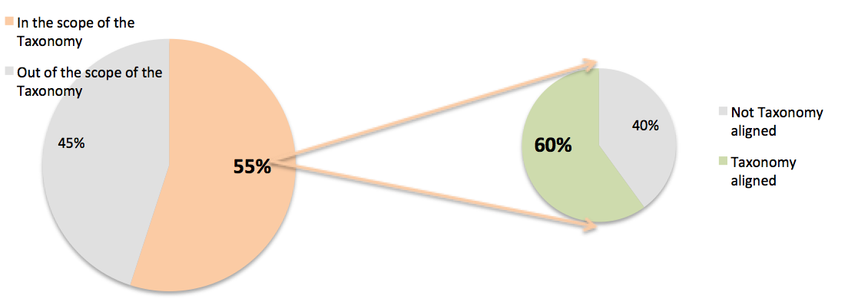

<ESA_QUESTION_ESG_6>

1. : Do you have any views on the statement of taxonomy compliance of the activities the financial product invests in and whether those statements should be subject to assessment by external or third parties?

<ESA_QUESTION_ESG_7>

TYPE YOUR TEXT HERE

FMPs may decide to request an external/third party opinion on alignment, but this should not be compulsory. We do not believe that disclosing the use of third party is necessary. FMPs are in any case providing confirmation of whether products are aligned with the taxonomy, so are taking responsibility for these statements. The statement of taxonomy compliance will be challenging at the beginning, as data sets are expected to be incomplete especially regarding the Do Not Significant Harm and Minimum Safeguards tests. In the short-term, reporting on a ‘best effort basis’ should be allowed until the Taxonomy is finalised and data sets improved. In parallel, we also encourage the EC and the ESAs develop an official methodology when no information is available in order to assess small and non-EU issuers (coefficient-based model).

<ESA_QUESTION_ESG_7>

1. **: Do you have any views on the proposed periodic disclosures which mirror the proposals for pre-contractual amendments?**

<ESA_QUESTION_ESG_8>

TYPE YOUR TEXT HERE

**Content issue:** Having a standardised presentation of the required information can be useful for end clients, especially non-professional ones. However, we find the information displayed in the templates too lengthy and often confusing making it hard to read from a retail end-customers perspective. This level of complexity is not always required by level 1 texts and was clearly identified as an issue by consumer tests conducted by the ESAs.

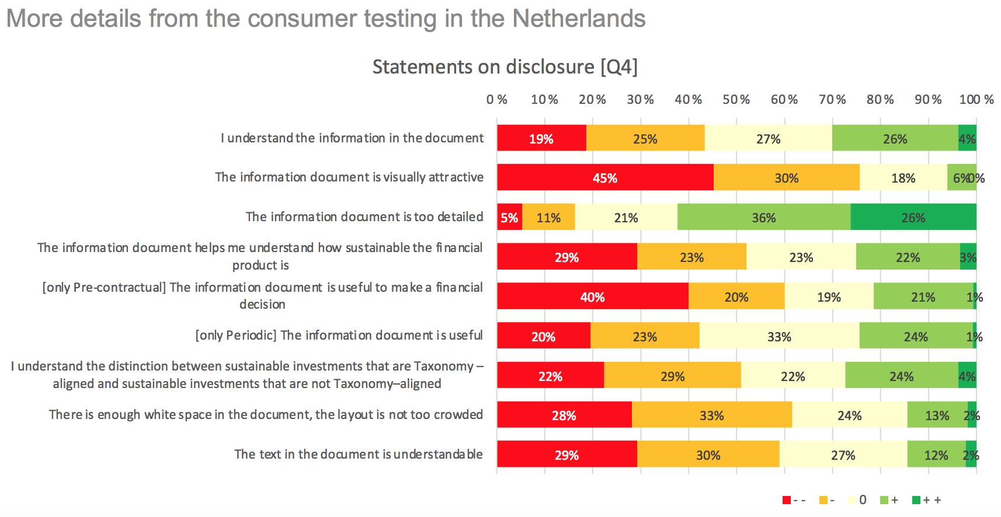

**Format issue**: Also, the proposed presentation (i.e., Q&A, graphs) does not fit in with the current prospectus and annual report formats. This pre-contractual and periodic information is intended to be included into existing documents provided for under EU sectoral legislation and provided by, for example, AIFMs, UCITS management companies.

To avoid overload and ensure that information can be provided in compliance with EU and national legislation, the ESAs could (1) delete overlapping information (see proposal in annex) and (2) allow the use of cross-reference to other sections of the annual report and the FMP’s website. Websites or periodic reports are better suited for the disclosure of graphical representation of investments of the financial products: they allow more frequent and continuous updating than the pre-contractual documents. The need for flexibility in updating this type of information is important as there is still uncertainty as to what would qualify as a “sustainable investment” under SFDR/Taxonomy and as the ESG footprint of investee companies will evolve over time.

<ESA_QUESTION_ESG_8>

1. : Do you have any views on the amended pre-contractual and periodic templates?

<ESA_QUESTION_ESG_9>

TYPE YOUR TEXT HERE

Although this is not new, we are still not at ease with the concept of minimum share of taxonomy alignment.  The level of taxonomy alignment is not entirely at the discretion of the product manager: it very largely depends on the availability of taxonomy aligned assets. Product managers are likely to compete for a scarce amount of assets in the early implementation stage of the EU Taxonomy. The implementation of novel concepts such as the DNHS and MSS might limit the supply of assets at the very beginning. The RTS should instead refer to the expected average/target rather than a firm binding minimum proportion and allow for temporary deviations given the dynamic nature of all the variables involved. As there is no obligation to invest in taxonomy aligned investments, the templates should not require an explanation as to why the product has invested in activities that are not taxonomy environmentally sustainable.

<ESA_QUESTION_ESG_9>

1. : The draft RTS propose unified pre-contractual and periodic templates applicable to all Article 8 and 9 SFDR products (including Article 5 and 6 TR products which are a sub-set of Article 8 and 9 SFDR products). Do you believe it would be preferable to have separate pre-contractual and periodic templates for Article 5-6 TR products, instead of using the same template for all Article 8-9 SFDR products?

<ESA_QUESTION_ESG_10>

TYPE YOUR TEXT HERE

We support having one template albeit with optionality. For Article 8 products that do not intend to invest in taxonomy aligned investments, the taxonomy alignment sections of the template should be omitted. Giving ‘zero’ disclosures for such products may be confusing for retail investors.

<ESA_QUESTION_ESG_10>

1. : The draft RTS propose in the amended templates to identify whether products making sustainable investments do so according to the EU taxonomy. While this is done to clearly indicate whether Article 5 and 6 TR products (that make sustainable investments with environmental objectives) use the taxonomy, arguably this would have the effect of requiring Article 8 and 9 SFDR products making sustainable investments with social objectives to indicate that too. Do you agree with this proposal?

<ESA_QUESTION_ESG_11>

TYPE YOUR TEXT HERE

Only if the reporting break out assets in/out the scope of the Taxonomy and indicate the actual level of taxonomy alignment of the underlying investments currently in the scope of the Taxonomy.

<ESA_QUESTION_ESG_11>

1. : Do you have any views regarding the preliminary impact assessments? Can you provide more granular examples of costs associated with the policy options?

<ESA_QUESTION_ESG_12>

TYPE YOUR TEXT HERE

We are concerned that the information overload will confuse retail investors. We would like to propose in the annex a shorter yet comprehensive alternative template.

##### AMIC proposal for an alternative SFDR template

##### Template precontractual disclosure for financial products referred to in Article 8(1) of Regulation (EU) 2019/2088

**Product name/legal identifier:** [complete]

**Information related to environmental and/or social characteristics:**



*[tick when relevant]*

This product:

Promotes environmental or social characteristics, but does not have as

its ***core*** objective a sustainable investment (SI)

It does not intend to invest in SI

It intends to invest partially in SI

In activities aligned with the EU classification (Taxonomy)

In activities other than ones aligned with the EU classification (Taxonomy)

Has sustainable investment as its objective. Sustainable investment means an investment in an economic activity that contributes to an environmental or social objective, provided that the investment does not significantly harm any environmental or social objective and that the investee companies follow good governance practices.

In activities aligned with the EU classification (Taxonomy)

In activities other than ones aligned with the… EU… Environmental Classification (Taxonomy)

###### What environmental and/or social characteristics does this financial product promote?

###### Does this financial product take into account principal adverse impacts on sustainability factors?

###### Principal adverse impacts are the most significant negative impact of investment decisions on sustainability factors relating to environmental, social and employee matters, respect for human rights, anti-corruption and anti-bribery matters.

###### What indicators and binding elements are used to measure the attainment of the environmental or social characteristics promoted by this financial product?

###### What is the policy to assess good governance practices of the investee companies?

###### What is the expected share of investments contributing to promote environmental and/or social characteristics of the product?

###### What is the purpose of other investments and does any minimum environmental or social safeguards apply to them?

###### Are derivatives used to attain the environmental or social characteristics promoted by the financial product? If so how and in what expected proportion?

###### Information related to sustainable investments (to be omitted if product does not intend to invest in sustainable investments):

###### Sustainable investment means an investment in an economic activity that contributes to an environmental or social objective, provided that the investment does not significantly harm any environmental or social objective and that the investee companies follow good governance practices.

###### The EU Taxonomy is a narrower classification system, establishing a precise list of technical criteria for economic activities and investments to be considered environmentally sustainable.

###### What is the expected average % for share of sustainable investments?

###### What is the expected average % for the share of investments aligned with EU Environmental Classification (Taxonomy)?

###### Macintosh HD:Users:arthurcarabia:Desktop:Capture d’écran 2021-05-10 à 13.52.49.png

###### What is the expected average % for share of investments in transitional and enabling activities (two types of activities that are in the scope of the EU classification (Taxonomy)?

###### How will sustainable investments contribute to a sustainable investment objective and not significantly harm any sustainable investment objective?

**Information related to benchmarks:**

* Is a specific index designated as a reference benchmark to determine whether this financial product is aligned with the environmental or social characteristics that it promotes?
* How does the designated index differ from a relevant broad market index?
* How is the reference benchmark continuously aligned with each of the environmental or social characteristics promoted by the financial product and with the investment strategy?

**More product-specific information can be found on the website:** (hyperlink)

<ESA_QUESTION_ESG_12>

1. Regulation (EU) 2018/1725 OF THE EUROPEAN PARLIAMENT AND OF THE COUNCIL of 23 October 2018 on the protection of natural persons with regard to the processing of personal data by the Union institutions, bodies, offices and agencies and on the free movement of such data, and repealing Regulation (EC) No 45/2001 and Decision No 1247/2002/EC, OJ L 295, 21.11.2018, p. 39.