|  |
| --- |
| **Response Form** |
| **Consultation on Fees charged to Credit Rating Agencies by ESMA** |

**Responding to this paper**

ESMA invites comments on all matters set out in this paper and in particular on the specific questions summarised in Annex 1. Comments are most helpful if they:

* respond to the question stated;
* indicate the specific question to which the comment relates;
* contain a clear rationale; and
* describe any alternatives ESMA should consider.

ESMA will consider all comments received by **15 March 2021.**

All contributions should be submitted online at [www.esma.europa.eu](http://www.esma.europa.eu) under the heading: ‘Your input - Consultations’.

**Instructions**

In order to facilitate analysis of responses to the Consultation Paper, respondents are requested to follow the below steps when preparing and submitting their response:

1. Insert your responses to the questions in the Consultation Paper in the present response form.
2. Please do not remove tags of the type <ESMA_QUESTION_CRAFees_1>. Your response to each question has to be framed by the two tags corresponding to the question.
3. If you do not wish to respond to a given question, please do not delete it but simply leave the text “TYPE YOUR TEXT HERE” between the tags.
4. When you have drafted your response, name your response form according to the following convention: ESMA_CRAFees_nameofrespondent_RESPONSEFORM. For example, for a respondent named ABCD, the response form would be entitled ESMA_ CRAFees_ABCD_RESPONSEFORM.
5. Upload the form containing your responses, in Word format, to ESMA’s website ([www.esma.europa.eu](http://www.esma.europa.eu) under the heading “Your input – Open consultations” 🡪 “Consultation on Fees charged to Credit Rating Agencies by ESMA”).

**Publication of responses**

All contributions received will be published following the closure of the consultation period, unless you specifically request otherwise. Please clearly and prominently indicate in your submission any part that you do not wish to be publicly disclosed. A standard confidentiality statement in an email message will not be treated as a request for non-disclosure. A confidential response may be requested by ESMA in accordance with ESMA’s rules on access to documents. We may consult you if we receive such a request. Any decision we make not to disclose a response is reviewable by ESMA’s Board of Appeal and the European Ombudsman.

**Data protection**

Information on data protection can be found at [www.esma.europa.eu](http://www.esma.europa.eu) under the heading [Legal Notice](http://www.esma.europa.eu/legal-notice).

**Who should respond to the consultation paper**

Credit Rating Agencies (CRAs) issuing or endorsing credit ratings for use in the EU and their auditors, CRAs certifying credit ratings for use in the EU, firms considering registration as Credit Rating Agencies or firms applying for certification status. This Consultation Paper may also be of interest to trade associations representing CRAs and users of credit ratings.

**General information about respondent**

|  |  |
| --- | --- |
| Name of company / organisation | European Association of Credit Rating Agencies (EACRA) |
| Activity | Other Financial service providers |
| Are you representing an association? |  |
| Country/Region | France |

**Introductory comments**

**Please use this space to provide any relevant introductory comments:**

<ESMA_ QUESTION_CRAFees_Qi>

With reference to your Consultation Paper on “Fees charged to CRAs by ESMA”[1] dated 29 January 2021, we are pleased to hereby provide the views of our association.

ESMA proposes a number of changes to the current Delegated Regulation on CRA Supervisory fees[2], the key elements being 1) the introduction of a flat annual supervisory of EUR 20.000 for CRAs with a turnover between EUR 1 and 10 mln, 2) the calculation of fees based on total turnover and 3) the introduction of an endorsement fee. You shall find our detailed responses to these proposals in Question 5, 6 and 7 below.

We have assessed ESMA CRA Supervisory fees proposal against the transparency reports of ESMA registered CRAs for 2018 covering the EU 28 at that time. We retained from using data for 2019, as several new entities were registered ahead of Brexit with still limited operations.

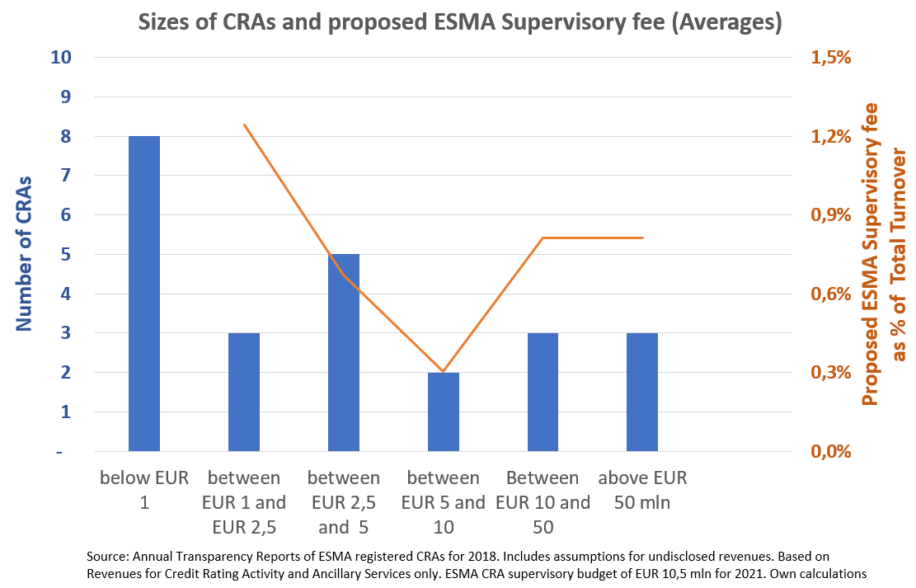

Based on our analysis, we estimate that the new revenue categories (flat supervisory fee on small agencies and endorsement fee) will contribute together only 5% to ESMA CRA Supervisory Budget. While the annual supervisory fee on small agencies is disproportionately high, the proposed endorsement fees are far too low compared to the role of endorsed ratings.

We believe that the current approach to CRA supervisory fees has worked – overall - properly well, except for two important elements:

* ESMA expects to receive audited annual accounts for the purpose of the CRA Supervisory Fees calculation. We note that some CRAs are not required to audit their accounts under Member States tax laws – these CRAs undergo costs of approx. EUR 6.000 solely to meet ESMAs formal requirements with the result that the concerned CRAs are thereafter exempted from paying supervisory fees!
* While the current Delegated Regulation includes a threshold of EUR 10 mln of total turnover before CRA Supervisory Fees are due, the threshold marks a cliff edge as thereafter the CRAs are subject to contribute in full to ESMA CRA Supervisory Fee budget. Whatever threshold is being defined and retained, we strongly recommend that this threshold is being excluded from the “applicable turnover” in order to smoothen the cliff.

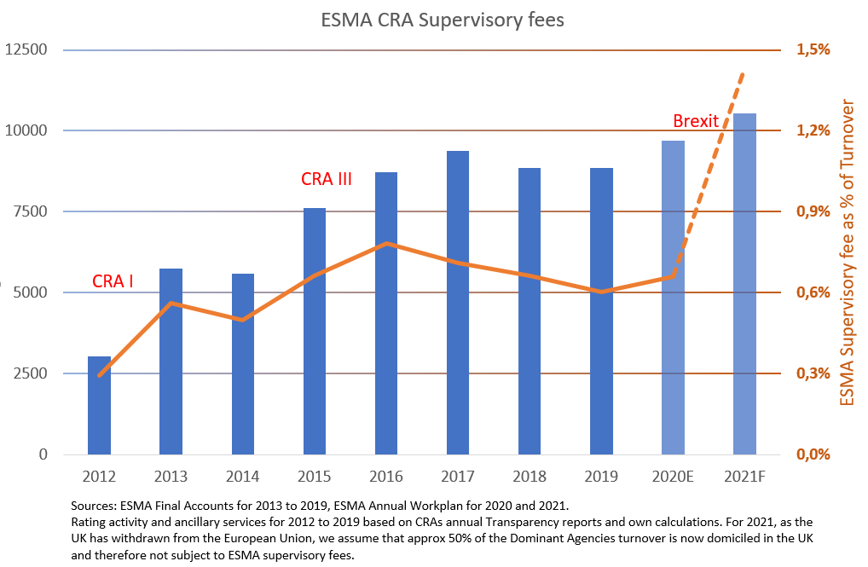Last but not least, let us express our concern with ESMA CRA Supervisory Budget on CRAs. While ESMAs budget averaged EUR 5,5 mln per year for 2013 and 2014, followed by average annual fees of EUR 8,7 mln for 2015 to 2019 reflecting the entry into force of CRA III and additional supervisory tasks for ESMA, ESMA budget of EUR 10,5 mln for 2021[3] is an unexplained, worrisome increase.

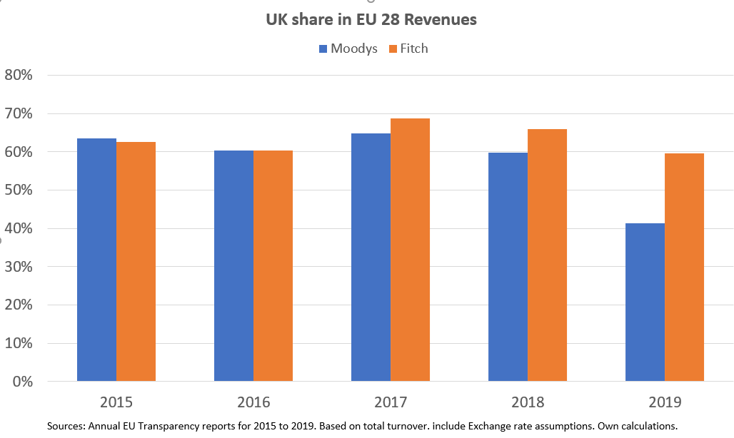

In view of the UKs final Withdrawal from the EU and that approx. 50% of the Dominant CRAs[4] applicable turnover for the calculation of supervisory contributions has fallen outside of ESMA merit, we are particularly concerned as European agencies paying supervisory fees to ESMA currently will see their contributions probably doubled. We recommend that ESMA reviews its CRA Supervisory Budget in order to reflect the new environment.

<ESMA_ QUESTION_CRAFees_Qi>

1. **Changes to general budgetary approach**

**Q1: Do you agree with the proposals to reflect ESMA’s general budgetary approach in the revised Fees Delegated Regulation? If not, please explain why not.**

<ESMA_ QUESTION_CRAFees_Q1>

We take note of ESMAs wish to modify the current approach to CRA Supervisory Fee’s where any surplus / deficit in a given year is refunded / charged to the CRAs the following year to align it with its “universal budgeting model” where any surpluses or deficits would be absorbed by the general ESMA budget.

We highlight that ESMA new budgeting model is not universally applied across EU authorities. For instance, the ECB Banking Supervision uses the same approach as currently ESMA for CRAs. The ECB charges a total of EUR 603 mln for 2020 in supervisory fee, the large bulk being paid by significant institutions.[5]

According to ESMAs work plan for 2021, ESMA expects to collect a total of EUR 18,5 mln in supervisory fees from its supervised entities. CRAs are expected to pay EUR 10,5 mln or about 60% of all supervisory fees. If harmonisation of ESMAs approach to supervisory fee across all industries is really required, then other market segments should follow the main contributors benchmark. Additionally, CRAs are the oldest industry under ESMAs direct supervision. Finally, we believe that Benchmark Administrators (73 registered or recognized entities under different categories) as well as the Trade Repositories (4 being registered) industries are different to the CRA industry (with 30 registered or certified players) in terms of structure and revenues - a “one approach to all sectors” may therefore not correspond to the different industries.

With respect to the proposal on annual fixed fees, we refer to our response in Question 5 below.

With respect to ESMAs wish to collect the whole supervisory fee in one instalment in March, we believe that this requirement creates an unnecessary liquidity peak for both, the supervised CRAs and ESMA. We therefore propose to keep the current 2 instalments. <ESMA_ QUESTION_CRAFees_Q1>

1. **Registration fees**

**Q2: Do you agree with the proposed changes to registration fees? If not, please explain why not.**

<ESMA_ QUESTION_CRAFees_Q2>

TYPE YOUR TEXT HERE

<ESMA_ QUESTION_CRAFees_Q2>

**Q3: Do you agree with the proposed changes to the reimbursement of registration fees? If not, please explain why not.**

<ESMA_ QUESTION_CRAFees_Q3>

TYPE YOUR TEXT HERE

<ESMA_ QUESTION_CRAFees_Q3>

**Q4: Do you agree with the proposed changes to the calculation of initial supervisory fees for CRAs? If not, please explain why not.**

<ESMA_ QUESTION_CRAFees_Q4>

TYPE YOUR TEXT HERE

<ESMA_ QUESTION_CRAFees_Q4>

1. **Annual supervisory fees**

**Q5: Do you agree with the proposal to exempt CRAs with a total turnover of under €1,000,000 from the payment of annual supervisory fees? If not, please explain why not.**

<ESMA_ QUESTION_CRAFees_Q5>

Upfront to the current Delegated Regulation on CRA Supervisory Fees, ESMA proposed in its Technical Advice dated May 2011 a minimum annual registration fee of EUR 5.000[6]. The final Delegated Regulation rejected ESMA wish and introduced the threshold of EUR 10 mln for exempting CRA of supervisory fees, the reasoning being provided in Recital 3: “An annual supervisory fee should be charged to credit rating agencies exceeding a certain threshold of turnover in order to provide for budgetary certainty for both ESMA and the credit rating agencies concerned. Annual supervisory fees should not become a burden for new entrants to the credit rating market. Moreover, small credit rating agencies are expected to engender significantly less supervisory costs than larger ones. It would be therefore proportionate to fully exempt small credit rating agencies from paying the annual supervisory fee where the credit rating agency (…) do not exceed a certain threshold of turnover.

As cited by ESMA in the Consultation Paper, Recital 8 of the current Delegated Regulations states: “In view of possible future developments, it is appropriate for the thresholds for exempting credit rating agencies from paying annual supervisory (…) to be reviewed and updated as necessary.“

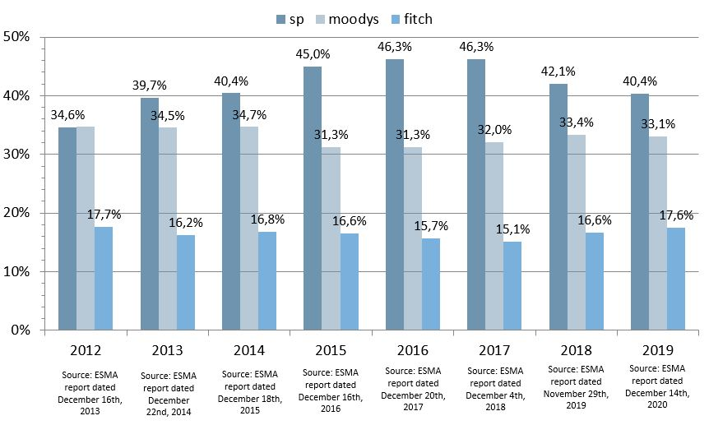

While the term “future development” is more than vague, we believe that this can be measured against the objectives of the CRA III regulation, which entered into force shortly after the Delegated Regulation. While the number of registered CRAs has reached 30, the Dominant 3 Agencies continue to control over 90% of the market. As the EU rating market structure has not materially changed, we do not see the immediate need to trigger this clause.

In 2012, the threshold for exempting CRAs from Supervisory fees was set at EUR 10 million. ESMA now proposes to lower this threshold to EUR 1 million. Based on the annual transparency reports for 2018, we assume that 11 CRAs would become subject to supervisory fees. These 11 CRAs would pay together EUR 220.000 of supervisory fees – representing only 2,1% of ESMAs CRA Supervisory Budget for 2021. Such a contribution does therefore not significantly change ESMAs revenues, but impacts heavily on new and small players. We therefore reject ESMAs proposal to lower the threshold.

In fact, assuming an average annual inflation of 1,3% since 2011, the threshold of EUR 10 million set in 2011 should be raised to EUR 11,3 million by 2021 to reflect overall macro-economic developments. We therefore propose that the threshold should be updated if not annually at least every 5 years.

Finally, as mentioned in our introductory comment, we propose that the threshold should be excluded from the supervisory fees calculation in order to reduce cliff effects when crossing the threshold.

<ESMA_ QUESTION_CRAFees_Q5>

**Q6: Do you agree with the proposed changes to annual supervisory fees charged to CRAs? If not, please explain why not.**

<ESMA_ QUESTION_CRAFees_Q6>

As mentioned in our response to Question 5, we reject the proposal to introduce a flat supervisory fee for CRAs with a total turnover between EUR 1 and EUR 10 mln.

With respect to the annual endorsement fee, given the role of endorsed ratings in the EU, we see some merit in introducing such a revenue category for ESMA. Given the final withdrawal of the UK from the EU, the share of endorsed ratings is likely to raise from 71% to approx. 90%.

The endorsement fee as proposed by ESMA would generate total fees of approx. EUR 250.000 and thereby contribute to 2,2% to ESMA CRAs Supervisory budget. This share is not representative of the role played by endorsed ratings issued by the Dominant 3 Agencies. In order to better reflect these endorsed ratings, we propose that the applicable turnover for CRAs above EUR 10 mln is multiplied by a factor. The factor could be set in a range of 2 to 5:

* A factor of 2 would reflect approximately the withdrawal of the UK from the EU
* A factor of 5 reflects the EU 27 share in the Dominant 3 Agencies global operations.

In view of ESMAs mandate to contribute to investors protection and that the Dominant 3 Agencies are of systemic importance to the financial system, introducing such a factor would mirror ESMA supervisory focus.

As an alternative approach, we propose that endorsement fees should cover 50% of ESMA CRA Supervisory budget. CRAs having less than EUR 10 mln turnover would be subject to a flat fee as proposed by ESMA, the remaining amount to be paid by other CRAs endorsing ratings (shared along the respective applicable turnover).

<ESMA_ QUESTION_CRAFees_Q6>

1. **Applicable turnover**

**Q7: Do you agree with the proposed changes to the calculation of CRAs’ applicable turnover? If not, please explain why not.**

<ESMA_ QUESTION_CRAFees_Q7>

ESMA proposes to change the basis for the calculation of supervisory fee’s from credit rating activities and ancillary services to total revenues

Based on the transparency reports for 2018, we estimate that the change to total revenues would increase the basis of calculation of supervisory fees by around 7%. At the same time, we note that the Dominant Agencies report on average about 3% of non-rating revenues only. In fact, these agencies generate high rating related revenues (eg for the subscription to their rating data feeds) outside of the ESMA supervised entities. European CRAs, on the other hand, may report larger shares of non-rating activity as they can’t shift away revenues into other geographies or legal entities. Taking total turnover would therefore primarily impact on European Agencies.

On the other hand, we agree with ESMA that the terms “credit rating activity”, “ancillary services” and “non-rating activities” are poorly defined in the CRA Regulation and that CRAs may potentially classify specific revenues in different categories. We therefore share ESMAs frustration regarding “individual requests for deductions from total revenues as these assessments require specialist resources and are not sustainable as ESMA assumes new supervisory mandates”[7].

In order to streamline the calculation of supervisory fees and to reduce the burden on CRAs, we would agree on using “total turnover” if the following items are also implemented:

* As mentioned already in our introductory comment, ESMA should not require audited accounts from the supervised entities, CRAs should be able to submit annual accounts finalized according to the tax laws of the concerned Member State.
* As total turnover shall be used, CRAs should not be mandated to provide revenue breakdowns.
* The threshold of EUR 10 mln for exempting small CRAs to pay supervisory fees is being deducted from the applicable turnover. The removal of this hard threshold reduce cliff effects of crossing the threshold and correspond to a proportionate approach.

We agree with ESMAs proposal to use the financial accounts of year n-2 (to be delivered by September of year n-1) for the purpose of calculating supervisory fees of year n.

<ESMA_ QUESTION_CRAFees_Q7>

1. **Certification fees**

**Q8: Do you agree with the proposal to revise the approach to the reimbursement of supervisory fees for certified CRAs? If not, please explain why not.**

<ESMA_ QUESTION_CRAFees_Q8>

TYPE YOUR TEXT HERE

<ESMA_ QUESTION_CRAFees_Q8>

**Q9: Do you agree with the proposal to exempt certified CRAs from the payment of initial fees? If not, please explain why not.**

<ESMA_ QUESTION_CRAFees_Q9>

TYPE YOUR TEXT HERE

<ESMA_ QUESTION_CRAFees_Q9>

**Q10: Do you agree with the proposal to require all certified CRAs to pay an annual certification fee of €6,000? If not, please explain why not.**

<ESMA_ QUESTION_CRAFees_Q10>

TYPE YOUR TEXT HERE

<ESMA_ QUESTION_CRAFees_Q10>

1. **Final comments**

**Please use this space to provide any other relevant information you wish to bring to ESMA’s attention not covered by your responses to the previous questions:**

<ESMA_ QUESTION_CRAFees_Qf>

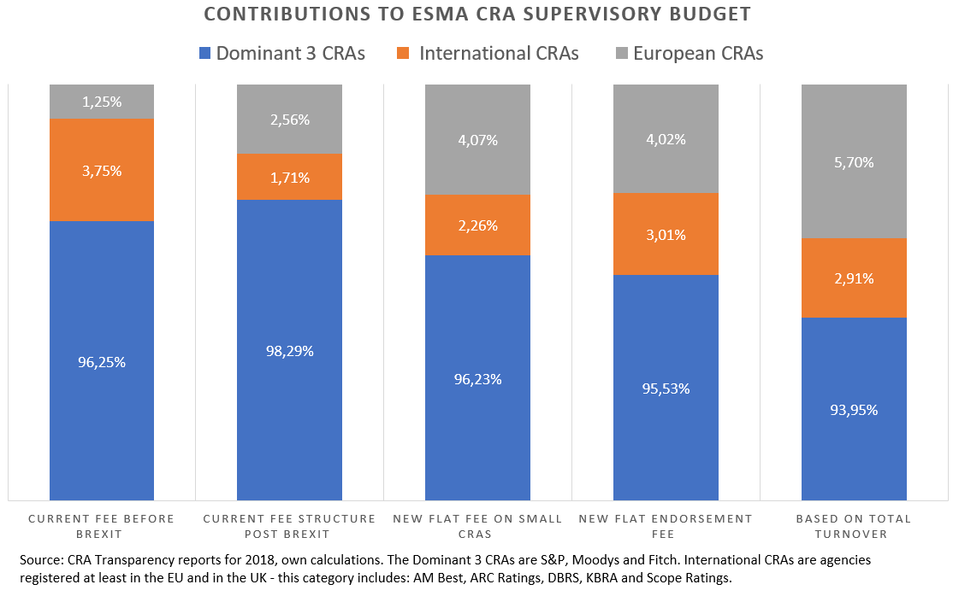

The graph above summarizes the impact of ESMAs proposal.

* The column on the left represents the current fee structure before the UK Withdrawal. The second column shows the post Brexit effect: as revenues of the Dominant Agencies and International Agencies has shifted outside of the EU, European CRAs are likely to see their contributions doubling.
* The third column includes the introduction of the flat annual supervisory fee on small agencies. Not surprisingly, the contributions of European CRAs raise while the share of the Dominant 3 decreases.
* The fourth column outlines the effect of the proposed endorsement fee. As International CRAs will be subject to this fee, their share increase.
* The last column marks the effect of changing the basis of calculation of supervisory fees to total turnover.

Compared to the current situation, when taking all ESMA proposals together, European Agencies would see their contributions nearly multiplied by 5 while the Dominant Agencies receive (unduly!) a discount!

Directly connected to ESMA supervisory activities are potential supervisory actions, including the issuing of sanctions and public notices. We highlight that the current sanctioning regime under the CRA Regulation is unfair and disproportionate:

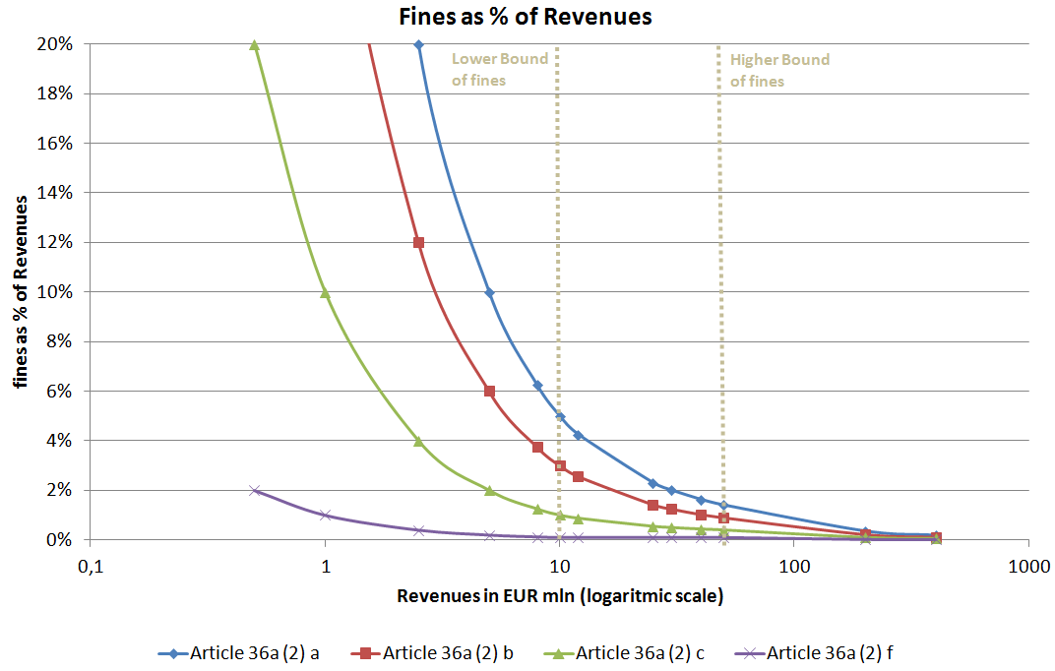

For the same infringement, measured against revenues, a small agency would receive a far higher fine than a Dominant Agency. As long as the sanctioning regime is not modified to “make it a more effective, proportionate and dissuasive sanctioning regime”[8], we believe that a material change in the calculation of supervisory fees to the disadvantage of small European agencies is not an appropriate.

In summary, we believe that the following approach is the most appropriate:

* Annual accounts provided to ESMA should follow Member States tax law requirements
* Introduce commensurate endorsement fees designed to cover 50% of ESMA CRA Supervisory Budget
* keep the current threshold of EUR 10 mln for exempting small CRAs from paying supervisory fees;
* Define the threshold based on total turnover
* Exclude the threshold from the applicable turnover.

The graph below summarizes our proposal:

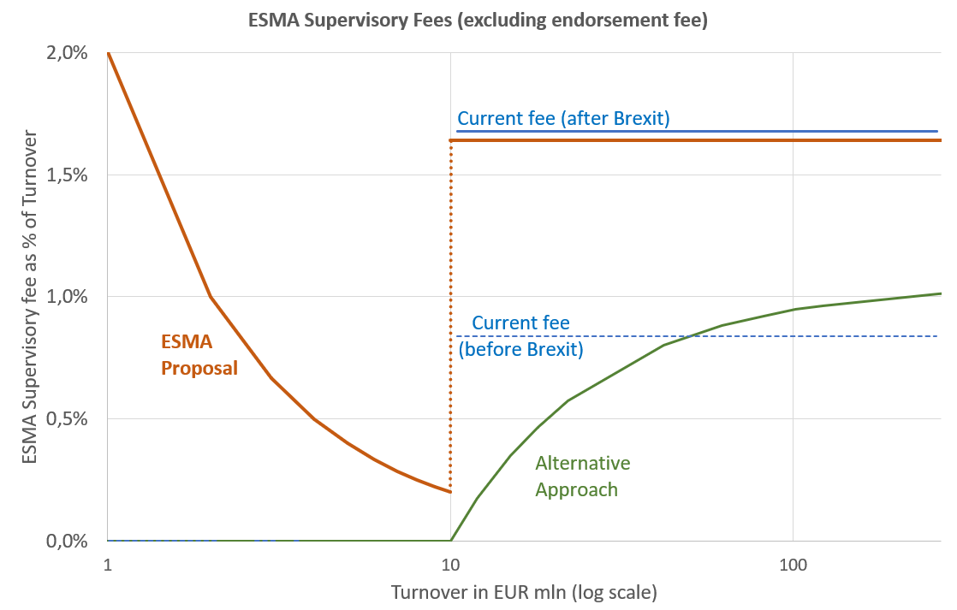

Our proposal has the following benefits:

* To ESMA: by setting as reference point of “total turnover” across the Delegated Regulation, the information collection exercise and the calculation of supervisory fees is substantially streamlined.
* To CRAs: through the removal of the hard threshold, CRAs can gradually grow and are not suddenly subject to high supervisory fees kicking in.

We thank you for the opportunity to provide our comments and remain at your full disposal for any clarifications or additional information. We trust that our above proposal mirrors the structure of the European rating market and the need for more competition as well as the unprecedented event of a Member State leaving the European Union.

<ESMA_ QUESTION_CRAFees_Qf>

1. Available at: <https://www.esma.europa.eu/sites/default/files/library/esma80_196_5019_consultation_paper_fees_charged_to_cras_by_esma.pdf>
2. Available at: [EUR-Lex - 32012R0272 - EN - EUR-Lex (europa.eu)](https://eur-lex.europa.eu/eli/reg_del/2012/272/oj)
3. See page 54 of ESMAs Workplan for 2021, available at <https://www.esma.europa.eu/sites/default/files/library/esma20-95-1273_2021_annual_work_programme.pdf>
4. Given S&Ps evolving corporate structure in Europe, S&P didn’t disclose separately the revenues generated in the UK.
5. For more information on the ECB Banking Supervision supervisory fees: <https://www.bankingsupervision.europa.eu/organisation/fees/total/html/index.en.html>
6. Quote §18 page 5: “ESMA recognises that there is a need to balance the risks of fees to competition against the need for CRAs to contribute proportionately to the cost of their supervision. ESMA continues to consider a minimum fee is appropriate given all CRAs, no matter their size, will require ESMA to expend supervisory resources. ESMA is mindful of the ability of smaller CRAs to bear a higher fee than 5.000 euros, on the other hand, a lower fee could force large CRAs to subsidise the fees of smaller CRAs; consequently, ESMA suggests the minimum fee to be set at 5.000 euros”. Available at: <https://www.esma.europa.eu/sites/default/files/library/2015/11/2011_144.pdf>
7. See § 59 page 19 of ESMAs Consultation Paper
8. See letter of ESMA Chair Maijoor to EC DG FISMA Director General Guersent dated 27January 2017, page 3, available at: <https://www.esma.europa.eu/sites/default/files/library/esma70-708036281-19_letter_to_com_-_emir_review_and_sanctioning_powers.pdf>  
   