|  |
| --- |
| Response Form to the Consultation Paper |
| MiFIR review report on the obligations to report transactions and reference data |

**Responding to this paper**

ESMA invites comments on all matters in this paper and in particular on the specific questions summarised in the Annex. Comments are most helpful if they:

* respond to the question stated;
* indicate the specific question to which the comment relates;
* contain a clear rationale; and
* describe any alternatives ESMA should consider.

ESMA will consider all comments received by **20 November 2020.**

All contributions should be submitted online at [www.esma.europa.eu](http://www.esma.europa.eu) under the heading ‘Your input - Consultations’.

**Instructions**

In order to facilitate analysis of responses to the Consultation Paper, respondents are requested to follow the below steps when preparing and submitting their response:

1. Insert your responses to the questions in the Consultation Paper in the present response form.
2. Please do not remove tags of the type <ESMA_QUESTION_CP_TRRF_1>. Your response to each question has to be framed by the two tags corresponding to the question.
3. If you do not wish to respond to a given question, please do not delete it but simply leave the text “TYPE YOUR TEXT HERE” between the tags.
4. When you have drafted your response, name your response form according to the following convention: ESMA_TRRF_nameofrespondent_RESPONSEFORM. For example, for a respondent named ABCD, the response form would be entitled ESMA_TRRF_ABCD_RESPONSEFORM.
5. Upload the form containing your responses, in Word format, to ESMA’s website ([www.esma.europa.eu](http://www.esma.europa.eu) under the heading “Your input – Open Consultations” 🡪 “Consultation paper on MiFIR review report on the obligations to report transactions and reference data”).

**Publication of responses**

All contributions received will be published following the close of the consultation, unless you request otherwise. Please clearly and prominently indicate in your submission any part you do not wish to be publicly disclosed. A standard confidentiality statement in an email message will not be treated as a request for non-disclosure. A confidential response may be requested from us in accordance with ESMA’s rules on access to documents. We may consult you if we receive such a request. Any decision we make not to disclose the response is reviewable by ESMA’s Board of Appeal and the European Ombudsman.

**Data protection**

Information on data protection can be found at [www.esma.europa.eu](http://www.esma.europa.eu) under the heading [Legal Notice](http://www.esma.europa.eu/legal-notice).

**Who should read this paper?**

This document will be of interest to all stakeholders involved in the securities markets. It is primarily of interest to competent authorities and firms that are subject to MiFID II and MiFIR – in particular, investment firms and credit institutions performing investment services and activities and trading venues. This paper is also important for trade associations and industry bodies, institutional and retail investors and their advisers, and consumer groups, as well as any market participant because the MiFID II and MiFIR requirements seek to implement enhanced provisions to ensure the transparency and orderly running of financial markets with potential impacts for anyone engaged in the dealing with or processing of financial instruments.

**General information about respondent**

|  |  |
| --- | --- |
| Name of the company / organisation | BNP Paribas |
| Activity | Banking sector |
| Are you representing an association? |  |
| Country/Region | Europe |

**Introduction**

***Please make your introductory comments below, if any***

<ESMA_COMMENT_CP_TRRF_1>

* 1. BNPP thanks ESMA for giving the opportunity to respond to this consultation.
  2. Although we welcome the various initiatives aiming at further simplification, we believe that the proposals presented in this Consultation Paper (CP) would lead to a wide range of additional requirements for market participants and operators (ISINs for non-TOTV IRS, duplicated contribution of instrument reference data to FIRDS), at great cost and with no added benefits for the financial community as a whole.
  3. BNPP believes that the MiFID II / MiFIR regime is meaningful and has commendable goals such as investor protection, market resilience and efficiency. However, in times of general economic recovery it is also pragmatic to keep an eye on benefit vs. costs, and the competitiveness of market participants and operators in the EU market, compared to those active in other markets with less expensive regulatory requirements and/or a larger lean revenue base.
  4. This consultation is rich in analysis and the questions are far reaching in terms of complexity, and impacts, hidden and/or unintended. For these reasons and because of the short amount of time available in the current context of Covid-19 and Brexit, we would to have preferred having more time to discuss those proposals with regulators and the industry.
  5. Simplification - Questioning the value of the Systematic Internaliser (SI) regime for Bonds and Derivatives (i.e. Non-Equity)
* While we recognise the rationale of transparency for investment firms trading TOTV instruments off-venue, in the spirit of a level playing field with investment firms executing on-venue, we question the value of the SI regime for Bonds and Derivatives.
* We believe that it is possible to continue complying with all MiFID 2 / MiFIR reporting obligations while simplifying the framework by removing the SI regime concept for Bonds and Derivatives.
* We suggest further regulators / industry analysis and reflection in that direction
  1. Simplification – clarify the market structure for bonds and derivatives
* The market structure is made of market participants and market operators.
* Market participants are not trading venues.
  1. Taking this into account, we argue that any change should go in that direction, i.e. that new regulatory requirements are not related to the abstract concept of SI and are instead defined in clear and simple terms of
* market participants and / or
* market operators and/or
* specific asset / sub-asset / sub classes or instruments
  1. Instead of extending the scope of instruments under MiFIR reporting, in RTS-2, RTS-22 and RTS-23, and instead of extending the size of the unnecessary ISIN factory for non-TOTV derivatives, we should focus on the following core objectives:
* data quality improvement on the current scope of instruments,
* simplification and streamlining of the regulatory reporting requirements
* access of the transparency data,
* set-up of the consolidated tape,
* and, above all, the understanding of all that the data and the market.
  1. We are keen to work with regulators to simplify regulatory reporting requirements to help market participants to comply with those requirements.
  2. We also reiterate our belief in a phased-approach for everything that we are attempting to build. While MiFIR is not even 3 years old and cover the whole range of asset classes, shares, bonds and derivatives, we keep attempting massive changes.

-------------------------------------------------------

* 1. Abbreviations used in the answer

CP Consultation Paper

IF Investment firm

MTF Organised Trading Facility

OTF Multilateral Trading Facility

SI Systematic Internaliser

STO Share Trading Obligations

TOTV Traded on a Trading Venue

TR Transaction Reporting

TV Trading Venue

uTOTV underlying is Traded on a Trading Venue

<ESMA_COMMENT_CP_TRRF_1>

**Questions**

1. : Do you foresee any challenges for UCITS management companies and AIF managers in providing transaction reports to NCAs? If yes, please explain and provide alternative proposals.

<ESMA_QUESTION_TRRF_1>

BNPP is not responding to this question.

<ESMA_QUESTION_TRRF_1>

1. : Do you foresee any challenges with the outlined approach? If yes, please explain and provide alternative proposals.

<ESMA_QUESTION_TRRF_2>

BNPPis not responding to this question.

<ESMA_QUESTION_TRRF_2>

1. : Do you foresee any challenges with the outlined approach? If yes, please explain and provide alternative proposals.

<ESMA_QUESTION_TRRF_3>

BNPP is not responding to this question.

<ESMA_QUESTION_TRRF_3>

1. : Do you foresee any challenges with the outlined approach? If yes, please explain and provide alternative proposals.

<ESMA_QUESTION_TRRF_4>

BNPP is not responding to this question.

<ESMA_QUESTION_TRRF_4>

1. : Do you envisage any challenges in increasing the scope including derivative instruments traded through an SI as an alternative to the expanded ToTV concept? Please justify your position and if you disagree please suggest alternatives.

<ESMA_QUESTION_TRRF_5>

* 1. BNPP does not agree with the assessment and proposal presented.

Q5 - Executive Summary

* 1. BNPP does not agree with the assessment and proposal presented because is it based on an incorrect representation of the structure of bonds and derivatives markets.
* First, the pursuit of a level-playing field is between investment firms (IF) executing on and off-venue. There is no concept of level-playing fields between market participants and market operators because they are different entities, with different roles in the market structure.
* Second, the concept of SI in bonds and derivatives is ambiguous, unnecessarily complex, continuously leads to misunderstanding and should be removed.
  1. In terms of increasing the scope of instruments, while BNPP is always aiming at being compliant with all regulatory reporting requirements, we need to keep in mind the core objectives of those regulations:

1. As mentioned in paragraphs 5 -7, the goal of transaction reporting under MiFIR is to monitor market abuse.

* It is questionable in which market abuse is monitored when looking at non-TOTV instruments i.e. any product that is not in the scope of the current narrow interpretation of TOTV and of uTOTV (where the underlying is a financial instrument or index/basket of financial instrument).
* All non-TOTV instruments are custom instruments traded between investment firms.
* If there is a need to monitor market abuse of “non-TOTV instruments executed off-venue“, we refer to EMIR whose scope includes all OTC derivatives.

1. Irrespective of any change in the TR (e.g. extension of uTOTV), the scope of transparency should remain exclusively limited to the narrow “interpretation“ of TOTV instruments, per definition.

* Please refer to our diagram: Transparency of TOTV instruments, based on principle of level-playing field between investment firms executing on- and off-venue, see further in our answer to Q5.

----------------------------------------------------------------------------------------------------------------------------------------

Section 1 Simplification of regulatory framework - Removing the SI regime for Bonds and Derivatives

* 1. As this consultation addresses the subject of TR, instrument data reference and transparency, together with the concept of SI, we wish to reiterate our belief in:
* simplification of
* the general regulatory framework, and of
* the technical wording and concepts and
* focusing on efficient regulatory reporting based on the market structure:
* an efficient Post-Trade Transparency, which does not need the SI regime
* an efficient Transaction Reporting, which does not need the SI regime - and which will work better by removing unnecessary complexity related to the SI concept
* an efficient Instrument data reference, which does not need the SI regime
  1. As we explain in the following pages, we believe that it is possible to continue complying with all MiFID 2 / MiFIR reporting obligations while simplifying the framework by removing the SI regime concept for Bonds & Derivatives.
  2. Moreover, this would allow efforts and resources to be redirected to the “core“ goals and requirements with added value / benefits
* data quality improvement on the current scope of instruments,
* simplification and streamlining of the regulatory reporting requirements
* access of the transparency data,
* set-up of the consolidated tape,
* and, above all, the understanding of all that the data and the market.

We recommend further regulators / industry analysis and reflection in that direction.

* 1. In our answer below, we wish to give more details on the following dimensions:

Section 1.1 - Clarification of the market structure in the bonds and derivatives markets and the distinct roles of TV and IF

Section 1.2 - Clarification of the level-playing field between IF executing on and off-venue

Section 1.3 - Rationale - The SI concept is meaningful for equity, not for bonds and derivatives

Section 1.4 - Clarification of the regulatory texts by using the most appropriate wording for each role / participant

Section 1.5 - Simplification, removing unnecessary complexity from the reporting

Section 1.6 - Description of the solution or envisaged action by the Regulators

Q5 Section 1.1: Market Structure of Bonds and Derivatives: TV and IF have distinct roles

* 1. There is no concept of level playing field or comparison between TV and IF (or SI), because TV and IF are distinct entities with different roles in the market structure.
* TV are market operators and
* IF are market participants.
  1. Next to that, as liquidity providers are often assimilated to SIs, it is also appropriate to clarify that:
* liquidity providers are IFs and market participants.
* liquidity providers (market participants) are not TV (market operators).
* liquidity providers commit their balance sheet to offer liquidity - and are exposed to market / hedging risk, when trading on- or off-venue. TVs do not, and are not similarly exposed.
  1. Consequently, the current concept of "level playing field" between market participants and market operators is ambiguous and a misleading objective to pursue, certainly in the bonds & derivatives market. This concept originates from pre-MiFID 2 Equity markets and dark pools (of TOTV / fungible instruments executed on order book).
  2. Next to that, BNPP recognises the need to bring more transparency to TOTV instruments executed on- and off-venue.

Q5 Section 1.2: Level-playing field between IF executing on and off-venue

* 1. In paragraph 195 of the ESMA consultation on the ”MiFIR review of the non-equity transparency regime“, ESMA states that “the status quo results in exempting many OTC derivatives form the MiFIR transparency and reporting requirements”.
* This is true and this is the goal of MiFID II / MiFIR Transparency regime, which is to have a level-playing field between investment firms executing on and off-venue, as illustrated by the diagram below.
* By definition, this means that instruments traded off-venue, if also traded on-venue, should be made transparent.
  1. In addition to TOTV instruments, investment firms offer a wide range of non-TOTV custom solutions to their clients.

* These can be offered under the form of derivatives, convertible bonds, structured notes, securitised derivatives, etc.
* Such custom instruments are typically tailor-made, unique, and the price specific to the product, depending on the capital consumption for example, and specific to the client, depending on counterparty risk among others.
* Moreover, it is also important to mention that the OTC derivatives market is not price-driven. Markets participants are not assessing the value of derivatives based on the prices that they observe on other transactions on economically comparable derivatives but based on observable or implicit parameters such as the price of the underlying, the volatility, the skew, etc.
* Making such non-TOTV instruments transparent would not serve any purpose:
* This would not help price discovery or identification of available liquidity either on- or off-venue for any existing or potential new market participants, because such products are custom, unique therefore not comparable and not price-driven.
* This would not help the development of those custom products & client solutions by liquidity providers if this transparency results in increased risks for them (notably more difficulty to hedge),
* This would not help clients trading those non-TOTV / custom products, because such products are custom, unique and therefore not comparable,
* This would not help the level-playing field between on- and off-venue execution, as such instruments are not available on venue and would never need to be.
  1. Diagram: Level-playing field between investment firms executing on- and off-venue

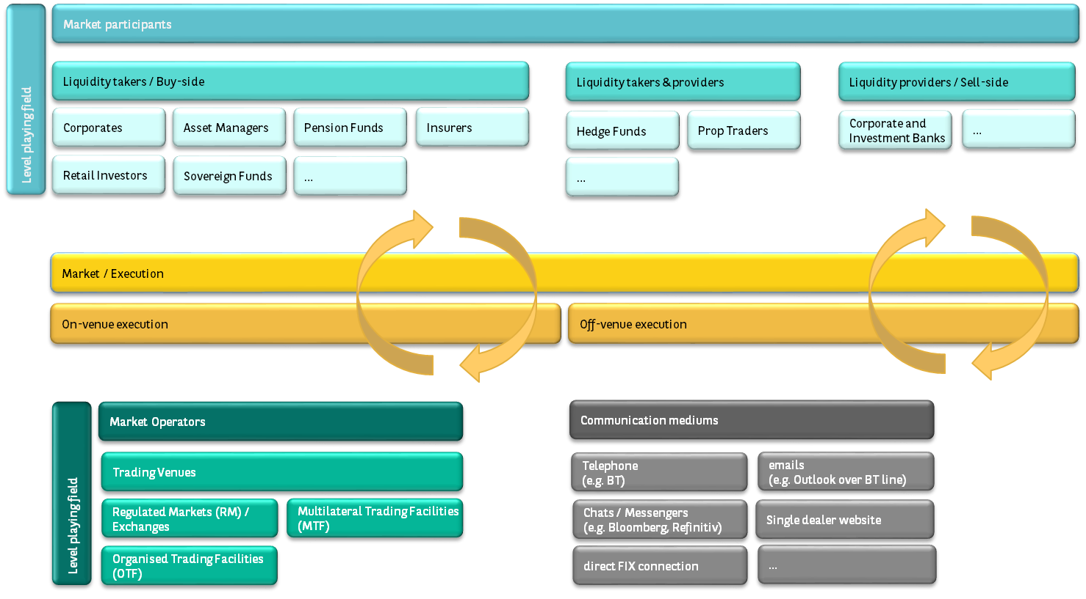

Source: BNP Paribas

* 1. Diagram: Transparency of TOTV instruments, based on principle of level-playing field between investment firms executing on- and off-venue

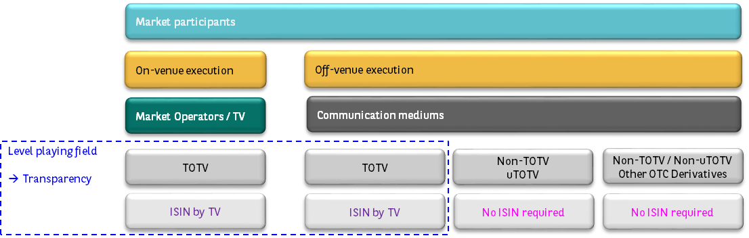

Source: BNP Paribas

Q5 Section 1.3: Rationale - The SI concept is meaningful for equity, not for bonds and derivatives

* 1. Within the bonds & derivatives markets, the SI concept has no reason to exist.
* The SI concept is only meaningful in equity where it defines a place of trading complying with the Shares Trading Obligations (STO).
* This STO, the double volume cap (DVC) mechanism and the pre-trade transparency were primarily set-up to reduce the use of equity dark pools.
* The goal was to bring pre-trade transparency from off-venue execution in dark pools to the “general market”, in shares that are all listed / TOTV and executed on order books.
* In the bonds and derivatives markets, the SI concept has no reason to exist as,
* the market structure is different and there are no dark pools
* the Derivatives Trading Obligations (DTO) is not linked to SI.
* In terms of transparency,
* post-trade transparency is requested from all Trading Venues (TV) and Investment firms (IF), not just from SI.
* pre-trade transparency for derivatives has proven not to be meaningful and not used by anyone, mainly because of the specific trading protocols, RFQ & voice trading, and other characteristics of the market (bespoke nature of instruments, pricing taking into account counterparty profile / risk, RFQ trading protocols including streaming of indicative or firm prices…).

Q5 Section 1.4: Clarification of regulatory texts by using the most appropriate wording for each role / participant

* 1. Avoid cross references of the ambiguous SI concept across regulatory texts (MiFID 2 / MiFIR, BMR), use clearer wording for each role / participant and instrument.
  2. Be aware of the role and risk of liquidity providers when assessing the regulation & market.
  3. Avoid that "unintended consequences become the rationale": avoid the situation where firms become SI, just as a way to perform Post-Trade Transparency for their clients

Q5 Section 1.5: Simplification, removing unnecessary complexity from the reporting

* 1. While we recognise the rationale of transparency for investment firms trading TOTV instruments off-venue, in the spirit of a level playing field with on-venue execution, we question the value of the SI regime for Bonds and Derivatives.
* For Transaction Reporting, the SI regime brings a large amount of unnecessary complexity and rejections, for SI and their clients, from the moment of execution through to transaction reporting. There are indeed multiples scenarios, interpretations, corner cases and possible values to fill in for
* Venue - SI MIC, XXXX, XOFF - in function of the instruments status – TOTV, uTOTV, non-TOTV
* Venue - SI MIC, XXXX, XOFF – for intragroup trades (inter entities within the same group), for risk management purposes
* TOTV status check based on presence of ISIN in FIRDS by a trading venue, while removing ISIN in FIRDS reported by an SI.
* ISIN for TOTV – ISIN for derivatives created in ANNA DSB but not reported into FIRDS
* ISIN for TOTV – ISIN for bonds / MTN / structured notes created in ANNA but not reported into FIRDS
* For Post-Trade Transparency, all investments firms have to submit their trades. The SI status only plays a role in the publication / reporting rule, which could easily be replaced by some other rule, independent from the SI status.
* For Pre-Trade Transparency, the obligation that has yet to prove its value for Non-Equity could remain in place but without the need of a trigger by an SI status. However, the suppression of this obligation should not be opposed by anyone.
  1. Therefore, we believe that it is possible to continue complying with all MiFID 2 / MiFIR reporting obligations while simplifying the framework by removing the SI regime concept for Non-Equity. We suggest further regulators / industry analysis and reflection in that direction.

Q5 Section 1.6 Description of the changes required

* 1. Finally, we list below the specific changes that would be required for removing the SI regime for Bonds and Derivatives.

1- Pre-Trade Transparency:

* 1. Removing the obligation, as of no benefit to, and not used by market participants.
  2. Alternatively, requiring the obligation to apply to any market participant providing a firm quote when trading off-venue (removing the notion of SI).

2- Scope of Transaction Reporting and Post-Trade Transparency:

* 1. No change / same scope of instruments (the SI does not impact the scope).

3- Post-Trade Transparency:

* 1. We use the "SI industry registry" (SIR) that we rename into the "Post-Trade Transparency Master Reporter registry" (PTT MRR), or any other name that does not refer to SI, which IF can use to take over the responsibility of reporting (no additional contract, fee).

4- Transaction Reporting:

* 1. When trading off-venue, the only information required is the LEIs of the 2 counterparties and the indication that the trade is executed off-venue.
  2. Instead of SI MIC we just indicate XOFF (not adding much value to give an SI MIC).
  3. Simplification for investment firms, in
* their transaction reporting,
* control and monitoring, and in
* the exchange of information with clients at execution (e.g. no need to communicate an SI MIC when executing voice, which actually requires to get the exact ISIN, the TOTV status...).
  1. Simplification for NCAs,
* fewer reporting exceptions due to reporting complexity,
* less difficulty in control and monitoring,
* fewer supervisory investigations for reconciling flows between PTT and TR,
* easier Market Abuse control

5- RTS-23 ISIN reference data

* 1. Only required for TOTV instruments, reported by the trading venues (or ESMA to connect directly to instrument reference golden sources – see further answer in this consultation).
  2. Not required for non-TOTV / uTOTV instruments, not required for SI / IF
  3. Simplification for investment firms, in
* their transaction reporting,
* control and monitoring, and in
* the exchange of information with clients at execution (e.g. no need to communicate an SI MIC when executing voice, which actually require to get the exact ISIN, the TOTV status...).
  1. Simplification for NCAs,
* fewer reporting exceptions due to reporting complexity,
* less difficulty in control and monitoring,
* fewer supervisory investigations for reconciling flows between PTT and TR,
* easier Market Abuse control

6- Easier Market Abuse control

* 1. Due to simplified transaction reporting, improved data quality, improved control and monitoring

7- SI regime interpretation differences

* 1. Removing difference of / complexity of interpretations on the scope of the SI regime to apply to
* TOTV and/or non-TOTV instruments,
* Specific operating models of an entity
* Specific entity for intragroup trades
  1. Suppressing many long hours of discussion, within each IF, within industry associations, with regulators.

8- SI determination calculations:

* 1. Removing market volumes assessment by ESMA.
  2. Removing calculations of market shares / thresholds by investment firms.
  3. Simplification for ESMA and for investment firms.

9- Benchmark Regulation (BMR) – Scope

* 1. Scope to be defined in terms of Benchmark Administrators and TOTV (removing notion of SI or “traded on an SI“).

----------------------------------------------------------------------------------------------------------------------------------------

Q5 Section 2: feedback on the assessment presented

In this section, we wish to provide feedback on specific paragraph / statements of this consultation.

* 1. CP paragraph 33. The concept of TOTV is indeed central to the MiFID 2 reporting transparency framework. The rationale bears examination: it is about the level playing field between market participants who execute the same instruments on- and off-venue. It is about defining those instruments available on TV and which can also be traded off-venue. In this context, the so-called narrow definition of TOTV does make complete sense. Next to this, EMIR mandates reporting of all derivatives to Trade Repositories and encompasses the whole set of Exchange Traded Derivatives (ETD) and OTC derivatives.
  2. CP paragraph 34. We agree that the concept of TOTV is self-explanatory for instruments that are centrally issued and that are fully standardised such as shares and bonds as well as ETD. And we believe that it is also straightforward for OTC Derivatives. *Bilateral derivatives are not standardised, each time two parties enter into a contract, such contract might be slightly different from the otherwise similar one entered into by two other counterparties*.
* Bilateral derivatives are often custom solutions defined for the needs of a specific client, are by definition not TOTV, and it would not help anyone for those instruments being made transparent under the MiFIR regime.
* Next to this, EMIR mandates reporting of all derivatives to Trade Repositories and encompasses the whole set of Exchange Traded Derivatives (ETD) and OTC derivatives. Increasing the scope of the TOTV definition for transparency will only duplicate further reporting requirements between MiFIR and EMIR.
  1. CP paragraph 34. This narrow interpretation of TOTV should be kept. Instead of extending (duplicating) the scope of instruments under MiFIR reporting, we should focus on the following core objectives:
* data quality improvement on the current scope of instruments,
* simplification and streamlining of the regulatory reporting requirements
* access of the transparency data,
* set-up of the consolidated tape,
* and, above all, the understanding of all that the data and the market.
  1. Paragraph 36. ESMA refers to the initial assessment of the TOTV concept made within the context of the CP on the MiFIR review on the non-equity transparency regime.
* BNPP re-iterates that it does not agree with ESMA’s assessment and has exposed the rationale in the answer to this consultation.
* See Q16-17-18 on pages 25-29.
* esma_cp_mifid_nqt_bnpparibas_replyform.docx,
* <https://www.esma.europa.eu/file/55852/download?token=MfO4W91k>
  1. Paragraph 37. ESMA mentions a split of views between the answers of TV and prop traders vs. the answers of liquidity providers. This statement does not reflect an understanding of the role of each entity in the market structure, the market itself, and the goals of the regulation which are market resilience, market liquidity and market efficiency. It all seems too easy to follow the views of TVs to enforce some measures. We refer here to the section explained earlier on our answer on the market structure of bonds and derivatives, the role of each entities and the level playing field which is mainly between IF executing on- and off-venues (not between TV and IF).
* TVs revenues come from execution fees and market data fees.
* To maximise their revenues, they advocate for the whole market to be moved on-venue.
* To maximise revenues = increased cost of market data for investment firms, buy-side and sell-side
* TVs do not seek the optimal market liquidity, on- and off-venue.
* When considering market resilience, liquidity and efficiency, the views of TV and liquidity providers should not be considered together.
* TV have no interest in the level playing field between investment firms executing on- and off-venue.
* TVs have no interest in market efficiency in terms of access to optimal level of liquidity, across on- and off-venue.
* Instead, we should attempt to take into consideration the views of current and potential market participants, buy-side, sell-side, institutional and corporates, retail investors, to make sure that the markets are resilient and that the liquidity is available, on- and off-venue, especially in time of crisis. With those views expressed and taken into account, regulators can assess the optimal regulatory measures to take.
  1. Moreover, one should not succumb to the path of Equitisation, i.e. thinking that Bonds and Derivatives markets behave like shares.
* Bonds and Derivatives are much different from shares in terms of instruments and market structures and will always require off-venue execution for accessing liquidity.
* We describe in the table below the main characteristics of those asset classes.
* BNPP will be happy to work further with the industry and regulators to document further those differences and identify the optimal market structure set-up and the potential need for further transparency.
  1. Table: Equity, bonds and derivatives: assets classes characteristics, market structure and transparency

|  |  |  |  |  |
| --- | --- | --- | --- | --- |
|  | **Equity** | **Bonds** | **Exchange traded**  **derivatives** | **OTC**  **derivatives** |
| **Standardisation** | Standardised | Standardised / Customised | Standardised | Customised / bespoke |
| **Fungibility** | Fungible | Fungible / Not fungible | Fungible | Not fungible |
| **Liquidity** | Liquid | Liquid /  illiquid | Liquid | Much less liquid |
| **Counterparty**  **default risk** | No  (on Exchange) | Yes | No  (on Exchange) | Yes, but most liquid IRS & Index CDS instruments are subject to central clearing |
| **Trading systems / protocols** | Order book | RFQ & Voice | Order book &  Voice | RFQ & Voice |
| **Pre-Trade**  **Transparency objectives** | Price formation via visibility on orders | Limited because no order book | Price formation via  visibility on orders | Limited because no order book |
| **Transparency allowing**  **comparison** | Yes because multiple trades on same instrument | Limited because infinite number of custom instruments with specific pricing depending on counterparty risk | Yes because multiple trades on same instrument | Limited because infinite number of custom instruments with specific pricing depending on counterparty risk |
| **Other sources of price information** | - | Indicative or firms streamed prices,  RFQs themselves, to multiple liquidity providers | - | Indicative or firms streamed prices,  RFQs themselves, to multiple liquidity providers |

Source: BNP Paribas

* 1. The paragraph 37 also mentions that a “very limited proportion of OTC derivatives trading is currently subject to transparently and reference data reporting”. This is in line with the goal of the MiFIR regulation. Next to this, EMIR mandates reporting of all derivatives to Trade Repositories and encompasses the whole set of Exchange Traded Derivatives (ETD) and OTC derivatives.
  2. Paragraph 38. We agree that expanding the TOTV concept will introduce additional and unnecessary complexity.
  3. About removing the TOTV concept, one can wonder of the value of this duplicate reporting compared to the existing EMIR reporting.
  4. The concept of “bespoke derivatives contracts“ is also brought in.
* We struggle to find a definition of such bespoke derivatives contract that would differentiate some non-TOTV derivatives from other non-TOTV derivatives.
* We believe that all non-TOTV derivatives are bespoke, non-standardised, custom-built, to meet investors and corporates specific needs.
  1. On that basis, we believe that the conclusion of this paragraph 38 reflects the position that should be adopted for all non-TOTV instruments, as per current definition and interpretation, that: “*imposing transparency on those non-standardised derivatives might not only represent an unnecessary burden for reporting entities but it might, more generally, introduce reporting noise for other participants rather than meaningful transparency“*.

Paragraph 39. We would have preferred that the proposal of changing the definition of TOTV for the scope of Transparency was more clearly identified in a dedicated CP instead of within a CP on Transaction Reporting and Instrument Reference Data.

* 1. Paragraph 40. BNPP does not agree with the assessment and proposal presented because is it based on an incorrect representation of the market structure of bonds and derivatives.
* First, the pursuit of a level-playing field is between IF executing on and off-venue. There is no concept of level-playing fields between market participants and market operators because they are different entities, with different roles in the market structure.
* Second, the concept of SI in bonds and derivatives is ambiguous, unnecessary complex, continuously leading to misunderstanding and should be removed.
  1. **Bringing the notion of SI in the definition of TOTV / uTOTV, and in the scope of reporting, is one step further in the direction of ambiguity, unnecessary complexity, and continuous misunderstanding**.
  2. We can only repeat our points exposed earlier while advocating for the suppression of the SI regime, that this would allow the clarification of regulatory texts by using the most appropriate wording for each role / participant:
* Avoid cross references of the ambiguous SI concept across regulatory texts (MiFID 2 / MiFIR, BMR), use clearer wording for each role / intervenants
* Be aware of the role and risk of liquidity providers when assessing the regulation & market
* Avoid that "unintended consequences become the rationale": avoid the situation where firms become SI, just as a way to do the Post-Trade Transparency for their clients
  1. Paragraph 41. BNPP disagree with the proposal presented.
  2. We do not understand what is the rationale or motivation for extending the scope, and disagree with the arguments of level playing field between TV and IF.
* If the non-mentioned motivation is to get more reference data, we encourage instead ESMA to further reflect on connecting to golden sources (ISINs, LEI).
* Nevertheless, we also suggest a further industry discussions with IF on the relevance of ISINs for OTC derivatives.
* Finally, we remind that all ETD and OTC derivatives are already reported in the framework of EMIR.
  1. We do believe that bringing the notion of SI in the definition of TOTV / uTOTV and of the scope or reporting will bring more ambiguity and unnecessary complexity and cost. Instead of making the regulatory text more complex, increasing the regulatory reporting burden for IF by extending (duplicating) the scope of instruments under MiFIR reporting, we should focus on the following core objectives:
* data quality improvement on the current scope of instruments,
* simplification and streamlining of the regulatory reporting requirements
* access of the transparency data,
* set-up of the consolidated tape,
* and, above all, the understanding of all that the data and the market.

Cost vs. Benefit

* 1. In general, we do wonder what the benefit of this additional scope is for the financial community, form market resilience, liquidity and efficiency, in comparison to the burden, complexity and cost of implementation.
  2. Moreover, we continuously see that the additional requirements of market data (transparency) and instrument reference data are only bringing:
* more revenues to golden sources, market data vendors, technology vendors, trading venues and
* more costs to investment firms, buy-side and sell-side.
  1. While the industry and regulators focus on simplification and economic recovery initiatives, those proposals are going in the opposite direction.
  2. Paragraph 42. **BNPP does not agree with the proposal of bringing the notion of “traded through SI systems” in the definition of TOTV / uTOTV, and in the scope of reporting, which is one step further in the direction of ambiguity, unnecessary complexity, and continuous misunderstanding**.
  3. In terms of increasing the scope of instruments, while BNPP is always aiming at being compliant with all regulatory reporting requirements, we need to keep in mind the core objectives of those regulations:
* As mentioned in paragraphs 5-7, the goal of transaction reporting under MiFIR is to monitor market abuse.
* It is questionable in which market abuse is monitored when looking at non-TOTV instruments i.e. any product that is not in the scope of the current narrow interpretation of TOTV and of uTOTV (where the underlying is a financial instrument or index/basket of financial instrument).
* All non-TOTV instruments are custom instruments traded between investment firms.
* If there is a need to monitor market abuse of “non-TOTV instruments executed off-venue“, we refer to EMIR whose scope includes all OTC derivatives.
* Irrespective of any change in the TR (e.g. extension of uTOTV), the scope of transparency should remain exclusively limited to the narrow “interpretation“ of TOTV instruments, per definition.
* Please refer to our diagram: Transparency of TOTV instruments, based on principle of level-playing field between investment firms executing on- and off-venue, see further in our answer to Q5.
  1. Moreover BNPP is not in favour of unnecessary burden of creating and reporting ISIN for non-TOTV derivatives, when they relate to instruments where the underlying is not TOTV. This means not in favour of using ISINs for such instruments in an RTS-23 and RTS-22 Transaction Reporting.
  2. Paragraph 43. BNPP is not in favour of this proposal of
* extending the scope of instruments of RTS-22, RTS-23, RTS-2.
* Using the notion of SI in the definition of the scope
  1. We do not understand how we expect to differentiate the so called “pure bespoke OTC transactions from the whole set of non-TOTV derivatives.
  2. There is no value / benefit to increase the scope of public transparency on non-TOTV custom derivatives instruments.
  3. It creates a major increase on the number of ISINs creation and reporting for non-TOTV custom derivatives, which does not help transparency and has no value for anyone in the financial community. Again no benefit while increasing the size of the unnecessary ISIN factory and reporting burden.
  4. In terms of RTS-23, we reiterate that there is already no value in the current system for SI to create and report ISIN for uTOTV instruments.
* SI should not be required to do any RTS-23, as the notion of SI relates to Transparency, therefore to TOTV.
* The current system already shows that there is no value in the creation and reporting of ISINs for uTOTV custom derivative instruments.
* Again, we recommend the suppression of the SI regime for Bonds & Derivatives.
  1. If such instruments (e.g. non-TOTV IRS) were to become included in the scope of RTS-2, RTS-22, RTS-23, via an extension of the definition / interpretation of TOTV, the proposal does not indicate:
* Whether an ISIN would be required
* If so, which entity would be in charge creating and reporting the ISIN, knowing that the reporting of ISIN by SI to ESMA FIRDS does not make an that ISIN / instrument TOTV.
  1. Moreover, this would also bring changes and additional complexity in the eligibility filters of IF, ARM and APAs, which mainly look at FIRDS, the non-official golden source of TOTV instruments, and use an ISIN comparison with the ISINs reported in FIRDS by TV (not by SI, as not assumed TOTV) to assess the TOTV status of an instrument.
  2. In addition, ESMA does not seem to present any analysis of the instruments or asset classes scope targeted / impacted by this proposal. As per the example shown in paragraph 46, it is clear that the proposal is aiming at IRS. But it the proposal is unclear if targeting:
* All non-TOTV Interest Rates Derivatives, including “Other IR Derivatives“ for which ISIN templates most probably do not exist, or only IRS
* Non-TOTV FX Derivatives, including “Other FX Derivatives“ for which ISIN templates most probably do not exist
* Non-TOTV “Other Credit Derivatives“ for which ISIN templates most probably do not exist
* Non-TOTV Commodity Derivatives
  1. The same question on scope targeted can be raised on
* non-TOTV structured notes, which fall in the category of Medium Term Notes and asset class Bonds.

It will also be required to analysed further the possible cases of

* Non-TOTV convertible bonds
* Non-TOTV securitised derivatives

It is important to note that those instruments are not classified as OTC derivatives and that their ISIN are defined in ANNA, not in ANNA DSB. In ANNA, there would need to be further analysis to see if possible to create ISINs “on the fly“, like in ANNA DSB.

* 1. In other words, the scope of the proposal is potentially very large. If ESMA was to proceed in that direction, we could advocate for a phased approach, instrument per instrument.
  2. Finally, as for the third benefit mentioned in this paragraph 43, we can not agree that it will facilitate anything. This will only create a more complex reporting framework for the RTS-22, RTS-23 and RTS-2, and duplicating the EMIR reporting
  3. Paragraph 44. The SI concept is ambiguous and leading to misunderstanding.
* There is no reason why the scope of the transaction reporting, instrument data reference and post-trade transparency reporting should be defined in terms of SI.
* There is no reason why the scope of the transaction reporting, instrument data reference and post-trade transparency reporting should be defined in terms of SI mandatory or voluntary basis.
  1. If ESMA where to define a requirement based on the SI mandatory and voluntary, how shall we dissociate between mandatory from voluntary?
* Would the voluntary SI need to calculate their threshold to see if they are “voluntary-mandatory“ (above thresholds) of “voluntary-not mandatory“ (below thresholds)?
* Unnecessary complexity.
  1. The wording “acting in SI capacity“ is ambiguous and leading to misunderstanding. Therefore this whole paragraph 44 b) is ambiguous and leading to misunderstanding. Again, we call for simplification, for not using the notion of SI to define the scope of reporting and for removing this notion of SI for Bonds and derivatives.
  2. Paragraph 45. This shows that the MiFIR reporting framework is over-engineered and should be simplified by removing completely the notion of SI for Bonds and derivatives.
  3. Paragraph 46 (45 typo in the CP text) explaining the 3 options. Those 3 options are ambiguous, very difficult to understand and leading to misunderstanding.
* This shows again that the MiFIR reporting framework is over-engineered and should be simplified by removing completely the notion of SI for Bonds and derivatives.
* Data quality will arise from simple reporting rules (remove the notion of SI, keep non-TOTV derivatives out of scope) and an optimal framework (without duplication of identical feed from golden sources)
  1. Instead,
* the scope of transaction reporting and post-trade transparency reporting
* should be defined in terms of instruments, TOTV, non-TOTV uTOTV, non-TOTV non-uTOTV.
* And this should apply to all investment firms.
* the scope of instrument data reference should be defined in terms of instruments, TOTV, non-TOTV uTOTV, non-TOTV non-uTOTV. And this should be set-up in the most optimal reporting framework, by feeding the data from the instrument data reference golden sources (ANNA, ANNA DSB).
* There is no value in requiring TVs and SIs to report the ISINs and main instruments characteristics.
* This represents a duplication of identical reporting by TV and SI from ISINs golden sources to ESMA FIRDS.
  1. In the option 3, the wording “acting in SI capacity“, and of “not, e.g., when trading at their own initiative“ are ambiguous and leading to misunderstanding. We do not think that these notions have ever been defined. But, why should they, why should we go in that direction?
* This is leading to complex, unnecessary and costly implementation of the reporting.
* We question the added-value / benefit of this complexity.
* Again, we call for simplification,
* for not using the notion of SI to define the scope of reporting and
* for removing this notion of SI for Bonds and derivatives.

No extension of scope for Quote / Pre-Trade Transparency

* 1. We also note that ESMA is using the word “quotes“. We therefore understand that ESMA is expecting to bring such change also at the level of Quote / Pre-Trade Transparency.
* BNPP may not agree that extending the scope of instrument for an obligation not used by anyone will serve any purpose.
* We therefore recommend not moving in that direction.
* Instead, we could recommend analysing further the market structure of Bonds and Derivatives and the appropriateness of the Quote / Pre-Trade Transparency.

----------------------------------------------------------------------------------------------------------------------------------------

Q5 Section 3: Alternatives proposal

* 1. The narrow interpretation of TOTV should be kept.
  2. Remove the notion of SI for Bonds and Derivatives.
  3. Instead of extending the scope of instruments under MiFIR reporting (duplicating with EMIR), in RTS-2, RTS-22 and RTS-23, and instead of extending the size of the unnecessary ISIN factory for non-TOTV derivatives, we should focus on the following core objectives:
* data quality improvement on the current scope of instruments,
* simplification and streamlining of the regulatory reporting requirements
* access of the transparency data,
* set-up of the consolidated tape,
* and, above all, the understanding of all that the data and the market.
  1. We are keen to work with regulators to simplify regulatory reporting requirements to help market participants to comply with those requirements.
  2. We also reiterate our belief in a phased-approach for everything that we are attempting to build. While MiFIR is not even 3 years old and cover the whole range of asset classes, shares, bonds and derivatives, we keep attempting massive changes.

<ESMA_QUESTION_TRRF_5>

1. : Do you agree that the extension should include all Systematic Internalisers regardless of whether they are SI on a mandatory or voluntary basis? Please justify your position.

<ESMA_QUESTION_TRRF_6>

* 1. BNPP does not agree with the proposal presented.
  2. The SI concept has no reason to exist in the bonds & derivatives markets.
  3. The SI concept is ambiguous and leading to misunderstanding and this question is the evidence of it.
* There is no reason why the scope of the transaction reporting, instrument data reference and post-trade transparency reporting should be defined in terms of SI.
* There is no reason why the scope of the transaction reporting, instrument data reference and post-trade transparency reporting should be defined in terms of SI mandatory or voluntary basis.
  1. Instead,
* the scope of transaction reporting and post-trade transparency reporting
* should be defined in terms of instruments, TOTV, non-TOTV uTOTV, non-TOTV non-uTOTV.
* And this should apply to all investment firms.
* the scope of instrument data reference should be defined in terms of instruments, TOTV, non-TOTV uTOTV, non-TOTV non-uTOTV. And this should be set-up in the most optimal reporting framework, by feeding the data from the instrument data reference golden sources (ANNA, ANNA DSB).
* There is no value in requiring TVs and SIs to report the ISINs and main instruments characteristics.
* This represents a duplication of identical reporting by TV and SI from ISINs golden sources to ESMA FIRDS.

<ESMA_QUESTION_TRRF_6>

1. : Do you envisage any challenges with the approach described in paragraphs 45-46 on the scope of transactions to be covered by the extension? Please justify your position and indicate your preferred option for SIs under the mandatory regime explaining for which reasons. If you disagree with all of the outlined options, please suggest alternatives.

<ESMA_QUESTION_TRRF_7>

* 1. BNPP does not agree with the proposal and any of the 3 options presented.
  2. Please refer to our answers to Q5-6.

<ESMA_QUESTION_TRRF_7>

1. : Do you foresee any challenges with the proposal to replace the reference to the term “index” in Article 26(2)(c) with the term “benchmark” as defined under the BMR? If yes, please explain and provide alternative proposals.

<ESMA_QUESTION_TRRF_8>

* 1. BNPP does not agree with the proposal and do recommend the status quo / option 3.
  2. Options 1 and 2 would be challenging and costly to implement.

Unclear scope of this proposal, in terms of obligations impacted

* 1. With the previous section “4.1 Concept of TOTV“ aiming at changes of non-TOTV instruments for RTS-2, RTS22 and RTS-23, it is unclear if this section “4.2 Transaction Reporting indices under Article 26(2) (c), if ESMA is aiming at pushing those changes to RTS-22 and
* RTS-2 Transparency
* RTS-23 Instrument reference data reporting by SI

Cost vs. benefit

* 1. For both RTS-2 and RTS-23, for the same reasons exposed in our answer to Q5-6, we would suggest not bringing similar proposal, as this would bring a wide range of additional burdensome reporting for no added benefits for the financial community.

Remove SI concept

* 1. The wording “trading through an SI“ is ambiguous and continuously leading to misunderstanding.
* It leads
* to different interpretations and
* to a complex, unnecessary and costly reporting framework.
* We question the added-value / benefit of this complexity.
* We would suggest removing all references to the SI term / concept in the bonds & derivatives markets. This would greatly simplify the reading and understanding of regulatory texts (MiFID, BMR) and the reporting framework, while keeping the same scope of reporting.

Not relevant to MAR, not subject to BMR

* 1. Paragraph 53. We agree with the point that the proposal would significantly extend the scope of Transaction Reporting to instruments that are
* *neither relevant for market abuse supervision purposes* (which is, let’s remind it, TOTV and uTOTV, which the underlying being a financial instrument or index/basket of financial instruments)
* *nor subject to the BMR as the BMR does not apply to instruments that are purely traded OTC*

Unclear scope of this proposal, in terms of instruments

* 1. Paragraph 53 – 1). It is unclear why stock exchange indices are listed next to money market indices and risk free rates. Stock exchanges indices have always been assumed in scope of TR as composed of underlying being financial instruments (stocks, shares).

Complex and expensive to check the composition of the benchmark

* 1. Paragraph 53 – 2). We confirm that the reporting will be much “*more complex to implement as it requires reporting entities to check the composition of the benchmark*“.
* Without having the time to investigate in the details of our reporting systems, we can say that this would represent a massive challenge in term of data reference.
* Also probably involving additional fee / cost of reference data.

BMR

* 1. We would like to emphasize the link that currently exists between the scope of BMR and the scope of the SI reporting regime under MIFIR.
* By way of background, BMR applies to financial instruments that reference indices where they are traded on trading venues or traded via an SI.
* While the notion of trading on a trading venue is quite straightforward, the notion of “traded via an SI” is less clear.
* ESMA defined what “traded via an SI” means in its BMR Q&A (question 5.8) by reference to the categories of instruments in scope of article 26(2).
* Therefore, any extension of the scope of article 26(2) may symmetrically extend the scope of BMR.

Distinct objectives of BMR and MiFIR

* 1. We should bear in mind that the objectives of BMR and of the reporting regime of MIFIR are different in nature.
* BMR aims at increasing the quality and robustness of benchmarks used in the EU and/or provided by administrators located in the EU.
* MIFIR reporting regime aims at market abuse monitoring by regulators and at offering more public / market transparency.
  1. Therefore, we wanted to warn authorities that while extending the scope of the reporting obligations may achieve those market abuse monitoring and transparency objectives it can at the same time increase the scope of BMR and catch transactions that were not supposed to be subject to BMR.

Alternative approaches

* 1. Do not extend scope.
  2. Instead of extending the scope of instruments, we should focus on the following core objectives:
* data quality improvement on the current scope of instruments,
* simplification and streamlining of the regulatory reporting requirements
* access of the transparency data,
* set-up of the consolidated tape,
* and, above all, the understanding of all that the data and the market.
  1. Simplification of understanding of regulatory texts (MiFID 2, BMR) by removing the notion of “traded by an SI“, removing the term / concept of SI for bonds & derivatives.
  2. We are keen to work with regulators to simplify regulatory reporting requirements to help market participants to comply with those requirements.
  3. We also reiterate our belief in a phased-approach for everything that we are attempting to build. While MiFIR is not even 3 years old and cover all types of bonds and derivatives, we keep attempting changes.

<ESMA_QUESTION_TRRF_8>

1. : Which of the three options described do you consider the most appropriate? Please explain for which reasons and specify the advantages and disadvantages of the outlined options. If you disagree with all of the outlined please suggest alternatives.

<ESMA_QUESTION_TRRF_9>

* 1. BNPP does not agree with the proposal and do recommend the status quo / option 3.
  2. BNPP is not in favour of extending the scope of the current Transaction Reporting.

Not Option 1

* 1. The first option proposed by ESMA illustrates the risk we just mentioned in our answer to Q8.
* Applying 26(2)(c) of MiFIR to all instruments traded off-venue where the underlying is a benchmark as defined under the BMR may result in extending the scope of BMR to pure OTC transactions while these trades were supposed to be out of scope of BMR.
* For this reason, we do not support that first proposal.

Not Option 2

* 1. We do not favour the second option either, given the implementation difficulties it gives rise to and which are acknowledged in ESMA’s consultation paper.

Status quo / Option 3

* 1. We have a strong preference for option three, which maintains status quo.
* Given the impact any changes to article 26(2) MIFIR may have on the scope of BMR, we strongly believe that the scope of article 26(2) MIFIR should only be amended (if necessary) as part of the forthcoming BMR review and based on the BMR review consultation which should occur next year.

Unclear scope of this proposal, in terms of obligations impacted

* 1. We also note that, from this consultation, it is unclear whether ESMA is proposing to bring those changes into the scope of RTS-23 and RTS-2.
* In particular, requiring ISINs (RTS-23) for all non-TOTV instruments based on money markets indices and risk free interest rates would require more unnecessary and burdensome efforts.
* For both RTS-2 and RTS-23, for the same reasons exposed in our answer to Q5-6, we would suggest not bringing similar proposal, as this would bring a wide range of additional reporting for no added benefits for the financial community.

Unclear positioning of IRS

* 1. When looking at ESMA proposals under section “4.1 TOTV“ and section “4.2 uTOTV / Benchmarks“, it is unclear how would an non-TOTV IRS be considered:
* either TOTV, as per an enlarged TOTV definition in section “4.1 TOTV“
* Or uTOTV, as per rewording of Article 26 (2)(c)

Focus on core goals

* 1. Instead of extending the scope of instruments, we should focus on the following core objectives:
* data quality improvement on the current scope of instruments,
* simplification and streamlining of the regulatory reporting requirements
* access of the transparency data,
* set-up of the consolidated tape,
* and, above all, the understanding of all that the data and the market.

<ESMA_QUESTION_TRRF_9>

1. : Do you foresee any challenges with the outlined approach? If yes, please explain and provide alternative proposals.

<ESMA_QUESTION_TRRF_10>

BNPP is not responding to this question.

<ESMA_QUESTION_TRRF_10>

1. : Do you foresee any challenges with the outlined approach? If yes, please explain and provide alternative proposals.

<ESMA_QUESTION_TRRF_11>

BNPP is not responding to this question.

<ESMA_QUESTION_TRRF_11>

1. : Do you foresee any challenges with the outlined approach? If yes, please explain and provide alternative proposals.

<ESMA_QUESTION_TRRF_12>

BNPP is not responding to this question.

<ESMA_QUESTION_TRRF_12>

1. : Do you foresee any challenges with the outlined approach? If yes, please explain and provide alternative proposals.

<ESMA_QUESTION_TRRF_13>

* 1. BNPP strongly disagrees with this proposal.

Scope of instruments: non-TOTV + all TOTV

* 1. While the paragraph 65 referring to the section “4.1 Concept of TOTV“ indicates that ESMA is targeting derivatives (or only IRS?), the amendment of Article 27 suggested in paragraph 66 would lead to the Article 27 / RTS-23 to apply to all financial instruments of all asset classes, including shares, bonds, ETDs and all OTC derivatives.
  2. In other words, ESMA is proposing here that SIs:
* Create and report ISINs and related instrument reference data for non-TOTV instruments / “newly defined TOTV instruments“ (scope still unclear, as per our answer in Q5)
* **Report ISINs and related instrument reference data for all existing TOTV instruments, already reported by TV, across all financial instrument of all asset classes.**

Duplication of identical reporting

* 1. This latter point would create enormous duplication of reporting of TOTV ISINs and related instrument reference data.
  2. Duplicative reporting of instrument reference data will be a source of possible reporting errors and reconciliations in RTS-23

Risk of misunderstanding the market and drawing incorrect conclusions on transparency

Q13.16 Duplication of reporting can also cause other issues on the integrity of the data, which in turn may lead to a misunderstanding of the market, and most importantly, drawing incorrect conclusions on the state of transparency.

Q13.17 For example, we may speculate whether the bond population size in FITRS has been overestimated (initially as 500k, then adjusted to 300k, and now less than 200k) because of duplicative reporting from TVs over the first 3 years of MiFID II.

* The situation might have been mitigated by improved management by TVs of instrument termination in FIRDS.
* All in all, a bond population of that size (300k-500k) is not realistic, given that large banks stream prices for fewer than 10,000 bonds on a daily basis (and do not trade on some of them, even on a yearly basis).
* Comparing the list of 1,000 liquid bonds to a global population of 300k-500k bonds has led to a highly incorrect representation of transparency.
* This in turn is leading to pressure for regulatory change of the transparency regime, which, if too drastic, will negatively impact market liquidity.

New dependency on RTS-22

* 1. In addition, most probably, this new requirement will turn into another dependency for the RTS-22 Transaction Reporting, as
* NCAs will set-up a new “RTS-22 acceptance check“ on the presence of ISIN and SI MIC in FIRDS for non-TOTV instruments.
* This “RTS-22 acceptance check“ will further be impacted by the timing challenge of RTS-23 being End of Day, with publication in D+1 in ESMA FIRDS. For IF submitting their RTS-22 real-time or end of day, potentially all trades might be rejected and will require re-submission.

By opposition, the set-up for TV is much different in the way that they make instruments available to trade on their platform, days or weeks before a trade takes place (e.g. the IRS 10Y start date in 3 months, on 20 Feb 2021). IF, because of the vast scope of instruments that they can potentially trade off-venue (any bond or any custom derivatives) will not create and report “all“ ISINs in advance.

Loss of rationale for the existence of unique identifiers / ISINs – and of golden sources

* 1. Finally, we can wonder what is the rationale for the existence of:
* a unique identifier / ISIN, if every TV and IF has to report it together with related instrument reference data.
* golden sources, if every TV and IF has to report the same info available in the golden sources (ANNA, ANNA DSB, GLEIF, ISO).

Direct feed from golden sources

* 1. Instead of multiplying the reporting / feed of the same instrument reference data (200 TVs, 100+ SI reporting the same ISIN and related instrument reference data), we would recommend to feed that reference data directly from the instrument reference data golden sources, without passing through TV and IF. See our comments on Alternative Proposals further below.

Cost vs. Benefit

* 1. We do wonder what the benefit of this additional scope is for the financial community, for market resilience, liquidity and efficiency, in comparison to the burden, complexity and cost of implementation.
  2. While the industry and regulators focus on simplification and economic recovery initiatives, those proposals are going in the opposite direction.

Misconception of market structure

* 1. Next to this, we wish to reiterate that SI are not TV.
* We are talking here of investment firms (IF) / market participants.
* IF should not have the same obligations as TV.
* IF should not report any reference data to ESMA FIRDS (RTS-23).
* Please refer to our considerations about the market structure, the roles of each entity and the level playing field in the Bonds and Derivatives markets in our answer to Q5.

MAR = TOTV + uTOTV, not non-TOTV

* 1. Moreover, as this section 4.3 reflects on the alignment with MAR Article 4, we wish to remind that the market abuse regulation is defined in term of TOTV and uTOTV instruments, not in terms of non-TOTV instruments, as per MAR Article 2.
* The goal of the regulation is not to monitor non-TOTV / non-uTOTV instruments.
  1. MAR Article 4 does not refer to SI but refers rightly to
* market operators of regulated markets and
* investment firms and market operators operating an MTF or an OTF

Remove SI concept

* 1. The SI concept is ambiguous and continuously leading to misunderstanding.
* It leads
* to different interpretations and
* to a complex, unnecessary and costly reporting framework.
* We question the added-value / benefit of this complexity.
* We would suggest removing all references to the SI term / concept from the regulatory framework in the Bonds & Derivatives markets. This would greatly simplify the reading and understanding of regulatory texts (MiFID, BMR) and the reporting framework, while keeping the same scope of reporting.
* Please refer to the detailed considerations on this subject in our answer to Q5.

Loss of anonymity of Post-Trade Transparency

* 1. This RTS-23 reporting for TOTV instruments by liquidity providers will cause issues in terms of loss of anonymity of Post-Trade Transparency. Which, in turn, means increase of hedging risk, reduction of market liquidity, increase of prices.
  2. Let’s take an example, let’s assume that a liquidity provider trades a TOTV illiquid instrument (e.g. emerging market bond) off-venue / OTC / voice during the day.
  3. For the purpose of Post-Trade Transparency, the trade will be submitted immediately to an APA.
* In MiFID 2, the trade will be made public after deferrals in volume omission (D+2, W+4) or weekly aggregation (Next Tuesday, W+4) because illiquid, anonymously on the APA.
* In MiFID Refit, the trade might even be made public real-time with volume omission, anonymously on the APA.
  1. Now, if we add an RTS-23 reporting for the instrument reference data of this TOTV illiquid instrument by this liquidity provider, at the end of the day, this instrument reference data / ISIN, together with the SI MIC (and LEI depending on the instrument type) of this liquidity provider, will be made public on ESMA FIRDS on Day+1.
  2. Therefore,
* from Day+1 at 8am, any individual or firm can see a new ISIN, LEI, SI MIC of the liquidity provider from ESMA FIRDS – and know that this specific IF has taken / sold a position in this TOTV illiquid instrument.
* In MiFID 2,
* either from Day+2 before 19h00 (volume omission), any individual or firm can pull the ISIN and price of the trade from the APA – and match this info with the identity of the liquidity provider.
* or from the “Next Tuesday“ before 09h00, assuming there has been 2 trades in the previous week, any individual or firm can pull the ISIN, quantity and weighted average price of the trade from the APA – and match this info with the identity(/ies) of the liquidity provider(s) (1 or more firms, depending on the number of trades).
* In MiFID Refit, with the ESMA proposal of real-time transparency of all prices with volume omission, from Day+1 at 8am, any individual or firm can pull the trade details (ISIN, quantity, price) from the APA and the ISIN, LEI, SI MIC of the liquidity provider from ESMA FIRDS.
  1. In cases of illiquid instruments,
* just the knowledge that a trade has happened can make the whole market liquidity of that instrument to disappear (the other 2 or 3 market-makers withdraw their quotes, at least temporarily).
* knowing the price of the trade can also allow you to deduct the size of the position (large quantities lead to wider bid/offer generally, unless markets are rallying).
  1. Now, if we add the identity of the liquidity provider that has taken the position to the above information (occurrence of trade and price), it makes the hedging more complicated.
* If all market participants know that you have a large position in an instrument and that you want to decrease that position, everyone will use that information at their advantage and offer you a very low price (they know that you “have to sell“ to hedge yourself).
* The direct impact of this will be a loss of money for the liquidity provider (the price of the instrument moved rapidly between the moment of the first trade and the moment of the hedge).
* And next time, given the increased risk, the liquidity offered will be in much lower and the prices higher.
  1. This whole example is an illustration that market participants / IF are not market operators / TV and should not bear the same reporting obligations as market operators / TV.
* Market participants / liquidity takers invest their money (e.g. pensions, governments or corporates borrowing), take a position and a risk to obtain a return. The availability of liquidity and of good prices is a key factor in their investment strategies / decisions.
* Market participants / liquidity providers take a position to offer this liquidity. The ability to hedge that position by the liquidity provider is the key factor in the provision of this liquidity and the prices levels.
* Market operators do not participate in the market, do not invest their funds, do not offer liquidity, do not take positions, do not take a risk and do not hedge.
  1. This is also comes back to saying that there is no concept of level playing field between market operators and market participants. Instead, the pursuit of a level playing field is
* On the one hand, between market operators themselves
* On the other hand, between market participants or potential market participants executing on- and/or off-venue.
* Please refer to our considerations about the market structure, the roles of each entity and the level playing field in the Bonds and Derivatives markets in our answer to Q5.
  1. Decreasing the level of anonymity in the Post-Trade Transparency will have a direct impact on market liquidity and competitiveness of firms within the EU market.
* Liquidity takers, investors will invest in other markets, other products, other countries.
* This will also have a direct impact on government and corporates borrowing capacity in the EU (e.g. rich foreign investors will invest somewhere else).
  1. One could argue that this whole argument could be negated if all liquidity providers were sending all instrument reference data, on a daily basis, as per ESMA proposal in paragraph 71. But, as our answer in Q14-15, this set-up should be avoided for many reasons: duplication of reporting of identical data, loss of rationale of the existence of unique identifiers and golden sources, costly solution for no benefits for the financial community

Alternative Proposals

* 1. Instead of multiplying duplicate feed of instrument data reference, we should focus on the following core objectives:
* data quality improvement on the current scope of instruments,
* simplification and streamlining of the regulatory reporting requirements
* access of the transparency data,
* set-up of the consolidated tape,
* and, above all, the understanding of all that the data and the market.

Some ideas, to be analysed further:

Simplification of the whole regulatory reporting framework: let’s use golden sources as golden sources.

* 1. Diagram: Instrument reference data reporting – contribution by all TV and Liquidity Providers

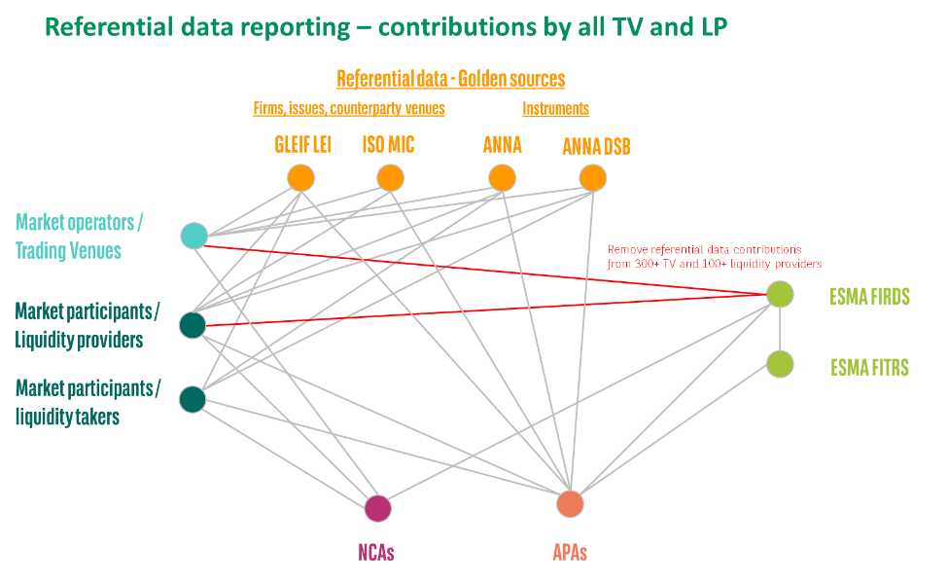

Source: BNP Paribas

* 1. Avoid duplication of reporting the same reference data.
* Avoid every TV to report each the same instrument reference data
* Avoid every liquidity provider to report each the same instrument reference data

This is prone to error for TV, for all IF and for regulators.

* 1. Instead, let’s use the golden sources, with everyone connecting to those golden sources to retrieve the right instrument reference data.
* Simplification
* No duplication of reporting of the same data
* Reduction of redundant connections / feed
* Reduction of errors (RTS-23, RTS-22, RTS-2 to ESMA, Transparency calculations)
* Data quality improvement (RTS-23, RTS-22, RTS-2 to ESMA, Transparency calculations)
* Strong cost savings for all parties
  1. The golden sources to which regulators, TV and IF can each connect are:
* GLEIF for LEI (LEI for firms, being counterparties in a trade or instrument issuers)
* ANNA for ISIN and CFI
* ANNA DSB for ISIN of OTC derivatives and CFI
* ISO for MIC (for TV identifiers)
  1. Diagram: Instrument reference data reporting – everyone using golden sources

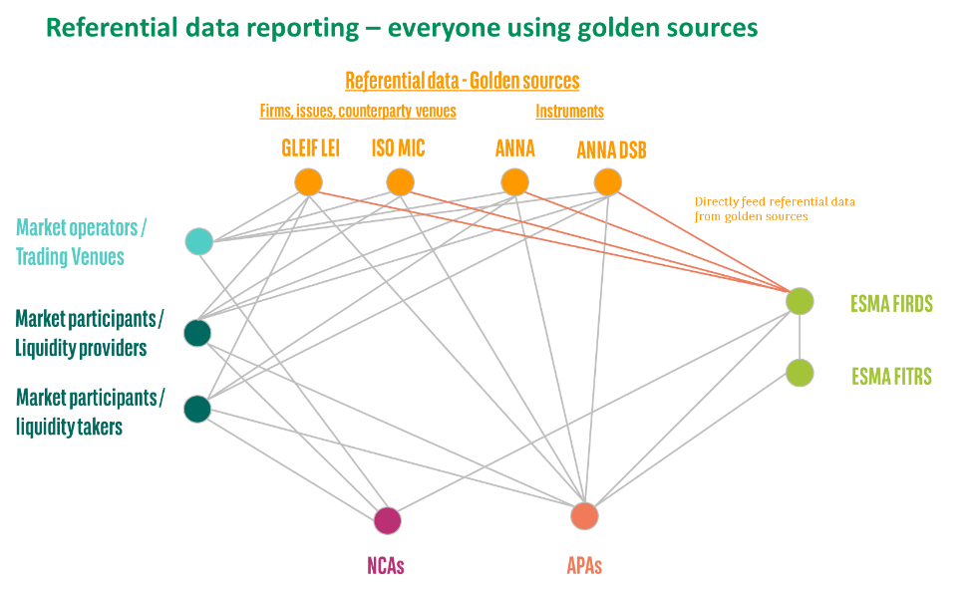

Source: BNP Paribas

Simplification of the whole regulatory reporting framework: a consolidated reference data provider (CRDP) or super golden source

* 1. All the same as the first proposal but with the set-up of a CRDP, as a “super golden source“, instead of ESMA connecting to multiple golden sources.
  2. A bit like a consolidated tape provider but for instrument reference data. Or this could be the same entity.
  3. Diagram: Instrument reference data reporting – super golden source

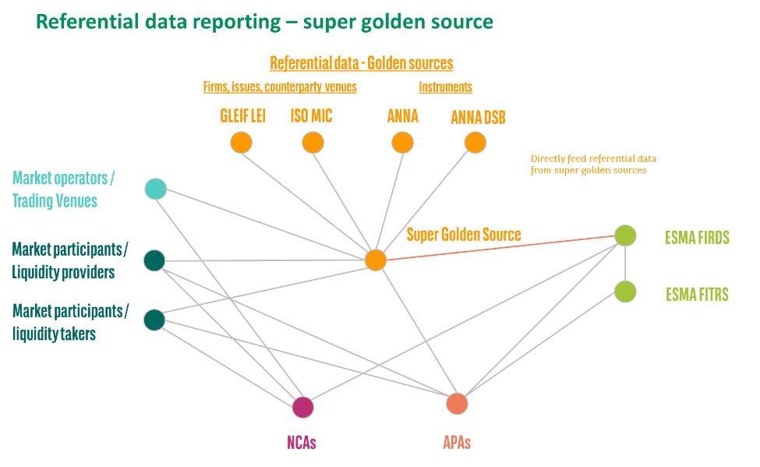

Source: BNP Paribas

<ESMA_QUESTION_TRRF_13>

1. : Did you experience any difficulties with the application of the defined list concept? If yes, please explain.

<ESMA_QUESTION_TRRF_14>

* 1. BNPP is an investment firm / market participant, not a market operator / TV.
  2. Investment firms / market participants do not operate on the basis of a defined or of an undefined list of instruments. Every day, IF can potentially trade any instrument.

<ESMA_QUESTION_TRRF_14>

1. : Do you foresee any challenges with the approach as outlined in the above proposal? If yes, please explain and provide alternative proposals.

<ESMA_QUESTION_TRRF_15>

* 1. BNPP does not agree with the proposal presented.

Misconception of market structure

* 1. Paragraph 71. In the middle of paragraph 71, ESMA speaks rightly of “level playing field between market operators“. However, in the same sentence, ESMA refers to SI. This proves one more time that the term / concept of SI is ambiguous and continuously leading to misunderstanding in bonds & derivatives.
* The market structure is made of
* market participants / investment firms and
* market operators / trading venues.
* Market participants are not market operators.
* We would suggest not to use the SI term / concept in bonds & derivatives.
* Please refer to our considerations about the market structure, the roles of each entity, the level playing field and the suggested removal of the SI concept from the regulatory framework in the Bonds and Derivatives markets in our answer to Q5.
  1. Investment firms / market participants are not market operators / TV.
  2. Investment firms / market participants do not operate on the basis of a defined or of an undefined list of instruments. Every day, IF can potentially trade any instrument.

Duplication of identical reporting, on a daily basis

* 1. We also reiterates all the concerns raised in our answer to Q13, for the duplication of identical reporting, which will be even more acute as recurring on a daily basis:
* Duplication of identical reporting
* Source of possible reporting errors and reconciliations in RTS-23
* New dependency on RTS-22
* Loss of rationale for the existence of unique identifiers / ISINs
* Loss of rationale for the existence of golden sources (ANNA DSB, ANNA)
  1. Again, recommend for ESMA to connect directly to reference data golden sources.

No ISIN for Quotes / Pre-Trade Transparency

* 1. We also note that ESMA is using the word “quotes“. We therefore understand that ESMA is expecting to bring such change also at the level of Quote / Pre-Trade Transparency for off-venue / SI.
* In the current MiFID 2, there is no requirement to create ISIN for Quote / Pre-Trade Transparency. This is confirmed in the ESMA Q&A on Transparency, General Q&A, Q5.
* BNPP may not agree that adding more requirements to an obligation that is not used by anyone will serve any purpose.
* Moreover, this would require additional set-up and risks:
* Create ISIN for all quotes = duplication of ISINs for benefit = additional noise
* Introduction of additional latency in price requests / streaming
* Addition of a new dedicated reporting set-up for ISIN for quotes to reach ESMA FIRDS, because those quotes do not fall into investment firms‘ booking systems.
* We therefore recommend not moving in that direction.
* Instead, we could recommend analysing further the market structure of Bonds and Derivatives and the appropriateness of the Quote / Pre-Trade Transparency.

Cost vs. Benefit

* 1. We do wonder what the benefit of this additional regulatory requirement is for the financial community, for market resilience, liquidity and efficiency, in comparison to the burden, complexity and cost of implementation.
  2. While the industry and regulators focus on simplification and economic recovery initiatives, those proposals are going in the opposite direction.

Alternative proposals

* 1. Please refer to our answer to Q13.

<ESMA_QUESTION_TRRF_15>

1. : Do you foresee any challenges with the outlined approach? If yes, please explain and provide alternative proposals.

<ESMA_QUESTION_TRRF_16>

* 1. BNPP does not agree with the proposal presented.

Keep the current definition of TOTV

* 1. We do not agree with this proposal for the same reasons as we do not agree to the extension of the notion of TOTV instruments to non-TOTV instruments.
* There is no benefit of making non-TOTV instrument transparent and creating ISIN for those.
* Please refer to our answer to Q5.

No ISIN for Quotes / Pre-Trade Transparency

* 1. Moreover, the proposal refers to MiFIR Article 18 about Quote / Pre-Trade Transparency. For the same reason presented in our answer to Q15, we may not agree that adding more requirements to an obligation that is not used by anyone will serve any purpose.
  2. Finally, we should add that quotes are not required for ESMA transparency calculations (SSTI, LIS, liquidity).

Cost vs. Benefit

* 1. We do wonder what the benefit of this additional regulatory requirement is for the financial community, for market resilience, liquidity and efficiency, in comparison to the burden, complexity and cost of implementation.
  2. While the industry and regulators focus on simplification and economic recovery initiatives, those proposals are going in the opposite direction.

Alternative proposals

* 1. Please refer to our answer to Q13.
  2. A simpler and streamline reporting framework where ESMA is pulling ISINs from ISIN golden sources will be more efficient and cost effective for the whole financial community.

<ESMA_QUESTION_TRRF_16>

1. : Do you foresee any challenges with the outlined approach? If yes, please explain and provide alternative proposals.

<ESMA_QUESTION_TRRF_17>

* 1. BNPP does not agree to the proposal presented.

Keep the current definition of TOTV

* 1. We do not agree with this proposal for the same reasons as we do not agree to the extension of the notion of TOTV instruments to non-TOTV instruments.
* Please refer to our answer to Q5.

MAR = TOTV + uTOTV, not non-TOTV

* 1. Moreover, the market abuse regulation is defined in term of TOTV and uTOTV instruments, not in terms of non-TOTV instruments, as per MAR Article 2.
* The goal of the regulation is not to monitor non-TOTV / non-uTOTV instruments.

Misconception of market structure

* 1. Finally, it seems necessary to reiterate that SI are not market operators / TV.
* SI are investment firms.
* Investment firms should not contribute instrument reference data to ESMA FIRDS (RTS-23).
* MAR Article 4 does not refer to SI but refers rightly to
* *Market operators of regulated markets and*
* *investment firms and market operators operating an MTF or an OTF*
* Please refer to our considerations about the market structure, the roles of each entity and the level playing field in the Bonds and Derivatives markets in our answer to Q5.

Remove SI concept

* 1. The SI concept is ambiguous and continuously leading to misunderstanding.
* It leads
* to different interpretations and
* to a complex, unnecessary and costly reporting framework.
* We question the added-value / benefit of this complexity.
* We would suggest removing all references to the SI term / concept from the regulatory framework in the Bonds & Derivatives markets. This would greatly simplify the reading and understanding of regulatory texts (MiFID, BMR, MAR) and the reporting framework, while keeping the same scope of reporting.

Alternative proposals

* 1. Please refer to our answer to Q13.

<ESMA_QUESTION_TRRF_17>

1. : Do you foresee any challenges with the approach outlined in paragraphs 75 and 76? If yes, please explain and provide alternative proposals.

<ESMA_QUESTION_TRRF_18>

* 1. BNPP does not agree with the proposal presented.

Misconception of market structure

* 1. Paragraph 78 - In the wording presented to change the MiFIR Article 26, there is a confusion due to the ambiguity of the concept of SI.
* An SI is not a TV
* An SI is an investment firm / market participant, not a TV / market operator.
  1. Therefore the wording used is not appropriate:
* “*the reports shall include a designation to identify the venue where the transaction has been executed*“
* Transactions are not executed “on an SI”, like “on a TV“, but with an investment firm (which market share is above some thresholds, according to MIFID definitions)
* “*a transaction identification code generated and disseminated by the trading venue or Systematic Internaliser*“
* Investment firms / market participants are not market operators / TV and do not generate a TV TIC, Trading Venue Transaction Identification Code
* “*link all transactions pertaining to the same execution of the financial instrument on the trading venue or Systematic Internaliser.“*
* As investment firms executing off-venue do not generate TV TIC, there is concept of link or chain.
* *“The member or participant or user of the trading venue or Systematic Internaliser“*
* An SI is an investment firm. An Investment firm does not have members, participants or users.
* *“as well as all the investment firms being part of the transaction chain shall disseminate the code generated by the trading venue or SI down the transaction chain.”*
* There is no concept of transaction chain for investment firms executing off-venue.

Focus on the core objectives of MiFID

* 1. Again, we do recommend to remove the concept of SI from the regulatory framework of Bonds & Derivatives and to focus on the following core objectives:
* data quality improvement on the current scope of instruments,
* simplification and streamlining of the regulatory reporting requirements
* access of the transparency data,
* set-up of the consolidated tape,
* and, above all, the understanding of all that the data and the market.

Please refer to our answer to Q5.

* 1. On that basis, the TV TIC and concept of transaction chain for off-venue execution between 2 investment firms should not be pursued.

Cost vs. Benefit

* 1. We do wonder what the benefit of this additional regulatory requirement is for the financial community, for market resilience, liquidity and efficiency, in comparison to the burden, complexity and cost of implementation.
  2. While the industry and regulators focus on simplification and economic recovery initiatives, those proposals are going in the opposite direction.

<ESMA_QUESTION_TRRF_18>

1. : Do you foresee any difficulties with the implementation of an additional code generated by the trading venue to be disseminated down the transaction chain in order to link all transactions pertaining to the same execution? If yes, please explain and provide alternative proposals.

<ESMA_QUESTION_TRRF_19>

* 1. Yes, BNPP foresees many difficulties.
  2. As mentioned in our answer to Q18, there is no concept of “transaction chain” for investment firms executing off-venue.
  3. Consequently, such operational set-up is non-existent today. As explained in our answer to Q18, investment do not operate as TV.
* This proposal is actually requiring investment firms / liquidity providers to build / set-up the infrastructure of a TV for all their off-venue execution.
* This is another costly, complex and unnecessary new requirement for bonds and derivatives markets.

Cost vs. Benefit

* 1. We do wonder what the benefit of this additional regulatory requirement is for the financial community, for market resilience, liquidity and efficiency, in comparison to the burden, complexity and cost of implementation.
  2. While the industry and regulators focus on simplification and economic recovery initiatives, those proposals are going in the opposite direction.

<ESMA_QUESTION_TRRF_19>

1. : Do you foresee any challenges with the outlined approach? If yes, please explain and provide alternative proposals.

<ESMA_QUESTION_TRRF_20>

* 1. BNPP is not responding to this question, mainly due to lack of time for analysis / discussion with our subject matter experts.
  2. We would be keen to analyse this further and come back with feedback at a later date.

<ESMA_QUESTION_TRRF_20>

1. : Do you foresee any challenges with the outlined approach? If yes, please explain and provide alternative proposals.

<ESMA_QUESTION_TRRF_21>

* 1. BNPP is not replying to this question.

<ESMA_QUESTION_TRRF_21>

1. : Which of the two approaches do you consider the most appropriate? Please explain for which reasons.

<ESMA_QUESTION_TRRF_22>

* 1. BNPP agrees with ESMA assessment and the option “a” to remove the short sale indicator.
  2. This will simplify the transaction reporting requirement and allow everyone to focus on core data quality improvement.

<ESMA_QUESTION_TRRF_22>

1. : Do you foresee any challenges with the outlined approaches? If yes, please explain and provide alternative proposals.

<ESMA_QUESTION_TRRF_23>

* 1. BNPP agrees with ESMA assessment and the option “a” to remove the short sale indicator.
  2. This will simplify the transaction reporting requirement and allow everyone to focus on core data quality improvement.
  3. We would recommend not to go with option “b“ and not to introduce additional requirements in MIFIR reporting framework. Again, we do recommend to focus on the following core objectives:
* data quality improvement on the current scope of instruments,
* simplification and streamlining of the regulatory reporting requirements
* access of the transparency data,
* set-up of the consolidated tape,
* and, above all, the understanding of all that the data and the market.
  1. We also reiterate our belief in a phased-approach for everything that we are attempting to build. While MiFIR is not even 3 years old and cover all types of bonds and derivatives, we keep attempting massive changes.

<ESMA_QUESTION_TRRF_23>

1. : Do you foresee any challenges with the outlined approach to pre-trade waivers? If yes, please explain and provide alternative proposals.

<ESMA_QUESTION_TRRF_24>

* 1. Yes, BNPP foresees large and expensive challenges in integrating the pre-trade waivers into the transaction reporting.

TV have a waiver, SI have a requirement under threshold / liquidity “condition“

* 1. First, there seems to be a misunderstanding on the concept of pre-trade transparency waiver.
* TV may request a pre-trade transparency waiver (liquid, SSTI, LIS)
* SI are required to provide Quote / Pre-trade transparency if instrument liquid and trade size below SSTI. There is no concept of waiver in Quote / Pre-Trade Transparency for SI, as per MiFIR Article 18.
  1. Therefore, it is misleading to talk about waiver for Quote / Pre-Trade Transparency for SI.
  2. In the rest of our answer below, we assume that ESMA is talking about pre-trade transparency “flags“, not waivers.

Complex implementation across quoting / booking / transaction reporting systems

* 1. Investment firms‘ transaction reporting systems are connected to their booking systems which do not include quotes related data (that did or did not result into a trade).
* Requiring getting this pre-trade transparency waiver would require connecting the quoting systems and regulatory eligibility engine to the transaction reporting systems.
* This would be a substantial development effort and cost.
* Feeding back the data / flag means:
* Merging distinct and asynchronous feed of data (pre-trade transparency feedback with transaction data feed)
* Merging “unmapped“ data (quotes and quotes systems / data warehouse not having the related trade id / reference of the trade system)
* Reconciliation
* Control and monitoring
* ...

Even more when feeding from an external APA

* 1. Moreover, for firms pushing their pre-trade transparency to an APA, the eligibility and those flags might only be defined at the APA level.
* Feeding back the data flag means all the same challenges and efforts presented in the point above, but more complex as involving an external feed.

Even more complex to share the data with clients

* 1. Finally, the proposal does not indicate whether the same pre-trade transparency waiver would be required from both counterparties in the transaction.
* Requiring that information from clients will prove even more complex and challenging, as this information is not relayed to clients.
* Without being specific in the requirements, firms interpretation will differ. Many will assume that they have to get and feed that information in their own transaction reporting.
* Investment firms trading off-venue are not set-up as TV. At the moment of a trade, on the phone for example, there is no “central“ system/platform that pushes a “central“ transaction identifier and various flags (TOTV, liquid, waiver...).

Cost vs. benefits

* 1. The question of benefits vs. cost in again raised.
* This is especially the case for the MiFIR Quote / Pre-Trade Transparency set-up for bonds and derivatives that has demonstrated not being used and useful since the beginning of MiFIR 3 years ago.
* Instead, market participants use other non-regulatory tools to get that information (axis, RFQ on MTF, streaming firm / indicative prices on TV).

No extension of requirements for Quote / Pre-Trade Transparency

* 1. More in general, BNPP does not agree that bringing new requirements to a Quote / Pre-Trade Transparency obligations that is not used by anyone will serve any purpose.
* We therefore recommend not moving in that direction.
* Instead, we could recommend analysing further the market structure of Bonds and Derivatives and the appropriateness of the Quote / Pre-Trade Transparency.

Focus on core goals

* 1. Instead of extending the scope obligations, we should focus on the following core objectives:
* data quality improvement on the current scope of instruments,
* simplification and streamlining of the regulatory reporting requirements
* access of the transparency data,
* set-up of the consolidated tape,
* and, above all, the understanding of all that the data and the market.

Phased approach

* 1. We also reiterate our belief in a phased-approach for everything that we are attempting to build. While MiFIR is not even 3 years old and cover the whole range of asset classes, shares, bonds and derivatives, we keep attempting massive changes.

<ESMA_QUESTION_TRRF_24>

1. : Have you experienced any difficulties with providing the information relating to the indicators mentioned in this section? If yes, please explain and provide proposals on how to improve the quality of the information required.

<ESMA_QUESTION_TRRF_25>

* 1. Yes, it has been extremely challenging and costly to gather the OTC post-trade transparency indicator into the transaction reporting, for exactly the same reason as presented in our answer to Q24 on Pre-Trade Transparency waiver.
  2. For OTC Post-Trade Transparency, investment firms may outsource this eligibility and flag definition to their APAs.
* Feeding back data and flag from the APA Post-Trade Transparency into firm Transaction Reporting systems and then into the ARM / NCA included the same challenges:
* Merging distinct and asynchronous feed of data (APA feedback with transaction data feed)
* Merging “unmapped“ data (APA id not having the same related trade id / reference as the transaction system)
* Reconciliation
* Control and monitoring
* ...
  1. And please refer to our answer to Q24, same challenges, even more complex to share the data with clients.

Control and monitor transparency in transparency

* 1. The best place to control and monitor the Post-Trade Transparency flags should be in the Post-Trade Transparency, at the level of the APA.
* The goal of Transaction Reporting should be to control and monitor market abuse, not to control and monitor the transparency.

<ESMA_QUESTION_TRRF_25>

1. : Do you foresee any challenges with this proposal? If yes, please explain and provide alternative proposals.

<ESMA_QUESTION_TRRF_26>

* 1. BNPP is not responding to this question, mainly due to lack of time for analysis / discussion with our subject matter experts.
  2. We would be keen to analyse this further and come back with feedback at a later date.

<ESMA_QUESTION_TRRF_26>

1. : Do you agree with this approach? If not, please clarify your concerns and propose alternative solutions

<ESMA_QUESTION_TRRF_27>

* 1. BNPP does not agree with this proposal.
  2. However, we are not able to provide much feedback in this consultation, mainly due to lack of time for analysis / discussion with our subject matter experts.
  3. We would be keen to analyse this further and come back with feedback at a later date.
  4. We would advise for regulators and the industry analyse and discuss the pro and cons and cost & benefits of the proposal.
* Among others, there are concerns of personal data protection and the related regulations (GDPR).
* Also, if smaller firms are not able to provide data to regulators, there are concerns that they will also not be able to provide other core data to the larger firms, together with consideration of timing of the reporting.
* Finally, we would need to think about the contractual documentation between the 2 parties, reconciliation, status reporting to client.

<ESMA_QUESTION_TRRF_27>

1. : Do you agree with this analysis? If not, please clarify your concerns and propose alternative solutions.

<ESMA_QUESTION_TRRF_28>

* 1. BNPP is not answering to this question, mainly due to lack of time for analysis / discussion with our subject matter experts.
  2. We would be keen to analyse this further and come back with feedback at a later date.

<ESMA_QUESTION_TRRF_28>

1. : Do you foresee any challenges with the outlined approach? If yes, please explain and provide alternative proposals.

<ESMA_QUESTION_TRRF_29>

* 1. BNPP is not answering to this question, mainly due to lack of time for analysis / discussion with our subject matter experts.
  2. We would be keen to analyse this further and come back with feedback at a later date.

<ESMA_QUESTION_TRRF_29>

1. : Do you foresee any challenges with the outlined approach? If yes, please explain and provide alternative proposals.

<ESMA_QUESTION_TRRF_30>

* 1. BNPP is not answering to this question, mainly due to lack of time for analysis / discussion with our subject matter experts.
  2. We would be keen to analyse this further and come back with feedback at a later date.

<ESMA_QUESTION_TRRF_30>

1. : Are there any specific aspects relating to the ISIN granularity reported in reference data which need to be addressed? Is the current precision and granularity of ISIN appropriate or is (for certain asset classes) a different granularity more appropriate?

<ESMA_QUESTION_TRRF_31>

* 1. BNPP is not answering to this question, mainly due to lack of time for analysis / discussion with our subject matter experts.
  2. We would be keen to analyse this further and come back with feedback at a later date.

<ESMA_QUESTION_TRRF_31>

1. : Do you foresee any challenges with the outlined approach? If yes, please explain and provide alternative proposals.

<ESMA_QUESTION_TRRF_32>

* 1. BNPP is not answering to this question, mainly due to lack of time for analysis / discussion with our subject matter experts.
  2. We would be keen to analyse this further and come back with feedback at a later date.

<ESMA_QUESTION_TRRF_32>

1. : Do you foresee any challenges with the outlined approach? If yes, please explain and provide alternative proposals.

<ESMA_QUESTION_TRRF_33>

* 1. BNPP does not agree with the proposal presented.

Misconception of market structure

* 1. SI are not TV / market operators.
* We are talking here of investment firms (IF) / market participants / counterparties in a transaction.
* IF should not have the same obligations as TV.
* IF should not report any reference data to ESMA FIRDS (RTS-23), neither for TOTV, nor for uTOTV instruments.
* Please refer to our considerations about the market structure, the roles of each entity and the level playing field in the Bonds and Derivatives markets in our answer to Q5.

Remove SI concept

* 1. This question is another evidence that the SI concept is ambiguous and continuously leading to misunderstanding.
* It leads
* to different interpretations and
* to a complex, unnecessary and costly reporting framework.
* We question the added-value / benefit of this complexity.
* We would suggest removing all references to the SI term / concept from the regulatory framework in the Bonds & Derivatives markets. This would greatly simplify the reading and understanding of regulatory texts (MiFID, BMR) and the reporting framework, while keeping the same scope of reporting.
* Please refer to the detailed considerations on this subject in our answer to Q5.

IF do not operate on the basis of a list of instruments

* 1. IF / market participants / counterparties in a transaction, buy-side and sell-side do not operate on the basis of a list of instruments “before trading commences“.
* Every day, they can potentially trade any instrument.

TV and IF have no relation to the bond issuer

* 1. TV and IF have no relation to the bond issuer when trading instrument on the secondary market.
* Instead the issuer is defined when setting up a new instruments, for example bond or ETF, before the primary market is started.

Issuer defined at issuance, ISIN and LEI Issuer in ANNA

* 1. At issuance, issuers should register their LEI with ANNA when requiring the creation of and ISIN.
* Issuers and ANNA should be responsible for the correct recording of their issued instruments in the ISIN golden sources.
* This has the advantage to be done once and for all centrally, instead of requiring all TV and IF
* to run after the LEI of an Issuer
* to multiply / replicate the identical reporting to ESMA FIRDS

Duplication of identical reporting

* 1. IF should not report the ISIN and the related instrument reference data, like the Issuer LEI, to ESMA FIRDS.
* This leads a tremendous duplication of the same reporting of TOTV ISINs and related instrument reference data.
* Multiplying the reporting / feed of the same instrument reference data will also be another source of possible reporting errors and reconciliations in RTS-23 and RTS-22.
* Please refer to our answer to Q13 for further consideration on this.
* See the screenshots of ESMA FIRDS below as illustration of the current reporting by TV.

Loss of rationale for the existence of unique identifiers / ISINs – and of golden sources

* 1. Finally, we can wonder what is the rationale for the existence of:
* a unique identifier / ISIN, if every TV and IF has to report it together with related instrument reference data, such as LEI.
* golden sources, if every TV and IF has to report the same info available in the golden sources (ANNA, ANNA DSB, GLEIF, ISO).

Alternative proposals

Direct feed from golden sources

* 1. Please refer to our answer to Q13 (see below the 2 related Diagram for illustrative purpose), where we recommend for ESMA to connect to golden sources if ISINs.
* A simpler and streamline reporting framework where ESMA is pulling ISINs and issuers LEIs from ISIN golden sources will be more efficient and cost effective for the whole financial community.
  1. Issuers should register their LEI with ANNA when requiring the creation of and ISIN.
  2. In Article 27 (1) / RTS-23, TV should only need to send the list of instruments, as the list of ISINs, available to trade on their platform.
* They should not need to send the related reference data of the instrument like the Issuer LEI, which should be in the ISIN golden source ANNA.
  1. Diagram: Instrument reference data reporting – everyone using golden sources



Source: BNP Paribas

* 1. Diagram: Instrument reference data reporting – super golden source



Source: BNP Paribas

* 1. Screenshot: ESMA FIRDS for DE0001030559 - 0.50% inflation-linked Federal bond 2014 (2030)

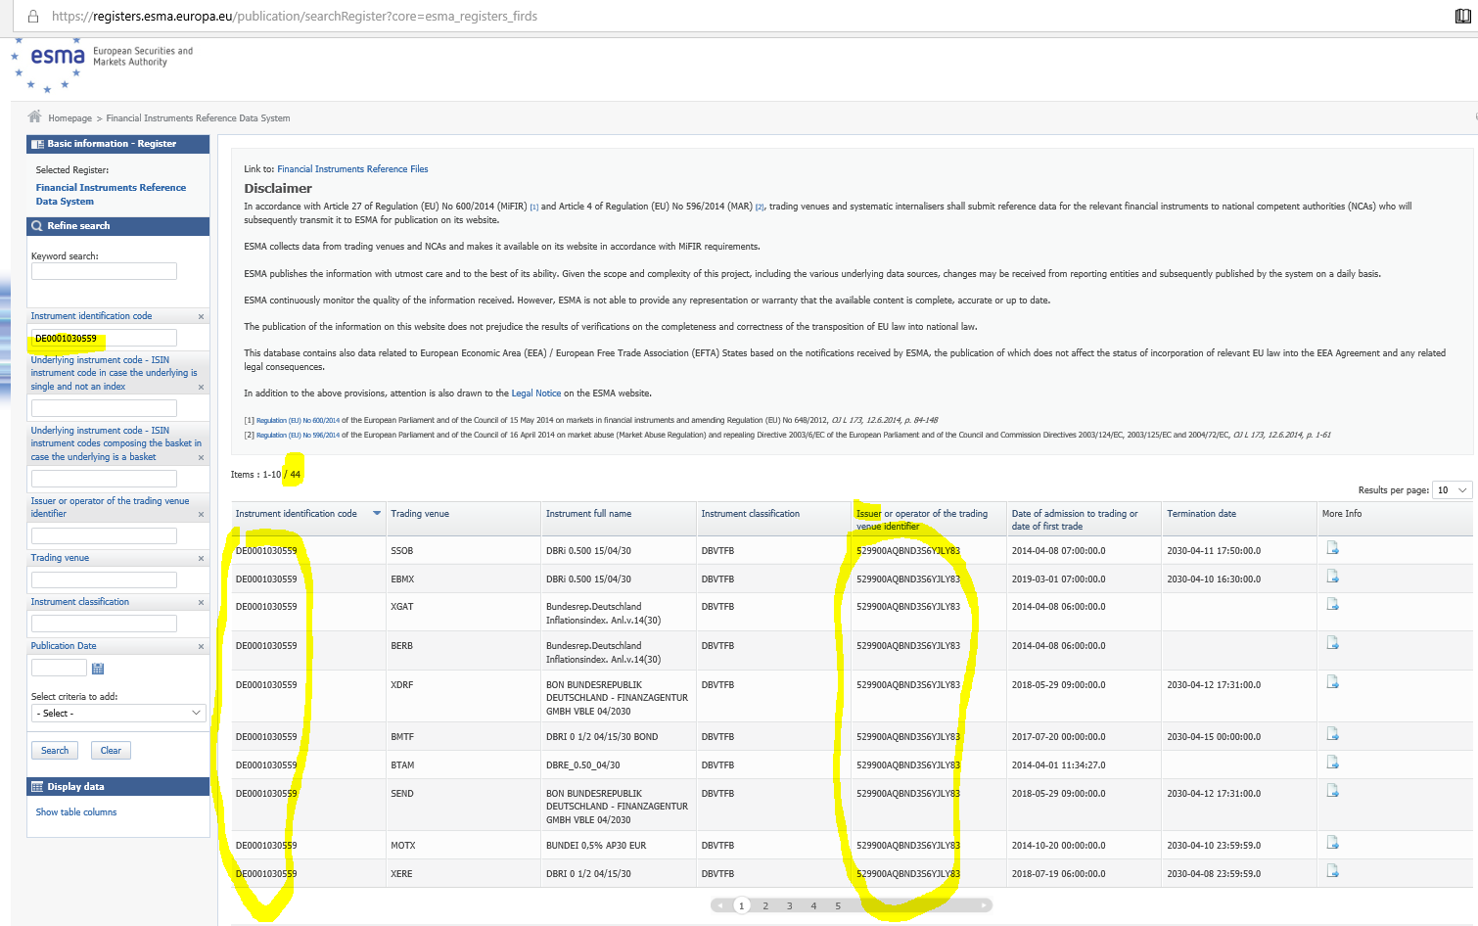

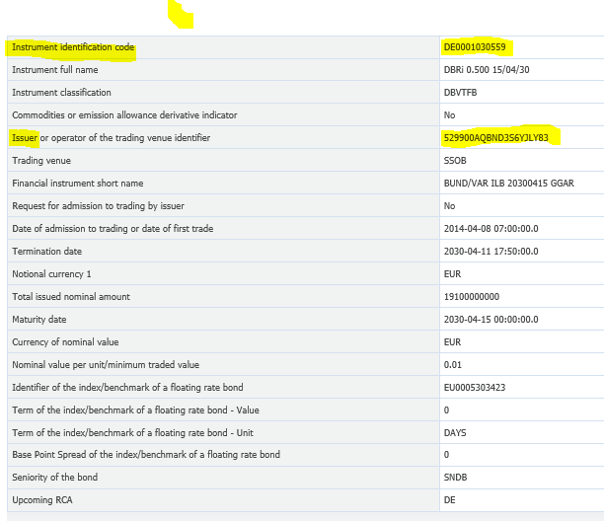

<ESMA_QUESTION_TRRF_33>