

|  |
| --- |
| JC 2020 16 |
| 23 April 2020 |

|  |
| --- |
| Joint Consultation Paper |
| ESG disclosures  Draft regulatory technical standards with regard to the content, methodologies and presentation of disclosures pursuant to Article 2a, Article 4(6) and (7), Article 8(3), Article 9(5), Article 10(2) and  Article 11(4) of Regulation (EU) 2019/2088  **In Regulation (EU) 2019/2088**  (30) **EBA, EIOPA and ESMA (collectively, the ‘ESAs’)** should be mandated, through the Joint Committee, to develop **draft regulatory technical standards** to further specify the content, methodologies and presentation of information in relation to **sustainability indicators** with regard to **climate and other environment‐related adverse impacts**, to **social and employee matters**, to **respect for human rights, and to anti‐corruption and anti‐bribery matters**, as well as to **specify the presentation and content of the information with regard to the promotion of environmental or social characteristics and sustainable investment objectives to be disclosed in pre‐contractual documents, annual reports and on websites of financial market participants** …  **Article 4(6) and (7)**  By **30 December 2020, the ESAs** shall develop, through the Joint Committee, draft **regulatory technical standard** …  **Article 8(3), Article 9(5)**  The ESAs shall, through the Joint Committee, develop draft regulatory technical standards to specify the **details of the presentation and content of the information to be disclosed** pursuant to this Article |

**Comments, questions and proposals of Much-Net GmbH on 26 August 2020**

**based on features of the ESG Screening and Scoring Platform of Much-Net GmbH**

*Question 1*: *Do you agree with the approach proposed in Chapter II and Annex I – where the indicators in Table 1 always lead* ***to principal adverse impacts*** *irrespective of the value of the metrics, requiring consistent disclosure, and the indicators in Table 2 and 3 are subject to an “opt- in” regime for disclosure?*

**MN’s reply**: No, we don’t agree with a treatment of the indicators specified in Table 1 in such a manner that it always leads to principal adverse impacts. We would prefer to group the metrics value into different “zones” of positive, neutral and adverse impact for example, i.e. green, yellow and red zone.

**Reason:** In ongoing documents, it is assumed that the ESG valuation is applied to existing risk types (i.e. market risk, credit risk, operational risk, liquidity risk, etc.) at a later stage. This leads to the idea that these risks are currently calculated at some neutral level of the ESG valuation and it can be assumed that there is an impact on these risks in both directions: positive and adverse impact.

**Proposal:** Application of non-linear transformation of the metrics values to the valuation score (see reply to Question 2).

*Question 2: Does the approach laid out in Chapter II and Annex I,* ***take sufficiently into account*** *the size, nature, and scale of financial market participants activities and the type of products they make available?*

**MN’s reply**: No, it is important to know what is the meaning and impact of the metrics value for every market participant according to the size and nature of the indicator as well as its relation to the production.

But the impact of the metrics values should be scaled through scoring and it should be comparable.

**Reason:** For example, an emission of 200t CO2 p.a. might be normal for one company, but too large for another company.

*Question 3: If you do not agree with the approach in Chapter II and Annex I, is there another way to* ***ensure sufficiently comparable*** *disclosure against key indicators?*

**MN’s proposal:** We apply non-linear transformation of the metrics values to the valuation score using S- and Z (reverse S)-transformation functions based on minimum and maximum metrics value. The calculation leads to a scoring between 0 and 100 which comprises all three zones for positive, neutral and adverse impact.

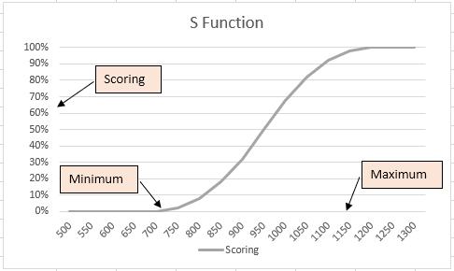 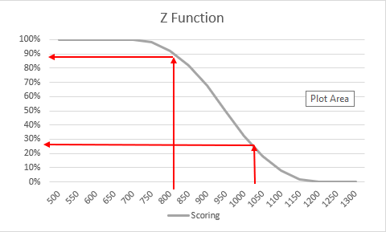

The disclosure in terms of scoring is unified in the range between 0 and 100. Zones can be defined as follows for example: Positive (55..100), neutral (45..55) and adverse (0..45) impact.

*Question 4: Do you have* ***any views on the reporting template*** *provided in Table 1 of Annex I?*

**MN’s proposal**: Based on our proposal for Question 3, more table columns can be added to include minimum and maximum values and scores for two years, where minimum and maximum should be specific values for every market participant. This ensures comparability of the participants’ scores.

The minimum and maximum values determine the definition area of the indicators.

*Question 5: Do* ***you agree with the indicators****? Would you recommend* ***any other indicators****? Do you see merit in including* ***forward-looking indicators*** *such as emission reduction pathways, or scope 4 emissions (saving other companies´ GHG emissions)?*

**MN’s reply:** We do not fully agree with the indicators. The indicators in Table 1 represent numeric exposures to ESG factors by value measures, but the ESG disclosure can include a set of non-numeric and qualitative values defined by selectors like (Yes/No), (Excellent, Very good, Good, … Bad). A range of replies should be allowed for questions such as e.g. “

**“**What is your intention for CO2 emission reduction in the next 5 years? Reply: Very good”

The important point is to apply scoring values to every reply value similarly to the scorings (0 to 100) of the numeric indicators, for example:

Excellent (95), Very good (80), Good (60), … Bad (5)

This allows for a comparison and consolidation of the scoring values for numeric and non-numeric indicators using weights.

*Question 6: In addition to the proposed indicators on carbon emissions in Annex I, do you see merit in also requesting a)* ***a relative measure of carbon emissions relative to the EU 2030 climate*** *and energy framework target and b) a relative measure of carbon emissions* ***relative to the prevailing carbon price****?*

**MN’s reply**: The relativity of the indicator values is covered by the S- and Z-transformation functions (see Question 3), i.e. the minimum and the maximum can be configured or scaled for a group of similar customers in accordance with points a) and b) above.

*Question 7: The ESAs saw merit in requiring measurement of both (1) the share of the investments in companies without a particular issue required by the indicator and (2) the share of all companies in the investments without that issue. Do you have any feedback on this proposal?*

**MN’s reply**: No comment

*Question 8: Would you see merit in* ***including more advanced indicators or metrics*** *to allow financial market participants to capture activities by investee companies to reduce GHG emissions? If yes, how would such* ***advanced metrics capture adverse impacts****?*

**MN’s reply**: Yes, the activities to reduce the GHG emissions are important and such indicators reflect a forward-looking approach. Based on our view concerning positive, neutral and adverse impact outlined in our reply to Question 1, the indicators for reducing the GHG emissions should have an adverse and positive impact on the risk and return of the companies, e.g. good reduction, acceptable reduction and bad reduction.

*Question 9: Do you agree with the goal of trying to deliver* ***indicators for social and employee matters****, respect for human rights, anti-corruption and anti-bribery matters* ***at the same time as the environmental indicators****?*

**MN’s reply**: Yes, the social and governance indicators in addition to the environmental indicators provide a holistic picture of the company regarding the ESG disclosure and subsequent risk assessment. We create separate scores for E, S und G by way of consolidating the basis indicator scores along a scoring hierarchy. The total ESG scoring is obtained through specific weighting for a given industry or NACE activity classification according to the EU Taxonomy.

*Question 10: Do you agree with the proposal that financial market participants should* ***provide a historical comparison of principal adverse impact disclosures up to ten years****? If not, what timespan would you suggest?*

**MN’s reply**: Yes, it is a good approach to provide a historical comparison of the indicators’ evaluation sessions and of the corresponding impacts within a large timespan to allow for an analysis of the development. The length of the historical comparison period can be unlimited, for example 15 years quarterly or on demand. What historical comparison will be required for the disclosure is another point, our view is to mandate a disclosure of 10 measurement sessions minimum e.g. 5 years for a semi-annual disclosure.

*Question 11:* ***Are there any ways to discourage potential “window dressing” techniques*** *in the principal adverse impact reporting? Should the ESAs consider harmonising the methodology and timing of reporting across the reference period, e.g. on what dates the composition of investments must be taken into account? If not, what alternative would you suggest to curtail window dressing techniques?*

**MN’s reply**: One way is to disclose a larger timespan divided into subperiods and to disclose cumulative values. For example:

**2018, 2019, 2020 cumulative values for 3 years**

**2019, 2020 cumulative values for 2 years**

**2020 for 1 year**

**Previous reporting took place from 2017 to 2019.**

Another methodology applied on the ESG Screening and Scoring Platform is the ESG scoring based on **similarity to an ESG index time series**, which can be used to compare or alternatively prove the ESG impacts. Brief introduction to this approach:

1. Large set of daily time series over a period of 1 to 3 years for global ESG indices serves as a basis for mapping the share or price time series of the company.
2. Two-level automatic mapping of the company’s time series to the selected appropriate ESG index time series using multi-factor regression. The results are similarity weightings used for a replication of the company’s time series (see charts below).
3. Since the ESG indices consist of ESG-rated (rated by ESG rating agencies) global companies grouped by ESG criteria (e.g. companies with the highest CO2 emission) analogously to ESG benchmarks, ESG scores can be obtained from the ESG indices.
4. As a last step, the ESG scoring of the company can be derived from the similarity weights (weight and ESG scores of mapping indices, see last four columns) provided in the table below.

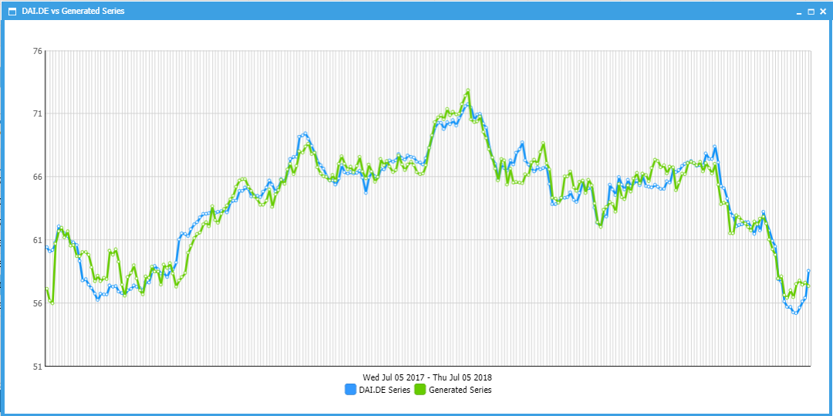

The above approach allows for massive ESG valuations without an expensive search for ESG indicator values for the disclosed or evaluated companies.

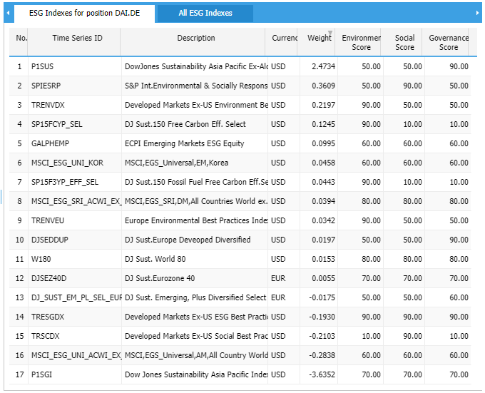

*Question 12: Do you agree with the approach to have* ***mandatory (1) pre-contractual and (2) periodic templates*** *for financial products?*

**MN’s reply**: Yes, we agree. This disclosure would help evaluate the ESG impacts and observe the periodic development of the company in relation to the ESG behaviour.

*Question 13: If the ESAs develop such pre-contractual and periodic templates,* ***what elements should the ESAs include*** *and how should they be formatted?*

**MN’s reply**: We think it is a good idea to use the same disclosure indicators as given in Table 1 for example, but also additional indicators as provided in the Question 5 reply. This would lead to a complete picture of the pre-contractual and the periodic disclosures. The use of unified scoring values after a transformation of real measures or selections would help preserve comparability. To achieve a balance between comprehensiveness and comprehensibility of the information however, we would recommend a disclosure of the impacts on the main levels (E, S, G) and on the next sub-levels (e.g. greenhouse gas (GHG) emissions, energy performance, water, waste etc. and in accordance with the climate sectors of the EU Taxonomy).

*Question 14: If you do* ***not agree with harmonised reporting templates*** *for financial products, please suggest what other approach you would propose that would ensure comparability between products.*

**MN’s reply**: We agree with Question 12.

*Question 15: Do you agree with the* ***balance of information between pre-contractual and website information requirements****? Apart from the items listed under Questions 25 and 26, is there anything you would add or subtract from these proposals?*

**MN’s reply**: See comments to Questions 25 and 26.

*Question 16: Do you think the* ***differences between Article 8 and Article 9*** *products are sufficiently well captured by the proposed provisions? If not, please suggest how the disclosures could be further distinguished.*

**MN’s reply**: We do not perceive any relevant difference between Article 8 and 9 (see below), in short:

Article 8 Actions/engagement policies for adverse sustainability impacts for the reference period:

(a) actions to avoid or reduce the principal adverse impacts identified; and

(b) an explanation of the reduction in principal adverse impacts

Article 9 Engagement policies

Explanation of the reduction in principal adverse impacts achieved by the actions taken during the reference period.

*Question 17: Do the graphical and narrative descriptions**of investment proportions capture indirect investments sufficiently?*

**MN’s reply**: No comment

*Question 18: The draft RTS require in Article 15(2) that for Article 8* ***products graphical representations illustrate the proportion*** *of investments screened against the environmental or social characteristics of the financial product. However, as characteristics can widely vary from product to product do you think using the same graphical representation for very different types of*

*products could be misleading to end-investors? If yes, how should such graphic representation be adapted?*

**MN’s reply**: Yes, we think that using the same graphical representation for very different types of

products could be misleading to end-investors. We use different disclosure models for different product groups which include appropriate weight and consolidation rules; as regards the main ESG level and the sub-levels for example we apply different weightings adapting the graphical representation to the disclosure model. Within the EU Taxonomy, the models correspond to the NACE activities, the sub-levels correspond to climate sectors.

*Question 19: Do you agree with always disclosing exposure to solid fossil-fuel sectors? Are* ***there other sectors that should be captured*** *in such a way, such as nuclear energy?*

**MN’s reply**: Yes, a lot of other sectors are pointed out within the EU Taxonomy – Technical Annex of TEG such as production of electricity from solar PV, wind power, ocean energy, hydropower, geothermal, gas, bioenergy, nuclear energy, etc.

*Question 20: Do the product disclosure rules take* ***sufficient account of the differences between products****, such as* ***multi-option products or portfolio management products****?*

**MN’s reply**: We think that the different financial product types should not have an impact on the ESG disclosure because the contractual terms e.g. embedded option rights, determine the behaviour of the financial instrument and do not have any connection to the ESG indicators.

*Question 21: While Article 8 SFDR suggests investee companies should have “good governance practices”, Article 2(17) SFDR includes specific details for good governance practices for sustainable investment investee companies including “****sound management structures, employee relations, remuneration of staff and tax compliance****”. Should the requirements in the RTS for good governance practices for Article 8 products also capture these elements, bearing in mind Article 8 products may not be undertaking sustainable investments?*

**MN’s reply**: We think that the aspect of “good governance practices” is important in all cases and that it should therefore be always captured.

*Question 22: What are your views on the preliminary proposals on “****do not significantly harm****” principle disclosures in line with the new empowerment under the taxonomy regulation, which can be found in Recital (33), Articles 16(2), 25, 34(3), 35(3), 38 and 45 in the draft RTS?*

**MN’s reply**: We think, the “do not significantly harm” principle should be maintained to meet the requirements in the RTS to explain how the investment of the financial product does not significantly harm the sustainable investment objectives at accounting or exclusion of adverse impact indicators.

*Question 23: Do you see merit in the ESAs defining widely used* ***ESG investment strategies*** *(such as* ***best-in-class, best-in-universe, exclusions****, etc.) and giving financial market participants an opportunity to disclose the use of such strategies, where relevant? If yes, how would you define such widely used strategies?*

**MN’s reply**: Yes, we would prefer financial market participants to have the opportunity to disclose how and for what elements the ESG investment strategies was applied. The strategy disclosure should be supported by tables showing classes, universes and exclusion lists.

*Question 24: Do you agree with the* ***approach on the disclosure of financial products’ top***

***investments*** *in periodic disclosures as currently set out in Articles 39 and 46 of the draft RTS?*

**MN’s reply**: Yes, we agree. Articles 39 and 40 provide to use and disclose financial products in comparison to product indices designated as reference benchmarks for top investments. This is similar to the approach described in our reply to Question 11 which refers to ESG indices however. Another approach applied by the ESG-Screening and Scoring Platform is the creation of peer groups on the basis of the industry or business activities, which are benchmarks of top companies and used for a comparison of the target company’s ESG impact.

*Question 25: For each of the following four elements, please indicate whether you believe it is better to include the item* ***in the pre-contractual or the website disclosures*** *for financial products? Please explain your reasoning.*

1. *an indication of any commitment of a minimum reduction rate of the investments (sometimes referred to as the “investable universe”) considered prior to the application of the investment strategy – in the draft RTS below it is in the pre-contractual disclosure Articles 17(b) and 26(b);*

**MN’s reply**:

In pre-contractual disclosures: Yes, important for potential contract conclusion

In website disclosures: No, not for public disclosure

1. *a short description of the policy to assess good governance practices of the investee companies*

*– in the draft RTS below it is in pre-contractual disclosure Articles 17(c) and 26(c);*

**MN’s reply**:

In pre-contractual disclosures: Yes, important for potential contract conclusion

In website disclosures: No, not for public disclosure

1. *a description of the limitations to (1) methodologies and (2) data sources and how such limitations do not affect the attainment of any environmental or social characteristics or*

*sustainable investment objective of the financial product – in the draft RTS below it is in the website disclosure under Article 34(1)(k) and Article 35(1)(k); and*

**MN’s reply**:

In pre-contractual disclosures: Yes, important for potential contract conclusion

In website disclosures: No, not for public disclosure

1. *a reference to whether data sources are external or internal and in what proportions – not currently reflected in the draft RTS but could complement the pre-contractual disclosures under Article 17.*

**MN’s reply**:

In pre-contractual disclosures: Yes, important for potential contract conclusion

In website disclosures: Yes, the data basis and sources can be common information

*Question 26: Is it better to include a separate section on information on how the use of derivatives meets each of the environmental or social characteristics or sustainable investment objectives promoted by the financial product, as in the below draft RTS under Article 19 and article 28, or would it be better to integrate this section with the graphical and narrative explanation of the investment proportions under Article 15(2) and 24(2)?*

**MN’s reply**: We prefer the second proposal: …integrate this section with the graphical and narrative explanation as the derivatives require a specific presentation including a narrative explanation and charts.

*Question 27: Do you have any views regarding the preliminary impact assessments? Can you provide more granular examples of costs associated with the policy options?*

**MN’s reply**: The ESG-Screening and Scoring Platform includes different methodologies for impact assessment:

1. Assessment through weighting of the basis indicator scores and hierarchical consolidation among the screening and scoring models specific for industries or for NACE-activities in accordance with the EU Taxonomy principles.
2. Assessment through mapping to ESG indices based on multi-factor regression (see reply to Question 11)
3. Assessment through mapping to benchmarks of industries or NACE-activities; the benchmarks are created as clusters within an ESG indicator database which contains the world’s top investments.

We are able to provide granular examples for the assessment methodology of point 1 above.