|  |
| --- |
| 27 March 2020 |

|  |
| --- |
| Response form for the Consultation Paper on post trade risk reduction services with regards to the clearing obligation (EMIR Article 85(3a)) |
|  |

|  |
| --- |
| Date: 27 March 2020 |

Responding to this paper

ESMA invites responses to the questions set out throughout its Consultation Paper on the Report on **post trade risk reduction services with regards to the clearing obligation** that ESMA is drafting under Article **85(3a)** of the Regulation (EU) No 648/2012 of the European Parliament and Council on OTC derivatives, central counterparties and trade repositories (EMIR, as amended by Refit).

Responses are most helpful if they:

* respond to the question stated;
* contain a clear rationale; and
* describe any alternatives ESMA should consider.

ESMA will consider all responses received by 15 June 2020.

Instructions

In order to facilitate analysis of responses to the Consultation Paper, respondents are requested to follow the below steps when preparing and submitting their response:

* Insert your responses to the questions in the Consultation Paper in the present response form.
* Please do not remove tags of the type <ESMA_QUESTION_PTRR_1>. Your response to each question has to be framed by the two tags corresponding to the question.
* If you do not wish to respond to a given question, please do not delete it but simply leave the text “TYPE YOUR TEXT HERE” between the tags.
* When you have drafted your response, name your response form according to the following convention: ESMA_PTRR_nameofrespondent_RESPONSEFORM. For example, for a respondent named ABCD, the response form would be entitled ESMA_PTRR_ABCD_RESPONSEFORM.
* Upload the form containing your responses, in Word format, to ESMA’s website ([**www.esma.europa.eu**](http://www.esma.europa.eu) under the heading “Your input – Open consultations” 🡪 “**Consultation Paper on post trade risk reduction services with regards to the clearing obligation (EMIR Article 85(3a))**”.

Publication of responses

All contributions received will be published following the close of the consultation, unless you request otherwise. Please clearly indicate by ticking the appropriate checkbox on the website submission page if you do not wish your contribution to be publicly disclosed. A confidential response may be requested from us in accordance with ESMA’s rules on access to documents. We may consult you if we receive such a request. Any decision we make not to disclose the response is reviewable by ESMA’s Board of Appeal and the European Ombudsman.

Data protection

Information on data protection can be found at [www.esma.europa.eu](http://www.esma.europa.eu) under the heading “Data protection”.

Who should read the Consultation Paper

All interested stakeholders are invited to respond to this consultation paper. In particular, responses are sought from financial and non-financial counterparties of OTC derivative transactions as well as central counterparties (CCPs) and clearing members.

# General information about respondent

|  |  |
| --- | --- |
| Name of the company / organisation | Eurex Clearing, Deutsche Börse Group |
| Activity | Central Counterparty |
| Are you representing an association? |  |
| Country/Region | Europe |

# Introduction

Please make your introductory comments below, if any:

<ESMA_COMMENT_PTRR_1>

Eurex Clearing appreciates the opportunity to provide feedback to the ESMA consultation on post trade risk reduction (PTRR) services with regards to the clearing obligation. We consider that PTRRS services have greatly helped reduce certain types of risk. We are however sceptical about the need to exempt from the clearing obligation standardized trades that result from PTRR services, given the broad use of these services. Eurex Clearing trusts that our comments are seen as a useful contribution, in addition and in alignment with the EACH response, and remain at the disposal of ESMA for any questions and additional feedback.

<ESMA_COMMENT_PTRR_1>

1. : Would you agree with the description of the benefits (i.e. reduced risks) derived from PTRR services? Are there any missing? Could PTRR services instead increase any of those risks? Are there any other risks you see involved in using PTRR services?

<ESMA_QUESTION_PTRR_1>

* Eurex Clearing welcomes activities aimed at reducing risk in the market, and notes that CCPs do regularly perform compression activities for cleared trades which are beneficial in terms of resource optimisation, operational risk and the default management process.
* For general PTRR actions, the **primary benefit is a cleaner and easier to understand portfolio**. PTRR services help clean up trading books and thereby enable a simplified reading as to where the exposure and risk actually stand. Such portfolio clarity improves the regulators and supervisors’ understanding of firms’ strategies and exposures.
* In addition, the original crisis reform package created incentives for firms to increase adoption of previous best practices in this space. This leads market participants to think of PTRRS both in terms of **operational and capital benefits**, as failure to conduct periodic post-trade portfolio clean-up results in higher capital charges. This is a key dimension to the popularity of these services. In other words, the “risk reduction” function of traditional PTRRS helps reduce margin and capital requirements.
* A **general risk of such services is the drift of trading activities into a space without similar regulatory control**. As portfolio rebalancing can bear similarities to brokerage, there is a risk that trading migrates onto unregulated or differently regulated PTRRS platforms. We note that the line can be quite thin on ways to differentiate both services and believe some conditions in the consultation are an appropriate way to distinguish these
* More generally, we note that the clearing obligation has not hindered the development and expansion of PTRRS, both in the uncleared and cleared space. In particular, no other jurisdiction has accepted proposals to exempt trades in the manner proposed; only legacy trades are exempted in certain jurisdictions.

<ESMA_QUESTION_PTRR_1>

1. : Would you agree with this description of portfolio compression? Please explain the different compression services that are offered and how they may differ from the description above. Are there today viable alternatives to using PTRR services to achieve a similar outcome?

<ESMA_QUESTION_PTRR_2>

* Portfolio compression is a current and wide-spread market practice used both for cleared trades within a CCP and, separately, for individual portfolios in the uncleared space.
* We agree with the description of portfolio compression but would draw attention to the point of “without changing the market risk of the portfolios”, since a key feature of compression is that no particular counterpart-to-counterpart portfolio changes (compared to portfolio rebalancing).
* PTRRS are generally understood as services provided by a third party. However, it is important to highlight that the process of portfolio compression – or cleaning up a trading book – is something that traders can (and already) do themselves.
* Please also note that within CCPs, the risk reduction described under portfolio compression for cleared trades – which does not change the underlying sensitives to the trading book – happens automatically, as participants need to specifically opt out to avoid compression.

<ESMA_QUESTION_PTRR_2>

1. : Without changing the market risk of the portfolios, how different can the transactions included in the portfolio compression exercise be? Would the market risk be changed at all by the applied tolerances and if yes, how can the portfolio remain market neutral? What tolerance levels are often applied and could/should restrictions be placed on tolerances?

<ESMA_QUESTION_PTRR_3>

* We agree that the way the tolerance levels are defined and set can have significant impact on the way these services can be used and to what objectives.
* If market risk (i.e. exposure) remains the same, conceptually the transactions can be as different as possible.

<ESMA_QUESTION_PTRR_3>

1. : Should there be a clearing exemption for PTRR trades that are a direct result from a portfolio compression? If not, why? Is there a difference between bilateral and multilateral portfolio compression for the sake of an exemption?

<ESMA_QUESTION_PTRR_4>

* As mentioned in our response to Q1, **we are sceptical about the possibility of exempting trades resulting from portfolio compression specifically, or from PTRRS more generally**. While we see little gains from such an exemption (PTRRS have never been more used than today), we see significant downsides to such an exemption:
  + Such an exemption reverses the logic of the G20 intention of risk mitigation for OTC derivatives. The core concept was that standardised OTC markets would be cleared, and thus come under the multilateral netting and collateralisation imposed by CCPs. The more exotic OTC derivatives would come under heightened capital and collateralisation requirements, with the intention to better safeguard against their inherent risks and incentivise market participants to employ standardised contracts when possible. Jointly, these two prongs were designed to create more transparent markets, as well as provide collateral and capital buffers to help insulate market participants from each other’s counterparty credit risk. We would note that it was always understood that exotic or uncleared risk is offset or hedged by standard OTC contracts that would be cleared.
  + In this context, we would like to express our concern that a potential PTRRS exemption could create a loophole to the clearing obligation incentivising market participants to include any trade into a PTRRS.
  + It should also be kept in mind that if a PTRRS exemption is permitted, then market participants can maintain their existing or future bilateral portfolios with reduced capital and collateral requirements which will lead to a shift of exposure that is currently risk managed by CCPs to bilateral OTC derivatives.
  + Beyond these conceptual arguments, we are concerned by the lack of data or quantitative impact available to determine the possible effects. We would assume that ESMA and the ESRB are able to provide order of magnitude type data for the current size of standardised risk that currently resides in bilateral portfolios. It would then be possible to estimate the type of participant and scale of plain vanilla OTC derivatives that would be added to bilateral portfolios. It would also be incisive to consider how much capital and collateral such moves would free up.
  + As a market structure consideration, we would highlight that the consultation on the topic has not touched on the cross-jurisdictional aspect of the muted services. We question whether such post trade actions could result in some firms avoiding local clearing requirements, as the PTRRS can be employed to move exposure to an offshore or third country booking hub of choice.
* **We do not believe a difference between bilateral and multilateral portfolio compression would be helpful in addressing a new loophole to the clearing obligation.** We would however note that a multilateral-only approach provides a safeguard to a more direct version of the concerns, wherein an individual firm could essentially determine itself whether or not its trades should be cleared.

<ESMA_QUESTION_PTRR_4>

1. : Would you agree with this description of PTRR Services? What other forms of PTRR services exist? What do they do? How do they work? Are there any other viable alternatives to PTRR services, if yes, why are they not sufficient?

<ESMA_QUESTION_PTRR_5>

* **Description of PTRRS** – we believe it is useful to clarify that PTTRS are an umbrella definition which includes different services:
  + 1) **portfolio compression** (described in the above section) which seek to clean up line by line items of trading books without out changing exposure to counterparties or risks to sensitivities of trades;
  + 2) **portfolio rebalancing** which seeks to adjust exposures, to either to reduce risk held against a particular counterparty or to bring overall exposures down (to a given sensitivity down); and
  + 3) **other services**, such as TriOptima’s TriResolve which seek to avoid disputed trades resulting from PTRRS and the possible capital impacting of not resolving them.
* To our understanding, paragraph 19 and the following diagram, rather describe multilateral portfolio compression, not portfolio rebalancing. Instead, we would rather describe portfolio rebalancing with the following diagram and practical market case of swaptions.

**Stylistic example of Swaptions** – options on swaps, or swaptions, are a right to exercise into a swap and have two primary market risk sensitivities: direct sensitivity to the underlying (delta) and sensitivities derived from the optionality feature (vega, gamma). It is presumed that when dealers enter into a swaption with a client, they will seek to hedge out all or some of this risk.

* **Market practice**: we see four scenarios in current market practice today to hedge the delta or sensitivity to the underlying

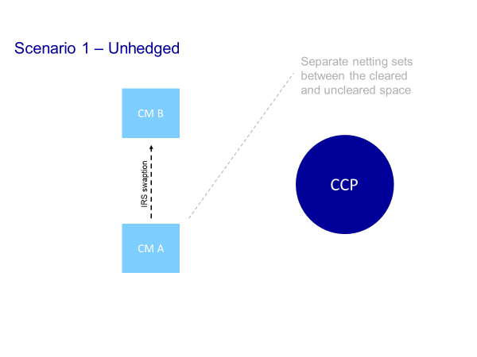

**Scenario 1** **– market participants decide not to hedge their swaption**. While this is possible, we would not expect it to be common market practice.

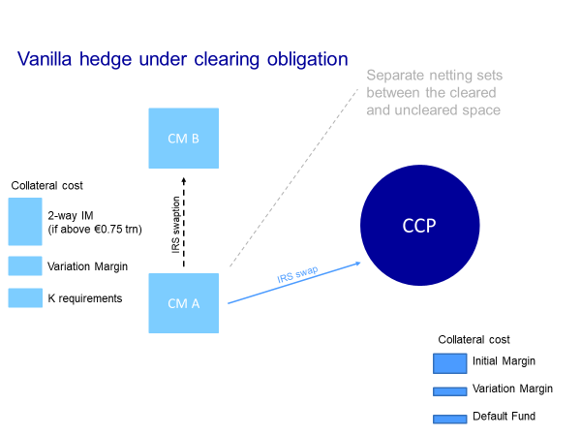

**Scenario 2 – market participants hedge the delta of the swaption with a standardized vanilla swap,** which then must be cleared. The **market participant has to face two netting sets**, **one netting set for the uncleared space and one netting set for cleared space**, which is less efficient in terms of capital costs than if it could net them altogether. Note the importance of mandatory initial margin requirements for uncleared OTC derivatives to support the incentives to clear.

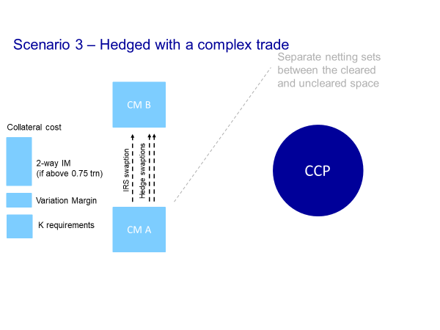

**Scenario 3 – market participants hedge the delta with complex trades**, which can remain uncleared. The market participant has **only one netting set but the very complex trades** to replicate the delta hedge is likely to increase its trading and capital costs.

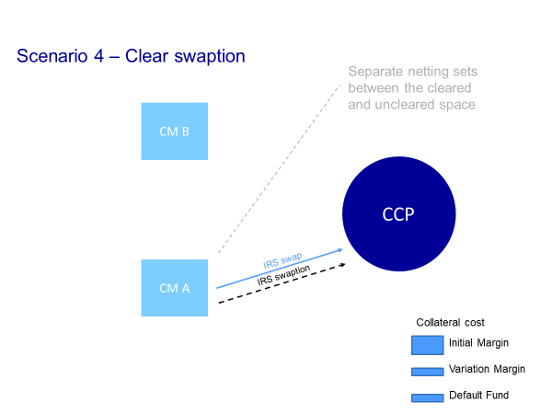

**Scenario 4** – **another way of resolving the capital costs of having two separate netting sets under Scenario 2, would be to clear the swaption in the CCP, if CCPs offer this**, in addition to the cleared delta hedge. As both trades would be netted and cleared, the **capital costs would be even lower in Scenario 4, provided that bilateral capital and collateral costs are in practice higher as intended**.

Note that **all scenarios are currently coherent with the objectives of the G20 reforms**, to support a shift towards central clearing, which is more cost/capital effective for the market participant. This is particularly the case if the swaptions or other bilateral trades are so complex or risky that clearing is unsuitable for them; in such cases one expects the higher capital and collateral to be prudent. In line with the incentives to clear, there is indeed an additional cost in entering into swaptions and keeping them in the uncleared space.

**Exemption of the clearing obligation – focus on Scenario 2 described above**

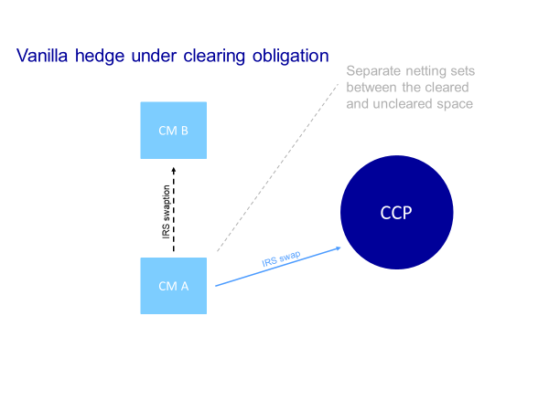 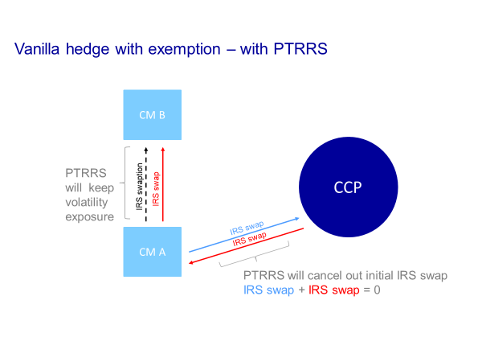 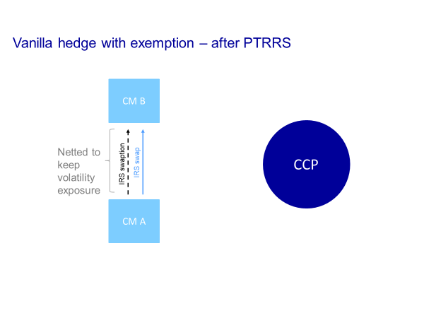

**The current proposal to exempt trades resulting PTRRS under Scenario 2 seeks to exempt the delta hedge covered by a vanilla swap from the clearing obligation** – thereby **weakening the clearing obligation itself** (as de facto less exposure are covered by central clearing), **but also the incentives to clear** (as there will now be a cheaper option to hedge the swaption in the bilateral space).

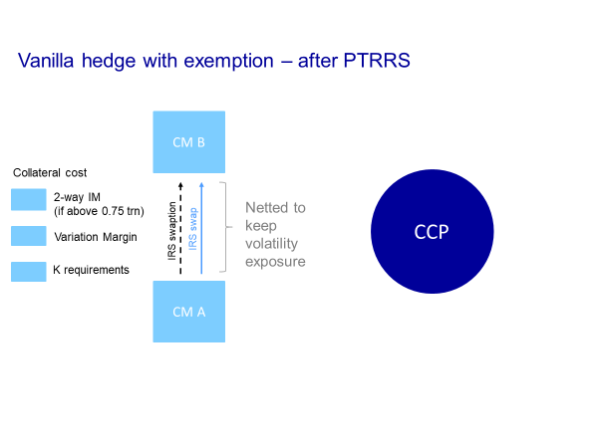

<ESMA_QUESTION_PTRR_5>

1. : Without changing the market risk of the portfolios, how different can the transactions included in the PTRR exercise be? What tolerance levels are often applied and what restrictions could/should restrictions be placed on tolerances (if applies)?

<ESMA_QUESTION_PTRR_6>

* As stated in our answer to Q3, we are of the view that the way the tolerance levels are defined and set can have significant impact on the way PTRR services can be used and to what objectives. If market risk (i.e. exposure) remains the same, conceptually the transactions can be as different as possible.

<ESMA_QUESTION_PTRR_6>

1. : Is the requirement under EMIR of portfolio compression sufficient to mitigate the risk of build-up of transactions and how is the market managing this risk today?

<ESMA_QUESTION_PTRR_7>

* Portfolio compression uniquely addresses the accumulation of line items and notional which make books 1) complicated to identify exposures and 2) increases operational risks. Comparatively, portfolio rebalancing seeks to modify the exposure of a portfolio to a given type of sensitivity (such as volatility) or to a given counterparty.
* However, **none of them address counterparty credit risk, and it should be clear that PTRRS cannot be perceived as a replacement of central clearing**. While we very much welcome the benefits of PTRRS as regards resource optimisation and operational risk, we are also mindful of key aspects of central clearing such as neutral risk valuation and default management are fundamental to prevent destabilizing effects on financial markets. Rather, we believe **portfolio compression to be complementary to central clearing**, as these services are also widely used for cleared portfolios too.

<ESMA_QUESTION_PTRR_7>

1. : Based on all of the above, how would you define (algorithm based, second order risk, market neutral) PTRR services that cover all of the relevant aspects?

<ESMA_QUESTION_PTRR_8>

* Without suggesting a clear definition, we would like to emphasize that the criteria of market risk neutrality as already included in Recital 27 of MIFIR should be a key criteria in finding a feasible definition. Thus, all trades entered into due to changed market risk in any way should not be considered PTRR trades. Adding trades that ultimately change the counterparty constellation should also be considered as market risk motivated trades, as a perceived lowering credit rating could be the motivation to enter into these trades.

<ESMA_QUESTION_PTRR_8>

1. : Should there be an exemption from the clearing obligation for PTRR trades (other than portfolio compression) that are a direct result from a PTRR exercise? If not, why?

<ESMA_QUESTION_PTRR_9>

* First and foremost, we would highlight that the description given by ESMA resembles that of multilateral compression, which is permitted today in both cleared and uncleared OTC derivative markets.
* Second, **we are sceptical of exempting trades resulting from PTRRS from the clearing obligation**.

 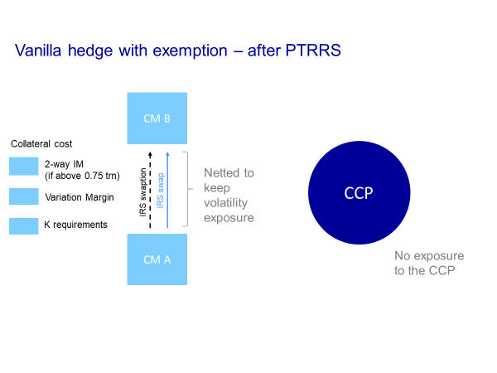

* As highlighted in our responses to Q4 and Q5, **the current proposal to exempt trades resulting from PTRRS would weaken the clearing obligation itself** (as de facto less trades are covered by central clearing), **but also the incentives to clear** (as there will now be a cheaper option to hedge the swaption in the bilateral space).
* We **call on regulators to consider the impact of shifting such trades into the bilateral space** and no longer benefit from the stabilising effects of central clearing and the strict third-party risk management framework of CCPs. We would also highlight that, as the initial margin requirements for the uncleared space are continuously delayed, the financial system may not even have the consolation that other forms of collateralization of exotic trades are implemented, as most participants will be below the thresholds.
* We consider such a **shift to be a substantial set back to the G20 reforms**, only ten years after a financial crisis which had exposed the deep weakness of opaque and uncleared derivatives markets. Such an exemption would result in a situation by which uncleared portfolios would always have a mix of ‘vanilla’ and ‘exotic’ trades going-forward, which would be opposed to the intentions of the G20 reforms which sought to shed light on overly complex OTC derivatives markets, which were source and catalyser of the last financial crisis.
* We would also like to **question the alleged benefits resulting from such an exemption**, as the current obligation to clear has not prevented the development of PTRRS services. We are sceptical of the alleged risks of not exempting trades resulting from PTTRS.
  + Default competition risk – as the stylised examples make clear, a CCP and participants are not adversely affected in a default management process in the current framework. PTRRS is expected to reduce the risk managed for the market by the CCP, and as such the CCP has less exposure to unwind in a member default.
  + Liquidity risk – while completing VM payments maybe be strenuous for brokers, the opposite option – i.e. not paying them in a timely fashion – would be far worse as counterparties would be undercollateralized thereby exposing them to each other’s default. While we have doubts as to how exempting PTRRS trades can help address concerns around the impact of VM on liquidity, ESMA could consider expanding the Anti-Procyclicality Measures to the bilateral space.
* To conclude, **we do not believe that the benefits from exempting such trades outweigh the risks to the financial system**.

<ESMA_QUESTION_PTRR_9>

1. : Is there a PTRR service today including offsetting transactions with a CCP?

<ESMA_QUESTION_PTRR_10>

* We would like to reiterate once more that compression cycles are run across CCPs and bilateral portfolios. However, we are unaware of services offsetting transaction away from the CCP, but rather of PTRRS having help backload part of legacy portfolios into CCPs.

<ESMA_QUESTION_PTRR_10>

1. : Assuming there would be an exemption to the clearing obligation:
2. Could PTRR services conduct offsetting opposite trades in the counterparty’s cleared portfolio and if yes, should it be mandatory to enter into such offsetting transactions?
3. Would the PTRR transaction in the non-cleared portfolio then remain between the counterparties or be terminated (netted)?

<ESMA_QUESTION_PTRR_11>

* **Question (i)** – The ‘offsetting opposite trade’ in the cleared portfolio is one of the steps a PTRR service would use to offset exposures across multilateral and bilateral portfolios and therefore does not itself provide any material safeguard.

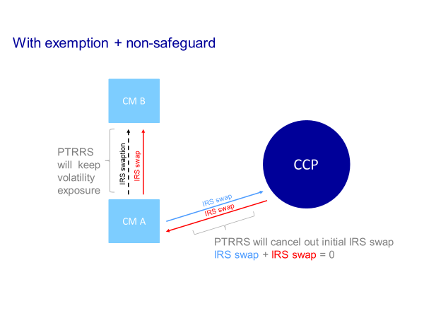

* + After concluding, for example, a swaption, youcreate a vanilla delta hedge which goes in your bilateral netting set (as now no longer subject to the CO) and then an opposite delta hedge cleared at the CCP – this is argued to keep the same number of trades in the CCP. While this is possible, we find this scenario particularly complex and unlikely, as it creates more trades and would likely result in hikes in Initial Margin requirement until the next compression cycles, which would defeat the very purpose of PTRRS which is to simplify trades and diminish capital/margin costs for market participants.
  + This is why the opposite delta hedge entered into the CCP would be immediately netted (terminated) against an opposite vanilla trade in the cleared portfolio, essentially **extracting vanilla trades already cleared in the CCP**. Note that most proponents insist that the PTRRS be able to pre-compress the trades facing the CCP to avoid IM hikes and thereby leaving no risk to be centrally cleared.
  + We believe in practice it would be very hard for supervisors to run through the bilateral and cleared books, leading to **possible regulatory arbitrage**. Exempting PTRRS from the clearing obligation may open the market into trading practices and structures that aim to take advantage of this treatment by entering a complex trade in order to extract vanilla trades already cleared through CCPs. This risks opening another loophole in the post-crisis reforms, against the alleged objectives of such an exemption.
* **Question (ii)** – yes, the trade would be netted, though we note that market participants could have decided to net both trades in the CCP, so we do not see the need for a clearing exemption.

<ESMA_QUESTION_PTRR_11>

1. : Please provide data (number of trades and notional compressed, amount of initial margin reduction, number of counterparties regularly using PTRR services, other metrics) per type of PTRR service, with as much granularity as possible (per entity, per asset class/currency, per run, over the years and over the past year, etc.) and the related explanations on how PTRR services are used.

<ESMA_QUESTION_PTRR_12>

* As mentioned above, within CCPs, the risk reduction described under portfolio compression for cleared trades – which does not change the underlying sensitives to the trading book – happens automatically.
* Like other CCPs, Eurex Clearing regularly performs compression activities for cleared trades, which are beneficial in terms of resource optimisation, operational risk and the default management process.
* Between end 2018 and end 2019, there were 5 compression cycles completed at Eurex Clearing, including up to 12 members participating per run and a total compressed notional of EUR 7.1 tn.
* However, as stated in our answer to the following question, we believe that ESMA should also take into consideration the data collected by Trade Repositories and other sources like regulatory reporting from ISDA SIMM.

<ESMA_QUESTION_PTRR_12>

1. : Please also, where possible, provide data whether those numbers would be expected to change if there was an exemption to the clearing obligation.

<ESMA_QUESTION_PTRR_13>

* While Eurex does not have access to data for the broader market, ESMA could look at data collected by Trade Repositories, ISDA SIMM and its own scenarios.

<ESMA_QUESTION_PTRR_13>

1. : Do you think an exemption from the clearing obligation for transactions resulting from PTRR services would increase the use of PTRR services? Please explain.

<ESMA_QUESTION_PTRR_14>

* As PTRRS have significantly grown over the past ten years, we do not believe the clearing obligation on the delta hedges of swaptions to have hampered the use of those services.

<ESMA_QUESTION_PTRR_14>

1. : Do you think an exemption from the clearing obligation is not needed for legacy portfolios and PTRR services generally? To what extent can the use of plain vanilla transactions in PTRR services be replaced with the use of non-plain vanilla transactions, or should this be avoided? Please explain.

<ESMA_QUESTION_PTRR_15>

* As mentioned in Q14, we do not think that trades resulting from PTRRS need to be exempt to support the growth of those services.
* In general, not granting an exemption was done intentionally to disentangle the highly standardized trades for central clearing from the more complex exotic trades to be dealt with under the bilateral margin rules as per the G20 Reforms.
* Regarding legacy trades, it is our understanding that all trades concluded prior to the clearing obligation can already be compressed today in the EU using portfolio compression services. However, new trades cannot be used to change the nature of the exposure of portfolios composed of old trades and be exempt from the clearing obligation.
* While a number of jurisdictions – Canada, Hong Kong, Singapore and Australia – have decided to clarify that legacy trades prior to the clearing obligations are exempt, no major jurisdiction has opted for an outright exemption from the clearing obligation of new trades resulting PTRRS. This is notably the approach followed by the US, where there is a “no action relief” letter from the CFTC exempting new swaps resulting from multilateral compression exercise if the original swap was executed prior to the applicable compliance date of the clearing requirement, and a new proposal that, under the uncleared margin requirements, legacy trades can retain their status following compression cycles. The CFTC has specifically not accepted lobbying in the past that proposed a broader exemption of the kind proposed presently to ESMA.
* As outlined in our answer to Q5, delta hedges to swaptions can also be done via complex exotic trades, rather than via simple vanilla trades. While such trades are indeed riskier than plain vanilla trades, they are not riskier than the swaption they were hedging in the first place. If some believe that there are such high financial stability concerns with swaptions and their exotic hedges, we would recommend reconsidering the decision to undertake such trades. We understand that the real issue behind using a complex set of trades to hedge an exotic trade is the overall capital and collateral impact this has on the broker – again we understand this was done intentionally to incentivize the use of less risky vanilla trades.



* Another option to the exotic hedge for swaptions would be to clear both the swaption and its vanilla hedge into the same cleared netting set, which out of the three option is by far the less risky and the most efficient in terms of capital.



<ESMA_QUESTION_PTRR_15>

1. : Would an exemption to the clearing obligation contradict the G20 commitments? Please explain.

<ESMA_QUESTION_PTRR_16>

* Yes. As outlined in Q9, the **current proposal to exempt vanilla trades resulting from PTRRS would weaken the clearing obligation itself** (as de facto less exposure would be covered by central clearing), **but also the incentives to clear** (as there would then be a cheaper option to hedge the swaption in the bilateral space).
* We ask **regulators to duly consider the impact of shifting such trades into the bilateral space** and no longer benefit from the stabilising effects of central clearing and the strict third-party risk management framework of CCPs.
* We consider such a **shift to be a substantial set back to the G20 reforms**, only ten years after a financial crisis which had exposed the deep weakness of opaque and uncleared derivatives markets.

<ESMA_QUESTION_PTRR_16>

1. : How could an exemption to the clearing obligation for PTRR trades lead to a circumvention of the clearing obligation? Please explain.

<ESMA_QUESTION_PTRR_17>

* As vanilla trades resulting from PTRRS would be exempt from the clearing obligation, less trades would be subject to the clearing mandate, thereby weakening the ‘obligation’ in itself and the G20 objectives.
* As outlined in Q1 and Q11, we are also concerned that this would open up significant possibilities for regulatory arbitrage and ‘clever’ trading to extract trades already present in cleared portfolios, to bring them back in the uncleared space. Even without such a form of de-clearing, the exemption would create a situation where whatever risk was entered into bilaterally dictates clearing.
* The potential for a circumvention of the clearing mandate – i.e. using PTRRS to extract trades cleared within a CCP – would then be basically limited to the amount of vanilla trades cleared in CCPs.
* Instead of supporting clearing, the end result would be to have the exact same number of vanilla trades in the bilateral space and in the CCP (before the opposite trade is netted/terminated), but the entire underlying risk being managed in the bilateral portfolio.

<ESMA_QUESTION_PTRR_17>

1. : Would you consider introducing an exemption to the clearing obligation as an incentive not to clear transactions that technically are covered by the clearing obligation. If yes, why?

<ESMA_QUESTION_PTRR_18>

* As outlined in Q5, exempting vanilla trades resulting from PTRRS would act as a disincentive to clear as there will now be a much cheaper option to hedge the swaption in the bilateral space as we expect many market participants would prefer not to clear, instead of supporting a shift to the cleared space.

<ESMA_QUESTION_PTRR_18>

1. : Are there risks with reducing collateral? Even if complying with regulatory requirements, could this lead to such capital being used to increase risks, possibly systemic risks?

<ESMA_QUESTION_PTRR_19>

* We find this question unclear as we understand capital to serve in a risk absorbing capacity. However, the proposed exemption is designed to reduce capital and collateralisation costs in bilateral portfolio management. As such, we would expect that any exempted trades are in the first instance placed into bilateral netting sets if and only if they reduce capital and collateral requirements for that trade relation. If this was not the case, there would have to be another benefit to the participants to shift trades to a more costly netting set.

<ESMA_QUESTION_PTRR_19>

1. : Are there other jurisdictions where PTRR trades have been exempted from the clearing obligation? Please explain the features of any such exemption. Do you use any of those exemptions, and for what type of trades?

<ESMA_QUESTION_PTRR_20>

* As highlighted in our response to Q15, we would like to highlight that in all the examples given – Canada, Hong Kong, Singapore and Australia – the local regulators have decided to clarify that **only legacy trades** prior to the clearing obligations are exempt. This is a typical exemption granted to ensure that notional reduction is still incentivised for bilateral trades. It is completely different to an on-going and forward-looking exemption from the clearing obligation.
* However, **no major jurisdiction has opted for an outright exemption from the clearing obligation of new standardized trades resulting PTRRS**. This is notably the approach followed by the US, where there is a “no action relief” letter from the CFTC exempting new swaps resulting from multilateral compression exercise if the original swap was executed prior to the applicable compliance date of the clearing requirement, and a new proposal that, under the uncleared margin requirements, legacy trades can retain their status following compression cycles.

<ESMA_QUESTION_PTRR_20>

1. : Should conditions, similar to the ones as outlined above, apply to a possible exemption under EMIR for PTRR transactions? Should other conditions apply? Would the answer depend on the type of PTRR service? Please explain.

<ESMA_QUESTION_PTRR_21>

* The conditions outlined do not in our view influence the primary intention or risks created by the exemption. As described in our previous responses, the proposed exemption reverses the incentive structure of the primary OTC derivative reforms. The conditions listed do not affect this, and thus their relative merits or demerits are only relevant for other aspects of possible concern with PTRRS exemptions.
* Condition 1 – If trades are vanilla after compressing trades limited to the uncleared space, it shows how much ‘vanilla risk’ is still present in uncleared portfolios, and that the G20 objectives of untangling standardized risk which should be cleared from more exotic types of risk have not been fully achieved.
* Conditions 2 – we believe that a higher number of participants involved does not in itself respond to the risk having vanilla trades moved back to the uncleared space. Such risk remains the same if two or more participants are involved.
* Condition 3 – as the aim of PTRRS is to reduce overall risk and exposure, we do not see how this condition could help supervisors avoid such regulatory arbitrage.
* Condition 4 – while we note that this condition could help avoid PTRRS becoming new brokerage services, we do not find it helpful to address the risks of circumventing the clearing obligation.
* Condition 5 – We believe the question of authorisation and supervision of PTRRS – albeit valid considerations given their key roles in post-trading – is not helpful in the context of granting an exemption from the clearing obligation (as exempting the trade would then be legal).

<ESMA_QUESTION_PTRR_21>

1. : Is there a difference between bilateral and multilateral portfolio compression justifying an exemption to the clearing obligation only to apply for multilateral portfolio compression?

<ESMA_QUESTION_PTRR_22>

* While we note that the more participants involved, the more the sensitivity threshold of the service would be set to the best common denominator to net trades, we do not believe that differentiating bilateral vs. multilateral portfolio compression would help limit the risk of regulatory arbitrage. A pure bilateral ability to exempt would however mean that an individual firm could select which trades to clear or not. We do not believe that a higher number of participants involved does not in itself respond to the risk having vanilla trades moved back to the uncleared space.
* Moreover, as proponents of an exemption understand the multilateral criteria to be reached as from 2 counterparties and a CCP, we would not see value in using this condition as a criterion to allow vanilla trades to be exempted.

<ESMA_QUESTION_PTRR_22>

1. : Should only uncleared transactions be included in portfolio compression in order to qualify for the clearing exemption? How would a possible limitation to uncleared transactions limit the effectiveness?

<ESMA_QUESTION_PTRR_23>

* We are uncertain how this condition could be helpful, as cleared trades are also compressed.
* The aim of the said exemption is to allow vanilla trades to hedge complex trades to stay in the uncleared space and be compressed in order to reduce bilateral and capital requirements.
* Instead, calling for vanilla trades to be exempt from clearing for compressing uncleared trades, only shows is that ‘vanilla risk’ is still present in uncleared portfolios, and that the G20 objectives of untangling standardized risk which should be cleared from more exotic types of risk has not been achieved.

<ESMA_QUESTION_PTRR_23>

1. : To benefit from an exemption to the clearing obligation, should PTRR trades be strict risk neutral or should there be tolerances for small changes in the risk of portfolios? How would you define what is an acceptably small change in risk?

<ESMA_QUESTION_PTRR_24>

* As the aim of PTRRS is to reduce overall risk and exposure, we do not see how this condition could help supervisors avoid such regulatory arbitrage.
* In the example of provided above, the compression trade with the CCP exactly offsets the vanilla trade currently cleared in the CCP. Therefore, even if the PTRR cycle was risk neutral, this would not prevent the vanilla trade from being extracted away from the CCP.

<ESMA_QUESTION_PTRR_24>

1. : To benefit from an exemption to the clearing obligation, to what extent should parties to a PTRR exercise be able to be changed, i.e. not limited to the original counterparties? Would the answer depend on the type of PTRR service? Please explain.

<ESMA_QUESTION_PTRR_25>

* While we note that this condition could help avoid PTRRS becoming new brokerage services, we do not find it helpful to address the risks of circumventing the clearing obligation.

<ESMA_QUESTION_PTRR_25>

1. : Should there be a requirement for PTRR services to reduce risk for a clearing exemption to apply? Should it apply to all PTRR services? If not, please explain why. How would a successful PTRR exercise be measured?

<ESMA_QUESTION_PTRR_26>

* As reducing risk is the basic principle of PTRRS, we do not see how such condition could be helpful.

<ESMA_QUESTION_PTRR_26>

1. : Could PTRR services increase exposure or risk on a participant basis? Would the answer depend on the type of PTRR service provided? How should the PTRR service provider limit any possible increase in notional amount or risk? Please explain.

<ESMA_QUESTION_PTRR_27>

* Yes, overall reduction could lead to individual increase.

<ESMA_QUESTION_PTRR_27>

1. : How could a limitation like “no participant worse off” be defined?

<ESMA_QUESTION_PTRR_28>

* If the intention is the reduction of capital and collateral costs for maintaining bilateral OTC derivative portfolios, then a plausible definition would be that all participants in the cycle manage to lower their capital and collateral costs. For the avoidance of doubt, we do not consider that such a condition could not prevent standardized vanilla trades from being moved away from the clearing mandate, although it may influence the selection process for permission to participate in such PTRRS runs.

<ESMA_QUESTION_PTRR_28>

1. : How should it be ensured that PTRR service providers are independent in their assessment? Should the conditions imposed on the providers of PTRR services include requirements on governance of the algorithms to ensure the definition and the setting of parameters takes place with minimum influence from market participants? Should algorithms run with minimum manual intervention? Any other conditions or structural requirements that should apply?

<ESMA_QUESTION_PTRR_29>

* As we understand market participants set their preferred tolerance levels through a paid service, we are unsure how the independence of the services could be guaranteed. We believe the question of authorisation and supervision of PTRRS – albeit valid considerations given their key roles in post-trading – is not helpful in the context of granting an exemption from the clearing obligation (as exempting the trade would then be legal).

<ESMA_QUESTION_PTRR_29>

1. : Do you consider that a PTRR service provider should be specifically licenced or authorised? Would this depend on the remits of the services provided? Would it be sufficient to provide requirements on the service provided, i.e. on transaction level rather than entity level? What do you see as the benefits of regulating PTRR services? Would this create any impediment or barriers?

<ESMA_QUESTION_PTRR_30>

* While we would see some benefits in having more scrutiny of PTRRS providers, we do not think that this requirement on entity level would address the risk of exempting vanilla trades from the clearing obligation. We believe such measures on a transaction level to be extremely impractical and subject to regulatory arbitrage.

<ESMA_QUESTION_PTRR_30>

1. : What would be the cost-benefit of exempting PTRR transactions (replacement and risk mitigation services through offsetting trades such as rebalancing) from the clearing obligation?

<ESMA_QUESTION_PTRR_31>

* As outlined above, we consider the cost-benefit to be one similar to the original QIS for the clearing obligation. We would suggest that the ESRB and ESMA employ their quantitative sources to evaluate the degree of more standardised risk that currently resides in bilateral portfolios, and the level of capital this currently attracts, and would attract under the exemption.
* In our perspective, the risks outlined in this response significantly outweigh the alleged benefits from exempting trades resulting from PTRRS, as the pick up of PTRRS has not been hindered by the existence of the clearing obligation.
* Such an exemption could also have the benefit for firms that they could select which global booking hub to use for their trades, as their ability to conduct back-to-back trades would not be localised by clearing obligation and CCP availability or recognition.

<ESMA_QUESTION_PTRR_31>