**Clarus Financial Technology** welcomes the opportunity to respond to the ESMA Consultation Paper on MiFID II/ MiFIR review report on the transparency regime for non-equity and the trading obligations for derivatives.

Analysis of Post-Trade Transparency in USD Markets during 2020

Pertaining to the ESMA consultation on pre- and post-trade transparency, we find that an analysis of liquidity conditions in OTC derivatives for US markets is relevant to many areas of the consultation.

Whilst it is possible to include some of this analysis in direct response to consultation questions (see for example our responses to Questions 1 and 11), it is not possible to provide an overall view of liquidity conditions as set out in this Annex.

We find that the current transparency regime in the US has had the following effects during particularly volatile market conditions in March 2020:

* A single deferral delay, applied only to large trades, has given market participants confidence that they know what is happening in OTC derivative markets at any point in time.
* Post-trade transparency improved the resilience of OTC derivative markets during stressed market conditions, with market participants drawing confidence from hard data relating to actual volumes and prices trading. There was clear evidence as a result of post-trade transparency (with almost no delay) that markets were not “seizing up” at any point.
* Liquidity conditions, as measured by Price Dispersion, have been the same for both normal sized trades and those above the block threshold. There was no discernible difference in these liquidity conditions either during March 2020 or over 2020 to –date.
* There is no evidence that market participants avoided executing block-size trades during volatile markets. In fact, the percentage of block trades executed on-SEF increased during March 2020. This is clear evidence that a single deferral of 15 minutes suits both liquidity providers and market participants more broadly.
* There is no evidence that the block thresholds, as currently calibrated to mask ~50% of traded notional per month, have motivated market participants to actively avoid the execution mandate. About 50% of notional has consistently been above the block threshold since the AMBS were originally calibrated.

The current transparency regime in the US is found to have no negative impacts on the ability of market participants to hedge risk. This is demonstrated using a statistical analysis of price dispersion (a liquidity measure) in USD interest rate swaps during 2020.

Liquidity in Stressed Market Conditions  
Clarus used post-trade transparency data from Swap Data Repositories (SDRs) to analyse the quality of execution for block trades and trades above the Appropriate Minimum Block Size (AMBS). Our analysis uses prices for 10y spot starting USD IRS during 2020 to show that liquidity is identical for swaps both above and below the AMBS. This provides clear, statistical evidence that the current transparency regime in the US is working. Specifically, a single deferral regime of 15 minutes, even for extremely large trades, has no negative impact on the ability of market participants to execute trades, both large and small.

ClarusFT use a widely-acknowledged measure of liquidity conditions called Price Dispersion. This measure was first introduced to us by a Bank of England staff working paper researching liquidity conditions for SEF execution.[1]

The methodology for measuring liquidity conditions in this way can be summarised mathematically as;

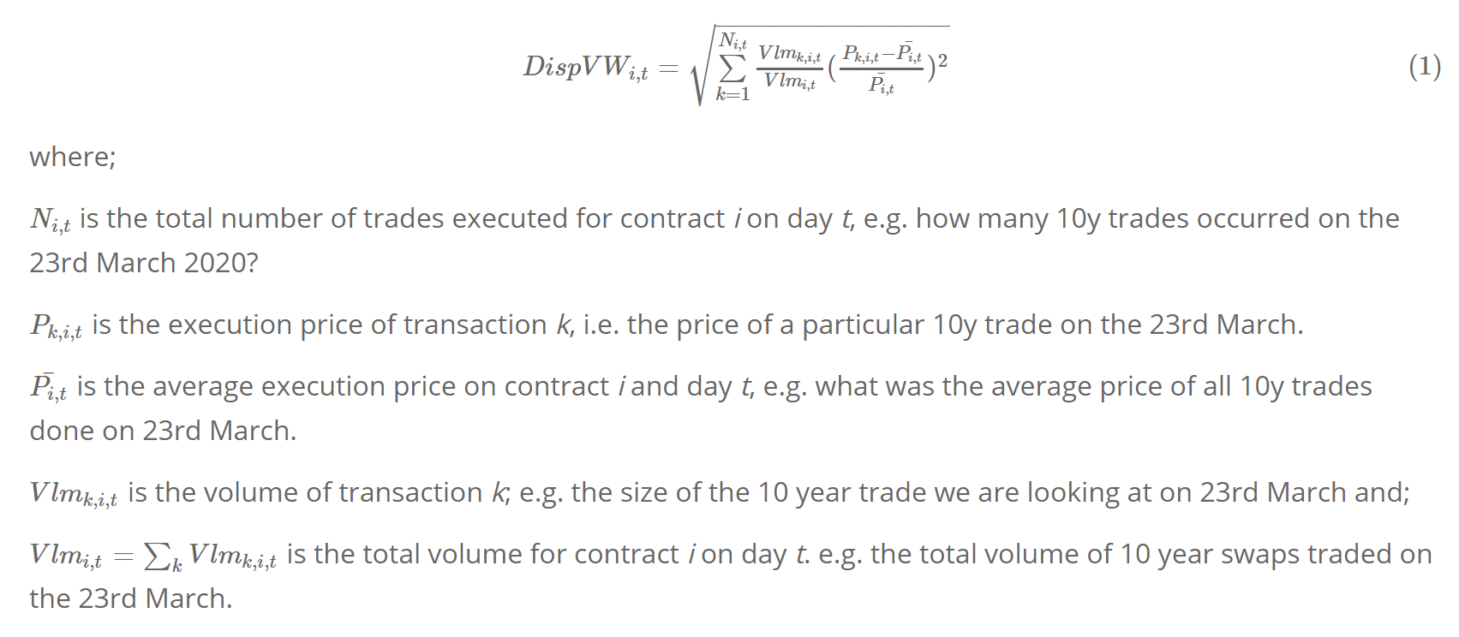

We have received positive feedback from market participants that this is a reliable and informative measure of liquidity conditions.

Using SDR data to perform the analysis on vanilla, spot starting 10Y USD Fixed-Float swaps (an instrument described by the Bloomberg ticker “USSW10”), shows that Price Dispersion for large swaps above the AMBS and all other swaps has been almost identical during 2020:

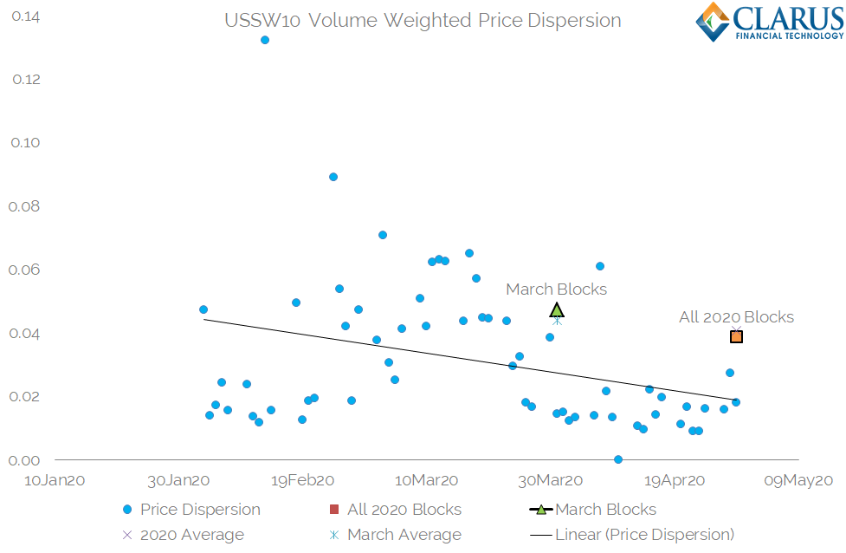

*Price Dispersion of USSW10 in 2020  
Source:* [*https://www.clarusft.com/cftc-block-trading-consultation-may-2020/*](https://www.clarusft.com/cftc-block-trading-consultation-may-2020/) *and* [*sdrview.clarusft.com*](https://sdrview.clarusft.com/)

Showing;

* Daily Price Dispersion for 10 year spot-starting USD IRS executed on-SEF during 2020.
* The average Price Dispersion for all trades during 2020 was 0.041 basis points.
* The average Price Dispersion for Block and Capped Notional Trades in 2020 was 0.039 basis points.
* Similarly, for March 2020 alone, the Price Dispersion for all trades was 0.044 basis points.

The average Price Dispersion for Block trades in March 2020 was 0.047 basis points.

Deferrals  
Introducing more than a single 15 minute delay for the reporting of any transaction leads to a severe negative impact on price discovery and market transparency. This is because market participants need certainty that they are receiving the full information regarding a market. In the event that multiple delays are introduced, the utility of any information published prior to the longest possible delay becomes very close to zero. This is especially true when the delays relate to a significant overall volume of the market. We see this with European MIFID II post-trade transparency in Europe.

Current Volumes in Large Swaps  
Analysing the current bock trading regime in the US, we find that block trades in USD swaps are currently **34% larger** than their total size reported to SDRs. Across the “super currencies” (USD, EUR, JPY and GBP), the average total size of a SEF-executed swap is 30% larger than that reported to SDRs:

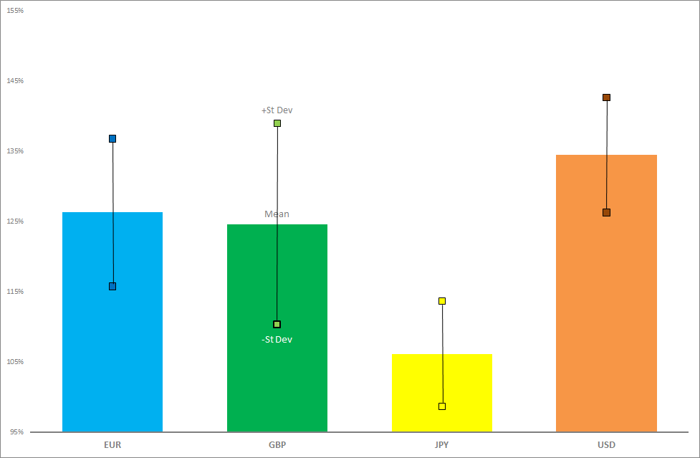

*Calibration of Part 43 SDR data for On-SEF executed Fixed Float Swaps versus Part 16 SEF volume data for 2018-2019.  
Sources:* <https://www.clarusft.com/block-trading/> *,* [*sdrview.clarusft.com*](https://sdrview.clarusft.com/) *and* [*sefview.clarusft.com*](https://sefview.clarusft.com/)*.*

Overall, the current calibration of the AMBS means that 43% of notional transacted on-SEF is a large swap above the notional reporting threshold. The volumes above the AMBS consistently make up 35-52% of total notional amounts per month:

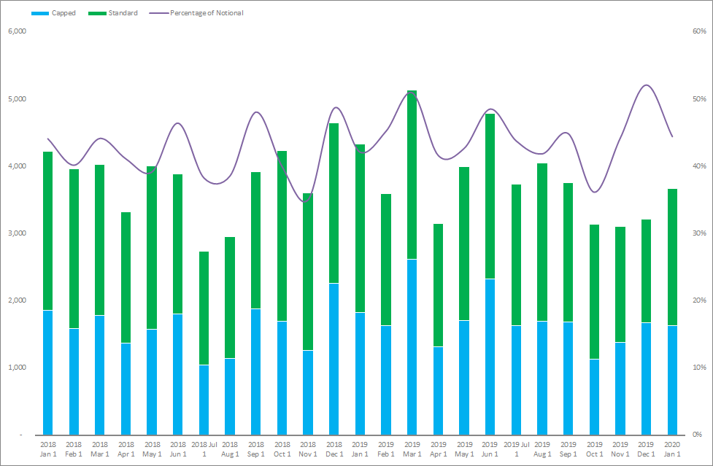

*Calibration of Part 43 SDR data for On-SEF executed Fixed Float Swaps versus Part 16 SEF volume data for 2018-2019.  
Sources:* <https://www.clarusft.com/block-trading/> *,* [*sdrview.clarusft.com*](https://sdrview.clarusft.com/) *and* [*sefview.clarusft.com*](https://sefview.clarusft.com/)*.*

This data set alone suggests that:

* The original calibration of the AMBS was accurate and that we still see almost 50% of notional transacted as “large” trades that benefit from some degree of deferral.
* Therefore, market behaviour has not changed since the AMBS were calibrated. Market participants are not avoiding moving large sizes of risk as a single trade.
* By extension, liquidity providers continue to service these large packets of risk in a very similar way to prior to the advent of post-trade transparency.

These are very positive signs for the current transparency regime and do not present any evidence that longer deferrals are warranted.

Large Swap Trading during March 2020  
The success of the current regime in the US can be further evidenced by the resiliency shown in the markets during the recent volatility in March 2020. Interest Rate Derivative markets saw all-time record volumes transacted during March 2020, in particular for USD interest rate swaps:

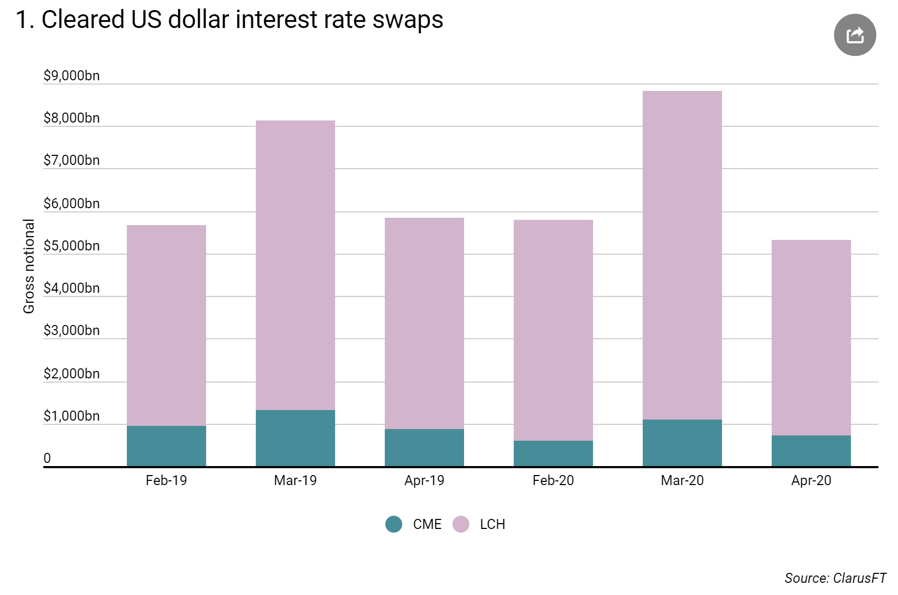

*Notional of cleared USD Fixed Float swaps reported by CCPs.   
Source:* <https://www.clarusft.com/swaps-data-record-trading-volumes-in-march/> *and* [*ccpview.clarusft.com*](https://ccpview.clarusft.com/)

The volumes above are for global cleared markets. We also saw volume records in US markets. In terms of the block regime in the US, it is notable that these volume records were driven by record amounts of large sized trades being transacted. March 2020 saw a record number of large swaps above the AMBS reported to the SDRs in USD Fixed-Float swaps:

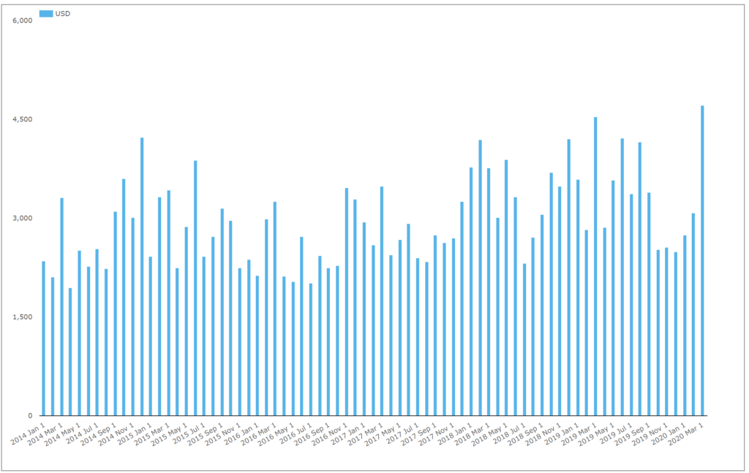

*Number of “block” and capped notional USD Fixed Float trades reported to SDRs.   
Source:* [*https://www.clarusft.com/cftc-block-trading-consultation-may-2020/*](https://www.clarusft.com/cftc-block-trading-consultation-may-2020/) *and* [*sdrview.clarusft.com*](https://sdrview.clarusft.com/)

Showing;

* March 2020 saw an increase in the number of trades above the AMBS reported of nearly 4% compared to the previous record month, March 2019.
* This is surely a good sign for how large amounts of risk can be transacted, even during stressed market conditions.
* It is also important to note that the number of capped notional trades transacted each month has generally increased in USD Swaps since reporting began. This is not just a facet of extremely volatile markets causing huge demand for large trades.

This shows that a single deferral period of just 15 minutes is highly effective in providing both post-trade transparency and in facilitating the trading of large amounts of risk.

On-SEF Trading during 2020  
Further, this huge amount of risk being transacted above the AMBS is not a reflection of market participants attempting to avoid the execution mandate. Whilst these large trades may have been eligible for off-SEF execution, Part 16 data shows that the volume of USD Fixed Float swaps transacted on-SEF was larger than in previous months during 2020:

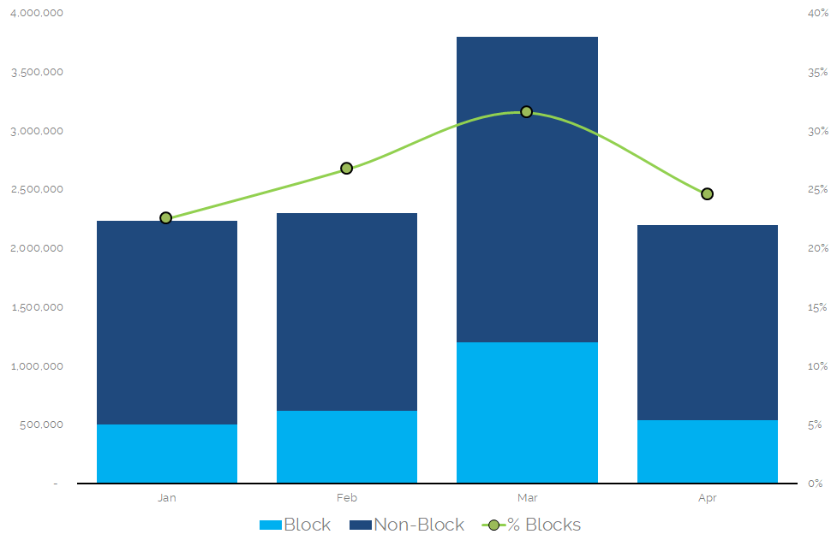

*Volume of USD Fixed Float swaps executed on-SEF  
Source:* [*https://www.clarusft.com/cftc-block-trading-consultation-may-2020/*](https://www.clarusft.com/cftc-block-trading-consultation-may-2020/) *and* [*sdrview.clarusft.com*](https://sdrview.clarusft.com/)

Showing;

* Notional volumes of USD IRS executed on-SEF in 2020.
* In March, 32% of total volume was executed as a block trade across just two platforms – Tradeweb and BBG.
* Both of these are RFQ D2C SEF platforms.

Summarising Our Review of Transparency in US Markets  
Data for the current transparency regime in the US strongly argues that there are no negative impacts being caused by a single deferral of 15 minutes for post-trade data.

This contrasts with the negatives that result from extended deferrals and a complex deferral regime, as seen for post-trade transparency data in Europe. European data is widely unusable. Due to the presence of four week delays for the majority of the data[2] there is currently insufficient post-trade transparency in Europe. Post-trade transparency has the most utility when it is made available in a timely manner, unencumbered and standardised. This is not the case in Europe and means that no market participant is able to gain any value from the data – market participants do not even use the data.

The current transparency regime in the US confers huge benefits to all market participants. These include, but are not limited to, improved price discovery, market understanding and resiliency of markets. ClarusFT are strong advocates[3] that transparency helps markets function better, and that this was a key component of the proven market resilience during recent, highly stressed market conditions.

The Transparency Regime in the US is Working  
This document has presented strong statistical evidence that the current transparency regime is working. This is demonstrated across:

* Volumes. Record volumes are repeatedly recorded across the markets we monitor.
* Block trades. Under the most stressful market conditions in recent memory, more block trade were executed in USD swaps during March 2020 than ever before.
* Liquidity. Block and other large swaps have performed almost identically in terms of Price Dispersion during 2020 when compared to smaller trades.

The Transparency Regime in the US Could Still be Improved  
With that stated, we believe that extra transparency could be provided for large trades in the US. Currently, capped notional amounts are disclosed 15 minutes after execution, whilst the full volume is disclosed at an instrument level T+1 for SEF executed trades. We would like to see the discrepancy between On-SEF and Off-SEF trades removed and total volumes all disclosed at the same time. We believe that this would provide market participants with clearer signs of liquidity and removes information asymmetry. During crisis times, it provides even greater reassurance that markets are not “seizing up”.

Finally, we believe that all transactions should be reported in real-time, regardless of asset class or “liquidity” considerations (very large trades aside). Taking an example of CHF interest rate swaps, these instruments must be closely monitored during the planned transition away from LIBOR and to Risk Free Rates. CHF interest rate swaps provided a great test case for markets when the original OIS index was deprecated (TOIS) and replaced with the RFR, SARON[4]. Being able to monitor these changes via the lens of post-trade transparency is crucial. We believe that this market, for example, would fail tests of “liquidity”, leading to unhelpful deferrals. Deferring all trades in a given currency will severely impact the confidence and understanding that market participants have for these markets. If a market participant looks to see the activity today in a given currency and sees zero, what confidence does that provide in current market conditions to be able to execute any size of risk? It would be hugely detrimental to price discovery, transparency and investor confidence to set defer all data for any given market. Deferrals threaten to reduce all of the benefits we now have in markets as a result of the post-GFC derivative reforms.

1. Staff Working Paper No.580 <https://www.bankofengland.co.uk/-/media/boe/files/working-paper/2018/centralized-trading-transparency-and-interest-rate-swap-market-liquidity-update>
2. <https://www.clarusft.com/what-we-need-to-do-to-fix-mifid-ii-data/>
3. <https://www.clarusft.com/is-transparency-helping-markets-function/>
4. <https://www.clarusft.com/we-found-the-chf-saron-swaps/>