4 February 2020

Reply form for the Consultation Paper on MiFID II/ MiFIR review report on the transparency regime for equity and equity-like instruments, the DVC and the trading obligations for shares

Date: 4 February 2020
Responding to this paper
The European Securities and Markets Authority (ESMA) invites responses to the specific questions listed in the Consultation Paper on the transparency regime for equity and equity-like instruments, the double volume cap mechanism and the trading obligations for shares MiFID II/ MiFIR review report published on the ESMA website.

Instructions
Please note that, in order to facilitate the analysis of the large number of responses expected, you are requested to use this file to send your response to ESMA so as to allow us to process it properly. Therefore, ESMA will only be able to consider responses which follow the instructions described below:
- use this form and send your responses in Word format (pdf documents will not be considered except for annexes);
- do not remove the tags of type <ESMA_QUESTION_CP_MIFID_EQT_1> - i.e. the response to one question has to be framed by the 2 tags corresponding to the question; and
- if you do not have a response to a question, do not delete it and leave the text “TYPE YOUR TEXT HERE” between the tags.
Responses are most helpful:
- if they respond to the question stated;
- indicate the specific question to which the comment relates;
- contain a clear rationale; and
- describe any alternatives ESMA should consider.

Naming protocol
In order to facilitate the handling of stakeholders’ responses please save your document using the following format:
ESMA_CP_MiFID_EQT_NAMEOFCOMPANY_NAMEOFDOCUMENT.
e.g. if the respondent were ESMA, the name of the reply form would be:
ESMA_CP_MiFID_EQT_ESMA_REPLYFORM or
ESMA_CP_MiFID_EQT_ANNEX1

Deadline
Responses must reach us by 17 March 2020.
All contributions should be submitted online at www.esma.europa.eu under the heading ‘Your input - Consultations’.

Publication of responses
All contributions received will be published following the end of the consultation period, unless otherwise requested. Please clearly indicate by ticking the appropriate checkbox in the website submission form if you do not wish your contribution to be publicly disclosed. A standard confidentiality statement in an email message will not be treated as a request for non-disclosure. Note also that a confidential response may be requested from us in accordance with ESMA’s rules on access to documents. We may consult you if we receive such a request. Any decision we make is reviewable by ESMA’s Board of Appeal and the European Ombudsman.

Data protection
Information on data protection can be found at www.esma.europa.eu under the headings ‘Legal notice’ and ‘Data protection’.

General information about respondent
Name of the company / organisation | Cboe Europe
Activity | Regulated markets/Exchanges/Trading Systems
Are you representing an association? | ☐
Country/Region | Europe

Introduction
Please make your introductory comments below, if any:

<ESMA_COMMENT_CP_MIFID_EQT_1>
The following correspondence is a response to the European Securities and Markets Authority (“ESMA”) Consultation Paper (“CP”) regarding provisions of MiFID II and MiFIR, as published on your website on the 4th of February 2020.
As the CP addresses a wide range of issues, we have limited our response to the items for which we wish to provide specific feedback on, rather than the CP in its entirety.

By way of an introduction, Cboe Europe (Cboe) is one of the largest pan-European equities exchanges by market share and value traded. Cboe operates lit and dark books, a periodic auction and a large in scale service for European equities trading. Cboe Europe is the brand name of Cboe Europe Limited, a subsidiary of Cboe Global Markets Inc., which is a leading operator of equity, futures and options, and FX markets in the U.S. and Europe. Cboe Europe is a Recognised Investment Exchange regulated by the UK Financial Conduct Authority (“FCA”). Cboe Europe recently established a new entity in the Netherlands, Cboe Europe B.V., and is authorised there as a Market Operator and Approved Publication Arrangement.

Cboe supports open competition and strives to drive innovation in the European equities markets.

Full details about Cboe Europe, the services it offers and how it operates can be found on our website at: http://markets.cboe.com/europe/equities/
<ESMA_COMMENT_CP_MIFID_EQT_1>

- What is your view on only allowing orders that are large in scale and orders in an order management facility to be waived from pre-trade transparency while removing the reference price and negotiated trade waivers? Instead of removing the RP and NT waivers, would you prefer to set a minimum threshold above which transactions under the RP and NT waivers would be allowed? If so, what should be the value of such threshold? What alternatives do you propose to simplify the MiFIR waivers regime while improving transparency available to market participants? Please explain.
<ESMA_QUESTION_CP_MIFID_EQT_1>
Cboe strongly disagrees. While we are supporters of good regulation, greater transparency and a level playing field, this proposal would be an extraordinarily damaging step that would restrict the number of execution options available to end investors. Having this choice is particularly important in times of extreme market stress, as we are seeing at the moment. Without the range of execution alternatives available, and the different types of liquidity against which to interact, the market swings that we are seeing would be even more pronounced and more damaging. If a more simplified market structure is the aim, we believe there are better ways this could be achieved.

As a general point, the ability to execute trades efficiently directly impacts investment strategies and, therefore, the performance of pensions and other savings plans. In our view, the promotion of choice and competition at all stages of the execution value chain is fundamental to an efficient trading ecosystem. That includes a range of execution options with levels of transparency that support different trading models and market conditions, with a competitive market for execution services by intermediaries, supported by a robust best execution regime to ensure that buyers and sellers are brought together efficiently. Cboe believes this ensures that investors receive the best possible outcome. We must remember that investors were poorly served by the monopolistic market structures that existed prior to MiFID I. Cboe’s view is that transparency is not a good in and of itself. It is important to the extent that it delivers the best possible outcome for investors and other end users of the markets. It is widely agreed that for large orders, transparency often puts best execution at risk. If ESMA were to propose the radical alterations to market structure discussed here only two years after the implementation of the current regime – and amid the current market stress - it would have to be based on genuine evidence of detrimental outcomes to investors. In our view, no such evidence exists and the reverse is the case.

Turning to the proposal to remove the reference price waiver specifically, this would eliminate a highly-valued execution option and is a move not supported by the data presented. The waiver is used to satisfy investor demand for urgent, low-impact midpoint executions, which are often the result of larger orders being broken up into smaller pieces and spread throughout the day so as not to adversely move prices. It should be noted that the use of the reference price waiver has already reduced since the introduction of MiFID II, as observed in chart 1 below. In any case, there was no evidence whatsoever that the levels of reference price trading seen under MiFID I were damaging.

Chart 1: Dark trading as % of total on-venue activity
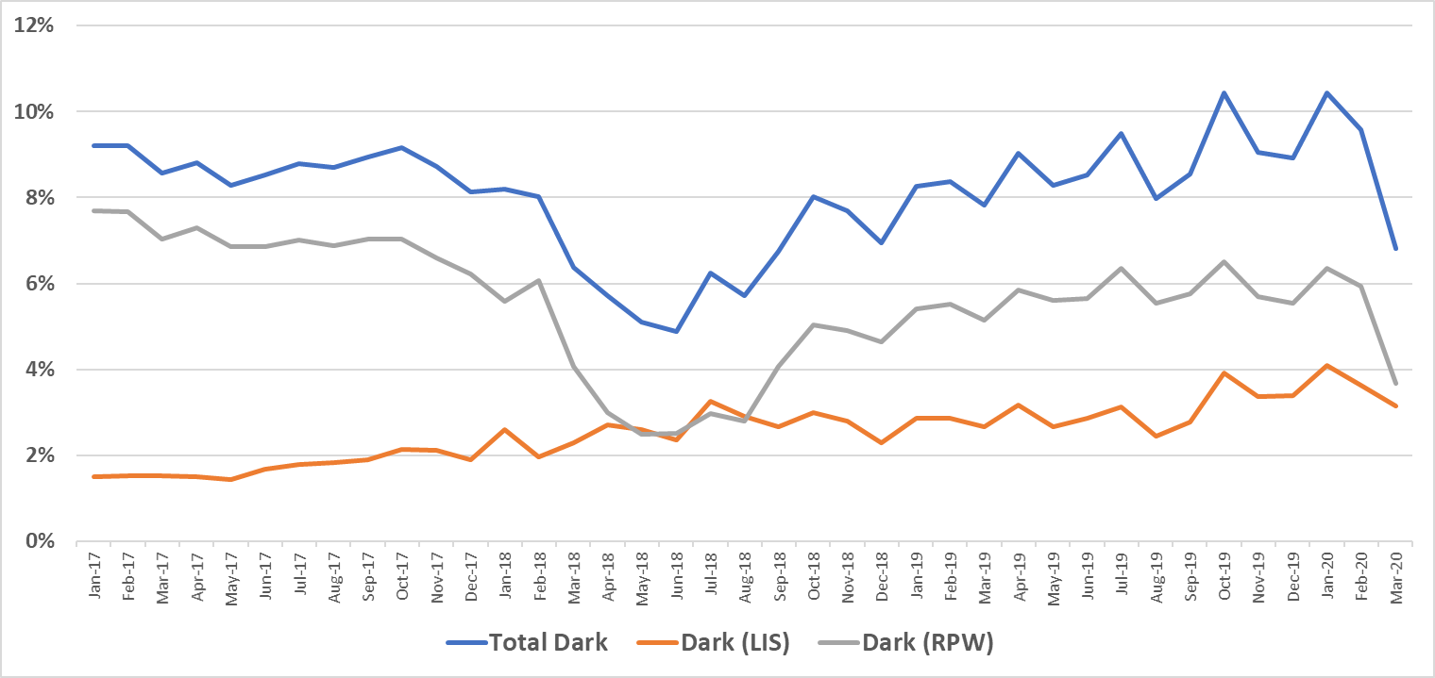Source: big xyt

The caps which reference price waivers already adhere to under MiFID II are already costing investors real money, by denying market participants access to an efficient execution alternative when suspensions are in place. Removal of the reference price waiver now would further damage European investors. Firms trading on reference books have already made a decision – for that order at least – to give up some of the spread as they would otherwise have rested at the BBO and waited to be executed against. Immediacy of execution has become more important than the half spread that they are giving up. Accordingly, we believe that it is reasonable to assume that, in the absence of reference price books, the submitting firm would instead be required to trade on the CLOB or with an SI at the EBBO, crossing the spread to get immediate execution. Any attempt to mitigate that cost by taking a blended passive and aggressive approach would reintroduce the risk of an adverse market movement for the passive element. Looking at 2019, if investors who traded on the dark reference price books at the midpoint were forced instead to trade at the European Best Bid or Offer (EBBO), it would have cost them in excess of €346 billion in explicit spread cost, and an additional €126.5 billion in market impact (calculated as the difference in price movement between lit order book and reference price books, 5 ms after a trade has taken place), as demonstrated in charts 2 and 3 below. Collectively this would have represented a cost of nearly €500 billion to European investors, and it is worth remembering that this was in 2019, a time of low market volume and volatility. If this option was taken away now that markets have become volatile, these costs would be much higher as investors have choice removed.

Chart 2: Spread cost (€) of RPW trading at EBBO instead of mid
Source: big xyt

Chart 3: Market impact cost (€) of RPW trading at EBBO instead of mid

Source: big xyt

Opponents of choice and competition in execution services often argue that a limit or even outright ban on reference price systems is desirable because, if left unchecked, volumes on reference price systems will continue to grow at the expense of lit venues until there is no more lit trading and therefore no price formation. In our view, this argument is flawed for three key reasons. First, it assumes that activity unable to take place under the reference price waiver would simply revert to lit markets, which is unlikely to be the case. Indeed, since the imposition of the DVCs, this has demonstrably not been the case. Lit venues are often regarded as venues of last resort given their high levels of market impact, so block venues, closing auctions and OTC markets could well be the beneficiary of flow diverted from reference price systems. It should be noted that ESMA has raised concerns over the latter two systems in this paper. Second, it implies reference price trading itself has weak price-forming characteristics. Cboe’s view is that price formation occurs whenever buyers and sellers agree a price, irrespective of the execution channel used. Use of a reference price system is just as valid an expression of a view on price as the use of any other multilateral system. Market participants know the inputs and take a positive decision to trade there. If they don’t want to trade at that price they can place a limit order on a lit book or participate in an auction. If they want immediate execution at a risk price they may go to an SI. All are as valid as one another when that choice is taken by informed intermediaries.

Third, as evidenced in the US, there is a natural ceiling to activity on reference price systems which prevents them from reaching levels that would be damaging to price formation on primary markets. It should be noted here that the FCA found in a 2017 study that dark trading is only damaging to price formation at a market share of over 15% - a level never reached under MiFID I nor possible under MiFID II. Reference price systems are only used to the extent that users positively agree with the quality of the input pricing. If lit books became so enfeebled that they were no longer useful sources of pricing data, then the reference price books would also be useless. Use of reference price systems is a healthy indicator of confidence in the price formation that takes place on the referenced books. Furthermore, there will always be those that require the immediacy of lit book execution and will be prepared to bear the costs of interacting there, and there will always be those that wish to express a price away from the current midpoint.

Indeed, the experience of markets in the US supports this point. We would note that the US market imposes no cap on the use of non-pre trade transparent venues and its lit exchanges continue to thrive. There has never been any suggestion that there is a problem with price formation, or indeed liquidity, in the US equity markets. Chart 4 shows that dark volumes in the US, having initially grown upon the introduction of these platforms, reached a natural upper limit and have fallen back since reaching that point. We have seen no evidence to suggest that European dark volumes would behave in a different way if left unchecked.

Chart 4: US dark ADV and market share
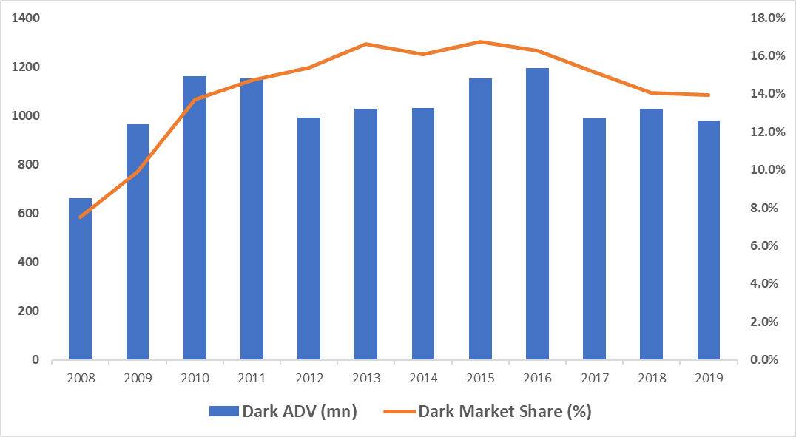
Source: Rosenblatt Securities
Note: US Dark ADV comprises Dark ATS and SDP systems

It is also important to stress that the data presented by ESMA on this point also fails to support the recommendations made. Figures 4, 5 and 6 in the CP illustrate that the mix of trading venue, OTC and SI volume varies depending on the liquidity of the instrument. This in and of itself merely confirms that a one-size-fits-all approach to market structure is inappropriate. However, the analysis provided is in any case flawed as it fails to drill down into the nature of OTC and on-venue trading, as we have done in the charts below.

The data presented in Figure 13 in the CP is particularly misleading in the way that it presents non pre-trade transparent trading, including all SI and OTC activity, along with all business conducted under a waiver. As demonstrated below, a majority of OTC and negotiated trade waiver business is technical in nature and is not appropriate for execution on a multilateral venue. It is not clear whether or not ESMA has included business conducted under the order management facility waiver, but if it has then this is not valid as this business has to be inserted into the lit book before it can be executed and therefore becomes pre-trade transparent. All SI business is subject to a pre-trade transparency regime, though that regime contains some exemptions for size and less liquid instruments. If it is ESMA’s belief that that regime requires amending, then those are the recommendations that it should be bringing forward.

The evidence as we see it suggests that there is no fundamental issue with the balance of trading between the available mechanisms.

Chart 5 shows the breakdown of all trading by mechanism since March 2018 with no filtering of non-addressable liquidity from the picture.

Chart 5: Breakdown of trading by execution mechanism – addressable and non-addressable
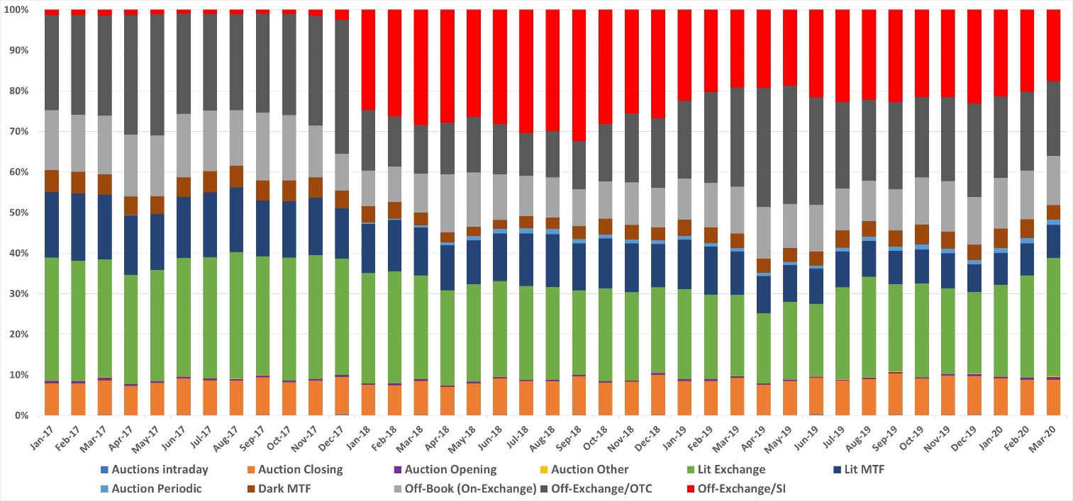
Source: big xyt

However, we believe that this fails to capture the meaningful split between mechanisms. Chart 6 removes OTC and SI business that is reported with the TNCP flag, and off-Book, on exchange business (negotiated trades) that is either above LIS or uses the PRIC flag to denote business that is non price forming.

Chart 6: Breakdown of trading by execution mechanism – addressable

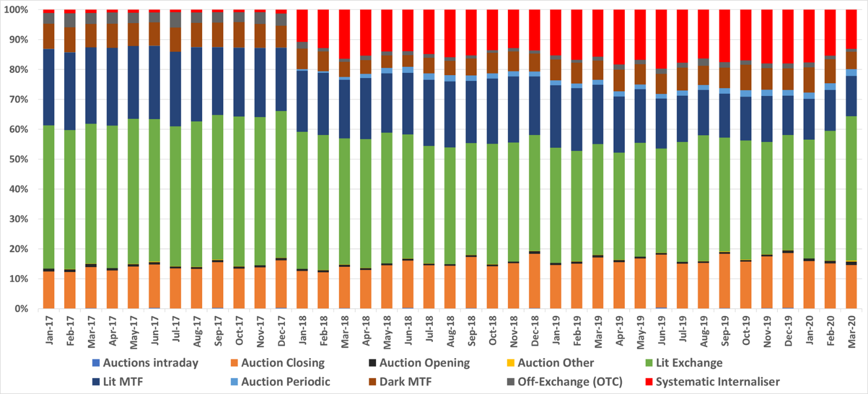Source: Cboe Europe, big xyt

This clearly demonstrates the ongoing dominance of lit mechanisms, particularly lit order books but also closing auctions and systematic internalisers, which are subject to mandatory pre-trade transparency under MiFID. If the suggestion is that these transparency requirements are not the right ones, then it is here that ESMA should recommend amendments, rather than removing categories of trading that provide genuine utility to market users.

With respect to the specific proposal to remove waivers, it is important to assess the actual current use of those waivers. Our data shows that the most used waivers continue to be LIS (see Chart 7), and we agree with ESMA that there is no case to remove this.

Chart 7: Waiver use

Source: big xyt

While we broadly agree with ESMA’s analysis of waiver use in Figure 2 of the CP – (our analysis doesn’t cover order management facility use as this is not transparent on market data) – we believe that the analysis is fundamentally lacking to the extent to it fails to provide further detail on the nature of waiver use, particularly with respect to the negotiated trade waiver. We would note that the vast majority of negotiated trade waiver use is flagged as PRIC, which denotes business that does not contribute to price formation. This has increased since the introduction of MiFID II, but there are two principle reasons for this. Firstly, under MiFID I, NCAs felt that they had more latitude to agree that essentially duplicative business – e.g. end of day nets of business that had already been reported intraday on a gross basis – need not be published. Under MiFID II, there is no scope to do this. Instead the approach has been to publish, but flag appropriately. Accordingly, a lot of business that is now published as PRIC or NPFT was previously not published. Secondly, as the venue that hosts the largest amount of this PRIC business (generally over 80%), we know that the trade type is used to access clearing for otherwise bilateral business, which allows brokers to more effectively manage risk, and to maintain post trade anonymity between clients. This push to move bilateral business into CCP clearing was a fundamental component of the G20 response to the 2008 financial crisis.

As a final point, we believe that it is important to place any amendment to MiFID II in the context of the ambitions for Capital Markets Union. The hope for CMU is that, as MIFID I did, we can use it to create conditions where European markets can move forward and attract new participants from around the world. By creating an environment in which European firms can innovate, and which is attractive to international firms, more capital can be provided to European enterprises, and European savings can be more efficiently allocated to provide a better return for savers. Crucial to that is retaining a market structure with a range of execution mechanisms to meet diverse global trading strategies.
<ESMA_QUESTION_CP_MIFID_EQT_1>

- Do you agree to increase the pre-trade LIS threshold for ETFs to EUR 5,000,000? Please explain.
<ESMA_QUESTION_CP_MIFID_EQT_2>
We have not seen evidence to warrant the increase in the pre-trade LIS threshold for ETFs. In any case, we do not think a one-size-fits-all approach to LIS thresholds would work for ETFs as their liquidity is closely linked to the liquidity of the underlying constituents. This is particularly true in non-equities, but is also relevant in equities.
<ESMA_QUESTION_CP_MIFID_EQT_2>

- Do you agree with extending the scope of application of the DVC to systems that formalise NT for illiquid instruments?
<ESMA_QUESTION_CP_MIFID_EQT_3>
We do not support the extension of the DVC to illiquid instruments. It should be remembered that this particular exemption was agreed upon to protect smaller markets that were heavily reliant on the negotiated trade waiver. We would also note from the chart presented above that use of the OILQ flag to denote Negotiated Trades in illiquid instruments is de minimis.
<ESMA_QUESTION_CP_MIFID_EQT_3>

- Would you agree to remove the possibility for trading venues to apply for combination of waivers? Please justify your answer and provide any other feedback on the waiver regime you might have.
<ESMA_QUESTION_CP_MIFID_EQT_4>
No. We would not be supportive of trading venues being prevented from using a combination of waivers, as we do not believe there is any evidence that combinations of waivers are damaging market efficiency or indeed market transparency. Being able to leverage a combination of waivers enables market operators to offer innovative trading services and meet the diverse needs of their participants. Prohibiting the combination of waivers would also just increase regulatory-driven fragmentation, to the detriment of the end investor. Compared to other developed financial markets, European equity markets are relatively straightforward. It is also worth noting that, while systems may use a combination of waivers, any given order or execution generally only takes place under one waiver.
It is our opinion that the desire to remove the possibility for trading venues to utilise multiple waivers, is driven by market operators who are not committed to the evolution of the European markets, and the resulting benefits that this healthy competition affords investors.
<ESMA_QUESTION_CP_MIFID_EQT_4>

- Do you agree with the proposal to report the volumes under the different waivers separately to FITRS? Please explain.
<ESMA_QUESTION_CP_MIFID_EQT_5>
While this will impose development costs on venues, we believe that a proper understanding of waiver use is important if regulators are to avoid drawing incorrect conclusions about their impact on market structure. Accordingly we would support enhanced reporting.
<ESMA_QUESTION_CP_MIFID_EQT_5>

- What would be in your view an alternative way to incentivise lit trading and ensure the quality and robustness of the price determination mechanism for shares and equity-like instruments? Please explain.
<ESMA_QUESTION_CP_MIFID_EQT_6>
There has been no evidence offered that there is any problem with the quality of price determination in European markets. As already stated above, an efficient and effective trading ecosystem is one that allows for competition and choice at all levels of the execution value chain. This includes a range of execution options to support all types of trading strategies and market conditions. Constraining all activity on to lit venues threatens to cause unnecessary volatility which is detrimental to end investors, and prevents them from achieving lower market impact and price improvement offered by alternative mechanisms.

It is worth noting that during the stressed market conditions experienced so far in 2020, the proportion of lit continuous trading has increased (see chart 8 below) which shows market participants will use execution mechanisms most suited to the market environment. That implies there is no issue with the presence of alternative mechanisms and waivers, and that the market is well informed enough to make their own choice from a range of execution options.

Chart 8: Breakdown of on-venue trading by execution mechanism
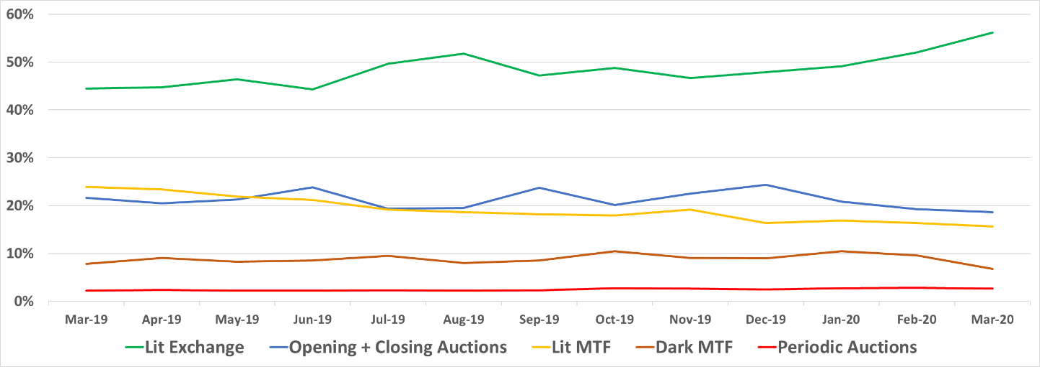Source: Cboe Europe, big xyt

It could be argued that there is a problem with liquidity for smaller companies and markets in particular. However we believe that the appropriate way to address this is through the Capital Markets Union initiative, which should push for a removal of national barriers and meaningful consolidation of European markets. Initiatives such as the European Consolidated Tape will promote cross-border investment in SMEs by providing enhanced visibility and transparency to these instruments.

In terms of incentivisation – and we say this as one of the largest operators of lit books in Europe – market operators should continue to strive to innovate and offer services which are attractive to their customers. If particular operators are not doing that, then the authorities’ priority should be to ensure that alternative providers are able to step in with competing, better services.

<ESMA_QUESTION_CP_MIFID_EQT_6>

- Which option do you prefer for the liquidity assessment of shares among Option 1 and 2? Do you have an alternative proposal? Do you think that the frequency of trading should be kept as a criterion to assess liquidity? If so, what is in your view the appropriate thresholds for the percentage of days traded measured as the ratio between number of days traded and number of days available for trading (e.g. 95%, 90%, 85% etc.)? Please explain.
<ESMA_QUESTION_CP_MIFID_EQT_7>
No, we do not. ADV and market capitalisation are not an indication of a stock’s liquidity level, free float is.
<ESMA_QUESTION_CP_MIFID_EQT_7>

- Do you agree in changing the approach for ETFs, DRs as proposed by ESMA? Do you have an alternative proposal? Please explain.
<ESMA_QUESTION_CP_MIFID_EQT_8>
No, we do not. ADV and market capitalisation are not an indication of a stock’s liquidity level, free float is.
<ESMA_QUESTION_CP_MIFID_EQT_8>

- Do you agree in removing the category of certificates from the equity-like transparency scope? Please explain.
<ESMA_QUESTION_CP_MIFID_EQT_9>
We don’t have a view on this.
<ESMA_QUESTION_CP_MIFID_EQT_9>

- Do you agree in deeming other equity financial instruments to be illiquid by default? Please explain.
<ESMA_QUESTION_CP_MIFID_EQT_10>
Yes
<ESMA_QUESTION_CP_MIFID_EQT_10>

- Do you agree in separating the definition of conventional periodic auctions and frequent batch auctions? Do you agree with ESMA’s proposal to require the disclosure of all orders submitted to FBAs? Please explain.
<ESMA_QUESTION_CP_MIFID_EQT_11>
We do not think there need to be separate definitions, but if there is to be a differentiation, it should be to assess the systemic risk and best execution issues posed by closing auctions. These now account for over 20% of daily on-venue business but execute at a single price and at a single point in time (see our answer to question 35).

We note that ESMA conducted a thorough and extensive consultation on FBAs last year. It received a large amount of feedback from a broad range of market participants and, on that basis, ESMA was able to conclude that minor enhancements were required to the transparency regime for FBAs. While we understand that the MiFID II review represents an opportunity to enshrine in legislation the conclusions that ESMA previously reached with respect to FBAs, we believe no evidence of investor detriment exists to justify different conclusions or materially different regulatory action on FBAs at this time. We agree with ESMA’s conclusion last year regarding the levels of pre-trade transparency provided by our FBA. To quote the report, “ESMA acknowledges that for the first type of system, it would be challenging to provide pre-trade information on the basis of only one order throughout the whole auction call. Nevertheless, ESMA considers it important that trading venues provide market participants with information that an auction has started. The disclosure of such information should allow other market participants to participate in the auction while at the same time not disclosing too much information thereby addressing concerns of excessive pre-trade transparency leading to information leakage.”

Under the current rules, including the enhancements ESMA proposed last year, FBAs have proven themselves as useful, price forming mechanisms that in many cases prioritise size over speed, helping firms to trade in a way that reduces market impact and delivers better execution outcomes.

As to the specific proposal to require disclosure of all orders in FBAs, we would reiterate a point made in our response to ESMA’s consultation on FBAs last year. Greater pre-trade transparency is safe and worthwhile for conventional auctions (i.e. Opening and Closing Auctions) because continuous trading is predominantly halted and there can be no impact on price formation elsewhere. In contrast, FBAs run in parallel to continuous trading and full order book transparency would indicate the direction of trading interest/market pressure and potentially influence other trading mechanisms. This would result in unnecessary order, cancel and replace activity as participants minimise their information leakage.

We also wanted to take this opportunity to respond to an update made on 2nd October 2019 to ESMA’s Q&A on MiFID II Market Structures topics. In Question 11 of the tick size regime section, the Q&A states that periodic auctions are subject to the mandatory tick size regime and those not benefitting from a reference price waiver are prohibited from executions priced at the mid-point where the spread is an uneven number of ticks wide. As we’ve said elsewhere in this response, Cboe strongly believes that the mid-point is a globally accepted price point for execution. Cboe’s periodic auction book is based on a genuine price formation process involving all orders, and does not default to any mid-point reference price. The price arrived at is not constrained to the mid, bid, or offer but any (half-tick) price point in between. If that price is determined to be a half-tick price point at the mid, then that represents the fairest price to buyer and seller. Preventing mid-point executions would create an unnecessarily complex market structure.

<ESMA_QUESTION_CP_MIFID_EQT_11>

- Do you agree that all non-price forming systems should operate under a pre-trade transparency waiver? Please explain.
<ESMA_QUESTION_CP_MIFID_EQT_12>
No. Use of a waiver is only required where pre trade transparency is not provided. As we noted in our response to ESMA’s call for evidence, ESMA previously considered whether or not all venues that import prices from another should be required to operate under a waiver and concluded that they should not (Consultation Paper on MiFID II/MiFIR ESMA/2014/1570, 19 December 2014).

In the absence of any significant market structural development or new information, and such a short intervening time period since the recent ESMA Call for Evidence, we do not believe revisiting this issue at this time is warranted.
<ESMA_QUESTION_CP_MIFID_EQT_12>

- What is your view on increasing the minimum quoting size for SIs? Which option do you prefer?
<ESMA_QUESTION_CP_MIFID_EQT_13>
Any amendment to the transparency regime should be based on evidence. 10% of SMS was an arbitrary figure and there would be little value in simply replacing it with another one. Bank SIs use the regime to provide risk capital to their clients. Any change to the regime should be based on feedback from those clients as what level of transparency would be useful.
<ESMA_QUESTION_CP_MIFID_EQT_13>

- What is your view on extending the transparency obligations under the SI regime to illiquid instruments?
<ESMA_QUESTION_CP_MIFID_EQT_14>
Given the low level of volume in illiquid instruments (see Chart 9 below), and the issues with sourcing liquidity in these instruments generally, we do not believe that this step would be justified.

Chart 9: SI business in illiquid instruments
Source: big xyt

<ESMA_QUESTION_CP_MIFID_EQT_14>

- With regard to the SMS determination, which option do you prefer? Would you have a different proposal? Please explain.
<ESMA_QUESTION_CP_MIFID_EQT_15>
We don’t have a view on this.
<ESMA_QUESTION_CP_MIFID_EQT_15>

- Which option do you prefer among Options A, B and C? Would you suggest a different alternative? Please explain.
<ESMA_QUESTION_CP_MIFID_EQT_16>
We would support removal of the DVCs altogether and believe this would go a long way to achieving ESMA’s stated aim of simplifying the currently complex pre-trade transparency waiver regime in Europe. As noted above, no damage to price formation was demonstrated to support their introduction and they already impose additional costs on investors seeking to achieve midpoint execution. Cboe strongly believes that the midpoint is a globally accepted price point for execution. The data presented by ESMA in Figures 39 and 40 show that any reduction in the threshold would dramatically increase the number of suspensions, which would increase the costs borne by investors. The imposition of suspensions also creates operational risk for market users, venues and regulators.

If the DVCs remained and the thresholds were amended, this would need to be based on a thorough study of the potential impact.
<ESMA_QUESTION_CP_MIFID_EQT_16>

- Would you envisage a different system than the DVC to limit dark trading? Please explain.
<ESMA_QUESTION_CP_MIFID_EQT_17>
As we stated in our answer to question 1, we do not believe it is necessary to limit dark trading and it is vital investors have access to a range of execution mechanisms to suit different trading models and market conditions. To reiterate, dark pools are used to satisfy investor demand for urgent, low-impact midpoint executions, which are often the result of larger orders being broken up into smaller pieces and spread throughout the day so as not to adversely move prices. The DVCs are already costing European investors real money and further limits on dark trading would be even more damaging.

The argument for mandatory pre-trade transparency has never been cogently made. Stock exchanges do not offer lit trading mechanisms because they are mandated to by regulation, and they do not offer lit books because they are somehow inherently virtuous. They offer lit books because there is demand for them, as there is for other mechanisms. The reason there is a demand for market participants to be able to display their trading interest to the broadest possible number of counterparties is because lit books provide immediacy of execution. Other investors are able to rest liquidity and capture the spread. Central limit order books in liquid instruments do not need any specific support from regulators.

Despite the effort and associated cost of implementing the DVC regime, and in the interest of competition and benefit to end investors, our position would be to remove the DVCs in their entirety rather than make arbitrary alterations to the current thresholds. Any other measures to limit dark trading would almost certainly result in a more complex market structure and have unintended consequences.
<ESMA_QUESTION_CP_MIFID_EQT_17>

- Do you agree in removing the need for NCAs to issue the suspension notice and require trading venues to suspend dark trading, if required, on the basis of ESMA’s publication? Please explain.
<ESMA_QUESTION_CP_MIFID_EQT_18>
We believe that the DVCs should be removed as they gave introduced cost, complexity and risk to European markets without any benefit for investors. If they are to remain, we would be supportive in removing the need for NCAs to issue suspension notices on the basis of an ESMA publication, as long as such suspension notices are published in a consistent and clear form. ESMA publication should be via FITRS, although ESMA must prioritise providing an effective date in its files to allow for automated processing.

A development in this regard would further the case for the creation of a consolidated tape in Europe, by means of a single and efficient source of published data, which can be consumed equally and efficiently by all market practitioners.

<ESMA_QUESTION_CP_MIFID_EQT_18>

- Do you agree in removing the requirement under Article 5(7)(b)? Please explain.
<ESMA_QUESTION_CP_MIFID_EQT_19>
Yes, we agree with removing the requirement under Article 5 (7) (b), as the current industry standard is both inefficient and prone to data quality issues, which are referred back to NCA’s and individual market operators for resolution.
<ESMA_QUESTION_CP_MIFID_EQT_19>

- Please provide your answer to the following survey (<= click here to open the survey) on the impact of DVC on the cost of trading for eligible counterparties and professional clients.
<ESMA_QUESTION_CP_MIFID_EQT_20>
[CLICK ON THE WORD “SURVEY” IN THE QUESTION IN ORDER TO PROVIDE YOUR ANSWER]
<ESMA_QUESTION_CP_MIFID_EQT_20>

- Do you agree in applying the DVC also to instruments for which there are not 12 months of available data yet? Please explain.
<ESMA_QUESTION_CP_MIFID_EQT_21>
No. The 12 month period allows for an averaging effect that can accommodate short term swings in market share. To apply the caps without 12 months data, particularly 6 or less would risk triggering suspensions on the basis of unrepresentative market swings.
<ESMA_QUESTION_CP_MIFID_EQT_21>

- Do you agree foresee any issue if the publication occurs after 7 working days instead of 5? Please explain.
<ESMA_QUESTION_CP_MIFID_EQT_22>
No, given that data is already provided with a month’s delay.
<ESMA_QUESTION_CP_MIFID_EQT_22>

- Do you agree that the mid-month reports should not be published? Please explain.
<ESMA_QUESTION_CP_MIFID_EQT_23>
No. As ESMA acknowledges, trading venues are not able to independently calculate this data, therefore the absence of the mid-month reports make our ability to take preventative action redundant.
<ESMA_QUESTION_CP_MIFID_EQT_23>

- Do you agree with ESMA’s proposal to include in Article 70 of MiFID II the infringements of the DVC suspensions? Please explain.
<ESMA_QUESTION_CP_MIFID_EQT_24>
No. As ESMA acknowledges, the breaches observed were the result of technical issues, and were not indicative of a lack of supervision or enforcement.
We do not believe that including infringements of DVC suspensions to Article 70 of MiFID II, will lead to an improvement to the application of and compliance with the DVC, and that the primary consideration should be either the suspension of the DVC regime, or significant improvements to how data is collected, aggregated and actioned in relation to the DVC (see question 19).
<ESMA_QUESTION_CP_MIFID_EQT_24>

- Do you agree with ESMA’s assessment that the conditions for deferred publication for shares and depositary receipts should not be subject to amendments? If not, please explain.
<ESMA_QUESTION_CP_MIFID_EQT_25>
Yes. We have not seen any evidence to suggest deficiencies with regards to the current deferred publication regime.
<ESMA_QUESTION_CP_MIFID_EQT_25>

- Do you agree with ESMA’s proposal to increase the applicable threshold for ETFs and request for real-time publication for transactions that are below 20,000,000 EUR? If not, please explain.
<ESMA_QUESTION_CP_MIFID_EQT_26>
No. We have not seen evidence to warrant the increase in the real-time publication threshold for ETFs.
<ESMA_QUESTION_CP_MIFID_EQT_26>

- Do you agree with ESMA assessment of the level of post trade transparency for OTC transactions?
<ESMA_QUESTION_CP_MIFID_EQT_27>
It is our opinion that data quality has improved significantly under MiFID II, however the ability for market participant’s to ensure overall compliance with their post trade transparency requirements for OTC trading is debatable. We believe this stems from a lack of enforcement by NCAs as a result of the need for more definitive guidance on interpretation of MiFID II’s requirements.
Additional NCA supervision and enforcement action, backed up by ESMA guidance, is required to ensure that reporting obligations, including accurate flagging or transactions, are applied consistently.

As our APA handles around 75% to 80% of all equity APA reports, we think particular consideration should be given to providing guidance on the required flags for:

- Give-Ups/Ins
- Exercising of derivatives contracts;
- Riskless principal transactions; and
- ECM transactions.

<ESMA_QUESTION_CP_MIFID_EQT_27>

- Do you agree with the proposal to report and flag transactions which are not subject to the share trading obligations but subject to post-trade transparency to FITRS? Please explain.
<ESMA_QUESTION_CP_MIFID_EQT_28>
We believe that this is already derivable – volume that is not executed on a venue or SI is not subject to the share trading obligation. We agree that use of the exemption deserves further scrutiny by NCA’s, and that further guidance from ESMA on its appropriate use might be useful.
<ESMA_QUESTION_CP_MIFID_EQT_28>

- What is your experience related to the publication of post-trade transparency information within 1 minute from the execution of the transaction? Do you think that the definition of “real-time” as maximum 1 minute from the time of the execution of the transaction is appropriate/too stringent/ too lenient? Please explain.
<ESMA_QUESTION_CP_MIFID_EQT_29>
We believe the current requirement to submit post trade reports in real time to be appropriate, and that it should remain consistent with the requirement for trading venues when publishing on venue executions.
As market participants have invested significantly in automated trade reporting solutions, automated control mechanisms and regulatory reporting surveillance teams we do not believe this to be a particularly onerous requirement to comply with.

We would reiterate our view on the need for additional NCA supervision and enforcement in this area (see question 27).
Our analysis shows the following distribution reporting times of Off-Exchange transactions for the first 2 months of 2020:

Time (milliseconds) | Reported Transactions
 | Jan-20 | Feb-20
0-1 | 659,148 | 488,311
1-100 | 2,493,047 | 1,833,311
101-1,000 | 1,658,364 | 1,281,605
1,001-2,000 | 1,415,957 | 930,796
2,001-5,000 | 2,267,546 | 1,644,792
5,001-10,000 | 335,414 | 224,525
10,001-60,000 | 610,300 | 440,992
60,001-300,000 | 68,164 | 51,177
>300,000 | 36,768 | 29,986

This shows that the largest proportion of business is reported between 1 and 100 milliseconds.
<ESMA_QUESTION_CP_MIFID_EQT_29>

- Do you agree with ESMA’s approach to third-country trading venues for the purpose of transparency requirements under MiFID II? If no, please explain.
<ESMA_QUESTION_CP_MIFID_EQT_30>
Yes.
<ESMA_QUESTION_CP_MIFID_EQT_30>
- Do you agree that the scope of the share trading obligation in Article 23 of MiFIR should be reduced to exclude third-country shares? If yes, what is the best way to identify such shares, keeping in mind that ESMA does not have data on the relative liquidity of shares in the EU versus in third countries? More generally, would you include any additional criteria to define the scope of the share trading obligation and, if yes, which ones?
<ESMA_QUESTION_CP_MIFID_EQT_31>
Yes. We believe that the starting point should be ISIN, such that non-EU/EEA ISINs should not be subject to the STO. However, if an EU/EEA ISIN is admitted for trading solely outside of the EU/EEA the STO should also not apply. Dual listed shares should be treated on a case by case basis. If ESMA requires data to decide upon individual cases we believe that the number is low enough that it could consult on the appropriate treatment of individual shares.
<ESMA_QUESTION_CP_MIFID_EQT_31>

- Would you support removing SIs as eligible execution places for the purposes of the share trading obligation? If yes, do you think SIs should only be removed as eligible execution places with respect to liquid shares? Please provide arguments (including numerical evidence) supporting your views.
<ESMA_QUESTION_CP_MIFID_EQT_32>
No. We do not believe the removal of SIs to be either in the interest of competition in the market place, or to the benefit of end investors.

The industry has completely remodelled at great cost, and the focus should be on ensuring that SIs provide meaningful competition to the market place on a level playing field to the benefit of end investors.
Furthermore, we believe the data shows that the objective of MiFID, to move trading from unclassified trading mechanisms to mechanisms that are subject to pre trade transparency has been broadly successful. The chart shows that, for addressable liquidity – i.e. liquidity that market participants could meaningfully hope to interact with, has largely moved from OTC to SI. As stated elsewhere, if ESMA believes that the transparency applied to SIs is insufficient then it should amend the transparency regime, not remove choice.

Chart 10: Addressable off exchange OTC vs SI

Source: big xyt

<ESMA_QUESTION_CP_MIFID_EQT_32>

- Would you support deleting the first exemption provided for under Article 23 of MiFIR (i.e. for shares that are traded on a “non-systematic, ad-hoc, irregular and infrequent” basis)? If not, would you support the introduction in MiFIR of a mandate requiring ESMA to specify the scope of the exemption? Please provide arguments supporting your views.
<ESMA_QUESTION_CP_MIFID_EQT_33>
No. We would not be supportive of the removal of the first exemption under Article 23 of MiFIR, which exempts transactions deemed to be non-systemic, ad-hoc, irregular and infrequent. However, it may be beneficial to clarify the scope of this exemption, and explicitly detail the types of transactions to which it applies.
<ESMA_QUESTION_CP_MIFID_EQT_33>

- Would you support simplifying the second exemption of Article 23 of MiFIR and not limiting it to transactions “carried out between eligible and/or professional counterparties”? Please provide arguments supporting your views.
<ESMA_QUESTION_CP_MIFID_EQT_34>
Yes. Our view is that the overriding factor is the nature of the transaction (i.e. is it price forming), and not the classification of the transacting parties.
<ESMA_QUESTION_CP_MIFID_EQT_34>
- What is your view on the increase of volumes executed through closing auctions? Do you think ESMA should take actions to influence this market trend and if yes which one?
<ESMA_QUESTION_CP_MIFID_EQT_35>
In Cboe’s view, the increase in closing auction volume is creating a systemic risk to the efficient and orderly running of equity markets in Europe, and is a situation which is detrimental to end investors.

Operators of closing auctions enjoy a natural monopoly, but are not subject to monopoly price controls. As a result, they are not forced to compete on pricing for executions at the close, or indeed for the market data that they produce. Clearly this arrangement is not conducive to encouraging competition within the market place, and seeking to provide best execution to end investors.

Our analysis shows that the continued migration and concentration of volume during closing auctions is the biggest contributing factor to the reduction of executed volumes on lit books during continuous trading.

Chart 11: Closing auction % of European on-venue trading
Source: Cboe Europe
As liquidity continues to consolidate around this single event at the end of the trading day, this will continue to harm competition within the market place as market participants are compelled to hold back volumes that could otherwise be executed via alternative trading mechanisms during the trading day. The trend is further compounded by volume profiling algorithms that direct still more flow to the auctions on the back of the volume executed.

A particularly concerning aspect of increased closing auction growth is its impact on price volatility. Auctions attract flow that is not necessarily driven by the desire to achieve the best possible price – e.g. large portfolio rebalances and transitions. This means that the auctions are subject to supply and demand characteristics that have very little to do with the underlying value of the instrument. However the existence of the closing price as a benchmark, provides cover for those that should be concerned by price. Investors may be losing out on best execution that could have been achieved earlier in the trading day, as orders are held back to the closing auction. In such an event, brokers are effectively abdicating their responsibility to achieve best execution for their clients. The example below shows what happened in a single stock, but this is happening elsewhere. In this example, the auction uncrossed over 100 basis points away from the level at which it had been trading in continuous trading. Then, immediately upon the start of trading the next day the price moved back towards that price, and within 15 minutes it had completely reverted beyond the original price.

Chart 12: Price reversion around closing auction
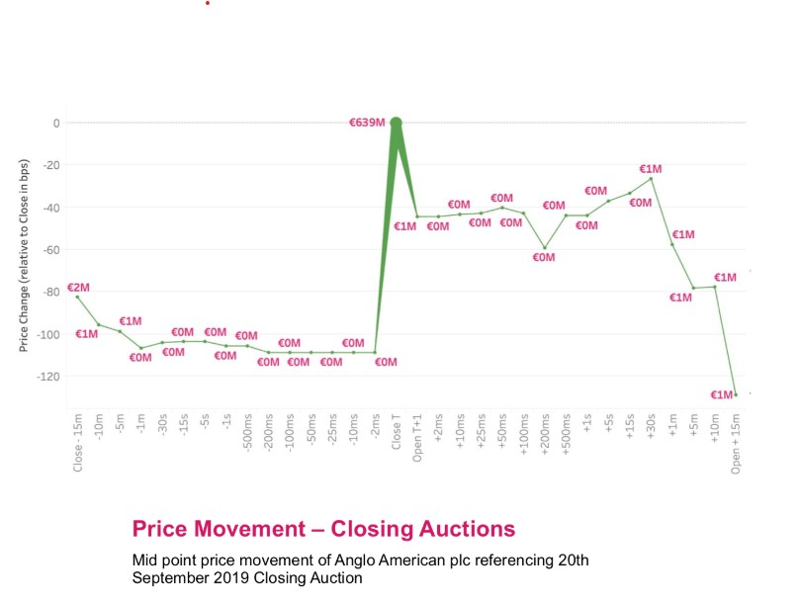
Source: big xyt

Furthermore, a comparison of closing auction prices and the volume weighted average price of continuous trading shows that there is a consistent difference across Europe’s exchanges. Chart 13 shows that a difference of around 50 bps is common across Europe. This is particularly concerning when we note that over 23% of multilateral volume is taking place on the closing auction, and is therefore potentially taking place at a materially incorrect price.

In our view, this trend should continue to be closely monitored, and assessed thoroughly from a systemic risk and best execution perspective.

Chart 13: VWAP versus official close price (bps)

Source: big xyt

<ESMA_QUESTION_CP_MIFID_EQT_35>

https://www.fca.org.uk/publication/occasional-papers/op17-29.pdf

