4 February 2020

Reply form for the Consultation Paper on MiFID II/ MiFIR review report on the transparency regime for equity and equity-like instruments, the DVC and the trading obligations for shares

Date: 4 February 2020
Responding to this paper
The European Securities and Markets Authority (ESMA) invites responses to the specific questions listed in the Consultation Paper on the transparency regime for equity and equity-like instruments, the double volume cap mechanism and the trading obligations for shares MiFID II/ MiFIR review report published on the ESMA website.

Instructions
Please note that, in order to facilitate the analysis of the large number of responses expected, you are requested to use this file to send your response to ESMA so as to allow us to process it properly. Therefore, ESMA will only be able to consider responses which follow the instructions described below:
- use this form and send your responses in Word format (pdf documents will not be considered except for annexes);
- do not remove the tags of type <ESMA_QUESTION_CP_MIFID_EQT_1> - i.e. the response to one question has to be framed by the 2 tags corresponding to the question; and
- if you do not have a response to a question, do not delete it and leave the text “TYPE YOUR TEXT HERE” between the tags.
Responses are most helpful:
- if they respond to the question stated;
- indicate the specific question to which the comment relates;
- contain a clear rationale; and
- describe any alternatives ESMA should consider.

Naming protocol
In order to facilitate the handling of stakeholders’ responses please save your document using the following format:
ESMA_CP_MiFID_EQT_NAMEOFCOMPANY_NAMEOFDOCUMENT.
e.g. if the respondent were ESMA, the name of the reply form would be:
ESMA_CP_MiFID_EQT_ESMA_REPLYFORM or
ESMA_CP_MiFID_EQT_ANNEX1

Deadline
Responses must reach us by 17 March 2020.
All contributions should be submitted online at www.esma.europa.eu under the heading ‘Your input - Consultations’.

Publication of responses
All contributions received will be published following the end of the consultation period, unless otherwise requested. Please clearly indicate by ticking the appropriate checkbox in the website submission form if you do not wish your contribution to be publicly disclosed. A standard confidentiality statement in an email message will not be treated as a request for non-disclosure. Note also that a confidential response may be requested from us in accordance with ESMA’s rules on access to documents. We may consult you if we receive such a request. Any decision we make is reviewable by ESMA’s Board of Appeal and the European Ombudsman.

Data protection
Information on data protection can be found at www.esma.europa.eu under the headings ‘Legal notice’ and ‘Data protection’.

General information about respondent
Name of the company / organisation | Liquidnet Europe Limited
Activity | Regulated markets/Exchanges/Trading Systems
Are you representing an association? | ☒
Country/Region | UK

Introduction
Please make your introductory comments below, if any:

<ESMA_COMMENT_CP_MIFID_EQT_1>
One of the key regulatory objectives of MiFID II was to restore investor confidence in European Capital Markets by improving pre and post trade transparency in trading. While Liquidnet agrees with ESMA that greater transparency is an important overall policy objective, buy-side institutions rely on pre-trade transparency waivers to reduce their market impact costs.

Investor confidence is not only influenced by regulation, but also by being able to successfully enter and exit an investment strategy. The ability to execute trades successfully directly impacts European citizens’ pension and savings plans, as well as the capital-raising processes of European governments and companies in reducing their cost of funding and their ability to list on European exchanges. Asset managers who trade on behalf of European investors often seek out alternative methods of execution to reduce market impact, look for price improvement on executions to enhance the fund performance of the very investors the regulators intend to protect.

- Maintaining the ability to price improve through crossing at the mid enables institutional asset managers to eliminate unnecessary market impact costs that ultimately would be borne by end investors. This amounted to a total savings of over €689 mln for Liquidnet members when trading large in scale over the last two years, an estimated €2.3 billion for pensions and investments traded by institutional investors when taking into consideration the proportion of activity traded on Liquidnet MTF as a proportion of the total activity traded LIS.
- While the ESMA Consultation Paper notes the importance of the Large-in-scale (LIS) waiver to protect market participants from adverse market movements1 it also states that there is little justification to trade small orders under the reference price waiver (RP) or negotiated Trade waiver (NT). However institutional asset managers are of the view that maintaining the RP and NT waivers also provide an important function in protecting institutional order flow from adverse information leakage. Even large cap household names such as Telefonica and Daimler Chrysler would need to trade 113 and 83 times the average lit order size to reach the pre-trade transparency protection of LIS thresholds.
- Many institutional orders are several multiples of what is currently available on lit continuous markets. Even using the Order Management Facility waiver risks incurring information leakage as a trader will often need to trade multiple times to complete an order. When market participants are forced to pay the spread—the offer price when buying and the bid price when selling—end investors and their pension providers pay a higher price or sell at a lower one and the beneficiary of the trade is the market maker or provider of risk, not the end investor. Each time the spread is crossed, quotes will adjust improving the bid or offer, resulting in pushing the execution price further away from the original price quoted which can incur significant costs, particularly in volatile markets. Matching asset managers who are looking to buy and sell at the mid not only enables both buyer and seller to benefit from saving the spread, but also delivers significant savings in relation to lowering market impact costs and reducing market volatility.
- While institutional Asset Managers acknowledge the need to support robust price formation on primary markets, industry participants would like to see regulatory focus on how to improve current levels of toxicity in the lit; if this is addressed this would encourage more activity in continuous trading.
- A key objective of MiFID II is to improve transparency in capital markets. Rather than focusing on pre-trade transparency, mandating the use of FIX MMT as a post-trade reporting standard to contribute to the formation of a European Consolidated Tape would be a significant step in delivering the transparency regulators and policy makers seek, but still ensure that the buy-side can continue to execute trades successfully to the benefit of the end investor.

<ESMA_COMMENT_CP_MIFID_EQT_1>

- What is your view on only allowing orders that are large in scale and orders in an order management facility to be waived from pre-trade transparency while removing the reference price and negotiated trade waivers? Instead of removing the RP and NT waivers, would you prefer to set a minimum threshold above which transactions under the RP and NT waivers would be allowed? If so, what should be the value of such threshold? What alternatives do you propose to simplify the MiFIR waivers regime while improving transparency available to market participants? Please explain.
<ESMA_QUESTION_CP_MIFID_EQT_1>
Rather than removing the RP and NT waivers, we would prefer to set a minimum threshold above which transactions under the RP and NT waivers would be allowed based on the LIS thresholds. This would enable institutions to continue to look for price improvement, but in a size that allows them to limit incurring full market impact costs. At the same time, orders below the minimum size threshold could return to the continuous lit market.
Analysis by Liquidnet has shown that for the first two years of implementation of MiFID II, the ability to cross at the mid and trade inside the spread above Large in Scale (LIS) amounted to a total savings of over €689 mln for their members (see Exhibit 1) – not just by saving the spread but more importantly by eliminating unnecessary market impact costs. This could be extrapolated further when taking into consideration the proportion of activity traded on Liquidnet MTF as a proportion of the total activity traded LIS, amounting to approximately a saving of €2.3 billion for pensions and investments traded by institutional investors over the last two years.

Exhibit 1:
Spread and impact savings since the introduction of MiFID II
- Spread Savings BPS | - Spread Savings € | - Market Impact BPS | - Market Impact € | - Total Savings BPS | - Total Savings €
- 5.56 | - 149,309,507 | - 17.87 | - 479,222,434 | - 25.71 | - 689,404,347

Whilst Liquidnet and its members continue to reiterate our support for simplified market structure, we believe that the RP and NT waivers also provide an important function in protecting institutional order flow from adverse information leakage.

Defining what constitutes a large trade can be a difficult task, especially when smaller trades can be part of a larger order and convey significant and impactful information. As such the removal of the RP and NT could have a significant negative impact on market participants, especially for long-term investors, and particularly in relation to trades in more illiquid names such as small and mid-cap stocks.
Many institutional orders are several multiples of what is currently available on lit continuous markets. Even using the Order Management Facility waiver risks incurring information leakage as a trader will often need to trade multiple times to complete an order. When market participants are forced to pay the spread—the offer price when buying and the bid price when selling—end investors and their pension providers pay a higher price or sell at a lower one and the beneficiary of the trade is the market maker or provider of risk, not the end investor. Each time the spread is crossed, quotes will adjust improving the bid or offer, resulting in pushing the execution price further away from the original price quoted which can incur significant costs, particularly in volatile markets. Matching asset managers who are looking to buy and sell at the mid not only enables both buyer and seller to benefit from saving the spread, but also delivers significant savings in relation to lowering market impact costs and reducing market volatility.
For example, when trading in the continuous market, the cost of trading equates to the spread plus the impact– in this instance 5.56 bps + 17.87 bps, totalling 25.71 bps (see Exhibit 1). In comparison, when executing on the far touch with a block counterparty, for example a systematic internaliser, you may need to pay the spread but eliminate the market impact, reducing costs to just over 5 bps. When trading at mid—half the spread and eliminating market impact, trading costs have been reduced from nearly 26 bps to just 2.8 bps.
The potential impact of restricting the ability to price improve just to LIS activity can be demonstrated in looking at the average trade size in Lit markets vs. Large-in-Scale thresholds (see Exhibit 2).
Exhibit 2: Average Lit Trade Sizes vs. Large-in-scale
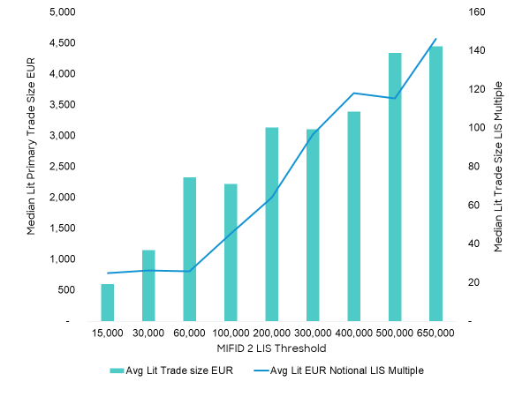
For large cap stocks, i.e. those with a threshold above €650k, the LIS threshold is an average of 140x the lit primary trade size (see Exhibit 2). Even household names such as Telefonica and Daimler Chrysler would need to trade 113 and 83 x the average lit trade to reach LIS thresholds (see Exhibit 3).

Exhibit 3: % of LIS as a Multiple of Average Lit Trade Sizes

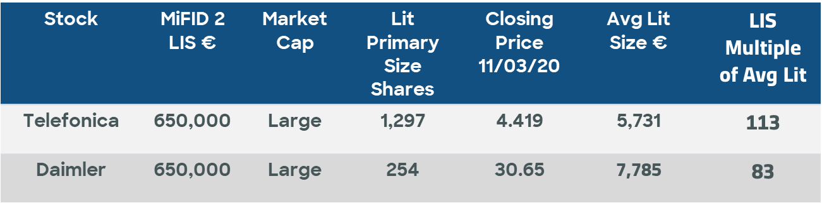

Taking a sample of 900 European stocks across market cap bands, the predicted market impact costs for these stocks range from 13bps for a 1x LIS trade in a €650k LIS band stock, to 60bps for a 1x LIS trade in a €15k LIS band stock. For those small names hard to trade, even a 10% of LIS size trade saves approximately 30bps of market impact costs (see Exhibit 4).
Exhibit 4: Sliding Scale of Market Impact Savings below LIS

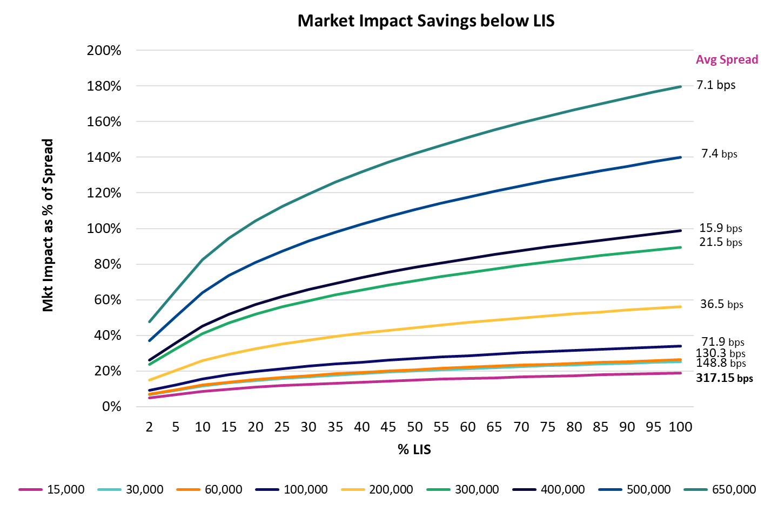.

<ESMA_QUESTION_CP_MIFID_EQT_1>

- Do you agree to increase the pre-trade LIS threshold for ETFs to EUR 5,000,000? Please explain.
<ESMA_QUESTION_CP_MIFID_EQT_2>
TYPE YOUR TEXT HERE
<ESMA_QUESTION_CP_MIFID_EQT_2>

- Do you agree with extending the scope of application of the DVC to systems that formalise NT for illiquid instruments?
<ESMA_QUESTION_CP_MIFID_EQT_3>
TYPE YOUR TEXT HERE
<ESMA_QUESTION_CP_MIFID_EQT_3>

- Would you agree to remove the possibility for trading venues to apply for combination of waivers? Please justify your answer and provide any other feedback on the waiver regime you might have.
<ESMA_QUESTION_CP_MIFID_EQT_4>
TYPE YOUR TEXT HERE
<ESMA_QUESTION_CP_MIFID_EQT_4>

- Do you agree with the proposal to report the volumes under the different waivers separately to FITRS? Please explain.
<ESMA_QUESTION_CP_MIFID_EQT_5>
TYPE YOUR TEXT HERE
<ESMA_QUESTION_CP_MIFID_EQT_5>

- What would be in your view an alternative way to incentivise lit trading and ensure the quality and robustness of the price determination mechanism for shares and equity-like instruments? Please explain.
<ESMA_QUESTION_CP_MIFID_EQT_6>
Asset managers are required to provide best execution for end investors. It is this requirement to evidence obtaining the best possible outcome when executing a trade that leads market structure to evolve and new execution methods, new venues and trading protocols to emerge.

Trading away from the exchange has always been an important element of equity trading. To limit signalling risk, buyers choose to connect with sellers without exposing their trading intention to the wider market ahead of execution. This limits any negative impact on the final execution price as well as reduce unnecessary market volatility.

Liquidnet agrees that pre-trade transparency and effective price formation constitute important policy objectives. However, the assumption that a majority of trades should be price forming in some way does not recognise that a large part of the market wants to trade at a set price without pushing the bid/offer price in one direction or another. The absence of a set price trading mechanism provides electronic market makers with an opportunity to push up the price and add artificial temporary noise around the bid and offer.

One example of this is the automated quoting systems that can be used when trading German mid-caps. Wide spreads and little activity mean that in order to trade, traders need to increase their bids if they are buying the stock or lower their offers if they are selling. The automated quote will better the bid or offer, perhaps only by a tick, meaning that the bid or offer is forced up or down. If that automated quote then pulls out, the original buyer or seller is left to trade, executing at a price that may have moved considerably and unnecessarily.

The impact of this can be demonstrated in looking at the bids and offers for a single instrument, Singulus Technologies AG (SNG GY), a German Renewable Energy stock. Over a half hour period, there were 56 bids fluctuating between €13.52 and €13.76 and only 29 offers between €13.82- 84 and just 2 trades (see Exhibit 6). Technically the overweight demand against supply is demonstrated in the price, with the bid price increasing vs. the offer price remaining relatively static. However, electronic market makers pushing up the price adds artificial temporary noise around the bid and offer, perhaps even short-selling, forcing the buyer to purchase at the high of the day, whereas the market-maker can buy back later at a lower price. As interest in the stock falls away, so does the best bid. The difference on the largest trade of the day equated to €7,500. For certain small and mid-cap stocks the impact will be much worse, which would have an even greater outcome on fund performance.

Exhibit 6: Bid vs Offer in SNG GY

Bid Time Bid Size Bid Price Offer Price Offer size Offer time
08:02:23 | 1,100 | 13.64 | 13.84 | 969 | 08:02:23
08:02:23 | 557 | 13.66 | 13.84 | 1,044 | 08:02:23
08:02:23 | 352 | 13.66 | 13.84 | 1,081 | 08:02:23
08:02:24 | 258 | 13.66 | 13.82 | 200 | 08:02:24
08:02:33 | 743 | 13.56
08:02:33 | 170 | 13.58
08:02:33 | 567 | 13.6
08:02:33 | 382 | 13.6
08:02:34 | 339 | 13.62
08:02:34 | 539 | 13.62
08:02:34 | 422 | 13.64
08:02:35 | 652 | 13.56 | 13.82 | 561 | 08:02:35
08:02:37 | 343 | 13.58
08:02:37 | 513 | 13.58
08:02:37 | 572 | 13.6
08:02:39 | 913 | 13.6
08:05:19 | 347 | 13.62
08:05:19 | 507 | 13.62
08:05:19 | 625 | 13.64
08:05:19 | 448 | 13.64
08:05:26 | 13 | 13.72 | 13.82 | 361 | 08:05:26
08:05:26 | 20 | 13.74 | 13.84 | 1,081 | 08:05:26
08:05:26 | 448 | 13.64
08:05:26 | 347 | 13.66
08:05:26 | 567 | 13.66
08:05:26 | 464 | 13.68
08:05:26 | 329 | 13.68
08:05:28 | 848 | 13.66 | 13.84 | 1,281 | 08:05:28
08:06:05 | 567 | 13.66
08:06:05 | 347 | 13.66
08:06:14 | 1,095 | 13.52 | 13.82 | 361 | 08:06:16
08:07:00 | 1,301 | 13.52
08:07:26 | 180 | 13.82 | TRADE
 |  |  | 13.82 | 181 | 08:07:26
08:07:26 | 200 | 13.7
08:07:26 | 308 | 13.7
08:07:26 | 376 | 13.7 | 13.84 | 1,281 | 08:07:26
08:07:27 | 190 | 13.72
08:07:27 | 298 | 13.72
08:07:27 | 366 | 13.72
08:08:09 | 176 | 13.72 | 13.84 | 1,081 | 08:08:09
08:08:09 | 523 | 13.72
08:10:00 | 553 | 13.72 | 13.84 | 1,081 | 08:14:01
08:14:01 | 523 | 13.72
08:14:21 | 170 | 13.74
08:14:21 | 350 | 13.74
08:14:21 | 458 | 13.74 | 13.84 | 1,186 | 08:18:11
08:14:21 | 526 | 13.74 | 13.84 | 1,081 | 08:18:11
08:14:21 | 346 | 13.74 | 13.84 | 1,169 | 08:18:11
08:14:23 | 347 | 13.76 | 13.84 | 1,081 | 08:18:11
08:14:23 | 517 | 13.76 | 13.84 | 1,144 | 08:18:11
08:14:23 | 347 | 13.76 | 13.84 | 1,081 | 08:18:11
08:14:23 | 455 | 13.76 | 13.84 | 1,131 | 08:18:11
08:14:23 | 523 | 13.76 | 13.84 | 1,161 | 08:20:04
08:20:04 | 553 | 13.76 | 13.84 | 1,111 | 08:20:04
 |  |  | 13.84 | 1,155 | 08:20:04
 |  |  | 13.84 | 1,111 | 08:20:04
 |  |  | 13.84 | 1,152 | 08:20:04
 |  |  | 13.84 | 1,111 | 08:20:04
 |  |  | 13.84 | 1,151 | 08:20:04
 |  |  | 13.84 | 1,121 | 08:22:03
08:22:03 | 523 | 13.76
08:27:11 | 693 | 13.76
08:27:24 | 523 | 13.76
Source: Bloomberg data 17/10/2018

Toxicity in the lit market remains the main inhibitor to the institutional trading community supporting lit continuous trading due to information leakage, market impact and price reversion. As a result, asset managers would rather seek alternative methods of execution in their such as anonymous block trades in their search for liquidity.

Instead of solely focusing on increasing lit trading, regulators could also look at ways to improve trading quality, reduce the noise and better police trading behaviours on lit venues by introducing a code of conduct. Without fixing the lit, regulators risk forcing asset managers to elect to trade on the lit over what is in the best interest of end investors. For instance, introducing a minimum resting time for orders could prevent electronic market makers from adding artificial liquidity to push up prices to force the buyer to purchase at the high of the day, whereas the market-maker can buy back later at a lower price.

Other dynamics exist however, there are clear benefits commercially from internalising and firms where possible will look to capitalise on these using whatever mechanism that is available to them within the market structure. Additionally, there are venues that offer midpoint fills which improve execution performance and return better prices back to the underlying investors.
<ESMA_QUESTION_CP_MIFID_EQT_6>

- Which option do you prefer for the liquidity assessment of shares among Option 1 and 2? Do you have an alternative proposal? Do you think that the frequency of trading should be kept as a criterion to assess liquidity? If so, what is in your view the appropriate thresholds for the percentage of days traded measured as the ratio between number of days traded and number of days available for trading (e.g. 95%, 90%, 85% etc.)? Please explain.
<ESMA_QUESTION_CP_MIFID_EQT_7>
TYPE YOUR TEXT HERE

<ESMA_QUESTION_CP_MIFID_EQT_7>

- Do you agree in changing the approach for ETFs, DRs as proposed by ESMA? Do you have an alternative proposal? Please explain.
<ESMA_QUESTION_CP_MIFID_EQT_8>
TYPE YOUR TEXT HERE
<ESMA_QUESTION_CP_MIFID_EQT_8>

- Do you agree in removing the category of certificates from the equity-like transparency scope? Please explain.
<ESMA_QUESTION_CP_MIFID_EQT_9>
TYPE YOUR TEXT HERE
<ESMA_QUESTION_CP_MIFID_EQT_9>

- Do you agree in deeming other equity financial instruments to be illiquid by default? Please explain.
<ESMA_QUESTION_CP_MIFID_EQT_10>
TYPE YOUR TEXT HERE
<ESMA_QUESTION_CP_MIFID_EQT_10>

- Do you agree in separating the definition of conventional periodic auctions and frequent batch auctions? Do you agree with ESMA’s proposal to require the disclosure of all orders submitted to FBAs? Please explain.
<ESMA_QUESTION_CP_MIFID_EQT_11>
TYPE YOUR TEXT HERE
<ESMA_QUESTION_CP_MIFID_EQT_11>

- Do you agree that all non-price forming systems should operate under a pre-trade transparency waiver? Please explain.
<ESMA_QUESTION_CP_MIFID_EQT_12>
TYPE YOUR TEXT HERE
<ESMA_QUESTION_CP_MIFID_EQT_12>

- What is your view on increasing the minimum quoting size for SIs? Which option do you prefer?
<ESMA_QUESTION_CP_MIFID_EQT_13>
TYPE YOUR TEXT HERE
<ESMA_QUESTION_CP_MIFID_EQT_13>

- What is your view on extending the transparency obligations under the SI regime to illiquid instruments?
<ESMA_QUESTION_CP_MIFID_EQT_14>
TYPE YOUR TEXT HERE
<ESMA_QUESTION_CP_MIFID_EQT_14>

- With regard to the SMS determination, which option do you prefer? Would you have a different proposal? Please explain.
<ESMA_QUESTION_CP_MIFID_EQT_15>
TYPE YOUR TEXT HERE
<ESMA_QUESTION_CP_MIFID_EQT_15>

- Which option do you prefer among Options A, B and C? Would you suggest a different alternative? Please explain.
<ESMA_QUESTION_CP_MIFID_EQT_16>
As suggested in Question 1 above, one option would be to introduce a minimum order size where the RP and NT waivers can be used. Limiting the ability to cross stock to this threshold and above will also automatically increase the average size of dark trades. A recalibration of waivers to more practical levels based on average daily volumes or nominal market sizes for large, mid and small caps could protect institutional sized activity being able to continue to cross at the mid. Basing this on a pilot scheme with ESMA will allow flexibility in implementation to ensure that increased transparency does not negatively impact execution performance.

<ESMA_QUESTION_CP_MIFID_EQT_16>

- Would you envisage a different system than the DVC to limit dark trading? Please explain.
<ESMA_QUESTION_CP_MIFID_EQT_17>
As suggested above, one option would be to introduce a minimum order size where the waivers can be used. Limiting the ability to cross stock to this threshold and above will also automatically increase the average size of dark trades. A recalibration of waivers to more practical levels based on average daily volumes or nominal market sizes for large, mid and small caps could protect institutional sized activity being able to continue to cross at the mid. Basing this on a pilot scheme with ESMA will allow flexibility in implementation to ensure that increased transparency does not negatively impact execution performance.

Rather than focus on shifting trading back to lit primary markets to the detriment of the end investor, improved standardisation of data, via a consolidated tape, would enable regulators to robustly monitor and supervise markets, yet still enable best execution to continue as it should, lowering the cost of investment in the process. That is how investor confidence in European Capital markets can best be restored. Mandating the use of FIX MMT as a post-trade reporting standard to contribute to the formation of a European Consolidated Tape would be a significant step in delivering the transparency regulators and policy makers seek, but ensure that the buy-side can continue to execute trades successfully - directly impacting European citizens’ pension and savings plans, as well as the capital-raising processes of European governments and companies in reducing their cost of funding and their ability to list on European exchanges.
<ESMA_QUESTION_CP_MIFID_EQT_17>

- Do you agree in removing the need for NCAs to issue the suspension notice and require trading venues to suspend dark trading, if required, on the basis of ESMA’s publication? Please explain.
<ESMA_QUESTION_CP_MIFID_EQT_18>
TYPE YOUR TEXT HERE
<ESMA_QUESTION_CP_MIFID_EQT_18>

- Do you agree in removing the requirement under Article 5(7)(b)? Please explain.
<ESMA_QUESTION_CP_MIFID_EQT_19>
TYPE YOUR TEXT HERE
<ESMA_QUESTION_CP_MIFID_EQT_19>

- Please provide your answer to the following survey (<= click here to open the survey) on the impact of DVC on the cost of trading for eligible counterparties and professional clients.
<ESMA_QUESTION_CP_MIFID_EQT_20>
[CLICK ON THE WORD “SURVEY” IN THE QUESTION IN ORDER TO PROVIDE YOUR ANSWER]
<ESMA_QUESTION_CP_MIFID_EQT_20>

- Do you agree in applying the DVC also to instruments for which there are not 12 months of available data yet? Please explain.
<ESMA_QUESTION_CP_MIFID_EQT_21>
TYPE YOUR TEXT HERE
<ESMA_QUESTION_CP_MIFID_EQT_21>

- Do you agree foresee any issue if the publication occurs after 7 working days instead of 5? Please explain.
<ESMA_QUESTION_CP_MIFID_EQT_22>
TYPE YOUR TEXT HERE
<ESMA_QUESTION_CP_MIFID_EQT_22>

- Do you agree that the mid-month reports should not be published? Please explain.
<ESMA_QUESTION_CP_MIFID_EQT_23>
TYPE YOUR TEXT HERE
<ESMA_QUESTION_CP_MIFID_EQT_23>

- Do you agree with ESMA’s proposal to include in Article 70 of MiFID II the infringements of the DVC suspensions? Please explain.
<ESMA_QUESTION_CP_MIFID_EQT_24>
TYPE YOUR TEXT HERE
<ESMA_QUESTION_CP_MIFID_EQT_24>

- Do you agree with ESMA’s assessment that the conditions for deferred publication for shares and depositary receipts should not be subject to amendments? If not, please explain.
<ESMA_QUESTION_CP_MIFID_EQT_25>
TYPE YOUR TEXT HERE
<ESMA_QUESTION_CP_MIFID_EQT_25>

- Do you agree with ESMA’s proposal to increase the applicable threshold for ETFs and request for real-time publication for transactions that are below 20,000,000 EUR? If not, please explain.
<ESMA_QUESTION_CP_MIFID_EQT_26>
TYPE YOUR TEXT HERE
<ESMA_QUESTION_CP_MIFID_EQT_26>

- Do you agree with ESMA assessment of the level of post trade transparency for OTC transactions?
<ESMA_QUESTION_CP_MIFID_EQT_27>
TYPE YOUR TEXT HERE
<ESMA_QUESTION_CP_MIFID_EQT_27>

- Do you agree with the proposal to report and flag transactions which are not subject to the share trading obligations but subject to post-trade transparency to FITRS? Please explain.
<ESMA_QUESTION_CP_MIFID_EQT_28>
TYPE YOUR TEXT HERE
<ESMA_QUESTION_CP_MIFID_EQT_28>

- What is your experience related to the publication of post-trade transparency information within 1 minute from the execution of the transaction? Do you think that the definition of “real-time” as maximum 1 minute from the time of the execution of the transaction is appropriate/too stringent/ too lenient? Please explain.
<ESMA_QUESTION_CP_MIFID_EQT_29>
TYPE YOUR TEXT HERE
<ESMA_QUESTION_CP_MIFID_EQT_29>

- Do you agree with ESMA’s approach to third-country trading venues for the purpose of transparency requirements under MiFID II? If no, please explain.
<ESMA_QUESTION_CP_MIFID_EQT_30>
TYPE YOUR TEXT HERE
<ESMA_QUESTION_CP_MIFID_EQT_30>
- Do you agree that the scope of the share trading obligation in Article 23 of MiFIR should be reduced to exclude third-country shares? If yes, what is the best way to identify such shares, keeping in mind that ESMA does not have data on the relative liquidity of shares in the EU versus in third countries? More generally, would you include any additional criteria to define the scope of the share trading obligation and, if yes, which ones?
<ESMA_QUESTION_CP_MIFID_EQT_31>
TYPE YOUR TEXT HERE
<ESMA_QUESTION_CP_MIFID_EQT_31>

- Would you support removing SIs as eligible execution places for the purposes of the share trading obligation? If yes, do you think SIs should only be removed as eligible execution places with respect to liquid shares? Please provide arguments (including numerical evidence) supporting your views.
<ESMA_QUESTION_CP_MIFID_EQT_32>
TYPE YOUR TEXT HERE
<ESMA_QUESTION_CP_MIFID_EQT_32>

- Would you support deleting the first exemption provided for under Article 23 of MiFIR (i.e. for shares that are traded on a “non-systematic, ad-hoc, irregular and infrequent” basis)? If not, would you support the introduction in MiFIR of a mandate requiring ESMA to specify the scope of the exemption? Please provide arguments supporting your views.
<ESMA_QUESTION_CP_MIFID_EQT_33>
TYPE YOUR TEXT HERE
<ESMA_QUESTION_CP_MIFID_EQT_33>

- Would you support simplifying the second exemption of Article 23 of MiFIR and not limiting it to transactions “carried out between eligible and/or professional counterparties”? Please provide arguments supporting your views.
<ESMA_QUESTION_CP_MIFID_EQT_34>
TYPE YOUR TEXT HERE
<ESMA_QUESTION_CP_MIFID_EQT_34>
- What is your view on the increase of volumes executed through closing auctions? Do you think ESMA should take actions to influence this market trend and if yes which one?
<ESMA_QUESTION_CP_MIFID_EQT_35>
TYPE YOUR TEXT HERE
<ESMA_QUESTION_CP_MIFID_EQT_35>

Based on Liquidnet internal data

