|  |
| --- |
| Reply Form to the Consultation Paper |
| MiFID II review report on position limits and position management  Draft Technical Advice on weekly position reports |

**Responding to this paper**

ESMA invites comments on all matters in this paper and in particular on the specific questions summarised in Annex 1. Comments are most helpful if they:

* respond to the question stated;
* indicate the specific question to which the comment relates;
* contain a clear rationale; and
* describe any alternatives ESMA should consider.

ESMA will consider all comments received by **8 January 2020.**

All contributions should be submitted online at [www.esma.europa.eu](http://www.esma.europa.eu) under the heading ‘Your input - Consultations’. Please follow the instructions given in the document ‘Reply form for the consultation paper on “MiFID II review report on position limits and position management and draft technical advice on weekly position reports’ also published on the ESMA website.

**Instructions**

In order to facilitate analysis of responses to the Consultation paper, respondents are requested to follow the below steps when preparing and submitting their response:

1. Insert your responses to the questions in the Consultation paper in the present response form.
2. Please do not remove tags of the type <ESMA_QUESTION_WPR_1>. Your response to each question has to be framed by the two tags corresponding to the question.
3. If you do not wish to respond to a given question, please do not delete it but simply leave the text “TYPE YOUR TEXT HERE” between the tags.
4. When you have drafted your response, name your response form according to the following convention: ESMA_WPR_nameofrespondent_RESPONSEFORM. For example, for a respondent named ABCD, the response form would be entitled ESMA_WPR_ABCD_RESPONSEFORM.
5. Upload the form containing your responses, in Word format, to ESMA’s website ([www.esma.europa.eu](http://www.esma.europa.eu) under the heading “Your input – Open consultations” 🡪 “Call for Evidence on Position limits and position management in commodities derivatives”).

**Publication of responses**

All contributions received will be published following the close of the consultation, unless you request otherwise. Please clearly and prominently indicate in your submission any part you do not wish to be publically disclosed. A standard confidentiality statement in an email message will not be treated as a request for non-disclosure. A confidential response may be requested from us in accordance with ESMA’s rules on access to documents. We may consult you if we receive such a request. Any decision we make not to disclose the response is reviewable by ESMA’s Board of Appeal and the European Ombudsman.

**Data protection**

Information on data protection can be found at [www.esma.europa.eu](http://www.esma.europa.eu) under the heading [Legal Notice](http://www.esma.europa.eu/legal-notice).

**Who should read this paper**

All interested stakeholders are invited to respond to this consultation paper. This consultation paper is primarily of interest to trading venues, investment firms and non-financial counterparties trading in commodity derivatives, but responses are also sought from any other market participant including trade associations, industry bodies and investors.

**General information about respondent**

|  |  |
| --- | --- |
| Name of the company / organisation | London Energy Brokers Association and European Venues and Intermediaries Association [“LEBA-EVIA”] |
| Activity | Regulated markets/Exchanges/Trading Systems |
| Are you representing an association? |  |
| Country/Region | Europe |

**Introduction**

***Please make your introductory comments below, if any***

<ESMA_COMMENT_WPR_1>

London Energy Brokers Association and European Venues and Intermediaries Association [“LEBA-EVIA”] have jointly authored a response to the question relating to the C6 exemptive provisions with the wider user community of the wholesale energy markets under the Joint Energy Associations’ Group:- “the JEAG.” LEBA member firms arrange and execute the majority of European wholesale Gas and Power transactions, a substantial part of which is indeed carried out under the C6 exemption which enables those markets to be conjointly MiFID and REMIT compliant without being fragmented in any form. The JEAG reply therefore sets out why and the C6 provisions were drafted to enable physical forward energy markets to steadfastly and consistently achieve the public policy aims for which both MiFID and REMIT were drafted and established. We would underscore that the JEAG paper has been widely supported by wider energy market stakeholders including NRAs and the major futures exchanges, most notably recently in the public statements by the CEER.

On the topic of position limits, LEBA has deferred to the comments of the market participants and principals. We expressed great and grave concerns about the validity and efficacy of the COT regime outside of futures contracts during the drafting period of MiFID and these still hold. However supervisory proportionality has resulted in no LEBA firms needing to post weekly position reports of its customers and therefore we make no comment despite the evident fallicy that fungible positions form discreet open interest in physical forward markets.

In collaboration with JEAG, LEBA-EVIA believes that open, robust, liquid, competitive and transparent energy markets are key to ensuring a secure, sustainable and competitive energy supply to the real economy and end customers in Europe. JEAG is of the opinion that these aims can be best achieved through sector-specific regulation, such as the REMIT and the Third Energy Package. Therefore, JEAG strongly supports the current so-called “REMIT Carve-Out” as defined in Nr. 6, Section C, Annex I of MiFID II and rejects any revision of the REMIT Carve-Out as suggested by ESMA’s Consultation Paper, in particular any deletion or restriction of it.

The REMIT Carve-Out provides that “wholesale energy products” pursuant to the REMIT are not financial instruments, if they are traded on an OTF (Organised Trading Facility) and must be physically settled. The Commission Delegated Regulation 2017/565 has built in sufficient safeguards and restrictions to define carefully what is meant by a “wholesale energy product” as to limit the scope of the REMIT Carve-Out to genuinely physical contracts.

JEAG is of the opinion that the REMIT Carve-Out should be maintained and that these physically settled gas and power products should remain out of scope of the MiFID II definition for financial instruments for the following reasons:

• REMIT provides for a comprehensive and efficient market transparency and integrity framework for these physically settled wholesale energy products. In general, physical gas and power markets (unlike metal, agricultural, and other energy commodities) are subject to strong sectoral regulations with adequate powers and capability of energy regulators to oversee these markets (see no. 1 below). Hence, there is no requirement for these markets to be similarly regulated by financial regulation.

• The deletion or restriction of the REMIT Carve-Out would jeopardise the political aims of the Third Energy Package and the attained successes of the internal European energy market to the detriment of energy consumers and the real economy (see no. 2 below). The consequential reclassifications of wholesale energy products as financial products would trigger burdensome and costly requirements for non-financial firms under financial regulation, such as licensing, capital and margining/collateralization requirements. Indeed, such a reclassification is likely to force a number of firms to curtail or stop their EU trading activity, or, where possible, to trade directly on bilateral OTC markets or via other international markets to avoid these requirements. The consequential fall in liquidity in physical and financial markets would significantly increase the costs of risk management for the real economy and severe hamper the ability to hedge the commercial risks efficiently. The ultimate net result would be higher end consumer gas and power prices.

• These costs of financial regulation would reduce the ability for energy firms to invest in the decarbonisation of the European economy and endanger the long-term goal of the “European Green Deal” of the EU Commission because the affected energy companies would have to reallocate capital and liquidity within their businesses to meet these requirements.

• JEAG does not agree with ESMA that the REMIT Carve-Out creates an unlevel playing field across trading venues (see no. 3 below). No Regulated Market (exchange) has been put at a competitive disadvantage. All exchanges have had the opportunity to set up their own OTFs and a significant number of exchanges have done so.

• The distinction between the treatment of OTFs and other trading venues in relation to physical gas/power delivery transactions has been clearly made at a political level with full awareness of the regulatory consequences. We see no reason to change this demarcation to the detriment of the European economy particularly as there is no evidence to suggest that it has had any negative effects on the functioning and stability of the financial markets.

• The alleged “shift of trading in physically-settled wholesale energy gas/power contracts from Regulated Markets and MTFs to OTFs” mentioned by ESMA has not in fact taken place (see no. 4 below).

• Finally, we believe that other components of financial regulation have been responsible for a more general reduction of liquidity in financially settled contracts traded over exchanges. In this context we would like to note that commercial bank guarantees cannot be used anymore as collateral for the purpose of central clearing under EMIR rules and this represents a disincentive for firms, in particular in the Nordic markets, to enter into long-term hedges over exchanges.

The detailed reasons for these views are set out below:

1. REMIT constitutes a proportionate, tailor-made and robust regulatory framework for physical wholesale energy markets

The REMIT Carve-Out should be maintained because the REMIT is the appropriate, tailor-made regulatory framework for physical wholesale energy markets which takes account of the specific characteristics and needs of the EU energy markets and its market participants, including the real economy. In proposing reform of the REMIT Carve-Out, it appears that ESMA has not fully considered the substantial differences between the energy sector and the financial sector.

Firstly, the energy sector poses no systemic risk to the financial markets and, consequently, was not a factor in the last financial crisis. There is certainly no evidence to suggest that the trading of physical gas and power is a threat to the financial markets.

Further, wholesale energy trading on own account between professional organisations poses no threat to savers and there is no requirement to protect investors (there are no end consumers or retail clients trading in wholesale energy products unlike the financial markets). Commodity traders do not have access to central bank liquidity to meet liquidity requirements and do not take deposits from private clients. Unlike traditional financial markets, physical energy markets are founded in the production, consumption and delivery of real, tangible gas and power products. Price changes pass along the value chain and affect real production and consumption decisions of the real economy and consumers.

Physical energy markets therefore benefit from an inbuilt “reality check” which continuously corrects mismatches between perceived and real values of gas or power. The physical energy markets are accordingly constrained by the limitations of the transportation network and the fact that gas and power are storable only to a relative limited extent. It is hence not possible to create a speculative bubble that may threaten the wider economy or the stability of the financial markets.

As clearly stipulated in recital 8 of MIFID II, it is considered “appropriate to include in the list of financial instruments commodity derivatives and others which are constituted and traded in such a manner as to give rise to regulatory issues comparable to traditional financial instruments.” As explained above, these concerns and regulatory issues have not been proven in respect of trading with physically settled wholesale energy products.

The differences between the financial sector and the energy sector are even more marked, when it comes to the overall trading approach and objective: Physical energy markets are used by real economy companies to source power and gas for their commercial activities and to mitigate their commercial commodity (gas/power price) risks.

As a result, the energy sector is exposed to specific, robust and tailor-made regulation such as REMIT and the Third Energy Package (which includes fundamental data transparency regulations) which provide a legal framework for – inter alia – transparency and market integrity. Moreover, sectoral regulatory authorities have extensive supervisory powers across the whole value chain and regulate the access rules and the economic returns of power and gas networks in a manner that is unmatched in other markets such as oil, coal, metals and agricultural commodities. Hence, there appears to be no legitimate rational for re-classifying of physically settled gas and power products as financial instruments. To do this would mean handling power to a financial regulator to supervise the functioning of the physical energy market where the EU has already established a specific, tailor-made framework for it and created a supervisory body in ACER as well as national energy regulators.

The consequential distinction between the scope of REMIT and MiFID II in relation to physical delivery transactions has been clearly made at a political level with full awareness of the regulatory consequences. We see no reason to change this demarcation to the detriment of the European economy particularly as there is no evidence to suggest that it has had any negative effects on the functioning and stability of the financial markets.

The scope of the REMIT Carve-Out is appropriately drafted as it relates only to transactions for physical gas and power that must be physically settled (wholesale energy products). The Commission Delegated Regulation 2017/565 has built in sufficient safeguards and restrictions to carefully define what is meant by “Wholesale Energy Products” and thereby limit the scope of the REMIT Carve-Out.

The REMIT already provides adequate regulation for physical gas and power transactions such that there is no further need for regulation. In summary, the REMIT provides a legal framework for:

• transparency through the reporting of order and transaction data, which is available to financial regulators in the event that they need to observe market activity.;

• measures to prevent market abuse, which include insider dealing, market manipulation and the abuse of market dominant positions at trading venues (e.g. cornering);

• obligations to publish inside information, which ensure an orderly price formation process and market-specific rules relating to insider dealing;

• market monitoring, supervision and enforcement by ACER and national energy regulators;

• registration of market participants;

• OTFs are Organised Market Places (OMPs) under REMIT, meaning that they are obliged to report orders and transactions and implement market surveillance systems;

• sharing of information between regulators (including ESMA); and

• co-operation at Union and national levels.

The trading of these wholesale energy products is therefore highly regulated reflecting the vital importance of the energy sector across the EU Member States and the need to protect a transparent and well-functioning energy market in accordance with the objectives of the Third Energy Package and current de-carbonisation targets.

1. Negative consequences of removing the C(6) REMIT Carve Out

The deletion or further restriction of the REMIT Carve-Out would jeopardise the political aims of the Third Energy Package and the attained successes of the internal European energy market to the detriment of energy consumers and the real economy. Furthermore, this would reduce the ability for energy firms to invest in the decarbonisation of the European economy and endanger the long-term goal of the “European Green Deal” of the EU Commission because the affected energy companies would have to reallocate capital and liquidity within their businesses to meet the requirements under financial regulation such as regulatory capital, margining and/or collateralization requirements.

The reasons are explained in the following paragraphs:

The removal of the REMIT Carve-Out would lead to a re-classification of physically settled gas and power products which are traded over OTFs as financial instruments meaning that all relevant financial regulation (e.g., MiFID II, EMIR) would apply to them. Such a change would extend the scope of the financial instruments` definition even more widely into the area of bilateral OTC contracts for the physically delivery of power and gas.

Removing the REMIT Carve-Out will impact direct, bilateral trading of physical wholesale energy products because it could consequently be reclassified as financial instruments due to their similarity to OTF contracts (see Nr. 7 Section C Annex I of MiFID II in conjunction with Article 7 of Commission Delegated Regulation (EU) 2017/565). Bilateral trading with industrial clients mainly takes places under standard master agreements (such as EFET General Agreements) stipulating contractual provisions as to the physical make or take obligation. Requalifying such contracts as financial derivatives would impact the real economy as physical supply agreements with industrial clients could become financial instruments even though they clearly do not possess the characteristic of financial instruments and serve instead to cover the physical power and gas demand of the real economy. In addition, the whole real economy would have to check on a case-by-case basis whether such equivalent contracts are traded on a trading venue somewhere in the EU.

This will not only bring real economy participants into the scope of financial regulation (MAR, EMIR Reporting, EMIR hedging documentation, EMIR clearing threshold calculation, MIFID II ancillary activity test, yearly exemption notifications, etc.) but it will also directly increase the cost of physical supply and physical hedging services for industrial clients, impacting their compliance and production costs and hence their overall competitive status.

This very wide re-classification of physical gas and power transactions as financial instruments would mean that many energy trading companies and even some industrial companies would be regulated as if they were banks. They would accordingly be subject to detailed oversight by financial regulators and required to comply with onerous and costly financial market rules, such as MiFID II licensing requirements, EMIR clearing and margining obligations, and prudential regulation (capital and liquidity requirements) under the newly adopted Investment Firm Regulation (“IFR”)

More particularly:

• Energy firms would be exposed to a risk of breaching the MiFID II ancillary activity exemption thresholds, which would trigger a MiFID licensing requirement and consequential prudential regulation under the IFR.

• Many energy firms would be exposed to a risk of breaching the EMIR clearing threshold thereby triggering EMIR clearing and margining obligations.

• There would be a material adverse impact on the EMIR risk-reducing framework of non-financial counterparties: Financial derivative transactions can only be considered as risk reducing if they reduce a risk directly related to the commercial (”non-financial”) activity or treasury financing activity of the non-financial counterparty or of that group. If the majority of the commercial activity of an industrial non-financial firm becomes financial as a result of the requalification of OTF traded physical forwards and bilateral physical forwards into financial instruments, most, if not all current non-financial counterparties in the wholesale energy market will no longer be able to demonstrate the risk reducing nature of their physical and financial hedges related to physical flows and breach the EMIR clearing threshold.

• The EMIR risk reducing definition is also used to determine which trades are “privileged” transactions for the MiFID II ancillary activity test and hence will impact the capability of wholesale energy market participants to demonstrate that they comply with the Ancillary Activity Exemption criteria, forcing industrial groups to apply for a MIFID authorisation, including all organisational requirements, conduct of business rules and significant capital requirements that will start applying under the newly adopted Investment Firm Regulation (IFR).

• This is likely to force a significant number of energy companies and eventually industrial companies to exit the market or reduce their trading activity to avoid what would be prohibitively expensive compliance, capital, margining and collateralisation requirements.

• Money tied up with the regulatory capital and margining requirements would be much better used in the investment in energy infrastructure and decarbonisation projects to make the EU energy sector sustainable in alignment with the “European Green Deal”.

• Trading activity may be routed via other international markets to avoid disproportionate licensing and capital costs in the EU. Trades may also migrate to purely bilateral, physical markets and products.

• Affected companies would have to reallocate capital within their businesses to meet their regulatory capital, margining and/or collateralization requirements for their trading unit. This will “trap” liquidity in the trading unit or force consolidation of asset (generation) businesses with trading businesses in order to utilise the liquidity.

• Despite the need for increased liquidity in many European energy markets, liquidity may dry out, particularly in less mature markets. The fall in liquidity would significantly increase the costs of risk management for energy companies and significantly reduce opportunities for commodity risk management by industrial customers. For some products, it may be impossible to hedge the embedded risks. Overall, this will result in higher end consumer gas and power prices.

• Damage to wholesale energy markets also directly undermines the political aims such as the completion of the internal European energy market. Illiquid wholesale markets would reduce market competition and efficiency in production and retail markets and prices for consumers and industry can be expected to increase as a result. Higher risk, constrained investment capital and poor market price signals would significantly undermine investment, production and consumption decisions and reduce security of supply. This would reduce the ability for firms to invest in the decarbonisation of the European economy and endanger the long-term goal of the “European Green Deal” of the EU Commission.

hese increased costs and risks come without additional improvement of the risk profile or integrity of the energy and financial markets. As explained above, energy markets are already effectively regulated, transparent and subject to the same high standards of conduct and integrity and are not of systemic relevance for the wider financial markets.

1. Unjustified claims of an unlevel playing field

JEAG does not agree with ESMA that the REMIT Carve-Out creates an unlevel playing field across trading venues.

No trading venues (including Regulated Markets) have been put at a competitive disadvantage as all venues have had the opportunity to set up their own OTFs and a significant number of Regulated Market operators have done so. Whether the OTFs they have established have been successful or not depends exclusively on the underlying market structure, quality and/or competitiveness of their commercial offerings rather than on any supposed unfair advantage granted to other players. We also highlight that competition among trading venues, while desirable, should not be a primary objective of the MiFID II licensing and position limit regimes.

The underlying purpose of regulation is rather to create a stable financial market, ensure market integrity and promote investor protections. MiFID II / MiFIR, together with the associated regulations such as EMIR, were designed to facilitate differences between the operation of Regulated Markets, MTFs, OTFs and Systematic Internalisers (SIs). ESMA argues these differences create penalties and an unlevel playing field whereas such differences of purpose and outcomes were the specific intent of the architecture in order to bring together the wide scope of counterparty types. Different rules around liquidity thresholds, applicable waivers, position limits, proprietary capital, facilitation, matched principal and modes of execution are abundant across MiFID II / MiFIR and were written with intent.

We particularly underline the Margin Period of Risk “MPOR” advantage that Regulated Markets enjoy over MTFs and OTFs, which together with the denial of Open Access has constricted competition and innovation as a direct consequence of Level 1 measures.

With regard to the Nordic power markets there has not been any demand for OTF venues listing physically settled Nordic Power as the Nordic system price is a reference price and not a physical area price. The reason for the absence of OTFs in the Nordic Market is hence not an alleged regulatory unlevel playing but rather the underlying market design.

We believe that other components of financial regulation have been responsible for a more general reduction of liquidity in financially settled contracts traded over exchanges, in particular in the Nordic power markets. It is evident that the liquidity in the Nordic power market has suffered significantly from the requirements under financial regulation (MIFID, EMIR and CRD IV) and as a consequence of the increased regulatory requirements there has been a drive in the Nordic market development towards “true” bilateral trading outside the Regulated Market. In this context we would like to note that commercial bank guarantees cannot be used anymore as collateral for the purpose of central clearing under EMIR rules and this represents a disincentive for firms, in particular in the Nordic

markets, to enter into long-term hedges over exchanges. A removal or restriction of the REMIT CarveOut would lead to negative consequences for the EU continental market similar to those we have seen in the Nordic market area. ESMA alleges that Regulated Markets, MTFs and SIs are “more heavily regulated trading venues” than OTFs which we believe to be false. OTFs are subject to almost identical regulatory and technical requirements under MiFID II as other trading venues including: Article 48 MiFID II (systems resilience, circuit breakers and electronic trading), Commission Delegated Regulation 2017/584 (RTS 7), Article 58 MiFID II (position limit reporting) and Articles 8-13 MiFIR (pre- and post-trade transparency). Indeed, the requirement for discretion within OTFs requires human interactions at a scale that brings more additional conduct regulation, operational risk metrics, common technological outsourcing and monitoring requirements into this specific category in direct contrast to the ESMA statement.

Indeed, the fact that the bilateral trading of physical gas and power outside of financial regulation has been made the preserve of OTFs reflects the discretionary nature of those platforms which play an important part in facilitating transactions where issues such as bilateral credit need to be resolved.

This difference in operational approach compared to exchange trading is a further illustration of why physical gas and energy contracts transacted in this way do not bear the characteristics of financial instruments.

1. REMIT Carve-Out caused no fundamental shift in liquidity away from Regulated Markets

ESMA has not provided any evidence of its alleged concerns with regard to an apparent shift of trading in physically-settled gas and power contracts from Regulated Markets (exchanges) and MTFs to OTFs post-MiFID II as a result of the REMIT Carve-Out.

If anything, the introduction of MiFID II in January 2018 has actually seen a shift in the opposite direction – as demonstrated by the Tables 1 to 4 below which show the division of market trading in European physical gas and European physical power from 2011 to present.

The concerned physically settled gas and power products have been out of scope of financial regulation since MiFID I: It should be borne in mind that prior to the introduction of MiFID II, a significant amount of trading of physical gas and power took place on non-MiFID I regulated broker platforms - many of which become OTFs under the MiFID II regime. We are not therefore considering a scenario in which Regulated Markets enjoyed a dominant market share before the introduction of MiFID II which has since been eroded. Nor did the wholesale energy market participants change their trading patterns with the introduction of MiFID II.

Table 1: Volume of European gas and power trades 2011-2019

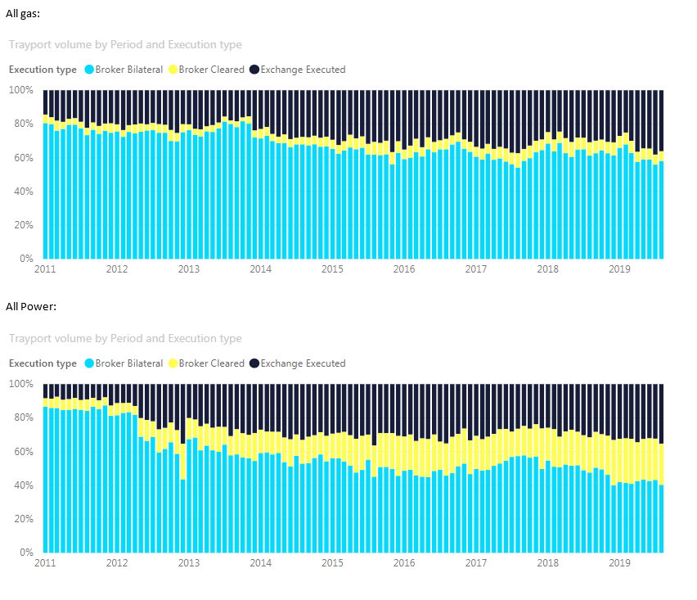

Table 1 clearly shows that there has been no shift of liquidity to OTFs from regulated markets since the implementation of MiFID II. Indeed, the opposite appears to be true as the data shows a decline in bilateral OTF trading compared with exchange-related trading, particularly in the case of power. In this context, “broker cleared” refers to trades which are arranged by OTC brokers and immediately registered with exchanges (usually as block futures transactions) and which from a regulatory perspective are Exchange-Traded-Derivatives. “Broker bilateral” refers to bilateral trades passing through OTFs.

Tables 2 to 4 below provide a more granular view of the splits between exchange traded, broker cleared and broker bilateral over the MiFID II implementation period for gas and power.

Table 2: Gas and Power



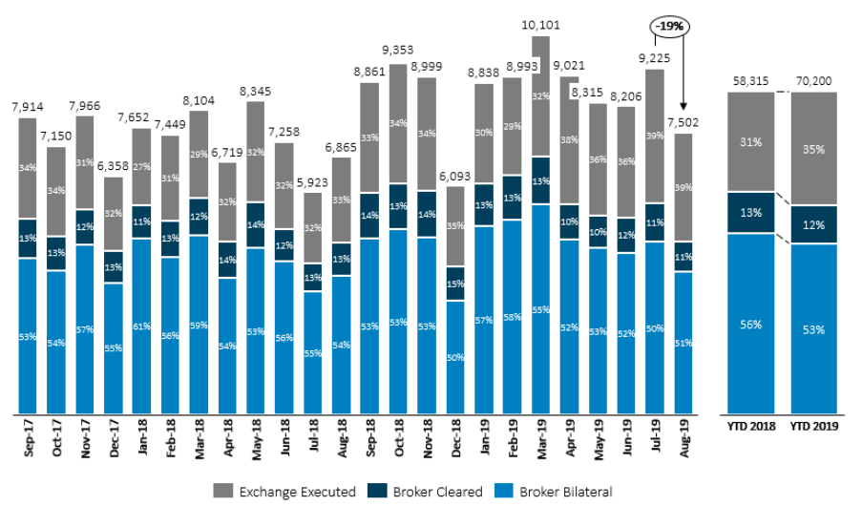

Table 3: Gas

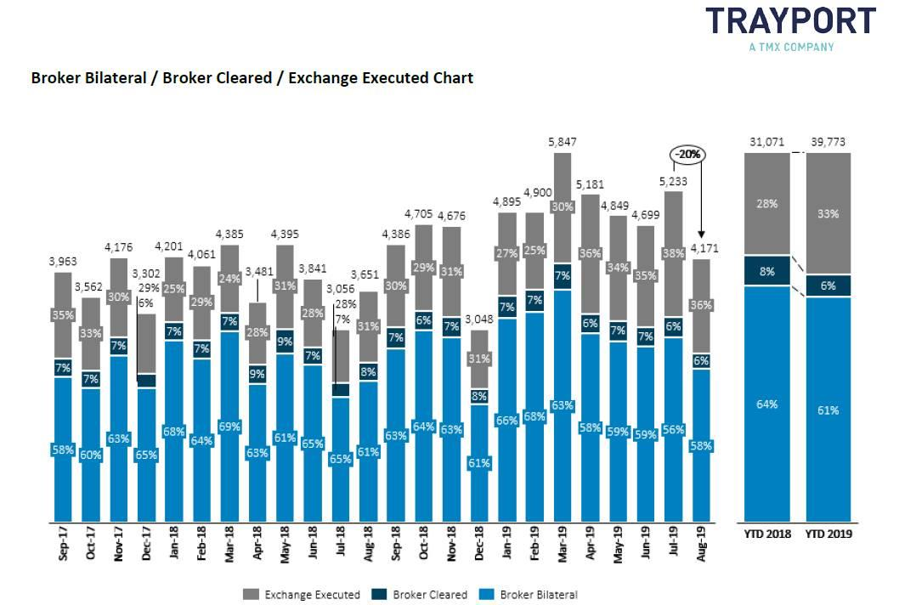

Table 4: Power

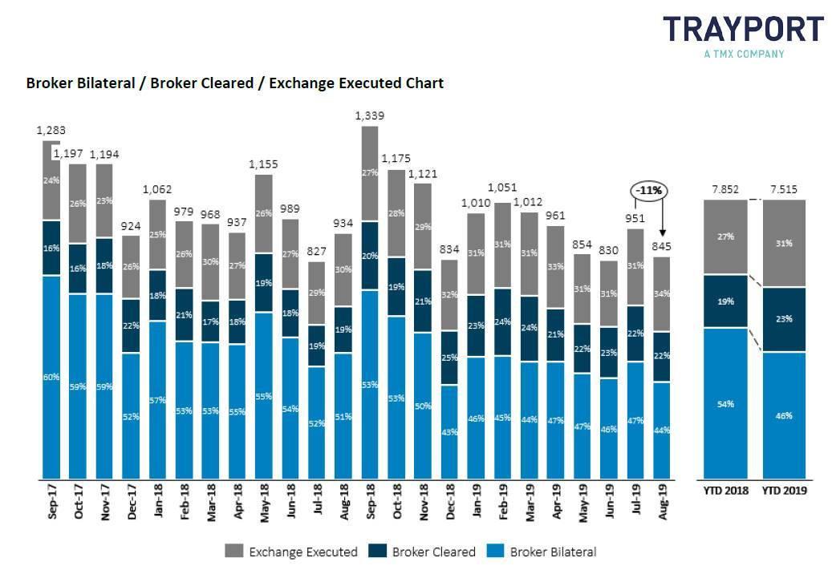

Table 2 shows that the proportions for combined gas and power trading has seen a fall in broker bilateral from 56% to 53% from September 2017 to August 2019 whereas the proportion of exchange traded contacts has risen from 31% to 35%.

The picture is more marked in power (Table 4) which shows a clear move in favour of exchanges over the MiFID II implementation period. In that period, the proportion attributable to exchange trading rose from 27% to 31% whereas broker bilateral trading dropped from 54% to 46%.

There is therefore clear evidence to show that the REMIT Carve Out has not created an unlevel playing field or distortion of competition between OTFs and regulated markets. Even if this were not the case, the operators of commodity futures exchanges could offer corresponding products themselves via their OTFs.

***Annex: Text of ESMA’s Consultation Paper, page 23***

“5.1.2 Reconsider the C(6) carve-out exemption

(1.) ESMA shares the concerns expressed by some respondents with regard to the shift of trading in physically-settled wholesale energy contracts (REMIT contracts) from regulated markets and MTFs to OTFs post-MiFID II as a result of the C(6) carve-out and the unlevel playing field this exemption has created.

(2.) Indeed, under the current framework, the exact same REMIT contract is subject to different rules, depending on where it is traded. Instruments traded on regulated markets and MTFs are subject to position limits as well as to other applicable MiFID II/MiFIR requirements, while identical instruments traded on OTFs are not considered as financial instruments and fall outside the scope of any of these obligations.

(3.) Unsurprisingly, the C(6) carve-out has proved a significant and successful incentive for market participants to move trading in REMIT contracts to OTFs and is the source of a major competitive disadvantage for regulated markets and MTFs, which ESMA can find no justification for.

(4.) ESMA first notes that the creation of the OTF category aimed at making the EU financial markets more transparent and efficient and at levelling the playing field between various venues offering multilateral trading services.

In ESMA’s view, the C(6) carve-out does not achieve this objective as it deliberately creates a competitive advantage for OTFs trading REMIT products.

Furthermore, ESMA notes that the C(6) carve-out penalises the already more heavily regulated trading venues. More fundamentally, ESMA considers that the same rules should apply to the same instruments independently of the EU trading venues where those instruments are traded and that the logic for any such differentiation remains unclear.

(5.) Consequently, ESMA is of the view that the current rules allowing for the exemption of the wholesale energy products traded on OTFs should be reconsidered.

[Q2]: Do you agree that the C(6) carve-out creates an unlevel playing field across trading venues and should be reconsidered? If not, please explain why.”

<ESMA_COMMENT_WPR_1>

**Questions**

**Part I**

1. : Which option (Option 1 or Option 2) do you support for dealing with competing contracts? Please explain why. If you support Option 1, do you have any suggestions for amending the definition of “same contract” in Article 5(1) of RTS 21? If you support another alternative, please explain which one and why.

<ESMA_QUESTION_WPR_1>

TYPE YOUR TEXT HERE

<ESMA_QUESTION_WPR_1>

1. : Do you agree that the C(6) carve-out creates an unlevel playing field across trading venues and should be reconsidered? If not, please explain why.

<ESMA_QUESTION_WPR_2>

No, LEBA-EVIA does not believe that the C(6) carve-out creates an unlevel playing field across trading venues and should be reconsidered for the reasons set out both in the introduction above and in the JEAG paper we co-authored which is attached.

<ESMA_QUESTION_WPR_2>

1. : Do you agree that the position limit framework should not apply to securitised derivatives? If not, please explain why.

<ESMA_QUESTION_WPR_3>

TYPE YOUR TEXT HERE

<ESMA_QUESTION_WPR_3>

1. : Which option do you support to address the negative impact of position limits on new and illiquid commodity derivatives: Option 1 or Option 2? Please explain why. If you support another alternative, please explain which one and why.

<ESMA_QUESTION_WPR_4>

TYPE YOUR TEXT HERE

<ESMA_QUESTION_WPR_4>

1. : If you support Option 1 and would suggest different or additional criteria to determine whether a contract qualifies as a critical contract, please explain which ones.

<ESMA_QUESTION_WPR_5>

TYPE YOUR TEXT HERE

<ESMA_QUESTION_WPR_5>

1. : Which open interest and participant threshold would you suggest for qualifying a commodity derivative as a critical one?

<ESMA_QUESTION_WPR_6>

TYPE YOUR TEXT HERE

<ESMA_QUESTION_WPR_6>

1. : Would you support a position limit exemption for financial counterparties under mandatory liquidity provision obligations? If not, please explain why.

<ESMA_QUESTION_WPR_7>

TYPE YOUR TEXT HERE

<ESMA_QUESTION_WPR_7>

1. : Would you support introducing a hedging exemption for financial counterparties along the lines described above? If not, please explain why.

<ESMA_QUESTION_WPR_8>

TYPE YOUR TEXT HERE

<ESMA_QUESTION_WPR_8>

1. : Do you agree with ESMA’s proposals to amend Article 57(8)(b) of MiFID II and to introduce Level 2 measures on position management controls? If not, please explain why.

<ESMA_QUESTION_WPR_9>

TYPE YOUR TEXT HERE

<ESMA_QUESTION_WPR_9>

**Part II**

1. : Do you agree with the revised proposed minimum threshold level for the open interest criterion for the publication of weekly position reports? If not, please state your preferred alternative for the definition of this threshold and explain why.

<ESMA_QUESTION_WPR_10>

TYPE YOUR TEXT HERE

<ESMA_QUESTION_WPR_10>

1. : Do you have any comment on the current number of position holders required for the publication of weekly position reports?

<ESMA_QUESTION_WPR_11>

TYPE YOUR TEXT HERE

<ESMA_QUESTION_WPR_11>