Reply Form to the Consultation Paper
  - MiFID II review report on position limits and position management
  - Draft Technical Advice on weekly position reports

Responding to this paper
ESMA invites comments on all matters in this paper and in particular on the specific questions summarised in Annex 1. Comments are most helpful if they:
- respond to the question stated;
- indicate the specific question to which the comment relates;
- contain a clear rationale; and
- describe any alternatives ESMA should consider.
ESMA will consider all comments received by 8 January 2020.
All contributions should be submitted online at www.esma.europa.eu under the heading ‘Your input - Consultations’. Please follow the instructions given in the document ‘Reply form for the consultation paper on “MiFID II review report on position limits and position management and draft technical advice on weekly position reports’ also published on the ESMA website.
Instructions
In order to facilitate analysis of responses to the Consultation paper, respondents are requested to follow the below steps when preparing and submitting their response:
- Insert your responses to the questions in the Consultation paper in the present response form.
- Please do not remove tags of the type <ESMA_QUESTION_WPR_1>. Your response to each question has to be framed by the two tags corresponding to the question.
- If you do not wish to respond to a given question, please do not delete it but simply leave the text “TYPE YOUR TEXT HERE” between the tags.
- When you have drafted your response, name your response form according to the following convention: ESMA_WPR_nameofrespondent_RESPONSEFORM. For example, for a respondent named ABCD, the response form would be entitled ESMA_WPR_ABCD_RESPONSEFORM.
- Upload the form containing your responses, in Word format, to ESMA’s website (www.esma.europa.eu under the heading “Your input – Open consultations” “Call for Evidence on Position limits and position management in commodities derivatives”).

Publication of responses
All contributions received will be published following the close of the consultation, unless you request otherwise. Please clearly and prominently indicate in your submission any part you do not wish to be publically disclosed. A standard confidentiality statement in an email message will not be treated as a request for non-disclosure. A confidential response may be requested from us in accordance with ESMA’s rules on access to documents. We may consult you if we receive such a request. Any decision we make not to disclose the response is reviewable by ESMA’s Board of Appeal and the European Ombudsman.
Data protection
Information on data protection can be found at www.esma.europa.eu under the heading Legal Notice.
Who should read this paper
All interested stakeholders are invited to respond to this consultation paper. This consultation paper is primarily of interest to trading venues, investment firms and non-financial counterparties trading in commodity derivatives, but responses are also sought from any other market participant including trade associations, industry bodies and investors.

General information about respondent
Name of the company / organisation | Europex
Activity | Regulated markets/Exchanges/Trading Systems
Are you representing an association? | ☒
Country/Region | Europe

Introduction
Please make your introductory comments below, if any
<ESMA_COMMENT_WPR_1>
Europex, the Association of European Energy Exchanges, welcomes the opportunity to contribute to the ESMA consultation paper on the MiFID II review report on position limits and position management in commodity derivatives. Europex has actively participated in previous MiFID related consultations, such as the call for evidence on position limits that took place last summer. While the review fulfils a legal obligation under MiFID II, this exercise is also a vital opportunity to assess the impact of position limits and position management on commodity derivatives markets and to ensure the regime is working in practice to fulfil its policy objectives.
Against this backdrop, Europex supports ESMA’s assessment of the issues to be addressed in the upcoming review, the two most important being the current regime’s negative impact on new and illiquid commodity derivatives and the lack of level playing field between exchanges offering liquid contracts with the same physical underlying. We firmly believe that the appropriate solution is to move towards a more proportionate and efficient position limit regime by focusing the application of the MiFID II position limit regime on a more limited set of important, critical commodity derivative contracts. This approach would help to foster the development of new and nascent contracts, while at the same time, it would better fulfil the overall objective of MiFID II to “improve the functioning and transparency of commodity markets and address excessive commodity price volatility”.
Well established position management controls that exchanges already have in place will ensure that contracts that are not assessed as ‘critical’ will continue to be controlled. The application of weekly position reporting to a wider set of contracts will also improve transparency.
<ESMA_COMMENT_WPR_1>

Questions

Part I

- : Which option (Option 1 or Option 2) do you support for dealing with competing contracts? Please explain why. If you support Option 1, do you have any suggestions for amending the definition of “same contract” in Article 5(1) of RTS 21? If you support another alternative, please explain which one and why.
<ESMA_QUESTION_WPR_1>
Europex supports Option 2.

We understand and agree with the rationale for levelling the playing field for competing commodity derivative contracts traded on different venues which are classified as liquid and have the same physical underlying. Indeed, the open interest figure which serves as a basis for setting the other months limit should be provided by the trading venue with the highest average open interest over a certain period, i.e. one year. The position limit of the most liquid commodity derivative contract should be applied identically to competing contracts that are deemed liquid and have the same physical underlying. Such an approach would prevent any discrimination of the MiFID II position limits regime towards trading venues with lower open interest in a contract with the same physical underlying.

In case of Option 2, three different scenarios might arise:

- If two trading venues list a commodity derivative contract with the same physical underlying, but neither of these contracts meets the criteria to be deemed liquid (or critical in the case the regime moved to a limited scope of application to critical contracts only) then no position limit applies.
- If one of the two contracts meets the criteria to be considered a liquid (or critical) contract, the position limit should apply only to the venue listing the liquid contract and not to the venue listing the commodity derivative contract with the same physical underlying that is not deemed liquid (or critical).
- Should both contracts be considered liquid (or critical), then the same position limit of the liquid (or critical) contract with the highest open interest should apply to the other liquid (or critical) contract(s) with the same physical underlying on other venues.

At the same time, most Europex members disagree with the proposal to amend the definition of the “same [commodity derivative] contract”. In this context, it should be emphasised that in practice commodity derivatives traded on different trading venues can never be considered as the “same contract”, even if they have the same physical underlying. This is because a contract is designed by the trading venue, whereby the rules and conditions, including those related to pricing and settlement, differ across venues. Thus, commodity derivatives traded on different trading venues cannot and should not be netted against each other for position limits or other purposes. Also, for this reason, the removal of the condition for contracts to “form the same pool of open interest” would not remedy the level playing field problem which ESMA is trying to solve. In addition, Option 2 would be a more pragmatic way forward, given the current set-up of NCAs towards position limits reporting and monitoring. It would, for example, be impossible for trading venues to have access to information on positions in contracts offered by other venues.
<ESMA_QUESTION_WPR_1>

- : Do you agree that the C(6) carve-out creates an unlevel playing field across trading venues and should be reconsidered? If not, please explain why.
<ESMA_QUESTION_WPR_2>
Europex continues to support the policy rationale for the exemption of physically settled gas and electricity contracts from the rules of EU financial regulation for the following reasons:

First, due to their specific characteristics carved out energy commodity contracts are subject to the energy-specific anti-market abuse regime of the Regulation on Wholesale Energy Market Integrity and Transparency (REMIT). Their inclusion in the complex and far-reaching matrix of the requirements under MiFID II/MiFIR, predominantly designed for investment firms and banks, could undermine their actual economic functions. In this context, it is important to note that they play an important role in the liberalisation and further development of the EU’s internal gas and electricity market. Moreover, they constitute important instruments for the energy transition as well as for the broader shift to a green and carbon-neutral economy in Europe.

Second, while there might be differences according to geography, market structures and specific asset classes, the overall trend of increased trading on regulated markets has not reversed since the beginning of the application of MiFID II/MiFIR on 3 January 2018 as is highlighted in the Trayport Euro Commodities Report from August 2019 (see below). We therefore currently do not see evidence that the C(6) carve-out has led to a shift in volumes to Organised Trading Facilities (OTFs).

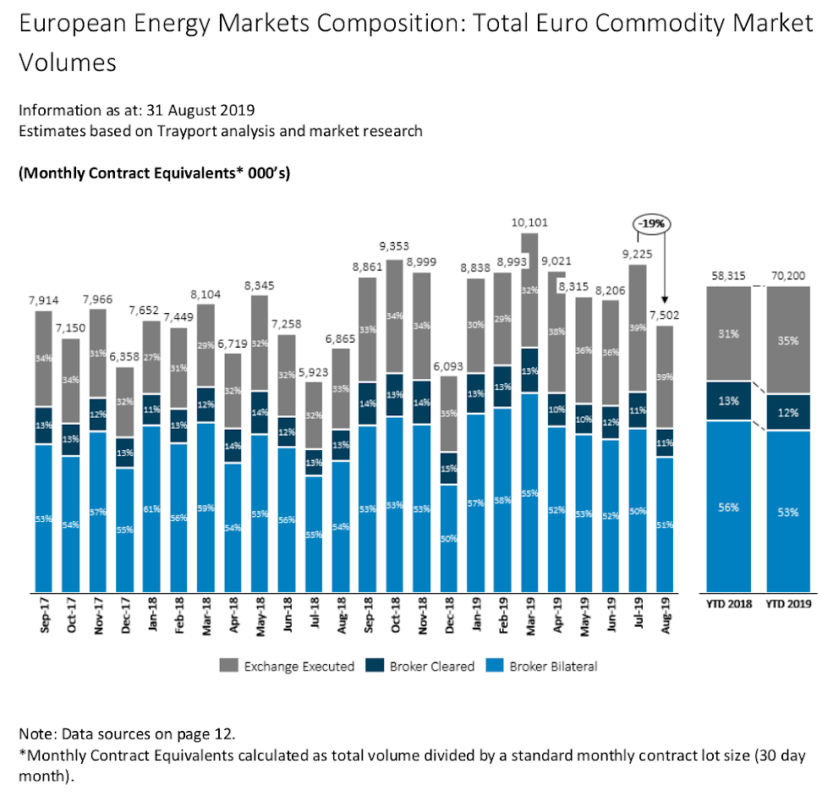

Finally, Europex believes that the focus of the upcoming MiFID II/MiFIR review should be on making MiFID II/MiFIR fit for firms trading commodity derivatives classified as financial instruments. In this view, ESMA should give priority to addressing the main flaws in the position limits regime by limiting its scope to critical contracts. The limitation in scope is urgently needed to allow exchanges in Europe to develop commodity derivative contracts and to successfully compete globally. Other unrelated policy changes could distract from this main objective.
<ESMA_QUESTION_WPR_2>

- : Do you agree that the position limit framework should not apply to securitised derivatives? If not, please explain why.
<ESMA_QUESTION_WPR_3>
No comment.
<ESMA_QUESTION_WPR_3>

- : Which option do you support to address the negative impact of position limits on new and illiquid commodity derivatives: Option 1 or Option 2? Please explain why. If you support another alternative, please explain which one and why.
<ESMA_QUESTION_WPR_4>
Europex believes that to effectively overcome the negative impact of the current regime on new and illiquid commodity derivatives a more fundamental review is needed, i.e. Option 1.

We believe that to solve the issues we have addressed in our response to ESMA’s recent call for evidence on this matter, we need to move towards a more proportionate and efficient position limits regime. This can be achieved by focusing the application of the MiFID II position limits regime on a more limited set of important, critical commodity derivative contracts, i.e. Option 1. This would not only allow new and illiquid contracts to develop, it would also better fulfil the overall objective of MiFID II to “improve the functioning and transparency of commodity markets and address excessive commodity price volatility”.

While in our response to the ESMA call for evidence that took place last summer, we have extensively demonstrated that the MiFID II position limits regime did not contribute to the prevention of market abuse, nor to the improvement of orderly pricing and settlement, we understand the view of policymakers that there might be a value in setting position limits to avoid excessive speculation adversely affecting prices. To achieve this objective - which is identical to the objective of the US position limits regime -, it is sufficient to consider only those contracts where the size of individual positions may affect the price of the respective financial instrument, and where this financial instrument is relevant for the price formation in the underlying commodity. New and illiquid products constitute a minor share of commodity markets. Such contracts are unlikely to influence price movements in the underlying physical commodity markets and do thus not negatively impact consumers.

The other (non-critical) contracts would remain subject to the position reporting regime under MiFID II Article 58, the pre-existing position monitoring and position management measures by exchanges and the market oversight practices of the exchanges’ market supervision and market surveillance departments that apply the principles set out in the Regulation on Wholesale Energy Markets Integrity and Transparency (REMIT) and the Market Abuse Regulation (MAR). (See also our response to Q9.) Thus, removing position limits for such contracts would not pose any risk to the transparency and functioning of the respective markets. On the contrary, attracting more volume to regulated venues would contribute to a more transparent trading environment.

However, while we clearly support Option 1, we believe that there is an urgent need to limit the negative impact the position limits regime in its current form has on new and illiquid contracts. For this, we recommend a two-tier approach whereby Level 2 is amended immediately, while the more fundamental reform is dealt with as part of the Level 1 review. As short term relief is essential, it must be ensured that any policy changes suggested under Option 2 can be introduced quickly before a more fundamental review is achieved in Level 1.

Such a Level 2 change should build upon the policy recommendations proposed by ESMA under Option 2. For this, we support a transitional period for new contracts during which no position limit shall apply. However, based on our experience, a 12-month period is too short to develop a contract. Therefore, this period should be extended to 24 months. Secondly, we believe that a 50% position limit for contracts below 20,000 lots of open interest is insufficient, especially for contracts with a very low open interest and typically a one-digit figure of market participants. If after 24 months the combined open interest has still not exceeded 20,000 lots, ideally a 10,000 lots limit should apply. Only such an approach can facilitate rapid growth and leave sufficient time for NCAs to set a bespoke position limit.

These transitional measures would only include an amendment of Articles 5 and 15 of the Delegated Act 591/2017. In particular, it should include a revision of the distinction between the ‘illiquid’ (below 10,000 lots) and ‘less liquid’ (below 20,000 lots) categories in Article 5 while introducing one basic category of ‘illiquid and less liquid’ contracts, i.e. all contracts below 20,000 lots of open interest. In line with this change, Article 15 should be amended accordingly, i.e. defining a new position limit of 10,000 lots. Article 15(1) would subsequently become redundant.

Furthermore, to facilitate the growth of fast-moving contracts of both illiquid and liquid contracts, we would like to recall our support for the introduction of a forward-looking model in which the position limit is calculated based on an extrapolation of the market’s historical development of open interest in the case of other month contracts and deliverable supply in the case of spot month contracts. This approach would be particularly well suited to accommodate for periods of strong market growth and should not only apply to setting the limits but also to classifying contracts as liquid or not.
<ESMA_QUESTION_WPR_4>

- : If you support Option 1 and would suggest different or additional criteria to determine whether a contract qualifies as a critical contract, please explain which ones.
<ESMA_QUESTION_WPR_5>
Exchanges use various criteria to assess the liquidity of a market. They include, inter alia, open interest, share of open interest versus deliverable supply, number of active trading participants, churn ratio (for physically settled contracts), share of screen execution and average trading horizon. However, based on internal assessments, Europex has come to the conclusion that these parameters are highly correlated and therefore open interest is sufficient to determine whether a contract qualifies as a ‘critical’ or not. It would be redundant to set additional parameters.

In addition, we would not oppose adding “underlying asset” as an additional factor.
<ESMA_QUESTION_WPR_5>

- : Which open interest and participant threshold would you suggest for qualifying a commodity derivative as a critical one?
<ESMA_QUESTION_WPR_6>
Europex considers a commodity derivative contract to be critical once it has developed into a highly liquid instrument with open interest levels that imply that all the various more detailed liquidity criteria have been met. Furthermore, the price signal of a critical contract should be broadly recognised in the wider market as a relevant benchmark price for its underlying commodity.

Based on the criteria that exchanges use to determine which markets should be considered mature and developed, Europex recommends that a contract should have at least 300,000 lots of open interest on average over one year to qualify as ‘critical’. This threshold is based on the open interest calculated by individual exchanges. This approach would produce an outcome broadly comparable with the US regime for position limits, whereby we expect more than 20 commodity derivative contracts offered for trading in Europe to be classed as critical (see table below).

Trading Venue offering the product | Type | Name of the product
EEX AG | Electricity | Phelix DE-Futures
EEX AG | Electricity | Italian Base
Nasdaq Oslo ASA | Electricity | Nordic Power
ICE Futures Europe | Oil | Brent Crude Futures
ICE Futures Europe | Oil | WTI Crude Futures
ICE Futures Europe | Oil | Low Sulphur Gasoil Futures
ICE Futures Europe | Oil | Crude Diff - Dated Brent vs Brent 1st Line Future
ICE Futures Europe | Oil | Brent 1st Line Future
ICE Futures Europe | Natural Gas | UK Natural Gas Futures
ICE Endex | Natural Gas | TTF Gas Futures
EEX AG | Natural Gas | EEX Regulated Market Futures TTF

Please note that Europex has merely provided examples of energy derivative contracts above the thresholds for critical contracts. Metals and agricultural contracts have not been taken into account and should add a considerable amount of additional critical contracts.

In relation to the ‘type and variety of market participants’, we consider this indicator to be normally highly correlated with open interest. For the sake of transparency and simplicity , we therefore recommend that this criterion is not considered.

However, should ESMA nevertheless wish to take this criterion into account, we recommend that there should be at least 50 actively trading market participants in a contract on average over a one-year period. This number of market participants is also a factor to be considered by NCAs when setting position limits under the implementing legislation of MiFID II Article 57. To qualify as critical, a contract would have to breach the thresholds for open interest and actively trading participants.
<ESMA_QUESTION_WPR_6>

- : Would you support a position limit exemption for financial counterparties under mandatory liquidity provision obligations? If not, please explain why.
<ESMA_QUESTION_WPR_7>
Yes, we fully support a position limit exemption for financial counterparties under mandatory liquidity provision obligations, similar to the one outlined in Article 2(4) of MiFID II. However, such an exemption should not be limited to financial counterparties only. Very often, if not in most cases, non-financial counterparties fulfil mandatory liquidity obligations. For this case, too, a position limit exemption should be granted.

This is particularly necessary for new contracts that need financial or non-financial entities to incentivise trading in the contract, at least if the position limits regime continues to include the restrictive 2,500 lots limit on new and illiquid contracts. If no such exemption is available and the 2,500 lots limit continues to apply, exchanges have to contract a ‘panel’ of liquidity providers to ensure that none of these firms exceed the 2,500 lots limit. In nascent markets it is highly possible that there may not be the required number of counterparties to build such a ‘panel’ and even where this is the case, it adds significant costs for the exchange.

In order to avoid such a situation, Europex recommends that the position limits regime includes an explicit exemption based on the same conditions as the liquidity provision exemption outlined in Article 2(4) of MiFID II and the ESMA Q&A on MiFID II/MiFIR commodity derivative topics. This exemption should be implemented similarly to the hedging exemption under the position limits regime.
<ESMA_QUESTION_WPR_7>

- : Would you support introducing a hedging exemption for financial counterparties along the lines described above? If not, please explain why.
<ESMA_QUESTION_WPR_8>
Europex supports the introduction of a hedging exemption for financial counterparties.

At the same time, Europex disagrees with ESMA’s view that the compliance monitoring of such exemptions by regulators would not be possible or efficient. In fact, exchanges such as ICE have been operating internal position management systems allowing for exemptions from limits of positions held for genuine hedging purposes by market participants, regardless of their regulatory status or nature of business. We believe that a similar system, inclusive for financial counterparties, could be operated by financial regulators across the EU, all the more given the amount of information the NCAs receive about the activities of such entities.
<ESMA_QUESTION_WPR_8>

- : Do you agree with ESMA’s proposals to amend Article 57(8)(b) of MiFID II and to introduce Level 2 measures on position management controls? If not, please explain why.
<ESMA_QUESTION_WPR_9>
Europex supports the current regime where trading venues have a substantial responsibility for position monitoring and control. Some trading venues have operated sophisticated position management regimes since before MiFID II. These regimes generally include:

- Accountability levels above which members are required to report certain information to the exchange (e.g. their positions in a contract in question and the beneficiaries thereof);
- Position, expiry and delivery limits indicating maximum positions that can be held by members in the contract in question at a given time;
- Exchange rules providing compliance teams with powers to:
- Request information from members as to the purpose of the positions they hold in a contract in question;
- Order members to decrease their position;
- Discipline members that do not comply with the above.

These position management regimes are operated by teams of competent staff and technologically advanced tools to monitor on a daily basis the open interest in contracts admitted to trading, positions held in those contracts by exchange members and the activity in physical markets underlying the commodity derivatives admitted to trading. These regimes are cautiously calibrated and tailored to the circumstances of each individual exchange such as the nature of its membership, characteristics of the contracts it admits to trading and the underlying markets. There is no ‘one size fits all’ for these position management regimes.

In reference to our response to the call for evidence, we would like to again highlight that besides being subject to position management regimes, exchange-traded gas and power derivatives markets are also under scrutiny of the exchanges’ market supervision and market surveillance departments. The departments apply the principles set out in REMIT and MAR, which both apply to gas and power derivatives markets. While REMIT introduces a sector-s​pecific legal framework for identifying and penalising insider trading and market manipulation in wholesale energy markets across Europe, MAR establishes a pan-European regime to prevent and detect market abuse, market manipulation and insider dealing in financial markets, including in energy derivatives markets.

These pre-existing regulations as well as the work of market supervision and market surveillance departments have been effective in preventing market abuse and excessive speculation. REMIT and MAR have a clear objective which stands in contrast to Recital 128 of MiFID II stating that “All venues […] should have in place appropriate position management controls […] to mitigate the effects of large and dominant positions.” From this perspective, we believe that MAR should be the appropriate framework to apply for the position management controls in order to secure that national implementations follow the same direction.
<ESMA_QUESTION_WPR_9>

Part II

- : Do you agree with the revised proposed minimum threshold level for the open interest criterion for the publication of weekly position reports? If not, please state your preferred alternative for the definition of this threshold and explain why.
<ESMA_QUESTION_WPR_10>
Europex supports the revision of the proposed threshold level for the publication of weekly position reports. However, we believe that the proposed threshold would be too low to prevent that market participants with open positions in a particular contract can be easily identified. We therefore suggest decreasing the current threshold of the absolute amount of open interest being four times the size of deliverable supply and to set a new threshold whereby open interest simply equals deliverable supply.
<ESMA_QUESTION_WPR_10>

- : Do you have any comment on the current number of position holders required for the publication of weekly position reports?
<ESMA_QUESTION_WPR_11>
We support the current number of position holders required for the publication of weekly position reports, provided that the open interest is higher than the size of deliverable supply.

However, the total number of position holders must be combined with a minimum threshold in each category for preserving the anonymity of market participants. Effectively, if the number of position holders in one category is too low, their positions might be deduced by other market players (primarily by others in the same category), putting at risk their strategy and economic position. Accordingly, we consider that for each category of position holders, there must be at least four different entities. This will provide increased transparency, also with regard to contracts that do not longer fall within the scope of the position limits regime, while preventing a situation in which market participants become easily identifiable.
<ESMA_QUESTION_WPR_11>

