|  |
| --- |
| Reply Form to the Consultation Paper |
| MiFID II review report on position limits and position management  Draft Technical Advice on weekly position reports |

**Responding to this paper**

ESMA invites comments on all matters in this paper and in particular on the specific questions summarised in Annex 1. Comments are most helpful if they:

* respond to the question stated;
* indicate the specific question to which the comment relates;
* contain a clear rationale; and
* describe any alternatives ESMA should consider.

ESMA will consider all comments received by **8 January 2020.**

All contributions should be submitted online at [www.esma.europa.eu](http://www.esma.europa.eu) under the heading ‘Your input - Consultations’. Please follow the instructions given in the document ‘Reply form for the consultation paper on “MiFID II review report on position limits and position management and draft technical advice on weekly position reports’ also published on the ESMA website.

**Instructions**

In order to facilitate analysis of responses to the Consultation paper, respondents are requested to follow the below steps when preparing and submitting their response:

1. Insert your responses to the questions in the Consultation paper in the present response form.
2. Please do not remove tags of the type <ESMA_QUESTION_WPR_1>. Your response to each question has to be framed by the two tags corresponding to the question.
3. If you do not wish to respond to a given question, please do not delete it but simply leave the text “TYPE YOUR TEXT HERE” between the tags.
4. When you have drafted your response, name your response form according to the following convention: ESMA_WPR_nameofrespondent_RESPONSEFORM. For example, for a respondent named ABCD, the response form would be entitled ESMA_WPR_ABCD_RESPONSEFORM.
5. Upload the form containing your responses, in Word format, to ESMA’s website ([www.esma.europa.eu](http://www.esma.europa.eu) under the heading “Your input – Open consultations” 🡪 “Call for Evidence on Position limits and position management in commodities derivatives”).

**Publication of responses**

All contributions received will be published following the close of the consultation, unless you request otherwise. Please clearly and prominently indicate in your submission any part you do not wish to be publically disclosed. A standard confidentiality statement in an email message will not be treated as a request for non-disclosure. A confidential response may be requested from us in accordance with ESMA’s rules on access to documents. We may consult you if we receive such a request. Any decision we make not to disclose the response is reviewable by ESMA’s Board of Appeal and the European Ombudsman.

**Data protection**

Information on data protection can be found at [www.esma.europa.eu](http://www.esma.europa.eu) under the heading [Legal Notice](http://www.esma.europa.eu/legal-notice).

**Who should read this paper**

All interested stakeholders are invited to respond to this consultation paper. This consultation paper is primarily of interest to trading venues, investment firms and non-financial counterparties trading in commodity derivatives, but responses are also sought from any other market participant including trade associations, industry bodies and investors.

**General information about respondent**

|  |  |
| --- | --- |
| Name of the company / organisation | Commodity Markets Council Europe |
| Activity | Non-financial counterparty |
| Are you representing an association? |  |
| Country/Region | Europe |

**Introduction**

***Please make your introductory comments below, if any***

<ESMA_COMMENT_WPR_1>

* Commodity Markets Council Europe (CMCE) is the only association in Europe representing the range of commodity market participants - agriculture, energy, metals and other commodity market participants, benchmark providers, price reporting agencies, and trading venues operating in the EU, EEA, Switzerland and neighbouring countries. The majority of CMCE members use commodity derivative markets to hedge the risks related to their physical activities and assets. CMC Europe’s key purpose is to engage with policy-makers and regulators to promote liquid and well-functioning commodity derivative markets in Europe.
* CMCE Members welcome the opportunity to respond to the consultation launched by ESMA on the review of the MiFID II position limits and position management in view of the future report that ESMA will submit to the European Commission.
* CMCE Members consider that MiFID II has generally not caused any significant negative consequences except for the constraints for new and illiquid contracts. We are of the view that the respective regime could still be improved and we welcome ESMA’s proposals in this regard.
* CMCE Members value the regulatory regime based on the current definition of same derivative contract for the legal certainty it provides. For the reasons detailed in the response, they are convinced that there is insufficient reason to change the current regime.
* CMCE Members strongly recommends that the C6 REMIT carve-out is retained. Its purpose is to avoid regulatory duplicity in respect of physically settled power and gas contracts; they are regulated under the Wholesale Energy Market Integrity and Transparency (REMIT) and supervised by ACER. It is essential to understand the specificity of the fine-tuned wholesale energy markets in the EU to ensure competitive gas and power prices for consumers across the EU. Supported with the data, CMCE demonstrates in the response that there is no unlevel playing field across trading venues and that there has been no migration of liquidity from trading venues to OTFs.

<ESMA_COMMENT_WPR_1>

**Questions**

**Part I**

1. : Which option (Option 1 or Option 2) do you support for dealing with competing contracts? Please explain why. If you support Option 1, do you have any suggestions for amending the definition of “same contract” in Article 5(1) of RTS 21? If you support another alternative, please explain which one and why.

<ESMA_QUESTION_WPR_1>

The CMCE members disagree with the proposal to amend the definition of the “same” commodity derivative.

CMCE Members particularly value the current regulatory regime for the legal certainty it provides.

The position limits regime is driven by overriding policy considerations, clearly expressed in Recitals (127) to (131) of MiFID2. The key objective of the position limits regime is to “prevent market abuse, including cornering the market, and to support orderly pricing and settlement conditions including the prevention of distorting positions. Such limits should promote integrity on the market for the derivative and the underlying commodity without prejudice to price discovery on the market for the underlying commodity…”.

CMCE Members do not consider that the current definition of the same commodity derivative has led to the fragmentation of markets or to disruption or to increased risks of market abuse or excessive speculation. To change the regime for the purpose of levelling a perceived inequality between trading venues, would be to risk undermining the fundamental purpose of the regime. Practical considerations of some complexity arise if “same contracts” were to arise for contracts on different markets with different trading rules, price discovery processes and settlement arrangements. There is also the risk of unintended consequences with potentially increased risks of cross-market manipulation across markets linked by a common position limit but with separate price formation functionalities.

Based on these explanations, the CMCE Members are convinced that there is insufficient reason to change the current regime.

<ESMA_QUESTION_WPR_1>

1. : Do you agree that the C(6) carve-out creates an unlevel playing field across trading venues and should be reconsidered? If not, please explain why.

<ESMA_QUESTION_WPR_2>

CMCE Members strongly disagree with the proposed approach. Based on the data, there has not been any migration of liquidity from trading venues to OTFs, in fact, the data confirmed that the opposite has been the case.

There is no need to remove the REMIT Carve-out for the following reasons:

* The C6 REMIT carve out captures only **physical** transactions of gas and power which are really for physical settlement and are thus demonstrably part of the commercial energy trading market and not financial in nature. Market participants need to be able to deliver or take delivery of the contract or they will be subject to sector-specific imbalancing procedures. The definition of **must be physically settled** is inherent to the nature of the REMIT carve-out.
* Wholesale energy trading in gas and power is subject to a specific functioning tailored regulation (REMIT) which has been well-established. REMIT was designed in 2011 by DG Energy, based on the advice from the Committee of European Securities Regulators (CESR) before the creation of ESMA, and of the European regulators Group for Electricity and Gas, to combat insider trading and market manipulation in this sector. Even if the Market Abuse Directive was reformed after REMIT’s adoption and the Market Abuse Regulation now addresses insider trading and market manipulation for commodity derivatives and spot commodity contracts, the basis for a specific regulation addressing European gas and power markets remains. It would not be appropriate to duplicate regulation and to apply MiFID to these markets.
* Under the current REMIT regime, the C6 REMIT carve-out contracts are regulated via tailored regime and supervised through a specialised competent authority, which ensures the functioning of the European gas and power energy markets according to principles designed to advance the general good. In addition, many sector specific regulations have been adopted (Third Energy Package, Transparency Regulation) which ensure supervision, integrity and transparency for wholesale energy products, regardless of the place of trading. We note that Energy Regulators also supervise system operators who manage the access to the energy networks including trading and scheduling arrangements for the delivery of gas and power. The network access arrangements between system operators and market participants include also credit controls and limitations to avoid the situations in which the exposure of the energy systems to market participants could reach levels that are unsustainable and, in case of default of the market participant, may have an impact on the other users of the energy systems.
* Each transaction is subject to REMIT reporting which guarantees transparency in the physical market. REMIT envisages information sharing as between energy regulators and financial regulators on this head.

Potential unintended consequences of Removal/Recasting of C6 carve-out:

* Energy firms may choose to enter into physical gas/power trades without using OTFs or EU trading venues.
* Energy firms may decide not to trade in these markets or to reduce trading levels. This would give rise to potential price volatility and, as these firms would be less able to hedge themselves and would carry more price fluctuation risk. This will have an adverse impact on the real economy which could result in higher end consumer gas and power prices.
* Such an inappropriate duplication and application of MiFID II requirements to these markets would complicate and confuse compliance with the existing regulation of contracts for the physical delivery of power and gas, creating substantial knock-on effects under EMIR and other parts of MiFID II.

C6 carve-out and the growing liquidity on regulated markets

ESMA states on page 23 that: “*ESMA shares the concerns expressed by some respondents with regard to the shift of trading in physically-settled wholesale energy contracts (REMIT contracts) from regulated markets and MTFs to OTFs post-MiFID II as a result of the C(6) carve-out and the unlevel playing field this exemption has created*.”

These physical products have been out of the scope of financial regulation since MiFID I (and before) and were predominantly traded on non-MiFID I broker platforms. It would, therefore, be incorrect to conclude that with the introduction of the C6 carve out trading in physically-settled wholesale energy contracts shifted from MiFID regulated platforms to OTFs. By introducing OTFs, MiFID II just provided formalization of the previous (MIFID I) non-MTF term and introduced the criterion “must be physically settled”. Additionally, OTF’s created transparency in the physical market, which set the right price signals to hedge.

The quantitative data do not seem to support the ESMA’s statement. On the contrary, the data which is publicly available https://www.trayport.com/category/market-dynamics-report/? shows that the opposite has happened and that since the implementation of MiFID II, the market share of exchange executed transactions in gas and power has grown.

The chart below shows the Trayport monthly data since 2011 for gas and power.

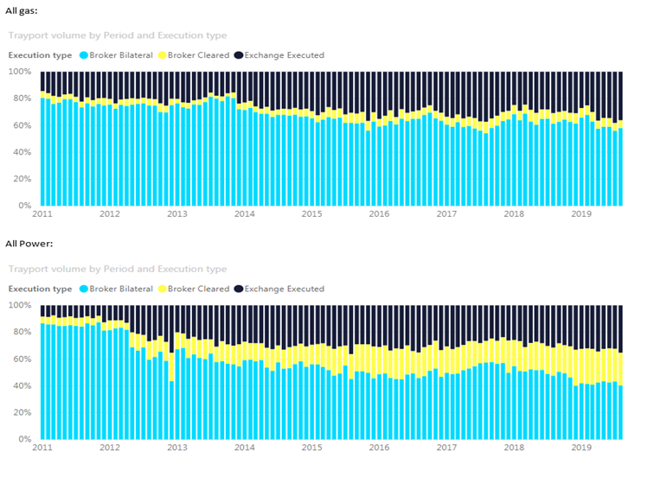

The data in the chart below shows that compared with 2018 in 2019 (YTD August) the market share of exchange traded gas and power products has grown by 4%.

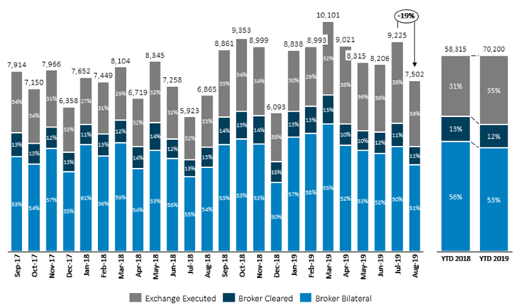

Substantial differences between the Energy sector and the Financial sector

CMCE Members strongly encourage ESMA to consider the substantial structural differences between the energy sector and the financial sector. Energy sector issues – which centre around transparency, conduct and security of supply are all specifically addressed under the well-developed REMIT regime and the Third Energy Package. CMCE Members are not aware of any additional financial regulatory objective which would be fulfilled by including these types of contracts in the MiFID II regime.

Conclusion

CMCE Members believe that the above-mentioned arguments and data establish there is no unlevel playing field across trading venues and that the C6 REMIT carve-out serves well its intended purpose as it is designed to address non-financial instruments which help to ensure competitive gas and power prices for consumers across the EU. Any change of the well-crafted and balanced regulation would affect the fine-tuned wholesale energy markets in gas and power in the EU.

<ESMA_QUESTION_WPR_2>

1. : Do you agree that the position limit framework should not apply to securitised derivatives? If not, please explain why.

<ESMA_QUESTION_WPR_3>

TYPE YOUR TEXT HERE

<ESMA_QUESTION_WPR_3>

1. : Which option do you support to address the negative impact of position limits on new and illiquid commodity derivatives: Option 1 or Option 2? Please explain why. If you support another alternative, please explain which one and why.

<ESMA_QUESTION_WPR_4>

CMCE Members consider that the position limits regime was unprecedented, in that it extends to every single commodity derivative traded in the EU, and after only two years of application, it remains difficult to assess its full impact. Having said that, CMCE Members have noted that the specific treatment of new and illiquid contracts and particularly the de-minimis threshold is a barrier to the development of markets.

Under RTS 21, ESMA has established a specific regime for new and illiquid contracts for the purpose of calculations of position limits. Article 15 of RTS 21, states that new contracts traded on a trading venue with a total combined interest in spot and other months not exceeding 10,000 lots over a consecutive three-month period shall be set a limit of 2,500 lots. CMCE Members note that some NCAs have interpreted this requirement to mean that on day 1 of a new commodity derivative, a limit of 2,500 lots would apply. Market participants have raised that this limit is too restrictive to allow a new contract to develop into a liquid instrument. In line with ESMA Q&As on ‘commodity derivative topics’, NCAs can use different derogations for illiquid markets which have an open interest between 5.000 and 10.000 lots, however, these remain difficult to apply in practice in a meaningful manner and are often not sufficient to mitigate the negative impact of disproportionately low position limits.

CMCE Members believe that a fundamental review is needed in the long run, along the lines of Option 1. This would imply a more proportionate and efficient position limit regime by focusing its application on a more limited set of ‘“critical’” commodity derivative contracts. Such a regime would allow new and illiquid products to develop, and also contribute to better fulfilling the overall objective of MiFID II to “improve the functioning and transparency of commodity markets and address excessive commodity price volatility”.

At the same time, given the complexity of the legislative process necessary to change the Level 1 text, we welcome ESMA’s statement that some amendments to the Level 2 measures on position limits may be appropriate until the change of the Level 1 text is implemented. To prevent the negative consequences for new and illiquid markets in the meantime, CMCE Members would encourage the responsible authorities that Option 2, i.e. suspending the limits for new contracts for a certain period, is implemented in the shortest possible term. However, a 12-month period suggested by ESMA is too short to develop a contract and CMCE therefore recommends, instead that this period should be extended to 24 months.

It is important to note, however, that a maximum position limit of up to 50% of the reference amount for contracts below 20,000 lots open interest might not be enough, especially for contracts with a very low open interest and typically a one-digit figure of market participants. For example, should a contract only have 4,000 lots open interest and the position limits is subsequently set at 2,000 lots, the proposal would result in more restrictive limits than the current regime. If, after 24 months, the combined open interest has still not exceeded 20,000 lots, ideally 10,000 lots de-minimis limit should apply. Such an approach can facilitate rapid growth as well as provide enough time for NCAs to set a bespoke position limit.

<ESMA_QUESTION_WPR_4>

1. : If you support Option 1 and would suggest different or additional criteria to determine whether a contract qualifies as a critical contract, please explain which ones.

<ESMA_QUESTION_WPR_5>

CMCE Members suggest continuing to use open interest as a parameter.

<ESMA_QUESTION_WPR_5>

1. : Which open interest and participant threshold would you suggest for qualifying a commodity derivative as a critical one?

<ESMA_QUESTION_WPR_6>

To ensure that only those contracts are captured of which the price serves as a benchmark for the underlying commodity, CMCE Members believe it would be appropriate to look at contracts that exceed 300,000 lots open interest. The number of market participants that correlate to this figure is significantly different across different asset classes, though the figure should not be lower than 20 market participants for a contract to be considered critical.

<ESMA_QUESTION_WPR_6>

1. : Would you support a position limit exemption for financial counterparties under mandatory liquidity provision obligations? If not, please explain why.

<ESMA_QUESTION_WPR_7>

TYPE YOUR TEXT HERE

<ESMA_QUESTION_WPR_7>

1. : Would you support introducing a hedging exemption for financial counterparties along the lines described above? If not, please explain why.

<ESMA_QUESTION_WPR_8>

TYPE YOUR TEXT HERE

<ESMA_QUESTION_WPR_8>

1. : Do you agree with ESMA’s proposals to amend Article 57(8)(b) of MiFID II and to introduce Level 2 measures on position management controls? If not, please explain why.

<ESMA_QUESTION_WPR_9>

TYPE YOUR TEXT HERE

<ESMA_QUESTION_WPR_9>

**Part II**

1. : Do you agree with the revised proposed minimum threshold level for the open interest criterion for the publication of weekly position reports? If not, please state your preferred alternative for the definition of this threshold and explain why.

<ESMA_QUESTION_WPR_10>

TYPE YOUR TEXT HERE

<ESMA_QUESTION_WPR_10>

1. : Do you have any comment on the current number of position holders required for the publication of weekly position reports?

<ESMA_QUESTION_WPR_11>

TYPE YOUR TEXT HERE

<ESMA_QUESTION_WPR_11>