|  |
| --- |
| Response Form to the Consultation Paper |
| Guidelines on performance fees in UCITS |

**Responding to this paper**

ESMA invites comments on all matters in this consultation paper and in particular on the specific questions summarised in Annex I. Comments are most helpful if they:

* respond to the question stated;
* indicate the specific question to which the comment relates;
* contain a clear rationale; and
* describe any alternatives ESMA should consider.

ESMA will consider all comments received by **31/10/2019.**

All contributions should be submitted online at [www.esma.europa.eu](http://www.esma.europa.eu) under the heading ‘Your input - Consultations’.

**Instructions**

In order to facilitate analysis of responses to the Consultation Paper, respondents are requested to follow the below steps when preparing and submitting their response:

1. Insert your responses to the questions in the Consultation Paper in the present response form.
2. Please do not remove tags of the type <ESMA_QUESTION_PFG_1>. Your response to each question has to be framed by the two tags corresponding to the question.
3. If you do not wish to respond to a given question, please do not delete it but simply leave the text “TYPE YOUR TEXT HERE” between the tags.
4. When you have drafted your response, name your response form according to the following convention: ESMA_PFG_nameofrespondent_RESPONSEFORM. For example, for a respondent named ABCD, the response form would be entitled ESMA_PFG_ABCD_RESPONSEFORM.
5. Upload the form containing your responses, in Word format, to ESMA’s website ([www.esma.europa.eu](http://www.esma.europa.eu) under the heading “Your input – Open consultations” 🡪 “Consultation on Position limits and position management in commodities derivatives”).

**Publication of responses**

All contributions received will be published following the close of the consultation, unless you request otherwise. Please clearly and prominently indicate in your submission any part you do not wish to be publically disclosed. A standard confidentiality statement in an email message will not be treated as a request for non-disclosure. A confidential response may be requested from us in accordance with ESMA’s rules on access to documents. We may consult you if we receive such a request. Any decision we make not to disclose the response is reviewable by ESMA’s Board of Appeal and the European Ombudsman.

**Data protection**

Information on data protection can be found at [www.esma.europa.eu](http://www.esma.europa.eu) under the heading [Legal Notice](http://www.esma.europa.eu/legal-notice).

**Who should read this paper**

This document will be of interest to asset managers managing retail funds and their trade associations, as well as institutional and retail investors investing into such funds and their associations.

**General information about respondent**

|  |  |
| --- | --- |
| Name of the company / organisation | Orbis Investment Management (Luxembourg) S.A. |
| Activity | Other Financial service providers |
| Are you representing an association? |  |
| Country/Region | Luxembourg |

**Introduction**

***Please make your introductory comments below, if any***

<ESMA_COMMENT_PFG_1>

Further to ESMA’s 16 July 2019 consultation paper on Guidelines on Performance Fees in UCITS (the **ESMA Paper**), we are pleased to provide the following comments on behalf of Orbis Investment Management (Luxembourg) S.A. and the other members of the Orbis group (collectively, **Orbis**).

Orbis is an investment management firm established in 1989 with approximately US$35 billion of assetsunder management (**AuM**). Orbis is authorised by the *Commission de Surveillance du Secteur Financier* as a management company under Chapter 15 of the law of 17 December 2010 relating to undertakings for collective investment, and has been appointed the manager of the Orbis SICAV (Luxembourg UCITS launched in 2002), and the authorised corporate director of the Orbis OEIC (United Kingdom UCITS launched in 2014).

Since its inception, Orbis has utilised performance fee models to link our remuneration to the extent possible to the performance outcomes experienced by our clients, with the ultimate goal of delivering excellent value for money. These models, some of which are described below, are now an integral part of our offerings and therefore of critical importance to our firm and clients. We are grateful for the opportunity to participate in this consequential consultation.

**Background**

Traditional performance fees have a bad name in the European fund management industry – and for good reason. Typically, these fee structures provide the manager both a significant share of assets under management as well as a share of any excess returns generated for clients. This creates a poorly aligned *“heads we win, tails you lose”* proposition for investors, which was highlighted in a paper published by London’s Cass Business School in 2014 (the **Cass Study**) and cited by the UK Financial Conduct Authority in its Asset Management Market Study Interim Report MS15/2.2 (the **Interim Report**).[1] The Interim Report highlights many examples of these misalignments including: misuse of benchmarks (4.54); excessive risk taking (6.13); complicated fee structures poorly explained (8.138); unfairness of asymmetric fees (9.19); and the use of performance fees with targeted absolute return funds (9.19).

We agree with the statements of the Chair of ESMA, Steven Maijoor, in his keynote address at the EFAMA Investment Management Forum on 16 November 2017, that the overall objective should be to ensure that performance fee models are fair and consistent with the investment policy of the fund, and that it is appropriate to look closely at performance fee structures and test them against the reasonable expectations of investors.

*Orbis Performance Fee Models*

Orbis is founded on the principle of aligning our interests with those of our clients. For this reason, and as detailed below, performance fees have always been offered in all of our Funds and regarded by our stakeholders as a differentiating competitive advantage, fundamental to the value we strive to deliver to our clients. We believe that managers who fail to deliver value for money should struggle to remain in business – that is the competitive reality for most other businesses, and investment management should be no exception. However, under prevailing fee models, driven primarily by levels of AuM, this is often not the case, as discussed below.

The Orbis SICAV and the Orbis OEIC offer seven strategies in 10 subfunds (collectively, the **Funds**, each a **Fund**). Our performance fee models can be divided into two broad categories: (i) traditional fulcrum fees (**Fulcrum Fees**), and (ii) as described below, enhanced forms of fulcrum fees (**Refundable Reserve Fees**). In all cases, Orbis’ remuneration is, and has always been, almost entirely dependent on the performance we deliver to our clients.

Our traditional Fulcrum Fees “swing” between a minimum and maximum based on the performance of the share class compared to the performance of a relevant benchmark within a rolling three-year performance reference period.

Our Refundable Reserve Fees also vary based on the performance of the share class compared to the performance of a relevant benchmark.[2] However, this enhanced model goes further than traditional Fulcrum Fees: performance fees earned by the manager are not automatically crystallised but instead accrue into a separate “Fee Reserve” that is available for symmetrical refunds to the share class in case of subsequent underperformance.[3] If the share class underperforms when there is no accrued balance in the Fee Reserve, relative losses must be recovered all the way to the high-water mark (**HWM**) before any performance fee can again begin to accrue in the Fee Reserve.

When the Fee Reserve is positive, a limited portion is crystallised on each dealing day (subject to certain caps that restrict the amount of the accrued performance fees permitted to be crystallised in any given period). While fee accruals into, and refunds out of, the Fee Reserve are uncapped, fee crystallisations from the Fee Reserve to Orbis are capped, resulting in performance fees earned for past outperformance being available for refund in case of future underperformance.

The accumulation of performance fees in the Fee Reserve and refund during periods of underperformance disincentivise Orbis from taking excessive or inappropriate risks because performance has to be generated *and sustained* for performance-related fees to crystallise. Indeed, when an asset manager’s remuneration truly depends on the value delivered to clients, there is no incentive to take undue risks or have a fund bear undue costs. *Anything that detracts from the value for money that the client receives only serves to put the manager’s business at risk.*

Conversely, the prevailing fee model in the asset management industry incentivises firms to focus primarily on growing AuM. As noted in the Interim Report[4], asset managers typically charge a fixed percentage of AuM on an ongoing basis – commonly referred to as the *ad valorem fee* model. Although managers’ costs grow with an increase in AuM, this is generally at a slower rate than revenue growth and asset managers therefore benefit from economies of scale. Under this fee model, in order to increase or maintain profitability, firms are highly incentivised to grow AuM. However, there is a potential conflict between an asset manager’s incentives to grow their AuM and the interests of investors if that growth is beyond the level at which the manager can continue to deliver excess returns.

In addition, retail investors base their investment decisions on past performance. As the Cass Study notes[5], good performance leads to capital inflows while equivalently poor performance does not lead to commensurate outflows. This convex relationship, combined with the *ad valorem* fee model, gives asset managers every incentive to focus on growing AuM as their primary objective, giving rise to behaviours that are not in the best interest of their investors.

Academics in the Cass Study used “Monte Carlo” statistical techniques to compare the effect of three alternative fee structures on the financial well-being of investors and asset managers: (1) an *ad valorem* fee; (2) an asymmetric fee where a base *ad valorem* fee is charged plus a performance fee where the manager earns a portion of the upside performance; and (3) a symmetric fee which is a performance fee where investors and managers share both the down-side and up-side of performance.

The Cass Study found that, while no single structure simultaneously maximises both investor and the manager satisfaction, the pure *ad valorem* fee is generally best for managers and worst for investors, while the symmetric fee is, on the whole, in the best interest of investors.[6]

Given this background, it is important that ESMA and National Competent Authorities (**NCAs**) be supportive of symmetrical performance fee structures that align incentives between investors and managers. As discussed below, we are concerned that forcing all performance fee models into a rigid, standardised framework will inevitably inhibit innovation, even where it is in the interests of investors. The result will be that the *ad valorem* fee model will become even more prevalent in the industry, to the detriment of investors’ best interests.

We thank ESMAfor the opportunity to participate in this consultation. Please direct any questions relating to these comments to Ali Ziai at [ali.ziai@orbis.com](mailto:ali.ziai@orbis.com).

<ESMA_COMMENT_PFG_1>

**Questions**

1. : Do you agree that greater standardisation in the field of funds’ performance fees is desirable? What should be the goal of standardisation?

<ESMA_QUESTION_PFG_1>

For the reasons we described in these responses, the best interest of UCITS investors would be best served by ESMA adopting a principles-based approach similar to IOSCO’s Good Practice for Fees and Expenses of Collective Investment Schemes (the **IOSCO Paper**).

Overly prescriptive guidelines will inevitably stifle innovative performance fee models. As mentioned in the ESMA Paper, there are a variety of performance fee models which may be used, taking into account the nature of the investment objective and strategy of the fund and investors’ preferences.[7] Standardisation should not come at the cost of limiting worthwhile innovation. Indeed, many innovative models are in principle fully compatible with the investor protection outcomes sought by ESMA and IOSCO, while not necessarily fitting the traditional and widespread models being addressed in the ESMA Paper.

NCAs should require compliance with a standard set of principles while at the same time providing the flexibility for managers to achieve superior outcomes using models with non-standard attributes. The goal of standardisation should be to address the substance, not the form, of performance fee models. NCAs should remain focussed on whether fees are fair to investors and should intervene where this isn’t the case. Rigidly imposing a one-size-fits-all set of rules will stifle the development of symmetrical performance fee models and attempts to better align managers’ and fund investors’ interests to the long-term risks and rewards of fund performance.

<ESMA_QUESTION_PFG_1>

1. : Are there any obstacles to standardisation that could be removed by regulatory action? Please elaborate.

<ESMA_QUESTION_PFG_2>

TYPE YOUR TEXT HERE

<ESMA_QUESTION_PFG_2>

1. : What should be taken into consideration when assessing consistency between the index used to calculate the performance fees and the investment objectives, strategy and policy of the fund? Are there any specific indicators which should be considered (eg: historical volatility, asset allocation composition, etc.) to ensure this consistency? Please provide examples and give reasons for your answer.

<ESMA_QUESTION_PFG_3>

An assessment of the consistency between the index used to calculate performance fees and the investment objectives, strategy and policy of a fund should occur on a case-by-case basis, taking into account the specific offering and its target investors. Overly prescriptive guidelines giving rise to an obligation on managers to make portfolio management decisions in order to maintain certain indicators within a range pegged to a benchmark would encourage closet index-tracking.

Instead, ESMA should require managers to explain in a fund’s prospectus why they have used a particular benchmark to calculate the performance fees and how that is consistent with the fund’s investment objectives, strategy and policy. This would allow investors to gain valuable insights into how the manager views the fund and how it believes the fund’s performance should best be assessed.

It would also avoid having to make reference to prescribed specific indicators – such as historical volatility, tracking error, beta, active share and asset allocation composition – that may not be applicable or appropriate given the fund’s investment objectives, strategy and policy.

<ESMA_QUESTION_PFG_3>

1. : What is the anticipated impact of the introduction of Guideline 3? Do you agree with setting a minimum crystallisation period of one year? Do you think this could help better aligning the interests of fund managers and investors? Please provide examples.

<ESMA_QUESTION_PFG_4>

We disagree with the overly prescriptive standardisation suggested in paragraph 20 of the ESMA Paper and paragraph 20 of the ESMA Guidelines.

While a one-year minimum crystallisation period may be an appropriate (and necessary) investor protection measure in the case of asymmetric performance fee models, as noted in our responses to Questions 1 and 5, ESMA and the NCAs should allow for shorter minimum crytallisation periods on a case‑by-case basis where managers employing innovative performance fee models are able to otherwise demonstrate compliance with the stated objectives.

The ESMA Paper states that the minimum crystallisation period for performance fees should be defined in such a way as to ensure alignment of interests between the portfolio manager and the shareholders and fair treatment among investors. And that, to this end, the manager should not be incentivised to take excessive risks and cumulative gains should be duly offset by cumulative losses (emphasis added).[8]

We agree with these principles and argue that the rigid imposition of an arbitrary one-year minimum crystallisation period would prohibit performance fee models which adhere to ESMA’s principles by non-traditional means.

By way of example, please refer to our response to Question 5 and 11.

<ESMA_QUESTION_PFG_4>

1. : Are there any other models or methodologies currently employed that, in your view, should be exempted from this requirement? For example, do you think that the requirement of a minimum crystallisation period of 12 months should also apply to HWM models? Please provide examples on how these models achieve the objectives pursued by Guideline 3.

<ESMA_QUESTION_PFG_5>

Yes, in our view, there are other models or methodologies currently employed that should be exempted from this requirement.

Regarding the stated rationale for the Fulcrum Fee exemption, the IOSCO Paper states that (with emphasis added):

1. an operator that charges a Fulcrum Fee is less likely to take inappropriate risks in selecting assets for the CIS, because under-performance would result in a reduction of the operator’s fee[9]; and,
2. methods to ensure that cumulative gains are offset in some way by cumulative losses can be considered because such methods incentivise the CIS operator not to take excessive risks that might result in losses, since any such losses will then need to be offset before any performance fee can be levied again[10];

And, regarding the purpose of the minimum crystallisation period, the ESMA Paper states that (with emphasis added):

1. the crystallisation period should ensure alignment of interests between the portfolio manager and the shareholders and that the manager should not be incentivised to take excessive risks and cumulative gains should be duly offset by cumulative losses[11]; and,
2. the crystallisation period should be long enough to ensure that any over-performance of the fund does not reflect short-term gains due to random market factors.[12]

We agree with these rationales and principles and argue that, where it can be demonstrated that a given performance fee model achieves all of the stated objectives, then shorter crystallisation periods should be permitted. Traditional Fulcrum Fee models should not be the only exemption to the minimum crystallisation period.

By way of example, we refer to our Refundable Reserve Fees, described under the heading *“Orbis Performance Fee Models”* above and under Question 11 below, where accrued performance fees are proportionately refunded in the event of subsequent underperformance. For our Refundable Reserve Fees, alignment of interests and fair treatment are ensured; the manager is not incentivised to take excessive risks; and cumulative gains are offset by cumulative losses. The proposed minimum crystallisation period is therefore irrelevant and should not be arbitrarily imposed.

In our view, ESMA should require NCAs to focus on whether fees are fair to investors in accordance with the principles identified above and intervene where this isn’t the case.

<ESMA_QUESTION_PFG_5>

1. : In your view, should performance fees be charged only when the fund has achieved absolute positive performance? What expected financial impact (e.g. increase or decrease of the manager’s remuneration or increase or decrease of the financial return for investors) would the proposed Guideline 4 have for you/the stakeholder(s) you represent? Are there models or methodologies currently employed where the approach set out in Guideline 4 would not be appropriate?

<ESMA_QUESTION_PFG_6>

As a general principle, if (i) the investment objective of the fund is to outperform a benchmark (achieve a positive relative return), and (ii) the benchmark is appropriate, then absolute positive performance should not be relevant to the question of whether or not a performance fee can be charged.

As a measure of fairness, this principle cuts in both directions – meaning, not only would a fee be charged if relative performance is positive in a negative market[13], but, equally, no fee would be charged if relative performance is negative in a positive market[14]. Either way, absolute performance is irrelevant.

To go further, as in the case of our Fulcrum Fees (and our Refundable Reserve Fees), any positive relative performance should result in an increase in (or accrual of) a fee, and any negative relative performance should result in a decrease in (or refund of) a fee. In the words of ESMA and IOSCO, cumulative gains should be offset in some way by cumulative losses, incentivising the manager not to take excessive risks that might result in losses.

The effect of Guideline 4 should not be to require both relative and absolute positive returns in order for performance fees to be charged. This may have a prejudicial effect on all managers employing performance fee models as they may be unable to earn any fees in negative markets despite significantly outperforming their benchmark or HWM. This may (i) incentivise managers to take excessive risks in order to achieve absolute positive performance, or (ii) disincentivise managers to achieve relative returns (for which they will not be compensated).

The ultimate effect of such a policy would be to promote the prevailing *ad valorem* fee models which incentivise firms to focus primarily on growing AuM rather than delivering superior performance to clients. Again, we believe that having such a strong incentive to gather assets means that the interests of managers are, in a fundamental way, poorly aligned with the best interests of investors who are seeking the optimal combination of return achieved, price paid, risk taken and quality of service.

<ESMA_QUESTION_PFG_6>

1. : If the performance fee model that you currently use provides for performance fees to be payable in times of negative returns, is a prominent warning on this provided to investors in the legal and marketing documents of the fund? If not, should this be provided? Please give examples for your answer and details on how the best interests of investors are safeguarded.

<ESMA_QUESTION_PFG_7>

We agree that performance fees being payable in times of negative absolute returns should be disclosed in the legal and marketing documents of the fund and include some examples from the Orbis SICAV prospectus below:

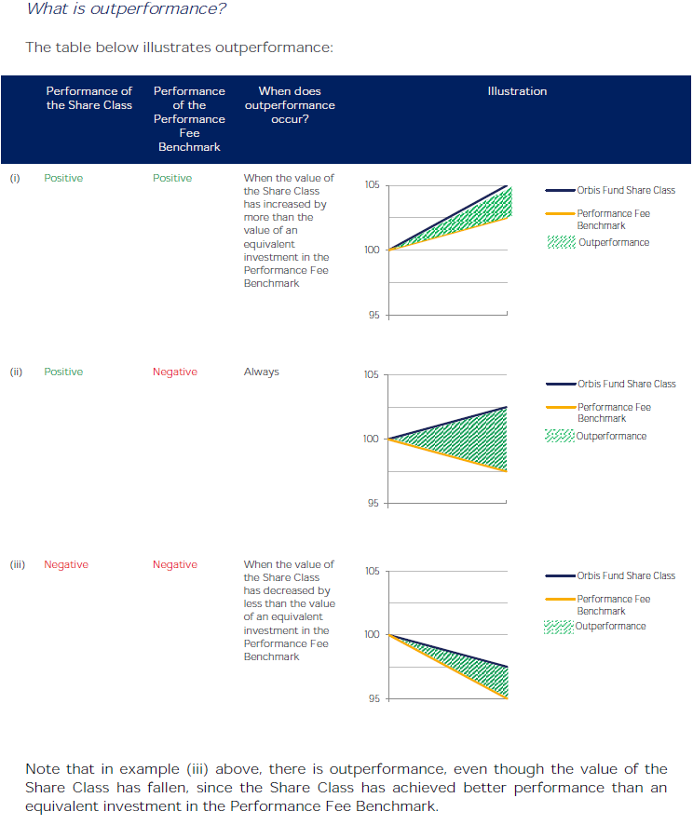

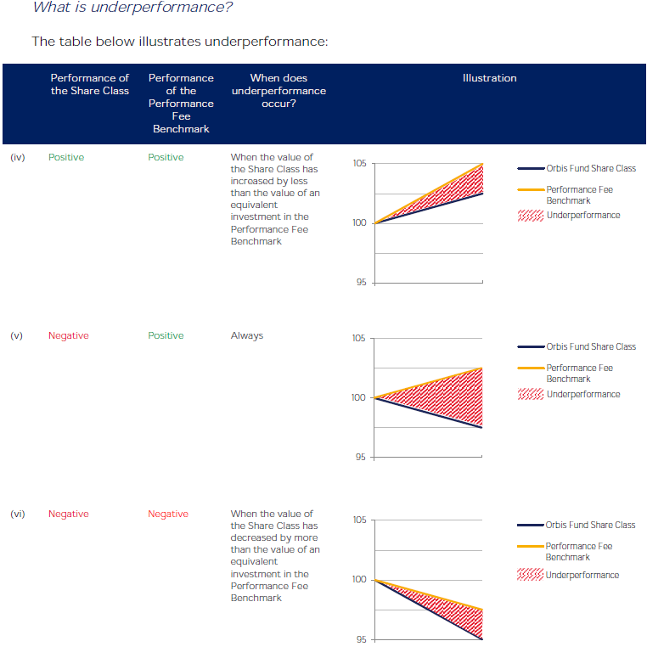

<ESMA_QUESTION_PFG_7>

1. : What are your views on setting a performance reference period for the purpose of resetting the HWM? What should be taken into account when setting the performance reference period? Should this period be defined, for example, based on the whole life of the fund (starting from the fund’s inception date), the recommended holding period of the investor or the investment horizon as stated in the prospectus? Please provide examples and reasons for your answer.

<ESMA_QUESTION_PFG_8>

Rather than imposing an arbitrary performance reference period for the purpose of resetting the HWM, ESMA and the NCAs should take a principles-based approach, focused on whether the performance reference period for the purpose of resetting the HWM is fair and appropriately disclosed to investors in accordance with the ESMA and IOSCO principles, and intervene where this isn’t the case.

As a general principle applicable to asymmetric performance fee models, we believe that longer performance reference periods for the purpose of resetting the HWM are proportionally better suited to the best interest of investors and that reference periods of shorter than one year are generally of little to no value or consequence.

<ESMA_QUESTION_PFG_8>

1. : Alternatively, would it be possible to envisage predefined time horizons for the purpose of resetting the HWM, such as 3 or 5 years? Please provide examples and details on what you think would be the best practice in order to better align the interests of fund managers and investors.

<ESMA_QUESTION_PFG_9>

TYPE YOUR TEXT HERE

<ESMA_QUESTION_PFG_9>

1. : How long do you think the performance reference period should be for performance fee models based on a benchmark index? What should be taken into account when setting the performance reference period for a performance fee benchmark model? Would it be possible to envisage predefined time horizons for the purpose of resetting the performance fee based on a benchmark, such as 3 or 5 years? Please provide examples and details on what you think would be the best practice in order to better align the interests of fund managers and investors.

<ESMA_QUESTION_PFG_10>

We agree with ESMA that performance reference periods should not apply to the Fulcrum Fee model, *as in this model the level of the performance fee increases or decreases proportionately with the investment performance of the fund*.[15] However, this rationale applies to more than just traditional Fulcrum Fees.[16]

We agree with IOSCO that alternative methods which ensure that cumulative gains are offset in some way by cumulative losses can be considered.[17]

For instance, where performance fees are proportionately refunded in the event of subsequent underperformance, the performance reference period is irrelevant and therefore should not be arbitrarily imposed. By way of example, we refer to our Refundable Reserve Fees, described under the heading *“Orbis Performance Fee Models”* above and under Question 11 below.

Rather than imposing an arbitrary performance period, ESMA and the NCAs should focus on whether the fees applicable to a performance period is fair to investors in accordance with the ESMA and IOSCO principles, and intervene where this isn’t the case.

<ESMA_QUESTION_PFG_10>

1. : Alternatively, do you think the performance reference period should coincide with the minimum crystallisation period or should it be longer/shorter? Please provide examples and reasons for your answer.

<ESMA_QUESTION_PFG_11>

In our view, the performance reference period and the minimum crystallisation period are independent measures, the coincidence of which is not a necessary measure of investor protection. Instead, we support a principles-based approach to determining reference periods, which provides NCAs with the discretion to take into account the nature of the investment objective and strategy of the fund and investors’ preferences. Such an approach is far more likely to serve investor best interests, particularly in the case of symmetrical performance fee models.

By way of example, we refer to our Refundable Reserve Fees, described under the heading *“Orbis Performance Fee Models”* above.

Under our Orbis SICAV Refundable Reserve Fee models, performance fees are measured and accrued into a “Fee Reserve” on each weekly dealing day but, instead of being automatically crystallised at the end of a minimum crystallisation period, accrued fees are available for symmetrical refunds to the share class in case of subsequent underperformance.

When the Fee Reserve is positive, a limited portion is crystallised on each weekly dealing day (subject to certain caps that restrict the amount of the accrued performance fees permitted to be crystallised in any given period). While fee accruals into, and refunds out of, the Fee Reserve are uncapped, fee crystallisations from the Fee Reserve to Orbis are capped, resulting in performance fees earned for past outperformance being available for refund in case of future underperformance.

In this example, there is no relationship between the performance reference period (which is whole life of the fund) and the minimum crystallisation period (which can be weekly), nor would such an alignment be a necessary measure of investor protection given the refund mechanism and caps on crystallisation.

<ESMA_QUESTION_PFG_11>

1. : What are your views on when the Guidelines should become applicable? How much time would managers require to adapt existing fee mechanisms to comply with the requirements of these Guidelines?

<ESMA_QUESTION_PFG_12>

The earliest application of the Guidelines should be at the start of the second full financial year from the date of their publication.

Managers with non-traditional performance fee models will need time to engage with their NCAs and investors regarding the intended application of the ESMA Guidelines to their performance fee models.

Should pre-existing performance fee models require amendments, multiple internal and external project streams with long lead times will ensue.

At the very least: (i) alternative performance fee models must be formulated and approved by internal and external parties, including NCAs; (ii) automated fee calculation models must be recoded, tested and audited; (iii) legal and marketing documents must be amended, translated and, where applicable, approved by the NCA; (iv) all material changes must be notified in advance to (or approved by) investors, other regulators, stock exchanges; etc.

More significantly, some managers will be asked by their clients (or elect) to provide best possible *status quo* options, for instance by redomiciling their UCITS, or launching either parallel AIFs or substitute vehicles outside of Europe.

In any case, in the interest of the investors which will be impacted by these ESMA Guidelines, managers will need time to formulate and execute appropriate contingency plans.

Material changes to pre-existing share classes will inevitably lead to untimely redemptions, whether because managers choose to liquidate a fund or share class, or investors choose to redeem given what they view as an undesirable change in the performance fee model.

Untimely redemptions would not only cause investors to lose the current and future benefits of innovative performance fee models, but may also cause them to suffer a potentially untimely capital gains tax event (and loss) in many jurisdictions. A longer lead-time in the application of these Guidelines may help alleviate this to some extent.

<ESMA_QUESTION_PFG_12>

1. : Do you consider that the principles set out in the Guidelines should be applied also to AIFs marketed to retail investors in order to ensure equivalent standards in retail investor protection? Please provide reasons.

<ESMA_QUESTION_PFG_13>

In our view, the principles set out in the Guidelines should not be applied to AIFs marketed to retail investors.

Investors who qualify as “well-informed” are sophisticated investors with the resources necessary to make informed judgments regarding the nature of their investments. These investors will always have the option to channel their savings into more traditional and regulated UCITS vehicles should they so choose; importantly however, the optionality to avail themselves of the broader range of options and features offered in AIFs, including non-standard performance fees, should be preserved.

A convergence of standards between products targeting retail investors and those targeting more sophisticated investors will reduce the choice for the latter by reducing the scope for innovative asset managers to design products that meet their needs. This could drive these investors and asset managers out of Europe to jurisdictions that are more open to innovation.

<ESMA_QUESTION_PFG_13>

1. : Do you agree with the above-mentioned reasoning in relation to the possible costs and benefits as regards the consistency between the performance fees model and the fund’s investment objective? What other types of costs or benefits would you consider in this context? Please provide quantitative figures, where available.

<ESMA_QUESTION_PFG_14>

TYPE YOUR TEXT HERE

<ESMA_QUESTION_PFG_14>

1. : In relation to Guideline 2, do you think that models of performance fee without a hurdle rate, or with a hurdle rate not linked to the investment objective (but clearly stated in the offering documents), should be permissible? For example, do you think that equity funds with a performance fee linked to EONIA, or a performance fee which is accrued as long as there are positive returns, should be allowed? Please give examples and reasons for your answer.

<ESMA_QUESTION_PFG_15>

It is unclear from this question what constitutes a hurdle rate.

By way of illustration, the investment objective of our long-only equity funds is formulated as the outperformance of an appropriate equity index benchmark. For example, the investment objective of the Orbis SICAV Global Equity Fund is to seek higher returns than the average of the world’s equity markets, without greater risk of loss. Depending on the share class selected by the investor, a performance fee would be payable when the Fund outperforms the FTSE World Index or the MSCI World Index. The hurdle rate to earn a performance fee is outperforming the chosen benchmark, and that outperformance is relative, meaning that a fee is payable when the relative performance against the benchmark is positive even though the absolute performance may be negative. Equally, it also means that no fee is payable (and in fact a refund may be due), when the Fund has delivered positive returns but its performance is not as high as that of the benchmark.

<ESMA_QUESTION_PFG_15>

1. : What additional costs and benefits would compliance with the proposed Guideline bring to you/the stakeholder(s) you represent? Please provide quantitative figures, where available.

<ESMA_QUESTION_PFG_16>

Please refer to our responses to Questions 4 and 5.

In our view, overly prescriptive Guidelines which stifle innovative performance fee models may deprive investors of fee structures which seek to better align manager and investor interests to the risk and long-term rewards of fund performance.

In addition to the other significant costs to be borne by managers and funds in relation to the actions described in our response under Question 12, material changes to pre-existing share classes will inevitably lead to untimely redemptions, whether because managers choose to liquidate a fund or share class, or investors choose to redeem given what they view as an undesirable change in the performance fee model.

Untimely redemptions would not only cause the investors to lose the current and future benefits of innovative performance fee models, but also cause them to suffer a potentially untimely capital gains tax event (and loss) in many jurisdictions.

<ESMA_QUESTION_PFG_16>

1. : What is the anticipated impact from the introduction of this proposed Guideline? Are there models or methodologies currently employed where this Guideline would not be appropriate? If so, please provide examples of these and details of how the best interests of investors are safeguarded.

<ESMA_QUESTION_PFG_17>

Please refer to our responses to Questions 6 and 7.

<ESMA_QUESTION_PFG_17>

1. : What additional costs and benefits would compliance with the proposed Guideline bring to the stakeholder(s) you represent? Please provide quantitative figures, where available.

<ESMA_QUESTION_PFG_18>

Please refer to our responses to Questions 16.

<ESMA_QUESTION_PFG_18>

1. : Which other types of costs or benefits would you consider in the disclosure of the performance fees model? Please provide quantitative figures, where available.

<ESMA_QUESTION_PFG_19>

TYPE YOUR TEXT HERE

<ESMA_QUESTION_PFG_19>

1. Footnote 185 of the Interim Report. In the interest of transparency, the Cass Study was sponsored by Orbis.
2. Our Refundable Reserve Fees, like our Fulcrum Fees, meet the definition of a “fulcrum fee” under the ESMA Paper given that (i) the level of the fee increases or decreases proportionately with the investment performance of the fund over a specified period of time in relation to the investment record of an appropriate securities index, and (ii) the fee can be negative, resulting in a refund to the investor.
3. The performance element is measured and accrued into the Fee Reserve on each dealing day in an amount equal to a percentage of the positive difference between the class and its performance benchmark.
4. Section 6.4 to 6.8.
5. Pages 3 and 4 of the Introduction of the Cass Paper.
6. Cass Business School press release dated 17 November 2014.
7. ESMA Paper, paragraph 11.
8. ESMA Paper, paragraph 19.
9. IOSCO Paper, paragraph 34.
10. IOSCO Paper, paragraph 35.
11. ESMA Paper, paragraph 19.
12. ESMA Paper, paragraph 20.
13. e.g. fund performance = -8%, and benchmark performance = -10%.
14. e.g. fund performance = 8%, and benchmark performance = 10%.
15. ESMA Guidelines, paragraph 25.
16. This rationale would apply to our Fulcrum Fees (where we note that the performance reference period is based on a rolling three-years), as well as our Refundable Reserve Fees (where we note that the performance reference period is based on the whole life of the fund/never reset).
17. IOSCO Paper, paragraph 34.