|  |
| --- |
| Response Form to the Consultation Paper |
| Guidelines on performance fees in UCITS |

**Responding to this paper**

ESMA invites comments on all matters in this consultation paper and in particular on the specific questions summarised in Annex I. Comments are most helpful if they:

* respond to the question stated;
* indicate the specific question to which the comment relates;
* contain a clear rationale; and
* describe any alternatives ESMA should consider.

ESMA will consider all comments received by **31/10/2019.**

All contributions should be submitted online at [www.esma.europa.eu](http://www.esma.europa.eu) under the heading ‘Your input - Consultations’.

**Instructions**

In order to facilitate analysis of responses to the Consultation Paper, respondents are requested to follow the below steps when preparing and submitting their response:

1. Insert your responses to the questions in the Consultation Paper in the present response form.
2. Please do not remove tags of the type <ESMA_QUESTION_PFG_1>. Your response to each question has to be framed by the two tags corresponding to the question.
3. If you do not wish to respond to a given question, please do not delete it but simply leave the text “TYPE YOUR TEXT HERE” between the tags.
4. When you have drafted your response, name your response form according to the following convention: ESMA_PFG_nameofrespondent_RESPONSEFORM. For example, for a respondent named ABCD, the response form would be entitled ESMA_PFG_ABCD_RESPONSEFORM.
5. Upload the form containing your responses, in Word format, to ESMA’s website ([www.esma.europa.eu](http://www.esma.europa.eu) under the heading “Your input – Open consultations” 🡪 “Consultation on Position limits and position management in commodities derivatives”).

**Publication of responses**

All contributions received will be published following the close of the consultation, unless you request otherwise. Please clearly and prominently indicate in your submission any part you do not wish to be publically disclosed. A standard confidentiality statement in an email message will not be treated as a request for non-disclosure. A confidential response may be requested from us in accordance with ESMA’s rules on access to documents. We may consult you if we receive such a request. Any decision we make not to disclose the response is reviewable by ESMA’s Board of Appeal and the European Ombudsman.

**Data protection**

Information on data protection can be found at [www.esma.europa.eu](http://www.esma.europa.eu) under the heading [Legal Notice](http://www.esma.europa.eu/legal-notice).

**Who should read this paper**

This document will be of interest to asset managers managing retail funds and their trade associations, as well as institutional and retail investors investing into such funds and their associations.

**General information about respondent**

|  |  |
| --- | --- |
| Name of the company / organisation | Amundi Asset Management |
| Activity | Investment Services |
| Are you representing an association? |  |
| Country/Region | France |

**Introduction**

***Please make your introductory comments below, if any***

<ESMA_COMMENT_PFG_1>

Amundi is Europe’s largest asset manager by assets under management and ranks in the top 10[1] globally. It manages 1,487 billion[2] euros of assets across six main investment hubs[3]. Amundi offers its clients in Europe, Asia-Pacific, the Middle East and the Americas a wealth of market expertise and a full range of capabilities across the active, passive and real assets investment universes. Clients also have access to a complete set of services and tools. Headquartered in Paris, Amundi was listed in November 2015.

Amundi welcomes ESMA consultation on its draft “Guidelines on performance fees in UCITS” and the opportunity that is given to express its views.

We strongly believe that some clarifications and standardization are needed. In particular, it is our view that such clarifications should be inspired by achieving more transparency and simplicity for investors. These are the key questions from an investor protection perspective.

Conversely, we believe that it is not appropriate for guidelines to regulate how a pricing policy should be built and to favour a model/methodologie over another.

Asset managers compete against each other in designing efficient pricing policies suitable to meet the investors’ expectations. Therefore, as much flexibility as possible should be left to asset managers in designing what in their views is the most effective pricing policy to win a client.

An excessive standardization will indeed have the unwanted effect to remove an area of competition reducing the range of choice available to investors.

Amundi has put in place a straightforward pricing policy which displays a clear value proposition for its clients. Such policy is centred on the offer of a dual share class mechanism. Investors can (i) opt for the standard share class paying a competitive base fee and sharing with Amundi the positive effect of a performance, only if such performance is delivered or, (ii) if they are reluctant to pay performance fees, can also opt for no performance fees’ share class of the same fund.

Regarding (i) above, in Amundi we believe that this scheme is fair as it offers a lower fee base and provides for an additional reward for the asset managers if an outperformance is realized, aligning therefore the interest of the asset manager with that of the investors.

Against this background, we believe that the Guidelines should be limited to bring a more consistent approach across Member States, without jeopardizing a healthy competition amongst asset managers on pricing policy.

In addition, it is essential that these Guidelines, which take IOSCO 2016 “Good Practices for Fees and Expenses of Collective Investment Schemes” as a reference, do not go beyond by being too prescriptive, with the risk of reducing the competitiveness of the European regulation and discourage the use of performance fees in general. It’s also essential that these guidelines do not impose one model of performance fees over another and preserve the freedom of choice for investors. Last but not least, it’s of paramount importance that the guidelines preserve both the equality between investors and the alignment of interest between these latter and the asset manager.

Therefore, and as explained in details in our replies below, we notably strongly advocate in favour of:

**1.** **Free choice for asset managers to apply or not performance fees (Dual Shares) and to select performance fees methods as part of the pricing policy**. Each asset manager should define and propose its own pricing policy. The choice of applying HWM, or any other additional conditions in performance fees methods, should remain in the hand of each asset manager.

**2.** **Setting consistent crystallization** (Q4) **and reference period** (Q8 to Q10) **of no more than 12 months** (except in some exceptional circumstances), would go in the direction of providing the investors with a straight forward, easy to understand model. In addition, no arbitrary restriction on when the period of crystallisation should end, as this decision should remain in the hand of the asset manager.

**3.** **Making clear that also relative performance can be rewarded** avoiding to restrict performance fees only when the fund has achieved absolute positive performance (Q6) is always in the best interest of the investors and even more so in a negative interest rate scenario.

**4.** **Giving a reasonable time to implement the Guidelines**. In this respect a two year period after their publication appears to a more appropriate period of time for these guidelines to be applicable (Q12) in order to align fund documentation and the offer to investors to the Guidelines.

**5.** **Limiting the application of the Guidelines to retail investor in UCITS funds** (Q13) since non-retail investors are generally more sophisticated and require a bespoke approach.

<ESMA_COMMENT_PFG_1>

**Questions**

1. : Do you agree that greater standardisation in the field of funds’ performance fees is desirable? What should be the goal of standardisation?

<ESMA_QUESTION_PFG_1>

Amundi believes that it would be good to have high-level principles or guidelines on performance fees in UCITS across the European Union since very prescriptive national requirements are barriers to the cross-border distribution of funds and should therefore be avoided. Furthermore, we believe that the Guidelines should be inspired by achieving more transparency and simplicity for the investors as ultimately they should be in a position to easily understand the value proposition offered to them.

IOSCO adopted in 2016 ‘Good Practices for Fees and Expenses of Collective Investment Schemes’, which are applied by many national regulators as a useful standard. In our view ESMA Guidelines should be consistent with IOSCO’ approach of not being too prescriptive and not go beyond that standard.

We believe that clarifying concepts and good practices could contribute to (i) enhance transparency, and thus investors’ protection, giving them the possibility to better compare the different value propositions in the market (ii) reduce the possibility of regulatory arbitrage and (iii) be in line with the objective of strengthening the capital market union. That said, we also believe that it is important that the Guidelines (a) will not go beyond the scope described above imposing a model over another and (b) duly consider the differences in models when they are formulated.

Designing an efficient pricing policy is one of the key areas where asset managers can compete, and therefore it is in the best interest of investors to have as many solutions available as possible. Furthermore, since there are many performance fee models used, it would, in Amundi’s view, not be appropriate to require only one model or methodology.

Finally, we do not believe that the Guidelines should apply to non-retail investors which being more sophisticated, having different risk tolerance and generally investing larger amount normally require a bespoke approach.

<ESMA_QUESTION_PFG_1>

1. : Are there any obstacles to standardisation that could be removed by regulatory action? Please elaborate.

<ESMA_QUESTION_PFG_2>

Within the scope of our answer to Q1 above regarding the **harmonization** of the rules consistently with the IOSCO 2016 ‘Good Practices for Fees and Expenses of Collective Investment Schemes’ we would be in favour of removing those differences that could frustrate and jeopardize cross border distribution through, for instance, providing clarity over the definitions used. However, for the reasons already stated before, we do not believe that the Guidelines should promote one model/methodology over another or be too prescriptive.

<ESMA_QUESTION_PFG_2>

1. : What should be taken into consideration when assessing consistency between the index used to calculate the performance fees and the investment objectives, strategy and policy of the fund? Are there any specific indicators which should be considered (e.g.: historical volatility, asset allocation composition, etc.) to ensure this consistency? Please provide examples and give reasons for your answer.

<ESMA_QUESTION_PFG_3>

We agree with the need for consistency between the index used to calculate the performance and the investment objective.

However, the criteria that are used to choose the benchmark are various (e.g. composition, availability of index, currency, dividend reinvested, reliability of the index, etc.).

The weight and the combination of the above mentioned criteria may vary on a case by case basis, in order to better ensure consistency with the investment objectives. Therefore, our view is that the final Guidelines should not make reference to any particular criteria, leaving the ultimate choice to the management company depending on the fund’s investment objectives and strategy.

<ESMA_QUESTION_PFG_3>

1. : What is the anticipated impact of the introduction of Guideline 3? Do you agree with setting a minimum crystallisation period of one year? Do you think this could help better aligning the interests of fund managers and investors? Please provide examples.

<ESMA_QUESTION_PFG_4>

[First of all, we note that the terminology used in the Guidelines would need to be better clarified in order to avoid any potential misunderstanding. For instance, we are not entirely clear whether under paragraph 18, pag. 11 ESMA intends to refer to performance reference period rather than crystallisation period or not.

That being said, and on the assumption that *crystallisation period* means the period during which the performance fee is accrued – without entering in the details of when it is effectively paid to the asset manager- **we are in favour of setting a 12-month period for crystallisation**. We also note that this is the same conclusion reached by the IOSCO 2016 ‘Good Practices for Fees and Expenses of Collective Investment Schemes, specifically under *Good practice 3*.

At Amundi we do not believe that it is correct to link the crystallization period to the fund’s recommended holding period mentioned in Guideline 3, paragraph 19, since the two concepts are not related. In addition, the effective holding period is most of the time not in line with the recommended holding period.

Practically, since funds are open-ended with daily subscription and redemption it would not be feasible to have a crystallization period in line with each investor’ holding period. Moreover, since many investors in UCITS invest through a distributor’ nominee account or an omnibus account, it is not possible for an asset manager to, determine the holding period of an individual investor[4].

Regarding the 12-month period, we believe that this is the best option since, as better clarified in Example 1 below, such timeframe reduces to the minimum the disparity between investors.

In addition, a 12-month crystallisation period also offers simplicity and clarity being fully aligned with the spirit of Mifid 2 which has introduced a yearly report on all charges and costs.

Without prejudice to the above, room for exceptions should be contemplated and shorter periods should, in any event, be allowed if they are in the interest of investors, or for technical reasons (liquidations or restructurings) or other practical circumstances and have to be disclosed to investors in advance, or when investors redeem before the end of the performance period. In such circumstances, the performance fee accrued on the redeemed units or shares can be crystallised under certain operating models.

Finally, **we disagree with Guideline 3, paragraph 20 where it provides that the *crystallisation period should end on 31 December or at the end of the financial year of the fund***. **We would suggest therefore to delete this recommendation and let the asset manager free to identify the crystallization’s date**.

It is our belief that the proposal to set one specific date for crystallization on all funds does not benefit the investor, nor the fund manager. Indeed, by doing so there is a concentration effect on all asset managers, which means investors and managers are more exposed to market turbulence, if such turbulence coincides with the given date for crystallization. For this reason, we believe it is best left to the individual manager to determine their dates of crystallization and in turn the investor should benefit as they have a wider scope to choose from and are less exposed to one off market events.

**Example 1**

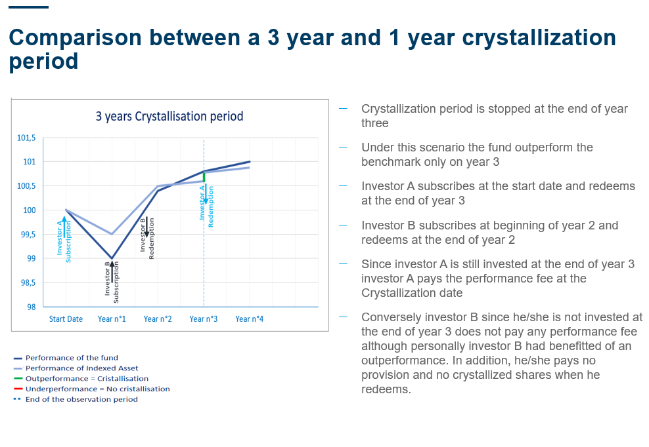

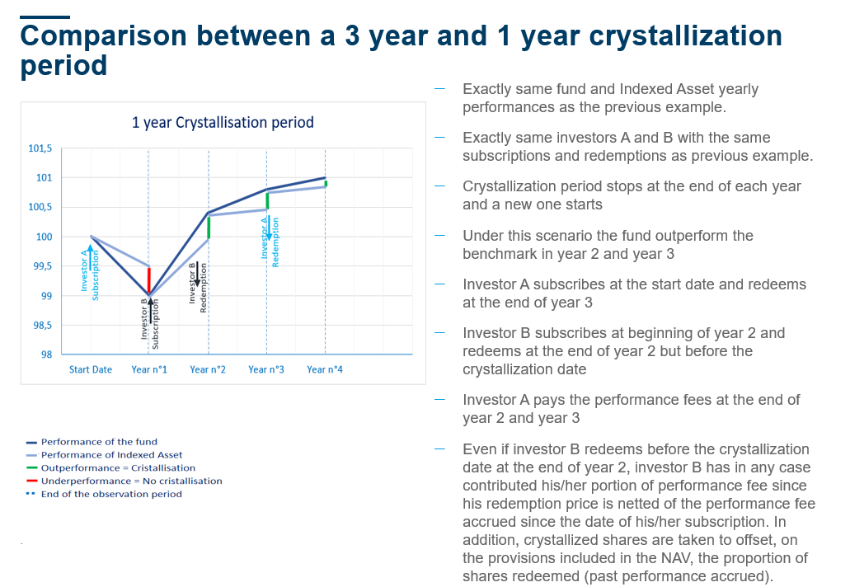

<ESMA_QUESTION_PFG_4>

1. : Are there any other models or methodologies currently employed that, in your view, should be exempted from this requirement? For example, do you think that the requirement of a minimum crystallisation period of 12 months should also apply to HWM models? Please provide examples on how these models achieve the objectives pursued by Guideline 3.

<ESMA_QUESTION_PFG_5>

Without prejudice to the exemptions mentioned in our reply to Q4, we do not believe that different methodologies should be exempted from the requirement.

<ESMA_QUESTION_PFG_5>

1. : In your view, should performance fees be charged only when the fund has achieved absolute positive performance? What expected financial impact (e.g. increase or decrease of the manager’s remuneration or increase or decrease of the financial return for investors) would the proposed Guideline 4 have for you/the stakeholder(s) you represent? Are there models or methodologies currently employed where the approach set out in Guideline 4 would not be appropriate?

<ESMA_QUESTION_PFG_6>

No, in our view performance fees should be paid any time there is an outperformance, although relative. For example, in a benchmark fund the objective is to deliver positive performance against the benchmark, regardless of whether we are in an absolute positive scenario or not. If the benchmark is down of 1.5% and the fund is down of 0.5% the fund has beaten the benchmark and the performance fee should accrue/paid.

We believe that the manager's ability to mitigate losses in negative market phases, such as in times of crisis, or in markets with negative interest rates, as the one we are now experiencing, is a value added of the active asset management and thus it should be rewarded.

For the reasons explained, in our view remunerating relative performance is in the best interest of investors because even in negative scenario where reaching an absolute performance is very difficult, the fund manager will do his/her best to beat the benchmark.

In addition, preventing an asset manager from collecting performance fees on assets delivering negative returns would incentivize asset management industry to concentrate their offering on riskier assets. Hence, it would facilitate access to funding for corporates with higher risk profile.

<ESMA_QUESTION_PFG_6>

1. : If the performance fee model that you currently use provides for performance fees to be payable in times of negative returns, is a prominent warning on this provided to investors in the legal and marketing documents of the fund? If not, should this be provided? Please give examples for your answer and details on how the best interests of investors are safeguarded.

<ESMA_QUESTION_PFG_7>

Although currently we are not providing any specific disclosure on this point, we would not oppose to provide information to the investors in this respect.

<ESMA_QUESTION_PFG_7>

1. : What are your views on setting a performance reference period for the purpose of resetting the HWM? What should be taken into account when setting the performance reference period? Should this period be defined, for example, based on the whole life of the fund (starting from the fund’s inception date), the recommended holding period of the investor or the investment horizon as stated in the prospectus? Please provide examples and reasons for your answer.

<ESMA_QUESTION_PFG_8>

The basic rationale for performance fees is that they align the interests of fund managers and their investors, since fund managers are incentivised to generate positive relative returns and there are various performance fee calculation models currently used in the investment funds industry.

However, not all of the methodologies used ensure an equal treatment amongst investors, nor are easy to be understood. For example, in our view, models like the HWM, have both the limit (i) of ignoring the fact that investors subscribe and redeem at a different point in time – which creates distortions – and (ii) of providing for a level of complexity not always easy to be understood by the average retail client.

Amongst these distortions, the main scenario we can observe is the so called **“free ride”** which benefits investors who subscribe when the fund is underperforming and is below its HWM. Between the subscription value and the fund’s HWM, these investors benefit from an outperformance but without paying any performance fee for such outperformance. This since no performance fees is accrued until the net asset value is higher than the HWM (see also Example 2 below).

This being said, an additional scenario, normally defined as “**unfair claw back**”, could also be observed. Unfair claw back occurs when a fund undergoes a period of underperformance and the net asset value declines as a result. When this happens, the accruals which have been gained through the period of performance are computed in the Net Asset Value. As such, new investors who enter the fund at the top of the outperformance cycle will also benefit from the accruals being computed into the Net Asset Value, even though they were not invested in the fund at the time the accrual have been made.

**EXAMPLE 2:**

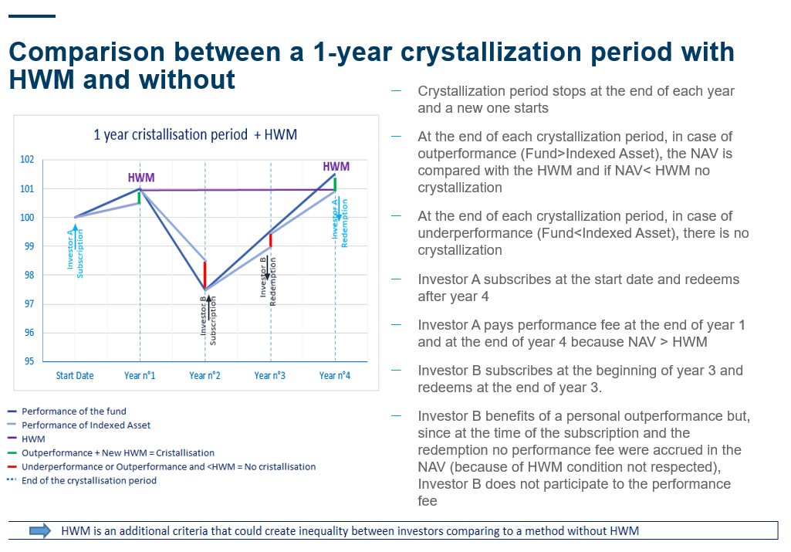

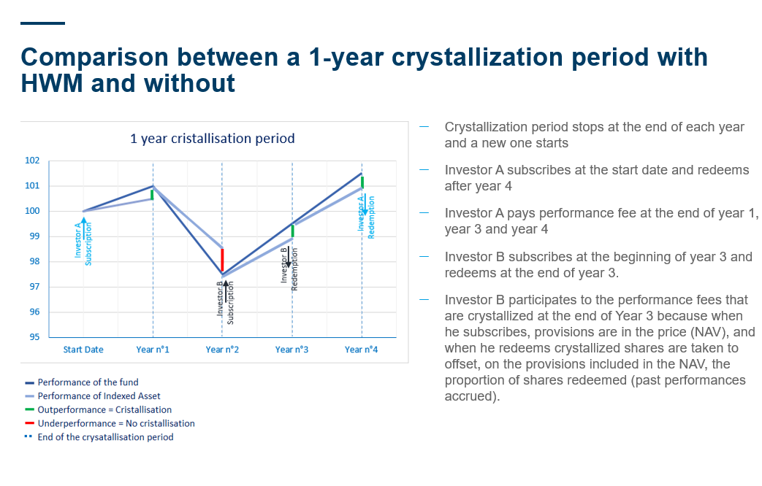

<ESMA_QUESTION_PFG_8>

1. : Alternatively, would it be possible to envisage predefined time horizons for the purpose of resetting the HWM, such as 3 or 5 years? Please provide examples and details on what you think would be the best practice in order to better align the interests of fund managers and investors.

<ESMA_QUESTION_PFG_9>

For the reasons explained in our answer to Q8, we do not believe that HWM model is in the best interest of investors in open-ended funds.

In any case, for the sake of clarity we would like to point out that introducing a resetting period longer than one year will not favour an alignment of interest between investors and fund managers since when a fund managers see no chance to recoup past performance, they may be incentivized to liquidate the fund.

<ESMA_QUESTION_PFG_9>

1. : How long do you think the performance reference period should be for performance fee models based on a benchmark index? What should be taken into account when setting the performance reference period for a performance fee benchmark model? Would it be possible to envisage predefined time horizons for the purpose of resetting the performance fee based on a benchmark, such as 3 or 5 years? Please provide examples and details on what you think would be the best practice in order to better align the interests of fund managers and investors.

<ESMA_QUESTION_PFG_10>

As explained in the answer to Q4, we believe a 12-month crystallisation period, which is also supported by IOSCO, reduces to the minimum the disparity between investors regardless of their individual holding period. Therefore, the best way to ensure this fair treatment and to provide a straightforward and easy to understand (for the investors) model is to align the reference period to the 12-month crystallisation period, in a performance fee model based on a benchmark index.

<ESMA_QUESTION_PFG_10>

1. : Alternatively, do you think the performance reference period should coincide with the minimum crystallisation period or should it be longer/shorter? Please provide examples and reasons for your answer.

<ESMA_QUESTION_PFG_11>

The performance reference period should, in order to best align the performance fee model with the investment objective, coincide with the crystallisation period of 12 months. However, as noted in the answer to Q4 there may be events where the period can be shorter than 12 months in order to ensure the best interest of the investors.

<ESMA_QUESTION_PFG_11>

1. : What are your views on when the Guidelines should become applicable? How much time would managers require to adapt existing fee mechanisms to comply with the requirements of these Guidelines?

<ESMA_QUESTION_PFG_12>

In order to be able to comply with the Guidelines we would believe that 24 months from their publications are required (both for new and existing UCITS).

<ESMA_QUESTION_PFG_12>

1. : Do you consider that the principles set out in the Guidelines should be applied also to AIFs marketed to retail investors in order to ensure equivalent standards in retail investor protection? Please provide reasons.

<ESMA_QUESTION_PFG_13>

[We believe that the Guidelines should only apply to UCITS retail investors.]

<ESMA_QUESTION_PFG_13>

1. : Do you agree with the above-mentioned reasoning in relation to the possible costs and benefits as regards the consistency between the performance fees model and the fund’s investment objective? What other types of costs or benefits would you consider in this context? Please provide quantitative figures, where available.

<ESMA_QUESTION_PFG_14>

[We generally agree. However we believe that the changes introduced by the Guidelines will result in additional cost for compliance, legal and operations tasks.]

<ESMA_QUESTION_PFG_14>

1. : In relation to Guideline 2, do you think that models of performance fee without a hurdle rate, or with a hurdle rate not linked to the investment objective (but clearly stated in the offering documents), should be permissible? For example, do you think that equity funds with a performance fee linked to EONIA, or a performance fee which is accrued as long as there are positive returns, should be allowed? Please give examples and reasons for your answer.

<ESMA_QUESTION_PFG_15>

We believe that in order to best align the investment objectives with the performance fee model flexibility to decide whether inserting a hurdle rate or not should be granted.

<ESMA_QUESTION_PFG_15>

1. : What additional costs and benefits would compliance with the proposed Guideline bring to you/the stakeholder(s) you represent? Please provide quantitative figures, where available.

<ESMA_QUESTION_PFG_16>

Please refer to our answer under Q14

<ESMA_QUESTION_PFG_16>

1. : What is the anticipated impact from the introduction of this proposed Guideline? Are there models or methodologies currently employed where this Guideline would not be appropriate? If so, please provide examples of these and details of how the best interests of investors are safeguarded.

<ESMA_QUESTION_PFG_17>

We believe that the draft Guideline 4 would not be appropriate for all types of performance fee models, namely for those funds choosing to measure their performance against an index. We specifically refer to the possibility for funds to apply performance fees even in bear markets, provided their performance relative to that of the chosen index is positive (i.e. positive relative performance) and thereby rewarding outperformance.

In terms of minimising incentives for managers to take on excessive risks (as per paragraph 23 under draft Guideline 4), we believe that the proposed performance reference period of one year would allow a management company a sufficient amount of time to recover any cumulative negative performance before levying a performance fee once again.

<ESMA_QUESTION_PFG_17>

1. : What additional costs and benefits would compliance with the proposed Guideline bring to the stakeholder(s) you represent? Please provide quantitative figures, where available.

<ESMA_QUESTION_PFG_18>

As stated in our reply to Q6 we believe that the possibility to charge performance fees also in the event of relative positive performance should be allowed. Should that not be the case some funds would no longer be economically viable. Generally we believe that if the final Guidelines were to go beyond the original scope of the IOSCO 2016 Best Practices that would disincentivize the use of performance fee models and in the end would be detrimental for investors – as it would limit their freedom of choice.

<ESMA_QUESTION_PFG_18>

1. : Which other types of costs or benefits would you consider in the disclosure of the performance fees model? Please provide quantitative figures, where available.

<ESMA_QUESTION_PFG_19>

In relation to disclosure costs, please refer to our reply to Q14 above. As to the benefits, we clearly see a positive outcome for end-investors in receiving more details on the functioning of certain performance fee models, including their calculations in order to be in a position to better understand how the models work and being able to make comparison amongst different products. That said, we believe that this aim should be balanced against avoiding too prescriptive Guidelines which will have the unwanted effect of restricting the availability of different products to investors.

<ESMA_QUESTION_PFG_19>

1. Source IPE “Top 400 asset managers” published in June 2019 and based on AUM as of end December 2018
2. 2 Amundi figures as of June 30, 2019
3. Investment hubs: Boston, Dublin, London, Milan, Paris and Tokyo
4. Note: Even in the very limited cases where it is possible to track the holding period of individual investors, we have observed, in a relation to a 2B AuM European Equity fund, that the average holding period since the launch date of the fund was: (a) 29 months for retail investors, (b) 26 months for institutional investors and (c) 20 months for private banking and fund of funds.