|  |
| --- |
| Response Form to the Consultation Paper |
| MiFID II/MiFIR review report on the development in prices for pre- and post-trade data and on the consolidated tape for equity instruments |

**Responding to this paper**

ESMA invites comments on all matters in this paper and in particular on the specific questions summarised in Annex 1. Comments are most helpful if they:

* respond to the question stated;
* indicate the specific question to which the comment relates;
* contain a clear rationale; and
* describe any alternatives ESMA should consider.

ESMA will consider all comments received by **06 September 2019.**

All contributions should be submitted online at [www.esma.europa.eu](http://www.esma.europa.eu) under the heading ‘Your input - Consultations’.

**Instructions**

In order to facilitate analysis of responses to the Consultation Paper, respondents are requested to follow the below steps when preparing and submitting their response:

1. Insert your responses to the questions in the Consultation Paper in the present response form.
2. Please do not remove tags of the type <ESMA_QUESTION_MDA_1>. Your response to each question has to be framed by the two tags corresponding to the question.
3. If you do not wish to respond to a given question, please do not delete it but simply leave the text “TYPE YOUR TEXT HERE” between the tags.
4. When you have drafted your response, name your response form according to the following convention: ESMA_MDA_nameofrespondent_RESPONSEFORM. For example, for a respondent named ABCD, the response form would be entitled ESMA_MDA_ABCD_RESPONSEFORM.
5. Upload the form containing your responses, in Word format, to ESMA’s website ([www.esma.europa.eu](http://www.esma.europa.eu) under the heading “Your input – Open consultations” 🡪 “Consultation on Position limits and position management in commodities derivatives”).

**Publication of responses**

All contributions received will be published following the close of the consultation, unless you request otherwise. Please clearly and prominently indicate in your submission any part you do not wish to be publically disclosed. A standard confidentiality statement in an email message will not be treated as a request for non-disclosure. A confidential response may be requested from us in accordance with ESMA’s rules on access to documents. We may consult you if we receive such a request. Any decision we make not to disclose the response is reviewable by ESMA’s Board of Appeal and the European Ombudsman.

**Data protection**

Information on data protection can be found at [www.esma.europa.eu](http://www.esma.europa.eu) under the heading [Legal Notice](http://www.esma.europa.eu/legal-notice).

**Who should read this paper**

All interested stakeholders are invited to respond to this consultation paper. This consultation paper is primarily of interest to users of market data and trading venues, but responses are also sought from any other market participant including trade associations and industry bodies, institutional and retail investors.

**General information about respondent**

|  |  |
| --- | --- |
| Name of the company / organisation | Clarus Financial Technology |
| Activity | Non-financial counterparty |
| Are you representing an association? |  |
| Country/Region | UK |

**Introduction**

***Please make your introductory comments below, if any***

<ESMA_COMMENT_MDA_1>

1. Clarus Financial Technology welcomes the opportunity to respond to this consultation. We provide content, data and analytics for the post-regulatory reform world of global derivatives. Clarus’ tools create a window into the data now available in swap data repositories and trading venues to help clarify and unify the vast, diverse information produced from the post-crisis regulatory changes. This is done using the free publicly available trade information from multiple sources and creating a cohesive database for users to interrogate with our custom interface.

2. The new legislative landscape for financial markets is intended to provide a much more transparent environment for companies to access trade information vital to their trading and hedging requirements. The derivatives market was previously seen as opaque and trade pricing was obfuscated. We work with market participants to enable them to take advantage of the greater transparency of price and volume data for all derivative products to facilitate improved price discovery and risk mitigation.

**Meeting the standards set by EMIR**

3. The core principles underpinning regulation under EMIR and in other regulatory jurisdictions such as Dodd Frank in the US are the same: greater transparency, mitigation of systemic risk and protection against market abuse. We believe there is now the opportunity to consider and evaluate experience since implementation within Europe and from other jurisdictions, in order to arrive at the point where standards in Europe can reflect best practice from around the world. Financial markets and the companies operating within them are largely global, although regulatory controls must necessarily be defined in accordance with political and geographic borders. However, it should be possible to reflect its global reach by achieving consistent levels of transparency across boundaries. Clarus’ responses therefore address some of the specific questions raised, but also the principles they raise, such as data quality and access, in a broader context.

4. We spend a lot of time looking at the US SDR data. This provides a great frame of reference for this particular Consultation Paper as it puts the accessibility and availability of data in Europe in perspective. A key aspect that we have discovered when working with the US data is a virtuous circle of data quality improvements. If the data is readily accessible and usable, then data users actively consume the data and feedback to trading counterparts any inaccuracies. This is particularly prevalent for activity conducted across trading venues, because the operators insist that data is correct so that market-share is accurately portrayed.

5. Our users of US data are looking to us to provide an equivalent MIFID data product so that they may consume and analyse post-trade transparency data in Europe. However, due to APAs and Trading Venues making this data unusable (both through technology and use-restrictions) we are unable to provide this service. Transparency in European markets is therefore suffering as a result.

6. Our experience in working with post-trade data has shown that it is insufficient to collect raw data. The data must be collated, curated and analysed for even seasoned market professionals to be able to use and understand it. There must therefore be very clear standards for data availability to begin with. Providing an imperfect or partial representation of a market is not what data users require.

7. With our history working with US SDR data, we have of course been trying to collect MIFID II data since January 2018. Broadly speaking, this has been unsuccessful. We have only been able to consistently collect data from Bloomberg APA and MTF, and the Nasdaq APA. We have put this data into a product called “MIFIDView” to which we would like to invite ESMA to access as part of this consultation. We feel this is the best possible way to understand what is possible with the data if all APAs and Trading Venues were to make their data available without any restrictions on use.

The data can be accessed via [mifidview.clarusft.com](http://mifidview.clarusft.com/) and ESMA can contact us at [info@clarusft.com](mailto:info@clarusft.com) to gain access.

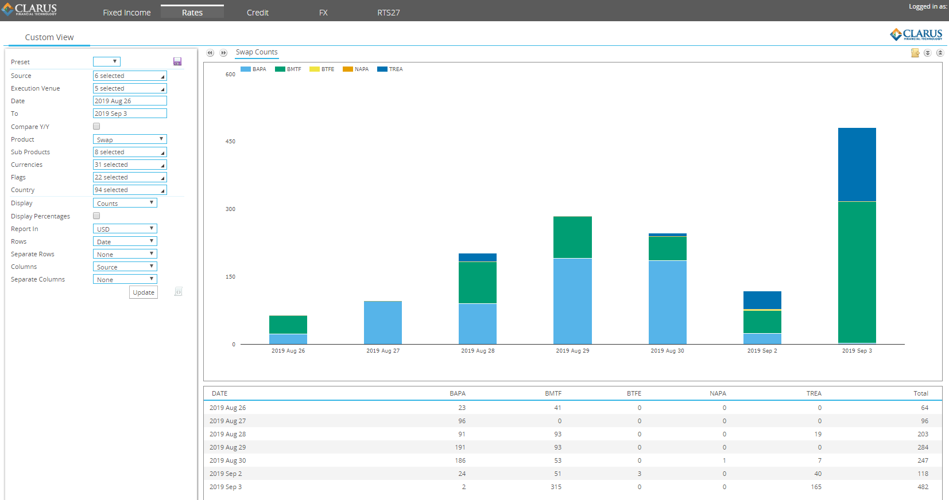

*Screenshot from* [mifidview.clarusft.com](http://mifidview.clarusft.com/)

<ESMA_COMMENT_MDA_1>

**Questions**

1. : Have prices of market data increased or decreased since the application of MiFID II/MiFIR? Please provide quantitative evidence to support your answer and specify whether you are referring to equity and/or non-equity instruments.

<ESMA_QUESTION_MDA_1>

TYPE YOUR TEXT HERE

<ESMA_QUESTION_MDA_1>

1. : If you are of the view that prices have increased, what are the underlying reasons for this development?

<ESMA_QUESTION_MDA_2>

TYPE YOUR TEXT HERE

<ESMA_QUESTION_MDA_2>

1. : Following the application of MiFID II/MiFIR, are there any market data services for which new fees have been introduced (i.e. either data services that were free of charge until the application of MiFID II or any new types of market data services)?

<ESMA_QUESTION_MDA_3>

TYPE YOUR TEXT HERE

<ESMA_QUESTION_MDA_3>

1. : Do you observe other practices that may directly or indirectly impact the price for market data (e.g. complex market data policies, use of non-disclosure agreements)? Please explain and provide evidence.

<ESMA_QUESTION_MDA_4>

TYPE YOUR TEXT HERE

<ESMA_QUESTION_MDA_4>

1. : Do you agree that trading venues/APAs/SIs comply with the requirement of making available the information with respect to the RCB provisions? If not, please explain which information is missing in your view and for what type of entity.

<ESMA_QUESTION_MDA_5>

TYPE YOUR TEXT HERE

<ESMA_QUESTION_MDA_5>

1. : Do you share ESMA’s assessment on the quality of the RCB information disclosed by trading venues, APAs and SIs? If there are areas in which you disagree with ESMA’s assessment, please explain.

<ESMA_QUESTION_MDA_6>

TYPE YOUR TEXT HERE

<ESMA_QUESTION_MDA_6>

1. : Do you agree that the usability and comparability of the RCB information disclosed could be improved by issuing supervisory guidance? If yes, please specify in which areas you would consider further guidance most useful, including possible solutions to improve the usability and comparability of the information.

<ESMA_QUESTION_MDA_7>

TYPE YOUR TEXT HERE

<ESMA_QUESTION_MDA_7>

1. : Do you think that the current RCB approach (transparency plus) can deliver on the objective to reduce the price of market data or should it be replaced by an alternative approach such as a revenue cap or LRIC+ model? Please justify your position and provide examples of possible alternatives.

<ESMA_QUESTION_MDA_8>

TYPE YOUR TEXT HERE

<ESMA_QUESTION_MDA_8>

1. : Do you consider that a revenue cap model as presented above might be a feasible approach to reduce the cost of market data? Which elements would be key for successfully implementing such a model?

<ESMA_QUESTION_MDA_9>

TYPE YOUR TEXT HERE

<ESMA_QUESTION_MDA_9>

1. : Did data disaggregation result in lower costs for market data for data users? If not, please explain why?

<ESMA_QUESTION_MDA_10>

TYPE YOUR TEXT HERE

<ESMA_QUESTION_MDA_10>

1. : Why has there been only little demand in disaggregated data?

<ESMA_QUESTION_MDA_11>

TYPE YOUR TEXT HERE

<ESMA_QUESTION_MDA_11>

1. : Do trading venues and APAs comply with the requirement to make available data free of charge 15 minutes after publication? If not, please explain in which areas you have identified deficiencies

<ESMA_QUESTION_MDA_12>

We believe that only the Bloomberg[1] and Nasdaq[2] APAs, and the Bloomberg MTF[3], fully meet the requirement to make available data free of charge 15 minutes after publication.

These publication arrangements fully meet the technical requirements and comply with the spirit of increased transparency. They achieve this by:

1. Providing data in a standardised, easily accessible format – specifically as CSV files.
2. The data is persisted for a period of time and therefore accessible.
3. The data is available for download.
4. The data is persisted in such a manner as to allow for programmatic access.
5. There is no data use agreement associated with the data. It is unencumbered.

Due to the efforts of these two providers, Clarus have created a transparency tool for European markets called mifidview. This can be accessed at <mifidview.clarusft.com>. Using this tool allows us to consume some of the transparency data that has been created since January 2018. For example, we can see how many EUR, GBP and USD IRS have been reported each month:

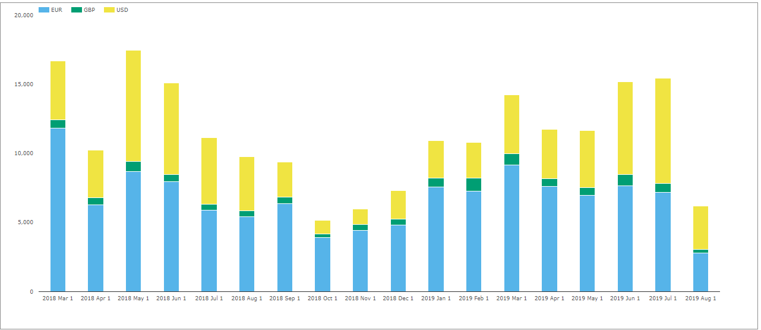

*Screenshot from* [mifidview.clarusft.com](http://mifidview.clarusft.com/)

Showing;

* Each month between 5,000 and 18,000 IRS are reported by these three venues (two APAs and one MTF).
* About 60% of these swaps are denominated in EUR.
* 35% are in USD (on average).
* GBP is a much smaller percentage.

The data we have collected so far covers 31 currencies in total.

The data also allows us to look at the notional amounts being reported:

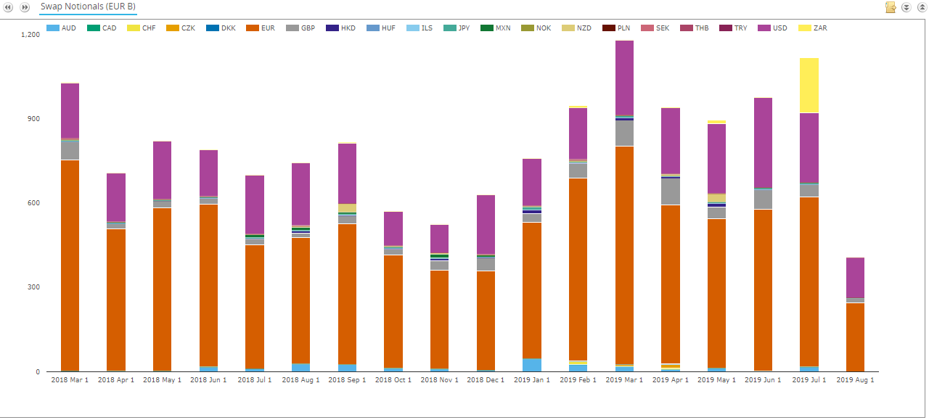

Showing;

* Notional amounts of over €1trn each month are common.
* Monthly totals range from €400bn to €1.2trn.
* EUR, USD and GBP are consistently the most active currencies traded.

We can take this analysis to a much more granular level as well, and look at the tenors being traded:

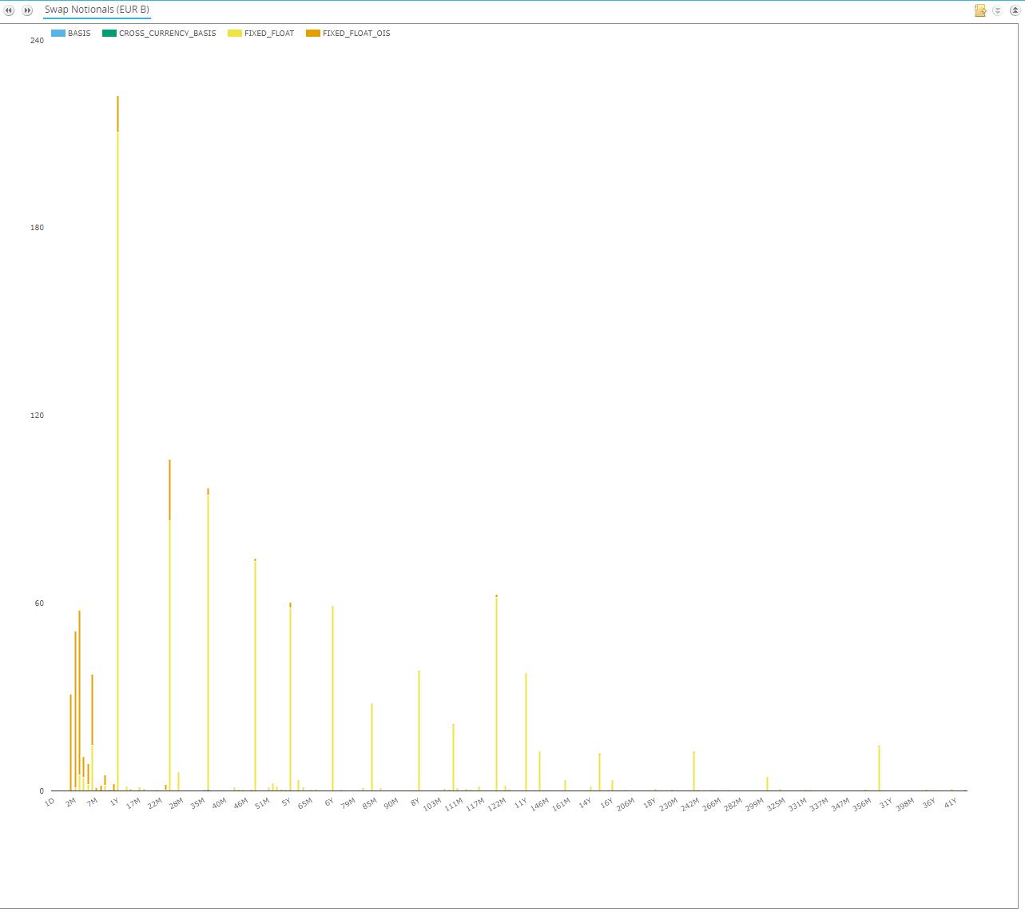

Showing;

* Swap activity in the month of July 2019 across all currencies.
* The activity is split by Sub Product into Basis swaps, Cross Currency Swaps, Fixed Float and OIS.
* We can see that OIS are extremely active in short tenors up to one year (the orange bars).
* Beyond this, Fixed Float IRS is the most traded instrument.

Trends like this are vital to monitor when considering the uptake of Risk Free Rates across the European markets as trading needs to transition in longer dated products into OIS products.

These three simple examples of analysis, we believe, strongly show the benefits of transparency and we would like to highlight the efforts of Bloomberg and Nasdaq in meeting the requirement to make data available free of charge that enables us to do this.

It is surely obvious that this level of transparency, applied across the whole market, would be beneficial to all market participants.

Sadly, the three sources of data that we have are not sufficient to provide an accurate representation of the market.

How do we know this?

Tradeweb provided us with data for the months of January and February 2018 on an ad-hoc basis. We have previously written articles using this data (see MIFID II DATA – [APA MARKET SHARE](https://www.clarusft.com/mifid-ii-data-apa-market-share/), [BOND TRADING](BOND%20TRADING), [MTF MARKET SHARE](https://www.clarusft.com/tradeweb-and-bloomberg-mtf-market-share/), [INTEREST RATE SWAPS](https://www.clarusft.com/tradeweb-mifid-data-interest-rate-swaps/)). These articles show the benefits of transparency as our readers access the blog for free and become more informed about market activity as a result.

This data shows how significant a market share the Tradeweb APA has of the transparency data.

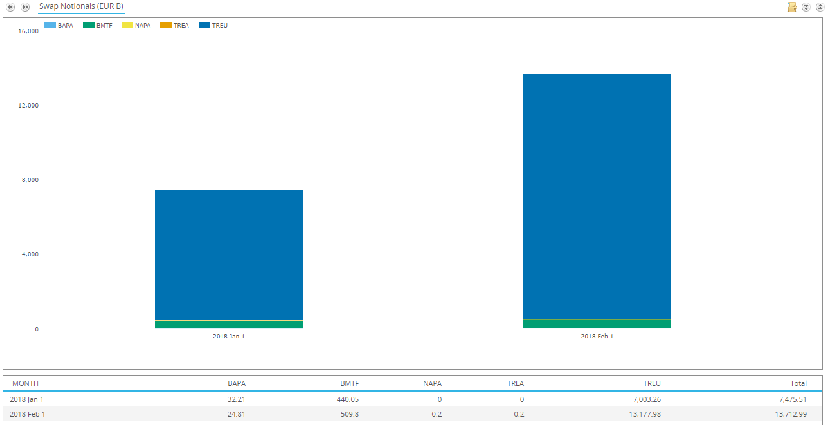

Showing;

* Notional amounts of Interest Rate Swaps (all currencies) reported in January and February 2018.
* In January 2018, €7trn out of the total €7.5trn was reported via Tradeweb. (94%).
* In February 2018, €13.2trn out of the total €13.7trn was reported via Tradeweb (96%).

Since early 2019, Tradeweb have not provided us with any more data.

We recently manually downloaded 24 hours of Tradeweb APA files on September 3rd. Unfortunately, due to all of the deferrals of data, it is very difficult to calculate the market share of APAs from the most recent data that we were able to pull. On a trade count basis alone, we found that the Tradeweb APA continues to be a hugely significant part of the market (32%).

**APA and Trading Venue Deficiencies**

Below, we list specific deficiencies of all of the data providers that we are trying to access.

**Tradeweb Deficiencies**

We believe that Tradeweb have significant deficiencies in providing free of charge data 15 minutes after publication. This is particularly significant to the overall transparency of the market because they have such a large market share.

The ways in which Tradeweb do not meet the requirements as set out in the Q&A Guidance[4] currently are:

* We consider the two minute slice files provided by Tradeweb (which cannot be downloaded as a whole package) to be an example of “Publishing information in a format that prevents users to read, use and copy the information” and for a “limited time period” that is prohibited in the Q&A guidance (Q&A 10).
* We consider this data to be in a format that prevents its use or copy because the manner in which they are hosted means they cannot be programmatically downloaded.
* Due to this, the data cannot be accessed in a repeatable nor reliable manner. This is in contravention of Q&A 10 guidance, which states “It is not reasonable to have the data available for a period that is not long enough for it to be downloaded reliably either on an ad-hoc or in a repeatable manner”.
* The files cannot be downloaded programmatically. The slice files provided are in CSV format, which is acceptable. However, each 24 hour period is split into two minute periods of activity, and it is not possible to access more than one slice file at a time. To therefore create a complete picture of trading activity on a single day, we have had to manually download each two minute slice file (it cannot be automated). This took approximately two hours of manual work. This falls significantly short of the requirement to make the data machine readable.
* The data is not provided free of charge. The website states:

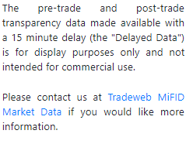

In our contacts with Tradeweb, they believe that the requirements to make data free of charge do not extend to ClarusFT – despite the fact that their competitors (Bloomberg and Nasdaq) already do so. Q&A 9(b) is unhelpful in our efforts to access this data. This means that we are unable to provide a complete picture of the market using any Tradeweb data. This falls way short of the requirement to be non-discriminatory; the data should be unencumbered of use restrictions and available for anyone to use for whatever purpose. This also seems significantly against the spirit of promoting transparency under MIFID II.

* There is no history available. Tradeweb fell significantly short of the requirements from day one by originally providing the data as an image. As a result, we have lost 20 months of transparency data. We strongly believe that to meet the requirements all of this missing data should be made available on the Tradeweb APA website free of charge and for public consumption. Q&A 9(b) is extremely unhelpful in trying to retrieve all of this lost transparency.

These comments apply to all post-trade 15 minute delayed data from the Tradeweb APA[5], Tradeweb MTF & OTF, Thomson Reuters FXALL & Matching and Forte.

**NEX APA Deficiencies**

The data provided at <https://apa.nexregreporting.com/home/trades> cannot be downloaded and consumed in an automated manner, which we consider fails to meet Q&A 10 guidance “a format that can be easily read, used and copied”.

The NEX APA website offers access to a “Machine Readable Feed” by sending an email to [enquiries@nexdata.com](mailto:enquiries@nexdata.com). We have done so and received no response. This is an example of how APAs have put different barriers in the way of Clarus being able to access what should be free of charge and unencumbered data. The data must be made available free of charge on a public website in a machine readable format of which the collection can be automated.

This is a prime example of why the guidance in Q&A 9(b) is extremely unhelpful in promoting transparency.

**TRAX APA Deficiencies**

The data provided at <https://traxapa.com/apa-publication/index.html#/trades> can be downloaded in a CSV format, which meets the requirements. To date, we have been unable to automate the download of this data, although this is currently subject to review by our technical experts.

Most pertinently, the data lies behind a very restrictive data licence, which states:

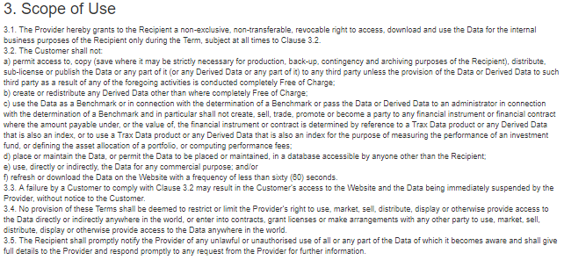

To our understanding, this prevents any user from creating derived data or providing the data (or any derivation of the data) for commercial purposes. Again, absent Q&A 9(b) this shows that access is not being provided in a non-discriminatory way.

In our opinion, this is against the requirement to make the data free of charge on a non-discriminatory basis and also very much against the spirit of the regulation to improve transparency.

As our previous analysis has shown, it is not a trivial matter to collate and curate data from multiple sources and then to make sense of it. This process is far beyond an end user of the data. This is shown with US SDR data as well. It typically takes a motivated third party (ClarusFT, Bloomberg, Refinitiv) with expertise in both data and the traded products themselves to make the data usable. This is the only way that transparency can be improved.

Such use restrictions of free data must be removed. The data should be free of charge and unencumbered by any data licences.

**Tradecho APA Deficiencies**

Despite numerous approaches and attempts on our behalf to Tradecho we have never been able to receive any data of any kind from them. There is no data accessible on their [website](https://www.tradecho.com/) and the link to “Trade Report Data” does not provide any data, only a link to [technical documentation](https://www.lseg.com/areas-expertise/technology/group-technology/group-ticker-plant). We consider this the most flagrant example of failing to comply with the requirements. There is no post-trade data made available for free. They have also been unresponsive to our communication efforts with them.

**TPICAP Trading Venue Deficiencies**

Registration for slice file downloads using our Clarus domain is prohibited on the TPICAP Slice File Registration portal:

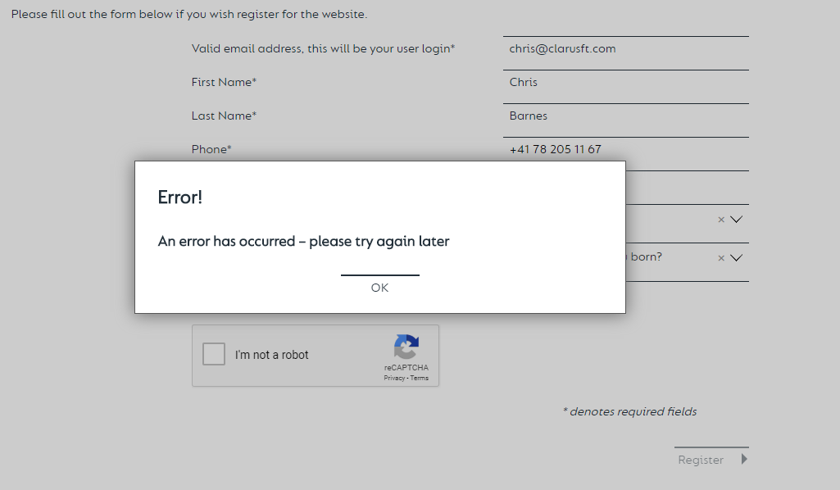

We were able to successfully register using other email domains and company name. We believe this is in contravention of the principle behind Q&A 10 “The post-trade data should be available to anybody free of charge”.

This shows how data providers can restrict access to transparency to different segments of the market. This is completely contrary to the requirements to make data available on a non-discriminatory basis. It is also setting a very dangerous precedent that providers of the data should be able to decide who can access their data. This should be left down to the NCAs alone. Restricting access based on domains or company names is clear discrimination, particularly for firms who may have treasury operations requiring access to FX or IRS data for internal purposes.

Furthermore, even if the data were accessible, the data licence is prohibitive of any use other than view only:

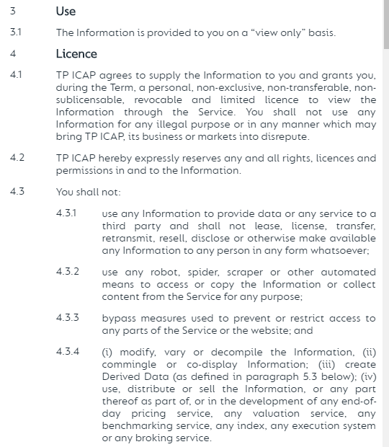

As we have explained previously, the data needs to be machine readable and usable so that it can be collated and analysed. Only being able to view data from multiple disparate sources will not enable end users to gain any transparency into markets.

**Fenics Trading Venues Deficiencies**

Fenics is the market data arm of all BGC group trading venues. We are unable to automate the collection of the post-trade data from <https://regdata.fenicsmd.com/dashboard>. We therefore believe that they are falling short of the requirements to provide machine readable data.

In addition, the data licence is restrictive to only allow personal use:

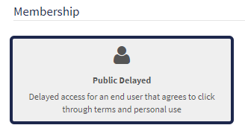

We have evidenced elsewhere in this response that this type of data is not suitable for “personal use” only. To be effective transparency data, it needs to be free of charge and unencumbered by restrictive data licences.

**MTS Trading Venue Deficiencies**

We are unable to automate the collection of data from <https://www.mtsmarkets.com/data-and-participant-reports/market-data-reports/mts-cash-delayed>. It therefore falls short of the requirement to provide machine readable data.

:<ESMA_QUESTION_MDA_12>

1. : Do you consider it necessary to provide further supervisory guidance in this area (for instance by reviewing Q&As 9 and/or 10) Please justify your position and explain in which area further guidance may be needed? Please differentiate between pre- and post-trade data.

<ESMA_QUESTION_MDA_13>

**Post-trade data**

Further supervisory guidance is essential to ensure that non-discriminatory access is provided to the free, public data. This will enable transparency of our markets to improve.

The current supervisory guidance provided in Q&A 9(b) is particularly unhelpful to achieving transparency.

To the best of our knowledge, no trading venue, data business or other provider has ever sold post-trade delayed data prior to MIFID II. This data is broadly used for research purposes and to aid understanding of markets. It is only useful when collated across the entire market and provides very limited transparency on a standalone basis outside of a consolidated data set. However, when consolidated it proves crucial for transparency purposes. The fact remains that it has not previously been commercialised.

This delayed data is not market moving and has evidently been outside of any previous data sales. We believe that it was intended to be made available free of charge, and to be public. The supervisory guidance provided to date has not been sufficient to ensure that free data is provided in a non-discriminatory manner.

As we have previously evidenced in our response, the transparency and research opportunities offered by this data are important to aid market understanding. However, no end-user will be in a position to consume and understand the data themselves. It takes expertise in both data processing and knowledge of the products to be able to use the data. Therefore, making the data free to only end-users will not meet the requirement to increase transparency.

Importantly, data from a single source cannot be used to view the whole market. For such delayed, post-trade data, it is a view of the entire market that is important. Only a view of the whole market enables an understanding of market trends. Therefore, consolidation across multiple sources is necessary for this data to be usable.

We therefore consider it entirely unhelpful that the commercial interests of APAs and Trading Venues should be so clearly protected in the Q&A answers 9 and 10. In particular, the answer to Q&A 9(b) is in direct contrast to the aims of Question 10 that seeks to promote the non-discriminatory access to data. Below, we outline the specific language that is problematic in the existing guidance.

**Question 9 (a)**

Answer 9 (a), the following highlighted (red, underlined) guidance is problematic:

“The information made available free of charge 15 minutes after its publication should replicate the information published on a reasonable commercial basis but with a 15 minutes delay. The information should be made available directly to end users. Where the trading venues make the data available via third parties, this should not impose restrictions on access to that data to end users. Trading venues are not required to make any further replication of already published information available free of charge.”

APAs and Trading Venues have been flagrant in their disregard of the transparency requirements, as evidenced in our previous answer. Therefore we believe that they should now, universally, make historic data available back to January 2018.

Any reference to “end-users” of the data needs to be removed from regulatory guidance. The data should simply be free of charge and available without a data licence. This is the only way to improve transparency. This is because end-users are not sophisticated enough in their data handling abilities to be able to consume multiple, disparate sources of data and create a holistic view of the market.

**Question 9 (b)**

“Trading venues, APAs and CTPs may not impose redistribution fees or other similar restrictions on redistributors/third parties making available data free of charge 15 minutes after the initial publication. Where a redistributor/third party charges fees for the distribution of data – including a general fee for accessing its services – trading venues, APAs and CTPs may impose redistribution fees or other similar restrictions on this redistributor/third party.”

This approach is demonstrably unfair to end users who do not have the sufficient skills or resources to consolidate multiple data sources. This is a level of protection that APAs and Trading Venues, who all have existing data businesses, simply do not need. This language should be removed entirely for transparency to improve.

“Furthermore, trading venues, APAs and CTPs may not charge fees or impose other similar restrictions on added-value services created by redistributors/third parties from data provided free of charge. Where a redistributor/third party charges for added-value services created from such data, trading venues, APAs and CTPs may impose fees or other similar restrictions to this redistributor/third party. “

Allowing any kind of restriction to data allows APAs and Trading Venues to become the gatekeepers to data. The data will therefore not be in the public domain as these operators will always protect their own commercial interests over and above promoting transparency.

Any use of the data should be allowed and data licences for post-trade 15 minute delayed data should be removed. This is the position already adopted by Bloomberg and Nasdaq. This should therefore be clearly stated as the standard that all operators must adhere to.

“However, MiFIR/MiFID II only requires data to be published after 15 minutes free of charge and therefore, trading venues, APAs and CTPs may charge fees for the use and redistribution of historic data that is considered as an added-value service.”

We strongly disagree with this entire statement. Data must be put in perspective, therefore an end user accessing transparency data must be able to compare and contrast current data to previous episodes. There should therefore be no differentiation between historic and current data. All of it needs to be in the public domain, free of charge, without any restrictions on use for it to aid transparency of markets. This is clearly demonstrated by the huge variability we see in daily volumes traded of OTC derivatives (data available at both sdrview.clarusft.com and mifidview.clarusft.com). An end user will be unable to interpret transparency data if they cannot assess trends in the market via access to historic data.

**Question 10**

We think the following highlighted guidance is problematic:

“ESMA expects trading venues, APAs and CTPs to make post-trade data, as well as pre-trade data, available free of charge 15 minutes after publication in an easily accessible manner for all potential users using a format that can be easily read, used and copied. This is without prejudice to Q&A 9(b) which allows, in certain cases, to charge fees or other similar restrictions on data. Furthermore, trading venues, APAs and CTPs are required to ensure the non-discriminatory access to pre- and post-trade data, including for data made available free of charge.”

The guidance should state that the data should be outside of any data licence and available to use for any purpose. This is the only way to allow end-users to be able to consolidate across multiple sources of data, either by using a third party (such as ClarusFT) or if they are exceptionally sophisticated, by consuming the feeds themselves. Allowing any operator to restrict access to data means that the data will never truly be in the public domain and will not aid transparency.

“Article 14 of RTS 13 requires APAs and CTPs to publish data in a machine readable way. In order to ensure that the information published by APAs and trading venues can be effectively and efficiently used by the public, ESMA expects that trading venues follow similar publication standards and publish data in a machine-readable way. In addition, APAs, CTPs and trading venues should also provide the data in a format that can be understood by an average reader.”

This guidance should add that all data, including historic data, should be consumable in an automated manner that allows for unrestricted usage via a public website without a data licence. This is so that data can be efficiently amalgamated across multiple sources and consumed without prejudice.

We also ask ESMA to issue supervisory guidance that states that the current publishing regime followed by both Bloomberg and Nasdaq are functionally meeting the requirements and that all operators should meet the same criteria.

•” Imposing restrictions on access to the published data

In order to ensure that all potential users can access the information made available free of charge 15 minutes after publication, trading venues, APAs and CTPs should make clear instructions to the public on their website on how and where to access the data. The post-trade data should be available to anybody free of charge and in a format which can be understood by the average reader.”

We strongly agree with the sentiment of this guidance; however it has become clear that the APAs and Trading Venues are not taking this in the spirit in which it was intended. To which end we suggest:

* Replacing “all potential users” with “anybody”.
* APAs and Trading Venues have clearly taken advantage of the “instructions” language to allow themselves to just not respond to queries from parties looking to access the data. The guidance should state that the data needs to be on a public website.
* APAs and Trading Venues have taken advantage of the “format” language to charge and/or restrict access to machine readable feeds. This language therefore needs to be replaced with language specifically stating that a machine readable feed is freely available, without restriction or discrimination on a public website.

“ESMA considers that publishing information on a website that is not accessible to everybody imposes restrictions on access to the data and does not meet the requirement for making information available free of charge. Similarly, the publication of data through third parties that do not charge specific fees for the relevant data but raise regular, for instance monthly or yearly, fees for subscribing to their services, does not meet the requirement to make information available free of charge. Furthermore, ESMA is of the view that allowing access to the data via a human interface only from ex ante registered IP addresses does not meet the requirement to make information available to the public free of charge. However, such a restriction is acceptable for data provided in a machine readable way.”

We again agree with the sentiment of this guidance; however the final line has clearly been manipulated by APAs and Trading Venues to allow themselves to discriminate access to their data. The machine readable feed should precisely be made available on a public website and in a way that the collection can be automated.

* “Publishing information in a format that prevents users to read, use and copy the information

Trading venues, APAs and CTPs should publish information in an electronic format that can be directly and automatically read by a computer, and that can be accessed, read, used and copied by any potential user through computer software that is free of charge and publicly available.”

We strongly agree with this guidance.

* “Requiring market participants to submit search queries in order to access data

The data made available free of charge should be published in a similar format as real-time data published on a reasonable commercial basis. ESMA does not consider that offering only publication arrangements whereby market participants are required to submit search queries in order to access limited portions of the data (e.g. ISIN-by-ISIN searches, limited time periods) meet the requirement of making data available free of charge, but such search queries could exist in addition.”

This language is not helpful as many of the commercial resellers of data require data to be delivered according to their own, proprietary technical standards. It would be much better to specify the technical standards that must be met precisely. We suggest adding particular reference to the current standards that Bloomberg and Nasdaq adhere to for their public data. This ensures that these operators are not unfairly penalised for fully meeting the transparency requirements from day one.

* Deleting data shortly after publication

“The data made available free of charge should replicate the information published on a reasonable commercial basis but with a 15 minutes delay. ESMA is of the view that the information should be available for any party to initiate a retrieval of the data for a period of at least 24 hours from the publication. It is not reasonable to have the data available for a period that is not long enough for it to be downloaded reliably either on an ad-hoc or in a repeatable manner”

Given that APAs have not kept to this guidance (see Tradeweb above), we believe the guidance needs to specify the exact technical specifications necessary, and that these should meet those of the current Bloomberg and Nasdaq platforms.

The data, at the very least, needs to be machine readable, available in a manner in which the collection can be automated, and persisted for a period of time. Historic data should also be made available for free.

* “No publication of post-trade data on transactions benefitting from a deferral

ESMA recalls that the obligation to make available post-trade data free of charge 15 minutes after publication applies also to transactions benefitting from a deferral. ESMA therefore expects that information on those transactions is made available on the same conditions as information on transactions not subject to deferred publication.”

This could be simplified to state that all data should be made available without specific reference to deferrals or not.

<ESMA_QUESTION_MDA_13>

1. : Do you agree that the identified reasons, in particular the regulatory framework and competition by non-regulated entities, make it unattractive to operate an equity CT?

<ESMA_QUESTION_MDA_14>

TYPE YOUR TEXT HERE

<ESMA_QUESTION_MDA_14>

1. : Do you consider that further elements hinder the establishment of an equity CT? If yes, please explain which elements are missing and why they matter.

<ESMA_QUESTION_MDA_15>

TYPE YOUR TEXT HERE

<ESMA_QUESTION_MDA_15>

1. : Please explain what CTP would best meet the needs of users and the market?

<ESMA_QUESTION_MDA_16>

TYPE YOUR TEXT HERE

<ESMA_QUESTION_MDA_16>

1. : Do you agree that real-time post-trade data is available from both trading venues and APAs as well as data vendors and that the data is currently not covering 100% of the market, i.e. including all equity trading venues in the EU and all APAs reporting transactions in equity instruments? If not, please explain.

<ESMA_QUESTION_MDA_17>

TYPE YOUR TEXT HERE

<ESMA_QUESTION_MDA_17>

1. : Do you agree that post-trade data is provided on a timely basis and meets the requirements set out in MiFID II/MiFIR and in the level 2 provisions? If not, please explain.

<ESMA_QUESTION_MDA_18>

TYPE YOUR TEXT HERE

<ESMA_QUESTION_MDA_18>

1. : Do you agree with the issues on the content of data and the use different data standards identified or do you consider that important issues are missing and/or not correctly presented?

<ESMA_QUESTION_MDA_19>

TYPE YOUR TEXT HERE

<ESMA_QUESTION_MDA_19>

1. : Do you agree that the observed deficiencies make it challenging to consolidate data in a real-time data feed? If yes, how could those deficiencies best be tackled in your view?

<ESMA_QUESTION_MDA_20>

TYPE YOUR TEXT HERE

<ESMA_QUESTION_MDA_20>

1. : What are the risks of not having a CTP and the benefits of having one?

<ESMA_QUESTION_MDA_21>

TYPE YOUR TEXT HERE

<ESMA_QUESTION_MDA_21>

1. : Would you be supportive of an industry-led initiative to further improve data quality and the use of harmonised standards or would you prefer ESMA guidance? Please explain.

<ESMA_QUESTION_MDA_22>

TYPE YOUR TEXT HERE

<ESMA_QUESTION_MDA_22>

1. : In addition to the standardisation of the reporting and format, as described before, did you identify any further relevant data quality issue to be considered for the successful establishment of CTPs?

<ESMA_QUESTION_MDA_23>

TYPE YOUR TEXT HERE

<ESMA_QUESTION_MDA_23>

1. : Do you agree that the mandatory contribution from trading venues and APAs to a CTP would favour the establishment of CT?

<ESMA_QUESTION_MDA_24>

TYPE YOUR TEXT HERE

<ESMA_QUESTION_MDA_24>

1. : Do you have preferences between the option of (i) requiring trading venues and APAs to contribute data to the CT, or, in alternative (ii) setting forth criteria to determine the price that CTPs should pay to TVs and APAs for the data? If so, please explain why.

<ESMA_QUESTION_MDA_25>

TYPE YOUR TEXT HERE

<ESMA_QUESTION_MDA_25>

1. : Do you agree that the mandatory consumption could favour the establishment of a CT? If not, please explain your concerns associated with the mandatory consumption.

<ESMA_QUESTION_MDA_26>

TYPE YOUR TEXT HERE

<ESMA_QUESTION_MDA_26>

1. : Would mandatory consumption impact other rules in MiFID II and if yes, how?

<ESMA_QUESTION_MDA_27>

TYPE YOUR TEXT HERE

<ESMA_QUESTION_MDA_27>

1. : Do you consider it necessary that the CT covers all trading venues and APAs and the whole scope of equity instruments or would you be supportive of limiting the coverage of the CT? Please provide reasons for your preference and explain your preferred approach.

<ESMA_QUESTION_MDA_28>

TYPE YOUR TEXT HERE

<ESMA_QUESTION_MDA_28>

1. : Do you agree with ESMA’s preferred model of real-time CT? If you consider that, on the contrary, the delayed or tape of record CT are preferable, please indicate the reasons of your preference.

<ESMA_QUESTION_MDA_29>

TYPE YOUR TEXT HERE

<ESMA_QUESTION_MDA_29>

1. : Are there any measures (either technical or regulatory) that can be taken in order to mitigate the latency impacts?

<ESMA_QUESTION_MDA_30>

TYPE YOUR TEXT HERE

<ESMA_QUESTION_MDA_30>

1. : Do you agree that the CT should be operated on an exclusive basis? To what extent should other entities (e.g. APA or data vendors) be allowed to compete with the CTP?

<ESMA_QUESTION_MDA_31>

TYPE YOUR TEXT HERE

<ESMA_QUESTION_MDA_31>

1. : Should the contract duration of an appointed CTP be limited? If yes, to how many years?

<ESMA_QUESTION_MDA_32>

TYPE YOUR TEXT HERE

<ESMA_QUESTION_MDA_32>

1. : Please indicate what would be, in your view and on the basis of your experience with TVs and data vendors, a fair monthly or annual fee to be charged by a CTP for the real-time consolidation per user?

<ESMA_QUESTION_MDA_33>

TYPE YOUR TEXT HERE

<ESMA_QUESTION_MDA_33>

1. : Would you agree with the abovementioned model for the CT to charge for the provision of consolidated date and redistribute part of the revenues to contributing entities? If not please explain.

<ESMA_QUESTION_MDA_34>

TYPE YOUR TEXT HERE

<ESMA_QUESTION_MDA_34>

1. : How would Brexit impact the establishment of a CT? Would an EU27 CTP consolidating only EU27 transactions be of added value or would a CT that lacks UK data not be perceived as attractive?

<ESMA_QUESTION_MDA_35>

TYPE YOUR TEXT HERE

<ESMA_QUESTION_MDA_35>

1. : In your view, how would an EU27 CT impact the level playing field between the EU27 and the UK? Please explain.

<ESMA_QUESTION_MDA_36>

TYPE YOUR TEXT HERE

<ESMA_QUESTION_MDA_36>

1. <https://www.bloombergapa.com/slicefiles>
2. <http://www.nasdaqomxnordic.com/nasdaq-apa/intraday>
3. <https://data.bloombergmtf.com/transparency>
4. Questions 9 and 10 of <https://www.esma.europa.eu/sites/default/files/library/esma70-872942901-35_qas_transparency_issues.pdf>
5. i.e. applies to all data accessed by the Tradeweb APA portal at [https://www.apa.tradeweb.com](https://www.apa.tradeweb.com/)