|  |
| --- |
| Response Form to the Consultation Paper |
| Guidelines for reporting under Articles 4 and 12 SFTR |

**Responding to this paper**

ESMA invites comments on all matters in this paper and in particular on the specific questions summarised in Annex III. Comments are most helpful if they:

* respond to the question stated;
* indicate the specific question to which the comment relates;
* contain a clear rationale; and
* describe any alternatives ESMA should consider.

ESMA will consider all comments received by **29 July 2019.**

All contributions should be submitted online at [www.esma.europa.eu](http://www.esma.europa.eu) under the heading ‘Your input - Consultations’.

**Instructions**

In order to facilitate analysis of responses to the Consultation Paper, respondents are requested to follow the below steps when preparing and submitting their response:

1. Insert your responses to the questions in the Consultation Paper in the present response form.
2. Please do not remove tags of the type <ESMA_QUESTION_RSFTR_1>. Your response to each question has to be framed by the two tags corresponding to the question.
3. If you do not wish to respond to a given question, please do not delete it but simply leave the text “TYPE YOUR TEXT HERE” between the tags.
4. When you have drafted your response, name your response form according to the following convention: ESMA_RSFTR_nameofrespondent_RESPONSEFORM. For example, for a respondent named ABCD, the response form would be entitled ESMA_RSFTR_ABCD_RESPONSEFORM.
5. Upload the form containing your responses, in Word format, to ESMA’s website ([www.esma.europa.eu](http://www.esma.europa.eu) under the heading “Your input – Open consultations” 🡪 “Consultation on Position limits and position management in commodities derivatives”).

**Publication of responses**

All contributions received will be published following the close of the consultation, unless you request otherwise. Please clearly and prominently indicate in your submission any part you do not wish to be publically disclosed. A standard confidentiality statement in an email message will not be treated as a request for non-disclosure. A confidential response may be requested from us in accordance with ESMA’s rules on access to documents. We may consult you if we receive such a request. Any decision we make not to disclose the response is reviewable by ESMA’s Board of Appeal and the European Ombudsman.

**Data protection**

Information on data protection can be found at [www.esma.europa.eu](http://www.esma.europa.eu) under the heading [Legal Notice](http://www.esma.europa.eu/legal-notice).

**Who should read this paper**

All interested stakeholders are invited to respond to this consultation. In particular, responses are sought from financial and non-financial counterparties to securities financing transactions, tri-party agents, agent lenders, central counterparties (CCPs) and trade repositories (TRs), as well as from all the authorities having access to the TR data.

**General information about respondent**

|  |  |
| --- | --- |
| Name of the company / organisation | International Securities Lending Association |
| Activity | Other Financial service providers |
| Are you representing an association? |  |
| Country/Region | UK |

**Introduction**

***Please make your introductory comments below, if any***

<ESMA_COMMENT_RSFTR_1>

This is the response by ISLA to the questions in Annex III.

ISLA would like to draw ESMA’s attention to the potential restriction on the use of Non-EU Issuer LEI’s as detailed in our response to Questions 41 & 69.

1. ISLA would like to point out that EU beneficial owners generally accept a diverse pool of collateral to reduce systemic risk, if the number of available securities is reduced;
2. It may increase the risk profile of these businesses.
3. Impact financial stability by reducing overall market liquidity, creating market squeezes and a global wholesale market unwind via mass recalls. This will not just impact EU markets as all global capital markets will be impacted, particularly those with lower LEI adoption rates. The Impact on liquidity will not just be on the securities with no LEI’s but also the wider indexes which they form part of.
4. It will reduce short covering in the market and restrict the ability of businesses to lend their pool of available assets.
5. Lead to an inability to hedge positions creating wider spreads & higher costs.
6. Damage the competitiveness of UCITs/AIFs involved in securities lending and more generally reduce the return to EU based pension funds.
7. Potentially move businesses and their transactions to non-EU based locations.

<ESMA_COMMENT_RSFTR_1>

**Questions**

1. : Do you agree with the above assessment? Are there any other transactions for which clarification is needed? Please detail the reasons for your response.

<ESMA_QUESTION_RSFTR_1>

The 'CSD fails-curing overdraft' section has caused some confusion with some participants of these programs now believing the L3 guidelines are advising that the whole of fails-curing reporting is out of scope for SFTR.  Our belief is that it wasn't the intension of ESMA to give this impression and that they were only trying to advise that functionality to cover cash shortages during settlement (e.g. via 'overdraft' type facilities) do not create new reportable SFTs on their own.

Most of this confusion probably stems from para. 40 where it might be better if it said: "...some CSDs offer additional fails-curing services that provide for cash shortages during settlement rather than just covering securities shortages. In these..."

<ESMA_QUESTION_RSFTR_1>

1. : Do you agree with the approach set out for reporting of SFTs under Article 4 of SFTR as detailed above? Please detail the reasons for your response.

<ESMA_QUESTION_RSFTR_2>

No Comment

<ESMA_QUESTION_RSFTR_2>

1. : Do you agree with the approach for reporting repos and reverse repos as detailed in this section? Please detail the reasons for your response

<ESMA_QUESTION_RSFTR_3>

N.A. for SL

<ESMA_QUESTION_RSFTR_3>

1. : Are there any other types of repos and reverse repos transactions for which reporting needs to be clarified? Please detail the reasons for your response.

<ESMA_QUESTION_RSFTR_4>

Gentran repo are traded under a Japanese stock lending agreement. The trade involves borrowing/lending stock and posting/receiving cash collateral. Therefore, the industry intends to report Gentan repos on the SBL template.

<ESMA_QUESTION_RSFTR_4>

1. : Are there any other aspects on reporting of master agreements or other elements of BSB/SBB that need to be clarified? Please detail the reasons for your response.

<ESMA_QUESTION_RSFTR_5>

N.A. for SL

<ESMA_QUESTION_RSFTR_5>

1. : Do you foresee any issues relating to the non-availability of information on the counterparties and the securities by T+1? Please detail the reasons for your response.

<ESMA_QUESTION_RSFTR_6>

Each reporting firm is reliant on other parties sharing information in order for them to report by their reporting deadline, e.g. UTI's from counterparties, allocations from Agent Lenders. If this data is not shared in a timely manner this will prevent reporting firms from adhering to their reporting deadline.

<ESMA_QUESTION_RSFTR_6>

1. : To what extent the SFTs that are cancelled and replaced bear price-forming information, i.e. does the cancellation imply an additional fee or price charged? If so, how can this information be better included in the reports? Please detail the reasons for your response.

<ESMA_QUESTION_RSFTR_7>

No Comment

<ESMA_QUESTION_RSFTR_7>

1. : Which approach would you favour in terms of reporting cash-driven SLB? Please detail the reasons for your response.

<ESMA_QUESTION_RSFTR_8>

ISLA members are advising as best practice that companies should book the trades to the template that best fits and annotate the Master Agreement Type in the relevant field under which it is governed. So for ‘Reverse Stock Loans’ which are essentially a structured finance trade with all the hallmarks of a Repo, i.e. loan of cash etc, report them in the Repo Template but reference the securities lending agreement in field 2.9 as the trade agreement.  
   
This was the conclusion, else these types of trades simply do not fit into a the Stock Loan template as they are traditionally not the loan of stock (therefore cash).

<ESMA_QUESTION_RSFTR_8>

1. : Do you agree with the proposal with regards to reporting of SFTs involving commodities? What other aspects should be clarified with regards to these SFTs? Please detail the reasons for your response.

<ESMA_QUESTION_RSFTR_9>

N.A. for SL

<ESMA_QUESTION_RSFTR_9>

1. : Are there any aspects that need to be clarified with regards to this type of SFTs? Please detail the reasons for your response.

<ESMA_QUESTION_RSFTR_10>

N.A. for SL

<ESMA_QUESTION_RSFTR_10>

1. : Do you agree with the proposal with regards to reporting of margin lending? What other aspects should be clarified with regards to these SFTs? Please detail the reasons for your response.

<ESMA_QUESTION_RSFTR_11>

N.A. for SL

<ESMA_QUESTION_RSFTR_11>

1. : Having in mind that position reporting of CCP-cleared SFTs is optional only when transaction-level reporting was made in accordance with paragraph 84, do you believe that additional clarifications need to be provided by ESMA? Please detail the reasons for your response.

<ESMA_QUESTION_RSFTR_12>

No Comment

<ESMA_QUESTION_RSFTR_12>

1. : Do you agree with the approach regarding allocation of responsibility with regards to SFTs concluded between TC-FC and EU SME-NFC? Please detail the reasons for your response.

<ESMA_QUESTION_RSFTR_13>

Yes, we agree.

<ESMA_QUESTION_RSFTR_13>

1. : Do you agree with the approach regarding allocation of responsibility with regards to UCITS management company and AIFM, established in third country? Please detail the reasons for your response.

<ESMA_QUESTION_RSFTR_14>

No Comment

<ESMA_QUESTION_RSFTR_14>

1. : Do you agree with the approach for determining conclusion of SFTs by EU branches of non-EU entities? Are there any other instances in addition to the ones in paragraph 102 that would need to be clarified? Please detail the reasons for your response.

<ESMA_QUESTION_RSFTR_15>

ISLA Agree with ICMA's position on branches.

<ESMA_QUESTION_RSFTR_15>

1. : Is the proposed guidance for determining whether an SFT conducted by a branch needs to be reported clear and comprehensive? Which areas require further clarification? Please detail the reasons for your response.

<ESMA_QUESTION_RSFTR_16>

Yes, it is clear.

<ESMA_QUESTION_RSFTR_16>

1. : Is the proposed guidance for reporting of intragroup SFTs clear and comprehensive? Which areas require further clarification? Please detail the reasons for your response.

<ESMA_QUESTION_RSFTR_17>

Yes, it is clear.

<ESMA_QUESTION_RSFTR_17>

1. : Do you agree with the approach for reporting by NFCs? Is there any additional aspect relating to reporting by NFCs that needs to be clarified? Please detail the reasons for your response.

<ESMA_QUESTION_RSFTR_18>

No Comment

<ESMA_QUESTION_RSFTR_18>

1. : Do you agree with the proposal for reporting conclusion of SFTs? Please detail the reasons for your response.

<ESMA_QUESTION_RSFTR_19>

1) In Section 5.8, paragraph 116, on page 30 (Q19) of the Consultation Paper it states;  
‘In case an SFT that is concluded is subsequently cancelled or not completed, due to reasons attributable to the counterparties or to third parties, such as CCPs or CSDs, then the counterparties after reporting it with Action type “New” or “Position Component”, as applicable, should report it with Action type “Error”.’  
  
The previous paragraph appears to manage the scenario whereby an SFT is traded but not settled, therefore the only logical response to the NEWT would be an EROR. ISLA agrees with ESMA’s proposal.  
  
2) In Section 5.12, paragraph 140, on page 37 of the Consultation Paper (row 3 of the table illustration), appears to conflict with the previous statement, when it states:  
“Counterparty Default or Settlement Fail” should result in a “ETRM” message template being generated.   
  
However, upon closer inspection the previous paragraph appears to manage the scenario whereby an SFT is traded and settled, therefore the only logical response to the NEWT would be an ETRM to reflect the restitution process. ISLA agrees with ESMA’s proposal.  
  
**The majority of ISLA members have concluded that the “Settlement Fail” referred to in the Level III text is only intended to be associated to a default scenario and not every-day, vanilla, settlement fails. Therefore, those members have removed settlement fails from scope and we would like to make our intentions clear to ESMA that we will proceed with our understanding on this basis for this relatively small pool of term trades (and subsequently very small number of fails) that exist in the SBL market. It should also be noted that CSDR will also enable ESMA to review any fails that do occur.**  
  
**In conclusion it is the majority view of ISLA members that we assume ‘perfect-settlement’ and do not modify the value dates upon vanilla settlement failures.** This view aligns with ICMA and also supports the notion that an SFT is ‘concluded’ upon the bilateral trading agreement between counterparties, e.g. trade event and not the settlement event.  
  
ISLA members would like to make clear to ESMA that any deviation from this approach and a need to report on the failure of settlement, would require a laborious build-out by all vendors and proprietary system owners.

Typically, in most trading/back-office systems, there is no ‘failed-settlement’ event; rather it is derived from the notion of a ‘pending’ status where the contractual settlement date is less-than or equal to today. ‘Today’ in this case would be different in every traded market, therefore a recognition of the opening hours and holiday dates of every global stock exchange would have to stored and monitored. The build-out required to manage the adjusted reporting of all vanilla settlement-fails would be a huge undertaking, therefore, should they be within-scope, then the industry would need to be advised ASAP to be ready for entry-into-force in April 2020.

As per ESMA’s request to provide examples the below use case demonstrates what happens when a term trade fails to settle;

In this example any pre-paid collateral posted in anticipation of settlement of the opening leg 3 June would not be returned until 14 June.

• Not included, but ISLA members would expect to report COLU messages daily through 12 June – ideally 14 June if there was a mechanism to do so.

• Members would report assuming perfect settlement of the opening leg (i.e. ‘Value date/start date’ would remain as is) and return leg (therefore ‘Maturity date’ would remain as is e.g. perfect settlement is reported)

• The obvious limitation of a failed return and keeping ‘Maturity date’ as was originally reported is that parties analysing the reports between intended settlement date of the return and actual settlement date of the return (where different) would lose visibility of the trade and collateral.

ISLA invite ESMA to complete the table below;



A potential number of approach’s exist for the next iteration of SFTR;

• In the event settlement failure is required to be reflected, one future phase II option to avoid this would be to report all SBLs as ‘Open term’ = True, then sending an ETRM upon actual settlement of the return.

• An alternative phase II approach is to add a field called “settlement status”. When a trade settles a MODI would be sent to update the “settlement status” field. ESMA would know that a trade had failed if the “settlement status” is pending and the value date is in the past. ESMA would only include trades with a “settlement status” of settled in the analysis of exposures.

• A less popular approach is that the ‘Value date/start date’ is rolled forwards in the event of a failed opening leg and/or the ‘Maturity date’ is rolled forwards in the event of a failed closing leg, because there is no other means of reflecting the impact of actual settlement.

<ESMA_QUESTION_RSFTR_19>

1. : Do you agree with the proposal for reporting modifications to SFTs? Please detail the reasons for your response.

<ESMA_QUESTION_RSFTR_20>

Yes, the Industry will report after the modification of the trade has happened.

<ESMA_QUESTION_RSFTR_20>

1. : Do you agree with the proposal for reporting collateral updates to SFTs? Please detail the reasons for your response.

<ESMA_QUESTION_RSFTR_21>

ISLA aligns with ICMA’s response.<ESMA_QUESTION_RSFTR_21>

1. : Do you have any issues with reporting in a timely manner valuation, margin and reuse updates pertaining to SFTs? Please detail the reasons for your response.

<ESMA_QUESTION_RSFTR_22>

The following are the agreed reportable dates;   
  
Valuation update Trade date plus 1.  
  
Margin update Pledge Date plus 1.  
  
Re-use update settlement date plus 1.

<ESMA_QUESTION_RSFTR_22>

1. : Do TRs require additional guidance in relation to how reports submitted by the entities mentioned in Article 2(2) and (3) of SFTR should be treated and the relevant procedures to follow? If so please confirm where further guidance is required.

<ESMA_QUESTION_RSFTR_23>

No Comment

<ESMA_QUESTION_RSFTR_23>

1. : Do you agree with the proposed rules for reporting of field 1.17? Are there any other instances that would need to be clarified? Please detail the reasons for your answer.

<ESMA_QUESTION_RSFTR_24>

Yes, we agree but would like to clarify where the reporting counterparty is using an Agent Lender / Custodian for the instruction of SFTs (irrespective of whether the reporting counterparty is the CSD Participant or not), the reporting counterparty should use option C within their reporting.

<ESMA_QUESTION_RSFTR_24>

1. : Do you consider proposal A or proposal B to be the most efficient way to ensure that details of SFTs are reported accurately, and why? What would be the costs and benefits of each approach? Please detail the reasons for your response.

<ESMA_QUESTION_RSFTR_25>

Option A is agreed.

Among our members, we have not identified any support for Proposal B, in part because many firms will utilise their strategic reporting platforms used for regimes such as EMIR which is consistent with Proposal A. We note similar feedback from the other trade associations.

Additionally, we are aware that at least one of the TRs, DTCC, is strongly against Proposal B and support their reasoning, as presented in the Workshop of 16 July:

Under Proposal B, it’s not clear how the blank should fields would be interpreted by the TR; whether the ‘Reporting Counterparty’ was purposely amending the values to ‘blank’, or not providing them because they are not mandatory for a given ‘Action type’.

Lastly, as also pointed out by a number of firms at the Workshop, most firms (including TRs) are already well progressed with their build, so a drastic change of approach in Q4 would not be able to be met by April 2020 go-live and would severely compromise testing completed to date.”

<ESMA_QUESTION_RSFTR_25>

1. : Do you agree with the sequences proposed? Please detail the reasons for your response.

<ESMA_QUESTION_RSFTR_26>

We agree with tables 2,3 and 4 with the exception that we require in table 2 a MODI to be permissible after a termination. In the event of a NACK on single or multiple messages ISLA members recommend that a NEWT is sent on the next complete ACK'd message. There is no replay of NACK'd messages because this method will give the latest view of systemic risk.  
Example  
Event 1: Monday Wk 1: Loan Booked. Rate = X. NEW report sent. NACK received due to a reference data problem (e.g. LEI).  
Event 2: Wednesday Wk 1: Loan Rate modified to rate = Y. Any message would be NACK’d due to the ongoing Ref Data problem.  
Event 3: Friday Wk 1: Loan Rate modified to rate = Z. Any message would be NACK’d due to the ongoing Ref Data problem.   
Over Weekend - Reference data release corrects problem.  
Event 4: Monday Wk 2: Loan rate modified. Rate = R. If the reporting firm sends a MODI it will be NACK’d as there has been no NEW.   
  
Option 1: Following the NACK of Event 1, any time a subsequent change is received, auto-detect that no NEW has previously been ACK’d, therefore send subsequent events as NEW. Ultimately, Event 4 would then be ACK’d as a NEW. Proposal is to accept that “latest is greatest” and therefore the position at event 4 is the correct position going forward, at Rate R.  
Option 2: Send event 4 as a NEW, once an ACK is received, then send Events 1, 2, 3 as MODI in sequence, and then RE-SEND Event 4 as a MODI to ensure that the current Rate is reflected.  
Option 3: Send all events in sequence.  
  
Our preferred option is 1 followed by option 3.

<ESMA_QUESTION_RSFTR_26>

1. : Do you agree with the proposed mapping between business events and action types? Are there any additional business events that should be included? Please detail the reasons for your answer.

<ESMA_QUESTION_RSFTR_27>

ISLA Steer Co have reviewed Table 5, Section 5.12, Paragraph 140, on page 37 of the Consultation Paper and have identified the following in the table below:  
- events which ISLA believe should be reported with a different action type;  
- events which apply to SBL but are currently marked as applying only to Repo;  
- events which are missing (new row).   
  
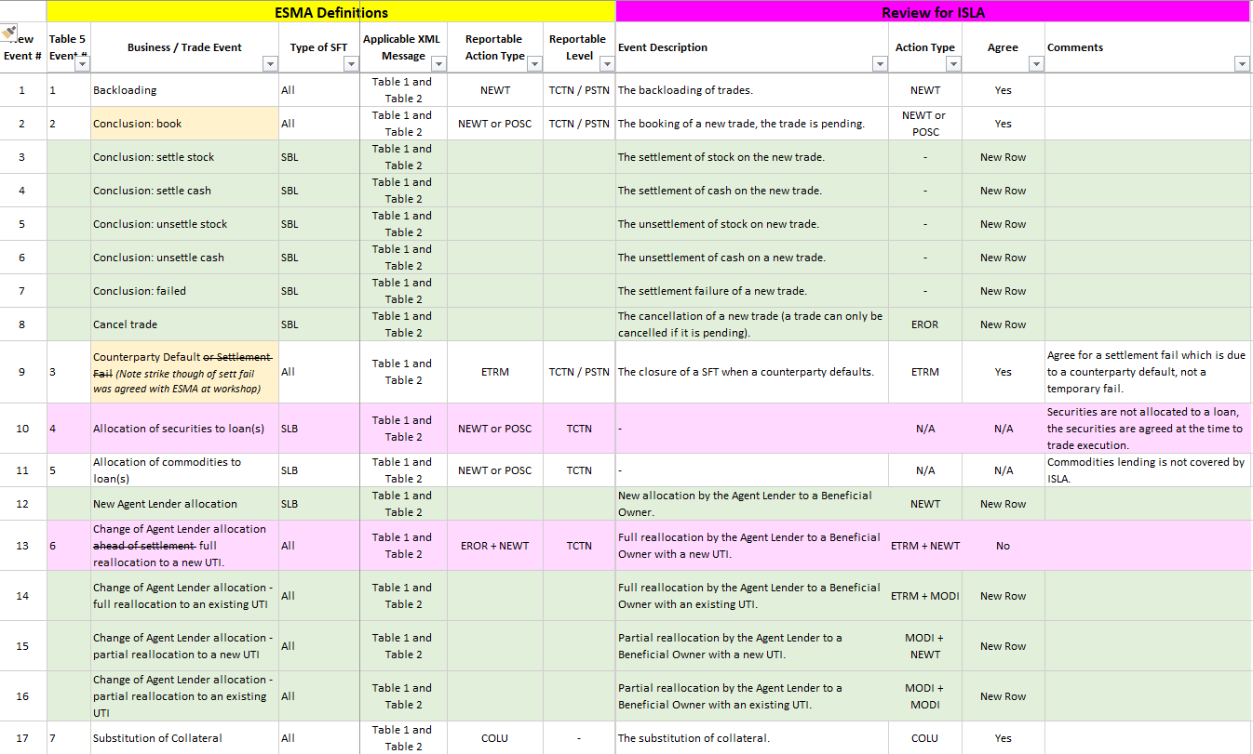

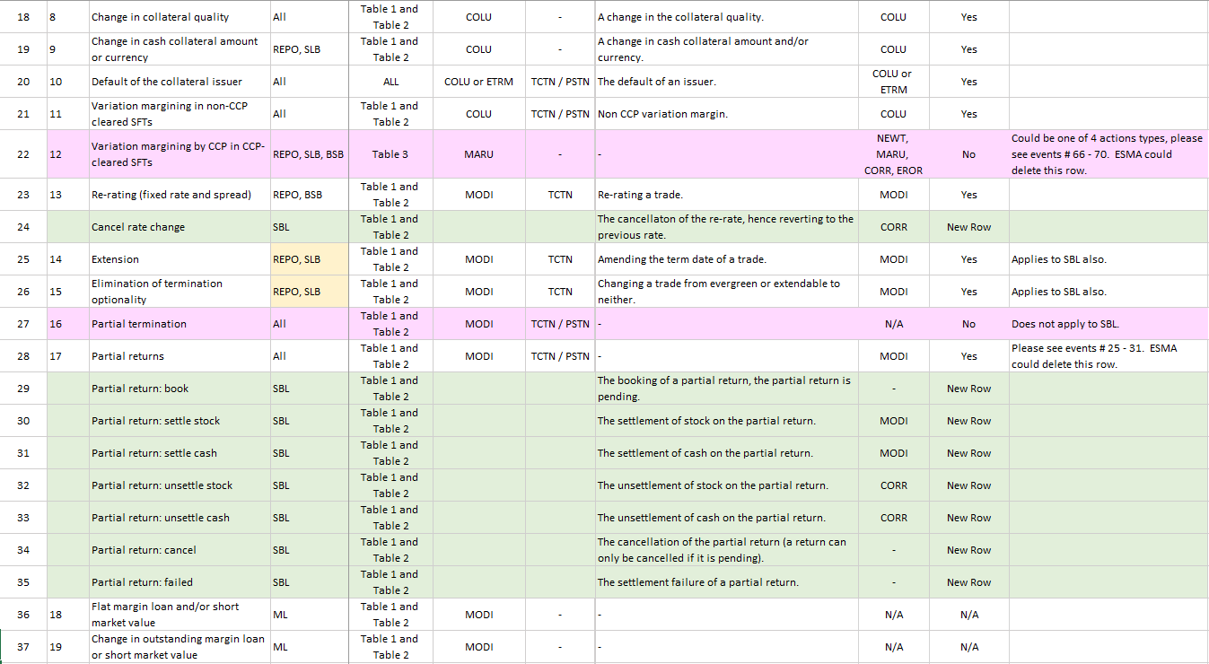

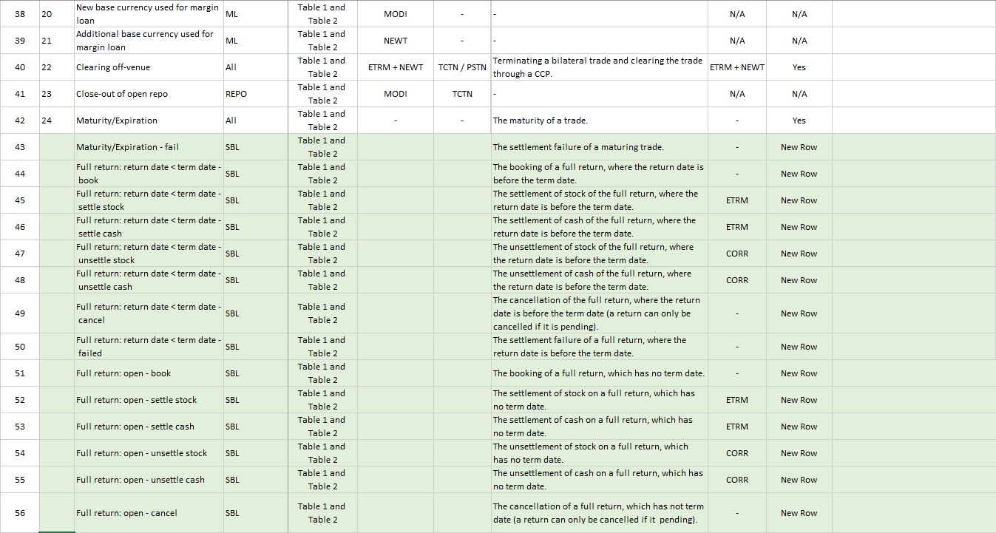

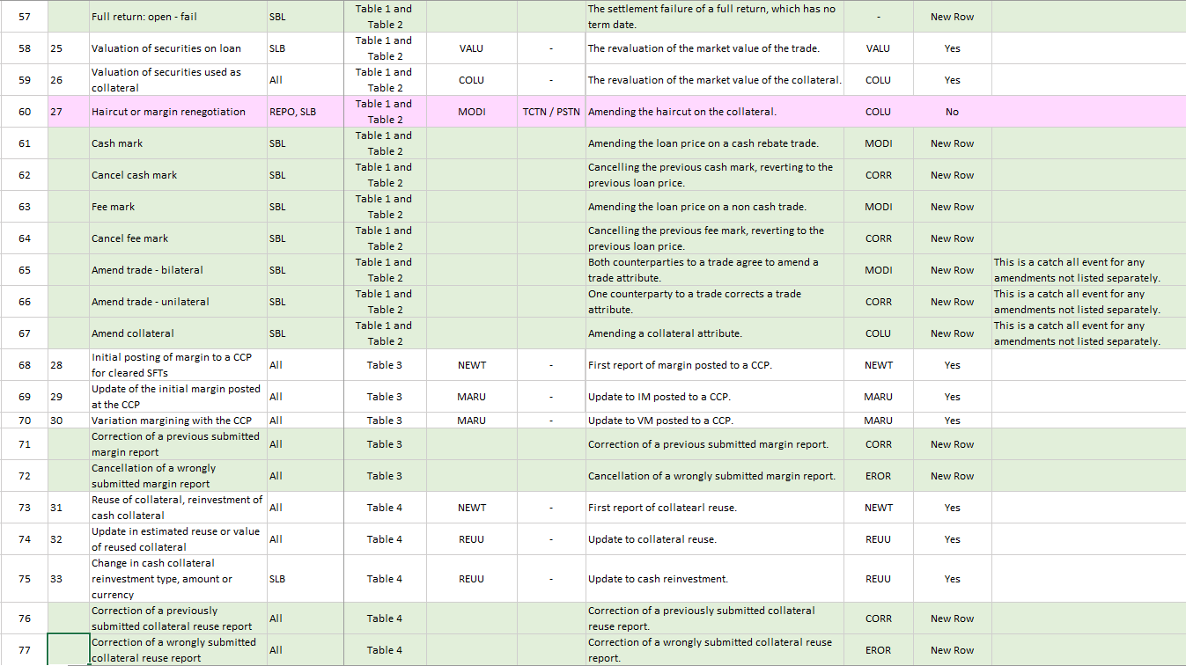

<ESMA_QUESTION_RSFTR_27>

1. : Are there any other relationships that would need to be defined? If so, please detail which ones.

<ESMA_QUESTION_RSFTR_28>

Please see the green rows in question 27.

<ESMA_QUESTION_RSFTR_28>

1. : Is there any aspect not covered by the ITS on reporting that would require further clarification? Please detail the reasons for your response.

<ESMA_QUESTION_RSFTR_29>

No.

<ESMA_QUESTION_RSFTR_29>

1. : Do you agree with the proposed approach for reporting of counterparty side in the case of CCP-cleared SFTs? Please detail the reasons for your response.

<ESMA_QUESTION_RSFTR_30>

Yes, we agree.

<ESMA_QUESTION_RSFTR_30>

1. : Do you agree with the proposed approach to determine which side of a transaction is the collateral provider and which is the collateral taker for unsecured lending/borrowing of securities? Please detail the reasons for your response.

<ESMA_QUESTION_RSFTR_31>

Yes, we agree.

<ESMA_QUESTION_RSFTR_31>

1. : Please indicate how frequently is a haircut, margin or any other type of discount/add-on, applied to the loan side of SLB?

<ESMA_QUESTION_RSFTR_32>

For the SBL market typically 35% of all trades are cash which have margin applied to the loan side and 65% of trades are non-cash which may and may not have margin applied. For further statistics please see http://isla.co.uk/assets/smart-pdfs/isla-securities-lending-market-report/

<ESMA_QUESTION_RSFTR_32>

1. : Do you agree with the proposed approach? Please detail the reasons for your response.

<ESMA_QUESTION_RSFTR_33>

Paragraph 150 states “any margin, add-on or discount that might apply to the security on the loan side of the trade should be included in field 2.49, i.e. the final price agreed between the counterparties for the transaction to take place”.  
  
For cash rebate trades we agree that we should report the fields 2.49 “security or commodity price” and 2.56 “loan value” after the margin requirement % has been applied.  
  
For cash pool and non-cash trades, the final price that is agreed does not include the margin requirement %.  
  
In the ESMA workshop on 16th July, this point was discussed and it was mentioned that the values reported for fields 2.49 & 2.56 should be after the margin requirement % is applied and therefore the value that is used in exposure calculations. However, loan value is not used in exposure calculations. **Therefore, for cash pool and non-cash trades, the ISLA Steer Co agree that we should report fields 2.49 & 2.56 before the margin requirement % has been applied.**  
**In order to compare exposure, the authorities should compare fields 2.57 market value and 2.88 collateral market value as per paragraph 154.**

<ESMA_QUESTION_RSFTR_33>

1. : Do you agree with the proposed approach? Please detail the reasons for your response.

<ESMA_QUESTION_RSFTR_34>

Paragraph 152 states “This means that the gross loan value should be reported in local currency, excluding the “Haircut or margin” % (field 2.89)”. This contradicts paragraph 150 which says that “The “security or commodity price” (field 2.49) should be reported in the original currency at which the transaction was agreed between the counterparties”. ISLA members agree that loan value should be reported in the currency that is agreed between the parties (field 2.50). There is no tolerance on field 2.56 “loan value”, therefore reporting this field in the currency that is agreed between the counterparties, (commonly known as the loan currency), will eliminate reconciliation breaks resulting from FX conversions. As there is only one currency field, the ISLA members agree that field 2.57 “market value” should be reported in the loan currency (field 2.50). There is a tolerance on the market value field, which will reduce the number of breaks resulting from FX conversions.

<ESMA_QUESTION_RSFTR_34>

1. : Do you agree with the proposed approach on timing and use of FX rates? Please detail the reasons for your response.

<ESMA_QUESTION_RSFTR_35>

ISLA members align to ICMAs comments on this topic; we do not expect firms to change applicable FX rates or market prices in their systems just to fix a reconciliation break. Note for ESMA's information Asian FX rates for valuation purposes are normally same day (being received in the morning) and European FX rates are prior day.

<ESMA_QUESTION_RSFTR_35>

1. : Does ESMA need to provide additional guidance on the reporting of the valuation fields? Please detail the reasons for your response.

<ESMA_QUESTION_RSFTR_36>

As previously communicated current industry practices with regards to prices, FX Rates and business methods mean valuations will not always reconcile. The only way to reduce reconciliation breaks in relation to the relevant fields would be to increase the tolerances to more realistic levels. ISLA aligns to ICMAs comments on this topic.

<ESMA_QUESTION_RSFTR_36>

1. : Do you have any remarks concerning the reporting of CFI? What other aspects need to be clarified to ensure that reporting is consistently performed? Please detail the reasons for your response.

<ESMA_QUESTION_RSFTR_37>

Can ESMA clarify the meaning of “official sources”, i.e. which sources qualify as official? Does this include ANNA and the key data providers/platforms in the market?

In case a CFI code from an official source is unavailable will ESMA define an alternative fall-back option?

1. Members request that this field is made optional on account that there are large data gaps. Members would expect to provide a CFI code where one exists in ANNA which may provide ESMA with a chance to validate.
2. If optionality is not granted, then members request that a dummy CFI code is set up and registered at ANNA.

<ESMA_QUESTION_RSFTR_37>

1. : Do you agree with the approach for back-loading? What other aspects have to be considered to make the reporting of backloaded SFTs more efficient for counterparties and TRs, i.e. the costs of this approach are minimised and also the usefulness of the reports submitted going forward is maximised? Please detail the reasons for your response.

<ESMA_QUESTION_RSFTR_38>

ISLA members appreciate the flexibility to report backloading using either method.

Since our most recent formal response on this subject, ISLA members have revisited the backloading requirement. While some members still favour backloading their entire book at go-live, a number have reconsidered their position and we no longer have a consensus. Our sense is that a significant number will not move forward with the full backload at go-live for the following reasons:  
1. Firms have reflected on the significant additional undertaking of readying their population of open trades for go-live, including creation and assignment of UTI, reference data sourcing and also accurate population of execution timestamp, etc. This has the effect of bringing go-live forward by several months.  
2. As they would be required to do (Paragraph 171.b), some firms have said that they cannot commit to a discretionary backload in advance of go-live of a project of this size. Recognising that both parties need to agree to the backloaded population, those firms that are in favour in principle are reluctant to have multiple bilateral agreements in place.  
3. Related to point 2, a firm undertaking a discretionary backload is putting themselves at risk of significant numbers of unpaired trades if their counterparties do not follow suit.  
4. A member with experience of derivative regime backloads commented that backloads tend to be most successful when a known eligible population is refined over a period of time, away from the core project, to ensure that everything is in place to meet the obligation deadline.  
5. A backload of the legislated population between 180 and 190 days from go-live will prevent any over-reporting and maximises the time to ensure the data is accurate  
Members would like to clarify that as result of this net collateral reporting will be skewed for a period after go-live, decreasing as the proportion of unreported trades decreases. This will happen as new trades come into reporting scope and old, unreported, trades close.

<ESMA_QUESTION_RSFTR_38>

1. : What other aspects with regards to the UTI have to be clarified? Please detail the reasons for your response.

<ESMA_QUESTION_RSFTR_39>

ESMA need to recognise that not all firms adopt the same process.

If the generating party has not shared the UTI with the reporting counterparty in-order for them to meet their reporting deadline then firms may do one of the following.

* Send with a blank UTI
* Send with their own UTI
* Wait indefinitely until they receive the UTI from the generating party.

<ESMA_QUESTION_RSFTR_39>

1. : Are there any other instances that need to be clarified? Please elaborate on the reasons for your response.

<ESMA_QUESTION_RSFTR_40>

No Comment

<ESMA_QUESTION_RSFTR_40>

1. : Please provide the relative volume of transactions for which issuer’s LEI (of securities used as collateral) or ISIN is not available in principle.

<ESMA_QUESTION_RSFTR_41>

1) LEI’s - Gaps in Global LEI Coverage;

ISLA is in alignment with AFME comments in their response. To quantify the potential size of these issues, LEI Issuer coverage has been analysed from several perspectives. The first is by a prominent securities reference data provider, who reported 70% of issuers not yet having an associated LEI. Perhaps a more relevant study for the SFT industry was LEI coverage for assets under custody, which highlighted 34% of assets missing issuer LEI across the board. Another study was undertaken using data from actively lent/borrowed portfolios. It is this last data set which has been used in the following graphic, following highlighting good levels of coverage in many EU jurisdictions, but also lower levels in Japan and USA.

It should be noted that the data used in the graphic is unweighted and does not include measures of value/volume. It does however provide a clear indication that some considerable effort is required to improve Issuer LEI registration.

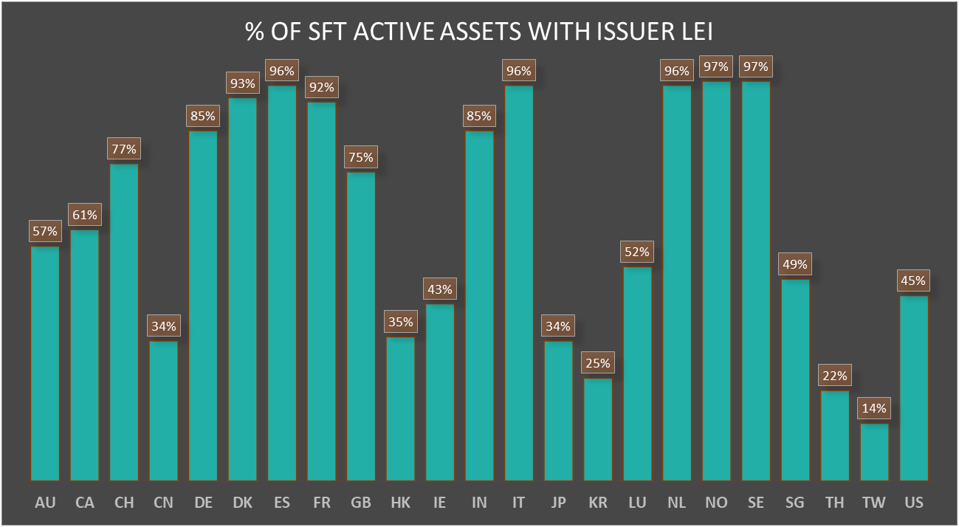

1 - [*https://www.fsb.org/2019/05/fsb-publishes-peer-review-of-implementation-of-the-legal-entity-identifier/*](https://www.fsb.org/2019/05/fsb-publishes-peer-review-of-implementation-of-the-legal-entity-identifier/)

ISLA members are concerned as previously submitted to ESMA Dec18 that a high quantity of loan and collateral positions will NACK. As ESMA has not made any changes the ISLA members reiterate that for a COLU the entire report will be REJECTED where the LEI is missing and that this will have a major impact on any ESMA exposure analysis.

ISLAs ‘Best Practice’ Dec18 recommended:  
Not all ISINs currently have an issuer LEI defined though, currently, both of these fields are defined as mandatory for all securities via the provided 'Conditional' logic. Recommend that both these fields are made 'Optional' in the validation rules to avoid significant TR rejections for ISINs with no defined issuer LEI.

**Recommendation:  
a) That fields 2.54 and 2.93 are made optional or;  
b) Allow the creation of a dummy LEI which is registered with GLEIF.**

**ISLA further point out that under CSDR an LEI is only required for every new security issued.**

Further statistics;  
JPM LEI Summary Statistics April 2019:   
 55k assets analysed:   
o 36k or 66% of assets have an associated LEI, representing 77% of the total AUC   
o 18k or 34% of assets with no associated LEI, representing 23% of the total AUC   
  
Of the 23% total AUC missing LEIs the breakdown is as follows:   
o JGBs make up 65%   
o Equities 24%   
o Other Bonds make up the remainder 11%   
  
Clearstream Response 1st July19.   
In terms of LEI coverage, : Based on our active holding of all securities as of 20.3.2019, we do have a coverage of all types of LEI at securities / ISIN level by 90% approx. (incl. both Domestic and International) and at Issuer level, by 63% approx. (incl. both Domestic and International)”

2) ISIN’s may not on occasion be available where private placements occur or where a new security has been issued and a temporary ISIN has been provided.

Members still require instruction as to whether fields #41 ‘Security identifier’, #78 ‘Identification of a security used as collateral’ in Table 2 as well as #7 ‘Collateral component’ should be reported blank for securities without an ISIN, or those lines should be omitted to ensure transmission of the rest of the submission?

**Recommendation:**

**1. Members request the field is made optional.**

**2. In the event that this field is not made optional, the industry would prefer to leave the field blank.**

<ESMA_QUESTION_RSFTR_41>

1. : Do you agree with this approach? What other aspects need to be considered? Please elaborate on the reasons for your response.

<ESMA_QUESTION_RSFTR_42>

Yes, we agree.

<ESMA_QUESTION_RSFTR_42>

1. : Do you believe there are other use cases that need to be further defined in this subsection? Do you agree with the applicability of those use cases to the different types of SFTs as outlined above? Please detail the reasons for your answers.

<ESMA_QUESTION_RSFTR_43>

No comment.

<ESMA_QUESTION_RSFTR_43>

1. : Do you agree with the population of the counterparty data fields? Please detail the reasons for your response and indicate the table to which your comments refer.

<ESMA_QUESTION_RSFTR_44>

On the whole we agree with the approach in this section however we would like to point out a few discrepancies:  
  
1. Table 14 should say “Broker E” in field 15.  
2. For tables 8, 10, 12, 16, 20, 24, 26, 28 & 30 the description of the scenario does not mention where the stock is settling, therefore it is impossible to ascertain how field 17 should be populated.

<ESMA_QUESTION_RSFTR_44>

1. : Do you agree with the approach to reporting action types? Please detail the reasons for your response and include a reference to the specific table.

<ESMA_QUESTION_RSFTR_45>

Yes, we agree these simple examples.

<ESMA_QUESTION_RSFTR_45>

1. : Do you agree with the approach to reporting event date? Please detail the reasons for your response and include a reference to the specific table.

<ESMA_QUESTION_RSFTR_46>

Please see the table as below;

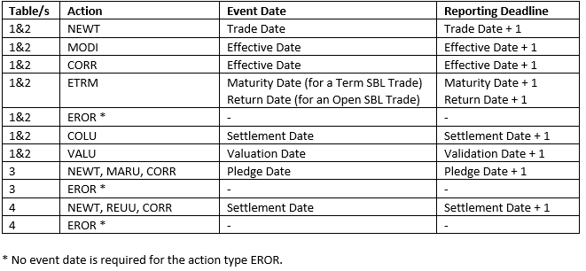

ISLA also asks that in any future SFTR Phase II that the inclusion of an effective settlement date field should be included.

<ESMA_QUESTION_RSFTR_46>

1. : Do you agree with the approach to reporting clearing? Please detail the reasons for your response and include a reference to the specific table.

<ESMA_QUESTION_RSFTR_47>

No Comment

<ESMA_QUESTION_RSFTR_47>

1. : Do you agree with the approach to reporting trading venue field? Please detail the reasons for your response and include a reference to the specific table.

<ESMA_QUESTION_RSFTR_48>

Yes, we agree.

<ESMA_QUESTION_RSFTR_48>

1. : Do you have any remarks or questions concerning the reporting of master agreements? Please detail the reasons for your response and include a reference to the specific table.

<ESMA_QUESTION_RSFTR_49>

As mentioned in the ESMA workshop with the associations on 16th July in Paris, the suggested approach from the 2 ICSDs (as proposed through ECSDA) is to use the special 'CSDA' code for all fails-curing SFTs so as to better help ESMA and the NCAs differentiate these trades from the other more regular SLB trades  
  
Can ESMA confirm if the introduction of the 'CSDA' Master agreement type was specifically aimed at the ICSDs for them to use for this purpose?

<ESMA_QUESTION_RSFTR_49>

1. : Do you agree with the approach to reporting conclusion and beginning of an SFT? Please detail the reasons for your response and include a reference to the specific table.

<ESMA_QUESTION_RSFTR_50>

Yes, we agree.

<ESMA_QUESTION_RSFTR_50>

1. : Do you agree with the approach to reporting term of the SFT? Please detail the reasons for your response and include a reference to the specific table.

<ESMA_QUESTION_RSFTR_51>

No Comment

<ESMA_QUESTION_RSFTR_51>

1. : Do you see any issues with the approach to reporting termination optionality? Please detail the reasons for your response and include a reference to the specific table.

<ESMA_QUESTION_RSFTR_52>

Per the RTS these 2 fields 2.16 and 2.17 are not applicable to securities lending, however in the real world they are applicable.

<ESMA_QUESTION_RSFTR_52>

1. : Which of these approaches do you favour for reporting general and specific collateral? Please detail the reasons for your response.

<ESMA_QUESTION_RSFTR_53>

We do not agree for item b. for securities lending it should be General Collateral as traders do not know the collateral at point of trade.

<ESMA_QUESTION_RSFTR_53>

1. : Do you agree with the approach to reporting collateral arrangements? Please detail the reasons for your response and include a reference to the specific table.

<ESMA_QUESTION_RSFTR_54>

No Comment

<ESMA_QUESTION_RSFTR_54>

1. : Do you agree with the approach to reporting fixed and floating rates of SFTs? Please detail the reasons for your response and include a reference to the specific table.

<ESMA_QUESTION_RSFTR_55>

No Comment

<ESMA_QUESTION_RSFTR_55>

1. : Do you see any issues with the approach to reporting repo and BSB/SBB principal amounts? Please detail the reasons for your response and include a reference to the specific table.

<ESMA_QUESTION_RSFTR_56>

No Comment

<ESMA_QUESTION_RSFTR_56>

1. : Do you agree with the approach regarding reporting fields 2.51 and 2.90? Please elaborate on the reasons for your response.

<ESMA_QUESTION_RSFTR_57>

**Recommendation:** In the cases where the trade parties do not agree the collateral quality, members do not support the proposal to report the lowest of those proposed by the two parties.   
  
The principal reason for this is because members are uncomfortable with reporting data they disagree. Further, as SFTR does not require usage of a common credit reference agency, market participants are free to choose. Broadly members are uncomfortable with relying on their counterparties data, given they have no oversight over its provenance and intrinsically disagree with it, having chosen an alternative source. Also, if the procedure is to reconcile or agree to another counterparties credit rating this is likely to lead to instances where a firm will report a different rating on the same security for trades with different counterparties.  
   
Members think it most appropriate that firms report their own records. Therefore, there will be breaks on these fields which members feel presents the most accurate picture to persons reviewing the reports.   
  
Further, in order to reduce unnecessary noise in reports, members again request that these fields are made non-matching – but understand that will require a revision to RTS 2018/8332.

<ESMA_QUESTION_RSFTR_57>

1. : Do you agree with the approach to reporting securities on loan? Please detail the reasons for your response and include a reference to the specific table.

<ESMA_QUESTION_RSFTR_58>

The 'main index equity' example incorrectly mentions nominal and currency that can add to confusion. In para 290 it should really state that field 2.46 is for a Quantity of 100,000 (rather than for a Nominal of 100,000 EUR).  
  
Also in the example in Table 75 field 2.48 ('Currency of nominal amount') should be left empty as this is an equity (as advised to do in para 151)

<ESMA_QUESTION_RSFTR_58>

1. : Do you agree with the approach to reporting SFTs involving commodities? Please detail the reasons for your response and include a reference to the specific table.

<ESMA_QUESTION_RSFTR_59>

No Comment

<ESMA_QUESTION_RSFTR_59>

1. : Do you agree with the approach to reporting cash rebate SLBs? Please detail the reasons for your response and include a reference to the specific table.

<ESMA_QUESTION_RSFTR_60>

Not all of these fields are applicable to cash SLB's (62 and 63 payment frequencies).

<ESMA_QUESTION_RSFTR_60>

1. : Do you agree with the approach to reporting non-cash collateral SLBs? Please detail the reasons for your response and include a reference to the specific table.

<ESMA_QUESTION_RSFTR_61>

This also applies to cash pool trades.

<ESMA_QUESTION_RSFTR_61>

1. : Do you agree with the approach to reporting margin loan data? Please detail the reasons for your response and include a reference to the specific table.

<ESMA_QUESTION_RSFTR_62>

No comment

<ESMA_QUESTION_RSFTR_62>

1. : Do you agree with the approach to reporting collateralisation? Please detail the reasons for your response and include a reference to the specific table.

<ESMA_QUESTION_RSFTR_63>

We are aligned with ICMA on the use of NTAV.

<ESMA_QUESTION_RSFTR_63>

1. : Do you agree with the approach to reporting cash collateral? Please detail the reasons for your response and include a reference to the specific table.

<ESMA_QUESTION_RSFTR_64>

Yes, we agree.

<ESMA_QUESTION_RSFTR_64>

1. : Do you agree with the proposed approach? Please detail the reasons for your response.

<ESMA_QUESTION_RSFTR_65>

Yes, we agree.

<ESMA_QUESTION_RSFTR_65>

1. : Do you agree with the proposed approach for calculating collateral haircuts or margin? Please provide justification for your response.

<ESMA_QUESTION_RSFTR_66>

Point 1) Table 90 and 91 field 88 should be blank as per the validation rules.   
  
Point 2) Table 91 is an invalid scenario because you do not apply haircut to cash collateral.  
  
Point 3) For SBL the formula in para 333 & 334 is not relevant.

<ESMA_QUESTION_RSFTR_66>

1. : Do you agree with the proposed approach for reporting collateral type field? Please detail the reasons for your response.

<ESMA_QUESTION_RSFTR_67>

Recommendation: In the cases where the trade parties do not agree the collateral type, members do not support the proposal to reconcile these fields. Broadly members are uncomfortable with relying on their counterparties data, given they have no oversight over its provenance, the mechanics of reconciling this data would be costly and problematic to the industry with no obvious benefit. Also, if the procedure is to reconcile or agree to another counterparties collateral type this is likely to lead to instances where a firm will report a different collateral type on the same security for trades with different counterparties.  
   
ISLA members think it most appropriate that firms report their own records. Therefore, there will be breaks on these fields which members feel presents the most accurate picture to persons reviewing the reports.   
  
Further, in order to reduce unnecessary noise in reports, members again request that these fields are made non-matching – but understand that will require a revision to RTS 2018/8332.

<ESMA_QUESTION_RSFTR_67>

1. : Do you agree with the proposed approach for reporting Availability for collateral reuse? Please detail the reasons for your response.

<ESMA_QUESTION_RSFTR_68>

Yes, we agree.

<ESMA_QUESTION_RSFTR_68>

1. : Do you agree with the proposed approach for reporting fields Identification of security and LEI of issuer? Are you aware of instances where securities provided as collateral do not have an ISIN? Please detail the reasons for your response.

<ESMA_QUESTION_RSFTR_69>

With regards to Security and Issuer LEI’s;

1. ISLA would like to point out that EU beneficial owners generally accept a diverse pool of collateral to reduce systemic risk, if the number of available securities is reduced:
   1. It may increase the risk profile of these businesses.
   2. Impact financial stability by reducing overall market liquidity, creating market squeezes and creating a global wholesale market unwind via mass recalls. This will not just impact EU markets as all global capital markets will be impacted, particularly those with lower LEI adoption rates. The Impact on liquidity will not just be on the securities with no LEI’s but also the wider indexes which they form part of.
   3. It will reduce short covering in the market and restrict the ability of businesses to lend their pool of available assets.
   4. Lead to an inability to hedge positions creating wider spreads & higher costs.
   5. Damage the competitiveness of UCITs/AIFs involved in securities lending and more generally reduce the return to EU based pension funds.
   6. Potentially move businesses and their transactions to non-EU based locations.

Will ESMA be contacting other market regulators to inform them if they decide to no longer allowing securities without LEI’s to be used in securities loans / repo’s and as collateral? Market participants will need advanced warning if positions need to be unwound.

Please also reference our answer to question 41.

<ESMA_QUESTION_RSFTR_69>

1. : Do you agree with the proposed approach for reporting plain vanilla bonds as collateral? Please detail the reasons for your response.

<ESMA_QUESTION_RSFTR_70>

Currently field 2.96 has to be populated if field 2.75 is populated with ‘SECU’, however you do know what collateral will be used when a non cash SBL trade is first executed. Therefore, the validation rule for field 2.91 should be updated as follows:

:

If field 2.75 is populated with 'SECU' and field 2.96 is not populated with “NATV”, this field shall be populated in a common input format: YYYY-MM-DD.

The validation rule for field 2.96 will then consistent with the validation rules for the other collateral fields.

Field 85 and 86 will be the same otherwise please explain on what occasions it will be different.

<ESMA_QUESTION_RSFTR_70>

1. : Do you agree with the proposed approach for reporting perpetual bonds as collateral? Please detail the reasons for your response.

<ESMA_QUESTION_RSFTR_71>

Yes, we agree.

<ESMA_QUESTION_RSFTR_71>

1. : Do you agree with the proposed approach for reporting main index equities as collateral? Please detail the reasons for your response.

<ESMA_QUESTION_RSFTR_72>

Yes, we agree.

<ESMA_QUESTION_RSFTR_72>

1. : Do you agree with the proposed approach for reporting variation margining with additional provision of securities by the collateral provider? Please detail the reasons for your response.

<ESMA_QUESTION_RSFTR_73>

In table 97 field 73 should be included as TRUE.

<ESMA_QUESTION_RSFTR_73>

1. : Do you agree with the proposed approach for reporting variation margining with return of the same securities to collateral provider? Please detail the reasons for your response.

<ESMA_QUESTION_RSFTR_74>

Please see response to Qs 73

<ESMA_QUESTION_RSFTR_74>

1. : Do you agree with the proposed approach for reporting variation margining with return of different securities to the collateral provider? Please detail the reasons for your response.

<ESMA_QUESTION_RSFTR_75>

In table 99 the collateral side field does not make sense as it is not a repeatable field, therefore we agree with the use of positive and negative signs on field 2.76, 2.83 and 2.88.   
  
In table 99 decimal places should be represented as dots and not commas, field 89 in the xml '0,02'.

<ESMA_QUESTION_RSFTR_75>

1. : Do you agree with the proposed approach for reporting prepaid collateral? Please detail the reasons for your response.

<ESMA_QUESTION_RSFTR_76>

If a firm prepays collateral for an SFT which is settling tomorrow, it would report todays date in field 3 “event date” and tomorrows date in field 74 “value date of the collateral”. If ESMA compare the trades for value date up to and including tomorrow vs the collateral for value date up to and including today, on many occasions a reporting counterparty will look under collateralised. This is because firms do not necessarily prepay all trades with a counterparty. Often a firm prepays collateral for borrows/loans in Asian markets due to the time difference, but not for borrows/loans in European or American securities. With the fields that are available for SFTR reporting, ISLA members cannot suggest a way of reporting this differently in order for the authorities to be able to compare exposures accurately.

However, for a future phase of SFTR we would recommend adding a field to table 2 for the “collateral settlement date”. This would be populated with the settlement date of the collateral. Field 74, although called “value date of the collateral” is actually the value date of the trade.

<ESMA_QUESTION_RSFTR_76>

1. : Do you agree with the proposed approach for reporting portfolio code? Please detail the reasons for your response.

<ESMA_QUESTION_RSFTR_77>

Yes, we agree. Note margin data will use the same Portfolio Code as reported under EMIR, and different figures could be reported for EMIR and SFTR under the same portfolio code.

<ESMA_QUESTION_RSFTR_77>

1. : Do you agree with the approach to reporting margin data? Please detail the reasons for your response and include a reference to the specific table.

<ESMA_QUESTION_RSFTR_78>

In table 102 and field 3 and 5 should be populated the other way around.

From table 102, we understand that variation margin has to be reported as end of date aggregate balance figures, and not as daily variations on a delta basis.

Initial and Variation margins should be consistently reported:  if the calculation of initial margin includes both derivatives and SFT’s, variation margin figures should also be computed on the same basis including both derivatives and SFTs.

In the case of cross product netting, where some CCPs mix derivatives and SFT transactions in a single collateral pool, both contributing to the overall margin requirement with the counterparty, both initial margin and variation margin amounts should combine SFTs and derivatives in their calculation.

<ESMA_QUESTION_RSFTR_78>

1. : Do you have any comments on the scope of the non-cash collateral re-use measure, and are there practical obstacles to the reporting? In the case of margin lending, do you agree with the exclusion of securities that cannot be transferred to the prime broker’s account due to rehypothecation limits agreed contractually?

<ESMA_QUESTION_RSFTR_79>

1) ESCB Collateral Re-Use

According to the regulation, SFTs that you execute with ESCB counterparties are non-reportable for SFTR. However, if you remove SFTs executed with ESCB counterparties from the collateral reuse calculation, the calculation can produce an error.   
  
For example:   
  
Borrow 100 from an ECB counterparty   
Loan of 100 to non ECB counterparty   
No firm assets   
  
Collateral reuse = ( 0 / 0 ) *100   
                             = error   
  
In this case where the calculation produces an error, the ISLA Steer Co agreed that we should report zero.

<ESMA_QUESTION_RSFTR_79>

1. : Do you have any comments on cash collateral reinvestment, and do you agree with the scope?

<ESMA_QUESTION_RSFTR_80>

1) Can ESMA please confirm: the following statement with regards to reinvestment; YES or NO;   
  
‘Our assumption is that “reinvestment” is the term used to describe where cash collateral is reinvested on behalf of beneficial owner lenders. Therefore, cash reinvestment will be not be reported by Broker Dealers / Banks.’   
  
2) Reinvestment Rate (field 4.11)   
ISLAs ‘Best Practice’ Dec 2018 recommended:   
This field should be a repeatable field for different currencies, otherwise providing blended rate information across different currencies would provide meaningless information.   
  
Recommendation: Please can ESMA confirm this field is repeatable for each currency by amending esma70-151 1019_consolidated_sftr_validation_rules. to show field 11 in the same block as fields 12, 13 and 14.   
  
3) Tables 103-113 field 2 event date should not be in the future.   
4) Tables 104-107 it is impossible to report re-use on behalf of another counterparty as you do not have a view of their own assets nor SFT's that they have executed with other counterparties. Can it be added to the guidelines that in this case that the other counterparty is obliged to provide this data to the report submitting entity.

<ESMA_QUESTION_RSFTR_80>

1. : Do you agree with the proposed approach for reporting reuse, reinvestment and funding sources? Please detail the reasons for your response and include a reference to the specific table.

<ESMA_QUESTION_RSFTR_81>

1) ISLA members need specific guidance as to what re-use reporting ESMA is expecting financial counterparties to report, on behalf of non-financial counterparties.   
  
ISLAs ‘Best Practice’ Dec 2018 recommended:   
It is sometimes impossible for the Financial Counterparty to report re-use on behalf of the Non-Financial Counterparty as all the necessary data will not be provided; either the estimated re-use of collateral amount or all the information to compute that figure, such as SFTs executed between the NFC and their other counterparties plus the NFCs firm assets.   
Could ESMA provide guidance on how they expect FCs to report collateral re-use for NFCs, especially small NFCs?   
  
ESMA initially advised that if NFC’s have voluntarily or mandatorily delegated the reporting obligation, that they also have an obligation for the provision of data to the delegate. If the NFC’s will not provide the data to the delegate, they will have to report their own collateral reuse.   
  
**Recommendation:**   
Will ESMA force the NFCs to provide this data through regulatory compliance, as opposed to the participants through a contractual agreement?   
  
2) Please can ESMA provide a calculation for field 4.13 for reinvested cash amount.   
  
3) Note for table 108-113 the event date should not be in the future. Again field 11 is not repeatable, therefore if we send you a blended rate it will be meaningless.

<ESMA_QUESTION_RSFTR_81>

1. : What other aspects need to be considered with regards to the aforementioned approach with regards to treatment of rejection feedback? Please detail the reasons for your response.

<ESMA_QUESTION_RSFTR_82>

ISLA member preference would be to ensure that, where the rejection is due to a schema validation failure (Article 1(1)(b) RTS on data verification) the rejection description is more detailed than "Schema Validation Failure" - specifying the element/rule in the schema validation that failed.

ISLA would prefer the TR to provide all rejection failures on a transaction in one message, so "DtldVldtnRule" needs to be repeatable. It may be already, but we do not know if there is an XSD for this anywhere?

Article 1(1)(k) does not seem to reference validation against the "SFTR Validation Rules" - as referenced in paragraph 190 of the Final Report. "The validation rules contain the complete guidance on applicable fields per SFT type, Action type and Level, as well as the relevant dependencies." Will these be validations applied by the TR?

Which field in the schema is intended to hold the "Reasons for rejection" as specific in Table 2 of the Annex to the RTS Specifying details of SFTs to be Reported?

<ESMA_QUESTION_RSFTR_82>

1. : What other aspects need to be considered with regards to the aforementioned approach with regards to treatment of reconciliation feedback? Please detail the reasons for your response.

<ESMA_QUESTION_RSFTR_83>

What are the values for field 'reporting type' and 'reporting requirement for both counterparties' as specified under paragraph 398 in table 115 in the schema?

<ESMA_QUESTION_RSFTR_83>

1. : What other aspects need to be considered to make the process more efficient? Please elaborate on the reasons for your response?

<ESMA_QUESTION_RSFTR_84>

No Comment

<ESMA_QUESTION_RSFTR_84>

1. : Do you have any comments on the aforementioned practicalities relating to the provision of access to SFT data to authorities? What other aspects need to be considered to make the process more efficient? Please elaborate on the reasons for your response?

<ESMA_QUESTION_RSFTR_85>

No Comment

<ESMA_QUESTION_RSFTR_85>