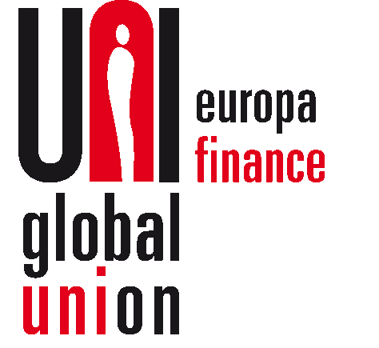

**UNI Europa Finance reply to ESMA consultation paper on integrating sustainability risks in MiFID II**

*As an organisation representing trade unions all over Europe and with many of our members working in the finance sector, UNI Europa Finance (UEF) is keen to see the legislation governing the sustainability risks of investments properly formulated. It is therefore with great pleasure that UEF seizes this opportunity to give our input to the debate and our views on why we believe that the Commission’s focus on only the environmental aspects of sustainability is too restrictive.*

*Q2: Do you agree with the suggested approach and the changes to the Article 23 of the MIFID II Delegated Regulation on ‘risk management’?*

While UEF recognises the limitations of ESMA in influencing the political objectives of the Commission, we still see it as very unfortunate that the taxonomy has been accepted to, at the initial stage, only include environmental consideration. As we have made clear to the Commission on numerous occasions, missing the chance now where nothing is already locked in, to include S & G criteria, is missing a big opportunity. However, UEF also takes note of the consistency with which ESG is mentioned and strongly expects the two other factors to be expanded upon in the near future.

*Q10: What current market standards or “labels” are you intending to take into account or already taking into account for the consideration of ESG factors? Do you see any issues when relying on current market standards or “labels”? Please describe.*

While these are not market standards, UEF would like to point to the existence of ILO recognized International Framework Agreements, or (on a European scale) Transnational Company Agreements. These can play a role in ensuring that decent labour standards are respected in multinational companies and in procurement. By making sure that the conditions for concluding these types of agreements are in place and subsequently making it clear in related investments, through labels, that the agreements have been made, UEF considers that a significant step in the right direction would have been achieved.

*Q12: Please specify any approach you see to assess environmental, social and governance criteria separately from each other or as single preferences. Please explain how the criteria would interact with each other and how the suitability assessment would be performed in such cases.*

1. ESG > E: allowing the investor to indicate his preference

It is vital that investors who have indicated a preference for ESG can trust that E(nvironmental); S(ocial) and G(overnance) are all respected when they buy a ESG products. Merely E(nvironmental) is not enough for clients who have indicated a ESG preference.

While for obvious reasons, we have a preference for ESG products, we recognize that there are products on the market that are merely E(nvironmental), for example Green Bonds. At the same time, there are products that fulfil all criteria. For example Sustainable Bonds (ICMA classification) or ESG investment funds

Investors should have the possibility to indicate their preference. This could be done, for example, by multiple choice questions. The number of choices can be proportional to the products that are offered by the distributor. One can assume that the major distinction will be between products with not ESG character at all; products that are E(nvironmental), such as Green Bonds, and full ESG products.

“As an investor,

* I have no ESG preference
* I prefer E(nvironmental) investments
* I prefer investments that are E(nvironmental); S(ocial) and have also been selected because of good G(overnance)”

The above is merely given as an example. For us, what counts is the principle.

Distributors can then link the preference of their investor to the characteristics of the product. The classification as part of MiFID II product governance (target market) can help.

1. Transparency

In the absence of a common taxonomy, transparency on the methodology used to classify investment instruments as E, or ESG should be given by the manufacturer.

1. Minimum safeguards

The draft Regulation on the establishment of a framework to facilitate sustainable investments provides for minimum safeguards (art 13). This is important. An investor who invests, for example, in companies making batteries, is entitled to know that cobalt is not mined by child labour in degrading circumstances. In this respect, we also refer to our answer on Question 10.

While this is outside the scope of MiFID, we want to seize the opportunity to stress the importance of the safeguard, even for investments that are merely E (and not fully ESG) and would prefer article 13 to be strengthened by changing the word “observed” into “respected and integrated”.

“The minimum safeguards referred to in Article 3(c) shall be procedures implemented by the undertaking that is carrying out an economic activity to ensure that the principles and rights set out in the eight fundamental conventions identified in the International Labour Organisation’s declaration on Fundamental Rights and Principles at Work, namely: the right not to be subjected to forced labour, the freedom of association, workers' right to organise, the right to collective bargaining, equal remuneration for men and women workers for work of equal value, non-discrimination in opportunity and treatment with respect to employment and occupation, as well as the right not to be subjected to child labour, are respected and integrated”.