|  |
| --- |
| 9 November 2018 |

|  |
| --- |
| Reply form for the call for evidence -  Periodic auctions for equity instruments |
|  |

|  |
| --- |
| Date: 9 November 2018 |

Responding to this paper

The European Securities and Markets Authority (ESMA) invites responses to the specific questions listed in the Call for evidence on periodic auctions on equity instruments published on the ESMA website.

*Instructions*

Please note that, in order to facilitate the analysis of the large number of responses expected, you are requested to use this file to send your response to ESMA so as to allow us to process it properly. Therefore, ESMA will only be able to consider responses which follow the instructions described below:

* use this form and send your responses in Word format (pdf documents will not be considered except for annexes);
* do not remove the tags of type <ESMA_QUESTION_CFE_PA_1> - i.e. the response to one question has to be framed by the 2 tags corresponding to the question; and
* if you do not have a response to a question, do not delete it and leave the text “TYPE YOUR TEXT HERE” between the tags.

Responses are most helpful:

* if they respond to the question stated;
* indicate the specific question to which the comment relates;
* contain a clear rationale; and
* describe any alternatives ESMA should consider.

**Naming protocol**

In order to facilitate the handling of stakeholders responses please save your document using the following format:

ESMA_CFE_PA_NAMEOFCOMPANY_NAMEOFDOCUMENT.

e.g. if the respondent were ESMA, the name of the reply form would be:

ESMA_CFE_PA_ESMA_REPLYFORM or

ESMA_CFE_PA_ESMA_ANNEX1

***Deadline***

Responses must reach us by **11 January 2019.**

All contributions should be submitted online at [www.esma.europa.eu](http://www.esma.europa.eu) under the heading ‘Your input - Consultations’.

***Publication of responses***

All contributions received will be published following the end of the consultation period, unless otherwise requested. **Please clearly indicate by ticking the appropriate checkbox in the website submission form if you do not wish your contribution to be publicly disclosed. A standard confidentiality statement in an email message will not be treated as a request for non-disclosure.** Note also that a confidential response may be requested from us in accordance with ESMA’s rules on access to documents. We may consult you if we receive such a request. Any decision we make is reviewable by ESMA’s Board of Appeal and the European Ombudsman.

***Data protection***

Information on data protection can be found at [www.esma.europa.eu](http://www.esma.europa.eu) under the headings ‘Legal notice’ and ‘Data protection’.

# General information about respondent

|  |  |
| --- | --- |
| Name of the company / organisation | UBS |
| Activity | Banking sector |
| Are you representing an association? |  |
| Country/Region | Switzerland |

# Introduction

Please make your introductory comments below, if any:

<ESMA_COMMENT_CFE_PA_1>

UBS thanks ESMA for the opportunity to respond on Periodic Auctions via their Call for Evidence.

Overall, UBS is supportive of a diverse market structure that offers a variety of market models catering for a set of market participants with different execution objectives as in our opinion single market models cannot be all things to all people. Regulation and regulators have an important role in enabling a competitive and innovative market structure to ensure the market structure can provide the best outcome for investors alongside maintaining market integrity.

UBS Investment Bank provides services for Institutional Clients looking to commonly trade large orders. In line with Best Execution requirements those firms value the ability to execute on a variety of platforms and reduce the explicit execution costs of crossing the spread and the implicit costs and price impact of information leakage to opportunistic traders where possible.

Periodic Auctions are one of the models that we and our Institutional Clients value, provide measurable benefits to execution performance and reduce costs to end investors. However we note that Periodic Auctions are relatively "new entrants" to the European market structure and have a small market share at present at around 2% of on-exchange activity.

Given the large changes over the course of 2018 to market structure, the liquidity environment and the unknown adoption of these venues by market participants, it is not possible to determine liquidity changes due to these venues so far. That will take more time, more data and similar exercises to the one ESMA is undertaking. Lastly we ask that regulators and consultations such as these consider the potential execution performance and cost benefits when analysing venues and market structures to ensure end investors are the beneficiaries of changes, or the impact and "cost / benefit" of changes are well understood.

In summary, UBS is supportive of a data driven approach to regulation, but asks:

* ESMA to consider the cost and performance benefits to investors from Periodic Auctions, which are not covered in the call for evidence;
* Regulators to be "technology neutral" in regards to the pre trade transparency market models permitted by MiFID II including Central Limit Order Books (MTF of Primary Market) and Periodic Auctions;
* Regulators to promote an innovative and competitive market structure to the benefit of end investors; and
* Recognition that mid-point represents a globally and universally recognised fair price and should be accessible as a limit price or execution price.

<ESMA_COMMENT_CFE_PA_1>

1. Do you agree with the two main differences identified to distinguish conventional periodic auctions from frequent batch auctions? If not, please explain why.

<ESMA_QUESTION_CFE_PA_1>

No. The aim to differentiate a subset of periodic auctions from another has no basis in the market models described in the underlying regulation.

The aim to segregate one kind of periodic auction from another based on speed and scheduling of auctions is akin to segregating Central Limit Order Books (CLOBs) on the basis of system latency and determination of priority of orders, which is not the case. Regulators should promote innovation in market structure and a diversity of market models to promote better outcomes for investors and reduced frictional costs.

Where ESMA refers to "frequent batch auctions" in questions, UBS will respond on the basis of Periodic Auctions as described in the underlying legal text.

<ESMA_QUESTION_CFE_PA_1>

1. Do you agree with the observation of a rising market share for equity trading on frequent batch auctions?

<ESMA_QUESTION_CFE_PA_2>

No. While periodic auctions gained share in the first half of 2018, their share has broadly levelled out over Q3 and Q4 2018.

New venues by definition start with zero market shares and so would be expected to increase their market share following go live. Nine months of data, in an environment changing hugely due to the Double Volume Cap mechanism and diverse market conditions, in our opinion does not represent enough data to draw conclusions on the long term market share and role of these venues in European market structure.

As shown in Figure 1, while the market share of periodic auctions has grown over the course of the year, (and broadly levelled out), more established market models have also grown.

Our data suggests Primary Auctions have grown by more and we have also seen increases to MTF continuously traded CLOBs and LIS venues. Primary continuously traded CLOB Market share has declined, but there are a variety of beneficiaries operating a range of venue types.

Figure 1 – Change in Three Month Average of On-Exchange Market Share – YTD End November 2018 – Baselined to Jan-March 2018

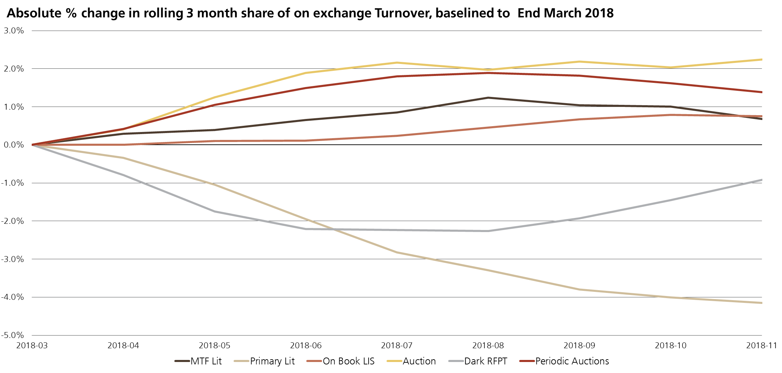

Source: Thomson Reuters (2018)

<ESMA_QUESTION_CFE_PA_2>

1. What are in your view the main factors driving this development?

<ESMA_QUESTION_CFE_PA_3>

It is not possible to point to the main factors driving this development due to:

* the short amount of time since the start of MiFID II and the operation of new Periodic Auction venues
* the significant changes market structure due to the Double Volume Cap's implementation
* the continuing adaption to those changes in market structure by market participants and the short timeframe so far for that to evolve
* diverse market conditions since MiFID II
* the lack of available public data on when market participants were able to join and participate on new periodic auctions
* the lack of available public data on the inclusion of those venues in market participants routing strategies, given their recent inclusion in the market structure
* the lack of available public data on the active market participants (e.g. market making flow, Institutional orders, retail flow) over the course of the Periodic Auctions, the mix of which could naturally impact the use of different market models in line with varying trading objectives by those participants

However, Periodic Auctions have been shown to benefit client orders through reduced information leakage and reversion[1], at the expense of decreased certainty of execution. This means some participants, particularly when trading large orders, may wish to interact with them as a preference to CLOBs, which are shown in Figure 2 as "lit", to have more price impact, but increased certainty of execution.

Figure 2 shows the price impact by market model as calculated across the market by big xyt. "Lit" CLOB markets can clearly be seen to have the largest post trade impact on price with block venues and periodic auctions having less impact. The quid pro quo for these models is the certainty of execution which is maximised on CLOBs and less on block venues for example.

Figure 2 – Price Impact by Market Model

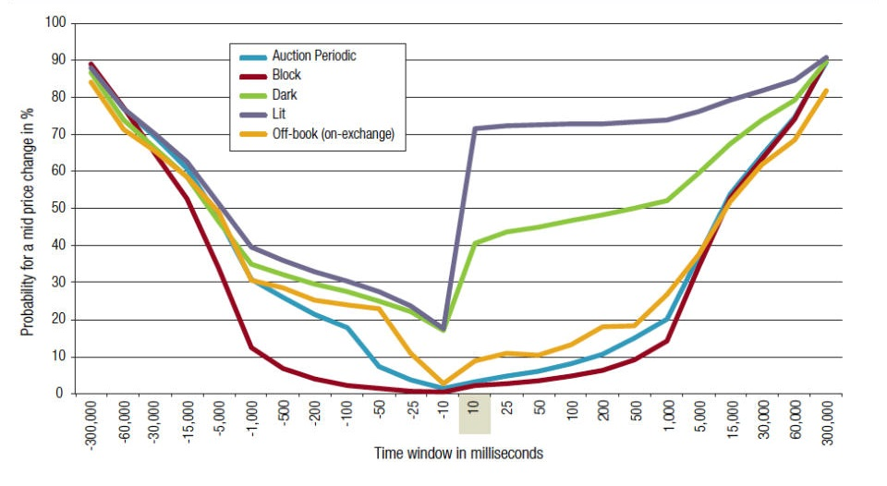

Source: Big XYT (2018)1

Where executing on behalf of institutional clients such price impact is important due to the size of orders considered.

Furthermore mid-point liquidity represents an important potential improvement to execution performance and hence saving end investors implicit costs of execution, as shown in Figure 2.

ESMA's Call for Evidence does not seem to consider any of the above benefits of such platforms as Periodic Auctions to end investors' costs which we feel is an important omission.

<ESMA_QUESTION_CFE_PA_3>

1. Do you agree with the four characteristics identified by ESMA? Please explain.

<ESMA_QUESTION_CFE_PA_4>

As ESMA describes, auctions initiation, differences in pre-trade disclosure, order cancellations and amendments as well as different order types all reflect some of the characteristics that may differ between periodic auctions.

<ESMA_QUESTION_CFE_PA_4>

1. Do you consider that other characteristics of frequent batch auctions may explain their success and/or raise questions in terms of compatibility with the MiFID II transparency provisions? Please explain.

<ESMA_QUESTION_CFE_PA_5>

Other characteristics that may contribute to firms looking to trade on periodic auctions include:

* Explicit price improvement over that available in Continuous Limit Order Books at the time, a benefit to end investors
* Implicit price improvement for further executions in an order through reduced information leakage and reversion, compared to Continuous Limit Order Books – a benefit to end investors
* The ability to execute at mid-point, a globally recognised fair price - a benefit to end investors

Periodic Auctions operating in Europe have been approved by regulators on the basis of their compliance with the underlying rules, including transparency provisions.

CLOBs are not the only kind of displayed market model, and the regulations permit operation of others, which in our opinion helps to promote innovation and competition to the benefit of end investors.

<ESMA_QUESTION_CFE_PA_5>

1. What is your view on the level of pre-trade transparency applied by systems that initiate auctions upon the receipt of a first order? In particular, should pre-trade transparency already be applied as of the start of an auction, irrespectively of whether there is a potential match or not? Please explain.

<ESMA_QUESTION_CFE_PA_6>

Addressing firstly the overall point raised by ESMA as to the transparency provided by Periodic Auctions and whether this is of a duration market participants would be able to respond to.

The European Cash Equities market is characterised by being largely electronic, both in terms of venue operation and market members' access and execution in the market.

As part of the UK Government's Foresight project, Farmer and Skouras (2012)[2] detailed some statistics on the typical timeframes in which European markets operate:

* London Stock Exchange Matching engine – 124 micro second (0.000124s)
* Low latency trading strategies – 40 micro seconds (0.00004s)
* "Market Making" trading strategies – 180 micro seconds (0.000180s)

Since the publication of this research, the market has continued to get "faster".

* For example, Xetra offers members a service called the "High Precision Timestamps File Service". This provides time stamps to nanosecond granularity (0.000000001s)[3]

Figure 3 – Summary of Latency Comparison between Periodic Auctions and CLOB Markets

|  |  |  |
| --- | --- | --- |
| Process | Timeframe in Seconds | Multiple of times Periodic slower by: |
| Periodic | 0.1* | 1x |
| LSE Marching Engine | 0.000124 | 806x |
| Low latency trading | 0.00004 | 2,500x |
| Xetra High Precision Timestamps | 0.000000001 | 100,000,000x |

*Typical Periodic Auction timeframe

Sources: UK Government Foresight Project and Xetra

Questions relating to pre-trade transparency based on the duration of Periodic Auctions, fail to compare those models to the wider market structure and current trading environment. A Periodic Auction lasting 100 milliseconds is 806 times slower than the London Stock Exchange's Central Limit Order Books latency.

Concerns over the ability of the market to respond to messages in millisecond timeframes, should not be applied inconsistently but impartially across market models permitted by the underlying regulation.

In terms of the specific question on pre-trade transparency and whether it should be applied as of the start of an auction. UBS would be supportive of such transparency.

<ESMA_QUESTION_CFE_PA_6>

1. What is your view on the level of pre-trade transparency applied by systems that initiate auctions upon the identification of a possible match? In particular, do you consider that systems locking in prices at the beginning and/or allowing the submission of orders pegged to the midpoint meet the pre-trade transparency requirements? Please explain.

<ESMA_QUESTION_CFE_PA_7>

Pre trade transparency is enhanced through price locking mechanisms as the price of execution is known. Market Participants can then choose whether to trade in the auction, or indeed to not trade, based on full knowledge of the price. Where the price is yet to be determined that is by definition less transparent.

Where venues allow a mid-peg order type that should not to be confused with price locking. In this case the submitter of the order is submitting a limit order where they do not want a price worse than the mid, but will take a better price. The order is not "mid only", it is "mid or better". As such the price of the execution is not known in advance to market participants, but those submitting a mid-peg know they will not get a price worse than mid, and will participate in an auction at mid, or better. Transparency here is no different to other auction models which allow limit orders.

The variety of mechanisms is part of competition as venues seek to have a market structure least open to manipulation.

UBS is supportive of innovation and user choice in market structure to cater for the variety of investment processes and execution objectives in the market.

<ESMA_QUESTION_CFE_PA_7>

1. Would you see benefit in frequent batch auction systems providing information on market/order imbalance? Please explain.

<ESMA_QUESTION_CFE_PA_8>

Frequent batch auctions currently provide a mechanism through which we are comfortable placing orders larger in size than we would be willing to expose through continuous display venues.

We are willing to do this because the quantity displayed to the market is only the quantity we are likely to trade, and hence there is less information leakage and market impact. If the imbalance was displayed we would not be comfortable using the mechanism in the same way.

Without the imbalance being displayed (for most batch auction models) market participants with genuine intent to trade can still send orders and increase the size of uncross if they find imbalance and this remains comfortable for us because we believe participants who disingenuously send orders to discover imbalance and then cancel them would be foul of exchange and possibly market abuse rules.

The result of such a move therefore would be smaller execution sizes.

<ESMA_QUESTION_CFE_PA_8>

1. Do you consider the auction length of frequent batch auctions as appropriate? In particular, how does the short auction length contribute to fair and orderly trading? Please explain.

<ESMA_QUESTION_CFE_PA_9>

Please see our response to Question 6

Yes, we consider that the timeframes employed by existing periodic Auction models are appropriate. They are sufficiently long for automated trading systems to be able to respond to the auction calls. They are not of such a short duration that only the most sophisticated automated systems would be able to respond.

In our view, by the labelling of Periodic Auction lengths as being short is potentially misleading and fails to recognise the latencies available on CLOBs.

<ESMA_QUESTION_CFE_PA_9>

1. Would you see benefits in having a longer auction duration? Do you consider that the auction duration should take into account the liquidity and/or type of instruments traded (e.g. a longer auction duration for less liquid instruments)? Please explain.

<ESMA_QUESTION_CFE_PA_10>

Venues should be allowed to innovate with models, such as longer duration for illiquid instruments, but not forced.

Longer auction times may have benefits in some situations, for example in illiquid instruments or to increase the likelihood of EBBO blocks. However as per our point above competitive pressures should ensure such solutions come to the market.

<ESMA_QUESTION_CFE_PA_10>

1. In your experience, how often do frequent batch auctions result in a match, and how many transactions are executed per frequent batch auction on average?

<ESMA_QUESTION_CFE_PA_11>

Many of the batch auction models only run an auction when a potential uncross has been established. In some models from this point in time a match for the initial orders is guaranteed or locked in.

Our experience of models that do not lock orders in also indicates a very high success rate for auctions once an indication is produced. UBS MTF's periodic auction is not a fair basis for comparison to other periodic auction venues given it's relatively nascent stage and lack of support for a mid-peg order type.

<ESMA_QUESTION_CFE_PA_11>

1. Do you consider frequent batch auction systems as non-price forming systems? Please explain. Should a characteristic of any trading system be that it is always price forming in order to operate without a waiver? Please explain.

<ESMA_QUESTION_CFE_PA_12>

No, Periodic Auctions are price forming and with the price determined in a similar way to closing / opening type auction models.

Locked auction models determine a price at initiation, this price is still price forming as is on the basis of multilateral interaction, but has the benefit of increased certainty and transparency through the auction to maximise volume discovery.

Mid-peg order types are also price forming. They are not "mid-point only", but "mid-point or better" and are exactly the same as an order limited at the mid. Mid-point represents a globally and universally recognised fair value price and should be accessible as a limit price or execution price.

Pre Trade Transparency waivers are waivers from pre trade transparency. Some transparent venues already operate today on a "reference price" basis, for example post close trading sessions operated by some Primary Markets. UBS are supportive of such mechanisms as part of a broader eco system of market models that allow a variety of types of market participants to trade in line with their execution objectives and permit more efficient risk transfer between participants.

<ESMA_QUESTION_CFE_PA_12>

1. Do you consider that these functionalities resemble reference price systems (in particular when matching transaction at mid-point)? Please explain.

<ESMA_QUESTION_CFE_PA_13>

No.

Periodic Auctions operate on a transparent basis with rules on price determination. They do not operate by solely executing at a reference price (or on a non-displayed basis).

The provision of Mid-peg order types on these venues is an efficient way for market participants to manage limit orders and represent their wish to trade at the mid-point or better. Mid-point represents a globally and universally recognised fair price and should be accessible as a limit price or execution price.

It is worth noting that suppression of such pegging functionality would be to the detriment of market participants with less sophisticated trading systems. Automated trading systems employed by HFT firms, for example, do not look to make use of such price protections as their business model and success can be predicated on managing limit prices incredibly quickly, at the expense of many millions of messages a day. Removing this price protection could ultimately mean more participants are forced into this style of limit management at the great expense of exchange capacity.

Pre trade transparency provisions and the Double Volume Cap should not be misinterpreted as requiring mid-point to be inaccessible as an execution price. Their role is to govern the amount of pre trade information visible to the market, not restrict price points themselves.

<ESMA_QUESTION_CFE_PA_13>

1. How do frequent batch auctions ensure multilaterality and interactions of trading interests in the price formation process (e.g. diversity of participating members, average number of participants, distribution of orders involved per transaction)?

<ESMA_QUESTION_CFE_PA_14>

At present MiFID II on to ensure multilateral interests require MTFs to have at least three active members in order to meet the regulatory requirements. There is no further requirement placed on venues.

There should not be a higher level requirement placed on Periodic Auctions compared to other venues and the regulation should be applied consistently.

We do not believe Periodic Auctions have any functionality that threatens multilaterality over and above any other market models. Broker Preferencing functionality offered is not unique to Periodic Auctions and any Broker Preferencing takes place after the price formation process and is an allocation process, so not "Broker Certainty".

<ESMA_QUESTION_CFE_PA_14>

1. Do you consider that the possibility of pegged orders might weaken the price determination logic? If yes, which measures would you recommend?

<ESMA_QUESTION_CFE_PA_15>

No.

Pegged orders are a mechanism for systematically managing limit orders and reducing message traffic.

Periodic auctions operating a "Mid Peg" order type, allow the wish of a participant to get no worse a price than mid to be systematised. That wish to trade at mid or better is information that is price forming. A Mid Peg order type recognises the universally recognised fair price status of mid, reduces complexity in the market through reducing the need to have advanced limit management technology (which is typically the purview of High Frequency Traders) and increases the efficiency of the price formation process.

<ESMA_QUESTION_CFE_PA_15>

1. How frequently are mechanisms used to prevent an auction uncross at a price outside the EBBO or PBBO (e.g. patterns and occurrences)?

<ESMA_QUESTION_CFE_PA_16>

UBS MTF applies well-formed market checks to guarantee that the price formed on its Periodic Auction Order Book is within the European Best Bid and Offer (using four venues for most instruments) at the time of the execution. Increasing the duration of an auction would potentially decrease the number of auction trades, especially in more liquid instruments.

When UBS MTF implemented the well-formed market checks in its dark order book, a potential impact of 25% was expected on the executed volume, however as this functionality enhances the quality of execution, Participants tends to increase their activity or leave orders slightly longer on the order book.

Other markets also support E/PBBO collar functionality but we do not have any data as to the frequency with which they take effect. We would expect that this is less frequent than would otherwise be the case on account of mid-peg support.

<ESMA_QUESTION_CFE_PA_16>

1. What are your views on self-matching functionalities, and in particular member preferencing, in the context of frequent batch auction systems taking into account their short auction length? Do self-matching functionalities, and in particular member preferencing, coupled with other features of frequent batch auctions (short duration, locked-in prices) contribute to fair and orderly trading?

<ESMA_QUESTION_CFE_PA_17>

Broker Preferencing is not a "self-matching" functionality. It is Broker Preferencing, but not Broker Certainty.

The auction determines the price and then allocates self vs self-allocations if the member has indicated. Such allocation preference is not mandatory but can reduce post trade clearing and settlement costs. Reduction of costs to trade reduces frictional costs and increases trading, improving price formation.

Primary markets such as NASDAQ also operate Broker Preferencing. It is not a unique characteristic of periodic auctions.

Periodic auctions are not "Short duration". They operate 1 billion times slower than Primary CLOB markets. 100 milliseconds is not a "short" time in an electronic trading environment.

<ESMA_QUESTION_CFE_PA_17>

1. Do you consider that self-matching functionalities, and in particular member preferencing, on frequent batch auction systems may be used to formalise privately negotiated transactions?

<ESMA_QUESTION_CFE_PA_18>

No, where a member elects for Broker Preferencing the Periodic Auction mechanism still operates on a multilateral basis to determine the auction result and is not simply a "recording" of a bilateral trade previously negotiated. It is broker preferencing, not broker certainty.

To our knowledge no periodic auction model will guarantee that the same member can trade against themselves, and particularly not at a specified price. If a member attempted to do so they could find existing orders on the platform from a 3rd party available at a better price, and would receive only one side of the trade.

<ESMA_QUESTION_CFE_PA_18>

1. In your opinion, is the feature of member preferencing indispensable for the success observed in frequent batch auction systems since the application of MiFID II?

<ESMA_QUESTION_CFE_PA_19>

No.

As per our answer to Question 3, it is not possible to draw conclusions on the market share of Periodic Auctions and how "successful" that is because of:

* the short amount of time since the start of MiFID II and the operation of new Periodic Auction venues
* the changing market structure due to the Double Volume Cap's implementation
* diverse market conditions over that time
* the lack of available public data on when market participants were able to join and participate on new periodic auctions
* the lack of available public data on the inclusion of those venues in market participants routing strategies, given their recent inclusion in the market structure
* the lack of available public data on the active market participants (e.g. market making flow, Institutional orders, retail flow) over the course of the Periodic Auctions, the mix of which could naturally impact the use of different market models in line with varying trading objectives by those participants

It should be noted that at around 2% of on-exchange market share, Periodic Auctions are a small minority of executions in Europe at present.

Other Periodic Auctions on Primary markets for the Opening and Closing auctions have market shares of over 20% of total exchange trading. These operate on, and only on, Primary Markets, due to lack of competition in this area. Regulators should consider whether investors could gain a better outcome through increased competition and reduced explicit costs in Opening and Closing auctions.

<ESMA_QUESTION_CFE_PA_19>

1. How do you determine on which execution venues to conclude transactions. Please explain.

<ESMA_QUESTION_CFE_PA_20>

UBS determines appropriate venues based on clients' execution instructions and objectives and our experiences of trading on the venues accessible, in line with our Best Execution policy and process.

<ESMA_QUESTION_CFE_PA_20>

1. Which execution venues attracted the most trading volume following the suspension of dark trading venues under the DVC and why? Please substantiate your answer by quantitative data where available.

<ESMA_QUESTION_CFE_PA_21>

As shown in Figure 4, Primary and MTF Central Limit Order Books combined accounted for 75.8% of on exchange market share up to the end of March 2018. For the three months to the end of June 2018, that average had fallen to 74.5%.

Within this fall we saw Primary CLOBs fall more than MTF books.

However the largest beneficiaries of this were Primary Auctions which increased from a three month average of 16.5% at the end of March 2018, to a three month average of 18.4% by the end of June 2018.

Other venue types also saw an increase, including Periodic Auctions, LIS venues and MTF CLOBs. This is further shown in our answer to Question 2 and Figure 1.

Overall as can be seen in Figure 4, at 2% of the on exchange market, Periodic Auctions represent a very small component.

Figure 4 – On Exchange Market Share by Market Model

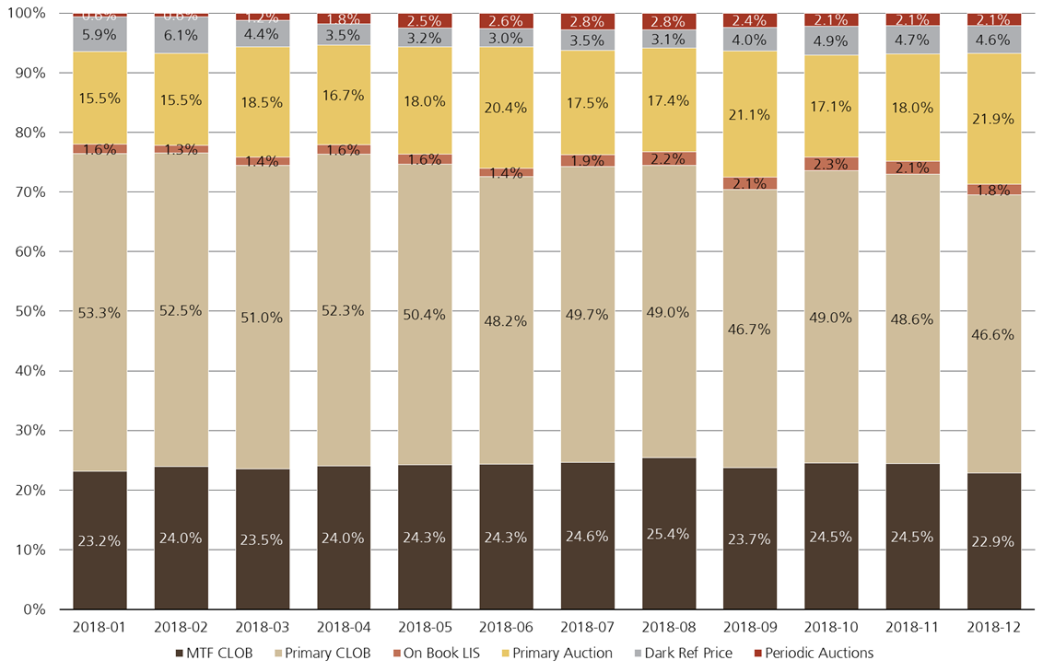

Source: Thomson Reuters (2018)

As per our response to Question 3, there is not enough data to conclude which exact factor has contributed to any growth in Periodic Auctions given the changing liquidity environment and short time frame in which participants have had to join, access and trade on such venues.

<ESMA_QUESTION_CFE_PA_21>

1. Should trading under frequent batch auctions become subject to stricter requirements in the future, to which type of execution venues do you expect the current trading volume under frequent batch auctions to migrate to?

<ESMA_QUESTION_CFE_PA_22>

The market benefits from a range of market models offering different methods of trading and different pros and cons. Periodic Auctions, operating within the prescribed regulation may offer benefits different to that of Central Limit Order Books, for example price impact as shown in Figure 2.

Diversity of Trading Venues, market models offering a range of solutions and characteristics is to be supported in order to promote competition and allow market participants to trade in line with their investment process, execution objectives and ultimately best execution.

Regulators should not risk conflicts with Best Execution by preferencing one permitted model over another, where operating within the confines of the prescribed rules such as the Share Trading Obligation and Double Volume Caps.

When Reference Price venues are suspended in instruments under the Double Volume Caps, there will still be market participants such as Pension Funds representing end investors, who trade in large parent orders sizes and are looking to limit information leakage to reduce costs for their end investors as part of their best execution process.

Within a market structure of a diverse pre trade transparent models and venues those participants will still value venues which have lower market impact. Some pre trade transparency models, such as Periodic Auctions may offer potentially less interaction with opportunistic flow and a greater level of "protection" to large institutional flow through mechanisms designed to offer less advantage to participants with lower latency (including High Frequency Trading firms), for example via randomised auction periods..

Given the regulatory objective of Best Execution, Investment firms need to ensure they trade on the available venues in a manner consistent with their execution objectives.

Therefore, to answer the question posed, trading volume would migrate to the venues most in line with the execution objectives of participants trading on Periodic Auctions. If their objective was to minimise price impact, then as per Figure 2, LIS venues may be a beneficiary given their lower price reversion post trade.

When either explicit or implicit frictional costs of trading increase, some volume will simply vanish rather than migrate to another venue. This reduces liquidity available to the market as a whole.

Regulators should not preference one model over another within the confines of a market structure permitting different pre trade transparent market models. The "sprit" of MiFID II is not maximising activity on CLOBs over other pre trade transparent execution venues.

When reviewing changes to market structure, regulators should ensure this is on the basis of a data driven approach, where possible, promoting innovation and competition and considering the benefits to end investors.

<ESMA_QUESTION_CFE_PA_22>

1. https://www.bestexecution.net/data-analysis-european-equities/
2. Farmer J. Doyne; Skouras, Spyros “Review of the Benefits of a Continuous Market vs. Randomised Stop Auctions and of Alternative Priority Rules (Policy Options 7 and 12),”  
   UK Government’s Foresight Project, The Future of Computer Trading in Financial Markets, Economic Impact Assessment EIA11, 2012
3. http://www.xetra.com/blob/3446750/8dd916876f87880372284be7e17f97fc/data/075_18d_Anhang.pdf