|  |
| --- |
| 19 June 2017 | ESMA70-156-166 |

|  |
| --- |
| Reply form for the Consultation Paper on the trading obligation for derivatives under MiFIR |
|  |

|  |
| --- |
| Date: 19 June 2017 |

Responding to this paper

The European Securities and Markets Authority (ESMA) invites responses to the specific questions listed in the ESMA Consultation Paper on the trading obligation for derivatives under MiFIR, published on the ESMA website.

*Instructions*

Please note that, in order to facilitate the analysis of the large number of responses expected, you are requested to use this file to send your response to ESMA so as to allow us to process it properly. Therefore, ESMA will only be able to consider responses which follow the instructions described below:

* use this form and send your responses in Word format (pdf documents will not be considered except for annexes);
* do not remove the tags of type <ESMA_ QUESTION_MIFID_TO_1> - i.e. the response to one question has to be framed by the 2 tags corresponding to the question; and
* if you do not have a response to a question, do not delete it and leave the text “TYPE YOUR TEXT HERE” between the tags.

Responses are most helpful:

* if they respond to the question stated;
* contain a clear rationale, including on any related costs and benefits; and
* describe any alternatives that ESMA should consider.

**Naming protocol**

In order to facilitate the handling of stakeholders responses please save your document using the following format:

ESMA_MiFID_TO_NAMEOFCOMPANY_NAMEOFDOCUMENT.

e.g. if the respondent were ESMA, the name of the reply form would be:

ESMA_MiFID_TO_ESMA_REPLYFORM or

ESMA_MiFID_TO_ESMA_ANNEX1

***Deadline***

Responses must reach us by **31 July 2017.**

All contributions should be submitted online at [www.esma.europa.eu](http://www.esma.europa.eu) under the heading ‘Your input/Consultations’.

***Publication of responses***

All contributions received will be published following the end of the consultation period, unless otherwise requested. **Please clearly indicate by ticking the appropriate checkbox in the website submission form if you do not wish your contribution to be publicly disclosed. A standard confidentiality statement in an email message will not be treated as a request for non-disclosure.** Note also that a confidential response may be requested from us in accordance with ESMA’s rules on access to documents. We may consult you if we receive such a request. Any decision we make is reviewable by ESMA’s Board of Appeal and the European Ombudsman.

***Data protection***

Information on data protection can be found at [www.esma.europa.eu](http://www.esma.europa.eu) under the headings ‘Legal notice’ and ‘Data protection’.

# General information about respondent

|  |  |
| --- | --- |
| Name of the company / organisation | Click here to enter text. |
| Activity | Choose an item. |
| Are you representing an association? |  |
| Country/Region | Choose an item. |

# Introduction

Please make your introductory comments below, if any:

<ESMA_COMMENT_MIFID_TO_0>

# 1. General information about respondent

|  |  |
| --- | --- |
| Name of the company / organisation | Clarus Financial Technology |
| Activity | Non-financial counterparty |
| Are you representing an association? |  |
| Country/Region | UK |

Clarus Financial Technology welcomes the opportunity to respond to this consultation. We provide content, data and analytics for the post-regulatory reform world of global derivatives. Clarus’ tools create a window into the data now available in swap data repositories and trading venues to help clarify and unify the vast, diverse information produced from the post-crisis regulatory changes. This is done using the free publicly available trade information from multiple sources and creating a cohesive database for users to interrogate with our custom interface.

2. The new legislative landscape for financial markets is intended to provide a much more transparent environment for companies to access trade information vital to their trading and hedging requirements. The derivatives market was previously seen as opaque and trade pricing was obfuscated. We work with market participants to enable them to take advantage of the greater transparency of price and volume data for all derivative products to facilitate improved price discovery and risk mitigation.

**Meeting the standards set by EMIR**

3. The core principles underpinning regulation under EMIR and in other regulatory jurisdictions such as Dodd Frank in the US are the same: greater transparency, mitigation of systemic risk and protection against market abuse. We believe there is now the opportunity to consider and evaluate experience since implementation within Europe and from other jurisdictions, in order to arrive at the point where standards in Europe can reflect best practice from around the world. Financial markets and the companies operating within them are largely global, although regulatory controls must necessarily be defined in accordance with political and geographic borders. However, it should be possible to reflect its global reach by achieving consistent levels of transparency across boundaries. Clarus’ responses therefore address some of the specific questions raised, but also the principles they raise, such as data quality, in a broader context.

4. We spend a lot of time looking at the US SDR data. This provides a great frame of reference for this particular Consultation Paper as it puts the ESMA data into perspective.

5. ESMA have done a good job with the EUR data available to them. Their sample size is still somewhat smaller than we would expect. Given EUR and USD swap markets are similar sizes, we would expect the true picture of EUR IRS markets to cover around 70,000 spot starting swaps over a six month period.

6. However, outside of EUR swaps, we are very concerned about the data being used to derive the Trading Obligation.

7. We therefore believe that the ESMA data should be combined with the US SDR data. This would give the most complete picture of liquidity available to a market participant, irrespective of where they are based.

8. Liquidity in global OTC derivative markets is not geographically constrained. If you are located in Frankfurt, you can just as easily access prices provided from a dealer located in London, New York, Singapore or Japan.

9. Analysis for a Trading Obligation should therefore be conducted on a similarly global data set. It should not be constrained by where the trades are reported.

10. We are confident that such a comprehensive review of the data would result in added benefits to market participants. Namely, a convergence of Trading Obligations around the globe, such that rules in Europe will be aligned with the current trading obligation in the US.

11. The two largest capital markets can then be considered the “gold standard” to which all other jurisdictions can aspire.

<ESMA_COMMENT_MIFID_TO_0>

1. Do you agree with ESMA’s assessment and proposed way forward for the criteria assessing the number and types of active market participants? If not, please explain your position and how you would integrate these elements into the liquidity test.

<ESMA_QUESTION_MIFID_TO_1>

TYPE YOUR TEXT HERE

<ESMA_QUESTION_MIFID_TO_1>

1. Do you agree with the revised proposal not to exempt post-trade LIS transactions? If not, please explain and present your proposal.

<ESMA_QUESTION_MIFID_TO_2>

We agree with the revised approach. There will be no timely pre- or post-trade transparency applied to these large transactions, therefore no information leakage will occur.

<ESMA_QUESTION_MIFID_TO_2>

1. Do you agree with this proposal? If not, please explain why and provide an alternative proposal for ESMA to populate and maintain the register.

<ESMA_QUESTION_MIFID_TO_3>

TYPE YOUR TEXT HERE

<ESMA_QUESTION_MIFID_TO_3>

1. Do you agree with this proposal? Would you add other parameters e.g. day count convention of the floating leg, notional type (constant vs. variable), fixed rate type (MAC vs. MAC)? If yes, please explain why and provide the parameters.

<ESMA_QUESTION_MIFID_TO_4>

We agree with ESMA that the pertinent fields to consider for Interest Rate Swaps when considering liquidity in a given instrument are:

* Currency
* Floating rate index and its term
* Trade date start type
* Maturity date

We do not agree that the following fields are pertinent to liquidity:

* Payment frequency fixed leg
* Day count convention fixed leg
* Day count convention of the floating leg
* Fixed rate type

There is no meaningful change in the Interest Rate risk of a trade if any of the parameters in the second list are changed. Liquidity is amalgamated according to risk factors, not by matching exact cashflows. Risk Factors are impacted by the first list, not by the second.

Paragraph 125 states “*ESMA therefore welcomes to receive additional data analysis for the period considered that could be integrated in the final report*.” In response, we attach Annex 1, a detailed study of Spot Starting swaps in EUR, USD, JPY reported to US SDRs during the sample period. We will happily make available all data regarding the period considered across all potential instruments to be covered by a Trading Obligation.

We are offering to do so because the data used to determine the Trading Obligation should be of high quality, granular and broad ranging. The data needs to recognise that liquidity is not geographically constrained. If you are located in Frankfurt, you can just as easily access liquidity from a dealer located in London, New York, Singapore or Japan.

The US, Canada and Japan all make trade-level reports publically available for Interest Rate Swaps traded by market participants in their jurisdictions. This data has proven to be far more reliable than the public data published by TRs in Europe.

When making any determinations, the trade-level data available from the US, Canada and Japan should be used in conjunction with the data that ESMA holds from TRs and MTFs.

<ESMA_QUESTION_MIFID_TO_4>

1. For each Case, specify if you agree with the proposal of qualifying the sub-classes as liquid for the purpose of the trading obligation and if not, please explain why and provide an alternative proposal

<ESMA_QUESTION_MIFID_TO_5>

As we discuss in Annex1, we broadly agree with the proposal for EUR swaps given the (limited) picture of the EUR swaps market available at this time.

To avoid circumvention of the TO, we would strongly propose:

* Reference to the Fixed Leg Payment Frequency is removed. Fixed Leg Payment Frequency has no impact on the Risk Factors being traded.
* Reference to the Fixed Rate Day Count is removed. Fixed Rate Day Count has no impact on the Risk Factors being traded.
* Trade start type should be expanded to encapsulate trades starting T to T+10. This reduces the possibility to circumvent the TO whilst still trading economically equivalent Risk Factors.

ESMA have only considered Spot Starting swaps with a maturity date +/- 5 days from benchmark maturities. These types of swaps account for only 30% of EUR IRS reported to US SDRs:

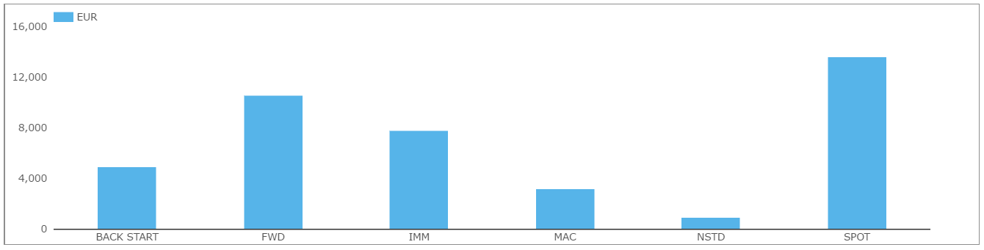

Therefore, we also recommend that the Trading Obligation includes trades that:

* Start on an IMM date
* MAC trades

Our data set, which we are making available to ESMA for the purposes of this Consultation, covers Forward Starting swaps as well. A graphical summary shows the most common forward start periods by notional below:

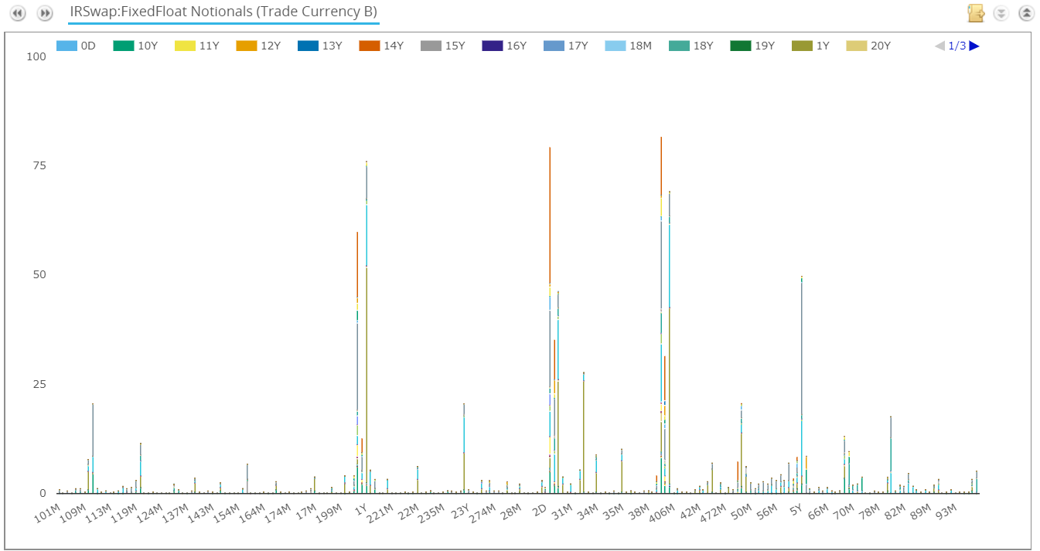

To summarise the data above, there are clearly identifiable peaks in the amount of notional traded around forward starting dates conforming to the following:

* T+ 1 week
* T + 1 month
* T + 1 year
* T + 2 weeks
* T + 2 months
* T + 2 years
* T + 3 weeks
* T + 3 months
* T + 3 years
* T + 5 years

A variety of tenors trade out of these forward dates. We can readily expand our analysis performed in Annex 1 for Forward Starting swaps, which we can supply to ESMA.

<ESMA_QUESTION_MIFID_TO_5>

1. Would you also consider any of these possible sub-classes as liquid? Which other combinations of fixed leg payment frequency and floating leg reset frequency specifically would you consider to be sufficiently liquid?

<ESMA_QUESTION_MIFID_TO_6>

Yes, we consider all types of Fixed Leg Payment Frequency as liquid.

With reference to the Floating Leg Reset Frequency, it must be aligned with the underlying Floating Reference Rate term, otherwise the trade has convexity and becomes a non-linear product – and hence not liquid. A Euribor 3m trade that resets every 6 months has convexity. A Euribor 6m trade that resets every 3 months has convexity. These two examples therefore have different Risk Factors than a vanilla trade and should not be deemed liquid.

It would be more useful to state that the Floating Reference Rate Term is equal to the Floating Leg Reset Frequency for all trades covered by the Trading Obligation.

<ESMA_QUESTION_MIFID_TO_6>

1. For each Case, specify if you agree with the proposal of qualifying the sub-classes as liquid for the purpose of the trading obligation and if not, please explain why and provide an alternative proposal.

<ESMA_QUESTION_MIFID_TO_7>

The ESMA data for USD swaps covers only 2% of the market. This is not a representative portion of the market from which to draw conclusions for the purposes of a Trading Obligation.

We provide in Annex 1 a detailed analysis of all Spot Starting USD Swaps traded in the six month observation period and reported to US SDRs. We find that each of the USD swaps below traded around 1,000 times during the observation period, and generally had a daily notional amount traded in excess of $900m:

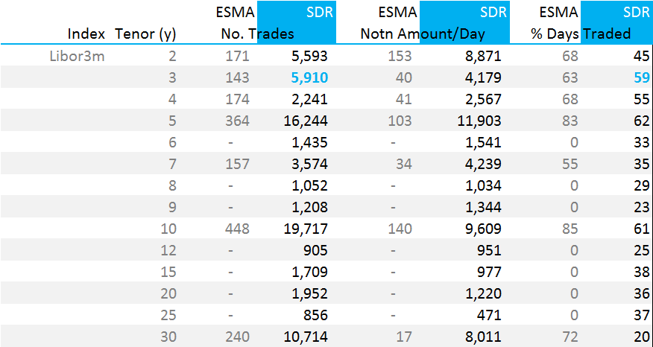

These USD swaps are all traded versus USD Libor 3M with a T+2 start date. As we have discussed, we do not consider payment frequencies or day count conventions as economically pertinent considerations for the purposes of liquidity assessments.

<ESMA_QUESTION_MIFID_TO_7>

1. Would you also consider any of these possible sub-classes as liquid? Which other combinations of fixed leg payment frequency and floating leg reset frequency specifically would you consider to be sufficiently liquid?

<ESMA_QUESTION_MIFID_TO_8>

Yes, we consider all of these possible sub-classes as liquid, and this is confirmed within our data set – which is available to ESMA for the purposes of this Consultation Paper.

In addition, we can also consider forward starting swaps in USD. As our data set shows:

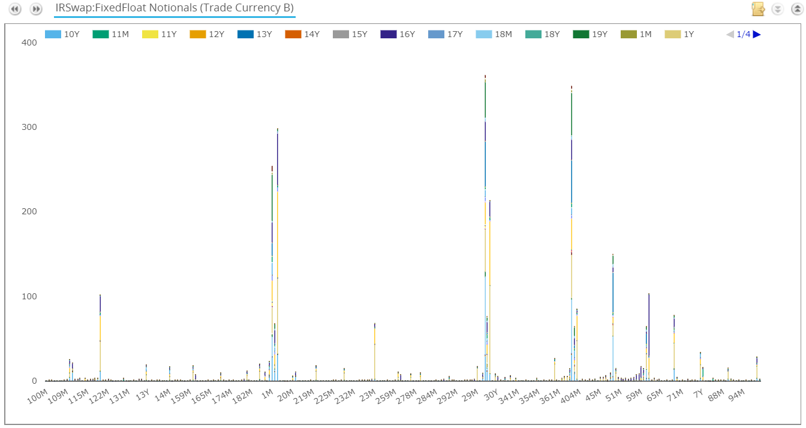

There are clearly identifiable peaks in the amount of notional traded around forward starting dates conforming to the following:

* T + 1 month
* T + 1 year
* T + 2 months
* T + 2 years
* T + 4 years
* T + 5 years

To avoid circumvention of the TO, we would strongly propose:

* Reference to the Fixed Leg Payment Frequency is removed. Fixed Leg Payment Frequency has no impact on the Risk Factors being traded.
* Reference to the Fixed Rate Day Count is removed. Fixed Rate Day Count has no impact on the Risk Factors being traded.

<ESMA_QUESTION_MIFID_TO_8>

1. For each case, specify if you agree with the proposal of qualifying the sub-classes as liquid for the purpose of the trading obligation and if not, please explain why and provide an alternative proposal.

<ESMA_QUESTION_MIFID_TO_9>

The data from the US SDRs for GBP swaps is not as broad reaching as for other currencies. In summary;

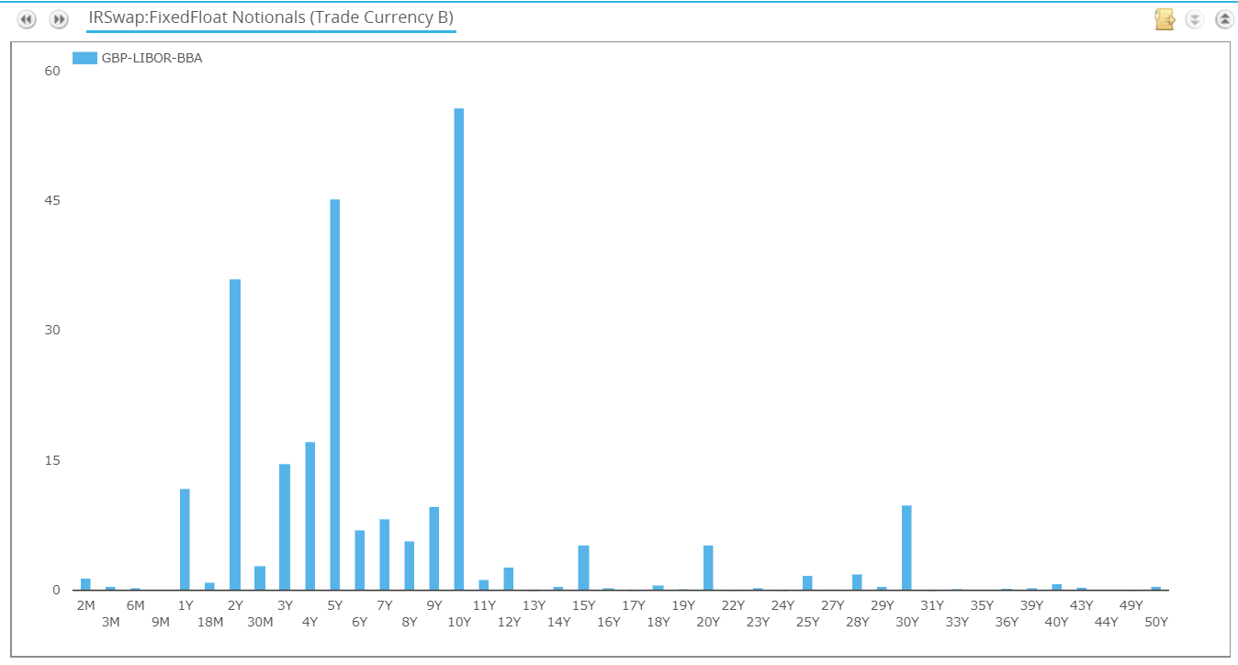

We find that the following GBP IRS (start T+0) have average daily volumes in excess of £75m for the observation period:

* 1y
* 2y
* 3y
* 4y
* 5y
* 9y
* 10y
* 30y

In addition, on a duration-equivalent measure, longer dated swaps such as 15y (ADV £40m) and 20y (ADV £40.3m) also trade in sufficient volume to be deemed liquid.

As stated, the US SDR data only covers a portion of the market. Therefore we would also support adding 6y and 7y maturities to this list, as they also see ADV in excess of £40m per day in our data.

<ESMA_QUESTION_MIFID_TO_9>

1. Would you also consider the possible sub-classes here below as liquid? Which other combinations of fixed leg payment frequency and floating leg reset frequency specifically would you consider to be sufficiently liquid?

<ESMA_QUESTION_MIFID_TO_10>

Yes, we consider all types of Fixed Leg Payment Frequency as liquid.

With reference to the Floating Leg Reset Frequency, it must be aligned with the underlying Floating Reference Rate term, otherwise the trade has convexity and becomes a non-linear product – and hence not liquid. A GBP Libor 3m trade that resets every 6 months has convexity. A GBP Libor 6m trade that resets every 3 months has convexity. These two examples therefore have different Risk Factors than a vanilla trade and should not be deemed liquid.

It would be more useful to state that the Floating Reference Rate Term is equal to the Floating Leg Reset Frequency for all trades covered by the Trading Obligation.

<ESMA_QUESTION_MIFID_TO_10>

1. Do you agree with this proposal? If not, please explain why and provide an alternative proposal.

<ESMA_QUESTION_MIFID_TO_11>

No. Our data shows that JPY swaps are liquid.

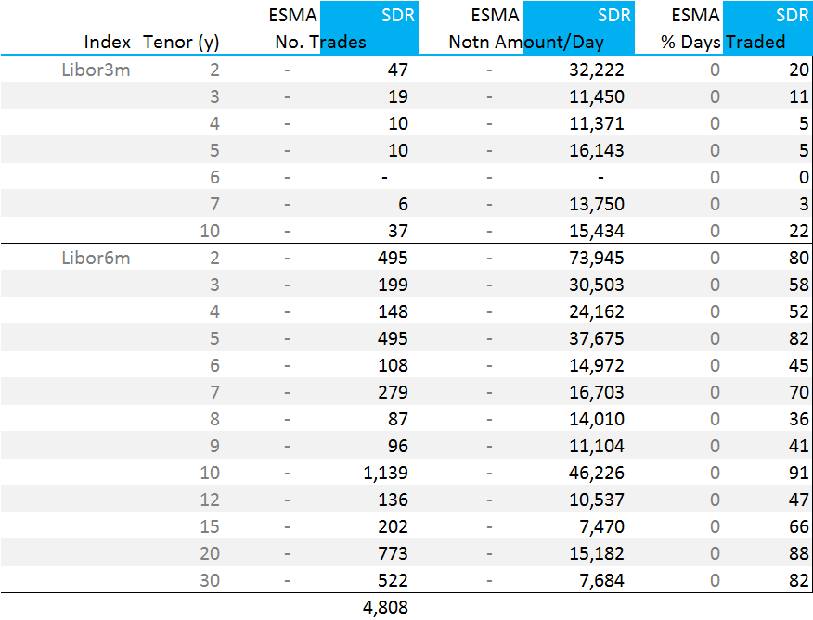

* Nearly 5,000 spot starting JPY IRS swaps were reported to US SDRs in the six month period across the main tenors.
* JPY IRS versus Libor 6m in the 2y, 3y, 4y, 5y, 7y, 10y, 15y, 20y and 30y tenors all traded on over 80% of days.
* We could reasonably label 2y, 5y, 7y, 10y, 20y and 30y JPY IRS as liquid using similar metrics to EUR, GBP and USD IRS.

<ESMA_QUESTION_MIFID_TO_11>

1. Do you agree with this proposal? If not, please explain why and provide an alternative proposal

<ESMA_QUESTION_MIFID_TO_12>

We also have data on Credit Derivatives traded and reported to US SDRs during the observation period. We would happily make this available to ESMA for the purposes of this Consultation Paper.

<ESMA_QUESTION_MIFID_TO_12>

1. Do you agree to the proposed timeline? If not, please explain why and present your proposal.

<ESMA_QUESTION_MIFID_TO_13>

Yes

<ESMA_QUESTION_MIFID_TO_13>

**CBA QUESTIONS**

1. This first question aims at identifying the category of firm/entity you belong to. Please provide the total notional amount traded in derivatives (trading venues + OTC) in 2016 in thousands euros and the related total number of trades in the relevant boxes

<ESMA_QUESTION_MIFID_TO_14>

|  |  |  |  |
| --- | --- | --- | --- |
| **Category** | **Number of employees** | **Total Notional traded 2016 (in thousands euros)** | **Total number of trades 2016** |
| **EMIR Category 1** | **[1-50]** | TYPE YOUR TEXT HERE | TYPE YOUR TEXT HERE |
| **[51-250]** | TYPE YOUR TEXT HERE | TYPE YOUR TEXT HERE |
| **[251-1000]** | TYPE YOUR TEXT HERE | TYPE YOUR TEXT HERE |
| **>1000** | TYPE YOUR TEXT HERE | TYPE YOUR TEXT HERE |
| **EMIR Category 2** | **[1-50]** | TYPE YOUR TEXT HERE | TYPE YOUR TEXT HERE |
| **[51-250]** | TYPE YOUR TEXT HERE | TYPE YOUR TEXT HERE |
| **[251-1000]** | TYPE YOUR TEXT HERE | TYPE YOUR TEXT HERE |
| **>1000** | TYPE YOUR TEXT HERE | TYPE YOUR TEXT HERE |
| **EMIR Category 3** | **[1-50]** | TYPE YOUR TEXT HERE | TYPE YOUR TEXT HERE |
| **[51-250]** | TYPE YOUR TEXT HERE | TYPE YOUR TEXT HERE |
| **[251-1000]** | TYPE YOUR TEXT HERE | TYPE YOUR TEXT HERE |
|  | TYPE YOUR TEXT HERE | TYPE YOUR TEXT HERE |
| **EMIR Category 4** | **[1-50]** | TYPE YOUR TEXT HERE | TYPE YOUR TEXT HERE |
| **[51-250]** | TYPE YOUR TEXT HERE | TYPE YOUR TEXT HERE |
| **[251-1000]** | TYPE YOUR TEXT HERE | TYPE YOUR TEXT HERE |
| **>1000** | TYPE YOUR TEXT HERE | TYPE YOUR TEXT HERE |
| **Trading Venue** | **[1-50]** | TYPE YOUR TEXT HERE | TYPE YOUR TEXT HERE |
| **[51-250]** | TYPE YOUR TEXT HERE | TYPE YOUR TEXT HERE |
| **[251-1000]** | TYPE YOUR TEXT HERE | TYPE YOUR TEXT HERE |
| **>1000** | TYPE YOUR TEXT HERE | TYPE YOUR TEXT HERE |

<ESMA_QUESTION_MIFID_TO_14>

1. Based on the draft RTS, which percentage of your derivative trading (notional amount and number of trades) do you expect to be captured by the TO? Please provide the data for derivatives globally, and then for interest rate derivatives and for credit default swaps, using 2016 trading data?

<ESMA_QUESTION_MIFID_TO_15>

|  |  |
| --- | --- |
| **% of trading captured by the TO** | **Year 2016** |
| % of total notional amount traded in derivatives captured by the TO | TYPE YOUR TEXT HERE |
| % of total number of transaction in derivatives captured by the TO | TYPE YOUR TEXT HERE |
| % of total notional amount traded in interest rate derivatives captured by the TO | TYPE YOUR TEXT HERE |
| % of total number of transactions in interest rate derivatives captured by the TO | TYPE YOUR TEXT HERE |
| % of total notional amount traded in credit default swaps captured by the TO | TYPE YOUR TEXT HERE |
| % of total number of transactions in credit default swaps captured by the TO | TYPE YOUR TEXT HERE |

<ESMA_QUESTION_MIFID_TO_15>

CBA Questions 16 and 17 are to be answered by investment firms and significant non-financial counterparties

1. Out of the trading activity expected to be captured by the TO, as identified under Q2, which % is already traded on an EU regulated market, an EU Multilateral Trading Facility (MTF), a US Swap Execution Facility (SEF) or another third-country trading venue?

<ESMA_QUESTION_MIFID_TO_16>

|  |  |  |  |  |
| --- | --- | --- | --- | --- |
| **Trading activity expected to be captured by the TO** | **Traded on a regulated market** | **Traded on an EU MTF** | **Traded on a US SEF** | **Traded on another 3rd country venue** |
| **% of total trading volume captured by the TO already traded on an EU trading venue, a US SEF or another third-country venue** | TYPE YOUR TEXT HERE | TYPE YOUR TEXT HERE | TYPE YOUR TEXT HERE | TYPE YOUR TEXT HERE |
| **% of total number of transactions captured by the TO already traded on an EU trading venue, a US SEF or another third-country venue** | TYPE YOUR TEXT HERE | TYPE YOUR TEXT HERE | TYPE YOUR TEXT HERE | TYPE YOUR TEXT HERE |

<ESMA_QUESTION_MIFID_TO_16>

1. Compliance with the TO may require some further trading arrangements. Which of the following statement would you consider relevant regarding the steps you might be taking to that end?Please add any comment as appropriate.

<ESMA_QUESTION_MIFID_TO_17>

|  |  |  |  |
| --- | --- | --- | --- |
| Arrangements contemplated to comply with the TO | Yes | No | Comments |
| 1. Current membership/Direct Electronic Access (DEA) arrangements are sufficient to comply with the TO | TYPE YOUR TEXT HERE | TYPE YOUR TEXT HERE | TYPE YOUR TEXT HERE |
| 2. I intend to become a member/ participant/client of one (or multiple) EU trading venues for the first time | TYPE YOUR TEXT HERE | TYPE YOUR TEXT HERE | TYPE YOUR TEXT HERE |
| 3. I intend to become a member/participant/client of additional EU trading venues | TYPE YOUR TEXT HERE | TYPE YOUR TEXT HERE | TYPE YOUR TEXT HERE |
| 4. I intend to seek access to EU trading venues through Direct Electronic Access (DEA) | TYPE YOUR TEXT HERE | TYPE YOUR TEXT HERE | TYPE YOUR TEXT HERE |
| 5. I intend to combine membership (2.or 3) with DEA (4.) | TYPE YOUR TEXT HERE | TYPE YOUR TEXT HERE | TYPE YOUR TEXT HERE |
| 6. I am considering other arrangements;  Please explain those arrangements in the Comments section | TYPE YOUR TEXT HERE | TYPE YOUR TEXT HERE | TYPE YOUR TEXT HERE |

<ESMA_QUESTION_MIFID_TO_17>

**CBA Question 18 is to be answered by trading venues**

1. Question 5: Which of the derivatives subject to the TO, based on the draft RTS, are currently available for trading on your trading venue? Do you consider extending trading on your venue to other derivatives subject to the TO?

<ESMA_QUESTION_MIFID_TO_18>

|  |  |
| --- | --- |
| **Derivatives potentially subject to the TO currently available for trading on your venue** | **Derivatives potentially subject to the TO that may become available for trading on your venue** |
| TYPE YOUR TEXT HERE | TYPE YOUR TEXT HERE |

<ESMA_QUESTION_MIFID_TO_18>

**CBA Questions 19 to 22 are to be answered by all respondents**

1. Based on the draft RTS, which impacts do you expect from the TO in the short and medium term? Please elaborate as appropriate under Positive or Negative impact.

<ESMA_QUESTION_MIFID_TO_19>

|  |  |  |
| --- | --- | --- |
| TO Impact | Positive Impact | Negative impact |
| Impact on your business model/ organisation/ client relationship | More pre- and post- trade transparency of activity means more data to analyse. | The TO is limited in scope, reducing the amount of data we could analyse. |
| Impact on your revenues | More data to cleanse, augment and classify results in increased revenues. | May attract more competitors |
| Impact on market structure (e.g. principal vs. agency trading etc). | More transparent market share figures, more information about transaction protocols, distinct order books between CCPs, more opportunities for pre-trade margin analytics given more transparency. Easier access to trading venues for all market participants. | None. |
| Impact on market liquidity and execution costs. | Increased liquidity as alternative, data-led liquidity providers enter the market. More innovative liquidity provision will be possible. | None. |
| Other impacts. Please elaborate |  | A continued effort is required to expand Trading Obligations and Transparency. Unknown quantity and format of data is difficult to plan for. |

<ESMA_QUESTION_MIFID_TO_19>

1. Is there any specific provision in the draft RTS that you would expect to be a source of significant cost? If so, please elaborate.

<ESMA_QUESTION_MIFID_TO_20>

TYPE YOUR TEXT HERE

<ESMA_QUESTION_MIFID_TO_20>

1. Please provide an indication, even a rough one, of compliance costs (in thousands of euros).

<ESMA_QUESTION_MIFID_TO_21>

|  |  |  |  |  |  |
| --- | --- | --- | --- | --- | --- |
| Draft RTS on the TO | a. IT costs | b. Training costs | c. Staff costs | d. Other costs (please identify) | Total costs ( if a., b, c or d. are not available separately |
| One-off costs | TYPE YOUR TEXT HERE | TYPE YOUR TEXT HERE | TYPE YOUR TEXT HERE | TYPE YOUR TEXT HERE | TYPE YOUR TEXT HERE |
| Recurring costs (on an annual basis} | TYPE YOUR TEXT HERE | TYPE YOUR TEXT HERE | TYPE YOUR TEXT HERE | TYPE YOUR TEXT HERE | TYPE YOUR TEXT HERE |

<ESMA_QUESTION_MIFID_TO_21>

1. Taking into account the size of your firm, would you qualify overall compliance costs with the draft RTS as low, medium or high?

<ESMA_QUESTION_MIFID_TO_22>

|  |
| --- |
| Please enter here “Low”, “Medium” or “High”  Low |

<ESMA_QUESTION_MIFID_TO_22>