|  |
| --- |
| Date: 13 July 2020  ESMA70-151-3190 |

|  |
| --- |
| QUESTIONS AND ANSWERS (Q&A) ESMA CCP STRESS TEST |

The European Securities and Markets Authority (ESMA) has published today the results of its third EU-wide stress test exercise regarding Central Counterparties (CCPs) which it conducted under the European Markets Infrastructure Regulation (EMIR). This Question and Answers (Q&A) document summarises the overall scope of the stress test exercise, the different scenarios and methodologies applied as well as how to understand the results.

**Why are CCPs needed? Why is central clearing necessary?**

Financial market infrastructures such as CCPs lie at the heart of the financial system. They help to reduce the risk of counterparties and provide post-trade transparency. CCPs sit between the buyer and seller of a transaction, leading to a less complex and centralised system of exposures. CCPs effectively guarantee the obligations under the contract agreed between the two counterparties, both of which would be participants of the CCP. If one counterparty fails, the other is protected via the default management procedures and resources of the CCP.

**Which CCPs did ESMA include in the stress exercise?**

ESMA assessed the resilience of 16 CCPs, including all authorised EU CCPs and the three UK CCPs. Namely, these are:

|  |  |
| --- | --- |
| CCP | |
| ATHX | Athens Exchange Clearing House |
| BME | BME Clearing |
| CCG | Cassa di Compensazione e Garanzia S.p.A. |
| CCPA | CCP Austria Abwicklungsstelle für Börsengeschäfte GmbH |
| ECC | European Commodity Clearing |
| ECAG | Eurex Clearing AG |
| EUROCCP | European Central Counterparty N.V. |
| ICEEU | ICE Clear Europe |
| ICENL | ICE Clear Netherlands B.V. |
| KDPW | KDPW_CCP |
| KELER | Keler CCP |
| LCHSA | LCH.Clearnet SA |
| LCHUK | LCH.Clearnet Ltd |
| LME | LME Clear Ltd |
| NASDAQ | Nasdaq OMX Clearing AB |
| OMI | OMIClear – C.C., S.A. |

**Who uses CCPs?**

The CCPs included in the exercise have close to 800 Clearing Members (CMs), which can also include multiple entities belonging to one group structure. CCPs are mostly used by financial counterparties such as banks and investment firms.

**Why is ESMA conducting these tests? Why are CCPs risky?**

CCPs are connected to financial firms and the markets, both locally and globally, which makes them exposed to and a potential source of systemic risk. Given the systemic importance of CCPs, assessing their resilience is important to ensure sound and safe market infrastructures. Stress testing CCPs’ default waterfalls, both individually and EU-wide, is an important supervisory tool to ensure the sector is safe and resilient to member defaults and market shocks.

**Are ESMA’s CCP stress tests similar to the ones of EBA and EIOPA?**

The common aim of such tests in general is to assess the resilience of financial institutions to adverse market developments, as well as to contribute to the overall assessment of systemic risk in the EU financial system. Even if the overall aim of the stress tests is the same, there are differences between the three stress tests exercises due to the types of businesses and different risks faced by CCPs compared to banks or pensions funds.

**Why is ESMA testing CCPs’ resilience now? Is ESMA concerned about specific issues?**

EMIR requires ESMA to run annual EU-wide tests in order to assess the resilience of CCPs to adverse market developments. This is the third EU-wide CCP stress test executed by ESMA.

**When was the exercise conducted exactly, based on what data?**

ESMA ran the exercise in different stages in 2019, assessing the actual exposures of EU CCPs using data provided by the CCPs for two reference dates in Dec 2018 and March 2019. Following the definition of the [framework](https://www.esma.europa.eu/sites/default/files/library/esma70-151-2198_framework_for_the_2019_ccp_st_exercise.pdf)[1] for conducting the exercise, CCPs provided in Q2 2019 the data for the stress test. National Competent Authorities (NCAs) initially and then ESMA validated the data before calculating the different stress scenarios.

**What exactly did ESMA test?**

ESMA tested the resilience of 16 European CCPs by exposing them to adverse market conditions. ESMA’s stress test covered the *counterparty credit risk*, which CCPs may face because of multiple CMs defaults and simultaneous market price shocks, the *liquidity risk,* which may materialize if CCPs have insufficient liquid funds to meet their payment obligations in a timely manner and the *concentration risk*, which assesses the additional cost of liquidating concentrated positions in a short period of time. The exercise was complemented with an analysis of the concentration of CCPs clearing activity, their interconnectedness through CMs, custodians or liquidity providers and of the potential spill-over effects to non-defaulting CMs.

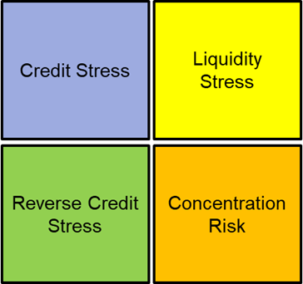The stress test exercise has the following four components:

Figure: Components of the Stress Test Exercise

* + **Credit Stress**: Assess the sufficiency of CCPs’ resources to absorb losses under a combination of market price shocks and CM default scenarios.
  + **Liquidity Stress**: Assess the sufficiency of CCPs’ liquid resources under a combination of market price shocks, member/liquidity provider default scenarios and additional liquidity stress assumptions.
  + **Concentration risk**: Assess the impact of liquidation costs derived from concentrated positions
  + **Reverse Credit Stress**: Increase the number of defaulting entities and level of shocks to identify at which point resources are exhausted.
  + **Additional Analysis**
    - **CM knock on analysis:** Assess the impact of the loss sharing mechanism of CCPs (default fund contributions and power of assessments) on non-defaulting clearing members.
    - **HHI concentration analysis:** Assess the degree of concentration of CCPs’ credit and liquidity exposures using the HHI Index.
    - **Inter-connectedness:** Assess the degree of inter-connectedness of CCPs through common clearing members, custodians or liquidity providers.

*Clearing member default scenarios*

ESMA’s stress test exposed CCPs to two different CM default scenarios, which include:

* The default of the two groups of CMs EU-wide with the largest aggregate exposures to EU CCPs (**Cover-2 groups EU Wide**), which is designed to collectively test the resilience of CCPs as a system of financial infrastructures.
* The default of the top-2 groups of CMs for each CCP (**Cover-2 groups per CCP**), which is designed to test the resilience of each CCP independently.

*Market price shock scenarios*

ESMA’s stress tests applied extreme market price shocks to CCPs using one common market stress scenario. Similarly to the second exercise, the stress results are not based on the CCPs’ own scenarios. The stress results are based on a pre-defined and internally consistent market stress scenario provided by ESRB for the purpose of this exercise. The scenario is common across all CCPs and is used both for credit and liquidity stress tests.

**Why is ESMA testing for simultaneous CMs defaults and market price shocks?**

From a credit risk perspective, a combination of CM defaults and simultaneous severe shifts of risk factor prices is needed to put a CCP at risk. If CMs continue to post margin and meet their obligations, periods of extreme market volatility in isolation will not pose a specific market risk to a CCP. Similarly, defaults of CMs without simultaneous adverse market shocks should not put a CCP at risk. CMs post margins and provide default fund contributions which taken together provide a very high confidence level. This should make sure that CCPs have sufficient resources to manage a default of a CM in normal market conditions and close out the resulting open positions in a stable market before suffering a loss. Therefore, under normal market conditions, the CCPs will have the resources to withstand multiple defaults. Hence, from a credit risk perspective and with the exception of investment risks, only simultaneous defaults and extreme, adverse shifts of market prices could pose potential risk to a CCP.

**What is counterparty credit risk?**

A key risk attached to financial market transactions is counterparty credit risk — the risk that one party to a contract defaults and cannot meet its obligations under the contract. This can lead to a loss for the counterparty on the other side of the contract. If those losses are severe enough, they may cause the affected parties financial distress, which, in turn, can have a knock-on effect for their creditors. CCPs were setup to reduce the counterparty credit risk stemming from bilateral relationships. But CCPs themselves are also exposed to this risk, as they become – with respect to a cleared transaction – the counterparty of two CMs and are therefore exposed to risks arising from the default of one, or multiple, of its counterparties.

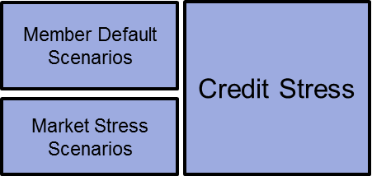

Figure: ELEMENTS OF COUNTERPARTY CREDIT RISK

**Is counterparty credit risk the only risk that CCPs face?**

No. CCPs are also subject to other types of risks, such as liquidity, investment (credit & market) and operational risks that could in isolation, or combined with counterparty credit risk, challenge their resilience.

**What is liquidity risk in this context?**

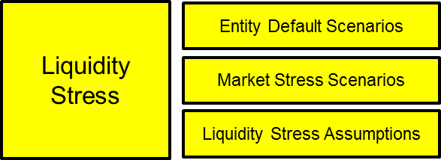Liquidity risk is the risk that a CCP may have insufficient liquid funds to meet its payment obligations in a timely manner when these become due over a relevant time horizon. It can arise due to unexpected liquidity needs and/or absence of sufficient liquidity resources. The liquidity stress test assesses the resilience of EU CCPs to market-wide and idiosyncratic liquidity stress events. It captures the systemic dimension of liquidity risk, in addition to the analysis of resilience of individual CCPs, and enables ESMA to identify potential shortcomings and issue recommendations to address those.

Figure: Liquidity Stress Test Components

A liquidity scenario involves the combination of market shocks with the simultaneous default of market participants. The shocks are equal to those applied in the context of counterparty credit risk. The default of market participants is the actual or technical insolvency of CMs and/or providers of liquidity and services with impact on the liquidity profile of an individual CCP.

**What is concentration risk in this context?**

For the purpose of this exercise, the market illiquidity (or concentration) risk is the added cost of liquidating in the market a position (or hedging it) in a short amount of time (in practice the time allocated to the management of a default by a CCP).

As part of the credit stress scenario, initial market shocks apply to the mid-price of all positions regardless of their size and direction. However, it is likely that CCPs would incur costs beyond this price, depending on the size of their positions and the depth of their markets.

In the context of a portfolio containing a single asset, e.g. an equity, the concept is quite straightforward. There is only so much the market can absorb in one day before the market price of the security moves in an adverse direction.

**Does the exercise model the whole default management procedure?**

This exercise does not model the whole default management procedure. More specifically, there is no attempt to factor in the impact of an auction which could lead to smaller or bigger concentration costs. Rather, we only assess the market impact of liquidating positions or setting up hedges.

**How was the concentration risk modelled?**

The market impact (in bps) of a position is assumed to be driven by its relative size and type.

The size of each position (or of its hedge) relative to the average daily volume of the instrument (or such relevant parameter) is first computed. The sensitivity table of the relevant sub asset class (for example, small cap equities or brent oil 1y-2y) is then interpolated to get the market impact (in basis points).

**How were the sensitivity tables calibrated?**

Each CCP was requested to provide sensitivity tables estimating the liquidation costs for the different asset classes it clears. Typically, for any given asset class or sub-class, the tables would give the cost (in bps or % market value) for executing trades that are x0.5, x1, x2 of the average daily volume (or average daily notional amount when relevant).

From all the contributions received, we then built EU-wide sensitivity tables for each asset class using the median contribution as baseline.

**How do the credit and concentration component interact?**

The credit component uses the CCPs’ own PNL calculation based on the common market stress scenario, while the concentration PNL is run by ESMA staff. In principle, the combined impact of the 2 components should be computed together.

However, it was not possible to recompute the exercise in full while combining the market price shock PNL and concentration PNL. To do so, ESMA staff would have needed a full transparency on the structure of accounts and to be able to run the waterfall in full.

Nevertheless, the exercise assessed the concentration risk and the combined credit / concentration effect against the mutualised resources under some simplifying assumptions.

**Would the exercise have identified the default experienced by Nasdaq in 2018?**

Since the exercise has to be run on the basis of common methodology and criteria, it cannot be aimed to identify topical deficiencies of individual CCPs. In particular, when modelling the scenarios and credit exposure, it is not possible to cover all possible risk factors and then all possible combinations of risk factor shocks for all CCPs. This includes for example the change of spread between two particular markets, as it was the case in the relevant event.

Nevertheless, the new concentration component would have modelled the losses arising from the liquidation of the defaulting clearing member’s large positions, independently from the applied market scenario. Following the default of the clearing member, it was assessed that its positions were too large to be closed in the market. The illiquidity of the positions made the final losses to largely exceed the mark to market losses prior to the default. Of course, the new component is a first step towards incorporating a fully-fledged assessment of the concentration risk and is subject to limitations that are duly explained in the report.

**Is stress testing part of CCPs risk management?**

Yes. CCPs are required to conduct daily stress tests as part of their on-going risk management.

**What is the difference between a CCP stress test and the one ESMA conducted?**

CCP stress tests mostly focus on the specific CCP and its market environment. CCPs are however inter-connected though common CMs. Thus, a default of one of the top CM in one CCP could trigger a simultaneous default of one or more entities in other CCPs. Individual stress tests run by CCPs cannot reveal any systemic implications because of their reduced scope. Therefore, the EU-wide stress test is an extremely useful tool in assessing the resilience of the system of EU CCPs.

**Is the exercise assessing the compliance of CCPs with regulatory requirements?**

As with previous exercises, the objective of the EU-wide stress test exercise is to assess the resilience of EU CCPS to adverse market developments. This exercise is not aimed at assessing the compliance of the CCPs with regulatory requirements, nor at identifying any potential deficiency of the stress testing methodology of individual CCPs. Despite the fact that it is not aimed to do so, it may expose individual shortcomings, in which case ESMA will issue the necessary recommendations.

**What are the different levels of protection a CCP has in place?**

CCPs have rules, arrangements and resources to ensure that they can respond, in an orderly and efficient way, to a defaulting member. For example, a CCP might seek to find new counterparties to take on the positions of the defaulting member and bring the CCP back to a matched book of contracts. This is sometimes achieved through an ‘auction’ of the defaulter’s position among surviving members.

In terms of resources to cover its obligations, CCPs have access to financial resources provided by the defaulting party, the CCP itself and the other, non-defaulting members of the CCP. The order in which these are drawn down helps to create appropriate incentives for all parties (members and CCPs) to manage the risks they take on. These funds are collectively known as the CCP’s ‘default waterfall’ (see figure below).

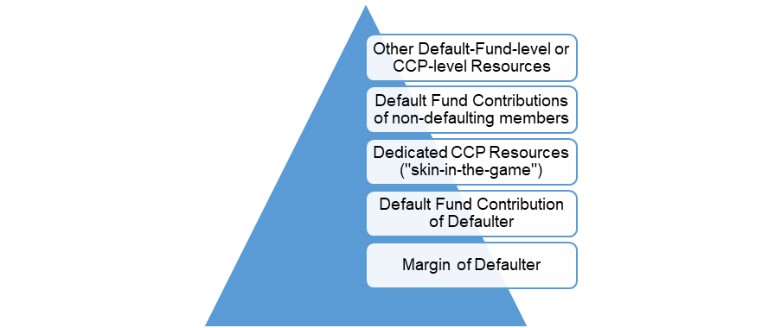

Figure: CCP Default Waterfall

**How does this look like for the CCPs tested?**

CCPs provided for the purpose of this exercise detailed data on their financial resources for one of the two reference dates (March 2019). The CCPs reported in total approximately 335 billion EUR of required margin, default fund contributions and other committed prefunded resources. The amount of mutualised resources alone contributed by clearing members to the Default Funds of all CCPs in March was 28.5 billion EUR.

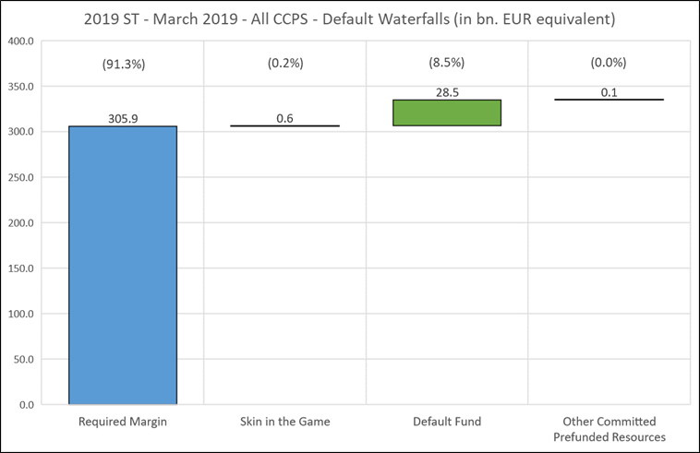

Figure: Default Waterfall Amounts – All CCPs

**How do overall results look like?**

In this exercise, the counterparty credit risk stress test was performed through the application of a single hypothetical scenario to two different dates (December 2018 and March 2019), with liquidity and concentration being tested only for one date (March 2019). Overall, the results show that the analysed network of CCPs is overall resilient to common shocks and multiple defaults.

The credit stress test highlighted differences in resilience between CCPs under the selected market stress scenario, although no systemic risk has been identified. For one of the two dates (March 2019), one CCP (LME) would exhibit a shortfall of prefunded resources. This shortfall would have to be covered with additional non-prefunded resources that the CCP has the right to call from its non-defaulting members, leaving no losses uncovered. For the other date (December 2018), the cover-2 per CCP scenario does not generate a shortfall of prefunded resources at any CCP. Overall, for the core cover-2 per CCP scenarios maximising the amount of loss beyond margin, only three out of the sixteen CCPs faced under at least one of the assumed scenarios a consumption rate that was greater than 50% of prefunded resources beyond margin. Scenarios used to maximise the % consumption of prefunded resources highlighted two smaller default funds for which the scenario would cause a high % consumption accompanied with lower amounts of losses.

For the EU-wide cover-2 scenario, the combination of defaults that led to the above highlighted shortfall would have a rather limited impact on the other CCPs, with the % consumption of prefunded resources being below 20%. When we looked for combinations of defaults that would be more impactful on an EU-wide level by hitting multiple CCPs at the same time, the results were similar. A smaller shortfall of prefunded resources for the same CCP for one of the dates and a higher consumption at other CCPs, but still in all considered scenarios a consumption of prefunded resources that was lower than 50%. Moreover, in the knock-on analysis we saw no evidence of systemic implications from second round effects to non-defaulting members via the risk-sharing mechanism of CCPs under the considered EU-wide scenarios.

For the liquidity stress tests, the exercise did not reveal any systemic risk. CCPs use different tools to cover their liquidity needs, some are highly reliable as central bank routine lines, other less, but no particular deficiency was found in the management of liquidity risks by EU CCPs.

For the concentration component, this first EU-wide analysis shows that concentrated positions represent a significant risk for EU CCPs. Moreover, the overall risk is clustered in one or 2 CCPs for most asset classes. The largest concentration risk can be found in fixed income derivatives (around 20bn EUR). Concentration in commodity derivatives and in the equity segment (securities and derivatives) is very significant as well, with around 9.5bn EUR of concentration risk.

The concentration risk is factored in explicitly in a majority of CCPs through dedicated margin add-ons. EU-wide, those reported concentration add-ons are much lower than market impact risk for commodity derivatives, and to a lesser extent for equity products.

The prudential analysis of the impact of concentrated positions on mutualised resources demonstrates that default fund sizing should take the liquidation costs properly into account.

Are any individual CCP results highlighted by the exercise?

The third CCP stress test finds that EU CCPs are overall resilient, however, some CCP results are highlighted in the report.

For the credit component, for one CCP (LME), the results flag a shortfall of the pre-funded resources, that would need to be covered with non-prefunded resources coming from the non-defaulting members. Given the size of the loss (266 million euro) and the size of the committed non-prefunded resources by the non-defaulting clearing members, there would be no losses uncovered and no systemic implications.

For the liquidity part of the stress tests, ESMA did not detect any major systemic risk concerns. CCPs use different tools to cover their liquidity needs, such as access to the short-term FX markets and the use of highly reliable central bank routine lines or others, but ESMA found no particular deficiency in the management of liquidity risks by EU CCPs.

As the methodology and assumptions of the concentration component were applied for the first time. the concentration stress test results have been presented on an anonymous basis.

What are the planned next steps?

In line with the EMIR mandate, where the assessments expose shortcomings in the resilience of one or more CCPs, ESMA will issue as a next step the necessary recommendations. ESMA is currently considering whether any recommendation is needed and what form it should take.

1. <https://www.esma.europa.eu/sites/default/files/library/esma70-151-2198_framework_for_the_2019_ccp_st_exercise.pdf>