1 December 2014

Reply form for the
Guidelines on asset segregation under the AIFMD

Responding to this paper
Date: 1 December 2014
The European Securities and Markets Authority (ESMA) invites responses to the specific questions listed in the ESMA Consultation Paper - Guidelines on asset segregation under the AIFMD, published on the ESMA website.
Instructions
Please note that, in order to facilitate the analysis of the large number of responses expected, you are requested to use this file to send your response to ESMA so as to allow us to process it properly. Therefore, please follow the instructions described below:
- use this form and send your responses in Word format;
- do not remove the tags of type <ESMA_QUESTION_G_AIFMD_1> - i.e. the response to one question has to be framed by the 2 tags corresponding to the question; and
- if you do not have a response to a question, do not delete it and leave the text “TYPE YOUR TEXT HERE” between the tags.
Responses are most helpful:
- if they respond to the question stated;
- contain a clear rationale, including on any related costs and benefits; and
- describe any alternatives that ESMA should consider
Naming protocol:
In order to facilitate the handling of stakeholders responses please save your document using the following format:
ESMA_CE_G_AIFMD _NAMEOFCOMPANY_NAMEOFDOCUMENT.
E.g. if the respondent were ESMA, the name of the reply form would be ESMA_CE_G_AIFMD _AIXX_REPLYFORM or ESMA_CE_G_AIFMD_AIXX_ANNEX1
Responses must reach us by 30 January 2015.
All contributions should be submitted online at www.esma.europa.eu under the heading ‘Your input/Consultations’.
Publication of responses
All contributions received will be published following the end of the consultation period, unless otherwise requested. Please clearly indicate by ticking the appropriate checkbox in the website submission form if you do not wish your contribution to be publicly disclosed. A standard confidentiality statement in an email message will not be treated as a request for non-disclosure. Note also that a confidential response may be requested from us in accordance with ESMA’s rules on access to documents. We may consult you if we receive such a request. Any decision we make is reviewable by ESMA’s Board of Appeal and the European Ombudsman.
Data protection
Information on data protection can be found at www.esma.europa.eu under the heading ‘Disclaimer’.

Which of the two identified options do you prefer?

<ESMA_QUESTION_G_AIFMD_1>
In summary, we would like to make the following comments:

- Neither Option 1 nor Option 2 adequately reflects the variety of potential approaches to, and the complexity of safe-keeping and recordkeeping of assets throughout the custody chain at a general level. In addition, the Options as drawn do not reflect the operational reality that there are various custody models in operation for safe-keeping assets, including non-delegation by the depositary, delegation by the depositary to a global sub-custodian (Level 1), delegation by the depositary directly to local sub-custodians (Level 2). A re-drawn diagrammatic representation of the custody chain in practice is provided with the aim of assisting with the considerations of this topic and demonstrating the complexity of the account structures that exist.
- It could be argued that neither Option proposed by ESMA, as displayed and depending on how it is interpreted, meets the requirements of the Directive and/or the Level 2 Regulations. Different interpretations can be applied principally because of the lack of clarity in the Directive and the Regulations where reference is made to ‘accounts’ in certain provisions and to ‘books and records’ in other provisions. Clearly they are understood by industry members to mean two very different things but they are used interchangeably in certain key provisions of the legislation creating a lack of clarity in terms of implementation.
- Both Options proposed by ESMA represent a dramatic increase in the cost and complexity of the system due to the extrapolation of accounts and associated reconciliations and it is not clear that either Option achieves the aim of enhancing investor protection in the event of bankruptcy of an underlying agent in the chain.
- Bearing in mind the anticipated increase in costs and operational complexity in order to support either Option 1 or Option 2 across the industry, we propose that before seeking to move the industry to implement either of these Options, it would be appropriate to support with a definitive legal opinion that the statement set out on page 8, paragraph 16 of the consultation reflects the actual intention of the Directive and the correct interpretation of Article 99(1) of the Regulations, i.e. that “the account where the AIF assets are to be kept at the level of the delegated third party can only comprise assets of the AIF for which the safe-keeping has been delegated to the third party and assets of other AIFs. Non-AIF assets cannot be included in such an account”. We raise this in particular as Recital 40 of AIFMD clearly envisages omnibus account holding structures and does not preclude the holding of AIF and non-AIF assets in this account as it is silent on whether the omnibus account may contain non-AIF assets. Furthermore, in its recent consultation on Principles regarding the Custody of Collective Investment Schemes’ Assets (October 2014), IOSCO expressly recognises the maintenance of omnibus accounts as a valid form of holding and segregating assets.
- By presenting only Option 1 or Option 2 for consideration, the consultation paper does not recognise that imposing segregation of AIF assets at account level throughout the custody chain may not be feasible for all delegates in all jurisdictions, given the operational differences that exist as a result of the applicable local regulatory requirements. For example, in the UK, omnibus account structures are permitted under the FCA's Policy Statement 13/5 and CASS 6.5.1 which permits prime brokers to hold omnibus accounts for AIF and non-AIF assets. Ultimately, this could lead to certain markets being closed for investment by AIFs where local safe-keeping arrangements applied by delegates in that particular market do not meet the criteria set out in either Option 1 or Option 2.
- Recital 41 of AIFMD states that the delegation provisions do not apply to central securities depositaries (“CSDs”) or securities settlement systems (“SSS”) and this is further set out in the final paragraph of Art 21(11). Hence, at the final holding level, AIF and non-AIF assets are today held on a co-mingled basis and will continue to be held in omnibus account structures in both scenarios as set out in Option 1 and Option 2. This ultimate comingling of assets in an omnibus account structure at the end of the custody chain does not seem to be acknowledged in the presentation of the Options in the consultation paper.
- The consultation paper does not clearly specify what is meant by non-AIF assets and in particular it is not clear on whether segregation requirements are only applicable to AIF assets. Are non-AIF assets to include only non-AIF collective investment schemes (CIS) /collectively managed assets or is the reference to non-AIF assets to include a wider definition, for example, to include all client assets of the depositary held by the delegate which are not AIFs. Depending on what is intended here, further account structures at the delegate level beyond what is envisaged in the consultation paper would be required.
- While it may appear to ESMA that both Option 1 and Option 2 provide enhanced investor protection in the event of insolvency of a delegate, neither Option 1 nor Option 2 results in any greater identification of the ownership rights of an AIF to particular assets in a pooled account structure. On this basis, we do not believe that either Option 1 or Option 2 provides any material additional protection to the investors of the AIF over and above the protections available as a matter of existing custody and asset segregation practice. We set out in response to Question 5 why we consider that Option 4 is consistent with the regulatory provisions while also meeting the overall policy objective of investor protection.
- The key protection which should be the focus when assessing safekeeping arrangements is in relation to whether there are sufficient records maintained and reconciliations performed at each level of the custody chain such that the AIF’s assets can be readily identified at all times. Segregation maintained through recordkeeping and reconciliations is well established in most developed financial jurisdictions (and frequently is supported by local legislative provisions or regulatory practice) and is relied upon as being as effective as accounting segregation in protecting asset in the event of the insolvency of a relevant person/entity.
- For the reasons outlined in our response, we do not believe that either Option 1 or Option 2 presents the AIFs or their investors with the optimal safekeeping structure. However, if these were the only Options, then Option 2 would be the preference (i.e. comingling of AIF assets of various depositaries by the delegates in the custody chain), but noting in our response areas where further clarity would be required in order that any implementation of either Option is adopted consistently.
Our detailed response is provided below:

Background

In order to provide a response in relation to the Options for asset segregation as proposed in the consultation paper, it is first necessary to consider those Options in the context of the safekeeping requirements, delegation of safekeeping and asset segregation as outlined in the Alternative Investment Fund Managers Directive 2011/61/EU ("AIFMD") (“Level 1”) and supplemented with the Commission Delegated Regulation (EU) No 231/2013 ("Level 2"). Under this framework, it is the AIFM which is ultimately responsible for compliance with AIFMD rules (Recital 11, Level 1) and the depositaries to the AIFs need to ensure compliance in relation to asset segregation with the key provisions of the Directive, Level 2 and any future guidelines produced by ESMA.
AIFMD and the Level 2 Regulations set out rules on asset segregation requirements when the safekeeping of the AIF assets is maintained directly by the depositary and where safekeeping is delegated by the depositary to a third party. The practical application of the rules in the delegation model has proven problematic to determine with various approaches based valid interpretations being presented by the different stakeholders including AIFMs, depositaries, global custodians, prime brokers, local sub-custodians. We welcome the provision of clear guidelines which are intended to ensure the consistent interpretation and application of the rules and achieve the overall policy objective of protecting the interest of AIF investors by safeguarding assets against exposure to events such as the bankruptcy of a party who is holding the assets in safe-keeping.
The depositary has an obligation to comply with the segregation and delegation requirements set out in AIFMD and Level 2 and, where safekeeping is delegated, to establish the delegation relationship in such a way as to ensure its delegate meets the requirements. The depositary shall in particular ensure that any third party appointed (for example a global sub-custodian, a prime broker and/or a local sub-custodian to whom safekeeping has been delegated) complies with the requirements of Level 2 Art 89 paragraph 1 (b) to (g) and the segregation obligations laid down in Art 99. It is the depositary's responsibility to establish the delegation relationship via contract and to oversee and monitor that relationship to ensure that the third party meets the requirements.

In summary, the key obligations in relation to safekeeping and delegation are set out below in addition to a diagrammatic representation of how assets are generally held in the delegation model:

Legal provisions - obligations of the depositary in relation to safekeeping of financial instruments

According to Article 21 8(a)(ii) the depositary shall ensure that all those financial instruments that can be registered in an account opened in the depositary’s books are registered in the depositary’s books within segregated accounts in accordance with the principles set out in Article 16 of Directive 2006/73/EC, opened in the name of the AIF or the AIFM acting on behalf of the AIF, so that they can be clearly identified as belonging to the AIF in accordance with the applicable law at all times.

The specific AIFMD and AIFMR requirements in respect of custody of financial instruments are detailed in AIFMD Article 21(8) and AIFMR Article 89. The following outlines the relevant obligations of the depositary in relation to the safekeeping of financial instruments held in custody. The depositary will ensure at least that:

- the financial instruments are property registered in accordance with Article 21(8) (a)(ii) of AIFMD;
- records and segregated accounts are maintained in a way that ensures their accuracy and in particular record the correspondence with financial instruments and cash held for AIFs;
- Where custody of financial instruments is delegated to a third party that the depositary’s record of financial instruments is frequently reconciled to the record of the financial instruments maintained by the third party;
- due care is exercised in relation to the financial instruments held in custody in order to ensure a high standard of investor protection;
- all relevant custody risks throughout the custody chain are assessed and monitored and the AIFM is informed of any material risk identified;
- adequate organisational arrangements must also be in place to minimise the risk of loss of financial instruments, or of rights in connection with those financial instruments as a result of fraud, poor administration, inadequate registering or negligence; and
- the AIF’s ownership right or the ownership right of the AIFM acting on behalf of the AIF over the financial instruments is verified.
In conducting its safekeeping obligations, the depositary may safe-keep the assets directly or delegate the safe-keeping to a third party.

Legal provisions - delegation of safekeeping to a third party

Where the depositary has delegated custody it remains subject to all of the above obligations with the exception of a) above. This is an important consideration as, where custody is delegated to for example a global custodian or prime broker, the depositary is not required to ensure that all financial instruments of the AIF are recognised within segregated accounts in the name of the AIF or its AIFM. The records of the global custodian or prime broker become the depositary’s record and the primary custodial record of the AIF.

Level 2 sets out the oversight responsibility of the depositary in relation to asset protection. Art 99(2) provides that “where a depositary has delegated its custody function to a third party in accordance with Art 21 (11), the monitoring of the third party’s compliance with its segregation obligations shall ensure that the financial instruments belonging to its clients are protected from any insolvency of that third party…”

Level 2 Art 99(1) provides that the delegate keeps such ‘records and accounts as are necessary’ to enable it at any time and without undue delay to distinguish assets and Art 99 (3) provides that the same requirements which apply under Level 2 Art 99 to the depositary apply mutatis mutandis to the delegate itself when it sub-delegates the holding of the AIF assets.

No delegation of safekeeping

Where the depositary does not delegate safekeeping, in line with Article 21 8(a)(ii) the depositary shall ensure that all those financial instruments that can be registered in a financial instruments account opened in the depositary’s books are registered in the depositary’s books within segregated accounts in accordance with the principles set out in Article 16 of Directive 2006/73/EC, opened in the name of the AIF or the AIFM acting on behalf of the AIF, so that they can be clearly identified as belonging to the AIF in accordance with the applicable law at all times.

The custody chain in practice
To determine how it should discharge its obligations under AIFMD Art 21(8)(a) in relation to custody of financial instruments and the corresponding AIFMR Art 89, the depositary must have regard to the complete custodial chain as to whether or not it utilises the services of a global custodian/prime broker or sub-custody agent as its custodial delegate. We suggest that the charts provided in the consultation paper depicting the safekeeping models Option 1 and Option 2 reflect an overly simplistic understanding of the factual position and do not reflect in practice how assets are held throughout the custody chain. In particular, neither Option 1 nor Option 2 addresses in sufficient clarity the account holding structure beneath the level of the delegate appointed by the depositary. However, Level 2 Art 99(3) provides that the same requirements which apply under Level 2 Art 99 to the depositary apply mutatis mutandis to the delegate itself when it sub-delegates the holding of the AIF assets.

In order to consider the questions posed in the consultation paper and in particular where they relate to the cost and operational impacts of how assets are held, it is important firstly to set out a clear representation of how in practice assets are typically held throughout the custody chain in the delegation model. The custody chain can be complex to display, particularly relating to AIFs where prime brokers/global sub-custodians are appointed who then subsequently appoint a series of local agents in order to facilitate AIF investments in a range of jurisdictions. Notwithstanding this, we have attempted to set this out as clearly as possible for Option 1 and Option 2 in the diagrammatic representations below.

In the delegation model, the custodial chain will typically take one of two forms:

- where the depositary utilises the services of a global custodian or prime broker; or
- where the depositary does not utilise the services of a global custodian or prime broker but appoints local sub-custodial agents directly in each market where its AIF clients invest.

Where the depositary appoints a global custodian or prime broker to safeguard and maintain records of financial instruments held by AIFs under a custodial agreement, the global custodian or prime broker appointed by the depositary selects, appoints and maintains the relationship with each of the local custodial agents in the markets where the AIFs invest. The custody of the financial instruments and the maintenance of the record of financial instruments owned by each AIF is delegated to the global custodian or prime broker by the depositary, as envisaged by AIFMR Art 89(2).

The local agent may maintain an omnibus account in the CSD for that market (where the CSD is the appropriate repository for that asset type). Financial instruments of the AIF are normally held in the omnibus account maintained by the local agent at the CSD, comingled with financial instruments belonging to all clients of that local agent. The CSD will arrange for the registration of the AIF’s financial instruments with the relevant registrar for the financial instrument.

Financial instruments are normally registered in the name of the local agent’s account with the CSD. Each local agent will reconcile the records of financial instruments it maintains on its books for its clients, typically one omnibus account, but may also include individual named AIF accounts, for each global custodian or prime broker, to the omnibus account it maintains at the CSD where the financial instruments of all its clients are held.

The global custodian or prime broker will in turn maintain a record of financial instruments for each AIF client of the depositary, one account opened in the name of the AIF or AIFM on behalf of the AIF for each AIF client. The global custodian or prime broker will reconcile its records across those AIF accounts to either the individual named account or the omnibus account it maintains with the local agent. These reconciliations in many instances are automated and may take place daily depending on volumes and other factors. These accounts record only those assets of the clients of the global custodian or prime broker, segregated from the proprietary assets of the global custodian or prime broker.

Option 1
Diagrammatic Representation of the Custody Chain (Restated version of Option 1 in the consultation paper)
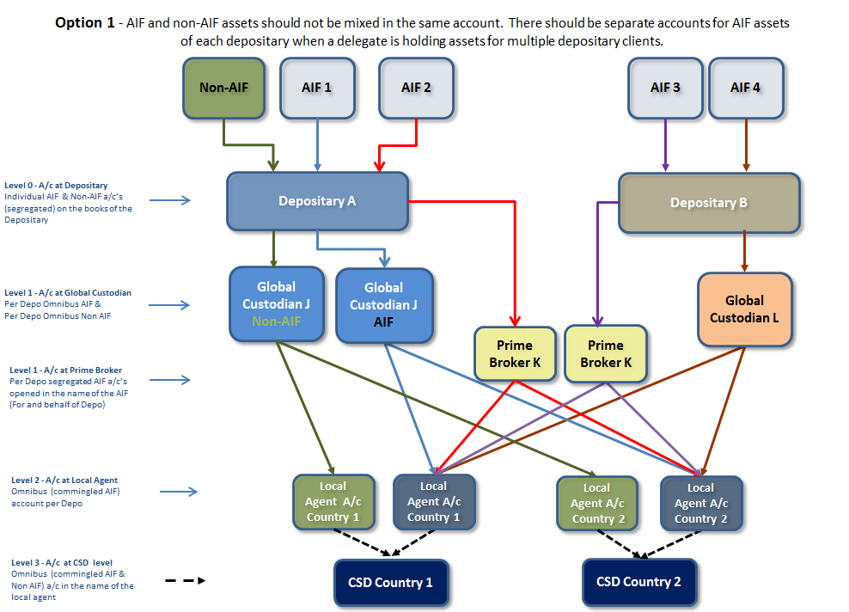

Option 2
Diagrammatic Representation of the Custody Chain (Restated version of Option 2 in the consultation paper)
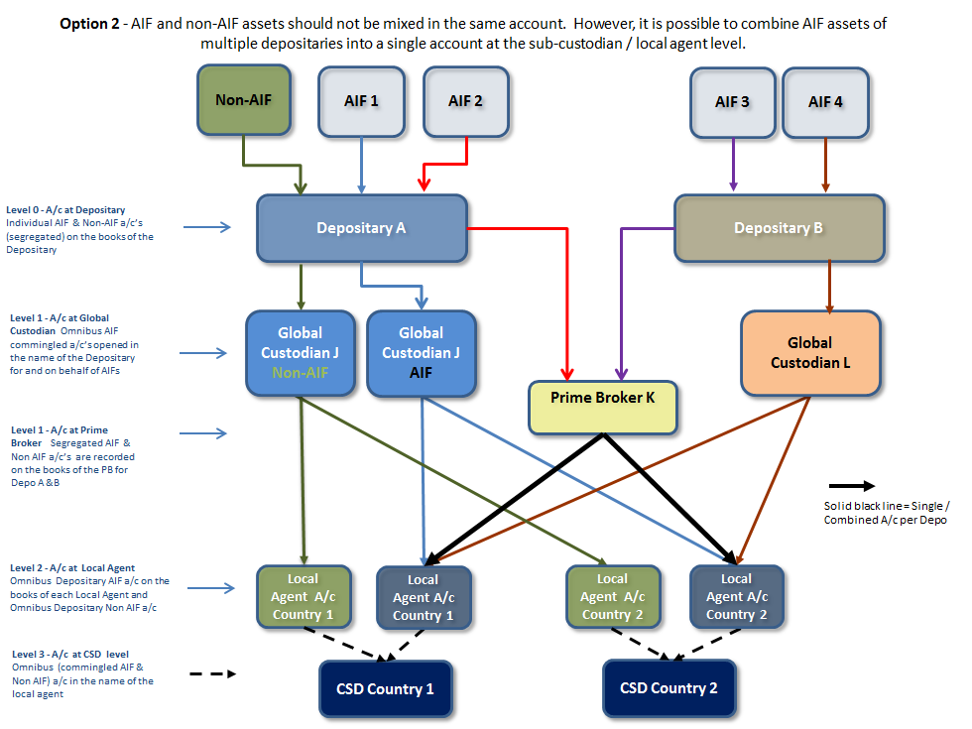

Are the key provisions of the Directive met under Option 1 and Option 2?

Delegation

In accordance with AIFMD Art 21(11) the depositary may delegate to third parties the functions referred to in paragraph 21 (8) subject to the following conditions:

“(d) the depositary ensures that the third party meets the following conditions at all times during the performance of the tasks delegated to it: …..

(iii) the third party segregates the assets of the depositary’s clients from its own assets and from the assets of the depositary in such a way that they can at any time be clearly identified as belonging to clients of a particular depositary;”

It would appear that Option 1 does satisfy this requirement but it is not clear that Option 2 as outlined above satisfies these conditions. Records in the name of the AIF or AIFM on behalf of the AIF for each AIF client are maintained by the global custodian/prime broker in both Option 1 and Option 2. Arguably, depending on whether records can be interpreted as ‘books and records’ on the global custodian system or the actual account at their local agent, it could be interpreted that Option 2 does not meet this test. If the interpretation of Art 21(8)d (iii) is that the requirement is to maintain an account at the local agent with only the assets of a particular depositary, then it could be reasonably questioned whether Option 2, which envisages the commingling of AIF asset from various depositaries, in fact meets this requirement.

Segregation

Article 99(1) of Level 2 sets out the relevant rules specifying the segregation obligation and states that where safekeeping functions have been delegated wholly or partly to a third party, a depositary shall ensure that the third party to whom safe-keeping functions are delegated pursuant to Art 21(11) of Level 1 acts in accordance with the segregation obligation laid down in point (iii) of Art 21(11)(d) by verifying that the third party:

“(a) Keeps such records and accounts as are necessary to enable it at any time and without delay to distinguish assets of the depositary’s AIF clients from its own assets, assets of its other clients, assets held by the depositary for its own account and assets held for clients of the depositary which are not AIFs.”

It can be argued that both Option 1 & Option 2 as outlined satisfy these conditions. Records which are maintained in both scenarios distinguish the assets of the depositary’s AIF clients from its own assets as there are no proprietary assets maintaining in any of the accounts as outlined. It should be noted that with the comingling of AIF assets for each depositary (Option 1) and the comingling of AIF assets for multiple depositaries (Option 2), it could be argued depending on how this provision is interpreted, that neither Option meets this requirement and in fact only Option 5 truly meets this provision as there is comingling of the assets of its (the depositaries) other clients in both scenarios. In practice, however, in both Option 1 and Option 2, through the combination of ‘Records and Accounts’ maintained at each level it is possible to clearly identify and reconcile back the asset of the AIF throughout the custody chain. In order to do this, the depositary and its delegate, would maintain systems processes and procedures to reconcile on an ongoing basis the assets in the omnibus account structures (for those held in omnibus or otherwise in individual accounts) to the book record maintained. It is worth noting at this stage that we believe through this same combination of ‘Records and Accounts’ maintained at each level, assets are clearly identified and reconciled throughout the custody chain and therefore Option 4 is also compliant with the Regulations. In the response to Question 5 there is further detail on the reconciliations and on-going due diligence performed by the depositary on its delegates and by the delegates on their sub-delegates.

Omnibus accounts
The holding of assets in Omnibus account structures is permissible under the Directive. Recital 40 of Level 1 provides for the following in the case of delegation of the safekeeping duties to a third party:

“A third party to whom the sake-keeping of assets is delegated should be able to maintain a common segregated account for multiple AIFs a so-called omnibus account.”

Both Option 1 and Option 2 as outlined operate structures which satisfy Recital 40. This Recital envisages the use of omnibus structures to facilitate the holding of assets and it does not preclude the co-mingling of AIF and non AIF assets but is instead is silent on whether the omnibus account may contain non AIF assets. Also, Level 2 Art 99(1)(a) does not outline that the third party must hold AIF assets in a segregated account but keep "records and accounts as are necessary to enable it …to distinguish asset of the depositary’s AIF clients…..”. Furthermore, in its recent consultation on Principles regarding the Custody of Collective Investment Schemes’ Assets (October 2014), IOSCO expressly recognises the maintenance of omnibus accounts as a valid form of holding and segregating assets.
Therefore we would suggest for the purposes for further clarity that it would be appropriate to support with a definite legal opinion that statement set out in the consultation paper on page 8, paragraph 16 that “the account where the AIF assets are to be kept at the level of the delegated third party can only comprise assets of the AIF for which the safe-keeping has been delegated to the third party and assets of other AIFs. Non-AIF assets cannot be included in such an account”.

Difficulty with imposing EU custody requirement on non-EU delegates
In the typical scenario with multiple agents in the custody chain, the depositary would require all parties in the custody chain (excluding SSS/CSDs) in both EU and non EU jurisdictions to comply with the account holding structures (Option 1 or Option 2) as set out. Where the account structures are not feasible for operational or other potential regulatory reasons imposed on the agent in the particular jurisdiction (e.g. in the UK where omnibus account structures are permitted under UK FCA's Policy Statement 13/5 and CASS 6.5.1 which permits prime brokers to hold omnibus accounts for AIF & non AIF assets), the depositary may not be in a position to provide custodial services to the AIFM in those particular markets.

Does “non-AIF assets” refer to non-AIF collectively managed structures?
The consultation paper does not clearly specify what is meant by non-AIF assets and in particular it is not clear on whether segregation requirements are only applicable to AIF assets. Are non-AIF assets to include only non-AIF collective investment schemes (CIS) /collectively managed assets or is the reference to non-AIF asset to include a wider definition for example to include all client assets of the depositary held by the delegate which are not AIFs. Depending on what is intended here, further account structures at the delegate level beyond what is envisaged in the consultation paper would be required.

Ultimate comingling of all assets at CSD level
In addition, it is important to note that the account structures as set out would not apply to the entire custody chain, as the account structure as outlined in Option 1 or Option 2 would not be required at the CSD level due to the holding of assets at the CSD/SSS level not being considered a delegation of safekeeping. Level 1, Art 21(11) final paragraph confirms the same delegation provisions do not apply in the case of a CSD/SSS: “for the purposes of this paragraph, the provision of services as specified by the Directive 98/26/EU by securities settlement systems as designated for the purpose of the Directive or the provision of similar services by third-country securities settlement systems shall not be considered a delegation of its custody functions”. This is further specified in Level 1, Recital 41. Hence, at the final holding level (as considered by the legislation) the assets will be held in co-mingled omnibus accounts containing the assets of multiple clients of the agent and containing both AIF and non-AIF assets (as set out in response to Question 5 Option 4).

Ownership rights of the AIF to particular assets
While it may appear that either Option 1 or Option 2 provides enhanced protection in the event of insolvency of a delegate, neither Option 1 nor Option 2 identifies the ownership rights of the AIF to particular assets. With the exception of certificated issue, financial instruments are typically held in dematerialised form and so therefore it is not possible to determine which unit of the financial instrument in that account belongs to a particular AIF. Hence these options do not provide the additional protection to the AIF which they appear to present (and in particular the additional protection which Option 1 appears to present through adding the additional layer of accounts being held for each depositary).

Conclusion
Neither Option 1 nor Option 2 as set out in the consultation paper clearly specify in sufficient detail how they meet the requirements of AIFMD while implementation of both Options would require additional account structures, adding significant additional cost for safekeeping assets globally without adding additional investor protection. It is our view the that Option 4, as set out in our response to Question 5, complies with the regulatory requirements and meets the policy objective of investor protection without adding undue cost. As set out above, we have questioned in a number of areas whether either of the two Options proposed fully satisfy all aspects of the Directive and Regulation (depending on how they are interpreted). However, if the only choice were simply between Option 1 or 2, we would favour Option 2 primarily as it is closest to the existing model and therefore is less onerous from an overall cost perspective.
<ESMA_QUESTION_G_AIFMD_1>

Would you suggest any alternative option which is compatible with the AIFMD and its implementing measures? If yes, please provide details.

<ESMA_QUESTION_G_AIFMD_2>
We would propose that the approaches outlined our response to Question 5 meet the requirements for the reasons outlined in that response and achieve the policy objective of protection of investor interests in the event of insolvency of a delegate. In particular Option 4 does not introduce additional complexity or cost to an already complex system which both Option 1 and Option 2 do. Furthermore, these Options are proposed without clear legal interpretation in the consultation paper to support why they provide better protection. Please refer to our response to Question 5.
<ESMA_QUESTION_G_AIFMD_2>

Do you have knowledge of the impact that each of the two options identified would have on your business in terms of restructuring of existing delegation arrangements in Europe and third countries? Please quantify the one-off and ongoing costs as well as the type of costs for each of the two options or any alternative option that you may prefer.

<ESMA_QUESTION_G_AIFMD_3>
We have split the response to this question into Part A and Part B to discuss the account restricting arrangements (Part A) and cost considerations (Part B).
Part A. Do you have knowledge of the impact that each of the two options identified would have on your business in terms of restructuring of existing delegation arrangements in Europe and third countries?

Option 1
Depositaries operating an omnibus account structure through their global custodians, including agent banks serving as sub custodian/prime broker on behalf of the depositary/AIF respectively would need to create a separate AIF versus non-AIF omnibus account for each AIF.
In the context of prime brokers we contend that under Article 21 of AIFMD there is no necessity for a depositary to have the prime broker/sub custodian open a separate client account for the purposes of segregating AIF vs non-AIF assets, or segregate client assets held through sub agents by depositary, or by AIF. We further believe it is sufficient for the depositary’s sub-custodian (also acting as prime broker) to segregate the prime broker's proprietary assets from the prime broker’s client assets and the sub-custodian to segregate its proprietary assets from its client assets accordingly.
Depositaries holding AIF and non-AIF securities via a single omnibus account, in the name of the depositary and or its global custodian, at CSDs - the Depository Trust Clearing Corporation (DTCC), or international securities depositories (Euroclear, Clearstream) - are held as per the non-negotiable terms of these facilities. CSDs are not delegates of the depositary as set out in the Directive and Recitals as outlined above but are market utilities in their own right and therefore we do not believe it necessary or a requirement under the Directive to segregate the assets in separate accounts.
Depositaries operating segregated AIF securities accounts through their global custodian, segregated from the depositaries own propriety assets, comply with the provisions of the AIFMD and Level 2 Regulations. In our view, there is no requirement for such depositaries to take further action relative to Option 1. The asset segregation rules under the AIFMD and Level 2 are respected under this arrangement.

Option 2
Under this arrangement depositaries would need to create a new (separate) omnibus account to delineate their AIF from their non-AIF book of assets and further into non-AIF CIS and non-AIF other accounts depending on the definition of non-AIF assets (please cross refer to this point in response to question 1). The challenges likely to be encountered would be similar to conversion of assets from one depositary to another, however, there should be no third party counterparty risk.

Part B. Please quantify the one-off and ongoing costs as well as the type of costs for each of the two options or any alternative option that you may prefer.
In each of the markets serviced, in addition to the account set up cost, on an on-going basis increased account maintenance and service costs would apply, with these costs being passed on to the AIFs. The broader impacts to depositaries having to restructure their client securities accounts would include:

- increased sub custodian fees, both initial and on-going. Cost estimates for operating a segregated account at the delegate level vary between $5k in mature markets to $15k in some emerging markets e.g. African markets;
- increased depositary account administration and maintenance costs;
- potential disruption to services - conversion of AIF assets, re-registration charges, updating of AIFs’ Standard Settlement Instructions (SSIs). The number of SSIs would increase exponentially which could lead to an increase the in number of settlement failures in the market;
- transaction charges arising from the transfer of assets to the new account structures; and
- on-going reconciliation and analysis. The multitude of additional reconciliations to be performed at each level in the custody chain will result in additional costs both at the transactional processing level (e.g. SWIFT message per account to be reconciled), at the system level potentially system investment in more advanced reconciliation tools to handle the volume of accounts, and the human resource cost factor employing staff to perform and control the additional reconciliations.
In addition, in order to support any re-structuring of accounts, existing legal (sub custody) agreements between depositaries and their delegate and between the delegate and the local sub-custodian would need to be redrafted and re-negotiated resulting in one-off costs for the re-papering exercise. This one off additional legal cost would be significant when viewed in terms of the number of depositaries, delegates and local sub-custodians involved in completing this repapering exercise.
Block trading for the manager combining multiple entities in the block transaction (for AIF and non-AIF structures and relating to EU and non-EU assets) will be significantly impaired where assets then have to be split into AIF and non-AIF accounts at the custody level throughout the chain leading to complexity in settlement and an increase in fails due to this added complexity as well as increased costs. Hence, the benefits the manager may have obtained from block trading processes would be negated due the additional cost imposed by the custody providers at all levels in having to split the block trade across multiple Standard Settlement Instructions (SSIs) in each jurisdiction. In addition, the brokers will bear the cost of maintaining these additional SSIs in each jurisdiction.
Given the complex nature of the custody chain and the varying cost structure per market for in excess of 100 markets serviced, it is too complex and large a data gathering exercise to come up with a single cost number which is a factually supportable number for the introduction of Option 1 or Option 2 across the industry. As well as the opening and the ongoing maintenance fees for accounts at all agents at all levels, there is the cost of system redesign to cope with the changed model, introduction of systems for some agents to cope with the increased volume of reconciliations and the human recourse cost of performing, controlling and reporting on the reconciliation processes.
In summary, in relation to the provision of an overall cost estimate relating to the implementation of either Option 1 or Option 2, we estimate that the cost associated with establishing and maintain the additional account structures in addition to the ongoing costs associated with the control structure and the repapering exercise needed to support either option would very significant.
<ESMA_QUESTION_G_AIFMD_3>

Do you see merit in foreseeing a specific treatment for certain types of arrangement (e.g. collateral management arrangements)? If yes, please specify how your proposal would ensure compliance with the relevant requirements of the AIFMD and Level 2 Regulation.

<ESMA_QUESTION_G_AIFMD_4>
It is our view that, given the liability conditions imposed on depositaries by AIFMD, any financial instrument transferred to an AIF under a title transfer arrangement must be transferred to the depositary or its delegates and safeguarded in the same manner as all financial instruments held by the depositary. We do not believe a different treatment of financial instruments passed to the AIF under certain types of arrangements (e.g. collateral management arrangements) is possible without a revision of the AIFMD Level 1 text.
We wish to bring to your attention our response to the recent IOSCO consultation on Principles Regarding the Custody of Collective Investment Schemes’ Assets, and specifically in response to Q1 on general market developments. Regarding treatment of collateral, we advised that where collateral in the form of a financial instrument is received under a title transfer arrangement or delivered to a third party via a pledge arrangement, depositaries now bear full custodial responsibility for such collateral assets.
This element of custodial responsibility for collateral has proved particularly challenging, as the requirement for restitution of assets lost now extends to collateral in the form of book entry securities, for which previously the CIS custodian would not have had a contractual obligation to safeguard. This has necessitated the appointment of collateral agents as sub-custodians by depositaries, and application of the full requirements of AIFMD to financial assets held/delivered as collateral assets. Depositaries would argue strongly that the delivery or receipt of collateral, and the agent appointed to hold that collateral, is carried out solely to facilitate a particular investment or trading arrangement and should not therefore fall subject to the restitution obligations of the depositary for financial assets in custody. Rather, it is more appropriate to align collateral loss to market or investment risk in respect of which the AIFs and investors should be directly exposed, subject to adequate and full disclosure of investment risk outlined in the AIF prospectus.
It has been our experience to date that the imposition of restitution obligations for collateral assets has been very counterproductive, both from a cost and asset concentration perspective. Depositaries must be compensated for this additional risk, a cost ultimately borne by the AIF investors. In addition, depositaries will only appoint collateral agents who pass rigorous due diligence testing and who are willing to accede to the contractual requirements of the depositary in question, leading to the exclusion of certain collateral agents by depositaries and asset concentration with others.
Rather than consideration of collateral in the form of book entry securities as a financial instrument of the AIF, the loss of which a depositary is strictly liable for, we would suggest an alternative approach to enhance investor protection, such as an oversight role being imposed on depositaries in respect of the collateral arrangements implemented by the CIS.

<ESMA_QUESTION_G_AIFMD_4>

Do you agree with ESMA’s approach to discarding the third, fourth and fifth options described in Section 5 of the CBA? If not please provide data and information that support your view.

<ESMA_QUESTION_G_AIFMD_5>
We do not agree with the approach of discarding the third and fourth options as set out in the consultation paper. We agree with ESMA’s view that Option 5 should be discarded, but only as it relates to record keeping employed by the local agent at the local country agent level of the custodian for the reasons outlined below. We have set out below how, in our view, Option 4 does meet the requirements of the Directive and Regulations and the policy objective of investor protection.

In determining the appropriate options for consideration and the extent to which assets should be segregated in the custody chain, one must have regard for the complete custodial chain as presented below.

Option 3
Diagrammatic Representation of the Custody Chain (Restated version of Option 3 in the consultation paper)
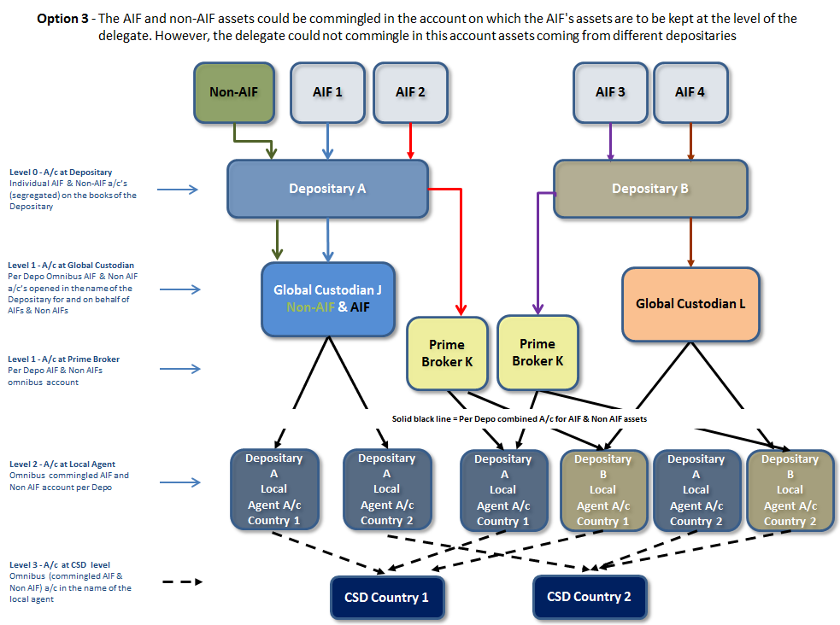

Option 4
Diagrammatic Representation of the Custody Chain (Restated version of Option 4 in the consultation paper)
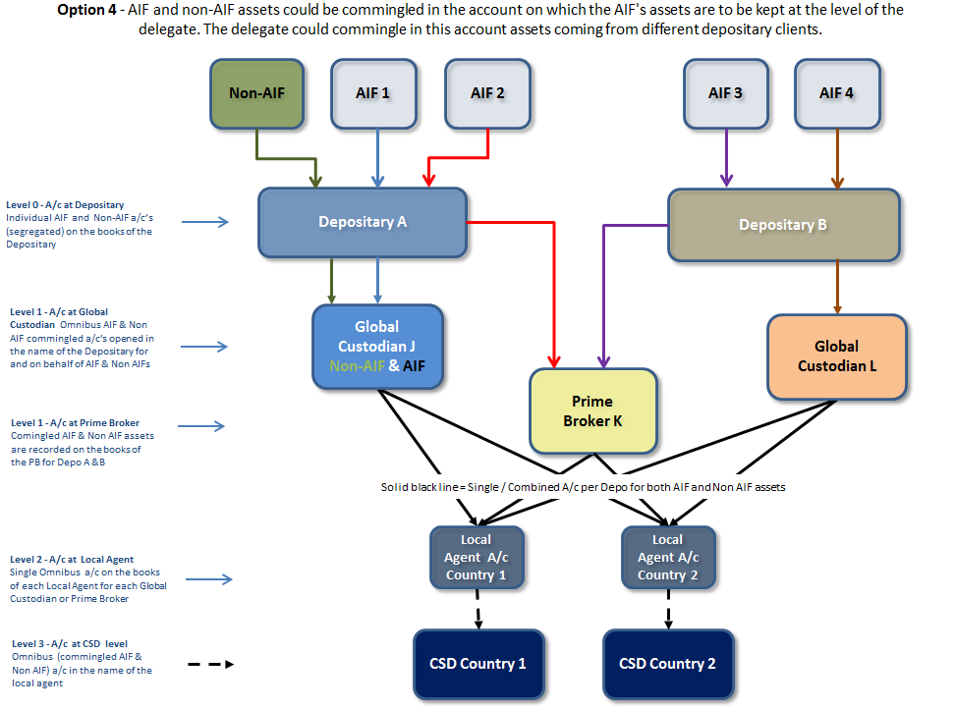

Option 5
Diagrammatic Representation of the Custody Chain (Restated version of Option 5 in the consultation paper)
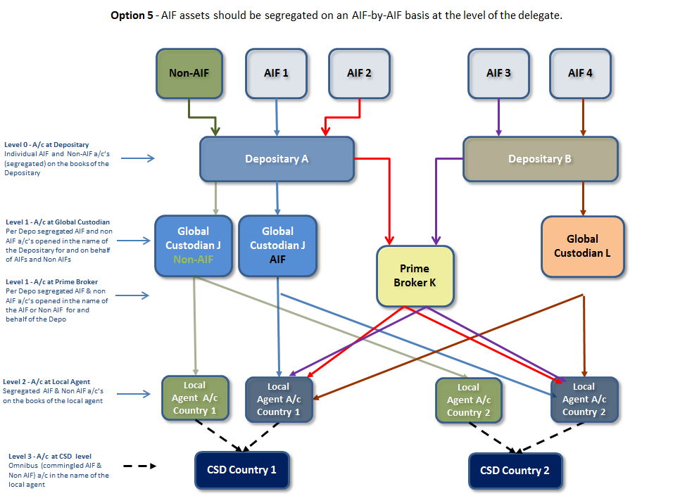

In the delegation model, the depositary appoints a global custodian or prime broker to safeguard and maintain records of financial instruments held by AIFs under a custodial agreement. The global custodian or prime broker appointed by the depositary appoints and maintains the relationship with each of the local custodial agents in the markets where the AIFs invest. The custody of the financial instruments, and therefore the maintenance of the record of financial instruments owned by each AIF is delegated to the global custodian or prime broker by the depositary, as envisaged by Art 89 Par 2 of AIFMR.
The local agent will maintain an omnibus account in the Central Securities Depositary (“CSD”) for that market. Financial instruments of the AIF are normally held in the omnibus account maintained by the local agent at the CSD, comingled with financial instruments belonging to all clients of that local agent. The CSD will arrange for the registration of the AIFs’ financial instruments with the relevant registrar for the financial instrument. Financial instruments are normally registered in the name of the local agent’s account with the CSD.
Each local agent should reconcile the records of financial instruments it maintains on its books for its clients, typically one omnibus account for each global-custodian or prime broker, to the omnibus account it maintains at the CSD where the financial instruments of all its clients are held.
The global custodian or prime broker will in turn maintain a record of financial instruments for each AIF client of the depositary, one account opened in the name of the AIF or AIFM on behalf of the AIF for each AIF client. The global custodian or prime broker will reconcile its records across those AIF accounts to the omnibus account it maintains with the local agent, which account records only those assets of the clients of the global custodian or prime broker, segregated from the proprietary assets of the global custodian or prime broker.
It is our view that segregation of AIF assets from the depositary, its delegates and sub-delegates is currently achieved (and therefore investor protection ensured in the event of a bankruptcy of any party in the custodial chain) through a combination of measures employed throughout the custodial chain, namely:

- the maintenance of records of financial instruments by the depositary (or its appointed global custodian/prime broker) for each AIF that it services, separate from its proprietary assets and from financial instruments it records for all other AIFs and non-AIFs that it services;
- the maintenance of records of financial instruments held by the local agent for each of its clients (including depositaries and global custodians/prime brokers) separate from its own proprietary assets, the proprietary assets of those depositaries, global custodians/prime brokers and from financial instruments it holds for other clients;
- account opening methodologies employed at local CSDs and registration methodologies employed by those CSDs;
- reconciliation practices employed by each party in the custodial chain, to ensure that it has and maintains an accurate record of financial instruments held for its clients as appropriate; and
- oversight and due diligence performed by each party in the custodial chain in respect of the practices employed by its delegates to properly record, segregate and reconcile the financial instruments its delegate holds on its behalf.
We note ESMA's rationale for discarding Options 3 to 5, as follows:
a) Options 3-5 do not seem to be compatible with the provisions of AIFMD and its implementing measures
In considering Options 3 and 4, we note that the Options may not be compatible with the provisions of AIFMD and AIFMR. However, given that Option 4 is reflective of the custodial chain predominantly employed today by global custodians and prime brokers, and the likely costs entailed in changing the model across the industry, we do not agree that these options should be discarded without more detailed analysis and discourse regarding AIFMD and AIFMR requirements as it relates to segregation, both in respect of the prescriptive regulatory requirement and the practical benefits of imposing a need for segregation of AIF assets from non-AIF assets throughout the custodial chain.
The reference that the Options “do not seem” compatible is in our view indicative of ESMA’s recognition of the numerous previous submissions from industry bodies and participants to both ESMA and EU regulators, and specifically that there is lack of clarity in AIFMD and AIFMR text as it relates to segregation requirements imposed on depositaries and their delegates. Indeed, in the first instance, neither AIFMD nor AIFMR provide a definition of “segregation”. It is unclear whether the term means holding assets separately from other assets or having the means to be able to identify and record specific assets as being held for a particular client.
The conclusion that Options 3 and 4 may not seem compatible with the provisions of AIFMD and AIFMR is based solely on the requirement of Art 98(4) of AIFMR, which requires that where a third party (being in this context the direct delegate of the depositary e.g. a global custodian or prime broker) further delegates any of the functions delegated to it (i.e. to a local agent), the conditions and criteria set out in Art 98(1),(2) and (3) shall apply mutatis mutandis”, presumably to the global custodian or prime broker.
Art 98 (3)(b) requires the depositary to ensure that its delegate segregates financial instruments in line with the requirements of Art 99. Art 99 in turn requires that a delegate of the depositary keeps records and accounts as are necessary to enable it at any time and without delay to distinguish assets of the depositary’s AIF clients from its own assets, assets of its other clients, assets held by the depositary for its own account and assets held for clients of the depositary which are not AIFs. The inference that these conditions apply at the local agent level is based solely therefore on the mutatis mutandis provision of Art 98(4).
In order to facilitate consistent implementation of AIFMD and AIFMR requirements across the EU jurisdictions, it is disappointing in respect of drafting, that such an important element of AIFMD requirements can only be concluded through such circuitous interpretation. It calls into question therefore whether AIF/non-AIF segregation at a local agent level was indeed intended.
The interpretation that segregation of AIF assets from non-AIF assets is required has also been called into question by other industry bodies and participants, on the basis that AIFMD Article 21(11)(d)(iii) requires segregation of client and proprietary assets only, and not segregation of AIF from non-AIF assets. (This is supported by references in the UK FCA's Policy Statement 13/5 to omnibus accounts which contain both AIF and non-AIF assets (which applies to prime brokers located in the United Kingdom).
Level 2 Article 99(1)(a) directs the depositary to ensure that its delegate "keeps such records and accounts as are necessary to enable it at any time and without delay to distinguish assets of the depositary's AIF clients from its own assets, assets of its other clients, assets held by the depositary for its own account and assets held for clients of the depositary which are not AIFs."
Level 2 does not expressly state that the delegate must hold AIF assets in a segregated account. The words "segregates" and "segregation" are used in this respect only in, and when referring to, the AIFMD text at Article 21(11)(d)(iii), and not in relation to the Level 2 obligations. Recital 40 of AIFMD expressly refers to the omnibus accounts and contemplates a common segregated account for multiple AIFs (not per depositary). It does not contemplate such accounts as being exclusively for AIFs.
The key requirement is to be able to distinguish the relevant assets, which can be carried out on a books and records basis without segregated accounts. It suggests that this terminology was carefully chosen to avoid imposing any additional segregation requirements on top of the AIFMD requirement set out in AIFMD Article 21(8)(a)(ii).
It is also argued that the text in Level 2, Article 99(1)(a) tracks the text in the UK’s CASS 6.5.1 to which prime brokers (located in the UK) are directly subject and which they satisfy by maintaining appropriate books and records and therefore the requirements of Level 2 should be complied with in the same way.
In respect of Option 5 we agree with ESMA’s view that Option 5 should be discarded, but only as it relates to record keeping employed by the local agent at the local country agent level of the custodial chain outlined in Options 1 and 2 above. It is always the case that, either at the global custodian or prime broker level, records should be maintained in a manner that enable a depositary to distinguish a particular AIF’s assets from all other AIF and non-AIF assets (i.e. records are maintained in this level of the custodial chain at an AIF by AIF level).

b) Options 3 and 4 are sub-optimal as they would have a provided a clearly lower level of investor protection given they would have allowed a higher level of commingling of assets of AIFs which might frustrate the recovery of assets in the event of a bankruptcy of a depositary or sub-depositary.
We refer to our comments above in respect of the simplicity of the Options provided in the consultation paper and the custodial models employed in practice as set out in in our diagrammatic responsentations. From a practical perspective, there is no evidence to suggest that Options 3 and 4 lower the level of investor protection or might frustrate the recovery of assets in the event of a bankruptcy of a depositary or sub-depositary assuming:

- the depositary and/or its appointed global custodian maintain a record of financial instruments it holds for each AIF that it services; and
- the local agent holds the assets in account separate from its own proprietary assets and the proprietary assets of each party in the custodial chain.
We note ESMA’s rationale for discarding Option 5, namely on the basis that there is marginal benefit to an individual AIF level of segregation in terms of the expeditious return of assets in the event of the bankruptcy of a depositary or sub-depositary when viewed against the cost of such a level of segregation. We believe the same logic should be applied in respect of Options 3 and 4, namely that there is marginal benefit to segregating AIF assets from other client assets, in terms of the expeditious return of assets in the event of a bankruptcy of a depositary or sub-depositary when viewed against the cost of such level of segregation. Whether or not an asset is returned and the speed at which it is returned is dependent on a number of factors, first and foremost that the asset is held and recorded through the custodial chain for the benefit of the clients of the depositary and its delegates and can be easily identified from their combined set of records as belonging to a particular client, as is the case currently in Option 4.
In addition, one must have regard for local insolvency law in the jurisdiction of the depositary, its delegates or sub-delegates. We refer again to the recent IOSCO consultation on Principles regarding the Custody of Collective Investment Schemes’ Assets, and specifically their question as to whether the requirement of proper segregation be combined with an additional requirement of the recognition of the segregation at custodian or sub-custodian level in the event of the insolvency of the custodian or sub-custodian.
We expressed the view that, although the mandating of segregation of the depositary’s proprietary assets from those of its clients throughout the custody chain will help to ensure the protection of CIS client assets, this will not necessarily guarantee the exclusion of such assets from the liquidation estate of an insolvent custodian. We also welcomed any global initiative that might be undertaken by IOSCO to influence local laws to recognise that CIS client assets cannot be included in the liquidation estate of an insolvent custodian nor used to satisfy the claims of the custodian’s creditors where it is clear that records collectively in the custodial chain identify those assets as belonging to clients of the depositary.

c) Option 5 was discarded, as a marginal benefit of the additional level of segregation (compared to Options 1 and 2) in terms of the expeditious return of assets in the event of the bankruptcy of a depositary or sub-depositary does not seem likely to exceed the marginal cost of this level of segregation.
As noted above, we agree with ESMA’s view that Option 5 should be discarded, but only as it relates to record keeping employed by the Local Agent at the Local Country Agent level of the custodial. It is always the case that, either at the global custodian/prime broker level or depositary level (where no delegation takes place) records should be maintained in a manner that enable a depositary to distinguish a particular AIF’s assets from all other AIF and non-AIF assets (i.e. records are maintained in this level of the custodial chain at an AIF by AIF level).
<ESMA_QUESTION_G_AIFMD_5>

