1 December 2014

Reply form for the
Guidelines on asset segregation under the AIFMD
Response submitted by DACSI (The Netherlands)

Date: 1 December 2014
Responding to this paper
The European Securities and Markets Authority (ESMA) invites responses to the specific questions listed in the ESMA Consultation Paper - Guidelines on asset segregation under the AIFMD, published on the ESMA website.
Instructions
Please note that, in order to facilitate the analysis of the large number of responses expected, you are requested to use this file to send your response to ESMA so as to allow us to process it properly. Therefore, please follow the instructions described below:
- use this form and send your responses in Word format;
- do not remove the tags of type <ESMA_QUESTION_G_AIFMD_1> - i.e. the response to one question has to be framed by the 2 tags corresponding to the question; and
- if you do not have a response to a question, do not delete it and leave the text “TYPE YOUR TEXT HERE” between the tags.
Responses are most helpful:
- if they respond to the question stated;
- contain a clear rationale, including on any related costs and benefits; and
- describe any alternatives that ESMA should consider
Naming protocol:
In order to facilitate the handling of stakeholders responses please save your document using the following format:
ESMA_CE_G_AIFMD _NAMEOFCOMPANY_NAMEOFDOCUMENT.
E.g. if the respondent were ESMA, the name of the reply form would be ESMA_CE_G_AIFMD _AIXX_REPLYFORM or ESMA_CE_G_AIFMD_AIXX_ANNEX1
Responses must reach us by 30 January 2015.
All contributions should be submitted online at www.esma.europa.eu under the heading ‘Your input/Consultations’.
Publication of responses
All contributions received will be published following the end of the consultation period, unless otherwise requested. Please clearly indicate by ticking the appropriate checkbox in the website submission form if you do not wish your contribution to be publicly disclosed. A standard confidentiality statement in an email message will not be treated as a request for non-disclosure. Note also that a confidential response may be requested from us in accordance with ESMA’s rules on access to documents. We may consult you if we receive such a request. Any decision we make is reviewable by ESMA’s Board of Appeal and the European Ombudsman.
Data protection
Information on data protection can be found at www.esma.europa.eu under the heading ‘Disclaimer’.

Which of the two identified options do you prefer?

<ESMA_QUESTION_G_AIFMD_1>
The Dutch Advisory Committee Securities Industry (DACSI) has a strong preference for option 2: option 1 would add substantially to the operational risks and costs without contributing to the protection of AIF assets against insolvency of any party in the custody chain. We will explain this below.
DACSI welcomes ESMA’s objective to develop guidelines on the AIFMD asset segregation requirements with the aim to ensure uniform and consistent application of the rules by the AIFMs (who are ultimately responsible for the compliance with the AIFMD rules, as stated out by the ESMA consultation paper) and the depositaries.
Divergent interpretations of AIFMD requirements for the segregation of assets are the cause for an un-level playing field among depositaries. As a result a depositary compliant with the segregation requirements is disadvantaged as it is not selected by an AIF which appoints a prime broker or a collateral manager not compliant with the AIFM requirements. Therefore a prompt publication and implementation of ESMA guidelines is needed in order to ensure a harmonized implementation and a level-playing field for market players. In addition, DACSI expects the guidelines to be explicit and to be enforced consistently to AIFs and to UCITS, in the frame of the UCITS V Directive.
For the sake of clarity, we summarise our understanding of (the contrast between) options 1 and 2 starting with a picture:
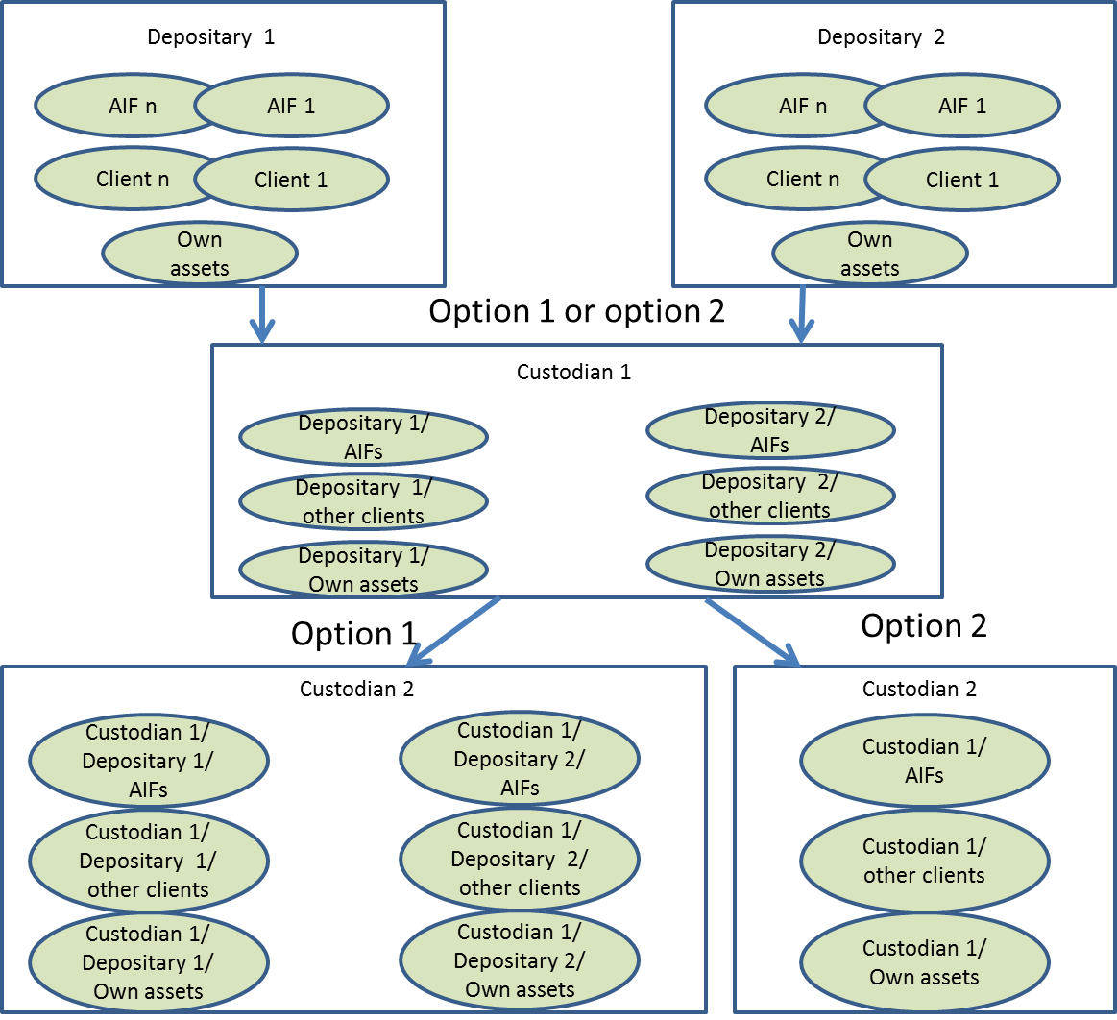
Options 1 and 2 lead to the same operational and legal outcome at the first level of delegation in the custody chain. Indeed article 21(11)(d)(iii) of the AIFMD requires that “the third party segregates the assets of the depositary’s clients from its own assets and from the assets of the depositary in such a way that they can at any time be clearly identified as belonging to clients of a particular depositary.”
Consequently, where several AIF depositaries delegate the custody of assets to the same custodian (custodian1), custodian 1 is not allowed to co-mingle assets entrusted by those depositaries in a same account, even under option 2.
Option 1 and option 2 both require the delegate (custodian 1) to record the assets in at least 3 different accounts for each depositary: 1. to record the AIFs’ assets, 2. to record other clients’ assets and 3. to record the depositary’s own assets;
The consequences of the 2 different set-ups (option 1 versus option 2) materialise at the second (and, should the case occur, subsequent further) level(s) in the custody chain:
- option 1 requires that custodian 2 - as delegate of custodian 1 - segregates the assets of each delegator (i.e. depositary), in at least 3 different accounts:
  - to record AIFs’ assets,
  - to record other clients’ assets, and
  - to record depositary 1’ s own assets;
- option 2 requires custodian 2 to record the assets entrusted by custodian 1 in 3 different accounts: one to record AIFs’ assets, other clients’ assets and another one to record custodian 1’ s own assets.

Provided that the proper legal protection is applicable to the segregation arrangements, options 1 and 2 are equivalent, as AIFs are in all circumstances identified and ring-fenced from the depositary’s and its delegates’ own assets.
The operational cost of being compliant with option 1 would be significantly higher than those for option 2 as it would require a higher degree of segregation of accounts at the second level of the custody chain and beyond.
Meanwhile, there is no additional value of option 1 compared to option 2 in terms of asset protection. Indeed DACSI considers that segregation should be viewed as a (useful) tool but it should be understood that segregation per se does not suffice to achieve the ultimate objective of legal protection of the assets in custody. Indeed, legal protection for assets in custody against insolvency is subject to the existence of a clear and unchallengeable legal environment in the location where the assets are held in custody.
On the other hand, implementing option 1 would increase the operational risk: when in a case of a custodian’s default a multitude of accounts is to be separated (and ported) - in contrast to a limited number of omnibus accounts -, the possibilities of operational mistakes with material effects are proportionately higher.
This is the reason why we prefer option 2, which is compatible with the provisions of AIFMD and its implementing measures.
<ESMA_QUESTION_G_AIFMD_1>

Would you suggest any alternative option which is compatible with the AIFMD and its implementing measures? If yes, please provide details.

<ESMA_QUESTION_G_AIFMD_2>
In our view there is no other relevant option that would be compliant with the level 1 text and the level 2 text of AIFMD on the segregation of AIFs’ assets from other assets all along the custody chain.
<ESMA_QUESTION_G_AIFMD_2>

Do you have knowledge of the impact that each of the two options identified would have on your business in terms of restructuring of existing delegation arrangements in Europe and third countries? Please quantify the one-off and ongoing costs as well as the type of costs for each of the two options or any alternative option that you may prefer.

<ESMA_QUESTION_G_AIFMD_3>
The account structure required by option 2 is already practice in many markets, including ours. Hence, there are no implementation costs for option 2.
Option 1 would require that existing delegation arrangements are amended and that a multitude of securities accounts is opened and maintained.
<ESMA_QUESTION_G_AIFMD_3>

Do you see merit in foreseeing a specific treatment for certain types of arrangement (e.g. collateral management arrangements)? If yes, please specify how your proposal would ensure compliance with the relevant requirements of the AIFMD and Level 2 Regulation.

<ESMA_QUESTION_G_AIFMD_4>
No, we do not see arguments to create exceptions for certain types of arrangements.
Compliance with AIFMD requirements is expected from all depositories and their delegates, all along the custody chain. In particular, all parties, including prime brokers, collateral managers, global custodians and CSDs/ICSDs when not acting in the capacity of Notary (Issuer CSD) should comply with the same segregation arrangements.
The segregation of the assets, all along the custody chain, between assets belonging to AIFs and assets belonging to other customers allows:
- to check that the specific rules, to which they are subject, are actually applied in accordance with the detailed requirements of AIFMD level 2 text,
- the liquidator of a custodian to quickly identify these assets as belonging to alternative collective investment funds and to authorize their return more quickly, in case of bankruptcy of this custodian.
In order to implement this segregation, the review of operating models can actually be done in different ways and has been implemented by some players.
There is no need to reduce the protection of AIF’s assets and to put at risk the level playing field between players.
Therefore, no delegation for custody can be licit under AIFMD if the segregation arrangements are not in place.
<ESMA_QUESTION_G_AIFMD_4>

Do you agree with ESMA’s approach to discarding the third, fourth and fifth options described in Section 5 of the CBA? If not please provide data and information that support your view.

<ESMA_QUESTION_G_AIFMD_5>
DACSI understands that ESMA discard options 3 and 4 as they are incompatible with AIFMD requirements with regard to segregation of assets as stated below:
- The AIFMD Directive, article 21(8)(11)(iii), requires that "the third party segregates the assets of the depositary’s clients from its own assets and from the assets of the depositary in such a way that they can at any time be clearly identified as belonging to clients of a particular depositary".
- Then this requirement is detailed in the Level 2 text (article 99) “the third party keeps such records and accounts as are necessary to enable it at any time and without delay to distinguish assets of the depositary’s AIF clients from its own assets, assets of its other clients, assets held by the depositary for its own account and assets held for clients of the depositary which are not AIFs".
- Then article 21(11) AIFMD concludes: "The third party may, in turn, sub-delegate those functions, subject to the same requirements”.
We also agree with the ESMA approach to discard option 5 as a preferred solution due to the costs for both the regulator and the firms which would be ultimately borne by the investors, however, the option should remain available to market participants. Indeed DACSI considers that the segregation should be viewed as a (useful) tool but it should be understood that segregation per se does not suffice to achieve the ultimate objective of legal protection of the assets in custody. Indeed, legal protection for assets in custody against insolvency is subject to the existence of a clear and unchallengeable legal environment in the location where the assets are held in custody.
<ESMA_QUESTION_G_AIFMD_5>

