1 December 2014

Reply form for the
Guidelines on asset segregation under the AIFMD

Responding to this paper
Date: 1 December 2014
The European Securities and Markets Authority (ESMA) invites responses to the specific questions listed in the ESMA Consultation Paper - Guidelines on asset segregation under the AIFMD, published on the ESMA website.
Instructions
Please note that, in order to facilitate the analysis of the large number of responses expected, you are requested to use this file to send your response to ESMA so as to allow us to process it properly. Therefore, please follow the instructions described below:
- use this form and send your responses in Word format;
- do not remove the tags of type <ESMA_QUESTION_G_AIFMD_1> - i.e. the response to one question has to be framed by the 2 tags corresponding to the question; and
- if you do not have a response to a question, do not delete it and leave the text “TYPE YOUR TEXT HERE” between the tags.
Responses are most helpful:
- if they respond to the question stated;
- contain a clear rationale, including on any related costs and benefits; and
- describe any alternatives that ESMA should consider
Naming protocol:
In order to facilitate the handling of stakeholders responses please save your document using the following format:
ESMA_CE_G_AIFMD _NAMEOFCOMPANY_NAMEOFDOCUMENT.
E.g. if the respondent were ESMA, the name of the reply form would be ESMA_CE_G_AIFMD _AIXX_REPLYFORM or ESMA_CE_G_AIFMD_AIXX_ANNEX1
Responses must reach us by 30 January 2015.
All contributions should be submitted online at www.esma.europa.eu under the heading ‘Your input/Consultations’.
Publication of responses
All contributions received will be published following the end of the consultation period, unless otherwise requested. Please clearly indicate by ticking the appropriate checkbox in the website submission form if you do not wish your contribution to be publicly disclosed. A standard confidentiality statement in an email message will not be treated as a request for non-disclosure. Note also that a confidential response may be requested from us in accordance with ESMA’s rules on access to documents. We may consult you if we receive such a request. Any decision we make is reviewable by ESMA’s Board of Appeal and the European Ombudsman.
Data protection
Information on data protection can be found at www.esma.europa.eu under the heading ‘Disclaimer’.

Which of the two identified options do you prefer?

<ESMA_QUESTION_G_AIFMD_1>

Introduction – Preliminary remarks

ALFI welcomes the opportunity to respond to the European Securities and Markets Authority’s (“ESMA”) consultation paper setting out proposals for possible guidelines regarding the asset segregation requirements in the case of delegation of safe-keeping duties by the appointed depositary of an AIF.

A depositary has an obligation to comply with the asset segregation and delegation rules set out in AIFMD and AIFM-CDR. AIFMs, depositaries and national competent authorities have experienced some issues on the interpretation and proper application of these rules. Consequently, we support guidelines which will promote common interpretation across Europe as well as the consistent application of the provisions of the Directive and its implementing measures.

Segregation between a depositary’s proprietary assets and its customer’s assets by way of separate accounts as well as at the levels below between delegate’s proprietary assets, depositary’s proprietary assets and customer assets is generally regarded as an efficient way of protecting the customer’s assets against depositary and/or delegate insolvency. This can be effectively achieved by using segregated accounts and/or omnibus structures which are commonly recognised as an effective method of protecting end investor’s interests.

Segregation that goes beyond the separation between proprietary assets and customer assets does not necessarily provide better protection of investor’s assets. In case of e.g. an insolvency of a sub-custodian, the depositary will seek to retrieve all assets in an omnibus account by way of one instruction as opposed to the need of sending a multitude of instructions (which may create associated risk) to retrieve assets from a multitude of accounts.

Segregation between AIF and non-AIF assets by way of separate accounts does not provide greater protection of investor’s assets, rather such level of segregation requires the set-up and maintenance of multiple accounts with associated costly controls and reconciliation risks. In any event, the segregation provisions under the AIFMD and AIFM-CDR require a delegate of the depositary to safe-keep financial instruments by registering them in an account in the delegate’s books and records and to hold them separately from any accounts holding the proprietary assets of the delegate or the depositary. The segregation between AIF and non-AIF assets at the level of the delegate would in no way strengthen the protection of AIF assets, nor contribute to more transparency in the intermediated holding chain nor accelerate the recovery process in case of insolvency of any of the parties.
We believe that there is no requirement to segregate AIF assets from non-AIF assets. AIFMD Article 21(11)(d)(iii) would seem to require segregation of customer and proprietary assets only. As a result article 99 (1) to (3) of the AIFM-CDR cannot be interpreted as imposing a segregation duty at the level of the delegate that would go beyond the scope set under the level 1 AIFMD text, between AIFs and non-AIFs assets of the depositary. It is rather an obligation similar to the record keeping obligation set forth under Article 16 (1) (a) of the Commission Directive 2006/73/EC related to the implementation measures of MiFID (“CD-MiFID”) which requires the third party to segregate the assets of the depositary’s customers from its proprietary assets and from the proprietary assets of the depositary in such a way that they can at any time be clearly identified as belonging to customers of a particular depositary. As explained by IOSCO, when omnibus accounts are used "the segregation of assets among different clients generally occurs operationally, through IT systems and books and records, rather than through the use of separate individual customer accounts". Article 99 (1) to (3) should not be seen as imposing further segregation methods.

For the reasons further explained under Q5, we believe that the commingling of AIF and non-AIF assets in the same account would not lead to cross-contamination risk in the event of bankruptcy of the delegate, or of other customers of the delegate and hence would not jeopardize the stated policy objective. Therefore, consideration should be given to, at least, commingle assets that are collectively managed, such as assets of AIF, UCITS or any other regulated fund.

In any case segregation of assets is only one part of the protective measures the depositary and the delegates have to undertake. Furthermore, the depositary and its delegates maintain robust processes, procedures and associated controls to:
- distinguish all records of AIF’s financial instruments;
- monitor the settlement cycle of the financial instruments related transactions;
- reconcile on a periodical basis the assets held by the delegate to the depositary’s books of records maintained for the AIF’s assets and due diligence control that an effective reconciliation process is in place across the custody chain;
- minimise the risk of loss of financial instruments and assess the custody risks throughout the custody chain;
- exercise due care in relation to the financial instruments to ensure a high standard of investor protection.

Regarding segregation at delegate level between various depositaries, consideration should be given in any case to assess this with respect to group level and not legal entity level. The assessment at legal entity level would lead to over-fragmentation whereas assessment at group level permits to properly take group competence centers (i.e. the provision and sharing of certain functions at a group level) into account as well as the need for group harmonised contracts with delegates. A “group” for this purposes can be defined as a group for the purposes of consolidated accounts, as defined under Directive 2013/34/EU or in accordance with recognized international accounting rules.

Q1: Which of the two identified options do you prefer?

Neither option 1 nor option 2 addresses the core issue which is the account structure requirements beneath the level of the depositary, i.e. the delegate appointed by the depositary and sub-delegate appointed by the delegate. The AIFMD requires segregation of customer and proprietary assets only. Article 99(1)(a) of the AIFM-CDR requires the depositary “to ensure that its delegate keeps such records and accounts as are necessary to enable it at any time and without delay to distinguish assets of the depositary’s AIF clients from its own assets, assets of its other clients, assets held by the depositary for its own accounts and assets held for clients of the depositary which are not AIFs.”

Although we recognize the importance of being in a position to identify at all times an AIF’s ownership interest in financial instruments that are maintained by its account provider, we strongly recommend an option that does not impose excessive separation of “AIF” from “non-AIF” accounts at the level of delegates and sub-delegates. Rather, segregation requirements should be focused on the protection of customer assets from events affecting the depositaries and the delegates own assets throughout the custody chain. A differentiated level of segregation according to the status of the third party as delegate (Level 1) or as sub-delegate (Level 2) makes much sense and provides efficient protection.

Accordingly, the depositary should ensure that 1) delegates maintain segregation of assets between the “proprietary assets” of these delegates, “proprietary assets” of the depositary, the AIFs and non-AIFs assets of the depositary and the assets of other customers of the depositary which are not AIFs and non-AIFs assets and 2) sub-delegates maintain segregation between its proprietary assets and customer assets.

Where in any particular market, account structures outlined in option 1 or option 2 are not supported for operational or other regulatory reasons, the depositary may not be in a position to provide safekeeping services to AIFMs in this market.

Provided that the above recommendation of differentiated account structures is considered, we lean towards option 2 that would thereby limit the number of accounts at the level of delegates.

<ESMA_QUESTION_G_AIFMD_1>

Would you suggest any alternative option which is compatible with the AIFMD and its implementing measures? If yes, please provide details.

<ESMA_QUESTION_G_AIFMD_2>

Option 2, if amended by the recommendation set out in our answer to Q1, is in our view compatible with the AIFMD. The depositary (so called “Level 0”) segregates / maintains records of each AIFs’ accounts in its books. Then the depositary must ensure that its delegate, at the first level of the custody chain (so called “Level 1”), segregates the AIFs and non-AIFs assets of the depositary’s customers from its proprietary assets and from the depositary’s proprietary assets and assets of the depositary’s customers other than AIF and non-AIF. Finally, at the level of the sub-delegate (so called “Level 2”) of the custody chain and below, the segregation of assets must be done between the “proprietary assets” of the sub-delegate, the “proprietary assets” of the delegate, the sub-delegate customer assets including assets of AIF and non-AIFs and the assets of other customers.

This amended option 2 provides for the required level of investor protection as it ensures a high level of segregation at the level of the depositary but also at the level of its delegate(s) and below. The use of omnibus accounts at Level 1 allows a higher on-going degree of control by the depositary and a quicker recovery in events such as bankruptcy.

As indicated in the introduction, the depositary and its delegate maintain adequate processes, procedures and due diligence controls over the reconciliation across the custody chain. The depositary maintains the record of financial instruments for each of its AIF clients. The financial instruments recorded at the level of the depositary for each account of AIFs and non-AIFs are reconciled by the depositary to the financial instruments held in an omnibus account of the depositary with each delegate.

The chart below illustrates the level of segregation described above:

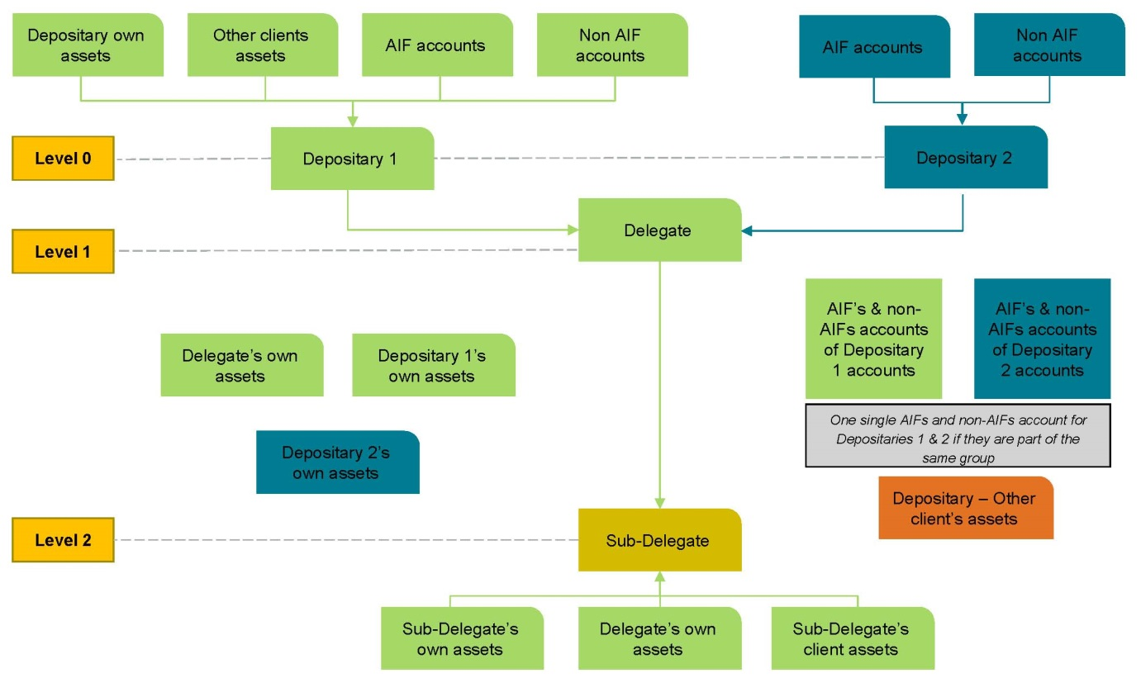

<ESMA_QUESTION_G_AIFMD_2>

Do you have knowledge of the impact that each of the two options identified would have on your business in terms of restructuring of existing delegation arrangements in Europe and third countries? Please quantify the one-off and ongoing costs as well as the type of costs for each of the two options or any alternative option that you may prefer.

<ESMA_QUESTION_G_AIFMD_3>

The multiplication of accounts at the different levels of the custody chain will inevitably result in significant additional costs in terms of infrastructure and operational costs, increased reconciliation costs, increased follow up required on un-reconciled items and associated resolution measures. Ultimately, the cost will be passed on to the investors.

As proposed under Q2, the costs to implement and maintain the alternative option will be less significant than the cost that would potentially be incurred under the two proposed options.

This being said, the focus should not be on increased costs per se but the focus must be whether stricter segregation rules and the additional costs are likely to enhance investor protection. The use of omnibus accounts which are not split according to AIF and non-AIF client assets reduces operational and structural complexity and thereby not only reduces costs but and more importantly the risk of operational error. In order to preserve legal and operational certainty, reduce risk of error and maintain cost and operational efficiency, we support an approach that does not impose excessive separation of AIF from non-AIF accounts at the level of sub-delegates.

<ESMA_QUESTION_G_AIFMD_3>

Do you see merit in foreseeing a specific treatment for certain types of arrangement (e.g. collateral management arrangements)? If yes, please specify how your proposal would ensure compliance with the relevant requirements of the AIFMD and Level 2 Regulation.

<ESMA_QUESTION_G_AIFMD_4>

Sensible segregation rules that do not require segregation of assets belonging to AIFs and assets belonging to non-AIFs at the level of the delegate (and thus prime broker / collateral manager and their delegates), as specified under Q2, would obviate the need for a specific treatment for certain types of arrangement, thus permitting a uniform regime. This is preferable to an approach that would provide for an exceptional regime for certain type of situations.

With respect to AIFs’ financial instruments that are held in custody by a third party appointed by the AIFM (prime broker, collateral safekeeping agent), the depositary should be able to rely on the books and records of third parties (e.g. prime broker, collateral manager...) so to meet its obligations in terms of safekeeping. This should be possible under the conditions that the depositary has daily access to the records maintained by the third party and performs a due diligence on the third-party.

<ESMA_QUESTION_G_AIFMD_4>

Do you agree with ESMA’s approach to discarding the third, fourth and fifth options described in Section 5 of the CBA? If not please provide data and information that support your view.

<ESMA_QUESTION_G_AIFMD_5>

We refer to our explanations above. We agree with ESMA’s decision to discard Option 5. Options 3 and 4 may merit consideration. Indeed our suggested solution is a hybrid solution, combining the possibility to commingle AIF and non-AIF assets at the delegate level (Level 1) and which allows to commingle assets from different depositaries which belong to the same group. Whereas at Level 2 the segregation of assets should be done between the “proprietary assets” of the sub-delegate, the “proprietary assets” of the delegate, the sub-delegate’s customers assets including assets of AIF and non-AIFs and the assets of other customers (as described in Q2).

The objective of this solution is to provide a high level of investor protection, where excessive segregation is rather likely to increase risk instead of reducing it.
In particular, we believe that the best protection against cross-contamination risk is achieved by segregating depositary client assets from other depositary client pools at Level 1, rather than by segregating AIF from non AIF assets.

<ESMA_QUESTION_G_AIFMD_5>

Principles regarding the Custody of Collective Investment Schemes Assets, Consultation Report, 48, p. 10.
AIF and non-AIF assets means assets that are collectively managed. Assets of the third party custodian/sub-custodian or those of other clients not collectively managed are excluded.

