1 December 2014

Reply form for the
Guidelines on asset segregation under the AIFMD

Responding to this paper
Date: 1 December 2014
The European Securities and Markets Authority (ESMA) invites responses to the specific questions listed in the ESMA Consultation Paper - Guidelines on asset segregation under the AIFMD, published on the ESMA website.
Instructions
Please note that, in order to facilitate the analysis of the large number of responses expected, you are requested to use this file to send your response to ESMA so as to allow us to process it properly. Therefore, please follow the instructions described below:
- use this form and send your responses in Word format;
- do not remove the tags of type <ESMA_QUESTION_G_AIFMD_1> - i.e. the response to one question has to be framed by the 2 tags corresponding to the question; and
- if you do not have a response to a question, do not delete it and leave the text “TYPE YOUR TEXT HERE” between the tags.
Responses are most helpful:
- if they respond to the question stated;
- contain a clear rationale, including on any related costs and benefits; and
- describe any alternatives that ESMA should consider
Naming protocol:
In order to facilitate the handling of stakeholders responses please save your document using the following format:
ESMA_CE_G_AIFMD _NAMEOFCOMPANY_NAMEOFDOCUMENT.
E.g. if the respondent were ESMA, the name of the reply form would be ESMA_CE_G_AIFMD _AIXX_REPLYFORM or ESMA_CE_G_AIFMD_AIXX_ANNEX1
Responses must reach us by 30 January 2015.
All contributions should be submitted online at www.esma.europa.eu under the heading ‘Your input/Consultations’.
Publication of responses
All contributions received will be published following the end of the consultation period, unless otherwise requested. Please clearly indicate by ticking the appropriate checkbox in the website submission form if you do not wish your contribution to be publicly disclosed. A standard confidentiality statement in an email message will not be treated as a request for non-disclosure. Note also that a confidential response may be requested from us in accordance with ESMA’s rules on access to documents. We may consult you if we receive such a request. Any decision we make is reviewable by ESMA’s Board of Appeal and the European Ombudsman.
Data protection
Information on data protection can be found at www.esma.europa.eu under the heading ‘Disclaimer’.

Which of the two identified options do you prefer?

<ESMA_QUESTION_G_AIFMD_1>
The Association for Financial Markets in Europe (AFME) welcomes the opportunity to comment on the ESMA consultation paper entitled “Guidelines on asset segregation under the AIFMD”. AFME represents a broad array of European and global participants in the wholesale financial markets. Its members comprise pan-EU and global banks as well as key regional banks, brokers, law firms, investors and other financial market participants. We advocate stable, competitive, sustainable European financial markets that support economic growth and benefit society.
AFME is the European member of the Global Financial Markets Association (GFMA) a global alliance with the Securities Industry and Financial Markets Association (SIFMA) in the US, and the Asia Securities Industry and Financial Markets Association (ASIFMA) in Asia.

AFME is listed on the EU Register of Interest Representatives, registration number 65110063986-76.

Overview
Having examined each of the options proposed by ESMA and being mindful of the key policy objectives embodied in the Directive and Regulation, we would like to share some analysis with you that indicates the following:

- Options 1 and 2 are not the only options cited in the consultation paper that would satisfy the asset segregation requirements under the Directive and Regulation. Option 4, which represents current best practice among prime brokers and custodians servicing AIFs, is also compatible with such requirements.

- Neither option 1 nor 2 would provide a greater level of investor asset protection than option 4 with respect to ensuring that the assets of the AIF are protected from negative events (such as bankruptcy) which may affect a third party to whom safekeeping of assets has been delegated.

- There are a number of substantial concerns with the resulting operating models advocated by options 1 and 2 that would be avoided were market participants to continue to act in accordance with option 4.

Accordingly, as set out more fully in our responses to questions 2 and 3, AFME supports option 4 and would recommend that ESMA clarify that asset segregation as contemplated under option 4 satisfies the relevant requirements. As regards options 1 and 2, we would note that the substantial concerns highlighted above are particularly acute in respect of option 1 and therefore, while we do not support either option 1 or 2, we would expect option 2 to have less of a damaging impact on the market.

Summary of legal basis on which option 4 is permitted by the relevant requirements

AFME Position | Explanation
Requirements to be able to “identify” and “distinguish” AIF assets under Article 21(11)(d)(iii) of AIFMD and Article 99(1)(a) of the Regulation do not mandate the use of accounts comprising only AIF assets | The “segregation obligation” that the consultation paper deals with is set out in the first part of Article 21(11)(d)(iii) of AIFMD: the depositary must ensure that any delegate custodian “segregates the assets of the depositary’s clients from its own assets and from the assets of the depositary”.  The remaining part of Article 21(11)(d)(iii) elaborates on the purpose of the aforementioned segregation requirement: to ensure that the assets of a depositary’s clients “can at any time be clearly identified as belonging to clients of a particular depositary”.  Similarly, Article 99(1)(a) deals primarily with what must be achieved in order to fulfil the segregation obligation under Article 21(11)(d)(iii). It provides that the segregation requirements of Article 21(11)(d)(iii) are satisfied if the records and accounts of the delegate custodian enable it to “distinguish” assets of the depositary’s AIF clients from its own assets, assets of its other clients, assets of the depositary held for its own account and assets of the depositary’s non-AIF clients.  It is not necessary to maintain accounts comprising only AIF assets to be able to satisfy the requirements to “identify” and “distinguish” AIF assets (so-called “full physical segregation”). These requirements can be satisfied through “records and accounts”, as specifically envisioned under Article 99(1)(a)1. As explained in more detail below, the prime broker maintains an individual account for each AIF on its books and records which, as a matter of fact, enables any AIF’s assets at any time to be immediately identified and distinguished in the required manner.  We would therefore suggest, contrary to paragraph 16 on page 8 of the consultation paper, that it is not accurate to state that the requirement under Article 99(1)(a) “means that the account where the AIF’s assets are to be kept at the level of the delegated third party can only comprise assets of the AIF” (i.e. full physical segregation). Neither Article 21(11)(d)(iii) nor Article 99(1) impose a requirement for full physical segregation of AIF assets. We believe that if a full physical segregation were intended, the rules would have made this clear.
The requirements under Article 21(11)(d)(iii) of AIFMD and Article 99(1)(a) of the Regulation can be satisfied by recordkeeping | Under current best practice, prime brokers maintain individual accounts for each client on their books and records. These accounts enable them at any time to immediately “identify” and “distinguish” any AIF’s assets, thereby satisfying the requirements.
The “mutatis mutandis” application of Article 99(1)(a) to a further delegate does not require a replication of the prime broker’s books and records at the delegate level. | Article 99(1)(a) refers to “such records and accounts as are necessary” to distinguish AIF assets. It is not necessary for the third party delegate to maintain a duplicative set of books and records, provided AIF assets are segregated from its proprietary assets and the proprietary assets of prime broker. Any doubt as to a particular AIF’s entitlement to assets can be resolved by reference to the prime brokers books and records. The mutatis mutandis application of the provision permits ESMA to read it in this manner.
Option 4 is consistent with MiFiD | Option 4 is consistent with the position of the Commission regarding the equivalent segregation requirements under MiFiD expressed in the impact assessment accompanying the AIFMD Level 2 Regulation. We do not believe that option 1 or option 2 are necessary to comply with the requirements of MiFiD.  Under MiFiD Article 16(1)(d), which is equivalent to AIFMD Level 2 Regulation Article 99(1), member states must require that investment firms take the necessary steps to ensure that client assets deposited with third parties are identifiable separately from financial instruments belonging to the investment firm and those belonging to that third party, by means of differently titled accounts on the books of the third party or other equivalent measures that achieve the same level of investor asset protection.  Therefore, it is clear that the MiFID segregation requirements (1) can be satisfied through segregation on books and records (full, physical segregation is not necessary) and that they (ii) only apply at the level of the delegate, requiring segregation between the assets of the investment firm and its clients. The segregation of the firm’s assets from its clients’ assets is necessary (in some jurisdictions) to ensure that the identified account or pool of client assets is not subject to the claims of the investment firm’s creditors, but no such principle requires segregation by client or asset type, and there is no requirement for higher tier account providers (i.e. sub-delegates) to replicate that structure throughout the custody chain.

Summary of Concerns with Options 1 and 2

AFME Concern | Explanation
Options 1 and 2 would not achieve a higher level of investor asset protection to existing general client omnibus accounts and would increase existing custodial risks | Compliance with option 1 or option 2 would require (particularly in relation to option 1) delegates holding client assets to create and maintain a significant number of additional client omnibus accounts. These additional client omnibus accounts would not deliver a higher level of investor asset protection to existing general client omnibus accounts. Options 1 and 2 mandate more omnibus accounts, but do not achieve a higher degree of segregation as would be the case with, say, an individually segregated account. They would also produce high levels of complexity, increase the probability of errors and settlement failures, reduce efficiency and significantly increase costs to both prime brokers, sub-custodians and, ultimately AIFs. Please see the “Insolvency and attachment” section of our response to question 2, and our response to question 3 for more details regarding these matters.
Options 1 and 2 would increase risk of permanent shortfalls and each AIFs’ exposure to other clients within the same omnibus account | A sudden and significant increase in the number of client omnibus accounts would increase the risk of operational error as market participants would be required to execute a correspondingly larger number of settlement instructions and account reconciliations, particularly in the context of multiple transfers between accounts to support rehypothecation and stock lending on a daily basis. In the event that permanent shortfalls occur which cannot be made good, losses will (in many jurisdictions) be shared pro-rata among the clients within the account. The fewer the clients within the account, the greater percentage of the shortfall will be borne by each client. Options 1 and 2 therefore increase AIFs’ exposure to the other AIFs in the same omnibus client account (particularly under option 1 whereby an AIF might find itself in an omnibus account with only a handful of other unaffiliated AIFs, which it may well find highly undesirable from an operational risk perspective).
Options 1 and 2 would distort competition within the market and reduce AIFs’ ability to diversify risk | The prime broker’s account infrastructure will become increasingly complicated and inefficient the more depositary relationships it maintains and the greater the number of markets in which it offers custody services via sub -custody arrangements. Consequently, the increased risks outlined for options 1 and 2 may lead to prime brokers having to rationalise the number of depositaries that they are able to face and the AIF jurisdictions that they are able to serve, or may even cause them to avoid providing custody services altogether in certain jurisdictions because there may be no adequate commercial rationale for building the necessary infrastructure. The likely result is that AIFs that use prime brokers will face a significantly reduced choice of (i) depositary (prime brokers will likely focus on building infrastructure only for the leading depositaries in a more limited number of jurisdictions); (ii) markets (prime brokers will likely focus on building infrastructure only for the most popular markets); and (iii) prime brokers willing to provide custody services. This will be harmful to AIFs’ ability to pursue particular investment strategies and to use multiple prime brokers and custodians as a means of diversifying risk. It may also force AIFs to obtain alternative financing sources and tools that may take them further away from the policy objectives of investor asset protection (e.g., synthetics, title transfer collateral arrangements, etc.)
Options 1 and 2 would prevent AIFMs from executing block trades | AIFMs managing (i) both an EU AIF and a non-EU AIF (a scenario that is especially common in, but not restricted to, managed accounts which are now typically onshore); or (ii) two or more EU AIFs with different depositaries, would no longer be able to execute block trades because different settlement instructions would be required for each AIF – the trades would no longer be able to settle into the general client omnibus account. Block trades are common across the market as such trades reduce operational risk and reduce transaction costs (which benefits the end client). Please see the “Block Trades” paragraph in our response to question 3 for more details.
Options 1 and 2 would reduce opportunities for internalised settlement (settling across the account provider’s own books rather than the books of the sub-delegate) | Options 1 and 2 will lead to a greater number of client omnibus accounts with fewer participants in each. This will materially reduce the number of opportunities for internalised settlement. Internalised settlement often occurs in the context of prime brokerage activity where clients take short positions which may be offset against a corresponding purchase. Internalised settlement can increase efficiency and reduce costs for the end client. The efficiencies are passed onto the client by offering settlement finality at an earlier point in time.

Further details and support for our position is provided in our responses to the remaining questions in this consultation.
<ESMA_QUESTION_G_AIFMD_1>

Would you suggest any alternative option which is compatible with the AIFMD and its implementing measures? If yes, please provide details.

<ESMA_QUESTION_G_AIFMD_2>
As described in further detail below, we support option 4, which is compliant with applicable EU and national regulations and represents current best practice among prime brokers and custodians servicing AIFs, on the following grounds:

- It is consistent with and permitted by AIFMD
- It achieves the policy objectives of AIFMD with respect to investor and client asset protection
- It is compliant with MiFiD requirements
- It does not share the significant risks, operational complexities and other shortcomings associated with options 1 and 2 (as outlined in our responses to questions 1 and 3).

Our response to this question will set out the following:

- The basis on which option 4 is permitted by AIFMD.

- An analysis of applicable insolvency law, demonstrating that options 1 and 2 would not deliver any greater degree of investor asset protection than option 4 in the event of an insolvency within the custody chain.

- The basis on which option 4 is compliant with corresponding asset segregation rules under MiFID.

- OPTION 4 is permitted by AIFMD
Background
Under option 4 as described in Annex II section 5 of the consultation paper: “AIF and non-AIF assets could be comingled in the account on which the AIF’s assets are to be kept at the level of the [sub] delegate. The [sub] delegate could comingle in this account assets coming from different depositary clients [as well as assets of non-AIF clients of the delegate, but excluding the assets of the delegate itself]”
Option 4 is compliant with applicable regulation, including AIFMD, and represents current best practice with respect to the way prime brokers hold clients’ intermediated book-entry securities in custody. An AIF typically engages one or several prime brokers to provide a range of services including various forms of financing, which is critical to the AIF’s ability to pursue its investment strategies. To facilitate these financing arrangements, the prime broker holds assets of the AIF’s in custody. Under the AIFMD framework, the AIF’s appointed depositary delegates its duties under Article 21(8)(a) of AIFMD to the prime broker. The prime broker, in turn, sub-delegates custody of the AIF’s assets to various entities within its global sub-custody network..
Appropriate segregation of the AIF’s positions and assets is achieved on an individual basis in the following manner:
  - The prime broker maintains separate accounts for each of its clients on its books and records, thereby separately recording each AIF’s individual securities entitlement (as distinct from the entitlement of any other client of the prime broker, including the depositary).

  - The prime broker requires any sub-delegate with which client assets are deposited to maintain separate accounts on its books and records for the prime broker’s own assets and for the prime broker’s clients’ assets. The account maintained for the prime broker’s clients’ assets would normally be an omnibus account to which the assets of all the prime broker’s clients are credited.
General client omnibus accounts are an integral part of the prime brokerage model and are key to enabling AIFs to pursue their investment strategies. They promote settlement efficiency, increase liquidity and lead to lower costs for clients. Clients are familiar with them and are aware of the attendant risks, which the prime broker is required to disclose in accordance with MiFID.
Article 21(d)(iii), AIFMD and Article 99(1)(a), AIFMD Level 2 Regulation
AIFMD Article 21(11)(d)(iii) permits a depositary to delegate safekeeping functions to a third party provided that the depositary ensures that the third party meets certain conditions, including the obligation to “segregate the assets of the depositary’s clients from its own assets, and from the assets of the depositary”. Article 21(11)(d)(iii) further provides that the purpose of such segregation is to ensure that the assets of the depositary’s clients “can at any time be clearly identified as belonging to clients of a particular depositary”.
It is important to note that Article 99(1)(a) of AIFMD Level 2 does not introduce or include a segregation obligation, but rather provides clarification as to what a depositary is required to ensure in order to comply with the segregation obligation under Article 21(11)(d)(iii). It states that the third party would be considered to be acting in accordance with the segregation obligation in Article 21(11)(d)(iii) if it “keeps such records and accounts as are necessary to enable it at any time and without delay to distinguish assets of the depositary’s AIF clients from its own assets, assets of its other clients, assets held by the depositary for its own account and assets held for clients of the depositary which are not AIFs”.
One way to so distinguish AIF assets would be to create and maintain physical accounts that only contain the assets of particular client types with the prime broker’s sub-custodian – so-called “full physical segregation”. This is what is envisioned under options 1 and 2. However, this is not the only way to achieve this, nor is there evidence in any of the relevant provisions that this is the mandated or preferred way: it is possible to both identify and distinguish AIF assets on an individual basis (i.e. per AIF) by reference to the individual AIF accounts maintained on the prime broker’s books and records. To this end, it is important to note that Article 99(1)(a), in referring to maintaining “records and accounts”, clearly envisions the prime broker’s own recordkeeping as a means to satisfy the segregation obligation and the reference to “accounts” refers to maintaining segregated client and proprietary accounts in line with Article 21(11)(d)(iii) of AIFMD.
Accordingly, option 4 meets the segregation obligation in the first part of Article 21(11)(d)(iii) and the related requirements under Article 99(1)(a), on the basis that the records and accounts maintained by the prime broker on its books and records enable AIF assets to be clearly identified as belonging to a particular AIF and therefore to a client of a particular depositary.
Article 99(3) of AIFMD Level 2 Regulation
If a prime broker sub-delegates custody of AIF assets to a third party custodian, Article 99(1)(a) applies on a mutatis mutandis basis under Article 99(3): “Paragraphs 1, and 2 shall apply mutatis mutandis when the third party, to whom safe-keeping functions are delegated in accordance with Article 21(11) of Directive 2011/61/EU, has decided to delegate all or part of its safe-keeping functions to another third party pursuant to the third subparagraph of Article 21(11) of Directive 2011/61/EU.”
As set out above, Article 99(1)(a) does not mandate “physical segregation” (i.e. accounts only comprising AIF assets) – the requirement is to be able to “distinguish” AIF assets, which can be achieved immediately at any time by reference to the individually segregated accounts maintained on the prime broker’s books and records.
When considering the application of the same requirements to the prime broker’s delegation to a third party, it is important to note that Article 99(1)(a) refers to “such records and accounts as are necessary” to distinguish AIF assets. The key question, therefore, is whether it is “necessary” for the third party delegate to maintain an identical set of accounts on its books and records to that maintained by the prime broker. Our view is that such accounts would merely duplicate the exact same set of accounts maintained by the prime broker and are therefore not necessary. In the event of any doubt as to a particular AIF’s entitlement to assets can be resolved immediately at any time by reference to the prime brokers books and records – an identical set of books and records with the third party delegate would be a highly costly exercise and would not be of any additional value.
We believe that the reference to “mutatis mutandis” in Article 99(3) provides sufficient scope for ESMA to read the application of Article 99(1)(a) to delegations by prime brokers to third party custodians as not requiring the third party to maintain records on a per-AIF basis. Use of the term “mutatis mutandis” permits the interpretation of the relevant text in light of the purpose of the provision. In this case, the immediate purpose of the provision is to ensure that an AIF’s assets can be immediately distinguished at any time, while the broader purpose of the provision is to ensure investor asset protection. Both of these purposes are achieved by the segregation of the AIF’s assets from the third party delegate’s proprietary assets, together with the prime broker’s books and records which evidence each particular AIF’s entitlement.
As discussed below, this structure protects the interests of the AIF investors by ensuring that the assets of the AIF are not exposed to events (such as bankruptcy) which may affect the prime broker or any other third party (e.g. other clients of the prime broker).
- Insolvency and attachment
In the following section we explain why options 1 and 2 would not deliver any greater degree of investor asset protection than option 4 in the event of the insolvency of an entity to whom custody of AIF assets has been delegated using the UK and US insolvency regimes as examples. Similar principles to those outlined in these summaries of the UK and US insolvency regimes can also be applied other EU member states and non-EU jurisdictions to illustrate that options 1 and 2 would not deliver any greater degree of investor asset protection than option 4 in the event of an insolvency of an entity to whom custody of AIF assets has been delegated. We would be happy to provide further information in this respect.
UK
Within Europe, the UK is considered to be the largest market for prime brokerage services, and as such prime brokerage agreements are typically governed by English law. Prime brokers that are registered in the UK are also required to comply with stringent UK regulations in relation to provision of custody services. Such regulations (for example, the UK FCA CASS Rules) impose robust record keeping, reporting and diligence obligations designed to achieve investor asset protection and safekeeping of client assets.
As a general point, English law (including English insolvency law) is protective of client assets. Indeed objective 1 of the investment bank special administration regime is to ensure the return of client assets as soon after a relevant insolvency event as is reasonably practicable.
The account holder of a securities account has a beneficial interest in the securities held by the account provider on trust. Where the account provider (i.e. the prime broker) deposits the securities of more than one of its account holders in a single upper tier account (omnibus account) provided by the account provider’s own upper tier account provider (i.e. its sub-delegate), the account holders are co-beneficial owners of the securities in the account..The chain of intermediation of intermediated securities therefore involves a series of (sub) trusts with each account provider in the series being a trustee for his account holder.
Accordingly, the prime broker has a beneficial interest in an AIF’s securities that it deposits with the sub-delegate but it holds that beneficial interest on trust for the AIF so that the AIF has the ultimate (and real) beneficial interest in the securities. If the prime broker deposits the AIF assets into an account with the sub-delegate that contains the securities of other clients of the prime broker (irrespective of whether they are AIFs), the AIF will be a co-owner of the securities in that account.
These general trust law principles are supported by regulatory requirements for securities intermediaries to introduce adequate organisational arrangements to minimise the risk of the loss or diminution of clients' safe custody assets, or the rights in connection with those safe custody assets, as a result of the misuse of the safe custody assets, fraud, poor administration, inadequate record-keeping or negligence. Account providers are therefore subject to rules requiring segregation of client assets from their own assets, proper documentation both with clients and any persons with whom they deposit client assets, and regularly reconciliation of their records.
A beneficiary of a trust is in general able to enforce rights associated with trust property only by suing his own trustee (i.e. the prime broker), not the trustee of a higher level trust or another third party; the trustee is obliged to enforce such rights on behalf of the beneficiary. Accordingly, an account holder’s entitlement is against his account provider and there is no look-through to upper-tier accounts. As a logical corollary, creditors of an account holder are not able to attach assets at the upper tiers – i.e. there is no upper-tier attachment. These principles are an element of ‘the place of the relevant intermediary approach’. PRIMA is reflected in the approach taken in the Settlement Finality Directive, the Financial Collateral Directive, the Insolvency regulation, the winding up directives in respect of credit institutions and insurance undertakings.
Hence:
    - During a relevant insolvency event:
      - the assets of an AIF held in an account on the books and records of the prime broker in the name of the AIF or in the name of the depository for the AIF will not form part of the insolvency estate of the depositary or otherwise be available to its creditors,
      - the prime broker’s clients’ assets will not form part of the insolvency estate of the prime broker or otherwise be available to its creditors,
      - assets deposited by the sub-delegate’s clients with it will not form part of its insolvency estate or otherwise be available to its creditors, and
      - each party’s entitlement vis-à-vis its account provider would be held on trust for it by its insolvency official.
    - An AIF (or an AIFM or depository on its behalf) can only assert the AIF’s beneficial interest in the securities at the level of the prime broker and cannot assert such proprietary rights at sub-delegate level.
    - Consistently with PRIMA, a creditor of a person whose assets are pooled in an omnibus account with an AIF’s assets is not able to attach against the omnibus account directly; it would need to go through the prime broker.
Accordingly, neither option 1 nor option 2 would provide greater investor asset protection to the AIF in the event of the insolvency of any account provider in the chain than that provided by option 4.
US
US legal analysis on the effectiveness of segregation in relation to protecting customer assets in the event of an insolvency is unequivocal (i.e. has zero impact). In the world’s biggest market (by some distance) both options 1 and 2 would simply increase costs and introduce operational complexity whilst adding nothing of benefit with respect to increasing investor protection or providing greater protection of client assets in the event of insolvency of the US entity.

We also make the following points:

- US prime brokers registered as broker-dealers with the SEC are subject to the liquidation regime mandated by the Securities Investor Protection Act of 1970 (a “SIPA Liquidation”);

- In a SIPA liquidation, all customers of a failed broker-dealer have a net equity claim against the total pool of customer property held by the broker dealer on behalf of its customers (i.e. cash and securities maintained in customer accounts at agent banks, local sub-custodians and central clearinghouses, as well as any cash and securities traceable as customer property that were transferred prior to liquidation and recovered by the SIPC trustee)

- Customers do not have any claim to any particular assets held by the broker-dealer (and cannot obtain such a claim through segregation arrangements); rather they share ratably in customer property on the basis and to the extent of their respective net equity claims; No accommodation or consideration is made or taken into account under SIPA in respect of customer property nominally held by the broker-dealer for any particular customer.

- Segregation of assets on behalf of particular clients at the level of the sub-delegate will not be relevant in a SIPA Liquidation for purposes of determining a customer’s net equity claim or the assets available to satisfy such claim

- Prior to a broker-dealer’s insolvency, the Uniform Commercial Code (UCC) will generally be the relevant law applicable to holding dematerializes securities with a broker-dealer

- Under the UCC, a customer’s beneficial ownership in securities is determined by the books and records of the broker-dealer; the books and records of the sub-delegate, and the manner in which securities are held by the sub-delegate, are not relevant for purposes of determining the customer’s entitlement;

Under the UCC, a customer’s rights in property held by the broker-dealer at the sub-delegate is determined on a pro rata basis with other customers holding claims against such assets; the establishment of segregated accounts will not have any impact on ownership of assets for purposes of the UCC. .

Shortfalls
A shortfall arises where the securities actually held through an intermediary fall short of the aggregate of customer entitlements, so that the pool is insufficient to meet such entitlements. An intermediary subject to UK FCA CASS rules is required to make good unresolved shortfalls where it is at fault.
In some jurisdictions, where assets are pooled in an omnibus account losses caused by shortfalls which are not resolved or made good by the intermediary (permanent shortfalls) are borne pro-rata by the persons whose assets are held in the pool. This is generally thought to be the likely approach under English law for complex cases.
Permanent shortfalls would generally require significant failures in the custody network such as poor accounting controls, intentional fraud or insolvency. Provided that the prime broker, as required in its role as a delegate under AIFMD Level 2, conducts ongoing diligence on its sub-delegates and regular reconciliations ( as required under existing applicable regulations) and takes action to resolve discrepancies (and is not insolvent), permanent shortfalls should not arise.
On the other hand, the requirement for prime brokers to open AIF specific accounts with sub-delegates would not eliminate the risk of shortfalls. AIF assets are not more or less susceptible than other assets to losses. Indeed, a proliferation of accounts would increase operational risk and, as a result, the risk of permanent shortfalls. Moreover, if mini omnibus accounts are required, in loss-sharing regimes the losses would be concentrated to a relatively small client population, potentially exacerbating the extent of the loss to each client and even resulting in the arbitrary imposition of losses to AIF clients. These risks are discussed in further detail in our response to question 3.
- Option 4 is compliant with MiFID
Annex II Section 2 of the consultation refers to the European Commission’s impact assessment accompanying the Level 2 Regulation. ESMA cites the following:
Under the heading “Assessment of IA need”, the Commission stated that:
“Similar rules exist already in MiFID. As there is no obvious reason to deviate substantially from those, there is also no need for a detailed IA. As regards the segregation of assets in case of further delegation, Level 1 imposes the same requirements. In such a case, the delegate of the third party would therefore need to segregate the assets of the third party's clients from its own assets and from the assets of the third party in such a way that they can at any time be clearly identified as belonging to clients of a particular third party.
This provides for a clear rule without any obvious substantive alternative option. While one could consider either to impose stronger obligation (e.g. to require individual segregation of assets of depositary's clients) or to impose less strict obligation (e.g. assets would not need to be identified as belonging to clients of a particular third party) but such options would not be consistent with Level 1 that only allows further delegation under the same conditions.”
We believe that option 4 is consistent with the MiFiD requirements since, under option 4, “the delegate (i.e. the sub-delegate) of the third party (i.e. the prime broker) would segregate the assets of the third party’s clients from its own assets and from the assets of the third party in such a way that they can at any time be clearly identified as belonging to clients of a particular third party.”
The delegated rules with respect to the segregation by investment firms of client assets from their own assets are contained in an implementing directive (Directive 2006/73/EC).
The provision of that directive which is equivalent to Article 99(1) AIFMD Level 2 Regulation Article 99(1) is Article 16(1)(d) as follows:-
“Member States shall require that, for the purposes of safeguarding clients’ rights in relation to financial instruments and funds belonging to them, investment firms comply with the following requirements:
[…]
    - they must take the necessary steps to ensure that any client financial instruments deposited with a third party, in accordance with Article 17, are identifiable separately from the financial instruments belonging to the investment firm and from financial instruments belonging to that third party, by means of differently titled accounts on the books of the third party or other equivalent measures that achieve the same level of protection.”
Therefore, the MiFID segregation requirements (i) can be fulfilled through “differently titled accounts” (i.e. books and records rather than full physical segregation) and (ii) only apply at the level of the delegate of the investment firm requiring segregation between the investment firm’s assets and its clients’ assets. As discussed above, segregation between the investment firm’s assets and its clients’ assets is necessary (at least in some jurisdictions) to ensure that the identified account or pool of client assets is not subject to the claims of the investment firm’s creditors, whereas no such principle requires the segregation of different classes of client assets. The MiFID rules do not require higher tier account providers to replicate the account structure throughout the custody chain.
Client omnibus accounts are also expressly contemplated in MiFID. The requirement to segregate is only between the client’s financial instruments and the investment firm’s financial instruments, on the books and records of the investment firm’s upper tier account provider. This is the same segregation as option 4.
Accordingly, a prime broker using option 4 would be compliant with MiFID. As stated by the Commission, and as demonstrated above, there is no obvious reason to deviate from the MiFID standard in the context of AIFMD.
<ESMA_QUESTION_G_AIFMD_2>

Do you have knowledge of the impact that each of the two options identified would have on your business in terms of restructuring of existing delegation arrangements in Europe and third countries? Please quantify the one-off and ongoing costs as well as the type of costs for each of the two options or any alternative option that you may prefer.

<ESMA_QUESTION_G_AIFMD_3>
General

We are responding to this question under the assumption that these guidelines only apply where a single depositary has been appointed under Article 21 and has delegated its custody duties under Article 21(8) to a third party.

Prime brokers do not currently segregate client assets in accordance with proposed option 1 or option 2, but rather segregate such assets in accordance with option 4. Consequently, compliance with option 1 or option 2 would have a material negative impact on market structure and the provision of client services, as well as significantly increasing risks and operational complexities, as outlined in our responses to questions 1 and 3. We note, however, that between the two proposed options, such risks, operational complexities and negative impacts would be greater with respect to option 1.

Further to our response to question 2 of this consultation, we reiterate that the manner in which prime brokers currently hold and segregate client assets (i.e. option 4) is consistent with and permitted by the AIFMD and achieves the policy objectives of AIFMD with respect to investor and client asset protection, and that neither option 1 nor option 2 provides higher levels of such protection compared to option 4.

Many relatively recent European regulations related to the prime brokerage and fund industries, or changes to existing regulations (e.g. EMIR, CSDR, the UK FCA CASS Rules), are being instituted in response to events that occurred during the worldwide economic crisis, including the Lehman Brothers liquidation (“Lehmans”). Much of this regulation is intended to ensure that Lehmans and other negative outcomes of the crisis are less likely to occur in the future. It is generally accepted that many of the relevant problems encountered after the crisis, including Lehman’s collapse (i.e., delays in returning client assets, loss of asset value, etc.), were not caused by inadequate segregation, but rather by the fact that many of the assets were subject to security interests for which internal records relating to those assets were either inadequate, incomplete or inefficient, and that this made it extremely difficult to unravel chains of ownership or quickly return assets to the ultimate owner.

Since that time, the regulations mentioned above require more detailed record keeping, more extensive reporting obligations (both with respect to clients and to regulatory bodies), and improved reconciliation procedures. In addition, prime brokers have modified their business structures and best practices, making it easier and more efficient to identify, distinguish and keep track of client assets.

In addition, the difficulties arising in connection with Lehman’s failure were not attributable to inadequacies in the level of segregation per se but rather with Lehman’s interpretation of which entities should be treated as clients with the benefit of segregation. Accordingly, most of the subsequent changes made by European national regulators, such as the FCA CASS rules, focus on record keeping and other organisational measures rather than further segregation of client assets. The EEA regulations that have introduced further segregation (EMIR and CSDR) have not mandated further segregation but rather have required that clients be offered the choice of additional forms of segregation. We believe that this is because European regulators recognize the benefits of existing omnibus account structures and understand further asset segregation does not necessarily increase investor asset protection and that the costs of further segregation may outweigh any benefits.

Current best practices as described in option 4 are consistent with, and reliant on, our discussions with, and statements made by, certain national regulators. For example, in FCA Policy Statement 13/5 “Implementation of the Alternative Investment Fund Managers Directive”, the FCA confirmed that “the omnibus account referred to in FUND 3.11.31G can include the assets of AIFs and other clients of the third party, as long as these assets are segregated from the third party’s own assets” and stated that it would amend its guidance accordingly.

Similarly, in the relevant FAQ (dated 29 December 2014) issued by the Commission de Surveillance du Secteur Financier (the “CSSF”), the CSSF states that, with respect to those financial instruments sub-custodied with a third-party (e.g. prime broker), the AIF’s appointed depositary can rely on the books of the third-party to meet its obligations relating to records and segregated accounts, provided that the depositary has a daily access to the records and segregated accounts maintained by the third-party. This does not require or anticipate the necessity of full physical segregation of AIF client assets as proposed under options 1 and 2.

We also note that (i) the inherent risks of omnibus accounts are not eliminated (and are in some cases exacerbated) by option 1 and option 2 (ii) neither option 1 nor option 2 (which both include a requirement for a larger number the same type of omnibus account), provides a greater level of investor asset protection than option 4 in the event of an intermediary default and (iii) the investor and client asset protection objectives of AIFMD are achieved by a single omnibus account with individual client accounts per-AIF on the prime broker’s records (and such objectives are not better served or achieved by options 1 or 2).

Proliferation of accounts

Compliance with option 1, and to a lesser extent, option 2, would require delegates holding client assets to create and maintain a very large number of client omnibus accounts. Based on the assumptions used in the illustrative diagrams below, compliance with option 1 would increase the number of omnibus accounts from 50 to at least 550, while compliance with option 2 would increase the number from 50 to at least 100.

We believe that an expansion in the number of omnibus accounts used to hold AIF assets would significantly increase risks, operational complexity and cost, many of which would ultimately be passed on to clients. These increased costs would include both one-time upfront costs related to opening and migrating such accounts, as well as ongoing costs related to account maintenance and monitoring, reconciliations, reporting and costs related to required additional changes to sub-custody accounts.

Account proliferation would also reduce efficiency and increase the probability of errors and settlement failures and may also materially reduce the number of market participants and the services offered by such parties.

For comparison with the following diagrams related to options 1 and 2, please see the chart below which illustrates the account structure under current best practices (i.e., option 4):

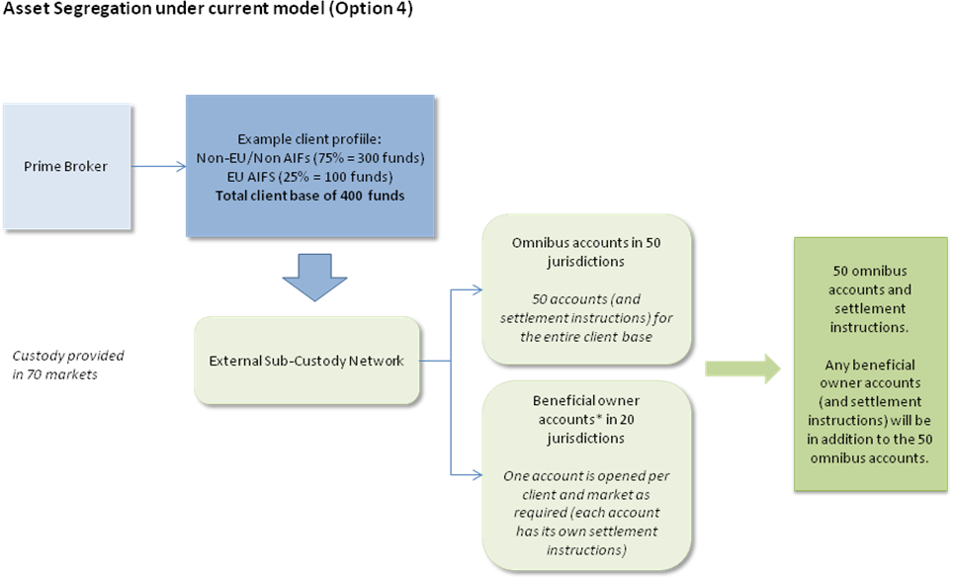

* A “beneficial owner account” is an account opened in a market which either (i) requires that securities be held or recorded in the final beneficial owner’s name rather than in the name of the intermediary (such as a custodian) as record owner or (ii) does not afford a distinction between beneficial owner and record owner and thus recognizes the record owner as the beneficial owner.

By way of contrast, the diagrams below illustrate the proliferation of accounts and other complexities that would be required to comply with proposed option 1:

Option 1

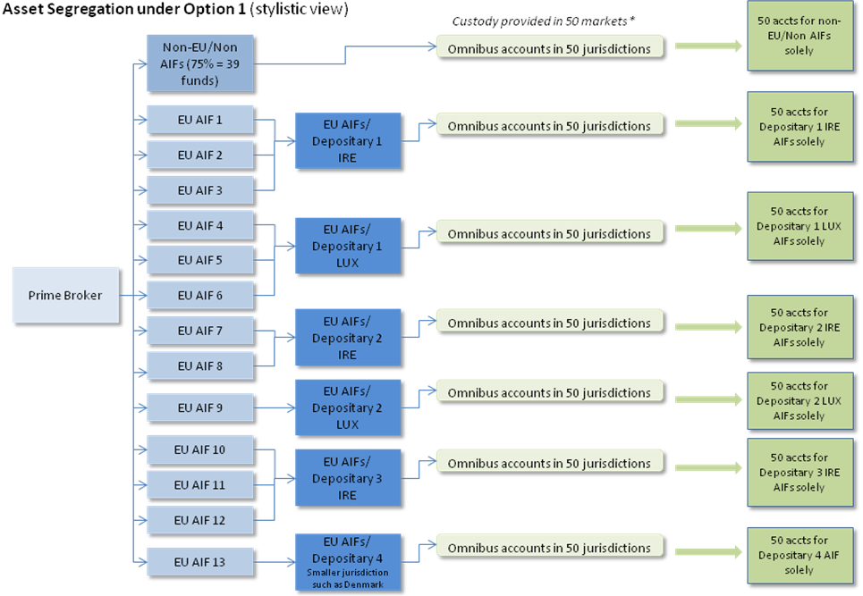

This diagram assumes (1) while the AIFMD segregation requirements do not apply to non-EU AIFs, under any proposed option non-EU AIFs may currently be included in the same account as Non-AIFs and (2) that the depositary uses a separate entity in each jurisdiction rather than a separate branch of the same entity.

Beneficial owner accounts would be agreed and opened on a case by case basis as requested, and would be in addition to the number of omnibus accounts.

Please note that if these guidelines are made to apply to non-EU AIFs in 2018, prime brokers would then be required to incur the relevant one-off costs discussed above with respect to such non-EU AIFs.

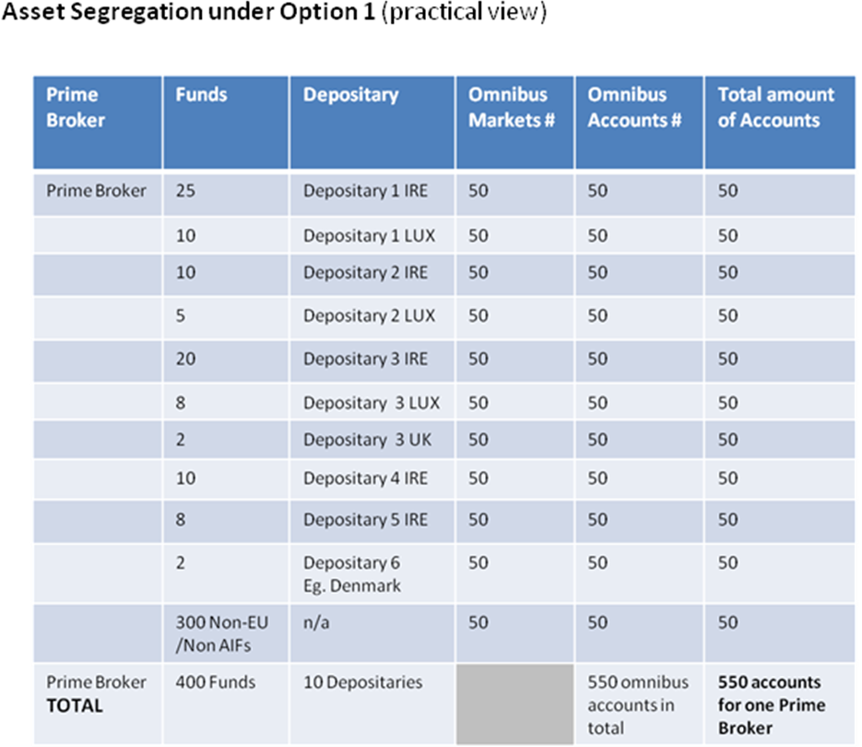
This diagram assumes (1) while the AIFMD segregation requirements do not apply to non-EU AIFs, under any proposed option non-EU AIFs may be included in the same account as Non-AIFs and(2) that the depositary uses a separate entity in each jurisdiction rather than a separate branch of the same entity.

Beneficial owner accounts would be agreed and opened on a case by case basis as requested, and would be in addition to the 550 omnibus accounts

In this scenario, there will be separate omnibus accounts and settlement instructions (i.e. 10*50=500 accounts and settlement instructions) for each Depositary, while for Non-EU/Non AIFs, there will be another 50 omnibus accounts and settlement instructions. In effect, there will be a total of 550 different accounts and settlement instructions solely for the omnibus markets (i.e. an additional 500 accounts to manage, settle and reconcile). Each executing broker would be required to maintain records of 550 settlement instructions instead of the current 50. In addition, there will be one account per client and market for the beneficial owner market in line with current structure.
Option 2

The chart below illustrates the consequences of compliance with option 2:

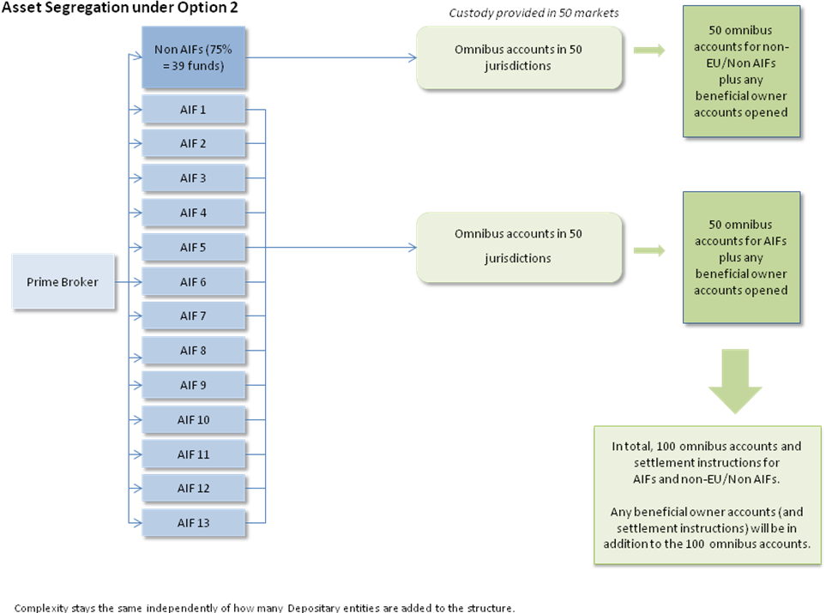

Option 2, whilst not as complex or costly as option 1, would still require at least 50 additional omnibus accounts and settlement instructions, and would still entail significant additional costs and risks, without providing any greater level of investor asset protection.

As stated above, a larger number of additional omnibus accounts (either for AIFs or per depositary) would neither (a) speed up the return of assets in the case of an insolvency of a prime broker nor (b) reduce shortfall potential for AIFs. The operational complexities of running multiple client omnibus would have no preventative effect on prime broker or depositary insolvency, and would likely increase the risk of both entity insolvency and segregated depositary shortfall. In addition, as described below, any shortfall would be shared with a smaller group of prime brokerage clients, with each bearing a greater pro rata share of any losses.

Reduction of diversity in omnibus accounts

Compliance with either of option 1 or 2 will reduce diversity of customers and client assets in each account, which will inevitably diminish the advantages and efficiencies of such diversification for our clients and increase the negative effects of any disadvantages. With Option 1 in particular, prime brokers will be required to (i) support costly ‘mini’ omnibus accounts where each AIF’s omnibus risks are concentrated to the activity of a few other AIFs or (ii) potentially withdraw from offering custody services in the smaller markets and/or limit their depositary relationships to those depositaries that have a sufficient number of AIF clients.

Of particular relevance to prime brokers and their clients are the following advantages and disadvantages:

- Cost (advantage diminished) – Using one single omnibus account results in reduced fees associated with:

      - Maintenance of account.
      - Performing transfers where netting of credit and debit entries can be applied.

- Internalised Settlement (advantage diminished) – Settling across the books of an account provider instead of using the CSD. This advantage is lost when using options 1 or option 2 since holdings held in separate accounts will need to be settled using external instructions. On the contrary, where an omnibus account is used internalised settlement can increase efficiency and reduce costs for the end client. Internalised settlement often occurs in the context of prime brokerage activity where clients routinely take short positions that can be offset against a corresponding purchase. The efficiencies are passed onto the client by offering settlement finality at an earlier point in time and reducing their costs. Fewer clients in an omnibus account will materially reduce the number opportunities for internalised settlement.

- To the extent that increased complexity and settlement failures result in permanent shortfalls (as described below), such permanent shortfalls would have a greater impact to mini-omnibus accounts (as required under option 1 and 2) as such permanent shortfalls would be allocated across a smaller population of AIFs in such mini-omnibus accounts under “rateable loss-sharing” regimes which potentially exacerbates the extent of loss for each AIF.

Safety and efficiency in settlement accounts

Compliance with option 1 or 2 would result in significant difficulties with respect to block trades, as well as increase the frequency and severity of settlement failures, as follows:

Block Trades – Compliance with the proposed options would in many cases prevent (i) AIFMs managing both an EU AIF and a non-EU AIF (a scenario that is especially common in, but not restricted to, managed accounts which are now typically onshore) or (ii) an EU AIFM managing 2 or more EU AIFs that do not have the same depositary from executing block trades. A block trade is a single execution on behalf of more than one entity that settles as one trade and is then allocated to the relevant underlying entities immediately post settlement. The additional accounts required under the proposed options would increase transaction costs and risks as managers, executing brokers and settlement agents would be required to execute a significantly larger number of settlements instructions and traders would need to restructure their operations to accommodate a significantly larger number of trades. This would increase the probability of settlement failures and other operational risks.

Block trades are common across the market and help to reduce transaction costs and operational risk (while also potentially reducing commissions and helping to increase liquidity). An inability to execute block trades would have a substantial negative effect with respect to option 2, which would be significantly greater with respect to option 1.

Settlement Fails – Executing brokers would be required to know/ specify multiple SSIs (standard settlement instructions) for each prime broker. Currently all client execution trades/transfers for delivery to a prime broker are instructed with a single SSI reflecting the single omnibus client account per market. Settlement failures can arise even with the existing account structures and highly automated modern securities markets.

Under the proposed options, each executing broker’s infrastructure would need to be restructured to facilitate multiple operational set ups for EU AIFs (settling into one or several accounts per depositary) and non-EU AIFs (settling into one omnibus account) and per prime broker. This would significantly increase and complicate the administrative burden for executing brokers by requiring them to maintain a much wider collection of SSIs per prime broker. It would become increasingly difficult and complicated to ensure settlement and reconciliation in a timely manner and unnecessarily complex multiple SSIs set ups would increase securities market operational risk.

We also note that the consequences of option 1, and to a lesser extent, option 2, in terms of the reduced efficiency and increased settlement failures are contrary to the objectives of the Central Securities Depositaries Regulation (CSDR) and Target 2 Securities (T2S). The main objectives of CSDR and T2S are to increase the safety and efficiency of securities settlement and settlement infrastructures. Option 1 and option 2 potentially undermine these objectives by diminishing the ability to achieve settlement finality at an earlier moment through internalised settlement and increasing the risk of settlement failures and delays due to the increased operational complexity associated with the proliferation of accounts and standard settlement instructions (“SSIs”). With the expansion of penalties for settlement failures envisaged under CSDR this is likely to result in significant increased costs for market participants that will ultimately be passed on to their clients.

Finally, we highlight the following additional risks inherent in compliance with proposed options 1 and 2:
Competition/Concentration Risk The prime broker’s account infrastructure will become increasingly complicated and inefficient the more depositary relationships it maintains and the greater the number of markets in which it offers custody services via sub -custody arrangements. Consequently, the increased risks outlined for options 1 and 2 may lead to prime brokers having to rationalise the number of depositaries that they are able to face and the clients that they are able to serve, or may even cause them to avoid providing custody services altogether in certain markets because there may be no adequate commercial rationale for building the necessary infrastructure. The likely result is that AIFs that use prime brokers will face a significantly reduced choice of (i) depositary (prime brokers will likely focus on building infrastructure only for the leading depositaries in a more limited number of jurisdictions); (ii) markets (prime brokers will likely focus on building infrastructure only for the most popular markets); and (iii) prime brokers willing to provide custody services.
Reduction in Choice Following the collapse of Bear Stearns and Lehman, hedge funds have increasingly sought to reduce their counterparty risk through diversification by the appointment of multiple prime brokers. The negative consequences of option 1 and 2 outlined above will harm the AIFs’ ability to pursue particular investment strategies (i.e. by forcing prime brokers to withdraw from providing custody services to AIFs in certain markets or to retreat from certain depositary relationships that are not economically viable) as well as their ability to use multiple prime brokers and custodians as a means of diversifying risk. They may also force AIFs to obtain alternative financing sources and tools that may take them further away from the policy objectives of investor asset protection (e.g., synthetics, TTCA arrangements, etc).
Market Disruption Introduction of multiple new linked accounts into existing prime broker sub-custody operational infrastructure is likely to lead to a period of reduced service levels and reduced efficiency of settlement in early phases of implementation e.g. introduction/testing/build out by the prime broker.
Capacity/Volume/Resource Constraints:Multiplying the number of custody accounts to be serviced by the local market sub-custodians is likely to result in a need for additional resourcing, which may not be immediately available and which may lead to delays in settlement/reconciliations at the outset. This may also lead to increased sub-custody charges. Some local sub-custodians may not be able to support such a significant increase in industry requirements and there may be a consequential reduction in local sub-custodian agents (concentration risk).
Prime Broker Processes: Increased operational risk arising from multiple transfers between accounts to support rehypothecation and stock lending on a daily basis.
Reconciliation Risks: Increased reconciliation risks arising from requirement for Prime Broker to reconcile a significantly larger number of accounts on a daily basis, as well as greater challenges with respect to settlement failure management.
Timing

In Section 5.3, subsection 1, the consultation paper states that “[the] guidelines apply from two months after the date of publication by ESMA”. For the reasons stated above, compliance with option 1 or 2 would require a significant restructuring of prime brokers’ account, settlement and reconciliation models. Prime brokers might also have difficulty completing any corporate actions in the relevant jurisdictions with the two month time frame. In many cases, there is more than one entity within a firm that acts as a prime broker, or more than one platform for a single prime broker, which further exacerbates these difficulties. Therefore, it would be extremely difficult, if not impossible, for prime brokers to comply with option 1 or 2 within two months of publication of any guidelines.

There are currently many European and national regulatory initiatives other than AIFMD that are applicable to the custody of client assets (e.g. EMIR, CSDR, the FCA CASS Rules and the IOSCO principles). Implementation and compliance with all of these regulatory requirements will be a complicated and time consuming exercise. Even if prime brokers were able to adequately restructure their business models within the two month period (which is highly doubtful) and considering that compliance will take even longer with respect to non-European markets (such as the US), it is unlikely that the global custodian industry would be ready to accommodate the new structure or requirements by that time. In addition, custodians would likely receive requests for increased accounts and other complexities from multiple prime brokers at the same time, further decreasing the likelihood of timely, efficient and successful compliance.

A further danger is that in local markets or markets where there is limited or no presence of a global institution, custodians may be unable or unwilling to make the changes necessary to comply with either of the two proposed options. All of the above may result in a prime broker or custodian deciding that it would be too difficult to comply in particular jurisdictions within the timeframe, and ultimately refusing to offer services in those jurisdictions.

In any event, it is important that custodians and prime brokers are able to make any required changes in a controlled manner. A two month timeframe makes it less likely that such a process can be completed in a controlled manner, and in a way that ensures optimal investor asset protection throughout the process.

If any guidelines are published that do not permit option 4, we strongly urge ESMA to consider a compliance date at least twelve months after the date currently contemplated in the consultation paper for compliance.
<ESMA_QUESTION_G_AIFMD_3>

Do you see merit in foreseeing a specific treatment for certain types of arrangement (e.g. collateral management arrangements)? If yes, please specify how your proposal would ensure compliance with the relevant requirements of the AIFMD and Level 2 Regulation.

<ESMA_QUESTION_G_AIFMD_4>
Whilst we do not intend to respond to this question at this time, it would be helpful for ESMA to explain its relevance to holding custody assets under AIFMD. When we have more information in this respect, we may provide a response accordingly]
<ESMA_QUESTION_G_AIFMD_4>

Do you agree with ESMA’s approach to discarding the third, fourth and fifth options described in Section 5 of the CBA? If not please provide data and information that support your view.

<ESMA_QUESTION_G_AIFMD_5>
As discussed in more detail above, we do not agree with ESMA’s approach to discarding the fourth option described in Section 5 of the CBA for the following reasons:

- Option 4 is permitted by the AIFMD Level 2 Regulation;

- Option 4 sufficiently furthers the policy objectives of AIFMD relate to investor and client asset protection in upon a relevant insolvency event

- Option 4 is compliant with MiFiD

- Neither proposed option 1 nor proposed option 2 offer any additional investor asset protection compared to option 4 in the event of a negative (i.e., insolvency or bankruptcy) development affecting a prime broker or third party as demonstrated in our analysis (Question 2)

- Options 1 and 2 will ultimately increase costs associated with:
  - Maintenance of complex account structures
  - Account fees
  - Inability to perform Internalised Settlements
  - Coverage of permanent shortfalls
  - Settlement fails
  - Internal processes such as accounts reconciliations
  - Inability to perform Block Trades

- Options 1 & 2 will increase concentration Risk due to fewer markets and depositary relations, and

- Options 1 & 2 will increase costs for US entities making the European market less attractive.

For these reasons, and based on all of the arguments raised above, we respectfully request that ESMA reconsiders its decision to discard option 4 as an acceptable method of client asset segregation under AIFMD, and confirm that prime brokers are permitted to continue to segregate client assets in a manner that is consistent with option 4.
<ESMA_QUESTION_G_AIFMD_5>

A trust is a fiduciary arrangement where someone or a group of people (trustees) are made responsible for assets for the benefit of another group of people (the beneficial owners).
Lomas and others v Rab Market Cycles (Master) Fund Ltd and another [2009] EWHC 2545 (Ch)
It is likely to be necessary to this analysis (and the protection of clients’ beneficial interests) that the account provider’s own assets are not commingled, in the upper tier account, with the securities of its account holders.
In other words, “rather than seek to a trust in favour of each client over their unallocated portion of client securities , one may identify one global trsut over all the client securities [ . . .]” (Madeleine Yates and Gerald Montagu, The Law of Global Custody, 4th edition, Bloomsbury Professional).
Under a sub-trust.
This is a principle that in relation to securities held with an intermediary, the law applicable to the effects against the intermediary and third parties of holdings and dispositions of such securities is determined by the place of the office of the intermediary with which the account is maintained, without consideration of any higher tier intermediary or the issuer of a security.
So long as the title of the account makes it clear that the assets belong to the AIF.
The principles of no ‘look through’ and upper-tier attachment is recommended by UNIDROIT and is applied in other jurisdictions (e.g. Russia).
One exception to this general rule is for so-called “customer name securities”, which are securities registered in the name of the customer that are not transferable in the hands of the failed broker-dealer. The SIPC trustee will seek to return such securities directly to the registered broker.
See Barlow Clowes v Vaughan [1992] 4 All ER 22. Pro ration is also specified in the Investment Bank Special Administration Regulations 2011
Which are required under UK regulations.
The scope for input error is greatly increased. The need for multiple accounts at each level is likely to exceed the available capacity of the infrastructure.
For example, if in a jurisdiction which did not recognise the segregation of client assets, a creditor of the prime broker were able to attach the prime broker’s client’s assets held with a sub-delegate and the only relevant account of the prime broker with the sub-delegate were the AIF client account, the loss of those assets would be borne by the AIF holders alone, whereas if the assets were held in a general client omnibus account , the losses would be borne by the prime broker’s clients generally.
The MiFID II regime is expected to retain this rule, and ESMA has proposed additional rules for investment firms to prevent the unauthorised use of client financial instruments, such as a requirement to closely monitor projected ability to deliver assets on the settlement date and put in place remedial measures if this cannot be done, with the aim of reducing the risk of shortfalls in omnibus accounts.
Were the depositary an investment firm, using Option 4 would also satisfy its obligations under MiFiD.

