Call for Evidence Investor Response
  - Competition, choice and conflicts of interest in the credit rating industry

  - Responding to this call for evidence
This call for evidence should be read by all those involved in the credit rating industry. It is particularly targeted at the following market participants and the groups and trade associations who represent them:
- Corporate and sovereign issuers of financial instruments requesting credit ratings.
- Credit rating agencies issuing credit ratings.
- Institutional investors and other users of credit ratings.
There are specific questions for corporate and sovereign issuers in section 4 of the call for evidence, followed by questions for credit rating agencies in section 5 and for investors in section 6. ESMA invites respondents to provide information about each relevant set of questions using the template response forms provided for each group.
Responses are most helpful to ESMA where they clearly indicate which question is being answered and provide evidence in support of the response, such as concrete examples of practices experienced, data or costs estimates.
ESMA will consider all responses received by 31 March 2015.
All contributions should be submitted online at www.esma.europa.eu under the heading ‘Your input - Consultations’.
Publication of responses
All contributions received will be published following the close of the call for evidence, unless you request otherwise. Please clearly and prominently indicate in your submission any part that you do not wish to be publically disclosed. A standard confidentiality statement in an email message will not be treated as a request for non-disclosure. A confidential response may be requested from us in accordance with ESMA’s rules on access to documents. We may consult you if we receive such a request. Any decision we make not to disclose the response is reviewable by ESMA’s Board of Appeal and the European Ombudsman.
Data protection
Information on data protection can be found at www.esma.europa.eu under the heading Legal Notice.

Table of Contents
Acronyms used 4
Executive Summary 5
6 Questions for investors and other users of credit ratings 6
6.1 About your organisation 6
6.2 Due diligence and use of credit ratings 6
6.3 Independence and quality of credit ratings 8
6.4 Multiple credit ratings 9
6.5 Disclosure requirements for structured finance instruments 10
6.6 Mandatory rotation 11
6.7 Competition between credit rating agencies 12
6.8 Other evidence 13

Acronyms used
CEREP ESMA Central Repository for publishing credit rating activity and performance statistics
Commission The European Commission
CRA Credit rating agency
CRA Regulation Regulation 1060/2009 on credit rating agencies as amended
ESMA European Securities and Markets Authority
EU European Union

Executive Summary
Reasons for publication
ESMA is publishing a call for evidence to collect information from market participants about the functioning of the credit rating industry and the evolution of the markets for structured finance instruments as required by Regulation 1060/2009 on credit rating agencies as amended (the CRA Regulation). ESMA is seeking evidence about competition, choice and conflicts of interests in the credit rating agency industry in general as well as about the impact of a number of specific provisions of the CRA Regulation.
Contents
This template response form contains the questions to be answered by investors and other users of credit ratings found in Section 6 of the call for evidence.
Respondents may need to disclose commercially sensitive information to ESMA in order to answer some of the questions asked. ESMA intends to present confidential information in anonymised and aggregated form in its Technical Advice so that individual respondents cannot be identified. In order to facilitate this process, ESMA therefore asks respondents to clearly indicate which parts of the answers to each question they believe to contain confidential information.
Next Steps
ESMA will carefully consider all responses to the Call for Evidence received by the deadline of 31 March 2015. The evidence obtained will be analysed by ESMA as part of the development of the Technical Advice to be provided to the European Commission pursuant to Articles 39(4) and 39(5) of the CRA Regulation.

Questions for investors and other users of credit ratings

About your organisation
- The questions in this part aim to obtain information about the nature of the organisation you represent and the different markets in which you are active. This information will help ESMA to put your responses in context and to compare responses from similar respondents.
Q1: Please provide the name of your organisation.
Association française des investisseurs institutionnels
36, rue de l’Arcade – F 75008 PARIS
Af2i is the French Association of Institutional Investors, created in 2002 to gather and represent the different families of Institutional Investors (insurance companies, pension institutions, foundations, corporate, special institutions (Caisse des Dépôts, FRR) etc., to promote institutional asset management techniques, to organize training and transmission of best practices. Af2i wishes also to defend interests of his members in France and in Europe.
Af2i meet 76 major institutional investors as members representing more than 2 trillion € of assets under management and 66 asset management companies, asset servicers or providers as associate members.
Each year, Af2i publishes a global survey on investment and assets covering its members.

Q2: Please explain whether you invest in instruments with credit ratings at local, national, EU and/or global level. If your organisation invests in instruments at EU or global level, please provide a list of the jurisdictions covered.

Here are charts giving some data extracted from our 2014 Af2i Global Survey, which covers 62 major French institutional investors respondents, members of Af2i, with a global AUM of 1,800 trillion €.
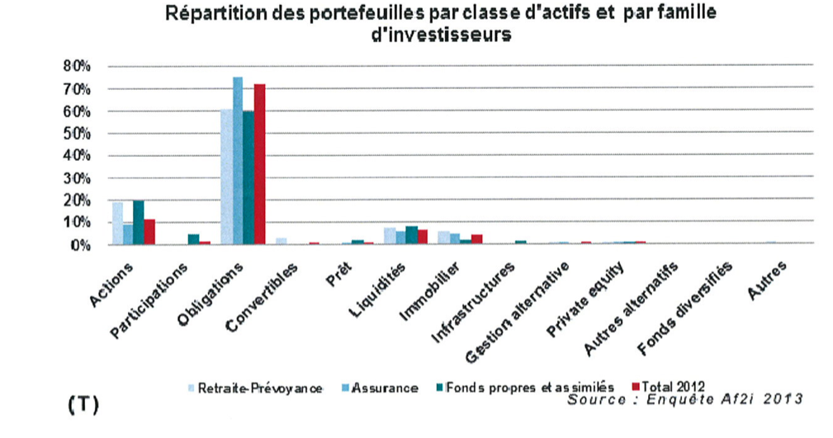

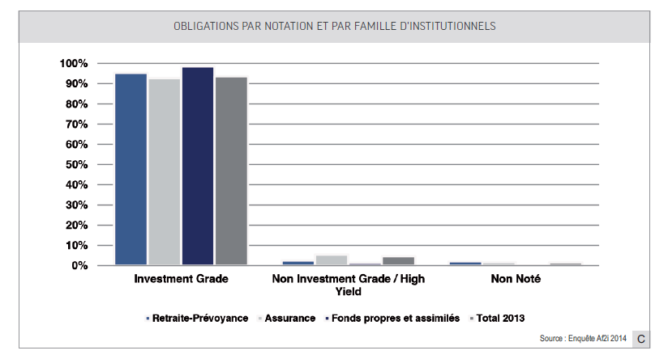

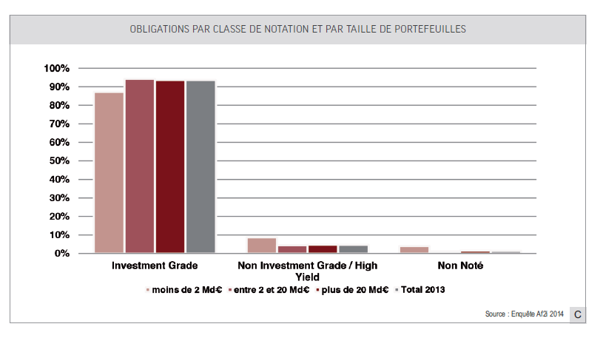

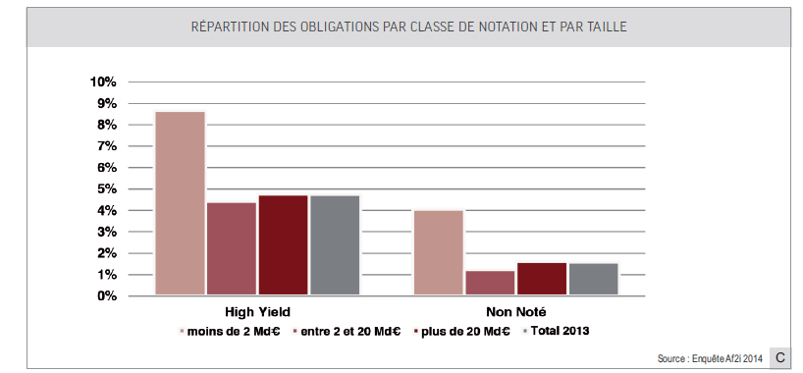

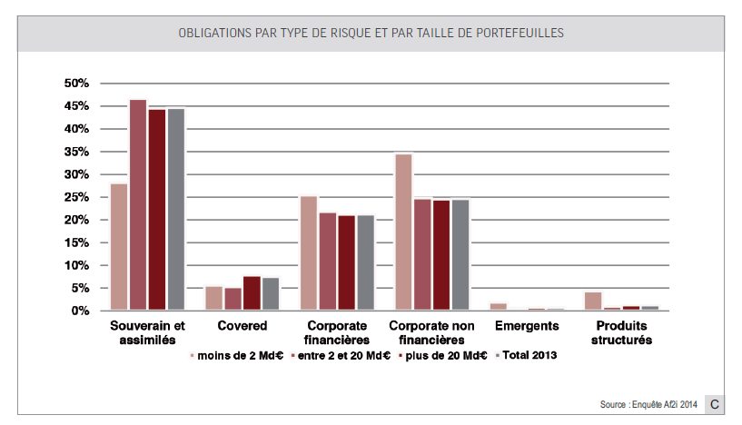
It seems important to replace the use of ratings in institutional management, as there has been in recent years a misinterpretation about it. Do not confuse the deliberate choice of rated instruments in a bond portfolio and the concept of undue or mechanic reliance on these ratings.
Actually, the ratings assigned by CRAs has finally segmented the bond and money markets into different investment universes for both the direct management of portfolios and for the creation of bond or money market funds.
The investment universes of an investor in a bond or money market fund are defined from an internationally recognized universal segmentation and uses different criteria: geographic or economic region, country, sector, currency, maturity and the issuer ratings categorization, the whole in connection with an expected return and one or several risk indicators.
Institutional investors remain attached to a strong segmentation of delegated management offer, which led them at all times to classify the bond market from these different types of risks. The composition of the bond indices supplied by the index providers met this type of segmentation.
There are five major rating universe groups: high credit quality (high grade), investment grade (investment grade), speculative also known as grade high yield or non-investment grade, unrated (not rated) and, finally, distressed debt.
These groups have led to the creation of specialized funds management companies that have developed specific expertise and appropriate formats.
If institutional investors have historically concentrated their attention on Government bond markets, considered as the least risky market, further events and metrics led them to invest in the corporate market, then in the high yield market and in the emerging bonds market, in every occasion with the use of either own management means and ad hoc analysis, or by delegating the investment management to a management company.
The "distressed debt" belongs, for example, to the alternative management strategies universe. In summary, it is therefore differentiated strategies as well as their investment process, credit analysis and management. Investors consider as very important to be able to identify the categories of management and funds because they integrate these specialized funds in their portfolios composed with various parameters, such as the nature and duration of their liabilities, regulations and internal rules.

Q3: Please explain whether you invest in CRAs or related companies, and if so, provide a list of these and your percentage shareholding in each.

We have no knowledge about French institutional investors owning a strategic interest in a credit rating agency.

Due diligence and use of credit ratings
- The CRA Regulation aims to increase investor protection and reduce reliance on credit ratings through a number of transparency and disclosure requirements.
- The questions in this part aim to understand what impact the CRA Regulation has had on how you use credit ratings in the course of your business and whether there is other information which you could use to assess credit risk instead of credit ratings.
Q4: Please explain the due diligence process you follow and the types of information you consider in order to decide which instruments to invest in.

As indicated in the charts shown above, French institutional investors are heavily invested in fixed income instruments and the amount of assets under management is the criteria which first determines the division between direct management carried out by a specialized internal team and delegated management to a professional asset manager.
Then it is the nature of the liabilities and accounting regulations (financial statements, consolidated financial statements, IFRS) that will set the type of management: "buy and hold" management , or not, distribution of maturities, choice of counterparty risks and signature.
Bond diversification, under open or dedicated funds, implies the acceptance of the accounting valuation of the net asset value at the opposite of those of the detention of a in house managed portfolio or through a mandate that allow accounting and valuation at amortized cost. Unrealized losses provisioning rules also differ significantly.
Finally, the specifics in the final composition of a portfolio may result from the application of an individual client (i.e. the hedging of a corporate social liability) or the level of risk aversion in the governance of the institution that require more stringent rules than those set by the regulations of the institutional family. Each institution will establish its own global investment process, which will be declined by type of commitment or by type of customer with a particular investment process, a strategic allocation and tactical allocation ranges. Matching lists of permitted and / or "black list" of unauthorized transmitters are set by the department "risk control" of the entity.
All of these prerequisites being fixed or reached, the due diligence performed by the management teams, whether internal or delegates, differ little between them. Methods of analysis will be chosen close to those of traditional financial analysis (investors analysts are mainly coming from this profession) or rating agencies. They are first marked by the membership of the issuer in a specific category of the investment universe (see answer to question No. 2). They are more specific for some new markets as non-rated issuers or private placements.
Compared to the CRAs methodologies, the essential difference may be related to the more limited investor access to confidential information on the strategy of the issuer and the direct and ongoing contact with the management of the issuer. Most analysts work from the reference to accounting documents published by the company and the information provided during analysts meetings. Some investors and managers use data from the extra-financial research to complement their purely financial or qualitative assessment. Different methods of “financial scoring" may be added.
Let’s recall that the final objective of the credit analyst is to determine, in particular:
- The solvency of the issuer, its potential default risk and, where appropriate, the recovery rate;
- Internal and external liquidity and the associated risks;
- The overall financial strength according to various favorable or adverse economic and financial scenarios and the ability of the issuer to meet them;
- The appreciation of the "spread" in the market, prospects and the relative value of the security relative to its comparable universe;
- Finally, a recommendation to buy, hold or sell.

Q5: Please explain whether your overall use of credit ratings in the course of your business or in making investment decisions has increased or decreased since 2010, giving reasons for your answer.

Portfolio movements were, in recent years, particularly important in several directions, motivated as much by prudential rules and by a very upset economic and financial environment. Its amplitudes have led investors to turn to research of agencies results as frequently as ever and in new areas which were formerly less invested by institutions. At the same time, investors and asset managers have set significant analytical resources in less developed areas of research by agencies such as SME.
First Movement: With the increased risk of some sovereign issuers, the weight of government bonds in the euro zone has fallen sharply in favor of corporate bonds and, at first in the financial sector which is a heavy and usual issuer;
Second movement: with occasional trips to and fro between bonds of the “core” euro area and those of peripheral governments, whenever the risk of sovereign debt has evolved into a more favorable way with attractive looking yields;
Third movement: increased weight of non-financial corporate bonds beyond the financial sector bonds (banking crisis), with an intrusion in the high yield debt market, as the business risk was appearing more clear;
Fourth movement: internationalization of markets (i.e. emerging debt), aiming to improve the portfolios performance;
Fifth movement: use of private placements, direct loans and non-rated bonds, for the same reason.
Ultimately, these movements were conductive to broaden the spectrum of fixed income research on both sides, and to care about the specific contributions of agencies.

Q6: Please explain whether and if so what information you use to assess the quality of credit ratings.

The investor believes the credit quality of an issuer from several sources, written or online, for free or by subscription:
- The legal, social and accounting documents published by the issuer;
- Credit Research papers from investment banks and brokers;
- The daily financial press or specialized local or international, on paper or online;
- Databases like Bloomberg, Reuters, Six-Telekurs, etc.;
- Quantitative databases made available by specialized subsidiaries of CRAs (for instance S & P Capital IQ).
Research papers issued by global rating agencies or, if appropriate, specialized agencies are added to these elements of information.

Q7: Please explain whether and if so to what extent you use internal rating models in addition to or instead of credit ratings in your business or investment decisions.

The institutions having developed sophisticated internal models of rating in their own investment activities are rather in a few number. Their teams of analysts are often reduced in comparison to those of internationally recognized CRAs.
Of course, investors necessarily benefit from important research works developed by the agencies. The latter are welcome as the contribution in research from the brokerage gets lower, the same way as the sharp decline of the market making activities.

Q8: Do issuers or CRAs currently give you more information about how their credit ratings are developed, issued and revised and how their credit ratings compare to the market performance of the rated instruments than they did before 2010? If so, does this additional information make it easier for you to understand and compare:

- the ratings products and other services being offered by different CRAs; and
Click here to enter text

- the quality of the credit risk analysis carried out on rated instruments?
The regular contacts we have with the CRAs allow us to organize with them, whenever necessary, information seminars or trainings for our members about their methodologies or other thematic issues.
Globally, it is a positive aspect of the various regulatory measures taken in recent years.

Q9: Are there other sources of information which you would use to make investment decisions instead of credit ratings?

As indicated in our answer to the question 6, investors use several written or online sources, for free or by subscription:
- Legal, social and accounting documents published by the issuer;
- Credit Research papers developed by investment banks and brokers;
- Daily financial press or specialized local or international, paper or online;
- Databases like Bloomberg, Reuters, Six-Telekurs, etc.;
- Quantitative databases made available by specialized subsidiaries of CRAs.
- Qualitative data provided by extra-financial research departments

Q10: Please explain whether and if so how your business uses unsolicited credit ratings, giving reasons for your answer.

No, unsolicited ratings are not often used except for sovereign issuers.

Q11: Please explain whether, and if so how, your approaches to the issues raised in questions 4-10 above have changed since 2010.

As explained in our answer to the question 5, the important movements in the portfolios have had consequences on ratings needs. They have conducted to increase the use of internal credit research and analysis.

Independence and quality of credit ratings
- One of the aims of the CRA Regulation is to increase the quality of credit ratings by seeking to reduce the conflicts of interest inherent where issuers pay for the rating of their financial instruments.
- The questions in this part aim to understand the different ways that CRAs can seek payment for the credit ratings issued and to assess the impact of the CRA Regulation on increasing the quality and independence of credit ratings.
Q12: Please explain in which circumstances you currently pay for credit ratings. If you do not currently pay for credit ratings, please explain whether, and if so under which circumstances, you would be willing to pay for credit ratings.

Access to databases (ratings) agencies is charged, directly or through terminals such as Bloomberg or Reuters. The use of ratings in the reports and other factsheets of funds or management mandates is subject to royalties.
We emphasize that we remain committed to the model of the issuer-payer, which allows a better understanding of the notes by the entire investment community without restriction. It corresponds anyway to the legal reality of solicited ratings.

Q13: Irrespective of whether you pay for credit ratings, please explain the circumstances in which links or existing relationships between an issuer of a particular instrument and a CRA would have an impact on how you would use a credit rating of that instrument.

This is a specious question and we will not fall into his trap. We do not have specific examples similar to those you seem to evoke.

Q14: Please explain whether the quality of credit ratings has increased or decreased since 2010, giving reasons for your answer.

The main issue is, and always will be, that of the proactive role and self-fulfilling decisions of the CRAs. Are conversations with public officials performed without any threat? What impact if agencies did not exist? Is the downgrading of the notes of sovereign issuers justified or not?
We believe that the CRAs decisions and their influence on investors forced governments - at least the responsible heads of them to initiate reforms and take bold decisions on public debts and deficits.
The events that have affected the quality of the rating activities were non-European events. We steadily observe quite a consistently high level of quality.

Q15: Please explain what, if any, further measures could be taken to increase the quality of ratings, giving reasons for your answer.

It is time for public officials, especially in Europe, to change their concern. One cannot want both a development in financing by the markets, especially for tens of thousands of SME / ETI, and simultaneously imagine that this investment universe should not be the subject of an accurate observatory about the credit risk and a "benchmarking" seriously developed by an external reference and constant over time. For us, it is one of the duties that CRAs have always been bound with teams of experienced analysts and the need for extensive development of healthy and safe financing market, for investors as for issuers.
We believe, however, that rather than accumulate additional control layers, one must encourage issuers to not turn away from scoring investors by combining internal analysis and external expertise and let the rating agencies work on these bases now clearly established.
But let’s be aware that the current monetary policy of the European Central Bank is killing the springs of these objectives, excessive prudential regulation, by too low returns for "no risk" assets by inappropriate market prices for risky assets and a risk of permanent loss of profitability of financial institutions, if this situation continues for a too long period. It is time for the European markets regulatory authority to really care about the consequences of the monetary policy on the sustainability of financial institutions.

Multiple credit ratings
- The 2013 amendments to the CRA Regulation introduced a number of requirements on issuers and sponsors of structured finance instruments to obtain multiple credit ratings. These requirements are set out in Articles 8c and 8d of the CRA Regulation.
- Article 8c of the CRA Regulation requires issuers to obtain at least two credit ratings for structured finance instruments. This obligation was introduced with the aims of restoring market confidence in complex financial instruments and reducing reliance on single credit ratings.
- Article 8d of the CRA Regulation aims to increase competition between CRAs by encouraging issuers to use smaller CRAs when they use multiple CRAs. Article 8d states that where issuers or related third parties intend to appoint at least two CRAs to rate an issuance or entity, they shall consider appointing at least one CRA with no more than 10% of the total market share where possible (hereinafter ‘small CRA’).
- The question in this part aim to understand whether these provisions have achieved their objectives and the impact they have had on your business.

Q16: Please explain what impact multiple credit ratings of the same instrument have on your investment or business decisions.

Multiple ratings are common among many issuers. We cannot ignore it. It allows investors to confirm, or to precise the degree of risk attached to the note issued by an agency. However, with multiple notes, several interpretations may appear among investors and asset managers.
The most common practice is to use only the lower of the 2 or 3 issued ratings.
The second is to consider the average of 3 ratings.
The rarest practice is to retain only the best one.

Q17: Please explain whether in your view, issuers should be obliged to obtain multiple credit ratings in respect of some or all asset classes and if so, how many ratings per asset class should be required.

We do not believe that a multiple rating is fundamentally safer or more useful than a single one issued by one agency whose skills are recognized. We believe, however, that the important factors are, and will always be, the quality of expertise of the agency, the permanence of its process and methodology, which allow better conditions for its evolution and its stability over time, as well as generate reliable statistics over long periods on a wider or narrower universe.
The choice to be rated by several CRAs must be a deliberate decision of the issuer, especially since the rating process has a consistent cost. The big agencies differ in methods and in results. Thus they provide an extra assessment that enhances the own discernment of the investor

Q18: Please explain whether you would use ratings from a small CRA, giving reasons for your answer. Please explain whether, and if so how, your approach to this issue has changed since 2010.

Our thought has always been that agencies specialized in economic sectors might have an interest if and only if they allow to bring an orthogonal view to the issuer or counterparty risk, so a different angle from that of a large multi-sectors agency.
Apart from that, strong and experienced teams, the quality of their analysis over time and independent judgment will always and foremost be determinants.

Q19: Please explain whether you would use ratings from a CRA who has not previously rated a particular asset class, giving reasons for your answer. Please also explain whether, and if so how, your approach to this issue has changed since 2010.

A new CRA should have passed the admission tests and prior recognition imposed by ESMA, which constitute a presumption of expertise.
Our judgment will, however, probably be much less comfortable, especially since as we said before, the confidence in the new agencies' judgments (like their statistics of default or recovery) cannot be measured over time.

Disclosure requirements for structured finance instruments
- The 2013 amendments to the CRA Regulation sought to increase transparency through the introduction in Article 8b of a joint obligation on issuers, originators and sponsors to publish information on the credit quality and performance of the underlying assets of structured finance instruments.
- The expression ‘structured finance instrument’ is defined as a financial instrument or other assets resulting from a securitisation transaction or schemes ‘whereby the credit risk associated with an exposure or pool of exposures is tranched, having both of the following characteristics:
(a) payments in the transaction or scheme are dependent upon the performance of the exposure or pool of exposures; and
(b) the subordination of tranches determines the distribution of losses during the ongoing life of the transaction or scheme’.
- Commission Delegated Regulation 2015/3 of 30 September 2014 sets out the disclosure requirements for issuers, originators and sponsors of structured finance instruments. Although this Delegated Regulation will only apply from 1 January 2017, its aim of improving transparency is clear. In this part ESMA therefore wishes to understand the benefits and costs of extending these disclosure obligations to other asset classes.
Q20: Please explain whether the requirements of the CRA Regulation for issuers, originators and sponsors to make information available through a website, including information regarding the creditworthiness and performance of structured finance instruments, are sufficient or should be extended to other asset classes, giving reasons for your answer. If so, please explain to which products this obligation should be extended.

This website is undoubtedly an excellent initiative but is still not recognized by institutional investors. We have not, at this stage, any particular opinion on improvements to it, except it is not easy to use and to know which information and data are available.

Mandatory rotation
- The 2013 amendments to the CRA Regulation introduced a mandatory rotation provision for CRAs issuing ratings on re-securitisations, which can be found in Article 6b of the CRA Regulation. Article 6b provides that CRAs may enter into ratings agreements for re-securitisations with a maximum length of four years, after which time they are prevented from rating new re-securitisations with underlying assets from the same originator for a period of four years.
- The CRA Regulation notes that the implementation of a rotation mechanism should remove the incentive for a CRA to give favourable credit ratings to issuers on the basis of their existing relationships and could encourage other CRAs to start rating these instruments.
- As the provision was also designed to help stimulate competition, Article 6b2(b) of the CRA Regulation explains that mandatory rotation will cease to apply where at least four CRAs each rate more than 10% of the total number of outstanding re-securitisations.
- Although this provision has only recently entered into force, the questions in this part are designed to help ESMA understand the impact of this provision and the extent to which it has already been used. They also aim to assess the appropriateness of maintaining a rotation mechanism, whether, and if so how, it should be extended to other asset classes and what impact this would have on issuers and CRAs.
Q21: Please provide details of any experience you have had of this rotation provision to date.

We have no previous experience in rotating rating agencies especially in the case of securitization.
If we reason by analogy with the rotation of auditors and auditors’ mandates in listed companies, it appears that the rotation leads to an important extra work of appropriation of knowledge of the business, to bring these actors to an appropriate level of knowledge. This work is performed by internal teams of the issuers for a very uncertain benefit.
Statistics from agencies are designed to assess short, medium and long-term issuers default probabilities in a same rating level, regardless of the sector. To be reliable, they obviously require greater stability in the rating process which suppose the stability of the rating agency. Otherwise, these statistics would have no truth and no investor confidence in these statistics.

Q22: Please explain whether a 4-year contract term is appropriate for this rotation provision, and if not, what would be an appropriate length?

For the reasons mentioned above, we are opposed to a mandatory rotation of rating agencies mandates, regardless of the duration. We do not believe in its usefulness and on the contrary, we believe that it would destroy everything what the permanence brings in matter of the reliability of the processes of rating.

Q23: Please explain whether mandatory rotation should be extended to other asset classes. If so, please:

- list the asset classes to be covered and state the appropriate contract length for each;
For the reasons mentioned above, we are opposed to extend a mandatory rotation of rating agencies mandates, regardless of the asset class. We do not believe in its usefulness and on the contrary, we believe that it would destroy everything what the permanence brings in matter of reliability of processes of rating.

- explain whether, and if so why an obligation should be introduced for CRAs to provide a handover file to the incoming CRA at the end of the maximum contract term.
We understand the value of such a transmission of information, but we are dedicated to the principle that any intellectual work spent by an agency serves a competing agency. This would be particularly the case of a company that would have been recorded for the first time by the outgoing agency.
The requirement of a permanent process and the rating methodology, the integrity of the agency and the quality of its expertise should be the only drivers.

Q24: Please explain, giving reasons for your answer whether, and if so how, the exemption from the mandatory rotation provision should be maintained where at least four CRAs each rate more than 10% of the total number of outstanding re-securitisations.

We have no opinion on this particular issue, probably a good example of unnecessary complication.

Competition between credit rating agencies
- The aim of improving the functioning of the markets within the CRA sector was a major driving force behind the development of the CRA Regulation. The CRA Regulation seeks to achieve this aim by stimulating competition between CRAs, through registration and disclosure requirements as well as through specific provisions regarding the use of multiple credit ratings and the mandatory rotation of CRAs.
- The questions in this part aim to collect further information about competition between credit rating agencies and whether competition between CRAs has changed since the CRA Regulation entered into force in 2010.
- ESMA would also like to take your views as to whether, and if so how, competition between CRAs could be stimulated without having a negative impact on the quality of credit ratings.
Q25: Please explain whether you are aware of any competition between CRAs. If so, please explain on which of the following parameters CRAs currently compete:

(1) quality of rating;
(2) relationship with issuers;
(3) investor relationships;
(4) by asset class;
(5) by price to issuer;
(6) by level of rating;
(7) through the offer of ancillary or non-ratings services; and/or
(8) other (please specify).

We would be very concerned if the CRAs began to compete and put themselves in competition, in addition because the European regulator urges them to do so. Indeed, the goal should be to have the highest-quality information based on the best expertise, allowing the investor to better measure the risk of its counterparties and the quality of its investments. Therefore, what kind of competition is it? Giving the highest ratings to issuers? At the risk of running unnecessary risks? Being rather alarmist? Facing the risk to not being credible?
We see that in both cases, it is neither in the interest of agencies, or those of issuers and investors, nor that of the ESMA to create conditions of competition between the agencies since that would bring only disappointment.

Q26: If you have been aware of competition between CRAs, please explain whether, and if so how, the nature of competition between them has changed between 2010 and present.

We do not have the feeling of be facing a commercial competition between agencies, at least between internationally recognized rating agencies. It is no doubt an intellectual competition in research credit, to improve constantly the knowledge of the investment universe and expanding the number of issuers in connection with the European objectives to develop financing markets.

Q27: Should further measures be taken to stimulate competition between CRAs overall and/ or in respect of the rating of particular types of asset class such as structured finance instruments? If so, please explain what measures could be taken without having a negative impact on the quality of credit ratings.

At the risk of repeating ourselves, it is not in the interest of CRAs, or those of issuers and investors, nor that of the ESMA to create conditions of competition between the agencies that bring as setbacks from all points of view.

Other evidence
- If there is any other evidence or information that you would like to bring to ESMA’s attention, please present it here.
After the serious malfunctions that affected the securitization market in the US, and only this market, for the fourth time in six years the operation and duties of credit rating agencies are questioned by the authorities
Measures adopted previously brought a great deal of transparency in methodologies with a large involvement of the regulatory institution ESMA. On these previous provisions, we think that they are acceptable but we remain without certainty about how they would have helped to prevent the past incidents.
Overall, it seems important now that we encourage agencies, existing or future, to work and develop their research on the basis of clearly stated rules today.
A world of finance and investment would be ineffective without scoring, and a financial world with a scoring function made uncertain by successive shocks should introduce undoubtedly an extremely damaging bias in the formation of prices and investment allocations of credit at the expense of an optimized financing of the economy.

See Recital 10 of Regulation 462/2013 of 21 May 2013.
See Recital 28 of Regulation 462/2013 of 21 May 2013.
Article 4(1)(61) of Regulation No 575/2013 of the European Parliament and of the Council of 26 June 2013 on prudential requirements for credit institutions and investment firms and amending Regulation No 648/2012 , OJ L 176, 27.6.2013.
OJ L 57, 6.1.2015, p. 2.
See Recital 12 of Regulation 462/2013 of 21 May 2013.
See Recital 15 of Regulation 462/2013 of 21 May 2013.
See Recital 13 of Regulation 462/2013 of 21 May 2013.

