For the attention of Mrs. Sarah Raisin European Securities and Markets Authority

For the attention of the Joint Committee of the European Banking Authority

Sent via e-mail :
Sarah.raisin@esma.europa.eu
Joint-committee@eba.europa.eu

Ref. 14-1012 | 7 February 2014

Dear Mrs. Raisin, dear Sirs,

EFAMA response on Joint Committee Consultation Paper on draft guidelines for complaints-handling for the securities (ESMA) and banking (EBA) sectors

EFAMA is the representative association for the European investment management industry. EFAMA represents through its 27 member associations and 60 corporate members about EUR 15 trillion in assets under management of which EUR 9.5 trillion managed by 55,000 investment funds at end September 2013. Just over 35,500 of these funds were UCITS (Undertakings for Collective Investments in Transferable Securities) funds. For more information about EFAMA, please visit www.efama.org.

- General remarks

EFAMA considers of utmost importance that financial institutions have sound procedures in place to deal with consumers complaints in an adequate way. Proper complaint-handling mechanisms are of benefit for both consumers and financial institutions as well as the financial markets in general.

However, EFAMA believes that we are missing a distinction between client categories. For the purpose of MiFID for example, there is a clear distinction between complaints by retail clients and by other clients. As set forth by the ESAs in the consultation paper:

“Article 10 of the MiFID Implementing Directive which sets out the obligations on firms in respect of complaints-handling and states that: “Member States shall require investment firms to establish, implement and maintain effective and transparent procedures for the reasonable and prompt handling of complaints received from retail clients or potential retail clients, and to keep a record of each complaint and the measures taken for its resolution”.”

Therefore, the guidelines should for each relevant financial sector firm establish a distinction between client categories. Otherwise the guidelines would go beyond the relevant Directives and their implementing national legislation.

- Key comments on proposed Guidelines on complaints-handling

Guideline 1 – Complaints management policy
EFAMA agrees with Guideline 1. However, we believe it should be implemented in a manner that takes into account the nature, scale and complexity of a firm’s business.

Guideline 2 – Complaints management function
EFAMA agrees with Guideline 2. However, we believe it should be implemented in a manner that takes into account the nature, scale and complexity of a firm’s business.

Guideline 3 – Registration
EFAMA agrees with Guideline 3.

Guideline 4 – Reporting
EFAMA recommends that the ESAs should focus on reporting to competent authorities upon request rather than implementing permanent reporting obligations to competent authorities which have no legal basis in European law, e.g. the UCITS Directive or the AIFM Directive. Without regard to legal concerns, we consider permanent reporting obligations as no additional benefit for consumers and not effective to enhance their relationship to financial service providers.

In certain Member States, for example, the existing German national competencies of the German Federal Financial Supervisory Authority provide effective tools to keep the activities of Capital Management Companies e.g. in the area of complaints-handling in line with European and national legislation. The German Federal Financial Supervisory Authority has the right to request all information from Capital Management Companies as far as there are indications for misbehavior. Furthermore, the German Authority as of today is able to prove and understand whether German Capital Management Companies comply with their legal obligations in terms of complaint handlings e.g. by the independent auditors´ annual report. In addition, consumers have the right to address their complaints directly to the Authority or respective alternative dispute resolution schemes to resolve problems, too.
As far as the Guidelines provide for reporting especially the number of complaints to the competent authorities, it should be considered that the number of complaints is not a meaningful figure per se given the fact that all complaints have to be registered by a company whether or not they are reasonable or not.

Guideline 5 – Internal follow-up of complaints-handling
EFAMA agrees with Guideline 2. However, we believe it should be implemented in a manner that takes into account the nature, scale and complexity of a firm’s business.

Guideline 6 – Provision of information
EFAMA would like to emphasise that while we think it is important to have transparent procedures for clients, it should be noted that most financial services providers have complex organizations. For example, in a credit institution, the complaint guidelines would cover various areas such as payment services, investment services, credit card services, loans and others. In line with business organization and client expectations, most institutions will have organized their complaint handlings procedures.
While it is good practice to acknowledge receipt of a complaint within a reasonable time frame, it seems overachieving to provide a client with further information on bank/management company internal procedures. We understand that clients’ need to understand complaint procedures and would propose to use a firm’s website to provide information on complaint procedures. Any receipt acknowledgement could then refer to the relevant website. Should clients wish for further information or an update on the process, they will always be provided with contact information and receive further information upon request. Any other general information does not seem feasible for an organization subject to various other legal requirements, not least of all, market practices and civil law requirements which may differ from product to product and business line to business line.

Therefore, we propose to use a wording along the following lines:
“6. Competent authorities should ensure that firms:

- On request, provide written information regarding their complaints-handling process.

- Publish details of their complaints-handling process in an easily accessible manner, for example, via the firm’s website.

- Keep the complainant informed about further handling of the complaint.”

Guideline 7 – Procedures for responding to complaints
With respect to Guideline 7c), EFAMA would like to emphasize that there should be no fixed timeframe for dealing with a complaint. Complaints vary in nature and often refer to complex issues which date back in time as the case may be. Therefore, a response within a reasonable timeframe without any unnecessary delay seems the most sensible way to proceed.

Sincerely yours,
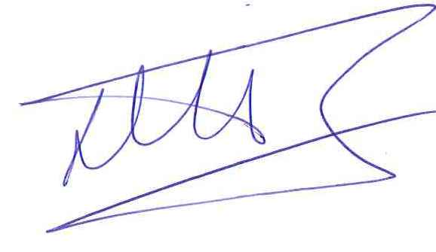
Peter De Proft
Director General

