ESMA
CS 60747
103 rue de Grenelle
75345 Paris Cedex 07
France

Amsterdam, 2 March 2015

European Central Counterparty N.V. (EuroCCP) thanks the European Securities and Markets Authority for the opportunity to contribute to the consultation on the MiFID II/MiFIR draft RTS. We have focussed on the access arrangements between CCPs and trading venues.
EuroCCP is a central counterparty, authorised under EMIR, active in clearing cash equities traded on exchanges, MTFs and through OTC platforms. Headquartered in Amsterdam, EuroCCP was formed in 2013 to provide equity clearing services throughout Europe. EuroCCP is the result of combining the businesses of EuroCCP Ltd. and EMCF N.V. The combination of EMCF NV and EuroCCP Ltd created the largest equities CCP in Europe by volumes cleared and platforms connected.
We are of the opinion that ESMA provided a comprehensive and thorough Consultation Paper and draft RTS on access in connection with articles 35 and 36 of MiFIR. We hope that our contribution will be of use to ESMA in finalising its proposals for technical standards.
We are of course at your disposal for any clarification you may require in connection with our contribution to the consultation.
Yours truly,
European Central Counterparty N.V.
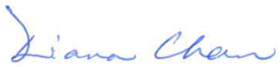

Diana Chan
Chief Executive Officer

