|  |
| --- |
| 15 July 2016 |

|  |
| --- |
| Reply form for the Call for Evidence  Asset Segregation and Custody Services |
|  |

|  |
| --- |
| Date: 15 July 2016 |

Responding to this paper

The European Securities and Markets Authority (ESMA) invites responses to the specific questions listed in the Call for Evidence Asset Segregation and Custody Services (ASCS), published on the ESMA website.

*Instructions*

Please note that, in order to facilitate the analysis of the responses, you are requested to use this file to send your response to ESMA so as to allow us to process it properly. Therefore, ESMA will only be able to consider responses which follow the instructions described below:

* use this form and send your responses in Word format (pdf documents will not be considered except for annexes);
* do not remove the tags of type <ESMA_QUESTION_CE_ASCS_1> - i.e. the response to one question has to be framed by the 2 tags corresponding to the question; and
* if you do not have a response to a question, do not delete it and leave the text “TYPE YOUR TEXT HERE” between the tags.

Responses are most helpful:

* if they respond to the question stated;
* contain a clear rationale, including on any related costs and benefits; and
* describe any alternatives that ESMA should consider

**Naming protocol**

In order to facilitate the handling of stakeholders’ responses, please save your document using the following format:

ESMA_CE_ASCS_NAMEOFCOMPANY_NAMEOFDOCUMENT.

E.g. if the respondent were XXXX, the name of the reply form would be:

ESMA_CE_ASCS_XXXX_REPLYFORM or

ESMA_CE_ASCS_XXXX_ANNEX1

***Deadline***

Responses must reach us by **23 September 2016.**

All contributions should be submitted online at [www.esma.europa.eu](http://www.esma.europa.eu) under the heading ‘Your input/Consultations’.

***Publication of responses***

All contributions received will be published following the end of the consultation period, unless otherwise requested. **Please clearly indicate by ticking the appropriate checkbox in the website submission form if you do not wish your contribution to be publicly disclosed. A standard confidentiality statement in an email message will not be treated as a request for non-disclosure.** Note also that a confidential response may be requested from us in accordance with ESMA’s rules on access to documents. We may consult you if we receive such a request. Any decision we make is reviewable by ESMA’s Board of Appeal and the European Ombudsman.

***Data protection***

Information on data protection can be found at [www.esma.europa.eu](http://www.esma.europa.eu) under the headings ‘Legal notice’ and ‘Data protection’.

# Introduction

Please make your introductory comments below, if any:

<ESMA_COMMENT_CE_ASCS_1>

The **German Banking Industry Committee (GBIC)** is the joint committee operated by the central associations of the German banking industry. These associations are the Association of German Banks (Bundesverband deutscher Banken, BdB), for the private commercial banks, the Bundesverband der Deutschen Volksbanken und Raiffeisenbanken (BVR), for the cooperative banks, the Bundesverband Öffentlicher Banken Deutschlands (VÖB), for the public banks, the Deutscher Sparkassen- und Giroverband (DSGV), for the savings banks finance group, and the Verband deutscher Pfandbriefbanken (vdp), for the Pfandbrief banks. Collectively, they represent approximately 1,700 banks.

GBIC warmly welcomes the opportunity to comment on ESMA’s call for evidence ESMA/2016/1137 (Call for Evidence). We are grateful for this opportunity to deliver the facts requested and to express our views.

Based upon what we have been hearing, it would seem that there are, within the different EU member states, and even among the various banks within the same market, differing interpretations of the asset segregation options originally proposed by ESMA. We therefore appreciate ESMA’s current Call for Evidence as a means of seeking the best way forward on the envisaged guidelines on asset segregation in connection with the AIFMD and the UCITS V Directive.

**Executive summary**

As set out in further detail below, GBIC would like to summarise the main outcome of this Call for Evidence as follows:

* No introduction of new account holding or segregation models (options 1 to 5) is necessary.
* Strong investor protection is already ensured under the provisions of MiFID I/II. Referring to these requirements for the custody of AIF and UCITS assets would be the most effective means of meeting ESMA’s policy objective.
* The concept of delegation of the depositary’s custody function needs clarification. No need for further clarification exists, in contrast, regarding the concept of custody itself.

**Client asset protection**

We have taken note of ESMA’s policy objective of providing an EU framework with strong client asset protection, especially in insolvency, for the safe-keeping of assets which are required to be held in custody by intermediaries in general and by AIF or UCITS depositaries in particular.

GBIC would like to point out that assets to be safekept in accordance with the AIFMD and the UCITS V Directive are generally broader in their scope than “only” securities. Furthermore, we would like to emphasise that the asset segregation requirements for AIF and UCITS assets can, however, **refer only to financial instruments**, and not to other assets, as only financial instruments are to be held in custody by the depositary in accordance with Article 21(8) of the AIFMD and Article 22(5) of the UCITS Directive. To be even more precise, the asset segregation requirements refer only to financial instruments that can be registered in a financial instruments account (cf. Article 21(8)(a)(ii) of the AIFMD and Article 22(5)(a)(ii) of the UCITS Directive).

These directives require that the assets need to be held in custody by registering them in the depositary’s books ensuring that they are “*clearly identified as belonging to the AIF [UCITS] in accordance with the applicable law at all times*”. For this reason, they impose a requirement that “*those financial instruments that can be registered in a financial instruments account opened in the depositary’s books are registered in the depositary’s books within segregated accounts in accordance with the principles set out in* ***Article 16 of Directive 2006/73/EC***”.

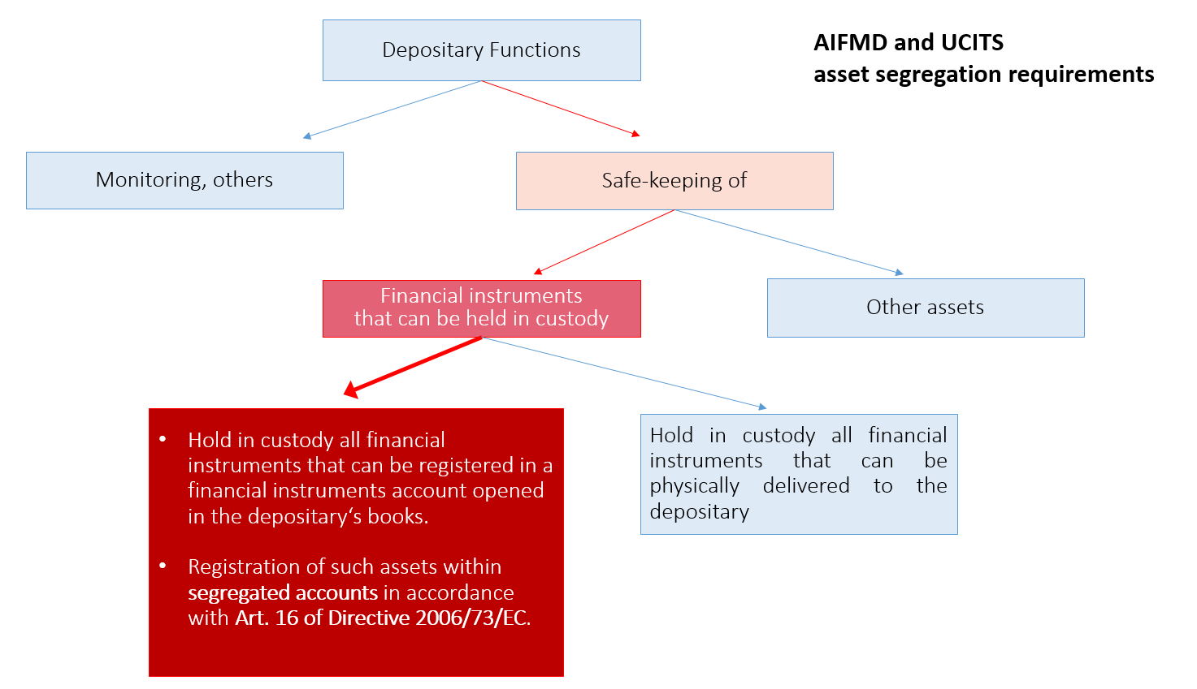

Typically, depositaries that are entrusted with the safekeeping of AIF or UCITS financial instruments are investment firms pursuant to MiFID that also offer safekeeping and administration of financial instruments for the account of (other) clients as an ancillary service pursuant to MiFID II, Annex I, Section B, point (1). For such depositaries, the MiFID requirements (including the principles set out in Article 16 of Directive 2006/73/EC) apply anyway.

We would also like to point out that most financial instruments in which AIFs and UCITS invest need to be registered in book-entry form according to Article 3(1) of the CSDR[1]. Therefore, most AIF or UCITS financial instruments are assets that can be registered in financial instruments accounts with banks already.

Hence, we welcome the fact that both the AIFMD and the UCITS Directive require the principles of Article 16 of Directive 2006/73/EC to be applied by all depositaries in the same way.

**General rules, MiFID requirements**

When considering guidelines for the segregation of financial instruments belonging to AIFs or UCITS, we take the view that general rules on safeguarding client financial instruments (including asset segregation requirements) could serve as a starting point.

We therefore believe it would make good sense to make reference to other MiFID requirements in addition to Article 16 of Directive 2006/73/2006 when regulating the safekeeping of AIF or UCITS financial instruments. This would ensure that depositaries and delegates also operating as MiFID investment firms could rely on their established account holding models and would not have to set up completely new systems and account structures for no benefit at all. It would further ensure that **all** depositaries – even those that do not operate as MiFID investment firms – followed the same rules for safekeeping AIF or UCITS financial instruments in a way that offered robust and safe client protection. Consequently, MiFID requirements like Article 19 of Directive 2006/73/EC[2] could be introduced in ESMA guidelines for the asset segregation of AIF or UCITS assets in order to meet ESMA’s concerns regarding a potential misuse of AIF or UCITS assets.

We therefore take the view that there is no need to introduce specific account holding options (like options 1 to 5).

In fact, IOSCO mentions in its recent work that every jurisdiction in the IOSCO C5 survey responded that the segregation of collective investment schemes’ assets is required under its regulatory regime[3]. To our knowledge and in our understanding, the rules regarding the custody of AIF and UCITS financial instruments have been established in accordance with the general rules on the custody and safekeeping of financial instruments laid down in MiFID as these have proven to be adequate for the protection of client assets for all client categories. With this in mind, we are not aware of any specific reasons which would justify treating AIF or UCITS financial instruments differently to those of other clients, particularly retail clients, in terms of segregation requirements.

It should be borne in mind that MiFID sets tried and tested client protection rules in relation to financial instruments irrespective of the category of client. They are flexible with regard to the different account holding models within the EU. Securities settlement and safekeeping systems have been built and developed over time and are operated in accordance with these rules. Article 16(8) of MiFID II and Article 16 of Directive 2006/73/EC[4] and, in certain cases, complementing national rules ensure the necessary level of asset segregation in order to achieve maximum client protection irrespective of the national model for holding securities as described in **Q1 f)** of the Call for Evidence. Further, MiFID rules already mentioned, such as Article 19 of Directive 2006/73/EC, support achieving the objective of strong and complete client asset protection in the safekeeping of financial instruments.

**Consequences and suggestion**

The operation of securities settlement and safekeeping systems has struck a sound balance between the objectives of client asset protection on the one hand and efficiency on the other. Services have evolved taking into account these circumstances. GBIC believes that any unnecessary new obligation in connection with the AIFMD and the UCITS V Directive guidelines on asset segregation would have a huge negative impact on general safekeeping rules and structures and could, as a result, have unwanted consequences, including negative effects on the performance of AIFs or UCITS without enhancing client protection. Even worse, it might lead to the termination of certain services for AIFs or UCITS, as described in more detail below.

GBIC believes that the requirements laid down in Article 21(8) of the AIFMD and Article 22(5) of the UCITS Directive to hold AIF or UCITS financial instruments in custody in accordance with Article 16 of Directive 2006/73/EC reflect the fact that this rule is a detailed yet flexible arrangement for achieving the level of client protection desired under MiFID. Article 16(8) of MiFID II reads:

“*An investment firm shall, when holding financial instruments belonging to clients, make adequate arrangements so as to safeguard the ownership rights of clients, especially in the event of the investment firm’s insolvency, and to prevent the use of a client’s financial instruments on own account except with the client’s express consent.*”

This MiFID requirement exactly matches, in our view, ESMA’s policy objective set out in paras 7 and 8 of the Call for Evidence. We would therefore urge ESMA to consider the **MiFID Level 2 measures** fleshing out Article 16(8) of MiFID II when creating guidelines to support strong AIF and UCITS asset protection**, instead of options 1 to 5.** These MiFID Level 2 measures offer the necessary flexibility regarding different account holding models in international markets.

Although MiFID rules do not generally apply to depositaries[5], we believe this should not prevent ESMA from making reference to certain MiFID requirements where it is reasonable to do so and where these requirements meet ESMA’s policy objective with regard to depositaries.

In our response, we focus on the asset segregation model and safekeeping requirements which are common in Germany.

TYPE YOUR TEXT HERE

<ESMA_COMMENT_CE_ASCS_1>

1. **Please describe the model of asset segregation (including through the use of ‘omnibus accounts’) in your custody chain/the custody chain of the funds that you manage. Please explain what motivates your choice of asset segregation at each level (e.g. investor demand, local requirements, tax reasons).**

**In your description, please take into account the following:**

1. **please describe – with the use of a chart/diagram – at least three levels of account-keeping in your custody chain, as follows:**
2. **the first level should be the level of the AIF/UCITS-appointed depositary,**
3. **the second level should be the level of a third party delegate of the depositary, and**
4. **the second level should be the level of a third party delegate of the depositary, and**
5. **the third level should be the level of a sub-delegate of the third party delegate or the CSD, where applicable.**

**You may wish to add further levels of accounts, depending on your custody chain.**

1. **if you use ‘omnibus accounts’ (i.e. accounts, in which the assets of different end investors are commingled, rather than each individual investor’s assets being held in a separate account) at any level of the custody chain, please provide, in as clear and detailed a manner as possible:**
2. **an explanation including at which level of the chain you use them;**
3. **a description of the features of these accounts (e.g. whose assets are held in them, who holds title to those assets or is considered to be the end investor, etc. - e.g. AIF, UCITS, other clients, depositaries or their third party delegates);**
4. **an explanation on how any restriction on reuse of the assets applying to the funds (AIF/UCITS) which you have in custody/manage (e.g. the restriction under Article 22(7) of the UCITS Directive) is respected, when they are held in an omnibus account at a given level; and**
5. **the number or percentage of ‘omnibus accounts’ versus ‘separate accounts’ in your custody chain.**
6. **if you do not use ‘omnibus accounts’, please specify why and how far down the chain it is possible for you not to use them (i.e. whether this works in all situations or, if it is necessary to use ‘omnibus accounts’ at some level of the custody chain, at which level)?**
7. **in the chart/diagram to be provided under a), if applicable, please refer to the five options in the table under Q22 below and specify if your model matches or closely matches with any of the models described therein.**
8. **if your model makes any distinction between AIF and UCITS assets, please highlight the difference between the two in the chart/diagram to be provided under a).**
9. **According to a Briefing Note[6] published by ECON in 2011, there are five basic models for holding securities with an intermediary: the trust model**[7]**, the security entitlement model**[8]**, the undivided property model**[9]**, the pooled property model**[10] **and the transparent model**[11]**. ESMA is interested in gathering evidence on whether there may be any link between certain securities holding models and certain asset segregation models. Therefore, ESMA invites stakeholders to provide input to the following questions:**
10. **What securities holding model do you use?**
11. **Is such model the market standard in your jurisdiction?**
12. **Is the market standard model in your jurisdiction one of the five mentioned above, or a different one? If a different one, please provide details.**
13. **Does the model you refer to under f) i) require a particular way of segregating assets or omnibus accounts at one of the levels referred to at letter a) above? If yes, please specify.**
14. **Please explain the naming conventions (i.e. in whose name is the account opened) applied to the accounts with the delegates/sub-delegates of the depositary in the model described under answers to questions a) to e) above. Please also specify if there are instances where the accounts with the immediate delegate of the depositary are opened in the name of the funds.**

<ESMA_QUESTION_CE_ASCS_1>

**Description of the asset segregation model in Germany**

The model of asset segregation (including the use of omnibus accounts) in Germany is based on legal requirements, such as the German Capital Investment Code (*Kapitalanlagegesetzbuch,* KAGB), implementing the AIFMD and UCITS Directive, and the German Safe Custody Act (*Depotgesetz,* DepotG) and the German Banking Act (*Kreditwesengesetz,* KWG). The Capital Investment Code requires the asset segregation of AIF and UCITS financial instruments that can be held in custody in accordance with Article 16 of Directive 2006/73/EC: Section 72(1) point 1(b) and Section 81(1) point 1(b) of the Capital Investment Code stipulate that “*financial instruments that can be registered in financial instruments accounts opened in the depositary’s books shall be registered in the depositary’s books within segregated accounts in accordance with the principles set out in Article 16 of Directive 2006/73/EC, opened in the name of*” the AIFs or UCITS […]. This is direct implementation of Article 21(8)(a)(ii) of the AIFMD and Article 22(5) of the UCITS Directive.

Financial instruments that can be held in custody are, according to Article 12 of the Commission Delegated Regulation (EU) 2016/438 and to Section 1(1) of the Safe Custody Act, securities and other defined financial instruments. The person holding such financial instruments for another person is considered a (securities) custodian pursuant to Section 1(2) of the Safe Custody Act.

Furthermore and pursuant to Section 1(1)2 point 5 of the Banking Act, holding such financial instruments in custody for others is considered a banking service requiring a banking license under the Banking Act. In consequence and within the scope of German law, depositaries always need to be credit institutions in accordance with the Banking Act when safekeeping the above-mentioned financial instruments. Hence, they also have to comply with Section 34a of the German Securities Trading Act (*Wertpapierhandelsgesetz*, WpHG) and Section 14a of the German Investment Services Conduct of Business and Organisation Regulation (*Wertpapierdienstleistungs-Verhaltens- und Organisationsverordnung,* WpDVerOV), which implement Article 13(7) of Directive 2004/39/EC (MiFID I)[12] as well as the associated Level 2 measures of Directive 2006/73/EC.

The obligations under Article 16 of Directive 2006/73/EC satisfy, in our view, ESMA’s policy objective as set out in paras 7 and 8 of the Call for Evidence since these requirements were originally established in order to protect client assets. Article 13(7) of MiFID I and Article 16(8) of MiFID II read: “*An investment firm shall, when holding financial instruments belonging to clients, make adequate arrangements so as to safeguard the ownership rights of clients, especially in the event of the investment firm’s insolvency, and to prevent the use of a client’s financial instruments on own account except with the client’s express consent.*”

In order to achieve a very high level of client asset protection even in the case of limited physically segregated accounts, German national law additionally stipulates in Section 4 of the Safe Custody Act that all assets entrusted with a custodian (e.g. depositary) and delegated to a third-party custodian (e.g. delegate or sub-delegate) are regarded as client assets even if they are held in the same account as the custodian’s proprietary (own) assets. This means that client assets (e.g. AIF or UCITS assets) will always be protected even if commingled with the assets of an entity that becomes insolvent.

These obligations and requirements lead to the following model of asset segregation:

**a) and b)**

Banks in Germany that operate as custodians and thus also as depositaries are able to manage client assets in various ways. It is, however, always required and common to all of them that **full client segregation takes place for all direct clients of a particular intermediary**, i.e. at each level of the custody chain. At the level of any given intermediary and from the perspective of that intermediary, **no use of omnibus accounts** normally takes place.

This means that

* intermediaries operating as a depositary segregate AIF or UCITS financial instruments in segregated accounts for each of the AIFs or UCITS. They also segregate financial instruments belonging to other clients in segregated accounts for each of these other clients.
* Intermediaries operating as a delegate segregate financial instruments in segregated accounts for each of their direct clients (i.e. depositaries or other clients).
* Intermediaries operating as a sub-delegate segregate financial instruments in segregated accounts for each of their direct clients (i.e. delegates or other clients).
* The German CSD Clearstream Banking AG Frankfurt segregates financial instruments in segregated accounts for each of its direct clients (i.e. banks operating as sub-delegates, delegates, depositaries or banks safekeeping their own or other clients’ assets).

Under Section 14 of the Safe Custody Act, every custodian is obliged to keep books and records in which to register every depositor and the kind, amount, number and other criteria specific to the particular financial instrument that is held in custody for them. If custody services are delegated, the third-party custodian also needs to be registered. Under Section 14a(3) of the Investment Services Conduct of Business and Organisation Regulation, investment firms (e.g. depositaries and delegates) are obliged to ensure the allocation of assets to each of their clients by means of accurate books and records at all times, to reconcile on a regular basis and to have adequate arrangements in place so as to minimise any risk of loss.

However, when delegating the safekeeping of assets to a third party, the assets of several clients from separate (internal) accounts are entrusted to that third party. Such third party may hold the assets of these clients (commingled) in one account under the name of the delegating intermediary who is the third party’s client (Section 3 of the Safe Custody Act). From the perspective of the delegating intermediary, the third party “uses” an external account which is an omnibus account. From the perspective of the third party, however, this account is a separate account as the account holds assets for one of its clients (i.e. the delegating intermediary) and the assets in the account are segregated from the assets of other clients of that third party. The use of omnibus accounts does not, in consequence, take place at the level of a delegating intermediary but always at the next level(s), i.e. at third-party level:

* From the perspective of a depositary, a “use” of omnibus accounts takes place at the next levels, i.e. at the level of the delegate, the sub-delegate or the CSD.
* From the perspective of a delegate, a “use” of omnibus accounts takes place at the next level, i.e. at the level of the sub-delegate or the CSD.
* From the perspective of a sub-delegate, a “use” of omnibus accounts only takes place if there is a level beyond such sub-delegate, like at the level of a sub-sub-delegate or of the CSD.
* From the perspective of a CSD, a “use” of omnibus accounts takes place at the next level, i.e. at the level of a foreign sub-delegate or CSD.

This account holding model is required by German law (Sections 3, 5 and 14 of the Safe Custody Act) in compliance with the segregation requirements pursuant to MiFID. The following chart demonstrates the legally prescribed standard account holding at each level of the custody chain:

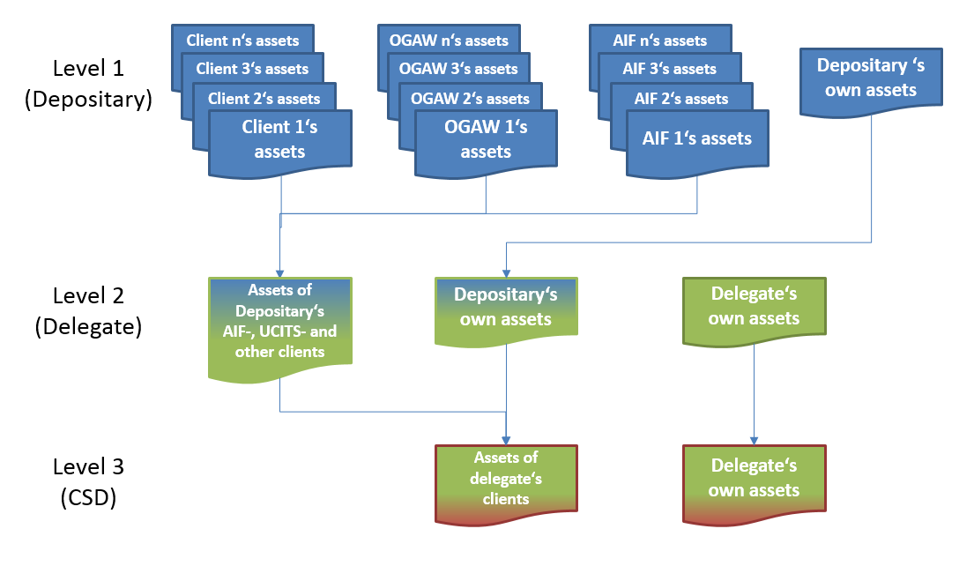

It should be noted, though, that due to, and within the scope of, the above-mentioned Section 4 of the Safe Custody Act and in accordance with Article 16 of Directive 2006/73/EC and Sections 3 and 5 of the Safe Custody Act, the delegate can even keep the depositary’s own assets in the same account as the assets of the depositary’s clients. Consequently, the same applies at the level of the sub-delegate or CSD operating within Germany.

Omnibus accounts are thus used on every level beyond level 1. From the perspective of each level, the accounts are described in the following three charts:

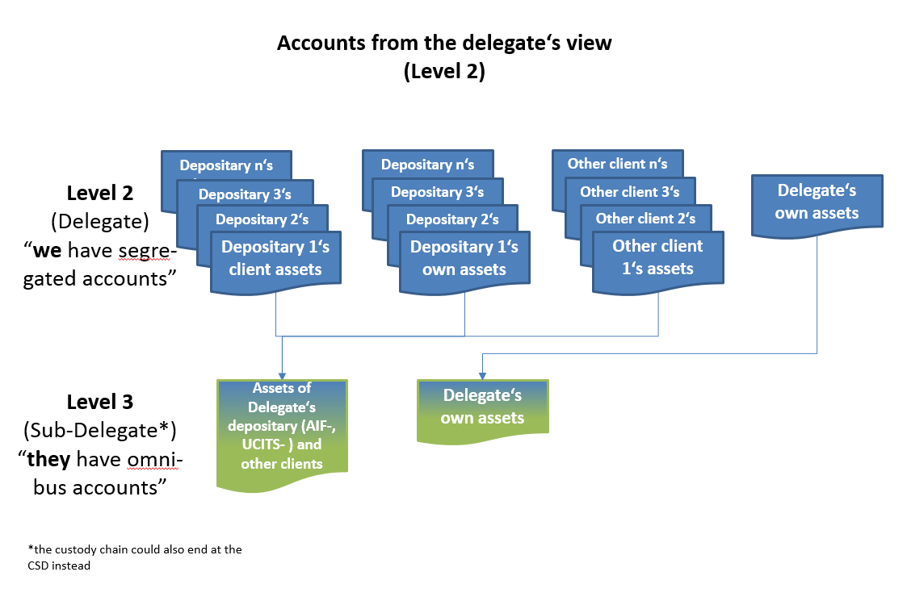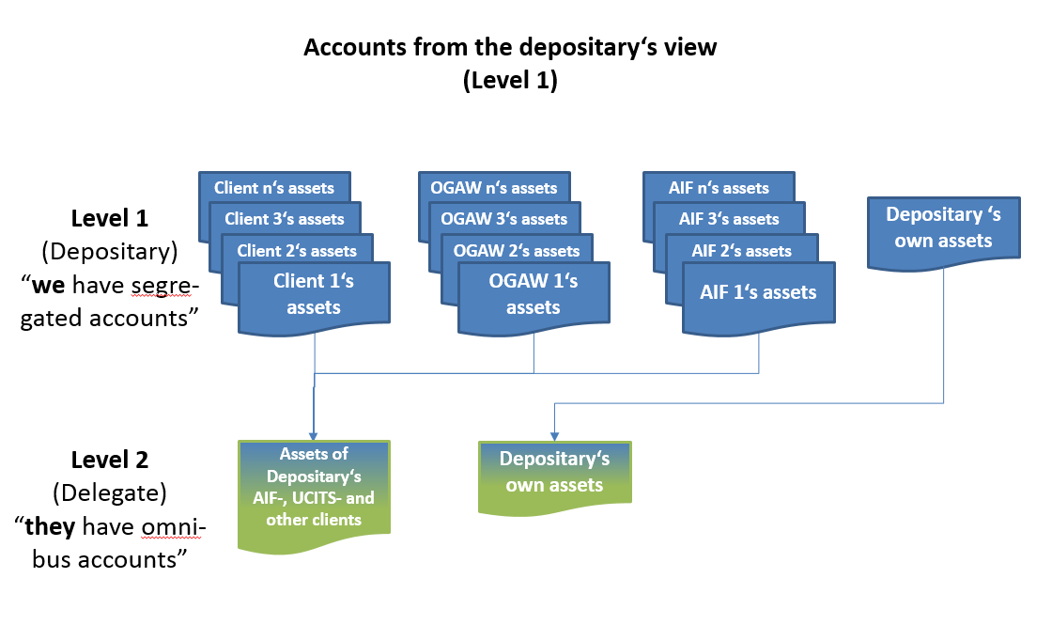

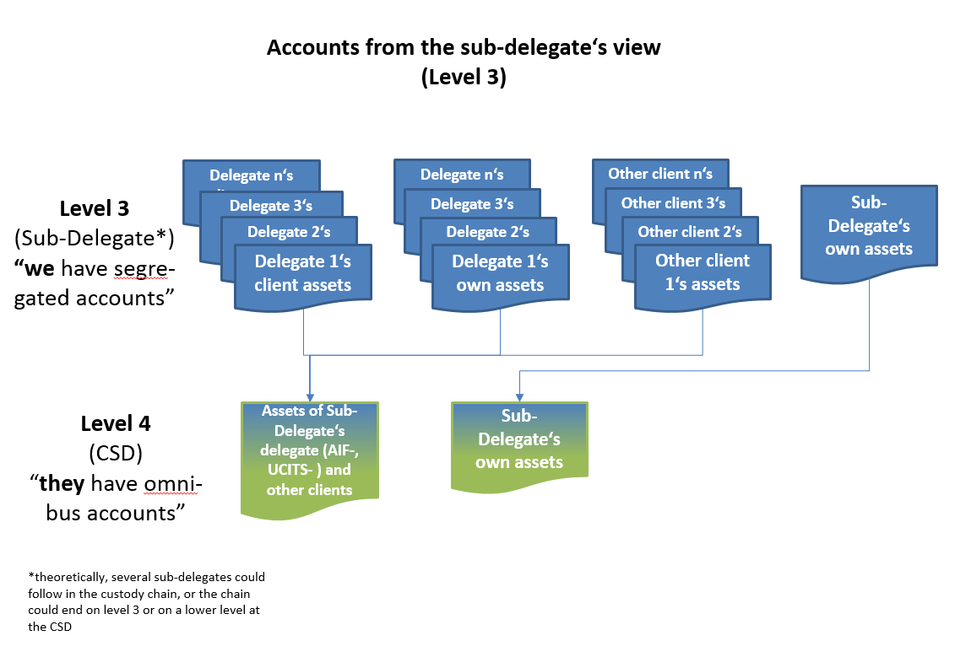

The segregation of assets on each level of the custody chain is motivated by the obligation to keep adequate and orderly accounts. The integrity, accuracy, meaningfulness and verifiability are not only part of proper record-keeping in general but also requirements laid down in item 10 of the announcement by the German Federal Supervisory Office for Banking (the predecessor of BaFin) on the requirements for the proper functioning of custody services and for the fulfilment of obligations associated with delivering securities (*Bekanntmachung des Bundesaufsichtsamtes für Kreditwesen über die Anforderungen an die Ordnungsmäßigkeit des Depotgeschäfts und der Erfüllung von Wertpapierlieferungsverpflichtungen*).

Every custodian which is entrusted with the custody of securities or which further delegates such custody to another (third-party) custodian is required to keep a custody ledger (books). This ledger has, or these books have, to be organised in such a way that the custodian is able to match securities to depositors.

The motivation for allowing third-party custodians to “use” omnibus accounts is to have an efficient yet safe securities safekeeping system which enables swift and reliable securities settlement. A potential misuse of the omnibus account holding structure is prevented by internal systems in accordance with Article 19 of Directive 2006/73/EC supported by making the incorrect handling of client assets a criminal offence under Section 34 and 35 of the Safe Custody Act.

In only a very few cases are segregated accounts opened on the next level at the investor’s request. Investors normally request the use of omnibus accounts. As we will explain below in our responses to other questions in the Call for Evidence, investor demand is dependent on the services expected (e.g. effective collateral management), the protection of their assets (e.g. the insolvency remoteness of their assets held in custody) and costs (e.g. the price to be paid for the account structure in question).

We note that within the EU, there are two fundamentally different models for client accounts:

a. Direct account holding: Some member states (e.g. the Nordic countries) employ a custody structure in which accounts are separately carried for each end investor, all the way down the chain to the level of the issuer CSD. When delegating the custody of assets to a third party, the third party administers the assets as an account operator in as many accounts as the delegating intermediary. Also from the perspective of the delegating intermediary, no omnibus accounts are used and the assets of its clients are not commingled in one account at the next level. These structures function only within the respective domestic markets[13], and thus where investors in these countries wish to invest abroad, omnibus accounts must be employed.

b. Omnibus account holding: Other member states, like Germany, employ custodial structures which enable sub-custodians (such as the delegate) to aggregate the assets of the various indirect clients (such as AIFs or UCITS) of one direct client (such as the depositary) into a single collective “omnibus” account of that direct client. These structures work equally across national borders.

**Whose assets are held in the accounts?**

In Germany, it is common that a delegate holds assets of more than one indirect client in a single account. The account can, therefore, be called an omnibus account although, in the view of the delegate, the omnibus account is an account segregating assets of one direct client (and containing assets of several indirect clients) from the assets of other direct clients. The assets held in such an account can be the assets of

* the depositary, and/or
* the depositary’s clients.

If a sub-delegate operates such an account, the assets held in it can be the assets of

* the delegate, and/or
* the depositary, and/or
* other depositaries and/or
* the depositary’s clients and/or
* other depositary’s clients.

**Who holds title to those assets?**

The person at the beginning of the holding chain holds title to those assets. Ownership lies with the end investor, e.g. the retail client, the AIF, the UCITS or legal entity who first entrusts a custodian with the custody of the assets and who does not safekeep the assets for another person but holds them for its own account. In our chart, this would be the persons or entities on the left, even if the holding chain runs all the way down to the CSD:

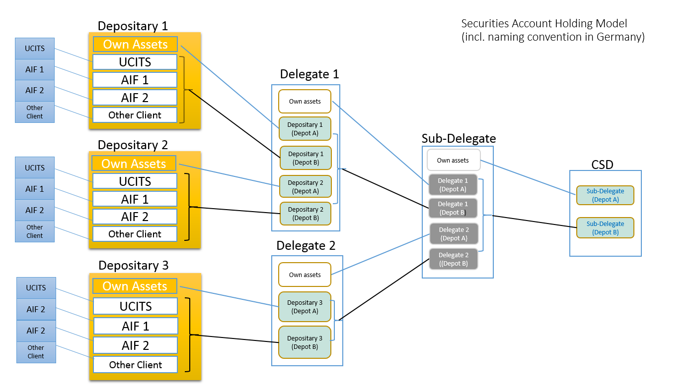

Please also refer to the above chart for the question regarding the naming convention.

**Explanation on how any restriction on reuse of the assets applying to the funds (AIF/UCITS) which you have in custody/manage (e.g. the restriction under Article 22(7) of the UCITS Directive) is respected, when they are held in an omnibus account at a given level**

In Germany, the reuse of any client assets is restricted to cases where explicit prior client consent has been given. As this rule (**Article 19 of Directive 2006/73/EC**) applies to all client assets, AIF and UCITS assets are included. Furthermore, item 9 of the announcement by the Federal Supervisory Office for Banking referred to above prohibits the use of assets that do not belong to the seller or to the custodian in the delivery of selling orders.

Therefore, tools and systems are in place at our member banks to avoid any unpermitted use or reuse of client assets. These tools and systems differ from member to member. They include, for example, the delivery management of the custodian and the referencing of trade and transfer orders. Furthermore, a hold and release mechanism is common in the settlement of securities. An intermediary sending a settlement instruction for a specific client to the next level intermediary puts the instruction on hold if not enough securities are in the client’s account and only releases the instruction if the securities are in the client’s account on the intended settlement date. For AIF or UCITS assets, the depositary would be prevented from using the assets for its own or for other clients’ account. The depositary would therefore not be allowed to send an instruction for assets held in an omnibus account at the next level custodian (i.e. delegate). The delegate could not release any assets from that omnibus account without the explicit instruction of the depositary. Apart from the obligation set out in Section 34a of the Securities Trading Act to comply with the above-mentioned mechanisms, other legal measures support this principle: Sections 34 and 35 of the Safe Custody Act deem any wilful breach of this obligation a criminal offence. In-house controls and the “four eyes” principle apply. Furthermore, compliance is supervised by auditors and the national supervisory authorities.

**The number or percentage of “omnibus accounts” versus “separate accounts” in the custody chain**

GBIC would like to make ESMA aware that this question could be misleading. For the German market, for instance, there is no ratio which would add up to 100% of all accounts used. As set out above, the use of omnibus accounts and separate accounts depends on the perspective of each intermediary at its own level. Furthermore, the use of certain accounts depends on the requirements in other jurisdictions. Given that only accounts in Germany should be considered for this response, we would estimate the following:

On each level of the custody chain, 100% separate accounts are used for direct clients.

Regarding the next level of the custody chain, especially where external third parties are entrusted with the custody of client assets, almost 100% of the client assets are held in omnibus accounts. In a few cases and only at the client’s express request, client assets are held in single individually separated accounts at the next level custodian. In other cases (and at the client’s request), client assets of specific clients are held in segregated omnibus accounts at the next level custodian. This means that, in addition to the traditional omnibus account, another separate account is operated by the next level custodian for the assets of certain clients. As the assets of these clients are commingled in that separate account, it should also be called an omnibus account.

**c) no use of omnibus accounts**

Not applicable

**d) Five options in the table under Q22 below and specification if our model matches or closely matches with any of the models described therein**

As already mentioned in our introduction, we take the view that there is no need to introduce specific account holding options for the custody of AIF or UCITS financial instruments (like the five options in the table under **Q22**). We believe it would be advisable instead to make reference to existing account holding structures in all member states which can also serve as structures for depositaries holding such assets. MiFID Level 2 measures flesh out Article 16(8) of MiFID II. A clarification that besides Article 16 of Directive 2006/73/EC, other MiFID Level 2 measures should also apply could achieve the desired level of client protection in all different account holding models within the EU and globally.

With respect to ESMA’s specific question, GBIC would like to mention that, due to the addition of the sub-delegate level, the description of the five options in the table under **Q22** is slightly different than in the Consultation Paper of 2014. The originally presented options read:

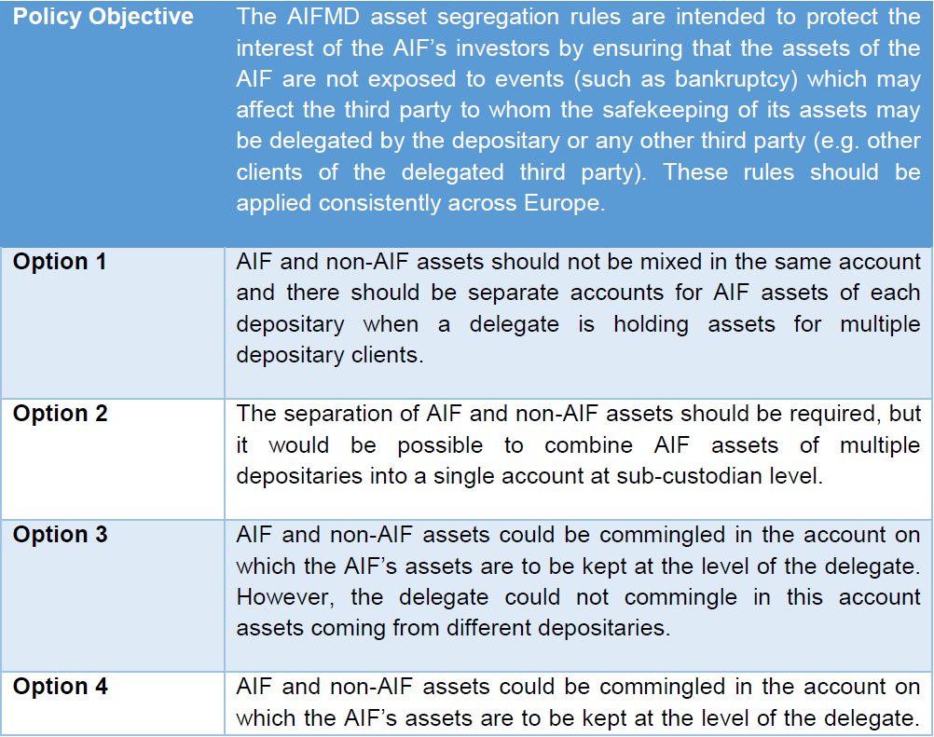

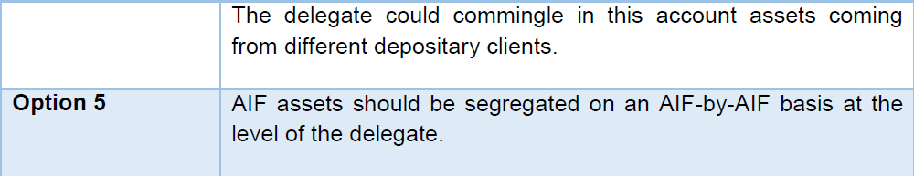

In our reply to the 2014 consultation, we stated that option 3 would best fit the present model in Germany and would also fulfil the purposes of the policy objective. The same would have applied to option 4, though in this option it was not clear enough in our view that assets from different depositaries should not be commingled. We believe the last sentence of the original option 4 should have read “The delegate could commingle in this account assets coming from different depositar**ies’** clients.”

However, the changes to the descriptions of the options in the table under **Q22**, particularly to option 3 and option 4, now make it very difficult to find a matching option.

The account holding model in Germany matches closest with option 3 and option 4.

Option 3:

Our account holding model matches the first paragraph of the description of option 3, which is also the option 3 originally presented by ESMA. The new second paragraph, however, is now inconsistent with our account holding model. In fact, we believe that the new second paragraph is not in line with Article 21(11) subparagraph 4 of the AIFMD and Article 22a(3) subparagraph 3 of the UCITS Directive, which stipulate that “*The third party may, in turn, sub-delegate those functions, subject to the same requirements*”. In order to fully match our account holding model, the second paragraph of the current option 3 would have to read “When the delegate appoints a sub-delegate, the sub-delegate could commingle in the same account AIF and non-AIF assets coming from different depositaries”. This is because no segregation needs to take place for AIF assets at the level of the sub-delegate and assets from different depositaries can also be commingled.

Option 4

Our account holding model closely matches the first paragraph of the description of option 4, which is also the option 4 originally presented by ESMA. In order to fully match our account holding model, the first paragraph needs to be adapted as set out above (depositaries’ clients) and the new second paragraph of the current option 4 should read “When the delegate appoints a sub-delegate, the sub-delegate could commingle in the same account AIF and non-AIF assets coming from different depositaries and assets coming from the delegates’ clients.” This is because depositaries own assets, in particular, do not need to be segregated within Germany.

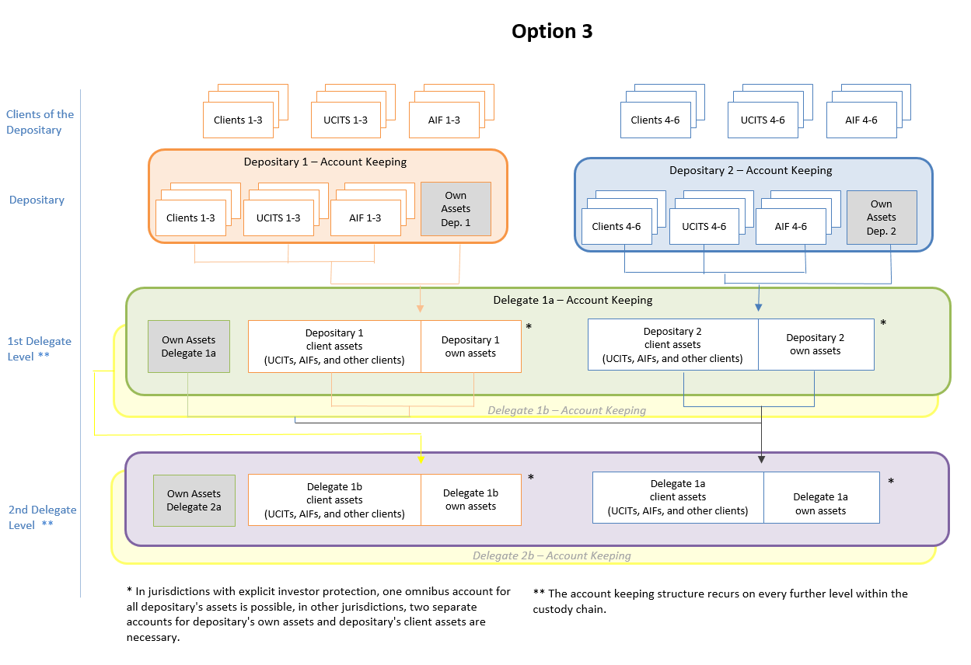

**e) model making any distinction between AIF and UCITS assets**

No distinction is made between AIF and UCITS assets in our model.

**f) ESMA is interested in gathering evidence on whether there may be any link between certain securities holding models and certain asset segregation models. Therefore, ESMA invites stakeholders to provide input to the following questions**

Regarding the five models described in **Q1 f)**, we would like to mention that these models refer to the legal nature of securities in different jurisdictions. They refer to the ownership of the securities within a holding chain but do not necessarily require a segregation of assets. Quite the contrary, some of the models require assets to be pooled or commingled in order to fit the purpose of the legal concept behind it. The German market can be described as a **pooled property model**. It is the market standard. It is, moreover, not only the market standard but the legally required model for securities admitted to trading on trading venues.

The model itself is not dependent on accounts but on the idea that paper certificates of securities are immobilised in one certificate, which represents the whole issue, and all rights are pooled in this certificate (Section 5 of the Safe Custody Act). Consequently, the safekeeping of the global certificate holds all rights of all end investors. The CSD does not own the certificate. Ownership of the securities remains with the ultimate investor. The debit and credit in the accounts reflect a legal position in the securities which is, however, not ownership. Rather, the intermediaries’ willingness to possess the securities for a certain person is documented.

For this concept of securities holding to work efficiently, omnibus accounts should be used on each level beyond the depositary.

**g) Please explain the naming conventions (i.e. in whose name is the account opened) applied to the accounts with the delegates/sub-delegates of the depositary in the model described under answers to questions a) to e) above. Please also specify if there are instances where the accounts with the immediate delegate of the depositary are opened in the name of the funds**

The naming conventions are laid down in Section 154 of German Tax Code (*Abgabenordnung,* AO), Sections 14 and 3 of the Safe Custody Act and the announcement by the Federal Supervisory Office for Banking referred to above. As a general rule (Section 154 of the Tax Code), an account has to be opened in the name of the client, using the full, true name and identity (date of birth and place of residence/registered seat). According to Section 14 of the Safe Custody Act, the books and records need to show the depositor of the assets, whereby the depositor is not necessarily the owner or end investor of the assets. In a custody chain, only in the books (i.e. the client’s account) of the first custodian that received the assets from the owner will show the name of that owner[14]. If the custodian delegates the custody to a third party, the third party is to name the account in its books and records after the first custodian[15]. According to Section 3 of the Safe Custody Act, the custodian is entitled to entrust the assets under its name to a third-party custodian. The books are to be listed in the order of the depositors. This means that the records in the book also serve as a personal account for each depositor[16].

Accounts are therefore opened in the name of the intermediary’s client:

* At depositary level, accounts are opened in the name of the natural person, the entity, the AIF or the UCITS who is the client of that depositary.
* At delegate level, accounts are opened in the name of the depositary (although holding clients’ assets).
* At sub-delegate level, accounts are opened in the name of the delegate (although holding clients’ assets).
* At CSD level, accounts are opened in the name of the CSD client which is also the CSD participant (although holding assets for other banks and clients).

At delegate level, accounts are not opened in the name of funds (AIF/UCITS) if these are clients of a depositary. The account will always be opened in the name of the depositary. Accounts are only opened in the name of the funds if the funds are direct clients of the delegate. In this case, however, the delegate is not considered to be a delegate but a depositary.

Furthermore, item 10(4) of the announcement by the Federal Supervisory Office for Banking referred to above requires that, along the custody chain, accounts at the sub-custodian (e.g. delegate) holding own assets of the depositing bank (e.g. depositary) must be named “Depot A” whereas accounts holding client assets must be named “Depot B”. Besides these accounts, special accounts exist for pledged securities (“Depot C” and “Depot D”). Please also refer to our chart “Securities Account Holding Model (incl. naming convention in Germany)” in our response to **Q1 a)+b)** above.

TYPE YOUR TEXT HERE

<ESMA_QUESTION_CE_ASCS_1>

1. **Please explain how, under the framework you have described in your response to Q1, the assets of the AIF/UCITS are protected against the insolvency of any of the parties involved in the custody chain (depositary, delegate, sub-delegate, – including prime broker – CSD) and – in case of use of ‘omnibus accounts’ – of their other clients whose assets are also held in this same account. In particular, what happens if a party, whose assets are held in another party’s ‘omnibus account’, becomes insolvent? Does this place at any disadvantage the other parties using the omnibus account who are not in default?**

<ESMA_QUESTION_CE_ASCS_2>

**Custody in Germany**

AIF/UCITS assets are protected against the insolvency of any of the parties involved in the custody chain (be it a depositary, delegate, sub-delegate or CSD) irrespective of the type of account used – segregated account or omnibus account – and irrespective of the function of the party – be it acting as a prime broker or not.

Civil and insolvency laws in Germany protect the ownership of securities held by custodians as they ensure that all custodians hold assets for their clients in a way which is insolvency remote. All clients of a custodian are protected in the same way. The rules are laid down in Section 47 of the German Insolvency Statute (*Insolvenzordnung*, InSO) in conjunction with Sections 6, 7 and 8 of the Safe Custody Act, pursuant to which the depositor and owner of securities can ring-fence and claim the ownership and delivery of the assets held in custody if the custodian becomes insolvent.

The obligation to keep books and records for the depositor in accordance with Section 14 of the Safe Custody Act supports investor protection. The depositor’s legal position is documented in the custody ledger (books and records), which puts the depositor in the position to demonstrate its rights, the custodian in the position to safekeep and administer the financial instrument in an orderly manner, and the supervisory authorities in a position to monitor the custody services of the custodian[17]. Pursuant to item 10 (bookkeeping) of the announcement by the Federal Supervisory Office for Banking referred to above in our reply to **Q1**, the books and records need to provide adequate means of assessing which assets belong to which depositor, and the custodian needs to establish reliable control systems.

Furthermore, and to cite a specific counterexample to account segregation being needed for investor protection, Section 4(1) of the Safe Custody Act provides a very high degree of investor protection even in the case of limited physically separated accounts: all assets entrusted to a custodian (e.g. a depositary) and delegated to a third-party custodian (e.g. a delegate or sub-delegate) are regarded as client assets even if they are held in the same account as the custodian’s (i.e. depositary’s) proprietary (own) assets. This means that client assets (e.g. AIF or UCITS assets) are always protected even if commingled with the assets of the entity that becomes insolvent.

This shows effectively that asset segregation may be successfully achieved not only through physically separate accounts but also through technical or record-keeping mechanisms. Where omnibus accounts are used, technical or record-keeping mechanisms are a prerequisite for operating them.

Investor protection against depositary or delegate insolvency is determined not only by account-level asset segregation. In fact, Section 47 of the Insolvency Statute and the laws for claiming the return of assets held in custody play a far greater determining role.

Account segregation at delegate or sub-delegate level (or at the national CSD Clearstream Banking AG – CBF) would not improve *legal* protection in Germany. The right of clients to ring-fence their assets in the event of the insolvency of the custodian is ensured by Section 47 of the Insolvency Statute in conjunction with Section 985 of the German Civil Code (*Bürgerliches Gesetzbuch*, BGB) and Sections 6, 7 and 8 of the German Safe Custody Act. This right invariably applies, even if a custodian’s own assets and its clients’ assets are held in a single account at a third party custodian or CBF. The fact that assets are held in collective custody at a third party does not affect the client’s legal right in rem.[18] The same is true of a global certificate physically held in collective custody at CBF in accordance with Section 9a(2) of the Safe Custody Act. In addition, any third-party custodian (including CBF) is obliged under Section 4(1) of the Safe Custody Act to assume that assets belong to clients of a custodian (or CSD participant respectively), not to the custodian (or participant) itself. Owing to Section 47 of the Insolvency Statute in conjunction with Section 985 of the Civil Code and Sections 4, 7 and 8 of the Safe Custody Act, it is therefore totally irrelevant which intermediary in the custody chain becomes insolvent, whether several intermediaries become insolvent and whether the assets of an insolvent intermediary and client assets are held in the same account. The client’s assets are protected in any event.

It is also totally irrelevant whether another client whose assets are in the same omnibus account becomes insolvent. Under Section 6(2) of the Safe Custody Act, the release of a client’s assets from an omnibus account does not depend on the agreement of other parties using the same account.

**Custody outside Germany**

The above-mentioned high standards of client asset protection set the minimum requirements for client assets to be held outside Germany. In order to protect client assets, including those of AIFs and UCITS, especially in the event of insolvency, a number of requirements need to be fulfilled. Where protection like in Section 4 of the Safe Custody Act does not exist, for instance, client assets must not be commingled with the custodian’s own assets.

Custodians of AIF or UCITS assets have to verify the following (by due diligence) when entrusting assets to third parties outside Germany:

All client assets need to be effectively protected, particularly in the case of insolvency. It is therefore common to agree a so-called three-point declaration between domestic custodians (e.g. depositaries) and non-domestic sub-custodians (e.g. delegates). The aim of the three-point declaration is to ensure by contractual agreement that non-domestic counterparties apply domestic client protection standards. In this agreement, the degree of the necessary asset segregation is determined (e.g. acknowledgement of assets being client assets, the separation of assets from the delegate’s assets), claims of the non-domestic custodian against the assets are restricted (i.e. liens, rights of retention or similar rights over the assets are only permissible if claims as have arisen in relation to the direct acquisition of those assets) and the custody of the assets takes place within the borders of the delegate’s jurisdiction and may not be delegated without the delegate’s prior consent. The effectiveness of such agreements and, in particular, the insolvency resistance, is additionally ensured by a legal opinion.

Auditors and supervisory authorities verify the existence of relevant three-point declarations on a regular basis.

TYPE YOUR TEXT HERE

<ESMA_QUESTION_CE_ASCS_2>

1. **Please describe the differences (if any) between ‘omnibus accounts’ (i.e. books and records segregation) and separate accounts in terms of return of the assets from the account in a scenario of potential insolvency or insolvency. In particular, please indicate whether the assets may be transferred to the depositary or another delegate more easily and/or quickly under a particular insolvency regime from either of the two types of account and explain why. If possible and relevant, please (i) distinguish among the various jurisdictions of which you have knowledge and (ii) explain whether a specific type of account may have an impact on the timeline for the aforementioned transfer of assets or, more generally, on the order of events in a scenario of potential insolvency or insolvency.**

<ESMA_QUESTION_CE_ASCS_3>

The return of assets held in a securities account is governed in Germany by Sections 7 and 8 of the Safe Custody Act. The depositor’s rights are vis-à-vis the depositary. The ability to demand a return of the assets does not depend on whether the depositary has separate or omnibus accounts.

The way in which assets are held could only make a difference in one respect: if assets are held in collective safe custody, depositors have a right to assets, but not necessarily the very same assets they deposited. If, by contrast, the assets are held in physically individual safe custody, the depositor can demand the return of the same assets which were deposited. The custody of physically held financial instruments is, however, not within the scope of the AIFMD and UCITS Directive asset segregation requirements.

It should also be borne in mind that individual safe custody is highly unusual and costly. Moreover, this type of safe custody is already not permitted in Germany for securities which are admitted to trading on trading venues. Assets are normally kept in collective safe custody and held by the CSD in a global certificate. Even in collective safe custody, it is possible to book assets to segregated individual accounts or to omnibus accounts. This makes no difference to the return of the assets, either in the event of insolvency or in the course of a routine transaction.

Nor does the separation of accounts offer the client any advantages in terms of *procedure*, particularly when it comes to determining the client’s ownership or co-ownership of assets and releasing them in the event of a participant’s insolvency. Regardless of whether a delegate holds its own and third-party assets in a single account or maintains separate accounts, the books of the depositary need to be consulted and an instruction is needed from the client. Even if a separate account is maintained for each individual client, this procedure (examination of the books and an instruction) is still necessary since the client is not the holder of the account with the delegate. Without an instruction from the depositary (or its insolvency administrator), the delegate is not permitted to transfer any assets from the account – even if separate accounts are maintained for each individual client. In Germany, therefore, the existing legal framework already offers without segregation within an omnibus account a level of protection which matches that envisaged by the European Commission and by ESMA for individual client segregation in accordance with option 1 of the Call for Evidence and Article 38 of the CSD Regulation.

So it is reasonable to assume that it will be quicker and less complicated to transfer assets from an omnibus account than from individually segregated accounts. If assets are segregated at each level, there will be further subdivisions of holdings, which will each have to be reconciled with those at the next highest level. If assets are held in an omnibus account, by contrast, it will only be necessary to check whether the aggregate holdings match the holdings of the depositors. This can be accomplished in a single step with a single checking process by a single party, while individually segregated accounts would require a number of checks and involve a number of parties. In consequence, transferring assets from a segregated account is likely to take longer and be a more complex process.

We would also like to mention a statement by one of the partners of PricewaterhouseCoopers LLP (PwC), who led the Lehman Brothers International (Europe) insolvency administration on behalf of PwC. In this statement[19], the reasons for the length of time needed to return assets held in an omnibus account structure are explained. PwC comes to the conclusion that many steps for the verification of claims were needed, and individually segregated accounts would have required the same steps plus additional reconciliation work for the segregated accounts. We believe that this statement confirms our assumption that further account segregation does not offer any advantages in terms of easier or quicker return of assets in the event of insolvency.

TYPE YOUR TEXT HERE

<ESMA_QUESTION_CE_ASCS_3>

1. **Should you consider that asset segregation pursuant to options 1 and 2 of the CP does not provide any additional protection to the existing arrangements you described in your response to Q1 in case of insolvency, and that these arrangements provide adequate investor protection, please explain which aspects of the regime contribute to meeting the policy objective through measures including:**
2. **effective reconciliation,**
3. **traceability (e.g. books and records), or**
4. **any other means (e.g. legal mechanisms).**

**Please justify your response and provide details on what any of the means under i) to iii) consist of.**

<ESMA_QUESTION_CE_ASCS_4>

GBIC believes that a combination of all three measures contribute to meeting the policy objective:

**i) effective reconciliation**

Daily reconciliation comprises, inter alia, the automated comparison of

* external positions reported by the next level in the custody chain with positions of own records
* transactions reported by the next level in the custody chain with completed transactions in the own system.

With this approach, any mismatches can be identified early in the process and potential incorrect bookings corrected.

Our members also rely strongly on process automation, which reduces the reliance on human intervention.

**ii) and iii) traceability and other means**

Books and records enable traceability. Legal mechanisms (e.g. coordinated civil and insolvency legislation protecting clients assets and requirements for orderly record and bookkeeping) complement these measures. Besides the obligations laid down in Section 14 of the Safe Custody Act, item 10 of the announcement by the German Federal Supervisory Office for Banking referred to in our reply to **Q1** spells out the organisational measures. Custodians need to have internal work instructions for the bookkeeping of securities accounts, which also have to be presented to the auditor. These instructions need to comprise precise descriptions of the booking process, the maintenance of the custody ledger (books), the manual control mechanisms and the measures for separating staff duties and responsibilities. All automated and organisational control mechanisms of the IT processes have to be described. Internal and external inspections can assess measures, proportionality and effectiveness at any time. A risk analysis takes place periodically. All manual controls and the results of automated controls and reconciliations have to be documented. The books and records always need to be up to date, complete, correct and controllable.

Furthermore, depositaries and delegates are, like MiFID investment firms, obliged to comply with Section 14a(3) of the Investment Services Conduct of Business and Organisation Regulation, under which they need to ensure the allocation of assets to each of their clients by accurate books and records at all times, to reconcile on a regular basis with the holdings at the third-party custodian and to have adequate arrangements in place to minimise any risk of loss. Furthermore, Section 14a(5) of the Investment Services Conduct of Business and Organisation Regulation stipulates that the correct distinction between client and proprietary assets must be ensured at all times.

Additionally, the so-called four-eye principles apply to any manual intervention in the process in order to avoid the misuse of system infrastructure and minimise fraudulent behaviour.

TYPE YOUR TEXT HERE

<ESMA_QUESTION_CE_ASCS_4>

1. **In the chart below (option 1 of the CP), AIF 1 would only have recourse against Depositary 1 under the PRIMA concept.**
2. **In the event of, for instance, a default of Depositary 2, would separate accounts at the level of the Delegate make it easier for Depositary 1 to enforce the rights in respect of the assets held in the account on its behalf against the Delegate?**



1. **In the event of the default of the Delegate, would separate accounts at the level of the Delegate make it easier for Depositary 1 and Depositary 2 to enforce their rights in respect of the assets held in the account on their behalf against the Delegate or its liquidators?**

<ESMA_QUESTION_CE_ASCS_5>

It is our understanding that the general civil law concept of contractual relationships between the parties in a custody chain determines that one party can only enforce property (and other) rights directly against the immediate next level, but not against further levels in the chain, unless contractual rights have been assigned or rights to skip a party in the chain are provided for by law. It is not, however, the concept of PRIMA which requires a party to enforce rights directly against its contractual counterparty, the immediate person on the next level in the chain. The concept of PRIMA, in contrast, determines the applicable law for the enforcement of property rights in securities in cases where the custody chain runs across borders. It is, in fact, a conflict of laws rule.

Having said this, we agree that, in the chart in **Q5**, AIF 1 would only have recourse against its contractual counterparty, Depositary 1, which would, in turn, have recourse against its contractual counterparty, the Delegate.

**Example a)**

In the event of a default by Depositary 2, AIF 1 is not affected. The default would only affect Depositary 2’s clients, i.e. AIF 4.

AIF 1 can enforce its rights against Depositary 1 and Depositary 1 against the Delegate under Section 47 of the Insolvency Statute in conjunction with Section 985 of the Civil Code and Sections 6, 7 and 8 of the Safe Custody Act.

Further segregation of accounts would therefore not simplify the enforcement of rights.

**Example b)**

In the event of a default by the Delegate, Depositaries 1 and 2 and all their clients (AIF 1 to 4) could theoretically be affected by the default. However, in the German account model, Depositary 1 has one account and Depositary 2 has another account with the Delegate. Under German law, all assets held in these accounts are insolvency remote, meaning that Depositary 1 and Depositary 2 can each enforce their rights in respect of the assets held in these accounts against the Delegate and/or its liquidators. It would make no difference if Depositary 1 and 2 each held more than one account with the Delegate. More separate accounts would not make it easier to enforce their rights under Section 47 of the Insolvency Statute in conjunction with Section 985 of the Civil Code and Sections 6, 7 and 8 of the Safe Custody Act.

Hence, also in case b) further segregation of accounts would not simplify the enforcement of rights.

TYPE YOUR TEXT HERE

<ESMA_QUESTION_CE_ASCS_5>

1. **Many respondents to the CP argued that, in an insolvency scenario, imposing a model where investors have individual accounts throughout the custody chain would not necessarily provide any particular benefit over the use of IT book segregation in an omnibus account (i.e. books and records instead of separate accounts). Please explain how the level of protection indicated in the policy objective at the start of this paper can be achieved through the use of omnibus accounts. Please also:**
2. **describe how segregation in books and records would ensure the aforementioned investor protection;**
3. **provide an example of how such books and records are used in insolvency proceedings to trace and return client securities when omnibus accounts are used; and**
4. **explain how the above-mentioned segregation in books and records would address any of the risks of ‘omnibus accounts’ mentioned in recent IOSCO work[20].**

<ESMA_QUESTION_CE_ASCS_6>

**a) and b) books and records**

As already set out in detail in our responses to **Q1** to **Q5**, the use of IT book segregation in an omnibus account provides sufficient client protection in an insolvency scenario.

In summary: in accordance with AIFMD and UCITS rules, assets are clearly identifiable in books and records, which will allow the depositary and delegates to further identify assets on each level. Robust operational controls (due diligence, operational efficiency, strong control framework, scalable and efficient technology) ensure that the books and records, supported by daily reconciliation, distinguish proprietary (own) assets from client assets. In the event of the custodian’s default, the client assets are ring-fenced and separated from the defaulted party’s estate.

**c) IOSCO work**

Potential misuse of assets held in omnibus accounts is addressed by the MiFID requirements, particularly by **Article 19 of Directive 2006/73/EC**, which apply to custodians. Systems and mechanisms exist for omnibus accounts to prevent the use of client assets for own or other clients’ account. For more details, please refer to our responses to **Q1 b) III)** and **Q4** above.

We therefore do not agree that the risks of omnibus accounts mentioned in recent IOSCO work exist in Germany. Furthermore, we would like to draw attention to Sections 34 and 35 of the Safe Custody Act, under which any of the mentioned misuse represents a criminal offence.

GBIC believes that a person who is determined to commit a crime will not be hindered from doing so by keeping client assets in segregated accounts as opposed to omnibus accounts. We furthermore doubt that someone would feel more “encouraged” to commit a crime if assets were held in omnibus accounts than if they were in segregated accounts.

We would like to take the opportunity to make ESMA aware that IOSCO also states in paragraphs 17 and 49 of its Standards for the Custody of Collective Investments Schemes’ Assets that “*Every jurisdiction responded that the segregation of CIS assets is required under their regulatory regime*”.

TYPE YOUR TEXT HERE

<ESMA_QUESTION_CE_ASCS_6>

1. **Please describe the impact of settlement process and account structures on the different levels through the custody chain in the case of**

* **Cross-border investments**

1. **Through CSD Links**
2. **In relation to cross-border investments through CSD links, what are the functions of an investor CSD[21]?**
3. **Through T2S**

* **Prime broker services**
* **Tri-party collateral management / securities lending.**

<ESMA_QUESTION_CE_ASCS_7>

**Cross-border investments**

GBIC would like to refer to an explanation of the Association of Financial Markets in Europe (AFME) as to why the use of segregated accounts up the chain of custody is more complex than the use of omnibus accounts:

*“There are two fundamental principles driving the use of omnibus accounts higher up the chain of intermediaries, rather than the use of more segregated account structures. The first is the principle of simplicity, rather than complexity; the second is the principle of data uniqueness (i.e. the principle that data should be stored and maintained in one place only, and not stored in multiple locations, so that – if the data change – there [will] not be the requirement that the update be effected in multiple locations, with the associated risk that not all updates are effected in the same manner, or at the same time).*

*Compared to the operation of multiple segregated accounts, the operation of one omnibus account is simpler, and less complex. The operation of a single omnibus account involves the maintenance of one account, with one account name, one set of static data, one set of securities balances, and one set of securities movements. The operation of multiple segregated accounts involves – at a minimum – the maintenance of multiple accounts with multiple names, multiple sets of static data, multiple sets of securities balances, and multiple sets of securities movements. It should be noted in many cases that the set of static data that is associated with a securities account may well include physical documentation (such as tax documentation).*

*The principle of data uniqueness suggests that the relevant data should be maintained at only one location (i.e. the last intermediary in the chain) and not duplicated up the custody chain.*

*These two principles suggest that the operation of omnibus accounts over segregated accounts is preferable both for reasons of cost (as simplicity is cheaper to manage than complexity) and for reasons of risk (as the maintenance of data in multiple locations creates the risk of inconsistencies between the data locations)”[22].*

We believe that this analysis gives a good overview of the impact of the compulsory use of more segregated accounts and of the additional documentation about clients which would have to be produced at each level of the chain.

The purpose of the analysis, and of the AFME paper as a whole, is not to argue that segregation up the chain should never occur. It is rather to explain that segregation up the chain is a tool whose purpose is to maintain additional data up the custody chain, and that use of this tool involves costs and more reconciliation. If there is a reason for additional data to be held up the chain, then these costs may be acceptable and justifiable. But if there are no reasons for additional data to be held up the chain, then segregation up the chain involves costs without benefits.

The analysis set out in the AFME paper applies generically to all custody chains, and thus it includes custody chains in which CSDs act as intermediaries (i.e. as investor CSDs), in which CSDs use T2S, in which intermediaries provide prime brokerage services, and in which end investors or intermediaries engage in securities lending and/or collateral management.

As ESMA rightly points out in para 14 in the introduction to section 3.3, the need to maintain different accounts would increase the likelihood of errors and failed trades. If segregated accounts were used, a specific securities settlement instruction would have to be sent to each account. This would have an adverse effect on settlement efficiency. All market participants in the EU would need to maintain at least three times the number of accounts per custody level as per option 1, which would lead to a substantial increase in the number of settlement instructions since a separate instruction would have to be sent by each individual account. This would make settlement much more complex at all levels.

The likelihood of booking errors in a system newly designed along these lines would be far greater than in existing systems. Costs would increase, not only as a result of the increased amount of instructions, accounts and processing costs per staff member, but also because the CSD Regulation will in future impose penalties for settlement failure. In summary, securities settlement would become more complicated and more costly.

A further problem is that, if a trade were inadvertently settled to the wrong account, legal issues might make it difficult to reverse the error, especially in the event of cross-border investments since the application of the PRIMA rule would mean the applicable law would not be that of the depositary, but that of the relevant delegate (please also see our response to **Q5** above).

Moreover, more segregated accounts along the custody chain would disadvantage investors such as AIFs and UCITS with respect to corporate actions and the execution of equity rights. Besides higher costs involved in corporate action processing, there is a potential impact on the investor also as regards fractions. An issuer would retain more fractions, which could not then be compensated, whereas in an omnibus account holding model the fractions could be sold on behalf of the investor (cash compensation). It should also be borne in mind that corporate action processes require quite a lot of manual processes, which could be delayed by a higher number of accounts needing to be processed.

When assets are held by a CSD, a question arises not only as to the legal applicability of the asset segregation requirements but also as to the practicalities of opening several accounts for a single client.

**CSD links**

Article 2(1)(29) of the CSD Regulation defines CSD link as “*an arrangement between CSDs whereby one CSD becomes a participant in the securities settlement system of another CSD in order to facilitate the transfer of securities from the participants of the latter CSD to the participants of the former CSD (…)*.” Practically speaking, the link between the participating CSD and the system-operating CSD normally consists of only one account, in which all assets are held. The assets in this account are booked in the system of the participating CSD in the same way as are securities issued by this CSD (issuance account). This is necessary to enable the assets of all participants in this CSD to be reconciled with the aggregate assets the CSD holds. Under current practices, the maintenance of a single account for a CSD link is therefore essential in the interests of correct settlement logic.

**Function of an investor CSD**

A CSD always acts as an investor CSD if it gives its participants access to securities which it has not itself issued. Article 1(g) of ESMA’s draft Regulatory Technical Standards (RTS) on CSD requirements under the CSD Regulation (ESMA/2015/1457/Annex II) states that this is the case both when the investor CSD is a direct participant in the issuer CSD and when the investor CSD uses an intermediary to participate in the issuer CSD (“*‘investor CSD’ means a CSD that is a participant in the securities settlement system operated by another CSD or that uses an intermediary that is a participant in the securities settlement system operated by another CSD in relation to a securities issue*”). The investor CSD therefore technically connects the domestic market with the market of the issuer CSD through the establishment of a CSD link. In other words: the investor CSD holds an account at the issuing CSD whereby access is granted to the securities of the issuing CSD.

As explained above, the investor CSD maintains an account at the issuer CSD to which all securities it leaves in safe custody with the issuer CSD are booked. This also applies if the investor CSD uses an intermediary to participate in the issuer CSD.

Although the opening of several accounts is technically feasible in the custody chain “beyond” the investor CSD (i.e. as far as the level of the issuer CSD), it is totally unusual.

**T2S**

In future, CSDs will be connected to one another on the joint T2S platform. As in current practice, T2S only provides for one account per investor CSD at each issuer CSD. This “one account” principle will apply to all European CSDs participating in T2S. The platform was constructed on the basis of established settlement standards among CSDs and was designed to be able to standardise cross-border securities settlement and custodial services in Europe. Any changes to the basic logic of booking practices would be incompatible with this just recently completed platform. Large-scale modifications of the platform’s systems and technology would be necessary. It is impossible for the time being to forecast how long such measures would take, and at what cost.

Nor is it clear whether and to what extent non-European CSDs would be willing and able to provide other CSDs with a number of accounts so that separate accounts could be maintained.

Please also see our answer to **Q18** in relation to T2S.

**Prime broker services**

In the context of prime brokerage, option 1 would have a substantial impact across all AIFMD/UCITS markets that are currently operated. Every sub-custodian (e.g. delegate) would have to open three separate accounts, namely for “AIFs”, “UCITS” and “other clients”. The prime broker would then have to transfer assets of AIF clients into the relevant accounts. The sub-custodian would have to ensure this was matched at CSD level (if required under local regulations).

As funds tend to invest globally, this realignment would have to happen on a global scale. Further, it needs to be borne in mind that some markets operate on a fully segregated account basis so this would require the accommodation of jurisdictional differences, especially outside the EU. Some markets would disappear because the sub-custodian would not wish to, or could not, operate in the structure required. In some markets such as the US, moreover, existing account structures and operating practices would not support such models, leaving difficult compliance questions and the potential related impact on access to key markets for AIF/UCITS investors.

The departure from current operational practices would lead to greater operational complexity throughout the custody chain and increase the number of failed trades. Capacity constraints would arise, especially when processing corporate actions. Rehypothecation, which benefits clients by allowing them to provide their own assets as collateral for their liquidity needs, would be impacted. The transaction costs of such arrangements would go up and there would be less opportunity to rehypothecate. Two outcomes are possible: i) increased borrowing costs, which would passed back to the AIF/UCITS, thus eating into fund performance, and/or ii) an increase in the amount of assets a fund would have to make available to be rehypothecated in order to partially offset such increased costs.

The reason for these developments is that a client of the prime broker would have to advise for which of its own clients (e.g. AIF, UCITS or other client) the order should be executed instead of simply giving one (and possibly only one) instruction. The prime broker would in turn have to confirm for which of its client’s client type the trade was executed and which account was credited or debited. This would increase the potential risk of mistakes (wrong accounts, more accounts, conflict of laws in the case of recourse). Additionally, the CSDR increases the time pressure for confirmations and other messages.

**Tri-party collateral management/securities lending.**

Tri-party collateral management systems aim at bringing a high level of automation to large scale collateral movements, allowing assets to be mobilised from multiple markets and optimising their use through sophisticated requirements independently of time zone, location and scale. The underlying basis is a global platform where a special agent acts on behalf of the counterparties wishing to collateralise their exposure. The key requirement is that the assets to be used as collateral have to be held on a common platform in order to remove any dependencies on local market timelines, time zones and to ensure the collateral can be enforced in the event of default. The assets are thus moved into custody with a tri-party agent and both the collateral provider and receiver hold their accounts with the tri-party agent. Since collateral optimisation requires that allocated collateral is able to be re-allocated/substituted and re-used, a collateral allocation by a tri-party agent does not lead to a movement of assets at the local agent (custodian bank or CSD) where the collateral is held, but only in the books of the tri-party agent. A requirement for tri-party providers to segregate AIF assets from other assets held with their sub-custodian would effectively exclude AIF clients from participating in tri-party arrangements.

With the regulatory and business drive to collateralise, any market participant that engages in trading financial instruments or that needs to source liquidity via loans or other types of credit exposure will be involved in the collateral management process on one side or the other – as a collateral taker or as a collateral provider. This has led to a fundamental review of the processes and practices utilised for collateral management. While collateral management has traditionally been a back-office function, it is becoming more and more of a front-office function that is integrated with collateral trading activity across multiple desks. Depending on the size of exposures, the number of counterparties, the frequency of collateralisation, and the segregation needs, different models for collateral management are employed.

A distinction needs to be made between the traditional “bilateral collateral management model” and the “tri-party collateral management model”.

“Bilateral collateral management model”

In the bilateral collateral management model, the two counterparties choose independently of each other where the financial assets that will be used for collateral management purposes will be held in custody and decide whether they want to appoint a collateral manager in the process. As a result, the collateral giver and the collateral receiver then have to agree whether the collateral giver should deliver assets to the depositary/custodian of the collateral receiver, or whether the collateral receiver should open an account at the depositary/custodian of the collateral giver to receive the assets. The choice depends on the legal mechanism used (title transfer versus security interest arrangements) and the negotiating power of the two counterparties. In the bilateral model, the securities collateral is typically settled “physically” by ordering movements throughout the sub-custody chain. It is therefore subject to market deadlines. If the collateral provider wants to substitute securities collateral, it will involve a process of over-collateralisation for some days (depending on market settlement conventions, this can be 2-4 days) as the collateral giver first has to provide new assets before it can receive/recall the other assets. This causes liquidity issues and operational constraints. If the delivery date of the collateral is close to the record date, the bilateral collateral management model creates additional operational and economic risks for participation in corporate actions.

“Tri-party collateral management model”

In the tri-party collateral management model, the tri-party agent becomes the custodian and collateral manager for both the collateral provider and the collateral taker. The system works on the basis that the tri-party agent maintains the collateral assets in an external client omnibus account at sub-custodian or local CSD level. All collateral transfers are thereafter performed in internal accounts at the tri-party agent with no further market movements required. This set-up significantly reduces risk, cost and operational time compared to the bilateral collateral management model. For example, the tri-party agent monitors forthcoming corporate actions or maturities and automatically substitutes the affected collateral prior to the record date. Collateral substitution can be applied in real time without external settlement throughout the sub-custody chain.

Independent industry analysts have found that, in view of the efficiency of the tri-party collateral management model, a large proportion of the securities lending market now collateralises securities lending trades via tri-party agents.

Impact

Securities lending: if a party needs a large number of a certain ISIN and several other clients (be they AIFs, UCITS or other clients) can each lend smaller chunks of that ISIN, the tri-party agent is in a position to execute the transaction. The number of securities needed is transferred within the internal books and accounts of the tri-party agent from the lending parties (with their express consent) to the borrower. If, in contrast, all assets of the lenders had to be held in segregated accounts all along the chain, the tri-party agent could not transfer the securities in its internal books and accounts. Instead, several transfer orders would need to be sent to the sub-custodian or CSD in order to match the large number needed by the borrower. This would result in many different agreements, as explained in the above section on the bilateral collateral management model and a higher number of settlements, generating more costs.

Segregation along the chain would also make it impossible to execute one trade for several providers of securities (e.g. block trades). Please also see our response to **Q10**.

TYPE YOUR TEXT HERE

<ESMA_QUESTION_CE_ASCS_7>

1. **It has been argued that each time a new end investor or new AIF or UCITS is added as a customer, instead of one new account being created, many new accounts would need to be created at multiple levels in the chain of custody. If you agree with this statement, please provide further details of how this would work in practice.**

<ESMA_QUESTION_CE_ASCS_8>

Options 1 or 2 would spark a proliferation of accounts throughout the custody chain, which would cause significant problems for funds and custodians alike. Taking option 1 as an example, we will show below how many additional accounts would need to be set up and why.

The delegate of the depositary would need to open **3 accounts** to segregate by asset type (number otherwise would be just 1; running total - 3:1):

* AIF client account
* UCITS client account
* Other client account

Prime broker would have to open **30 accounts**, assuming the prime broker acts for 10 separate depositaries (number otherwise would be 2, so 33:2):

* AIF client account for each of depositary 1-10
* UCITS client account for each of depositary 1-10
* Other client account for each of depositary 1-10

Sub-custodians - Sub-delegate would have to open **500 accounts** with sub-custodians, assuming the prime broker operates a global custodial model in 50 markets (number otherwise would be 52, so 533:52):

* AIF client account for each of sub-delegate/depositary 1-10
* UCITS client account for each of sub-delegate/depositary 1-10
* Other client account for each of sub-delegate/depositary 1-10

CSDs would, likewise, have to match each new account opened by each sub-custodian and so would also have to open **500 accounts**.

Under option 1, a large AIF client operating in 50 markets, for example, would have to initiate a significant number of transfers of assets out of the omnibus account for each market into smaller depository-specific omnibus accounts. This would increase costs and complexity enormously. We expect clients to be unwilling to accept this.

TYPE YOUR TEXT HERE

<ESMA_QUESTION_CE_ASCS_8>

1. **If the number of accounts were increased, what effect would it have on the efficiency of settlement operations (e.g. the ability to net off transactions)?**

<ESMA_QUESTION_CE_ASCS_9>

An increase in account numbers due to segregation requirements will result in the following changes and risks:

The number of standard settlement instructions (SSIs) will increase significantly, leading to a heavy administrative burden as counterparties will need to exchange and monitor said SSIs to ensure proper settlement in the market. The increased number of SSIs to be handled with each trade will lead to an increased risk of mismatches at market level and hence delayed or failed settlement with a subsequent interest claim submitted to the counterparty.

In markets with strict buy-in procedures, such an account structure will lead to a higher number of buy-ins due to unmatched trades and failed settlements (large number of SSIs).The execution of bulk orders with a subsequent settlement of market omnibus accounts and internal settlement at the depositary level will no longer be possible as one order will have to be executed per segregated account.

Netting of transactions will no longer be possible as each transaction per single client will need to be processed on the clients’ segregated accounts along the custody chain, leading to an increase of transaction charges due to the higher number of transactions compared to the low number of transactions on the market omnibus account.

Internalisation will no longer be possible as all transactions will need to be processed along the entire custody chain, leading to higher numbers of transactions and costs for the investor as the investor will have to pay the external market price of each party in the custody chain.

In summary, the efficiency of the settlement process will decrease significantly as the risk of mismatches of settlement instructions as well as delayed and failed settlements increases proportionally.

As a result of the settlement inefficiency, the number of claims for failed or delayed settlements will increase, for which the CSDR has just introduced settlement fines and buy-in requirements. The administrative burden of managing the increasing number of SSIs and ensuring that all necessary SSIs are exchanged with the counterparty will also be increased. Furthermore, operational units will face a higher workload due to the increasing number of transactions as well as the need to contact counterparties by phone to correct settlement instructions which have been mismatched.

For third-party lending, each additional account introduces a new set of instructions and also increases the risk of settlement failure (compared with our current operating model, which consolidates all client holdings into one clearing account). The risk of fails is greater with account segregation in securities lending programmes due to the short settlement cycle (T+1 or same day); this will likely lead to lower utilisation of UCITS/AIF clients in agency securities lending programmes, but may also lead to funds withdrawing from lending if they do experience fails.

TYPE YOUR TEXT HERE

<ESMA_QUESTION_CE_ASCS_9>

1. **Many respondents to the CP argued that option 1 in the CP would prevent asset managers from:**
2. **executing block trades; and**
3. **benefiting from internalised settlements (settling across the account provider’s own books rather than the books of the sub-delegate).**

**If you agree with the statements under a) or b), please explain the relevant issue.**

<ESMA_QUESTION_CE_ASCS_10>

In the current environment asset managers are in a position to trade bulk orders for more than one underlying fund/client, thus achieving better prices and lower costs at the stock exchanges (i.e. by saving the trading commission, stock exchange fees, etc. that are applied to each transaction). The transaction settles in the market omnibus account of the depositary at the delegate and the depository settles the transaction per client internally in its own books and records without affecting further the market omnibus account, thus saving transaction fees. Should the account structure change to segregated accounts, bulk orders/block trades and internal processing of transactions will no longer be possible due to the need to ensure that the transactions are settled on the customer’s individual account at each delegate level. Hence, transactions costs as well as trading costs will increase as they apply per transaction for the customer/investor.

Furthermore, external transactions are subject to market cut-off times, which are very different due to the time zones. As a result, many transactions that can now be processed internally in an omnibus account structure will not be able to be settled in a segregated account structure as transactions will need to be processed externally in the jurisdiction of the delegate.

The clearest way of showing the unintended consequences and impact of the segregation of AIF/UCITS accounts is by taking a simple securities finance transaction as an example.

Investment firms borrow securities to cover failed trade receipts/deliveries and to support market trading strategies. Securities lending agents (typically custodians) combine lending client portfolios to broadcast to borrowers. Large, consolidated pools of assets are attractive to borrowers as they can source supply from “one” omnibus account.

Segregating AIF/UCITS portfolios as proposed will fragment the pool of available stock to borrow, and will dissuade borrowers from accessing AIF/UCITS portfolios because multiple receipts of borrowed stock and multiple deliveries of collateral to each AIF/UCITS/depositary will be required to satisfy the borrowing transaction.

Multiple deliveries and receipts of stock and collateral with attendant instructions, account movements and reconciliations will make the transaction commercially unattractive.

The diagrams and examples on the following pages show the movements linked to a transaction in omnibus and segregated account environments.

**Securities financing transactions – omnibus account environment**

A single borrower (XYZ Ltd in this example) may wish to borrow 100 Renault shares against 102% collateral margin. Under an omnibus model, the borrower will receive 100 Renault shares from the agent lender against a transfer of €102 collateral to the lending clients’ account at the agent lender.

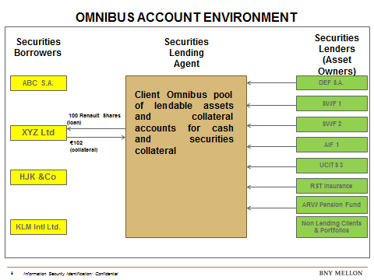Many asset owners (lenders) may participate in that loan of Renault shares but there will be only one movement of stock and cash collateral in the market. The agent lender allocates the collateral across the lending clients’ accounts proportionate to the amount of stock loaned from their account:

**Securities financing transactions – segregated account environment**

A single borrower (XYZ Ltd in this example) may wish to borrow 100 Renault shares against 102% collateral margin as in the previous example. Under a segregated account model, the borrower will ask the agent lender if it has 100 Renault shares available for loan.

The agent lender will look into the pool of lendable assets and each segregated AIF/UCITS account and confirm that there are 100 Renault shares available to borrow. In this example, there are 25 Renault shares in Depo/AIF 1 account, 25 Renault shares in Depo/AIF2 account, 25 Renault shares in Depo/UCITS 1 account and 25 Renault shares in Depo/UCITS 2 account.

If the agent lender offers 4 separate deliveries and 4 collateral calls to the borrower, the borrower will immediately ask for a consolidated holding of 100 Renault shares instead. In all likelihood, the shares will then be delivered from the client omnibus account containing the non-AIF/UCITS portfolios.

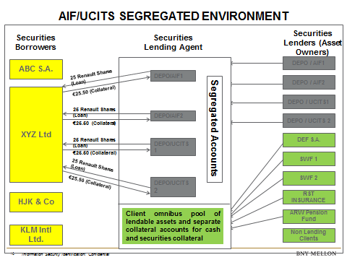

Segregation of AIFs/UCITS will force them out of tri-party collateral management arrangements into a bilateral environment, which is unattractive to major dealers and to the market in general. Segregation will therefore limit the revenues that AIFs/UCITS can generate through securities loans and repo transactions, creating an unnecessary performance drag on those funds.

TYPE YOUR TEXT HERE

<ESMA_QUESTION_CE_ASCS_10>

1. **Many CP respondents indicated that the costs associated with option 1 are very significant. Please provide further data on quantifying the cost impact (including one-off and on-going) of option 1 on AIFs/UCITS (and their shareholders), depositaries, global custodians, prime brokers, delegates, their clients and the different markets?**

<ESMA_QUESTION_CE_ASCS_11>

We have evaluated the cost question from the perspective of a depositary and concluded that the costs would be likely to grow exponentially with further levels in the custody chain where the account structure had to be replicated.

The markets with large trading and transaction volumes are currently markets with an omnibus account structure. Hence, transactions like bulk/block orders and lending/repo transactions are today internalised at the level of the depositary. With the implementation of option 1, additional market accounts would need to be opened at the level of the delegate and sub-delegate (depending on the number of safe-keeping levels), increasing the administrative burden and cost at each level. Initial set-up costs are difficult to estimate as this depends on the number of underlying clients and the procedures at the relevant depositary and delegates.

It is, however, possible to make a rough estimate of transaction costs based on the current number of internal transactions that would need to settle via the market. Under option 1, an internalisation of block orders and lending/repo transactions at the level of the depository would no longer be possible as such transactions would have to be routed through the market to ensure proper and correct settlement in each delegate’s books and records. Based on the business of our members and the current market prices per transaction, we would expect transaction costs to increase by 70% to 100%.

This increase would results from the fact that each delegate would add the market cost it had to pay its delegate/CSD to the transaction costs at its level. Ultimately, such costs would have to be borne by the investor as the originator of the transaction.

However, this is an estimate based on the business of a depositary. The cost impact may differ depending on the business model of the depositary or delegate.

**Account opening, maintenance, transaction fees etc.**

Option 1 would have a significant negative impact on costs without any benefit whatsoever in terms of improving investor protection:

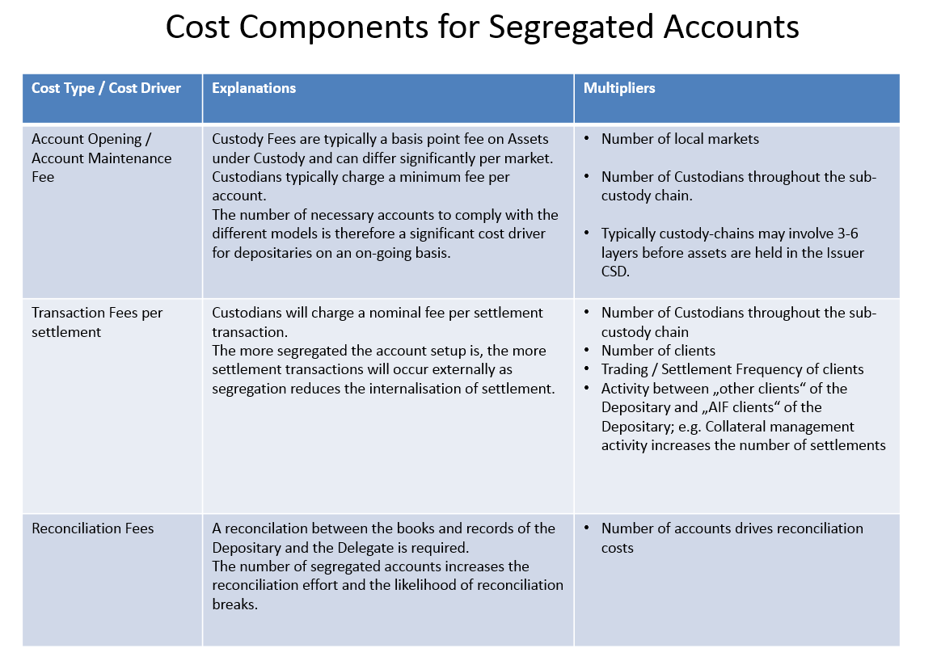

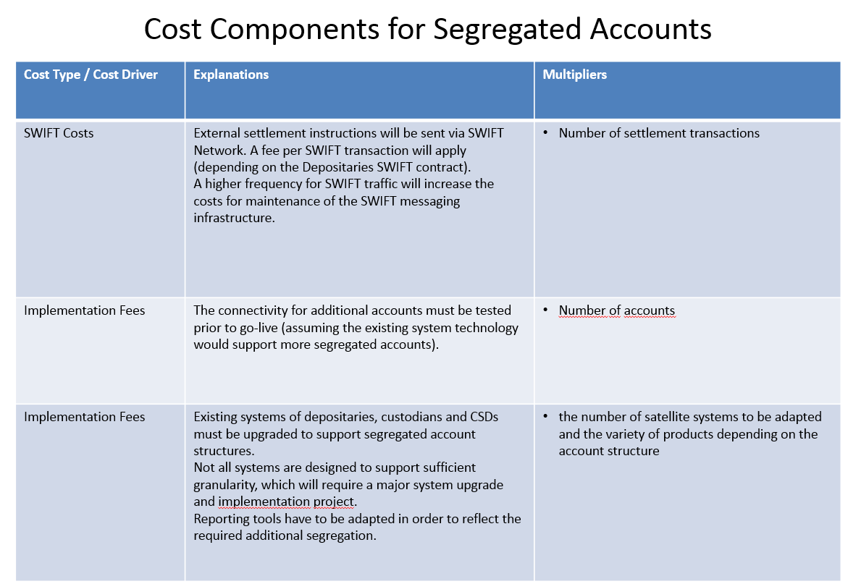

Particularly in the case of multi-level custody chains, moreover, option 1 would result in a dramatic increase in operational complexity (proliferation of unnecessary accounts, greater complexity of settlement instructions, etc.).

We also have serious concerns about the disparity which could arise under option 1 in the way that segregated assets are treated depending upon whether they are held directly with the issuing central securities depository (“issuer CSD”) as the ultimate custodian, or through an “investor CSD”. Unless an issuer CSD is deemed a “delegate” under Article 21(11) of the AIFMD, for instance, it would not be subject to the same safe-keeping stipulations of the AIFMD and thus be exempt from the burdensome requirements of option 1. In this case, an issuer CSD would be able to maintain collective (omnibus) accounts without any required segregation of AIF (or UCITS) assets. An investor CSD, which in contrast acts as part of the investor-side custody chain, i.e. essentially as the final delegated sub-custodian, would have to be deemed a “delegated third party” under the AIFMD (or UCITS Directive) and would be compelled to follow its safe-keeping stipulations. An investor CSD would therefore be compelled, under option 1, to segregate AIF assets, even if it had received these securities from another CSD acting as an issuer CSD.

In addition to this significant increase in operational complexity and operational risk, and in addition to significantly higher costs throughout the custody chain resulting from the greater number of settlements and accounts and more complex settlement instructions, option 1 would preclude AIFs or UCITS from using established and useful business models in order to save costs and generate income. Furthermore, local requirements governing individual markets or operators of investor CSDs could fully preclude the implementation of option 1 in some markets.

**Corporate actions**

Significant additional implications also relate to the processing of corporate actions:

* For the announcement notifications of corporate actions, option 1 would mean a significant increase in message traffic and the related messaging costs. As a lot more instructions would have to be processed, some messages might actually be delayed due to the significant volumes. This might also endanger the execution of AIFs’ or UCITS’ shareholder rights.
* Corporate action elections (inbound and outbound): due to the variations in each market for elective corporate actions, segregation would potentially increase the operational risk within the elective space. The process is manual at some CSDs, which would result in increased controls and operational risk. Due to the risks that are associated with an increased number of accounts, this might have an impact in some markets on the deadline set by the custodians within the transaction chain as operational areas would require more time to process elections, especially at the CSD, where the number of accounts could increase from one to 100+ per client.
* Proxy: with the exception of market instructions, account segregation would greatly increase the number of instructions that had to be sent to the CSDs. In some markets, participants need to lodge instructions in paper form for each segregated account. Electronic voting would also be for each segregated account, which in turn would increase vendor costs wherever third parties were utilised, and in addition physical attendance would increase the power of attorney requirements.

TYPE YOUR TEXT HERE

<ESMA_QUESTION_CE_ASCS_11>

1. **Are there any advantages of using omnibus accounts not covered in your responses to other questions?**

<ESMA_QUESTION_CE_ASCS_12>

Using omnibus accounts enables swift and effective client onboarding. Lengthy processes can be avoided as well as unnecessary documentation. Omnibus accounts enable asset managers to utilise already existing account structures in other markets, which is a client service not to be underestimated. Opening an account at a foreign CSD can take up to six months, and could take even longer if more accounts had to be opened. If such a process had to be carried out for each new AIF or UCITS wanting to invest in several foreign markets where no such AIF or UCITS account already existed, client onboarding could become long, inefficient and burdensome in the future.

TYPE YOUR TEXT HERE

<ESMA_QUESTION_CE_ASCS_12>

1. **Please consider the case where a third-party delegate or sub-delegate in the custody chain also acts as a clearing member under EMIR. What would be the impact (if any) of the interaction between the approaches described under each of the options in the table under Q22 below and the choices provided for under Article 39 (2) and (3) of EMIR[23] (including if this may raise any operational difficulties)? Should you consider that there is any impact, please explain why.**

<ESMA_QUESTION_CE_ASCS_13>

GBIC would like to begin by stressing that almost none of its members’ clients choose the individual client segregation option under Article 39 of EMIR. Clients normally do not wish to have this type of segregation. Nor do they wish to be burdened with the associated red tape and expense. In our view, the fact that clients have no interest in individual client segregation even though this option must be offered to them by law demonstrates that they, too, see no legal or procedural benefits in such segregation.

Total segregation of accounts at CCP level would also raise operational issues, in our opinion. Full segregation at clearing level would make it impossible to continue netting claims and orders, thus eliminating a key role CCPs perform in mitigating risk.

TYPE YOUR TEXT HERE

<ESMA_QUESTION_CE_ASCS_13>

1. **Please describe the functioning of the following arrangements and clarify the operational reasons why, and the extent to which, the segregation requirements under option 1 would affect them:**
2. **tri-party collateral management arrangements;**
3. **prime brokerage arrangements.**

<ESMA_QUESTION_CE_ASCS_14>

For a description of the functioning of tri-party collateral management arrangements, please refer to our response to **Q7**.

The implementation of option 1 would preclude existing business models, as these would no longer be compatible with current market practice. These business models, which provide significant cost reduction benefits to AIFs and UCITS, are **only** feasible through the use of omnibus accounts which are allocated to clients through established electronic or record-keeping mechanisms (which is why we have strongly endorsed ESMA’s original option 3 of 2014). If option 1 were to be introduced, it would only be possible to continue to offer these products to AIFs or UCITS by carving out of exceptions. However, once one starts down the road of exceptions and exemptions, there is a risk of disproportionality, and thus this path is to be avoided if possible.

In addition to the opportunities offered by these business models, access to all markets that work with omnibus rather than segregated accounts would also be precluded if option 1 were to be uniformly enforced – for example, the US market or Shanghai-Hong Kong Stock Connect. In the case of certain AIFs and UCITS, this would dramatically impact their investment strategies.

Segregating AIF and other client assets, including UCITS, at the sub-custodian level would prevent efficient collateral management since collateral flows, optimisation and substitutions between AIFs and non-AIFs would have to occur at market level.

This introduces timing challenges, especially when markets are closed, and alignment challenges intraday between the tri-party collateral agent’s books and records and the sub-custodian’s records (unless the sub-custodian can realign intraday on a real time basis).

If it is concluded by ESMA, notwithstanding the above, that the segregation of AIF/UCITS assets is required at all levels in the custody chain, AIFs/UCITS will likely become unattractive counterparties to the securities finance and repo market. This is because any securities borrowed from an AIF/UCITS will have to be delivered from a segregated account at the sub-custodian (rather than an omnibus account where other lenders’ assets are pooled) and because that pool of assets will be smaller than the omnibus pool, this will in all probability involve multiple deliveries, especially under option 1.

Further, collateral posted to the AIF/UCITS lenders will need to be segregated and this will mean that collateral optimisation and substitution will then involve the movement of assets at sub-custodian level (T+X). This is patently unattractive to borrowers, who optimise and substitute collateral many times a day in the tri-party collateral management environment. Substitution and optimisation of collateral at the sub-custodian level is not possible intraday since it will become subject to “physical” movements in local markets. Even if there was only two segregated accounts at each sub-custodian, one for non AIFs/UCITS and one for AIFs/UCITS, dealers would not be able to substitute/optimise their portfolios intraday across those two accounts.

This essentially means that AIFs/UCITS, which currently account for a sizeable part of the European investment markets, will have their assets and cash removed from generally accessible market liquidity.

There are two issues:

Firstly, fragmentation of asset/liquidity pools is counter-intuitive at a time when liquidity and collateral mobility is needed more than ever as a result of new regulation like EMIR, which requires freely available eligible collateral and access to high-quality liquid assets (HQLA) to reduce market risks for all investors.

Secondly, since AIFs/UCITS are subject to competitive performance benchmarks, impairing their attractiveness to other counterparties in the market and thereby reducing fund performance at a time when yield is low, does not seem sound. The initial reason AIFs/UCITS would become less attractive counterparties to the dealer community is that their funds tend to be smaller than large institutional and sovereign wealth funds, for instance. Consequently, if a group is looking to borrow, for example, one million liquid shares, it will today generally be able to source all of those shares from one omnibus account at one custodian as an agent lender. This would be different under option 1.

A similar request from a segregated pool of AIFs/UCITS would potentially mean that the order could not be filled in one delivery and would need to be sourced from multiple pools or even accounts. Equally, there would need to be separate collateral deliveries, which would add expense, fragment collateral and increase operational/settlement risk. If option 1 is deployed, the transaction will become much more complex and complicated as multiple deliveries/receipts will be required. This could, additionally, render the transaction commercially unviable for the dealer/borrower as the increase in segregated accounts would go hand in hand with an increase in operational and settlement risk with no apparent benefits.

In terms of impairment to AIF and UCITS fund performance through account segregation, one of our members already sees that AIFs/UCITS on loan balances are currently around 7.7% of available securities while non-AIF/UCITS average balance on loan is more than 12%. We believe that this in part reflects securities borrowers’ concern about loan collateral having to be segregated in the future and therefore AIFs/UCITS have become unattractive from a loan perspective already.

The delta in terms of revenue between AIF/UCITS revenue from loaned securities and those that a non-AIF/UCITS currently generates in that member’s securities lending programme is substantial, at $13 million. We take the view that not all of that delta is attributable to concerns about potential segregation, but there is a strong indication that some of it is, and the delta could well increase further as counterparties could refuse more and more to deal with AIFs/UCITS if segregation at sub-custodian level became mandatory.

TYPE YOUR TEXT HERE

<ESMA_QUESTION_CE_ASCS_14>

1. **Are you able to source any data on quantifying the additional costs and market impact for prime brokers and/or collateral managers as a result of implementing option 1?**

<ESMA_QUESTION_CE_ASCS_15>

Please also see our response to **Q11**.

Additionally, GBIC would like to set out the **impact on collateral management** by tri-party agents. This will not result in much additional cost but will lead to a significant change in their services.

As set out in our responses above and particularly to **Q14**, implementing option 1 is technically and operationally possible from a tri-party collateral management perspective. But the fragmentation of assets into multiple sub-custodian accounts would have a severe impact on the business model of tri-party agents. We therefore believe that such agents would withdraw from providing tri-party collateral management services to AIFs/UCITS. Though AIFs/UCITS could continue lending their assets, they would do so on a bilateral basis rather than through tri-party agents. However, the tri-party model would still remain the optimal model for borrowers.

Taking into account the reaction of tri-party agents, namely the withdrawal of services to AIFs/UCITS, we would not expect significant costs from segregating AIFs/UCITS under option 1 from a collateral management perspective. The market impact, however, would be substantial, as described in our response above to **Q14**.

TYPE YOUR TEXT HERE

<ESMA_QUESTION_CE_ASCS_15>

1. **Many respondents to the CP argued that the requirements under option 1 would trigger ‘legal certainty risk’ and ‘attendant operational risk’ in relation to collateral management. Should you agree with these statements, please specify what precisely you understand by “legal certainty risk and “attendant operational risk”. How could those risks be mitigated?**

<ESMA_QUESTION_CE_ASCS_16>

**Legal certainty risk**

With regard to legal certainty risk, option 1 will add complexity to account structures. It would take longer for relevant parties to clearly identify and enforce their *in rem* property rights. Another risk could arise from the fact that it might be unclear how option 1 was to be implemented outside the EU. This is what GBIC understands by “legal certainty risk” in connection with option 1. This risk could be mitigated by following the requirements under Article 16(8) of MiFID and its associated Level 2 measures. This would allow tried and tested structures to be retained in the markets and preclude uncertainty as to how asset segregation requirements were to be implemented in a cross-border context.

**Attendant operational risk**

Whenever there is a change in settlement arrangements and whenever there are new accounts to open/settle with/reconcile to, the potential for error will increase. In short, the more accounts there are, the more possibilities to post transactions to incorrect accounts or to issue settlement instructions, etc. to incorrect accounts.

Mitigating such risks is in part the responsibility of the custodian. But the risk will also have an impact on the asset managers and brokers who are responsible for issuing and executing instructions with regard to AIF or UCITS assets. Although we are of the opinion that risk control is part of the industry’s responsibility, it seems at odds with prudent regulation and best market practice to increase operational risk in this way as we see no benefits in terms of investor protection but only legal uncertainty and potential operational risk connected to an introduction of option 1.

TYPE YOUR TEXT HERE

<ESMA_QUESTION_CE_ASCS_16>

1. **Could adaptations to IT systems help to face the challenges that option 1 represents in relation to collateral management? If so, please explain how, if possible indicating the costs and timescales of the work that would be needed.**

<ESMA_QUESTION_CE_ASCS_17>

As explained both in this response and in our response to ESMA’s consultation paper of 2014, other options, namely options 3 and 4 of the 2014 consultation paper (though not the current options as described in **Q22**), comply with ESMA’s policy objective of strong client asset protection, especially in insolvency, while requiring few or no changes to existing account holding models. Although we can imagine that the adaptation of IT systems could help to face the challenges that option 1 represents, we do not believe it would be helpful to analyse the costs and timescales of the work that would be needed. Our members have clearly indicated that they would be unwilling to continue offering services for segregated accounts under option 1 because of the need to undergo such an exercise. They would rather cease offering collateral management services to AIFs and UCITS.

We also doubt that analysing the potential costs and work involved in overcoming the problems option 1 would present makes good sense given the fact that robust client protection rules are already in place under MiFID. GBIC does not consider it a sound approach to seek solutions to unnecessary problems when the current market set-up is already perfectly fit for purpose.

TYPE YOUR TEXT HERE

<ESMA_QUESTION_CE_ASCS_17>

1. **Have you identified any operational (or other) challenges in terms of the impact of the requirements under option 1 of the CP for the functioning and efficiency of T2S? If your answer is yes, please explain in detail.**

<ESMA_QUESTION_CE_ASCS_18>

Yes. As pointed out in our reply to **Q7**, CSDs are connected to one another on the T2S platform by means of one account only. Changes in the legal requirements for CSD links or investor CSDs would necessitate extensive technical changes to the T2S platform. Given the standardised legal framework established by the CSDR, the cost and effort involved in making these changes would not be matched by any benefit in terms of improved protection in the event of insolvency.

The specific impact on T2S depends on the following factors:

a/ the degree to which the custody chain is located on T2S;

b/ the degree to which segregation requirements apply to that part of the custody chain located on T2S; and

c/ the degree to which the segregation requirements under the AIFMD and the UCITS Directive also apply to assets held on behalf of other categories of investor.

*Explanation of factors*

**a) degree to which the custody chain is located on T2S**

If only the securities accounts provided by the issuer CSD are located on T2S, and all other securities accounts provided by intermediaries in the custody chain are located outside T2S, then the technical impact on the functioning of T2S will be negligible or non-existent. This is for two reasons. The first is that the segregation obligation under the AIFMD and UCITS Directive does not apply to accounts provided by the issuer CSD. This is because issuer CSDs should not be delegates, as further explained in our response to **Q29**. The second reason is that, in any event, T2S needs to allow an issuer CSDs to provide large numbers of accounts to its participants in accordance with Article 38 of the CSDR.

However, if securities accounts provided by several intermediaries in a custody chain are located on T2S, then, as explained below, there will possibly be a technical impact on the functioning of T2S.

**b) degree to which segregation requirements apply to that part of the custody chain located on T2S**

If securities accounts provided by several intermediaries in a custody chain are located on T2S, and if those intermediaries (like investor CSDs) are not under an obligation to segregate (i.e. are not considered delegates of the depositary), then the technical impact on the functioning of T2S will be negligible or non-existent. The same conclusion applies if investor CSDs are considered delegates of the depositary (and thus are under an obligation to segregate), but if there is only one investor CSD in the custody chain.

The reasoning behind this conclusion is that it would still be possible to operate one account only in the CSD link.

However, if investor CSDs are considered delegates (and thus are under an obligation to segregate), and if there are two or more investor CSDs in a custody chain (for example a technical issuer CSD and an investor CSD on T2S), then there may be the following technical impact. The full account structure for AIF/UCITS holdings in the books of the first investor CSD on T2S will need to be replicated in the books of all other investor CSDs in the custody chain before reaching the issuer CSD; such replication will involve not only opening the relevant inter-CSD accounts on T2S, but also opening the appropriate mirror accounts on T2S.

We regret that we are not in a position to provide an estimate of the scale of the technical impact on T2S of the opening, maintenance and use of these additional accounts (and mirror accounts). We assume that the necessary changes will have to be postponed until T2S is fully operational and other change requests have been implemented.

**c) degree to which the segregation requirements under the AIFMD and UCITS Directive also apply to assets held on behalf of other categories of investor**

Even if the technical impact on T2S of segregation requirements placed on AIF and UCITS assets are limited, it is important to consider the consequences for T2S if these segregation requirements are generalised so that they apply to assets held on behalf of all types of investor. A bank typically has no direct legal relationship with T2S, which is reserved for CSDs and/or national central banks. The impact on the efficiency of platforms therefore cannot be fully assessed from such a position. However, a number of observations can be made on the basis of the technical specifications publicly available.

The T2S User Requirements Document (URD) version 5.05 (1 August 2016) states:

“*Use of Multiple Omnibus Accounts 1 Reference ID T2S.16.740*

*For various reasons, an Investor CSD may decide [to] use several omnibus accounts within the technical issuer CSD for segregating the holdings of its participants within the technical issuer CSD. T2S shall support the use of multiple omnibus accounts, but its use by the CSDs should be very limited in order not to add unnecessary complexity.*”[24]

The question thus arises at which stage the complexity caused by segregated accounts would be of concern to the T2S operator, the CSD users or the underlying clients.

Equally, the T2S General Functional Specifications version 5.2 (August 2016) also conceptually expect cross-border CSD links to be based on omnibus account relationships:

“*Each CSD Account Link includes the following elements:*

*l A link to the party playing the role of the investor CSD;*

*l A link to the party playing the role of the technical issuer CSD;*

*l A link to a CSD participant account (within the relevant investor CSD);*

*l A link to an omnibus account (within the relevant technical issuer CSD);*

*l A link to a mirror account (within the relevant investor CSD);*

*l A link to an inter-CSD account (within the relevant investor CSD).*”[25]

The actual interpretation and consequences of option 1 need to be clarified in order to assess the level of account segregation needed and to assess whether it would materially exceed the segregation requirements at the time the platform was designed and its usage by the market was envisaged.

CSD links can take different forms, i.e. direct or indirect links. We understand option 1 would require the segregation of AIF, UCITS and non-AIF/UCITS assets by each delegate except at the level of the issuer CSD in the event that a CSD link is used. We note that there are different interpretations about whether investor CSDs other than the issuer CSD should be considered a delegate under this model. The decision as to whether the investor CSD is to be considered a delegate or not would have a considerable impact on the account structures in a CSD link. As explained in our response to **Q7**, the original design of T2S works on the assumption that only one account will be operated between two CSDs. Although it may be technically possible in T2S to operate more than one account between CSDs, the new account architecture would be incompatible with the current set-up of the platform and would require large-scale modifications of the systems and technology.

In addition, we would like to point out that the T2S system does not currently charge CSDs an account fee. However, this was based on the assumption “that actual usage will be within an expected consumption pattern” as defined when the price list was agreed in 2010. It can be concluded from the reference in the URD that the T2S pricing schedule did not anticipate a significant use of segregated accounts of investor CSDs at the level of the technical issuer CSD.

TYPE YOUR TEXT HERE

<ESMA_QUESTION_CE_ASCS_18>

1. **Many respondents to the CP argued that AIFs risk being shut out of key markets due to the following:**
2. **the mismatch that will arise between local jurisdiction securities ownership rules and the mandated level of segregation required under option 1 in the CP; and/or**
3. **the requirement in certain countries to hold omnibus accounts across multiple depositaries, as is the case for certain stock exchanges.**

**If you agree with the above statement, please explain your concern with reference to specific jurisdictions and/or stock exchanges and the relevant requirements.**

<ESMA_QUESTION_CE_ASCS_19>

Yes, we fully agree that AIFs risk being shut out of key markets. However, we take the view that a) local jurisdiction ownership rules and the mandated level of segregation are not the reason, at least in Germany. As already explained, the level of segregation needed for client asset protection is dependent not only on ownership rules but also on other civil law and, in particular, insolvency law aspects. For this reason, it is b) the requirement in certain countries to hold omnibus accounts that would drive AIFs out of markets where the new segregation requirements could not be met. Also, this structure runs counter to US custody practices (omnibus holding market), for example, and it is not clear how this would be reconciled. Furthermore, this model would inevitably lead to prime brokers concentrating relationships with key depositaries to reduce account proliferation, which would increase concentration risk. It is also the case that the relative attractiveness of trading synthetically (cost, efficiency, and access to leverage) would increase, which would be an unintended outcome. Further, all documentation would have to be amended across multiple jurisdictions and the associated costs would be passed on to AIF/UCITS clients.

TYPE YOUR TEXT HERE

<ESMA_QUESTION_CE_ASCS_19>

1. **Should you/the funds that you manage comply with option 1 in the CP, please provide details on if and how you apply the requirements under this option when delegating safe-keeping duties to third parties outside the EU.**

<ESMA_QUESTION_CE_ASCS_20>

The German market does not currently comply with option 1.

TYPE YOUR TEXT HERE

<ESMA_QUESTION_CE_ASCS_20>

1. **Many respondents to the CP argued that, given that many delegated third parties are located outside of the EU, option 1 of the CP could lead to higher fees charged by the delegated parties. Are you able to source any data on the potential higher fees charged by the delegated parties outside the EU as a result of implementing option 1?**

<ESMA_QUESTION_CE_ASCS_21>

It is very hard to estimate costs given that the fees would be charged by a third party that has so far not been pushed in that direction. One needs to consider the impact on a single sub-custodian given the total number of clients they have that themselves operate UCITS/AIF/other accounts. Each sub-custodian would have its own capacity constraints, impact on staffing, impact on system development, KYC/AML burden to comply with, paperwork and consequential pricing of custody and transaction costs that they would then pass on to their clients. This multiplied across a number of markets globally and the 10 to 15 depositaries that such sub-custodian services would provide a reasonable indication of the scale of the impact.

As things stand today, prime brokers do not normally charge AIF or UCITS clients any fees for opening an account or general custody services, but significant changes to the costs incurred would result in new charges being passed on to AIFs/UCITS. The same applies to specific custody services, such as processing corporate actions.

For our members, the fees which might be charged by third parties located outside the EU are therefore not so much an issue. As such fees could be allocated to specific (AIF or UCITS) clients, they could simply be passed on to them as third party fees. This, in turn, would however have a negative impact on the performance of AIFs/UCITS and reduce the attractiveness of the product itself.

TYPE YOUR TEXT HERE

<ESMA_QUESTION_CE_ASCS_21>

1. **How would you compare and contrast the five options in the cost-benefit analysis (CBA) of the CP in terms of achieving the policy objective described in the above introduction? In your opinion, does any one of the options offer a better solution for achieving this aim, and if so, how? In answering to these questions, please refer to the table below which is copied from the CBA of the CP and adds the sub-delegate level.**

**Please note that as the present call for evidence is intended to cover asset segregation requirements for both AIFs and UCITS, with regard to the latter any reference in the table below to ‘AIF’ should also be read as ‘UCITS’, i.e. when applied to UCITS, references to ‘AIF’ should be read as ‘UCITS’ and references to ‘non-AIF’ should be read as ‘non-UCITS’.**

|  |  |
| --- | --- |
| **Option 1** | AIF and non-AIF assets should not be mixed in the same account and there should be separate accounts for AIF assets of each depositary when a delegate is holding assets for multiple depositary clients.  When the delegate appoints a sub-delegate, this should hold separate accounts for AIF assets of each depositary and should not mix in the same account non-AIF assets of that depositary or AIF assets coming from different depositaries. |
| **Option 2** | The separation of AIF and non-AIF assets should be required, but it would be possible to combine AIF assets of multiple depositaries into a single account at delegate or sub-delegate level. |
| **Option 3** | AIF and non-AIF assets could be commingled in the account on which the AIF’s assets are to be kept at the level of the delegate. However, the delegate could not commingle in this account assets coming from different depositaries.  When the delegate appoints a sub-delegate, this should hold separate accounts for assets coming from different depositaries. However, AIF and non-AIF assets could be commingled in the account of a given depositary in which the AIF’s assets are to be kept at the level of the sub-delegate. |
| **Option 4** | AIF and non-AIF assets could be commingled in the account on which the AIF’s assets are to be kept at the level of the delegate. The delegate could commingle in this account assets coming from different depositary clients.  When the delegate appoints a sub-delegate, this could commingle in the same account AIF and non-AIF assets and assets coming from different depositaries and the delegates’ clients (but should not be mixed with the delegate’s or depositaries’ own assets). |
| **Option 5** | AIF assets should be segregated on an AIF-by-AIF basis at the level of the delegate or sub- delegate. |

<ESMA_QUESTION_CE_ASCS_22>

**Option 1**

Option 1 would cause the complexity, problems and costs described in our response to the foregoing questions.

**Option 2**

Option 2 would, in our view, conflict with the essential logic of safe-keeping and would, moreover, be in violation of the law (German law and, in particular, Article 16 of Directive 2006/73/EC). While client assets may indeed be safely and legally aggregated in an omnibus account, the **client assets of one and the same depositary** may only be aggregated in such an omnibus account at the next (delegated) level of safe-keeping. For the purposes of investor protection, the question of identifying the specific clients to whom AIF assets held in an omnibus account with a delegated third party belong is immaterial because all client assets held in omnibus accounts for clients are insolvency-remote; whether such insolvency is of the delegate or of the depositary itself makes no difference. If the client assets of a depositary are held in separate accounts with a particular delegated third party – for example, in a so-called AIF account – this may serve as a convenience for identifying client ownership, but it does not enhance legal protection against insolvency.

If, in contrast, AIF client assets from multiple depositaries are commingled in a single omnibus account at a delegated third party, as envisaged in option 2, then, should one of the participating depositaries become insolvent, it might no longer be clear which AIF the assets belong to. A lack of clarity might also arise as to which parties (potentially including an insolvency administrator) are authorised to access the AIF omnibus account and effect transactions involving account assets. A depositary should only be able to issue instructions affecting the assets of its own clients (AIF or otherwise), and these should on no account have any effect on the client assets of other depositaries. In fact, option 2 would not only undermine investor protection but would conflict with the essential logic of safe-keeping structures: at the level of the delegate, an omnibus account is opened for each depositary. This account holds assets of this depositary (and its clients) only. The depositary, in turn, maintains a separate account for each individual client, ensuring that these holdings may, at all times, be precisely allocated to each client. In the case of option 2, however, the delegated third party would commingle the AIF assets of several depositaries and would thus not be able to know how many shares of each security belonged to each depositary. What is more, option 2 would, in our eyes, conflict with Article 21(11)(d)(iii) of the AIFMD, whereby the depositary must ensure that any delegated third party segregates AIF assets “*in such a way that they can at any time be clearly identified as belonging to clients of a particular depositary*”. Option 2 must thus be discarded on legal grounds alone.

**Options 3 and 4**

We strongly disagreed with ESMA’s former decision to discard the options 3 and 4 originally presented in its 2014 consultation paper. We saw these as potential models which fully conformed with the law and were suited to actual banking practice – and which would be fully able to efficiently implement the asset segregation requirements as set forth, for instance, in the AIFMD. In particular, we vehemently disagreed with the presumption that option 3 would provide “a clearly lower level of investor protection”.

We note, however, with surprise that ESMA has changed the originally presented options 3 and 4. The options 3 and 4 in the above table no longer reflect current market practice in Germany.

From a purely legal point of view, option 1 and the original options 3 and 4 provide an identical level of protection of client assets in the event of a depositary or delegate becoming insolvent. One must, however, also factor in the significantly greater operational complexity in identification and settlement which option 1 would create compared to the original options 3 and 4. Under option 1, there would be many more accounts to be reconciled, leading to significant additional cost and complexity. Moreover, option 1 would necessitate longer and more complex settlement instructions and booking procedures, which would therefore also be (at least in theory) more prone to error.

Finally, on the matter of cost, the original options 3 and 4 are significantly and unquestionably less expensive and more effective. This is explained in detail in our reply to **Q11**.

We would also refer you to our response to **Q1 d)**. This explains in detail why options 3 and 4 closely match our current account model and which changes to the current options 3 and 4 are needed to comply with the legal requirements set out in Article 21 of the AIFMD and Article 22 of the UCITS Directive.

**Option 5**

Option 5 would be even more complex and costly than option 1. Although client asset protection could also be achieved by option 5, it would be the most burdensome option to implement and would not function in markets that do not operate the same level of account segregation. Options 2 and 5 are therefore the least suitable options.

**Alternative means**

All in all, however, GBIC is of the view that **an easier and more inexpensive solution** than any of the options in the table under **Q22** would be **to refer to the MiFID Level 2 measures fleshing out Article 16(8) of MiFID II[26].** This solution would achieve the desired high level of client asset protection while at the same time accommodating all the different account holding models in the EU.

We believe that the guidelines should provide for flexibility in choosing the best solutions for intermediaries and clients.

TYPE YOUR TEXT HERE

<ESMA_QUESTION_CE_ASCS_22>

1. **Articles 38(3) and (4) of the CSDR state that a CSD shall offer its participants the choice between:**
2. **‘omnibus client segregation’ at the CSD level (holding in one securities account the securities that belong to different clients of that participant);**
3. **‘individual client segregation’ at the CSD level (segregating the securities of any of the participant’s clients, if and as required by the participant).**

**In addition, under Article 38 (5) of CSDR, a participant shall offer its clients at least the choice between omnibus client segregation and individual client segregation and inform them of the costs and risks associated with each option[27].**

1. **Do you consider that a regime similar to the one under Article 38 of the CSDR but applied throughout the custody chain (according to which the manager of AIFs/UCITS, on behalf of their investors, informs the depositary of the level of asset segregation it wishes to apply throughout the custody chain to each individual AIF/UCITS, after having duly assessed the risks and costs associated with the different options) would achieve the policy objective described in the above introduction? Please explain why and, if the answer is yes, how.**
2. **Applying a regime similar to the one under Article 38 of the CSDR to the AIF/UCITS framework would mean that the fund investors would have the choice to invest in a given fund or not, after having been made aware – through appropriate disclosures – of the level of asset segregation that the managers of AIFs/UCITS had chosen and the related costs. However, investors would not have the opportunity to participate in the choice of the level of asset segregation as such a choice would have to be made by the manager for each individual fund as a whole (i.e. it would not be possible to have different levels of segregation for the investors in the same fund). Do you consider that this could raise any concern in terms of investor protection or could any concern be alleviated through appropriate disclosures? Please explain the reasons for your answer.**
3. **Please comment on any implications of such a regime for the account related provisions under Article 39 of EMIR.**

<ESMA_QUESTION_CE_ASCS_23>

1. **Regime similar to Article 38 CSDR – choice of fund manager**

We do not believe that that a regime similar to the one under Article 38 of the CSDR should be applied throughout the custody chain. It would not help to achieve the policy objective described in ESMA’s Call for Evidence.

As explained in our response to **Q1**, client protection in Germany is not achieved by segregating accounts at delegate or sub-delegate level. Due to Section 4(1) of the Safe Custody Act, ESMA’s policy objective could be achieved without even segregating the depositary’s own assets from those of its clients. Owing to the legal assumption that all assets in the account at delegate level belong to the depositary’s clients, client asset protection is very strong and robust, especially in the event of the depositary and/or delegate becoming insolvent.

Delegates have no obligation under German law to segregate accounts for their clients’ clients (i.e. AIFs or UCITS) when assets are held in safe custody in Germany. Even after Article 38 of the CSDR takes effect, delegates will still be permitted to hold a depositary’s own assets together with assets belonging to the depositary’s clients in a single omnibus account. It must, however, be possible to demonstrate at all times which assets belong to the depositary and which belong to its clients. Under German law, separating a custodian’s own assets from those of its clients does not offer a higher level of protection than if the assets are not separated.

It is true that Article 38(2) of the CSDR requires CSDs to enable a participant to segregate its own securities from those of its clients. This does not, however, oblige the participant to maintain separate accounts at the CSD for the participant’s own and for its clients’ securities. Only if a client of the participant expressly wishes to have an individual client account is the participant required to establish a separate account with the CSD for this client’s assets. There is consequently only a need to diverge from current practices if a client chooses to have an individual segregated account.

Article 38(2) of the CSDR also requires CSDs to “*keep records and accounts that enable any participant to segregate the securities of the participant from those of the participant’s clients*”. Once again, this does not mean the participant is under any obligation to maintain separate accounts for its own and for its clients’ securities. The fact that the CSD must enable its participants to keep separate accounts in no way makes them obligated to do so. The requirement set out in Article 38(2) of the CSDR is addressed to the CSD and the CSD alone. The obligation incumbent on the CSD must be interpreted in accordance with the spirit and purpose as well as the subsequent wording of Article 38. Paragraph 2 of Article 38 of the CSDR is to be understood as the overarching obligation, which is then fleshed out further in the following paragraphs. Article 38(3) requires the CSD to keep records and accounts which enable securities belonging to *different* clients to be held in a *single securities account* (omnibus client segregation). Article 38(4) then goes on to require the CSD to segregate client securities at the request of, and in the manner requested by, the participant. A request by a client, by contrast, can only take the form of asking that their securities are held in a segregated account of the participant at the CSD. Though the client may request the individual client segregation which the participant is required to offer under Article 38(5), the client is not entitled to further influence the manner of the account segregation. It can consequently be inferred from Article 38(3) and (4) of the CSDR that Article 38(2) of the CSDR permits participants to hold in an omnibus account the securities of those clients who have not explicitly opted for individual client segregation.

What is new, however, is that the CSD must in future offer two different types of account segregation, namely omnibus client segregation (Article 38(3) of the CSDR) and individual client segregation (Article 38(4) of the CSDR). Article 38(5) and (6) of the CSDR set out obligations for CSD participants. These are also new. In future, participants must offer their clients a choice between omnibus client segregation and individual client segregation. This duty to their clients corresponds to the CSD’s duty to enable each participant to segregate its own securities from those of its clients, either by means of omnibus client segregation or individual client segregation.

There is therefore only a need to change current safe custody practices if a client explicitly chooses individual client segregation. Only then will the participant be obliged to segregate those client’s securities into a separate account at the level of the CSD. In all other cases, the participant may separate its own assets and client assets – and the CSD must give the participant this option – but the participant is under no obligation to do so.

Therefore, we take the view that a regime similar to that under Article 38 of the CSDR would not achieve any benefit in terms of the policy objective.

Furthermore, there is no legal basis in the AIFMD or UCITS Directive for a choice of account segregation mutatis mutandis Article 38 of the CSDR. It should be borne in mind that the fund manager’s expertise lies in deciding which assets the AIF or UCITS should invest in, and not which account structure is best for the market invested in. For this reason, depositaries are appointed to decide matters such as how best to protect the fund’s assets in any given area. Typically, legal advice is sought to determine the appropriate model or level of segregation in each individual market to ensure full investor protection in the event of insolvency.

It should be considered that clients rarely, if ever, opt for an individually segregated account because it would increase costs and the operational complexity.

We have noted, however, that some fund managers do have specific views as to which sub-custodian should be appointed for specific markets.

1. **Disclosure to fund investors**

As outlined in a), we do not consider a regime similar to that under Article 38 of the CSDR an appropriate way of achieving a higher standard of investor protection. Even if such a choice of segregation level were disclosed, we do not see how this would facilitate the fund investor’s investment decision, as either option would provide the same level of client asset protection. It should also be considered that AIFs and UCITS typically invest in more than one market and that the level of segregation may differ between markets. Unnecessary disclosure of account segregation options would overburden

* the AIF/UCITS when producing the prospectus and other fund documentations, and
* the investor in making an informed decision.

1. **Regime similar to Article 39 of EMIR**

Likewise, we do not believe that a regime similar to Article 39 of EMIR would achieve ESMA’s policy objective.

TYPE YOUR TEXT HERE

<ESMA_QUESTION_CE_ASCS_23>

1. **Please describe any alternative regime which, in your view, would achieve the policy objective described in the above introduction.**

<ESMA_QUESTION_CE_ASCS_24>

When considering guidelines for the segregation of financial instruments belonging to AIFs or UCITS, we take the view that existing general rules on safeguarding client financial instruments (including asset segregation requirements) could serve as a starting point. Moreover, such an approach would ensure that a high level of protection would be provided to AIFs, UCITS and other categories of client alike.

As explained in the introduction to our response, it may make good sense to make reference to other MiFID requirements in addition to Article 16 of Directive 2006/73/2006 when regulating the safekeeping of AIF or UCITS financial instruments. This would ensure that depositaries and delegates also operating as MiFID investment firms could rely on their established account holding models and would not have to set up completely new systems and account structures for no benefit at all. It would further ensure that **all** depositaries – even those that do not operate as MiFID investment firms – followed the same rules for safekeeping AIF or UCITS financial instruments in a way that offered robust and safe client protection. Consequently, MiFID requirements like Article 19 of Directive 2006/73/EC[28] could be introduced in ESMA guidelines for the asset segregation of AIF or UCITS assets in order to meet ESMA’s concerns regarding a potential misuse of AIF or UCITS assets.

We therefore take the view that there is no need to introduce specific account holding options (like options 1 to 5) or a regime for choosing the level of account segregation (regime similar to Article 38 of the CSDR/Article 39 of EMIR).

GBIC believes that the requirements laid down in Article 21(8) of the AIFMD and Article 22(5) of the UCITS Directive to hold AIF or UCITS financial instruments in custody in accordance with Article 16 of Directive 2006/73/EC reflect the fact that this rule is a detailed yet flexible arrangement for achieving the level of client protection desired under MiFID.

Article 16(8) of MiFID II[29] reads: “*An investment firm shall, when holding financial instruments belonging to clients, make adequate arrangements so as to safeguard the ownership rights of clients, especially in the event of the investment firm’s insolvency, and to prevent the use of a client’s financial instruments on own account except with the client’s express consent.*”

This MiFID requirement exactly matches, in our view, ESMA’s policy objective set out in paras 7 and 8 of the Call for Evidence. We would therefore urge ESMA to consider the **MiFID Level 2 measures** fleshing out Article 16(8) of MiFID II when creating guidelines to support strong AIF and UCITS asset protection**, instead of options 1 to 5**. These MiFID Level 2 measures also offer the necessary flexibility regarding different account holding models in international markets.

Although MiFID rules do not generally apply to depositaries[30], we believe this should not prevent ESMA from making reference to certain MiFID requirements where it is reasonable to do so and where these requirements meet ESMA’s policy objective with regard to depositaries.

TYPE YOUR TEXT HERE

<ESMA_QUESTION_CE_ASCS_24>

1. **Do you see a need for detailing and further clarifying the concept of “custody” for the purposes of the AIFMD and UCITS Directive?**

<ESMA_QUESTION_CE_ASCS_25>

GBIC does not see a need to clarify the **concept of custody** for the purposes of the AIFMD and UCITS Directive. The concept of custody of financial instruments is understood to be the same for all depositaries and other types of custodians.

Guidance on the **concept of delegating** custody under the AIFMD and UCITS Directive, however, would be of help.

We would furthermore welcome clarification of the **terminology of “safekeeping”** for the purposes of the AIFMD and UCITS Directive. It seems to us that the term “safekeeping” applies to all AIF or UCITS assets (including financial instruments) that the depositary is entrusted with. With regard to financial instruments that can be held in custody, the safekeeping requirements under Article 21(8) of the AIFMD and Article 22(5) of the UCITS Directive are fulfilled by holding such assets in custody. Under MiFID II, by contrast, the term “safekeeping” only applies to financial instruments. Point 1 of Section B of Annex I to MiFID II states:

*“(1) Safekeeping and administration of financial instruments for the account of clients, including custodianship and related services such as cash/collateral management and excluding maintaining securities accounts at the top tier level*”.

From a purely functional perspective, custody of financial instruments is much broader than the mere safekeeping of financial instruments. It seems to us, however, that the approach taken under the AIFMD and UCITS Directive is the other way around, i.e. safekeeping is broader than custody.

TYPE YOUR TEXT HERE

<ESMA_QUESTION_CE_ASCS_25>

1. **If your answer to Q25 is yes, should the concept of “custody” of financial instruments include the provision of any of the following services for the purpose of the AIFMD and UCITS Directive:**

* **initial recording of securities in a book-entry system (‘notary service’);**
* **providing and maintaining securities accounts at the top tier level (‘central maintenance service’)**[31]**;**
* **maintaining or operating securities accounts in relation to the settlement service;**
* **having any kind of access to the assets of the AIF/UCITS; or**
* **having any access to the accounts where the assets of the AIF/UCITS are booked with the right to pledge and transfer those assets from those accounts to any other party?**

<ESMA_QUESTION_CE_ASCS_26>

Although our answer to **Q25** is no, we would like to comment on **Q26** as follows:

The services listed above do not need clarification as regards the concept of custody but in respect of the delegation of custody functions by a depositary. As explained in more detail in our response to **Q29**, services that are not provided by the depositary cannot be subject to delegation (e.g. a) and b)). Any other services listed that are provided merely as ancillary services to a) and b) cannot, in consequence, be subject to delegation either.

TYPE YOUR TEXT HERE

<ESMA_QUESTION_CE_ASCS_26>

1. **If your answer to Q25 is yes, would you include any other services in the concept of “custody” of financial instruments for the purpose of the AIFMD and UCITS Directive? If your answer is yes, please list and describe precisely the services that should be included.**

<ESMA_QUESTION_CE_ASCS_27>

Not applicable.

TYPE YOUR TEXT HERE

<ESMA_QUESTION_CE_ASCS_27>

1. **Please explain how, in your views, “custody” services interact with “safe-keeping” services, in particular those referred to under Article 21(8) of the AIFMD (as well as Article 89 of the AIFMD Level 2[32]) and Article 22(5) of the UCITS Directive (as well as Article 13 of the UCITS V Level 2[33]).**

<ESMA_QUESTION_CE_ASCS_28>

We would welcome clarification of the **terminology of “safekeeping”** for the purposes of the AIFMD and UCITS Directive. It seems to us that the term “safekeeping” applies to all AIF or UCITS assets (including financial instruments) that the depositary is entrusted with. With regard to financial instruments that can be held in custody, the safekeeping requirements under Article 21(8) of the AIFMD and Article 22(5) of the UCITS Directive are fulfilled by holding such assets in custody. Under MiFID II, by contrast, the term “safekeeping” only applies to financial instruments. Point 1 of Section B of Annex I to MiFID II states:

*“(1) Safekeeping and administration of financial instruments for the account of clients, including custodianship and related services such as cash/collateral management and excluding maintaining securities accounts at the top tier level*”.

From a purely functional perspective, custody of financial instruments is much broader than the mere safekeeping of financial instruments. It seems to us, however, that the approach taken under the AIFMD and UCITS Directive is the other way around, i.e. safekeeping is broader than custody.

TYPE YOUR TEXT HERE

<ESMA_QUESTION_CE_ASCS_28>

1. **If you consider that the provision by a CSD of any of the core services (i.e. services mentioned under Section A of the Annex to the CSDR) or ancillary services (i.e. services provided in accordance with Section B or Section C of the Annex to the CSDR) should not result in the CSD being considered as a delegate within the meaning of Article 21(11) of the AIFMD and Article 22a of the UCITS Directive, please list the specific services and explain the reasons why.**

<ESMA_QUESTION_CE_ASCS_29>

GBIC would like to begin by pointing out that CSDs are essential financial market infrastructures of a unique kind, which is why they are subject to their own specific regulation, the CSDR.

It is common to all CSDs that they operate a securities settlement system (SSS). In doing so, they accomplish a key function in the transfer of certain financial instruments, i.e. securities. It is our understanding that the AIFMD and UCITS Directive clarify in this context that the settlement of financial instruments in an SSS should not be seen as a delegation of safekeeping functions under the respective directive. Settlement in an SSS is, in fact, the execution of transfer orders within the meaning of Article 2 of Directive 98/26/EC (the SFD).

**Settlement service**

Both Article 21(11) of the AIFMD and Article 22a(4) of the UCITS Directive stipulate that the provision of services by securities settlement systems (SSS) as designated should not be considered a delegation of custody functions. We would like to point out that an SSS is a formal arrangement and not a person or legal entity. If these provisions are understood to mean that the operator of an SSS should not be regarded as a delegate, it should be taken into account that the purpose of an SSS is to provide securities **settlement.** The crucial task of an SSS is to execute transfer orders in accordance with the SFD. In this context, it is totally irrelevant whether a custody function is operated at the same time.

We therefore consider that the provision of the “settlement service” in point 3 of Section A of the Annex to the CSDR (operating a securities settlement system) should not result in the CSD being considered a delegate within the meaning of Article 21(11) of the AIFMD and Article 22a(4) of the UCITS Directive.

**Other CSD core services**

On the other hand, Recital 41 of the AIFMD states that “Entrusting the custody of assets to the operator of a securities settlements system […] should not be considered to be a delegation of custody functions”.

It has to be taken into account that a depositary can only delegate the custody functions it provides or would be obliged to provide under Article 21(8) of the AIFMD or Article 22(5) of the UCITS Directive. In other words: a depositary **cannot delegate** functions that only a CSD can provide.

We therefore believe that the provision of the CSD core services “notary service” in point 1 and “central maintenance service” in point 2 of Section A of the Annex to the CSDR and the services related to the notary and central maintenance services in point 2 of Section B of the Annex to the CSDR should also not result in the CSD being considered a delegate within the meaning of Article 21(11) of the AIFMD and Article 22a(4) of the UCITS Directive as only CSDs authorised under the CSDR may provide these services. This would also be in line with our statement above that the CSD core service “settlement service” should not be regarded as a delegation of custody functions. Under Article 18 of the CSDR, an SSS can be operated by an authorised CSD only.

It is true that the central maintenance service (particularly in connection with the notary service) is, at the same time, safekeeping of securities in collective safe custody under the application of German law (Section 5 of the Safe Custody Act). It cannot, however, be seen as a delegation of the depositary’s safekeeping (or custody) functions in cases where the securities are kept in custody by the CSD as a result of a choice by the issuer of the assets in question and not by the choice of the depositary or its delegates in the custody chain.

The delegation of depositary functions must occur on the basis of a decision to do so by the depositary. Article 21(11) of the AIFMD and Article 22a(4) of the UCITS Directive make it clear that a delegation of **its** (i.e. the depositary’s) functions can only take place in respect of safekeeping and, as assumed under c)[34] of these rules, after the selection and appointment of a delegate by the depositary. A CSD initially recording securities in book-entry provides its (core) services by the selection of the issuer of those securities to have them admitted to trading on trading venues and not by the selection of the depositary.

“Entrusting of custody services”, as referred to in Recital 41 of the AIFMD, is the result of the provision of CSD core services. It is therefore not the result of the delegation of the depositary’s custody functions. We therefore believe that Recital 41 of the AIFMD serves as clarification in this respect. This is confirmed by the first sentence of Recital 21 of the UCITS Directive.

**Other services**

With regard to other CSD services, we would like to point out that Sections B and C of the Annex to the CSDR are non-exhaustive. In order to determine which of such services should result in the CSD being considered a delegate, an assessment of the function provided by the CSD must take place.

As a general rule, there is a need to differentiate between whether the depositary can select a sub-custodian of its choice (including the CSD) for the services provided or whether there is no choice because the custody chain necessarily ends at the CSD in question. Where the depositary has a choice, the delegation of the depositary’s custody functions to a CSD is possible in accordance with Article 21(11) of the AIFMD or Article 22a(4) of the UCITS Directive.

TYPE YOUR TEXT HERE

<ESMA_QUESTION_CE_ASCS_29>

1. Regulation (EU) No 909/2014
2. Corresponding to the future Article 5 of MiFID II Commission delegated directive C(2016) 2031 final
3. Paragraphs 17 and 49 of IOSCO’s Standards for the Custody of Collective Investment Schemes’ Assets, final report, November 2015
4. Corresponding to Article 2 of MiFID II Commission delegated directive C(2016) 2031 final
5. MiFID II Recital 34 reads: “*It is necessary to exclude from the scope of this Directive collective investment undertakings and pension funds whether or not coordinated at Union level, and the depositaries or managers of such undertakings, since they are subject to specific rules directly adapted to their activities*.”
6. <http://www.europarl.europa.eu/document/activities/cont/201106/20110606ATT20781/20110606ATT20781EN.pdf>
7. See pages 14-15 of the Briefing Note.
8. See page 16 of the Briefing Note.
9. See page 17 of the Briefing Note.
10. See page 18 of the Briefing Note.
11. See page 19 of the Briefing Note.
12. Corresponding to Article 16(8) of Directive 2014/65/EU (MiFID II)
13. Please also see ECON Briefing Note in 2011, p. 19
14. Scherer, Safe Custody Act, Section 14 para 21
15. Heinsius/Horn/Than, Section 14 para 12
16. Scherer, Safe Custody Act, Section 14 para 22
17. Scherer, Safe Custody Act, Section 14, para 1
18. Heinsius/Horn/Than, Section 5, para 68
19. As we were provided with this statement by one of our members, we will send the statement to ESMA via e-mail to be treated in confidence
20. See paragraphs 29 and 30 of the [Standards for the Custody of Collective Investment Schemes’ Assets – Final Report (FR25/2015)](http://www.iosco.org/library/pubdocs/pdf/IOSCOPD512.pdf): “*Depending on the operational framework in the jurisdiction, there is a risk that CIS assets in the custodian’s care can become co-mingled with (i) assets of the responsible entity; (ii) assets of the custodian; or (iii) the assets of other clients of the custodian (although it should be noted that CIS assets may be held in a permissible "omnibus account"). The consequences of these risks could result in the ownership of the assets being called into question in the event of misuse or insolvency of the custodian, which may create difficulties differentiating ownership of the assets*”. The positive and negative aspects of omnibus accounts are also mentioned on page 11 of the IOSCO [Survey of Regimes for the Protection, Distribution and/or Transfer of Client Assets – Final Report (FR05/11)](http://www.iosco.org/library/pubdocs/pdf/IOSCOPD351.pdf).
21. According to Article 1(g) of the ESMA draft technical standards under CSDR (ESMA/2015/1457/Annex II), ‘investor CSD’ means a CSD that is a participant in the securities settlement system operated by another CSD or that uses an intermediary that is a participant in the securities settlement system operated by another CSD in relation to a securities issue (available at [www.esma.europa.eu/sites/default/files/library/2015/11/2015-esma-1457_-_annex_ii_-_csdr_ts_on_csd_requirements_and_internalised_settlement.pdf](http://www.esma.europa.eu/sites/default/files/library/2015/11/2015-esma-1457_-_annex_ii_-_csdr_ts_on_csd_requirements_and_internalised_settlement.pdf)).
22. “CSD Account Structure: Issues and Proposals” (available at [www.afme.eu/WorkArea/DownloadAsset.aspx?id=5897](http://www.afme.eu/WorkArea/DownloadAsset.aspx?id=5897)), AFME, March 2012, p. 9
23. Article 39(2) and (3) of EMIR states the following: “*2. A CCP shall offer to keep separate records and accounts enabling each clearing member to distinguish in accounts with the CCP the assets and positions of that clearing member from those held for the accounts of its clients (‘omnibus client segregation’). 3. A CCP shall offer to keep separate records and accounts enabling each clearing member to distinguish in accounts with the CCP the assets and positions held for the account of a client from those held for the account of other clients (‘individual client segregation’). Upon request, the CCP shall offer clearing members the possibility to open more accounts in their own name or for the account of their clients*”.
24. <https://www.ecb.europa.eu/paym/t2s/pdf/2016-08-01_urd_v5_05.pdf?deb2f72e6f034175278bae60b601caab>, p. 420.
25. https://www.ecb.europa.eu/paym/t2s/pdf/2016-08-01_gfs_v5.2.pdf?c94d051b9f0dab3213f5e985dee7015a
26. Corresponding to Article 13(7) MiFID I
27. However, under Article 38(5) of the CSDR a CSD and its participant shall provide individual clients segregation for citizens and residents of, and legal persons established in, a Member State where required under the national law under which the securities are constituted as it stands at 17 September 2014.
28. Corresponding to the future Article 5 of MiFID II Commission delegated directive C(2016) 2031 final
29. Corresponding to Article 13(7) MiFID I
30. MiFID II Recital 34 reads: “It is necessary to exclude from the scope of this Directive collective investment undertakings and pension funds whether or not coordinated at Union level, and the depositaries or managers of such undertakings, since they are subject to specific rules directly adapted to their activities.”
31. These services are part of the core services of central securities depositories under Section A, point 2 of the Annex to Regulation (EU) No 909/2014 (“CSDR”).
32. Commission Delegated Regulation (EU) No 231/2013 of 19 December 2012.
33. Commission Delegated Regulation (EU) 2016/438 of 17 December 2015.
34. (c) the depositary has exercised all due skill, care and diligence in **the selection and the appointment** of any third party **to whom it wants to delegate** parts **of its** tasks, and keeps exercising all due skill, care and diligence in the periodic review and ongoing monitoring of any third party to whom it has delegated parts of its tasks and of the arrangements of the third party in respect of the matters delegated to it